A Novel 2D Nickel(II) Coordination Polymer MOF Type Containing Trimesic Acid as Ligand With Coordination of Glyphosate
João Manoel Rocha Gonçalves, Ademar Wong, Pedro H. O. Santiago, Guilherme Arroyos, Augusto H. Piva, , Javier A. Ellena, Gregóire J.F. Demets, Benedito S. Lima-Neto, Regina C. G. Frem

E-mail: joaomanoel@usp.br

SUPPORT INFORMATION
.
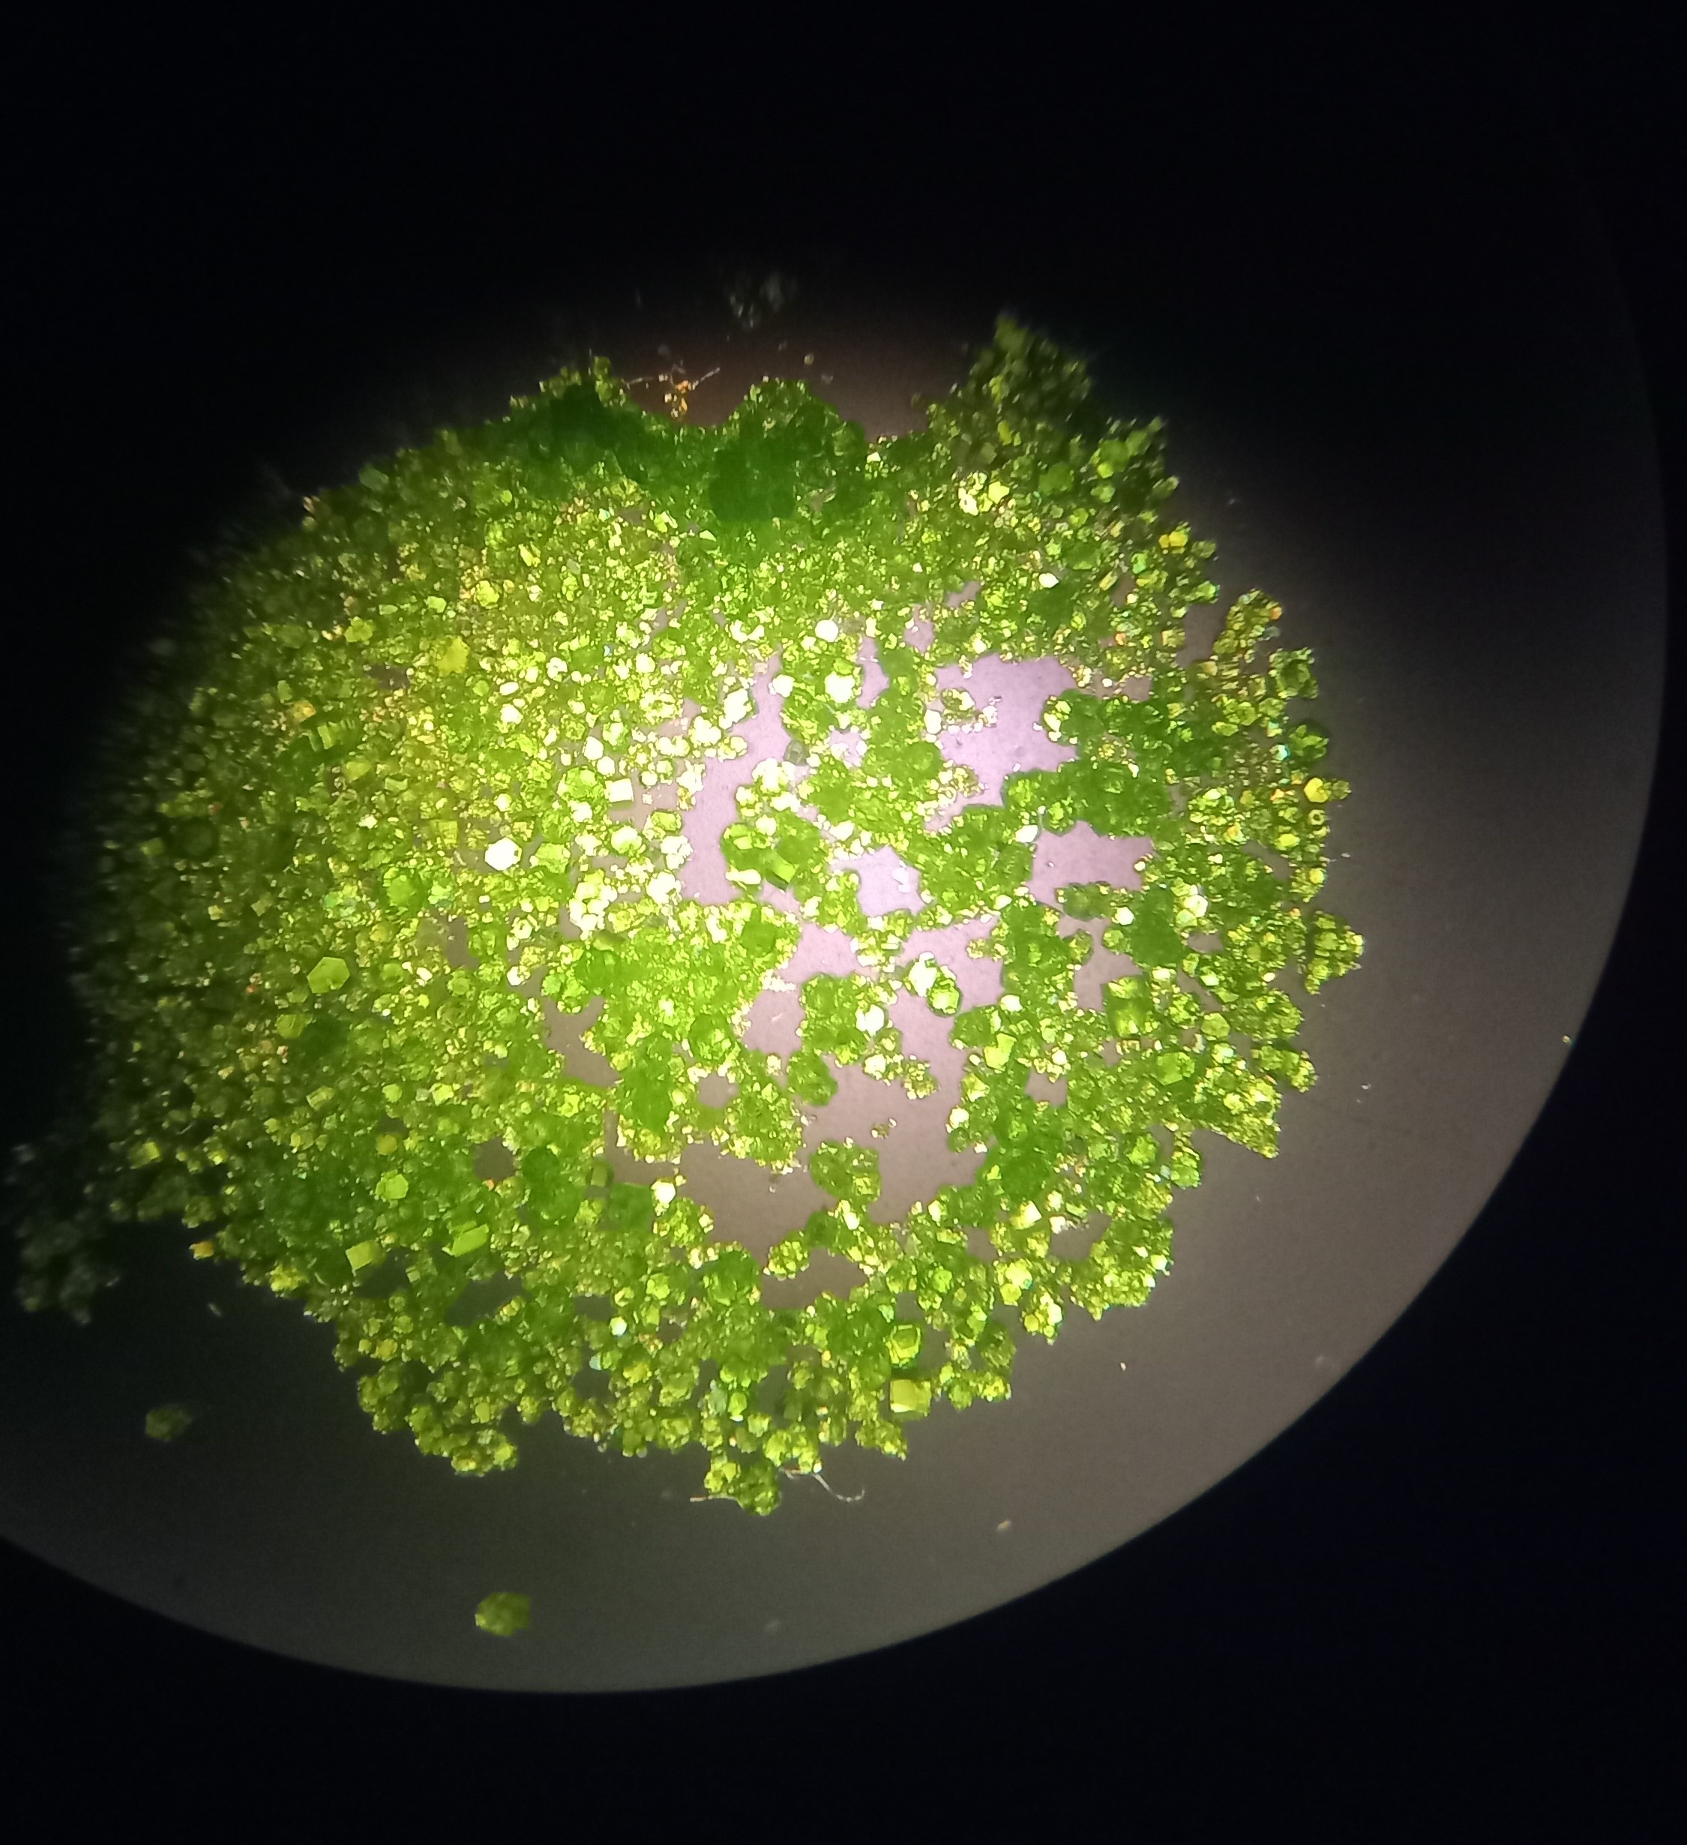
Figure S1. Ni-BTC compound (1) crystals seen through optical microscopy.
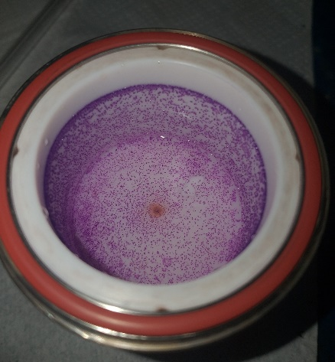
Figure S2. Crystals of the Co-BTC (2) adhered to the walls of the post-synthesis teflon cup.
Table S1. Selected geometric parameters (Å, º) for (1).
Ni1—O9^{i} | 2.103 (3) | Ni2—O7 | 2.092 (4)
Ni1—O9^{ii} | 2.103 (3) | Ni2—O8 | 2.101 (5)
Ni1—O4 | 2.035 (8) | Ni2—O1 | 2.031 (6)
Ni1—O4^{iii} | 2.035 (8) | Ni2—O6^{iv} | 2.035 (4)
Ni1—O10^{iii} | 2.071 (5) | Ni2—O11 | 2.046 (9)
Ni1—O10 | 2.071 (5) | Ni2—O12 | 2.070 (9)
O9^{ii}—Ni1—O9^{i} | 63.10 (16) | O7—Ni2—O8 | 62.78 (15)
O4^{iii}—Ni1—O9^{i} | 156.6 (4) | O1—Ni2—O7 | 93.52 (17)
O4^{iii}—Ni1—O9^{ii} | 93.9 (6) | O1—Ni2—O8 | 156.28 (17)
O4—Ni1—O9^{i} | 93.9 (6) | O1—Ni2—O6^{iv} | 109.6 (2)
O4—Ni1—O9^{ii} | 156.6 (4) | O1—Ni2—O11 | 89.1 (2)
O4^{iii}—Ni1—O4 | 109.4 (10) | O1—Ni2—O12 | 90.2 (4)
O4—Ni1—O10 | 86.9 (9) | O6^{iv}—Ni2—O7 | 156.9 (3)
O4^{iii}—Ni1—O10 | 93.4 (9) | O6^{iv}—Ni2—O8 | 94.09 (18)
O4^{iii}—Ni1—O10^{iii} | 86.9 (9) | O6^{iv}—Ni2—O11 | 90.8 (3)
O4—Ni1—O10^{iii} | 93.4 (9) | O6^{iv}—Ni2—O12 | 88.3 (3)
O10^{iii}—Ni1—O9^{ii} | 90.44 (16) | O11—Ni2—O7 | 90.3 (3)
O10^{iii}—Ni1—O9^{i} | 89.12 (16) | O11—Ni2—O8 | 91.8 (3)
O10—Ni1—O9^{ii} | 89.12 (16) | O11—Ni2—O12 | 178.6 (3)
O10—Ni1—O9^{i} | 90.44 (16) | O12—Ni2—O7 | 91.0 (2)
O10^{iii}—Ni1—O10 | 179.5 (3) | O12—Ni2—O8 | 89.3 (2)
Symmetry code(s): (i) x, y+1, z; (ii) −x+1, y+1, −z+1/2; (iii) −x+1, y, −z+1/2; (iv) −x+1/2, y−1/2, z.

Figure S3. Crystal packing of (1) viewed through the [010] direction, showing the Ni²⁺-trimesate and DMF layers.

Figure S4. Calculated cavities in the structure of (1) viewed through the [001] (a), [100] (b) and [010] (c) directions.

Elemental Analysis
Considering the empirical formula of the MOF Ni-BTC {[Ni(HBTC)(DMF)₂] (1), in molecular formula [Ni(HC₉H₃O₆)(C₃H₇NO)₂] (MM = 411.88), and Co-BTC [Co(HBTC)(DMF)₂] (2) [Co(HC₉H₃O₆)(C₃H₇NO)₂] (MM = 412.08), CHN percentages are distant. This can be interpreted as an excess DMF solvent remaining inside the framework.
Table S2. CHN Elementary Analysis CHN Data of Ni-BTC (1) and Co-BTC (2).
MOF | C experimental | C  theorical | H  experimental | H  theorical | N  experimental | N  theorical
Ni-BTC (1) | 33.46758906 | 43.70 | 3.097766479 | 4.13 | 1.698207815 | 6.80
Co-BTC (2) | 34.18053436 | 43.68 | 3.029276371 | 4.12 | 0.884459714 | 6.79

CHN Elemental Analysis exhibited similarity in the amounts of C and H, (33.46 and 34.18; 3.03 and 3.09 respectively) while the amount of N in the Ni-BTC MOF is practically twice the quantity of N on the Co-BTC (1,70 and 0,88). Experimental values are far from theoretical due to excess DMF within the structure (table S3).

Table S3. Magnetic susceptibility data for Ni-BTC (1) and Co- BTC (2).
 | Ni-BTC | Co-BTC
l (cm) | 1.7 | 1.6
m (g) | 0.0296 | 0.0293
R₀ | -70 | -69
R | 112 | 441
C | 1 | 1
χ_{g} | 1.045E-05 | 2.785E-05
 | (Paramagnetic) | (Paramagnetic)

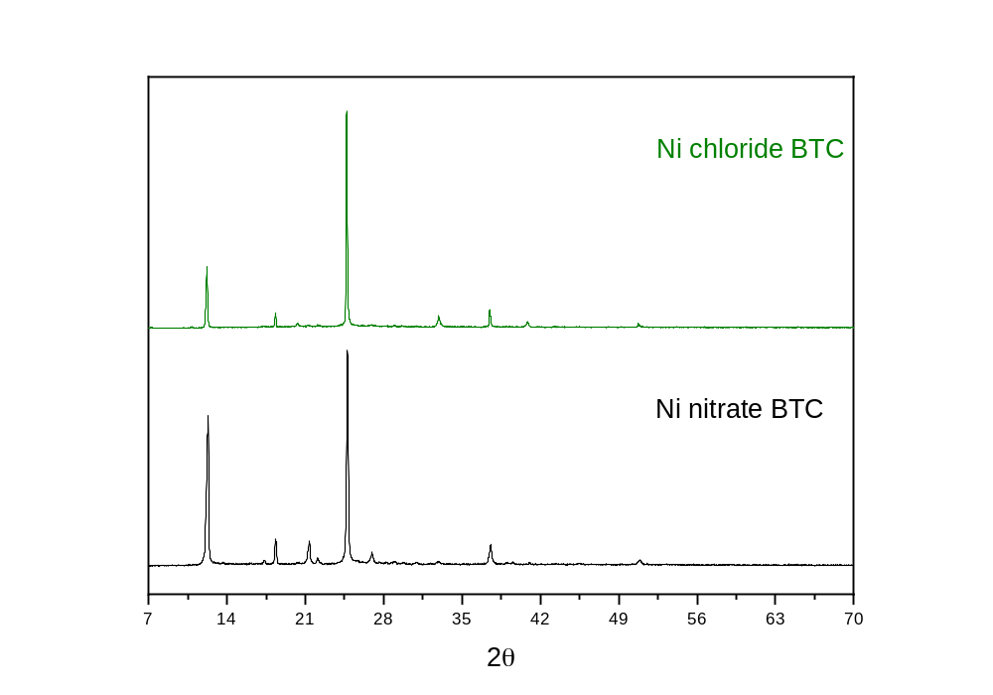
Figure S5. Stacked PXRD spectra of synthesized Ni-BTC Nitrate and Ni-BTC chloride.
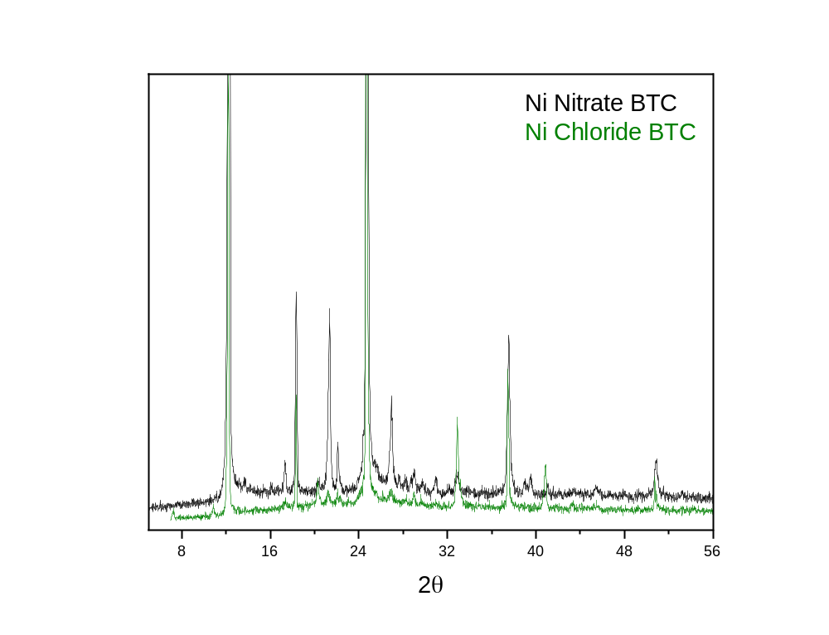
Figure S6. Superimposed PXRD spectra of synthesized Ni-BTC Nitrate and Ni-BTC chloride.

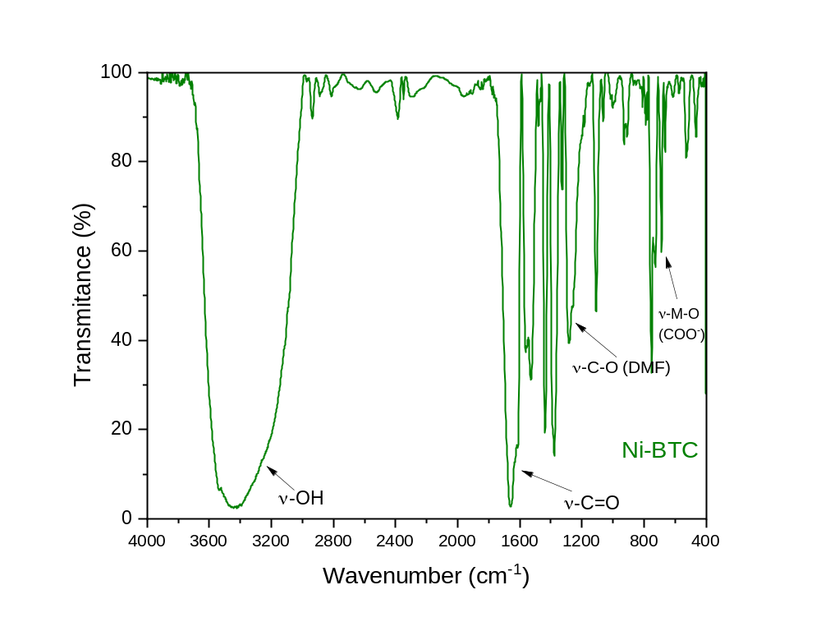
Figure S7. FTIR spectrum of Ni-BTC (1).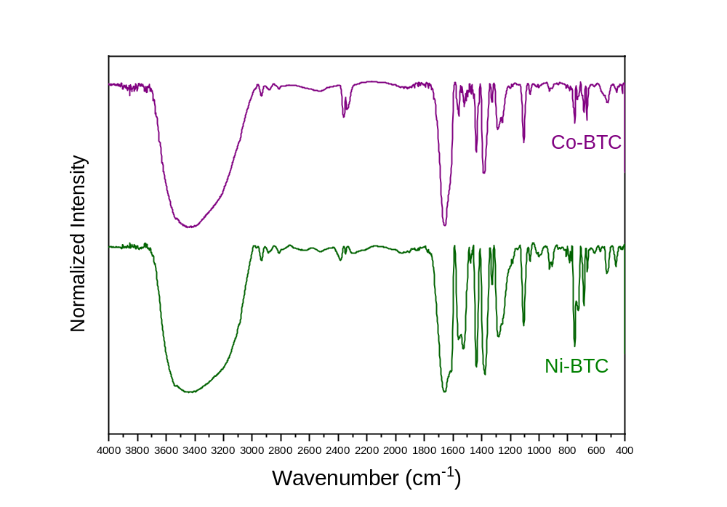Figure S8. Stacked FTIR spectra of Ni-BTC (1) and Co-BTC (2)
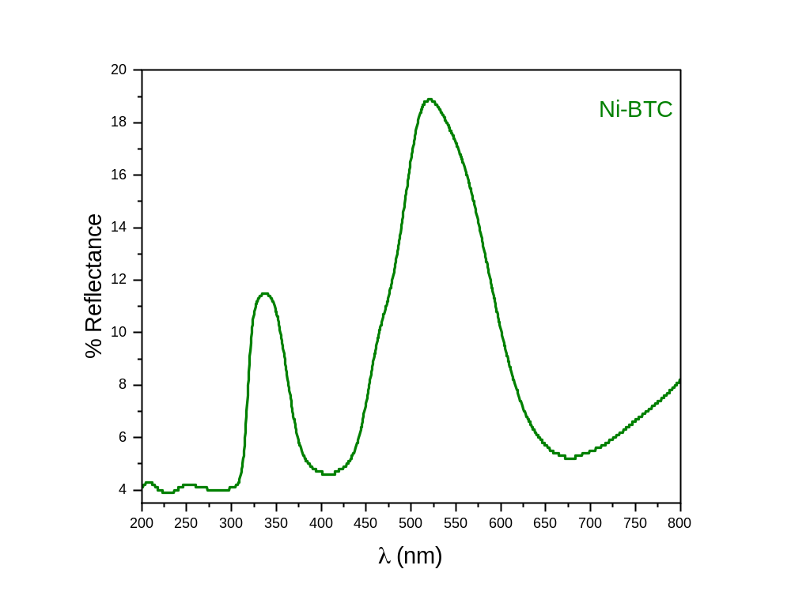
Figure S9. UV-Vis Diffuse Reflectance spectrum of Ni-BTC (1).
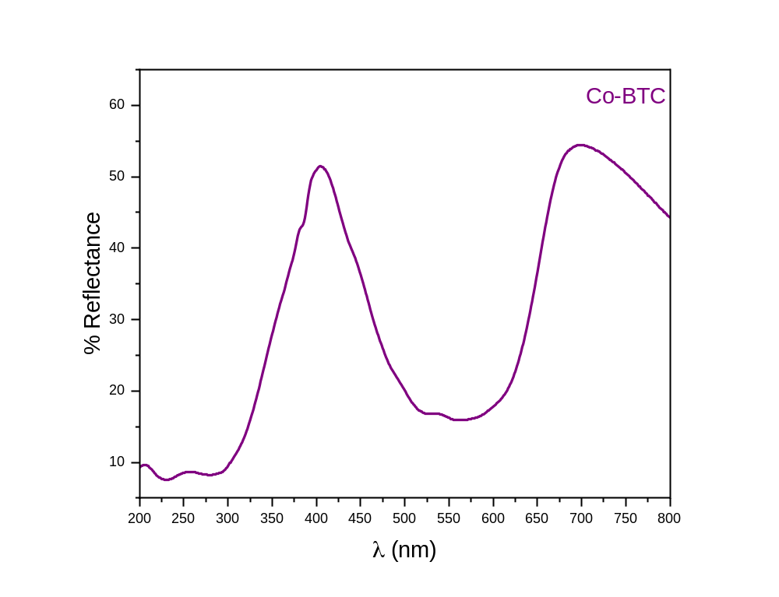
Figure S10. UV-Vis Diffuse Reflectance spectrum of Co-BTC (2).
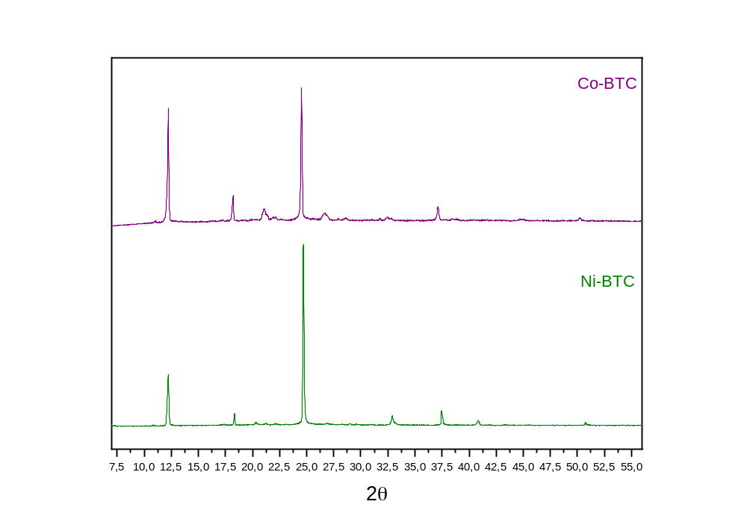
Figure 11. PXRD of Ni-BTC (1) and Co-BTC

.
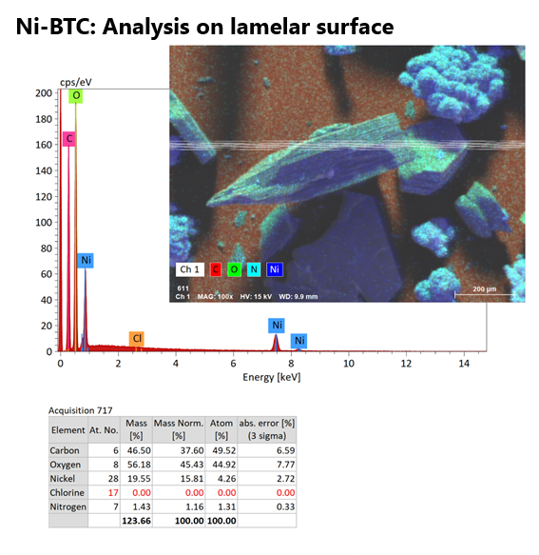
Figure S12. MEV with EDS spectrum of Ni-BTC (1) in lamelar hexagonal phase.
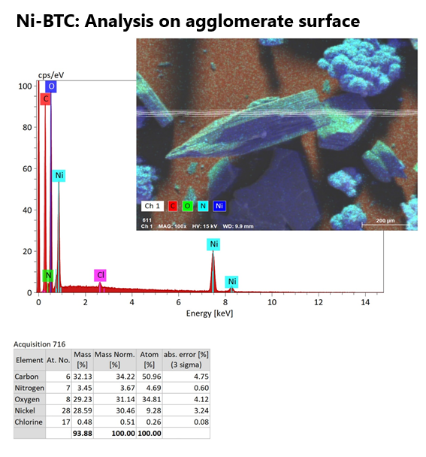
Figure S13. MEV with EDS spectrum of Ni-BTC (1) agglomerated phase.
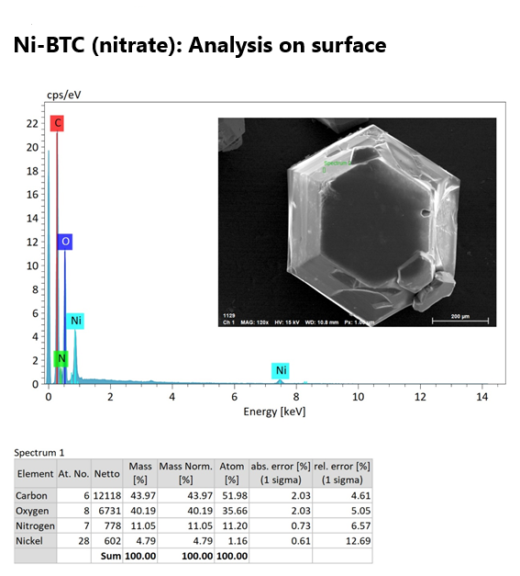
Figure S14. MEV with EDS spectrum of Ni-BTC (1) Ni(NO₃)₂·6H₂O synthesis.

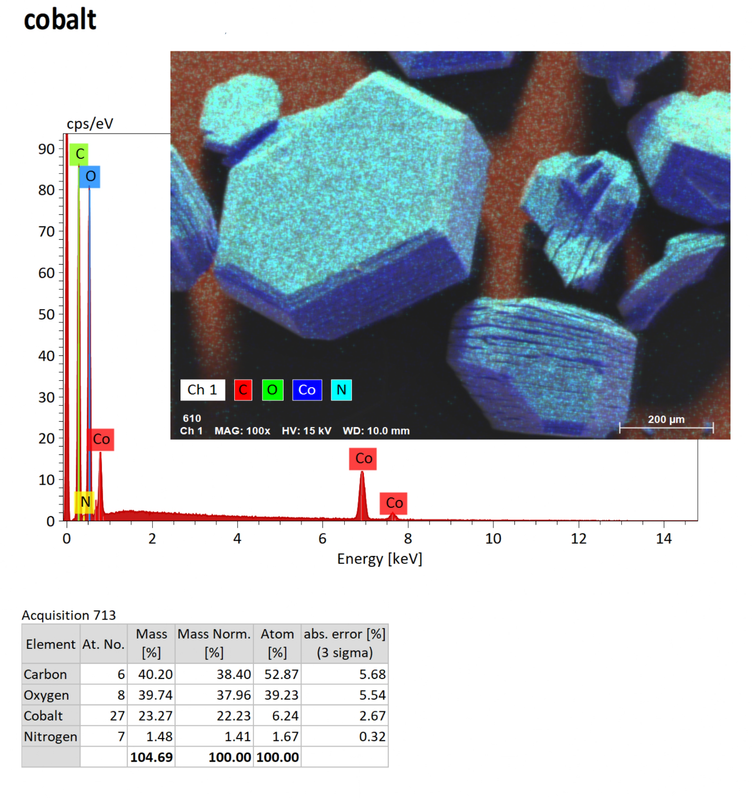
Figure S15. MEV with EDS spectrum of Co-BTC (2).
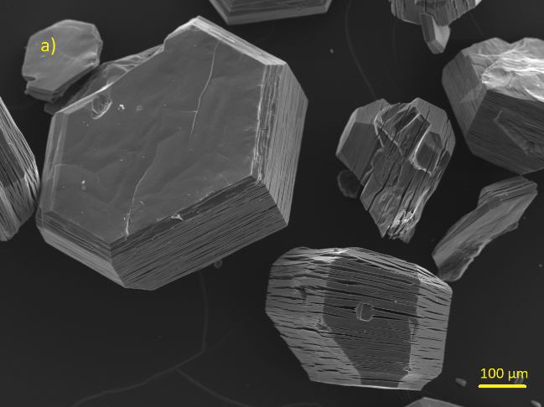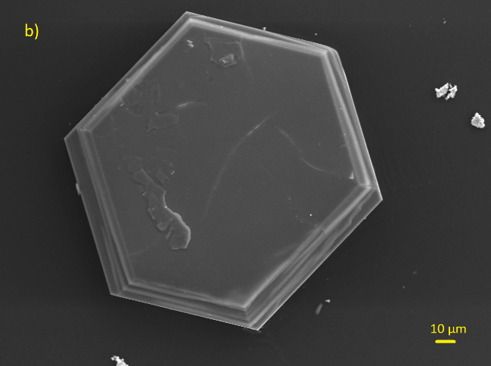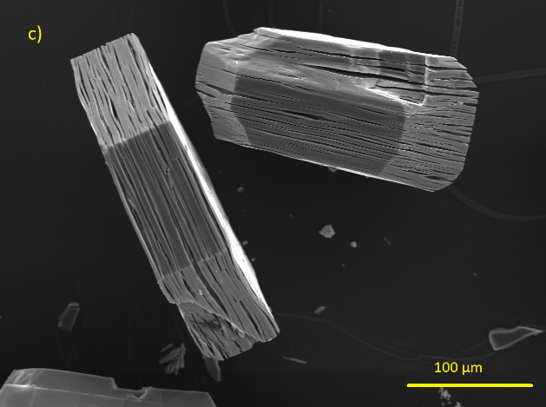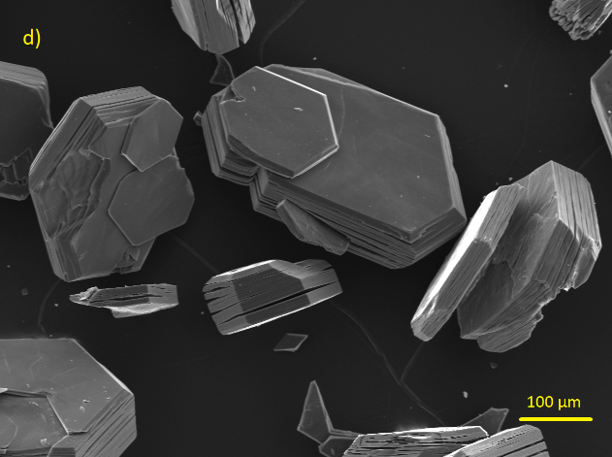
Figure S16. SEM images of Co-BTC (2).

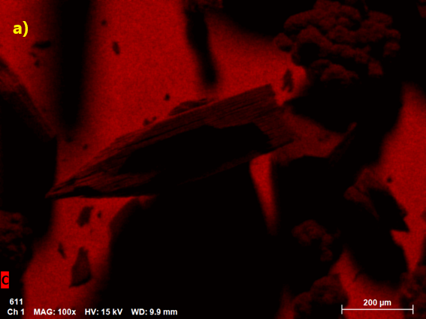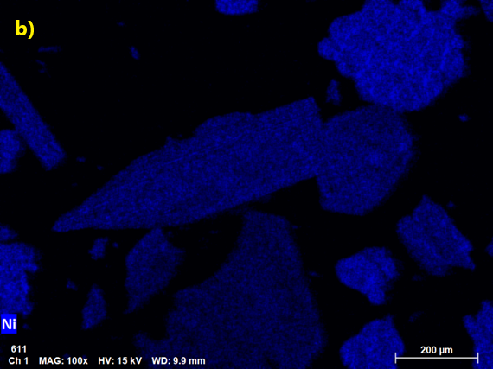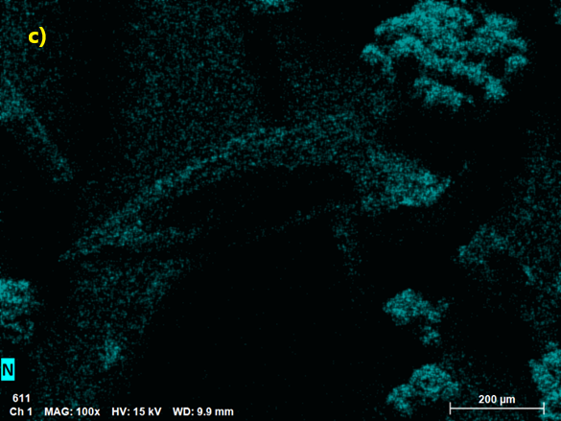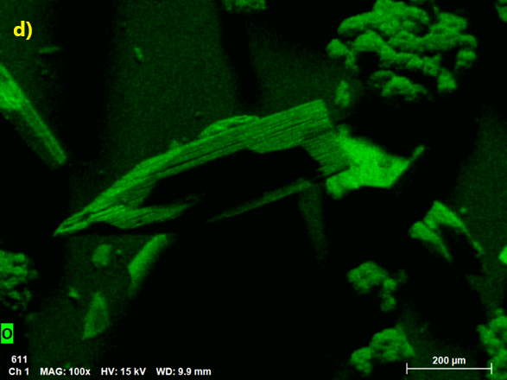
Figure S17. Elemental Mapping C (a), Ni (b), N (c) and O (d) for Ni-BTC (1).
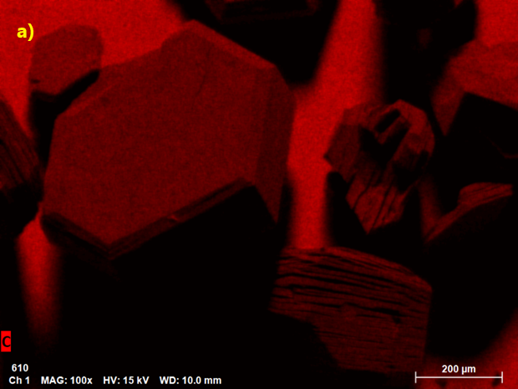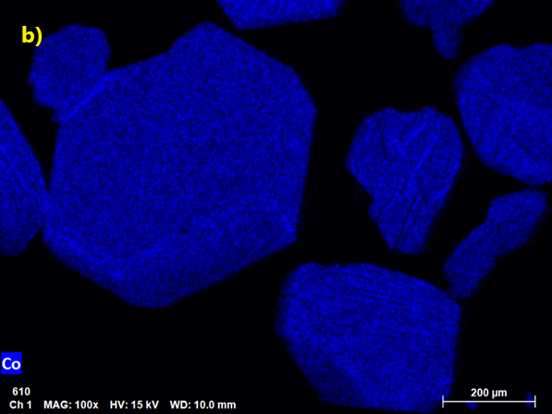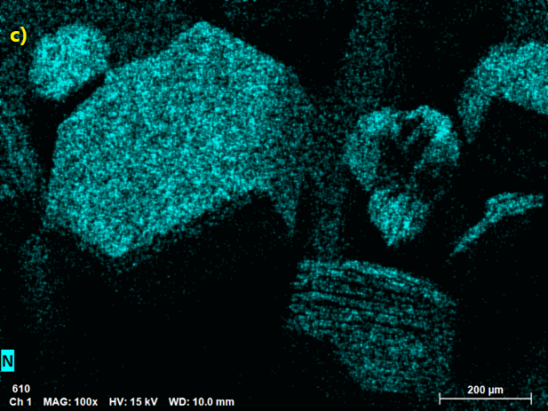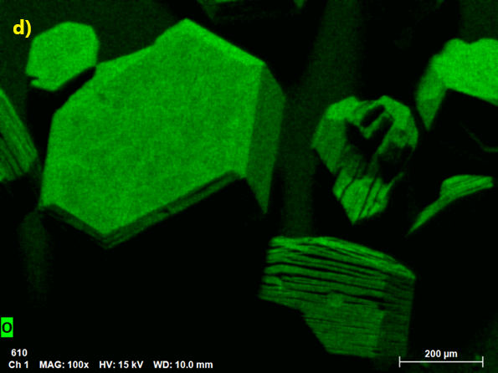
Figure S18. Elemental Mapping C (a), Co (b), N (c) and O (d) for Co-BTC (2).

Stability Test

The stabilities of both networks were tested in function of the pH in aqueous solutions. The pHs tests were adjusted and carried out in HCl (pH = 4), deionized H₂O (pH = 7) and NaOH solution (pH = 10). Figure S18 shows the comparison between the PXRD spectra of the MOF after exposure to the solutions. For Ni-BTC (1), pH = 10 was the one that achieved the highest stability of the network while still preserving the structure. At pHs 4 and 7, H₃O⁺ ions potentially displace the coordinated DMF and ligand molecules in the framework, leading to its collapse. For Co-BTC (2), it is possible to observe in figure S19 that it does not exhibit stability in aqueous medium regardless of the pH. It was also possible to observe that the resulting solution had a pink color after the tests, indicating the leaching of Co(II) ions out of the framework, leading to the formation of an aqua-complex [Co(H₂O)₆]²⁺. Thus, the Ni-BTC MOF did not show stability when applied in an aqueous medium.

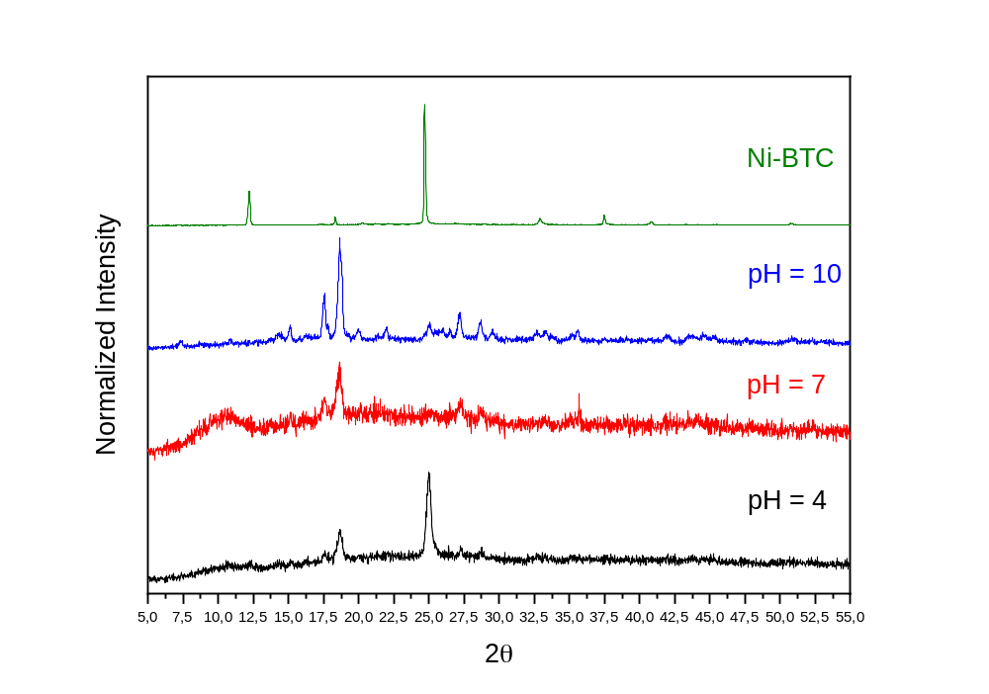
Figure S19. Stability test: PXRDs of Ni-BTC (1) in aqueous environment at different pH.

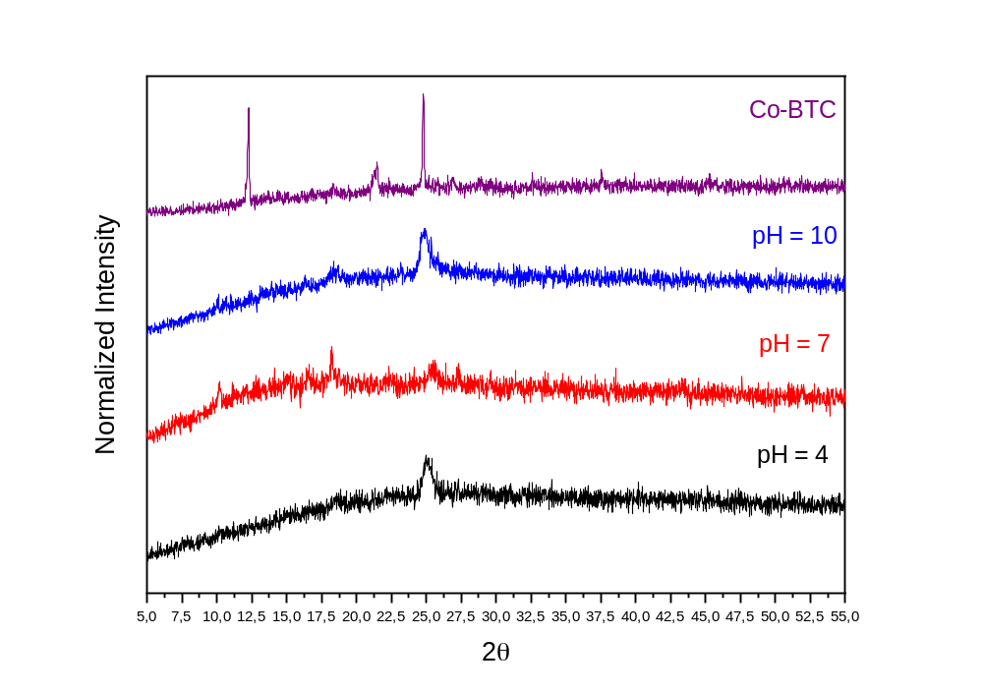
Figure S20. Stability test: PXRDs of Co-BTC (2) in aqueous environment at different pH.

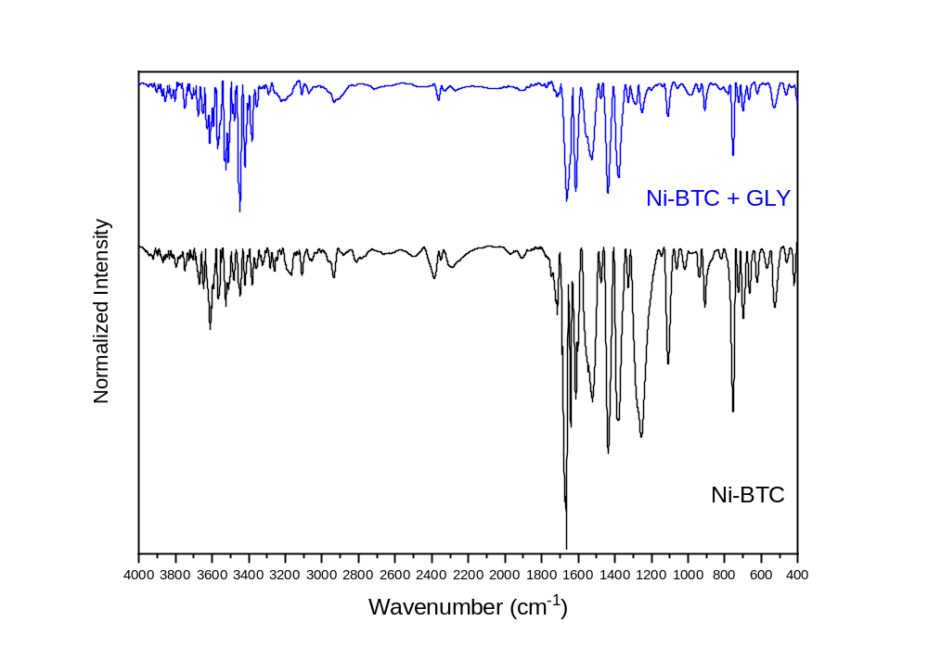
Figure S21. Complete PXRD stacked spectra of Ni-BTC and Ni-BTC with glyphosate added in DMF after 48 hours.
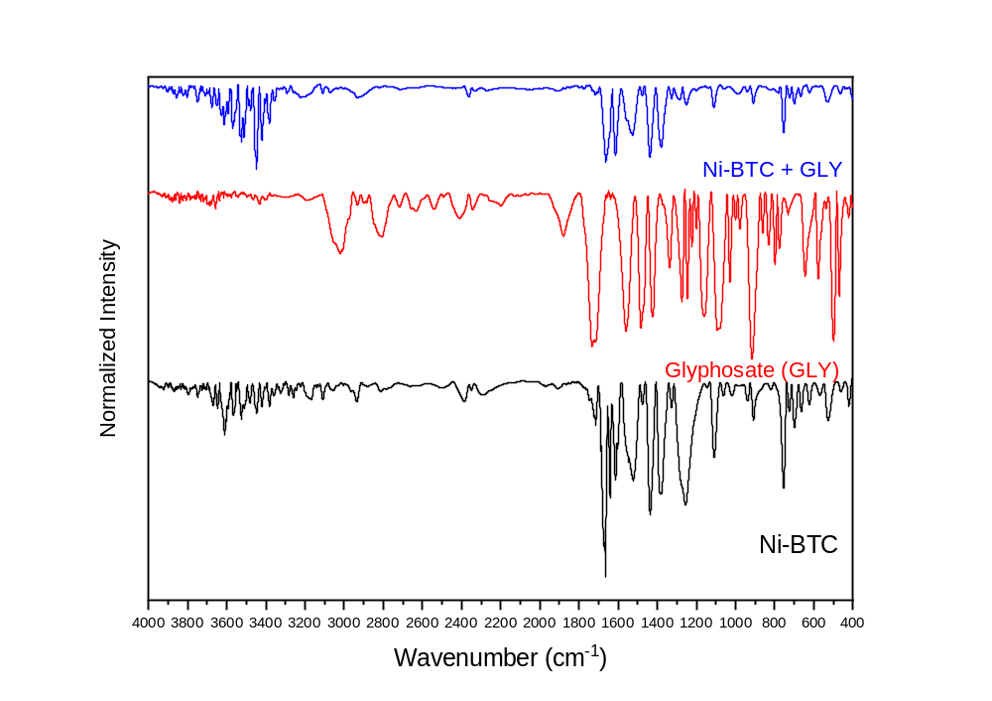
Figure S22. FTIR stacked spectra of Ni-BTC, glyphosate and Ni-BTC with glyphosate added in DMF after 48 hours.
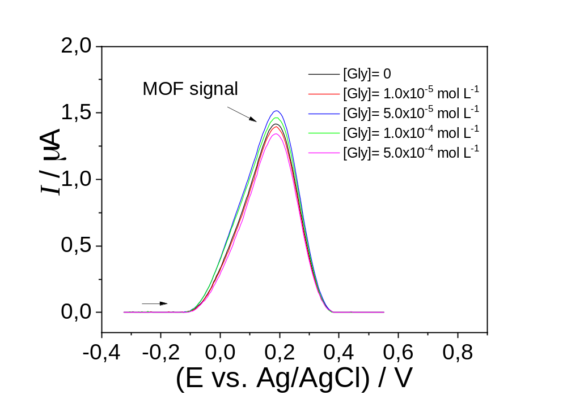
Figure S23. Electrochemical determination of GLY by SWV using the MOF/CPE sensor in 0.1 mol L⁻¹ phosphate buffer solution (pH 7.0. SWV conditions: f = 10 Hz, a = 75 mV, ΔE_{s} = 5 mV.

Determination of Glyphosate Coordination by ¹H and ³¹P NMR

¹H and ³¹P NMR experiments: The NMR spectra of glyphosate were obtained using 500 MHz Agilent model 500/54 in D₂O solution at 250 °C. The external standard was a cappilar tube filled with H₃PO₄ 85%. 10 mg of glyphosate (GLY) were dissolved in 750 μL of deuterated water (D₂O). In the MOF Ni-BTC (1) glyphosate experiment, 5 mg of MOF were added in the same tube.
The glyphosate molecule (N-(phosphonomethyl)glycine) (GLY) intrinsically have a chemical equilibrium, with protons moving between the carboxylate, phosphonate and amine groups, as can be observed in figure S23. This leads to the formation of zwitterionic species, where at a pH = 7 species III prevails in the equilibrium. This phenomenon can be analyzed by NMR. It is also possible to study the coordination of GLY to the Ni(II) centers by this technique.
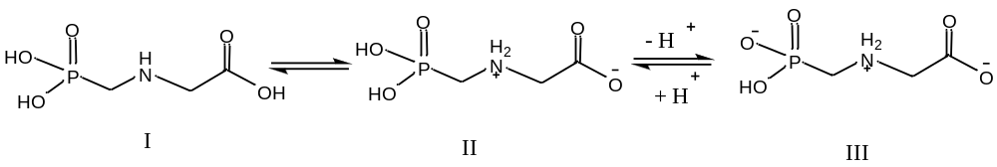
Figure S24. Main species present in glyphosate equilibrium in aqueous medium.

Figure S25A presents the ¹H spectrum of GLY in D₂O. It is possible to observe two main signals related to the methylene groups (CH₂), one singlet at 3.85 ppm (signal A) for the group (-CH₂COO⁻), and a doublet at 3.14 and 3.16 ppm (signal B) for a group (-CH₂P(OH)O₂⁻); Figure S25B presents the ³¹P spectrum, in which is possible to observe a singlet signal at 8.57 ppm, related to the P atom in GLY molecule. The H₃PO₄ pattern in D₂O was placed in a capillary tube to serve as an internal reference, appearing as 0.39 ppm.
After 5 mg of activated Ni-BTC (1) MOF (treated at 100 °C for 1 hour then dissolved using 750 μL of D₂O) was added to the tube, and the ¹H and ³¹P spectra indicated the coordination of GLY to the Ni(II) centers. In the ¹H spectrum, by the shift of signal A from 3.85 ppm to 3.69 ppm in addition to the enlargement of signals A and B, it is possible to infer the coordination of GLY to Ni(II). In the ³¹P spectrum the signal shifted from 8.57 ppm to 9.58 ppm in addition to the enlargement of the peak, which is characteristic of paramagnetic species in the NMR. We can also observe the presence of free DMF in the medium (Fig. S26A). Considering these results, it is possible to propose that the coordination with Ni(II) occurs by the phosphonate group, as its signal in the ³¹P spectrum appears more unshielded. In ¹H NMR spectrum, the signal assigned to the CH₂ of COO‾ group (signal A) appears more shielded in relation to the spectrum of free glyphosate. Therefore, if coordination occurred via the carboxylate group, signal A would appear in a more unshielded region, as can be observed in figure S25A.
An attempt was made to perform this analysis using ¹H and ³¹P NMR spectroscopy using DMF-d₇ as the solvent, but in this case, glyphosate was insoluble, as is characteristic of some molecules being less soluble in deuterated solvents than in non-deuterated ones.

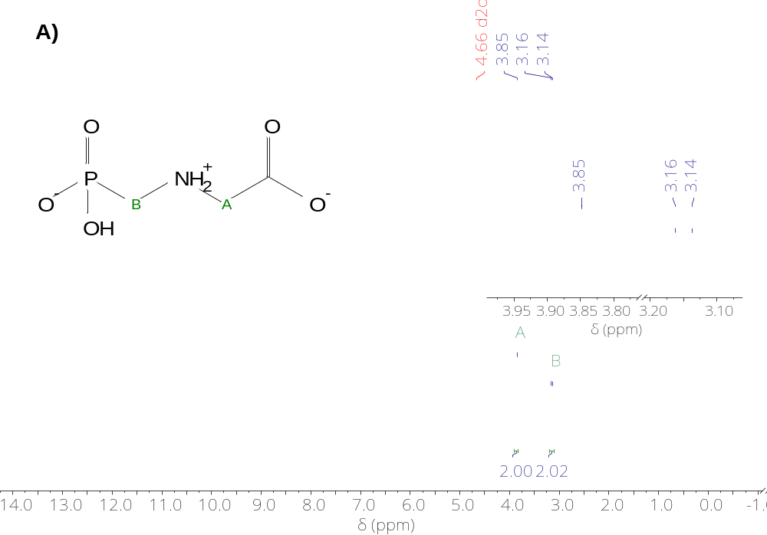
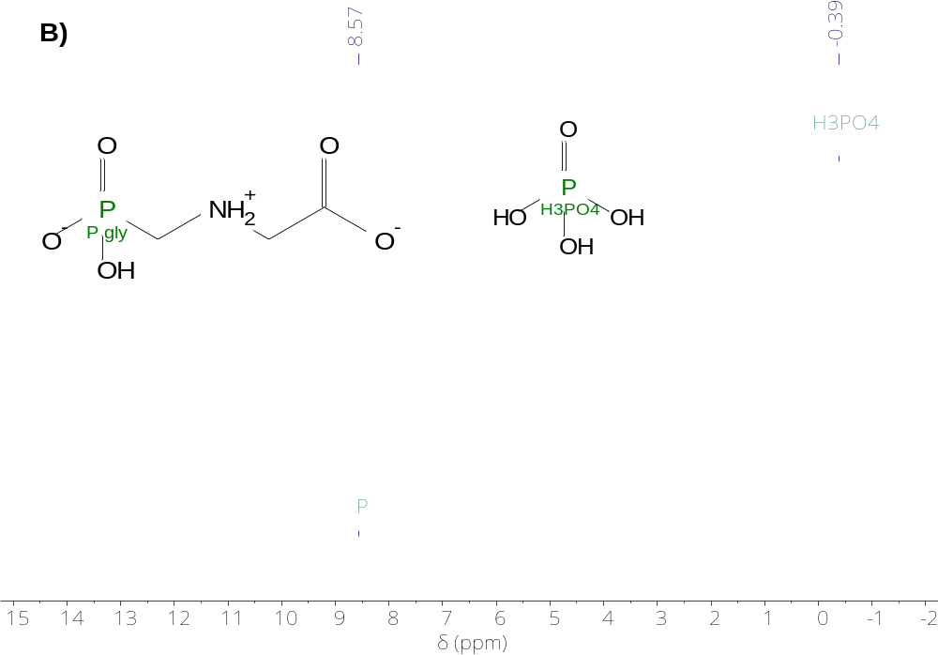
Figure S25. NMR spectra ¹H (A) and ³¹P (B) of free glyphosate (GLY) in D₂O at 25°C.
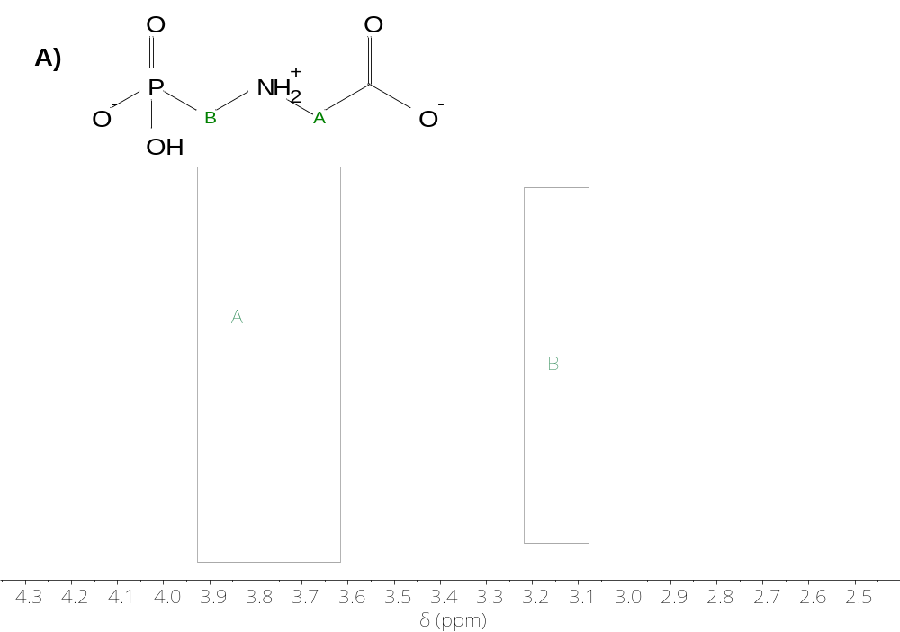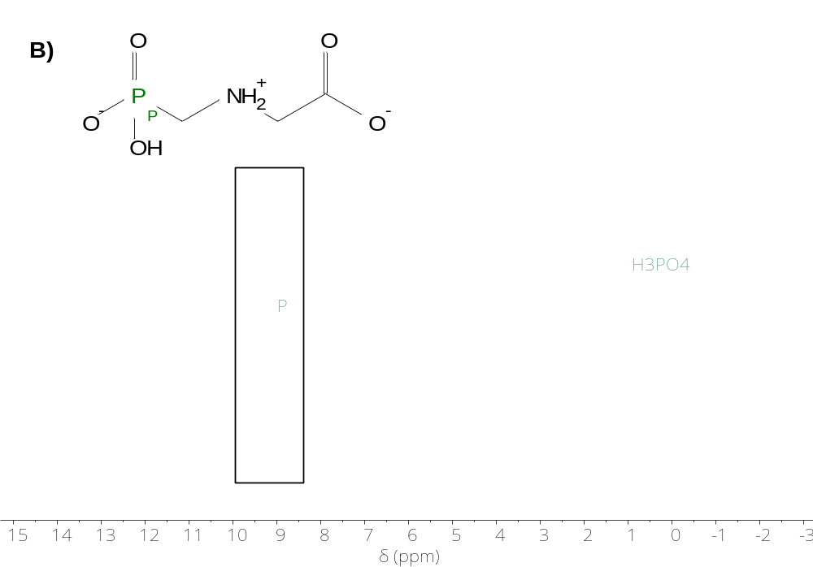
Figure S26. Comparative ¹H (A) and ³¹P (B) NMR spectra of GLY in the presence of Ni-BTC MOF in D₂O at 25°C.
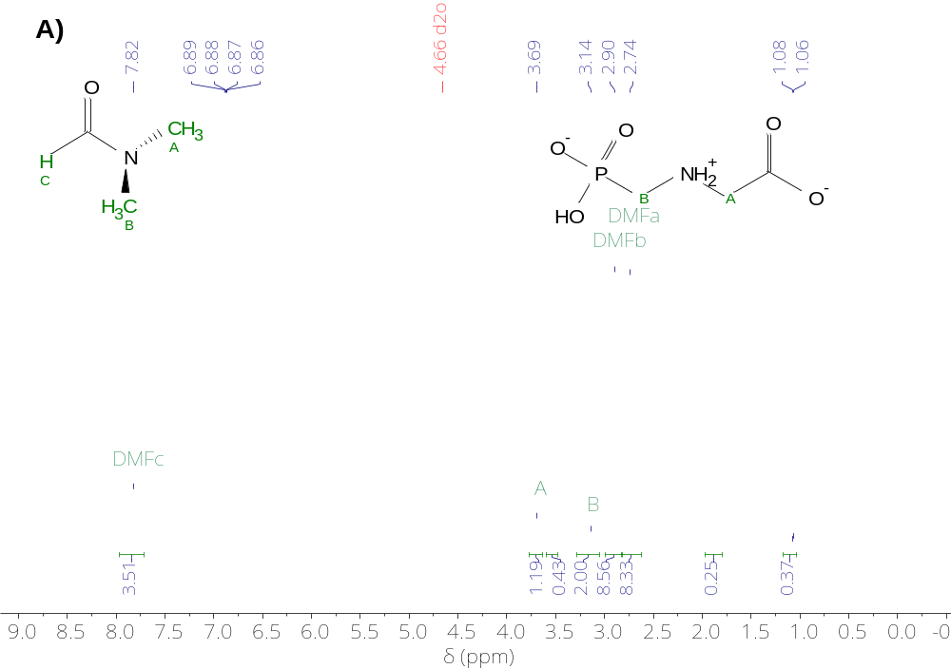
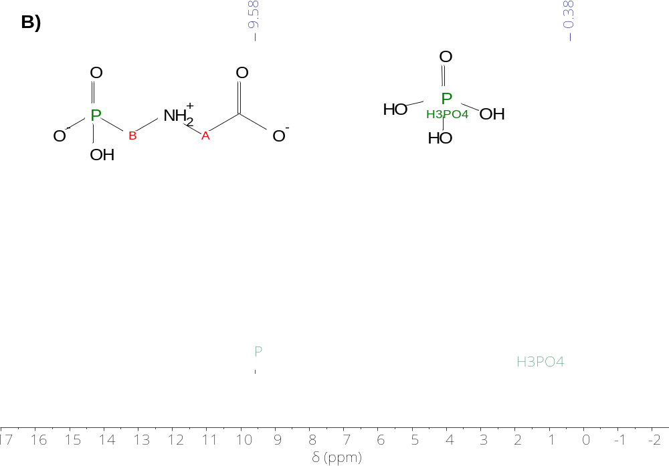
Figure S27. ¹H NMR spectra (A) and ³¹P (B) of Ni-BTC (1) in D₂O in presence of GLY (full scale).

