A Synthesis of Metal-Organic Frameworks Using Terephthalic Acid Obtained from PET Bottles with Dye Adsorption for Application in Experimental Chemistry Classes
João M. R. Gonçalves¹, Júlia V. Brandão¹, Benedito S. Lima-Neto¹
¹Instituto de Química de São Carlos, Universidade de São Paulo, Avenida Trabalhador São Carlense, 400, 13566-590, São Carlos, SP, Brazil
joaomanoel@usp.br

SUPPLEMENTARY MATERIAL

Figure S1 NMR spectrum of ¹H of Terephthalic Acid (H₂TPA) obtained from PET in DMSO-d₆.

Figure S2. ¹³C NMR Spectrum of Terephthalic Acid (H₂TPA)obtained from PET in DMSO-d₆
Figure S3. NMR HSQC ¹H-¹³C spectrum Terephthalic Acid (H₂TPA) obtained from PET in DMSO-d₆.
Figure S4. NMR spectrum of ¹H of TPA²⁻(terephtalate anion) in DMSO-d₆.
Figure S5. NMR spectrum of ¹H of commercial Sigma-Aldrich Terephthalic Acid in DMSO-d₆.
Figure S6. FTIR spectrum of Terephthalic Acid (H₂TPA) obtained from PET bottles.
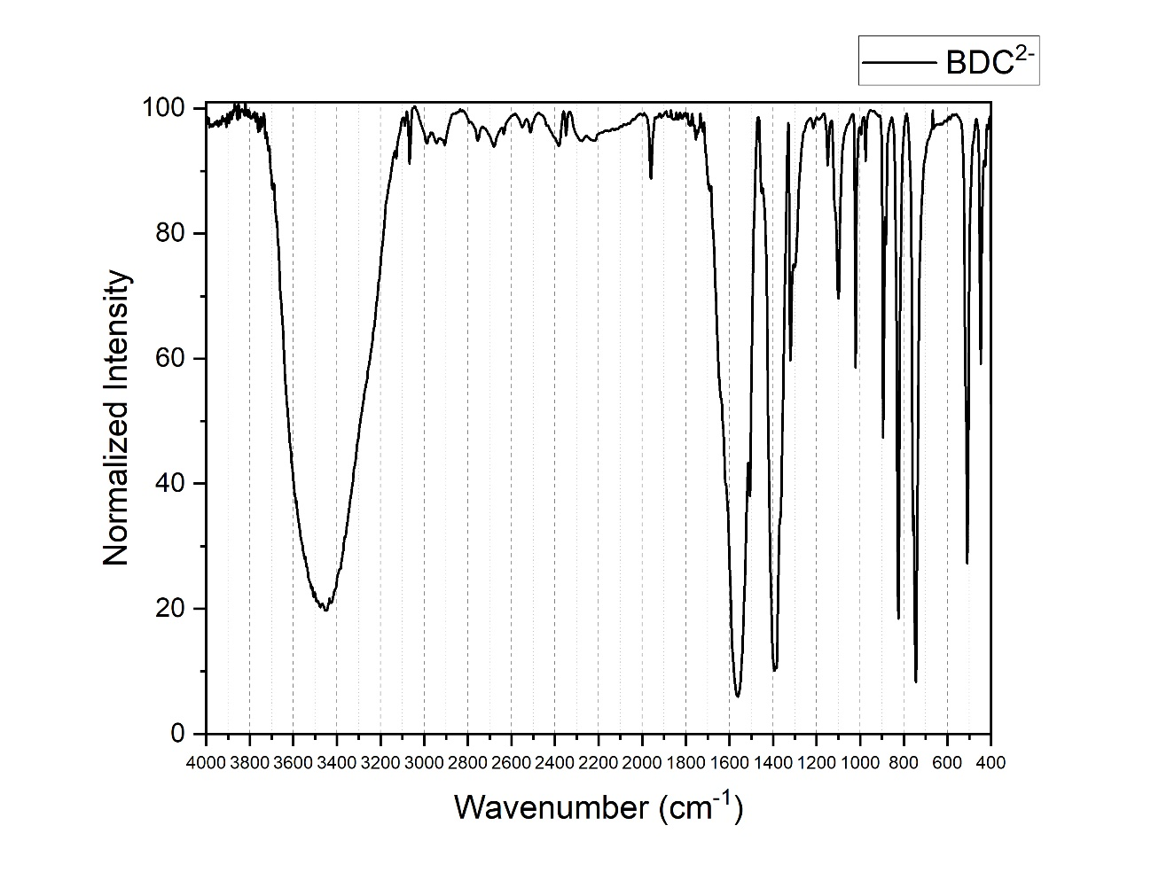
Figure S7. FTIR spectrum of Na₂TPA (sodium terephtalate) obtained during basic hidrolysis.

