Supplementary information
Predictive Modeling of 6-fluoro-3-hydroxy-2-pyrazinecarboxamide Drug Delivery Efficacy of PEGylated Bionanocomposites through the First Principles Simulations
Oluwasegun Chijioke Adekoya^{1*}, Gbolahan Joseph Adekoya¹, Wanjun Liu², Emmanuel Rotimi Sadiku¹ and Yskandar Hamam^{3,4}

- Institute of Nanoengineering Research (INER) & Department of Chemical, Metallurgical and Materials Engineering, Faculty of Engineering and the Built Environment, Tshwane University of Technology, Pretoria 0001, South Africa
- Key Laboratory of Textile Science & Technology, Ministry of Education, College of Textiles, Donghua University, Shanghai 201620, China
³ Department of Electrical Engineering, Faculty of Engineering, and the Built Environment,
Tshwane University of Technology, Pretoria 0183, South Africa
⁴ École Supérieure d’Ingénieurs en Électrotechnique et Électronique, Cité Descartes, 2 Boulevard Blaise Pascal, Noisy-le-Grand, Paris 93160, France
*Correspondence: adekoya.oc@gmail.com

This supplementary document complements the research article on the predictive modelling of 6-fluoro-3-hydroxy-2-pyrazinecarboxamide (FAV) drug delivery efficacy, through the first Principles simulation in PEGylated bionanocomposites. It provides, comprehensive visual representations, including the optimized 3-D structures, molecular electrostatic potential (MEP) maps, RDG isosurface maps, scattered plots, and the binding configurations of the GF complex, in different phases (Figure S1-S6). Additionally, Table S1 presents the blending parameters for the drug-excipient system, offering the essential data for the understanding of the interactions and behaviour of the system. This supplementary material enriches the understanding and interpretation of the primary article's findings and the methodologies followed, and hence, providing additional context and visual aids for interested readers.
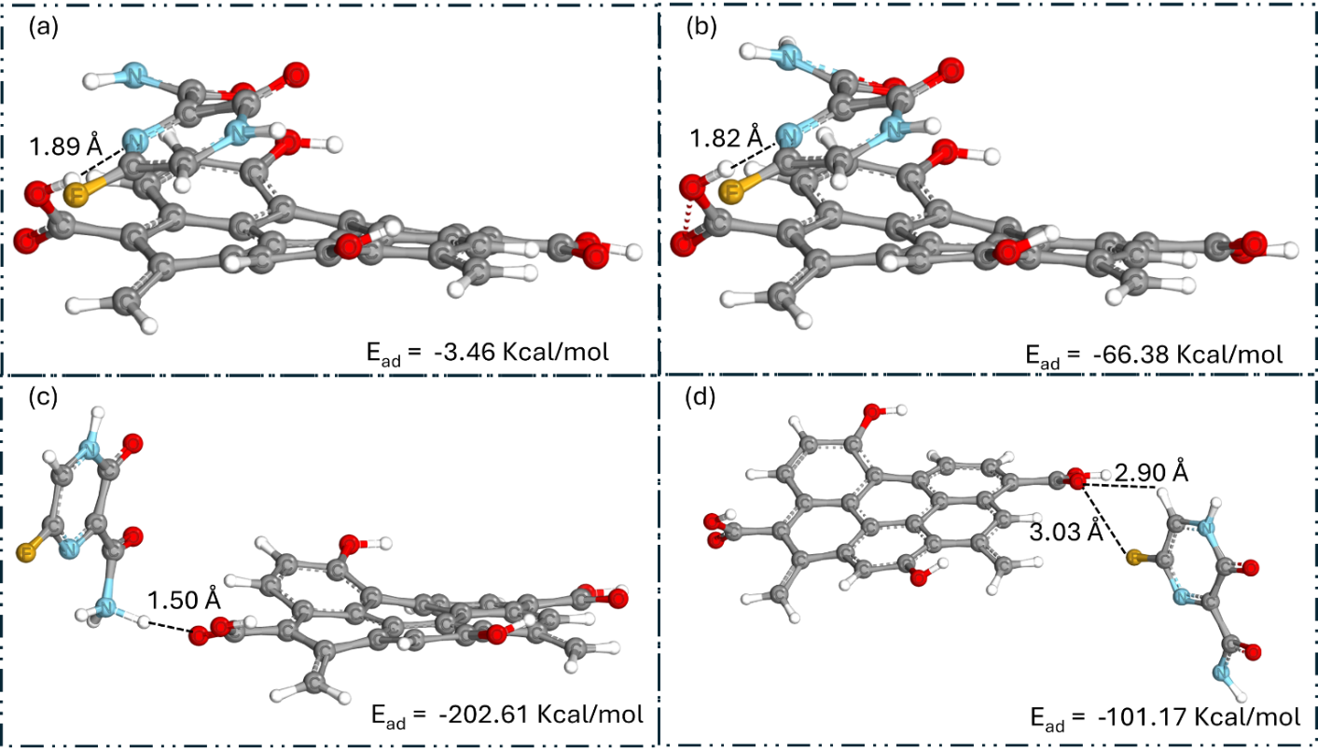
Figure S1. Optimized 3-D structures of the GF complex, in: (a) gas, (b) aqueous, (c) acidic, and (d) alkaline phases

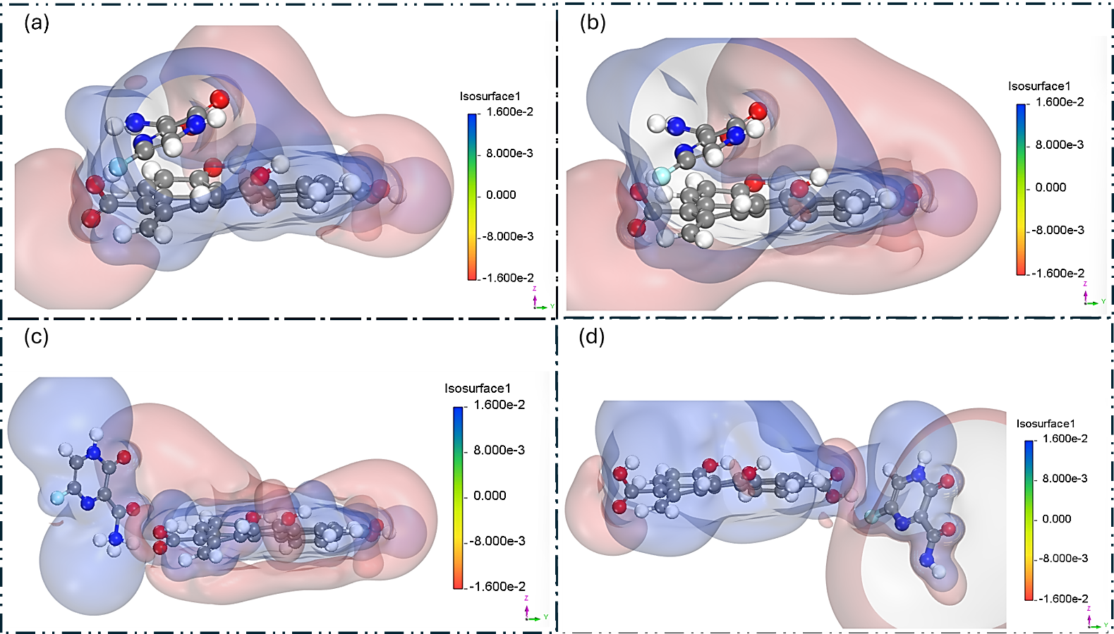
Figure S2. Depictions of the molecular electrostatic potential (MEP) maps of the optimized GF complex, in: (a) gas, (b) aqueous, (c) acidic, and (d) alkaline phases
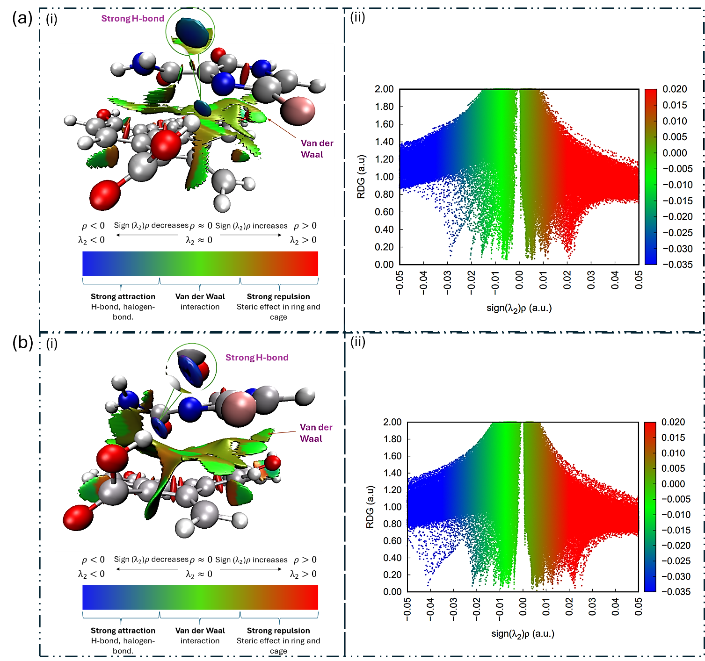
Figure S3. Illustrations of the RDG isosurface maps (left) and the scatter plots (right), showcasing the noncovalent interactions within the optimized GF complex, in the gas (a) and aqueous (b) phases.
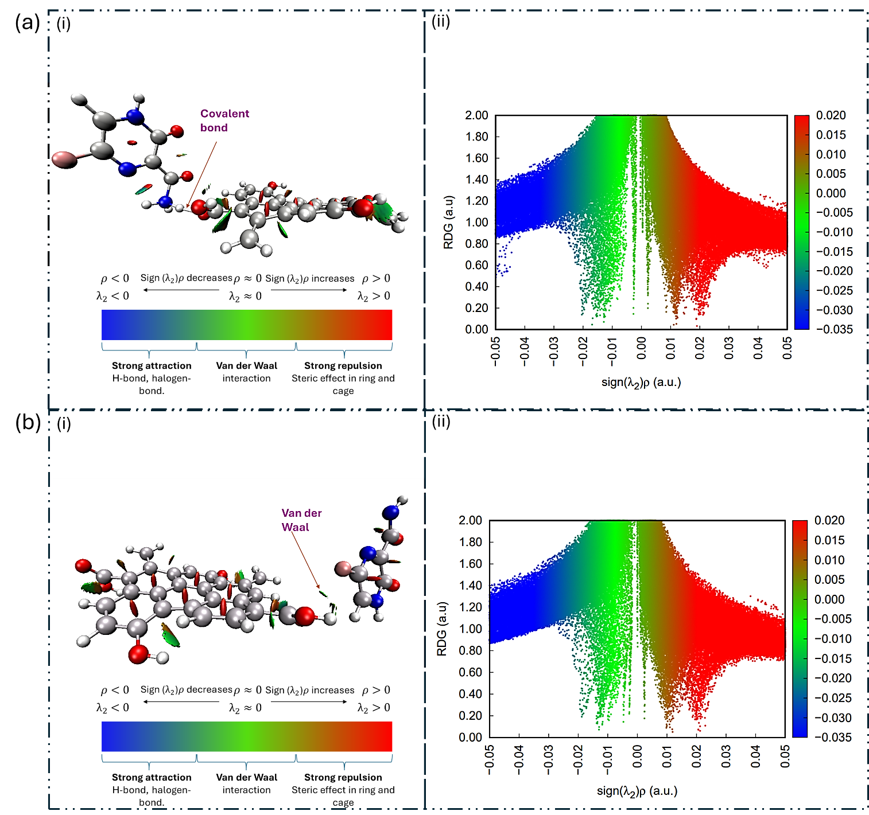
Figure S4. Illustrations of the RDG isosurface maps (left) and the scattered plots (right), showcasing the noncovalent interactions within the optimized GF complex, in the: (a) acidic and (b) alkaline phases.
Table S1. Blending parameters for the drug-excipient system
Systems | Chi (298 K) | E_{mix} (298 K) | Ebb avg (298 K) | E_{bs} avg (298 K) | E_{ss} avg (298 K) | Z_{bb} | Z_{bs} | Z_{sb} | Z_{ss}
GF
Gas | 57.90 | 34.29 | -5.98 | -12.63 | -34.23 | 5.56 | 3.48 | 8.82 | 5.57
Aqueous | 46.87 | 27.76 | -6.25 | -13.43 | -33.35 | 5.56 | 3.47 | 8.82 | 5.57
Acidic | 13.62 | 8.06 | -3.82 | -8.73 | -17.34 | 5.56 | 4.07 | 7.60 | 5.58
Alkaline | 15.67 | 9.28 | -4.02 | -8.86 | -17.95 | 5.56 | 4.07 | 7.64 | 5.57
PEG/GF
Gas | 68.03 | 40.28 | -6.00 | -11.24 | -33.75 | 5.55 | 3.44 | 9.13 | 5.59
Aqueous | 68.64 | 40.65 | -6.24 | -11.83 | -34.86 | 5.56 | 3.43 | 9.13 | 5.60
Acidic | 16.62 | 9.84 | -3.81 | -8.38 | -17.75 | 5.55 | 3.92 | 8.06 | 5.57
Alkaline | 14.84 | 8.79 | -4.01 | -8.48 | -17.31 | 5.56 | 3.90 | 8.08 | 5.60

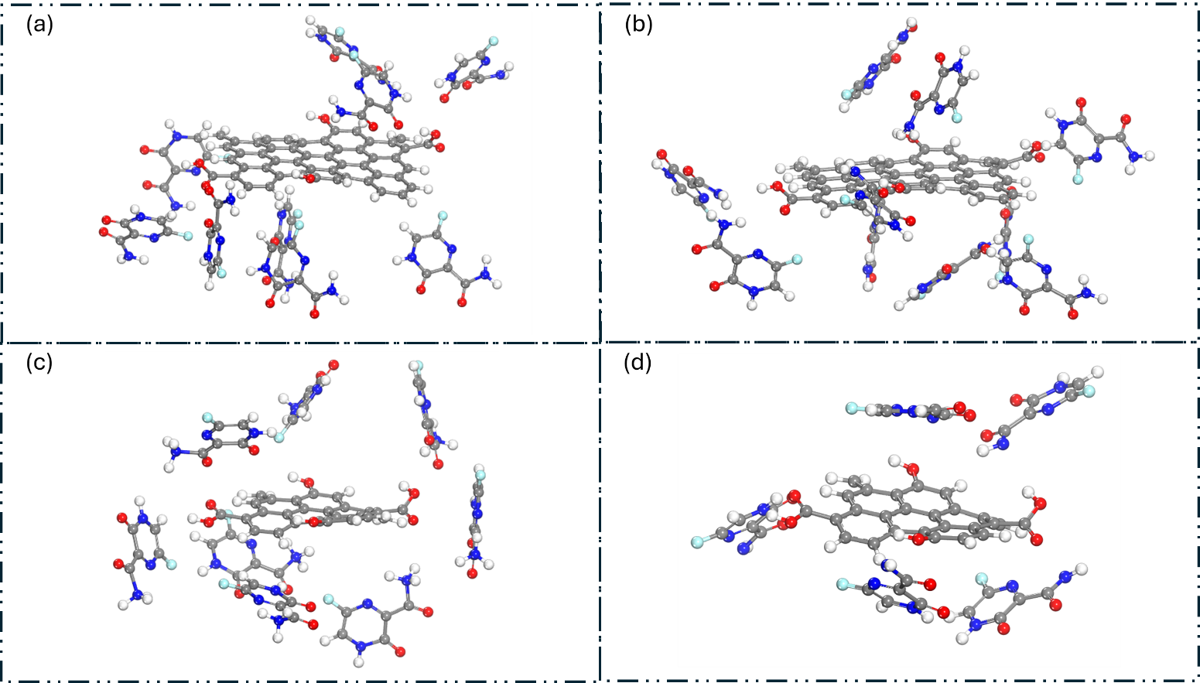
Figure S5: Display of the binding configurations of the GF complex, in: (a) gas, (b) aqueous, (c) acidic, and (d) alkaline phases.
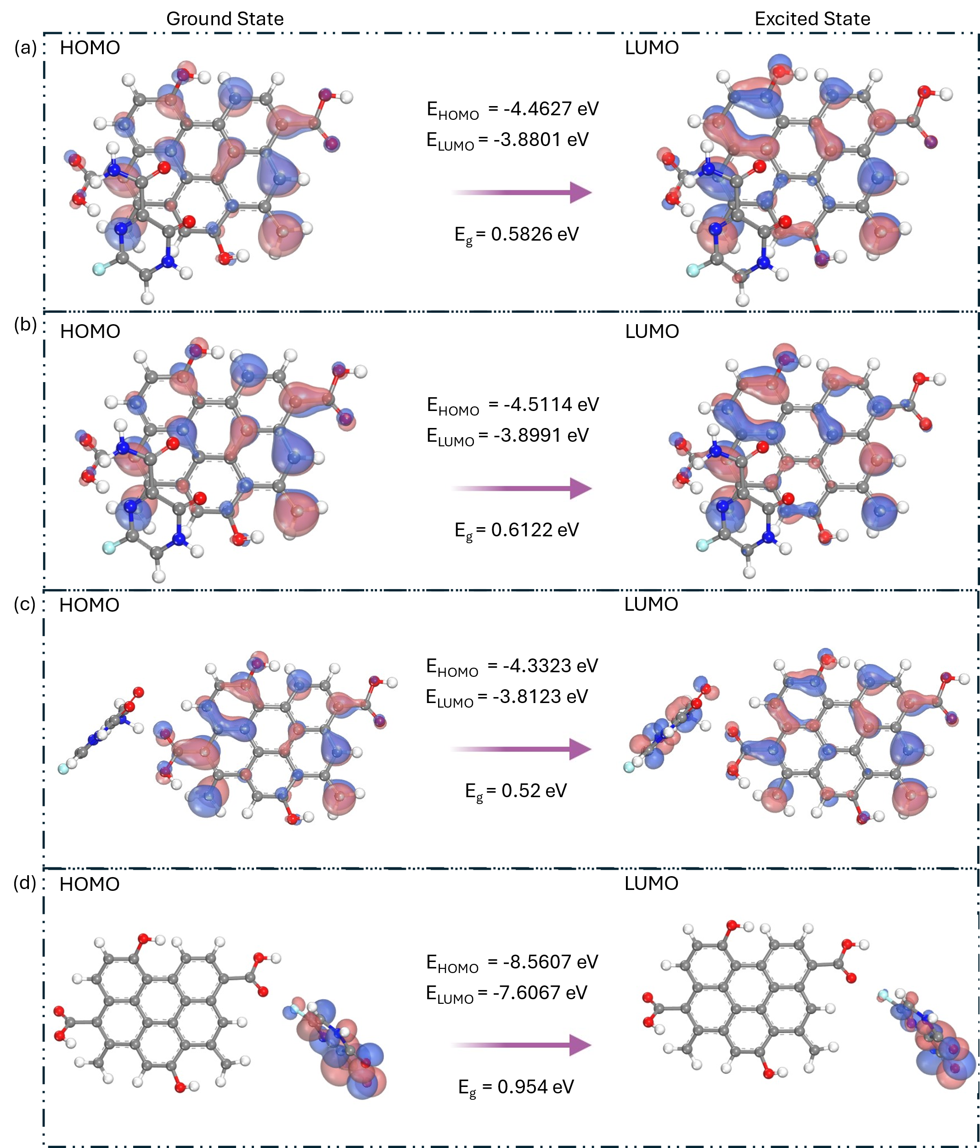
Figure S6: Illustrations of the three-dimensional representations of the frontier molecular orbital of the GF complexes in: (a) gas, (b) aqueous, (c) acidic, and (d) alkaline phases.

