Supramolecular polyrotaxane-based nano-theranostics enable cancer-cell stiffening for enhanced T-cell-mediated anticancer immunotherapy
Haifen Luo¹, Jingqi Lv¹, Peiye Wen¹, Shan Zhang¹, Wen Ma^{1*}, Zhen Yang^{1*}

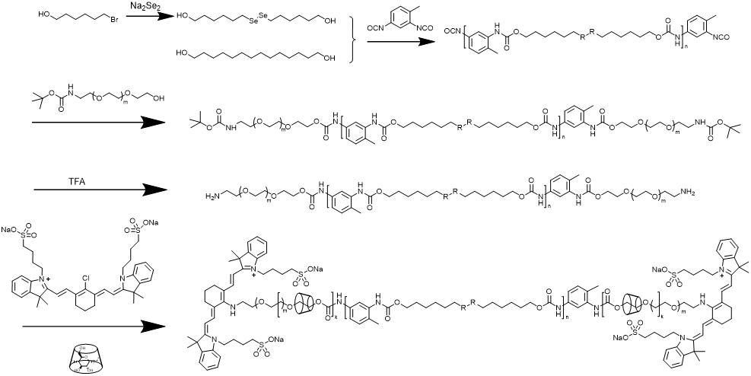
Supplementary Figure 1. Synthetic scheme of IR783-PEG-MeβCD-PDS (R = Se)/ IR783-PEG-MeβCD-PTD (R = C).

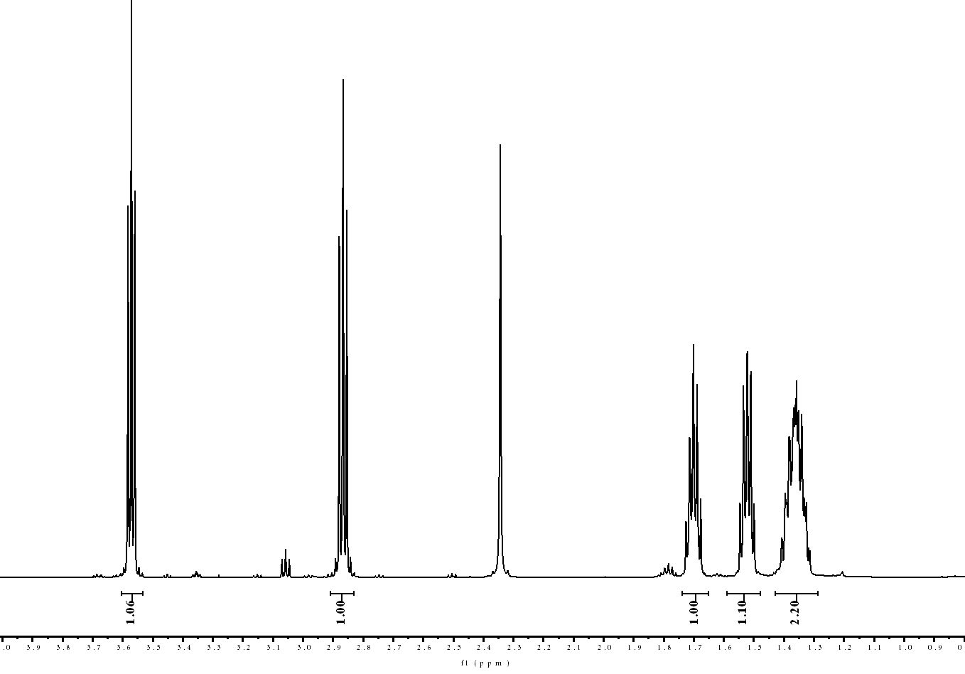
Supplementary Figure 2. ¹H NMR spectrum of 6,6'-dithiirane bis-(hexane-1-ol) (DSeOH).
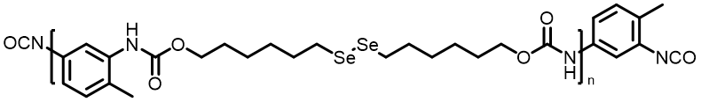
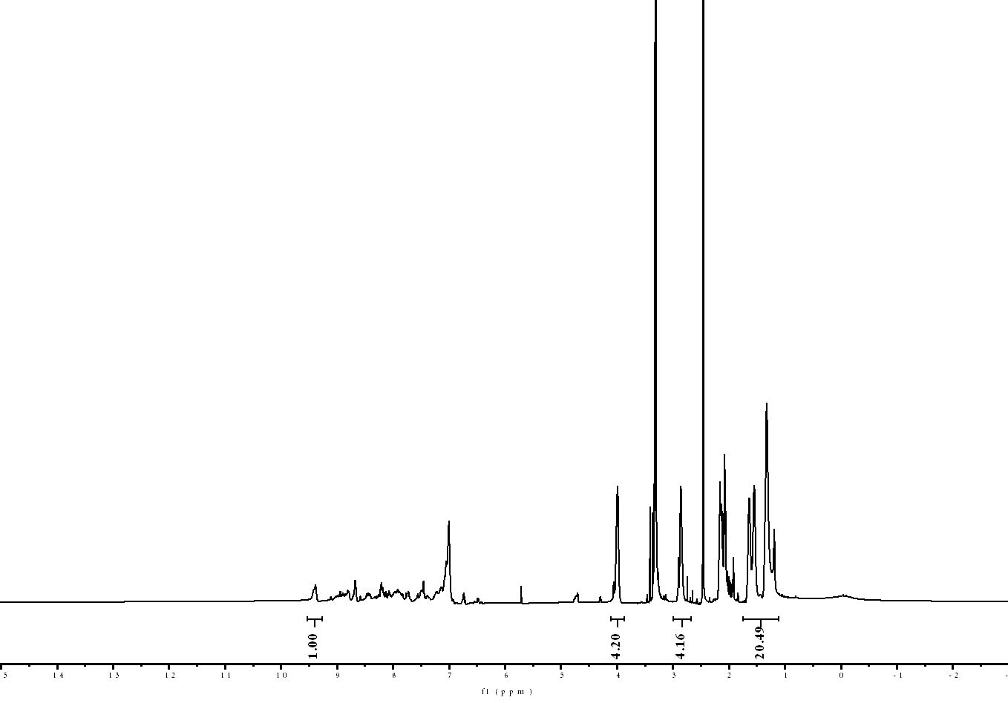
Supplementary Figure 3. ¹H NMR spectrum of DSeOH-TDI.

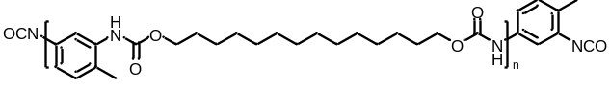
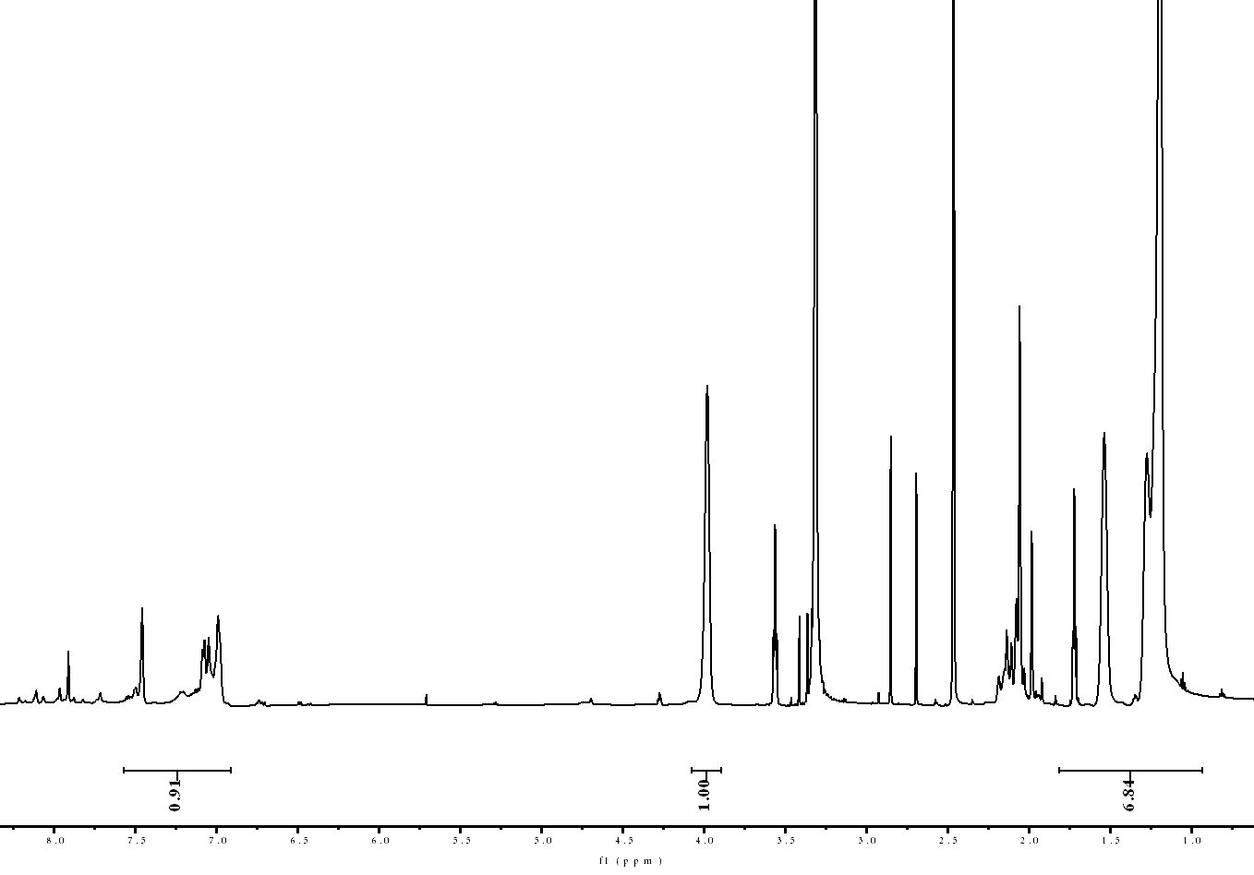
Supplementary Figure 4. ¹H NMR spectrum of C₁₄OH-TDI.
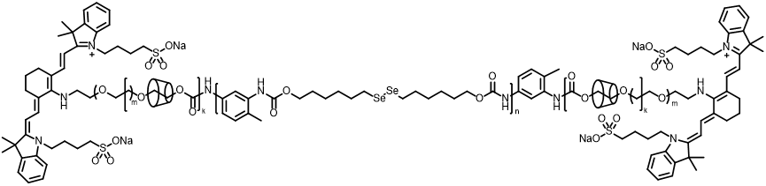

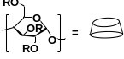
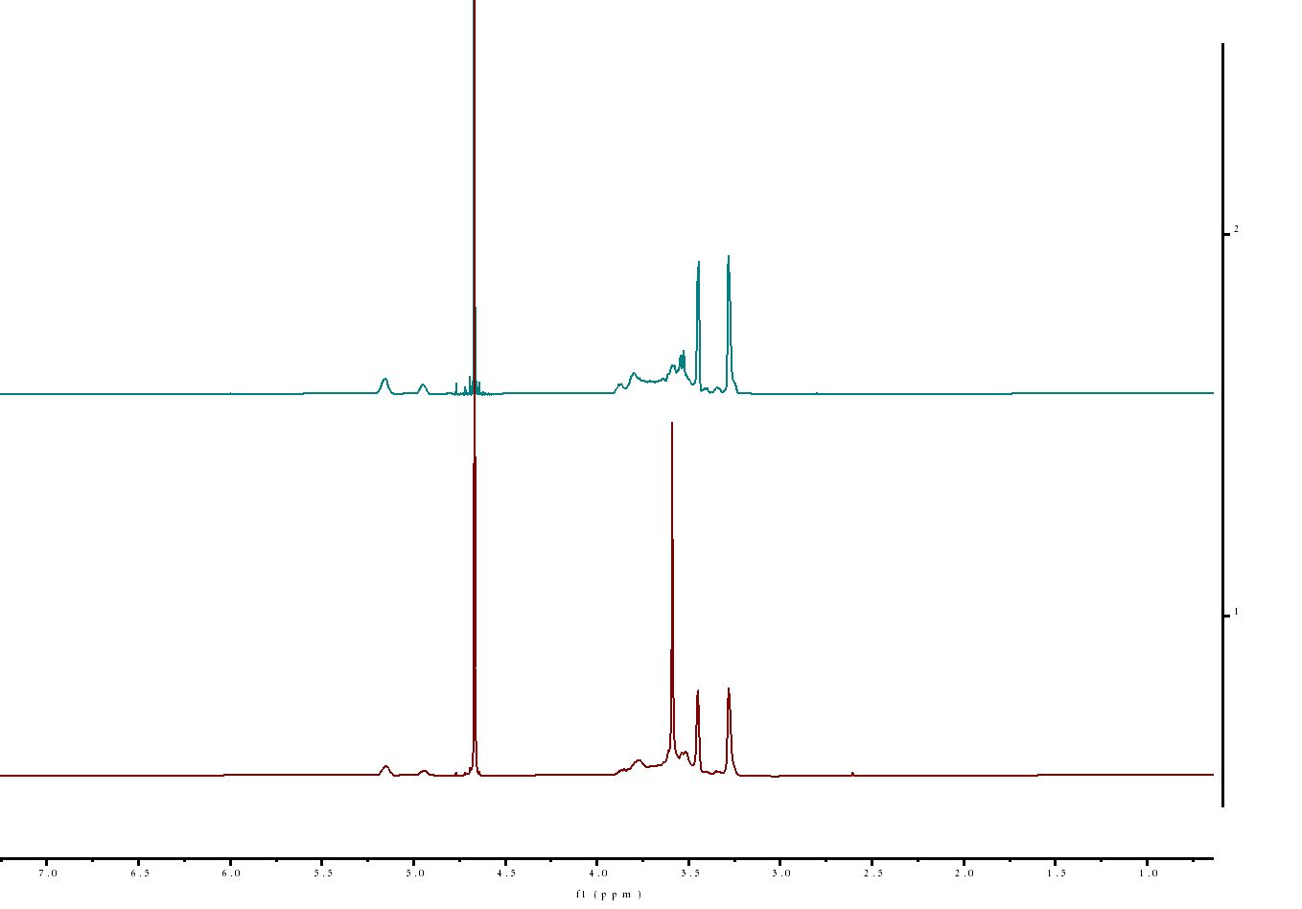
IR783-PEG-MeβCD-PDS
MeβCD
Supplementary Figure 5. ¹H NMR spectrum of IR783-PEG-MeβCD-PDS and MeβCD.

Supplementary Figure 6. GPC curve of PEG-PTD and IR783-PEG-MeβCD-PTD.

Supplementary Figure 7. UV-vis absorbance spectra of NPNs and IR-783.

Supplementary Figure 8. NPNs cannot be interrupted by ROS. (a) TEM images of NPNs and co-incubated with H₂O₂. (Scale bar=400 nm) (b) The hydrodynamic diameters and zeta potential of NPNs co-incubated with H₂O₂ determined. (n = 3 per group, repeated three times).

Supplementary Figure 9. The standard curve of diABZIs determined by HPLC.

Supplementary Figure 10. The standard curve of cholesterol content.

Supplementary Figure 11. Cholesterol levels in 4T1, B16F10 and MC38 tumor tissues and the adjacent muscle tissues (n = 3 per group, repeated three times). Data were expressed as means ± SD. Statistical significance was calculated via Two-tailed Student’s t-test. *P < 0.05, **P < 0.01, ***P < 0.001, and ****P < 0.0001

Supplementary Figure 12. Relative intracellular and plasma membrane levels of cholesterol in murine 4T1, B16F10 and MC38 cancer cells treated with PBS or MeβCD in vivo (n = 3 per group, repeated three times). Data were expressed as means ± SD. Statistical significance was calculated via Two-tailed Student’s t-test. *P < 0.05, **P < 0.01, ***P < 0.001, and ****P < 0.0001

Supplementary Figure 13. The mean fluorescence intensity (MFI) of Filipin Ⅲ level in 4T1 cancer cells after different treatments determined by Flow jo (n = 3 per group, repeated three times). (G1: PBS, G2: MeβCD, G3: NPNs, G4: RDPNs). Data were expressed as means ± SD. Statistical significance was calculated via One-way ANOVA with Tukey post-hoc test. * P < 0.05, **P < 0.01, *** P < 0.001, and **** P < 0.0001

Supplementary Figure 14. Relative cortical stiffness determined by nanoindentation measurements using AFM for 4T1, B16F10 and MC38 cancer cells after different treatments (n = 6 per group, repeated three times). Data were expressed as means ± SD. Data are presented as means ± s.d. Statistical significance was calculated via Two-tailed Student’s t-test. *P < 0.05, **P < 0.01, ***P < 0.001, and ****P < 0.0001

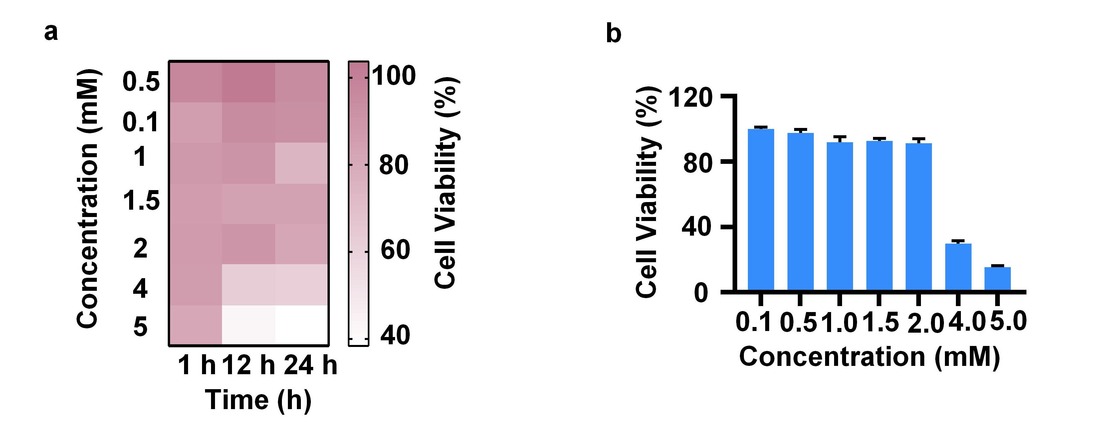
Supplementary Figure 15. (a) The cell viability of 4T1 cells was co-cultured with MeβCD for different time. (b) The cell viability of L929 cells was co-cultured with MeβCD for 24 h (n = 5 per group, repeated twice).

Supplementary Figure 16. The cell viability of L929 cells was co-cultured with NPNs or RDPNs for 24 h (n = 5 per group, repeated twice).

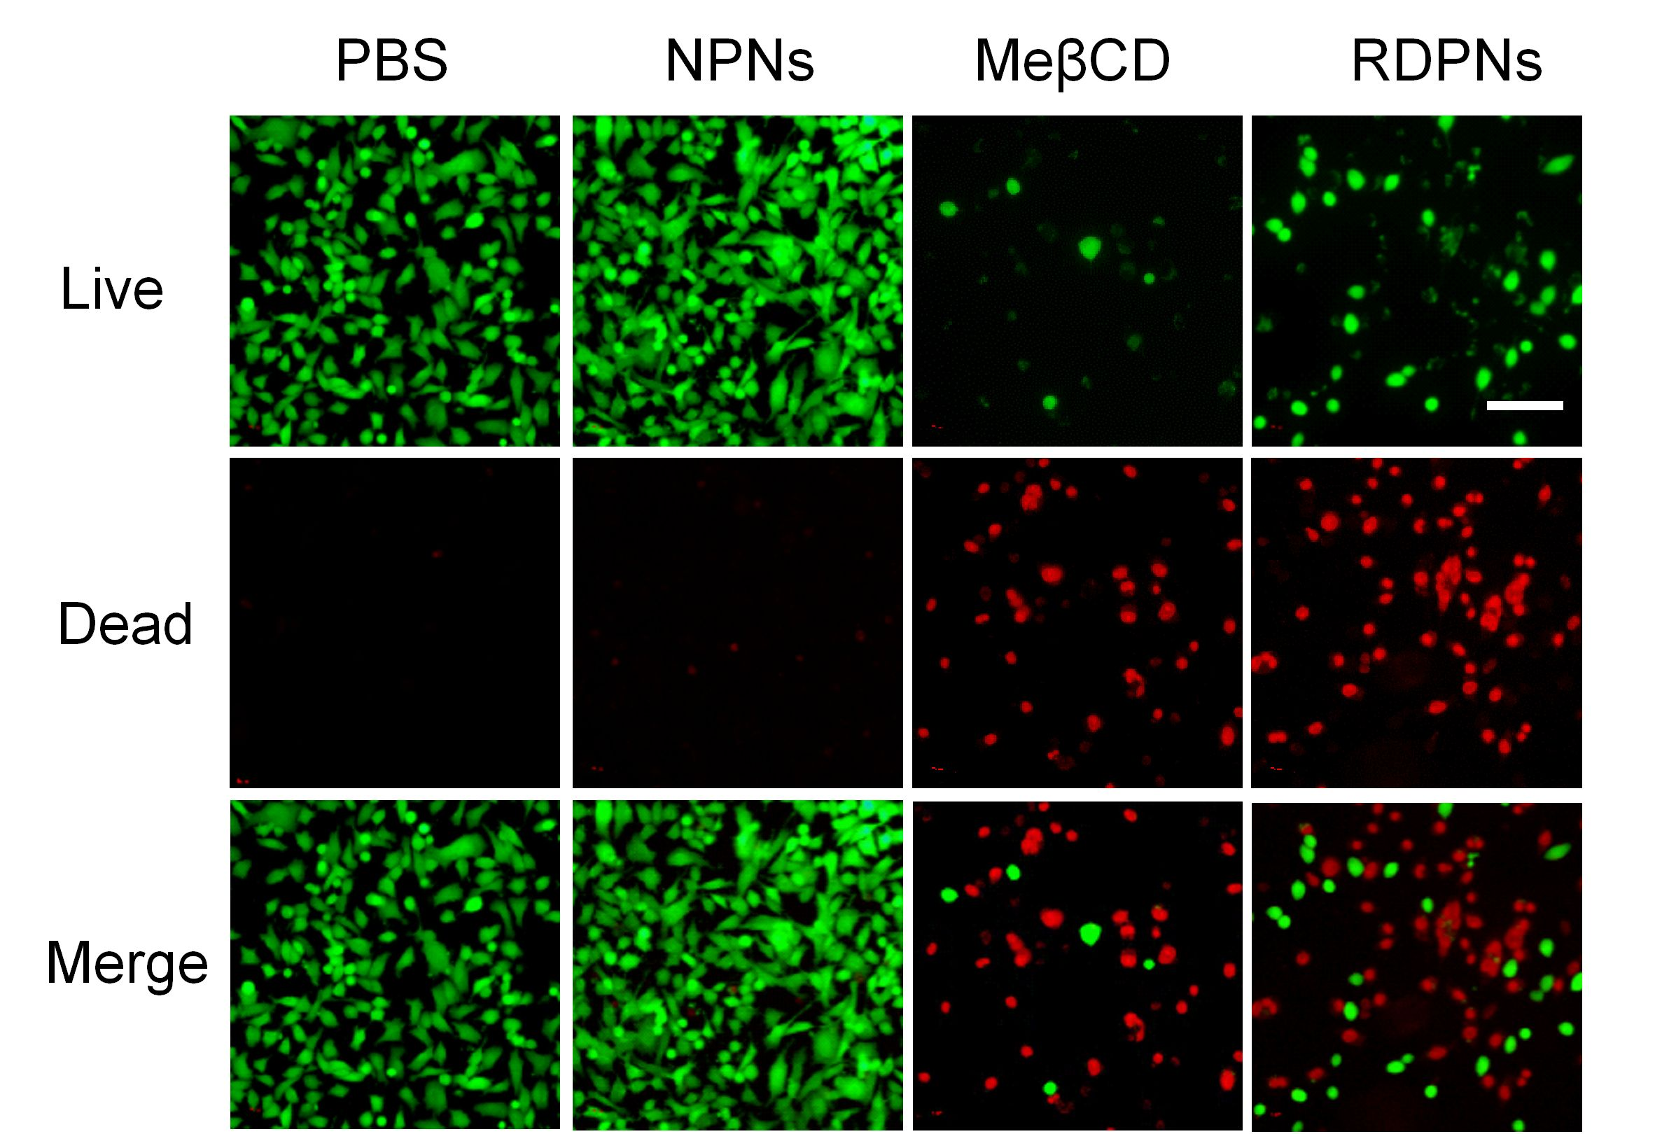
Supplementary Figure 17. Calcein-AM/PI staining in 4T1 cells treated with various formulations. n = 3 biologically independent samples per group. (Bar = 100μm)

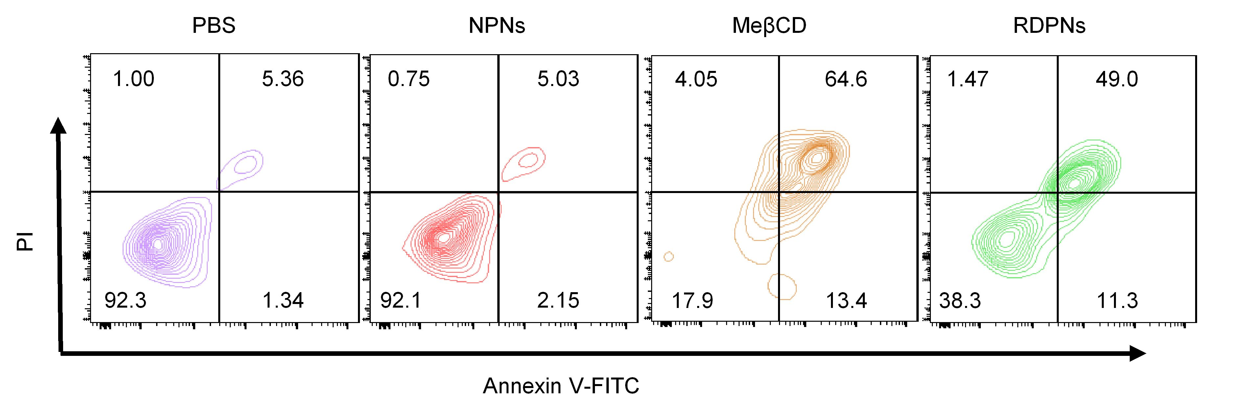
Supplementary Figure 18. Flow cytometry apoptosis analysis in 4T1 cells treated with various formulations.

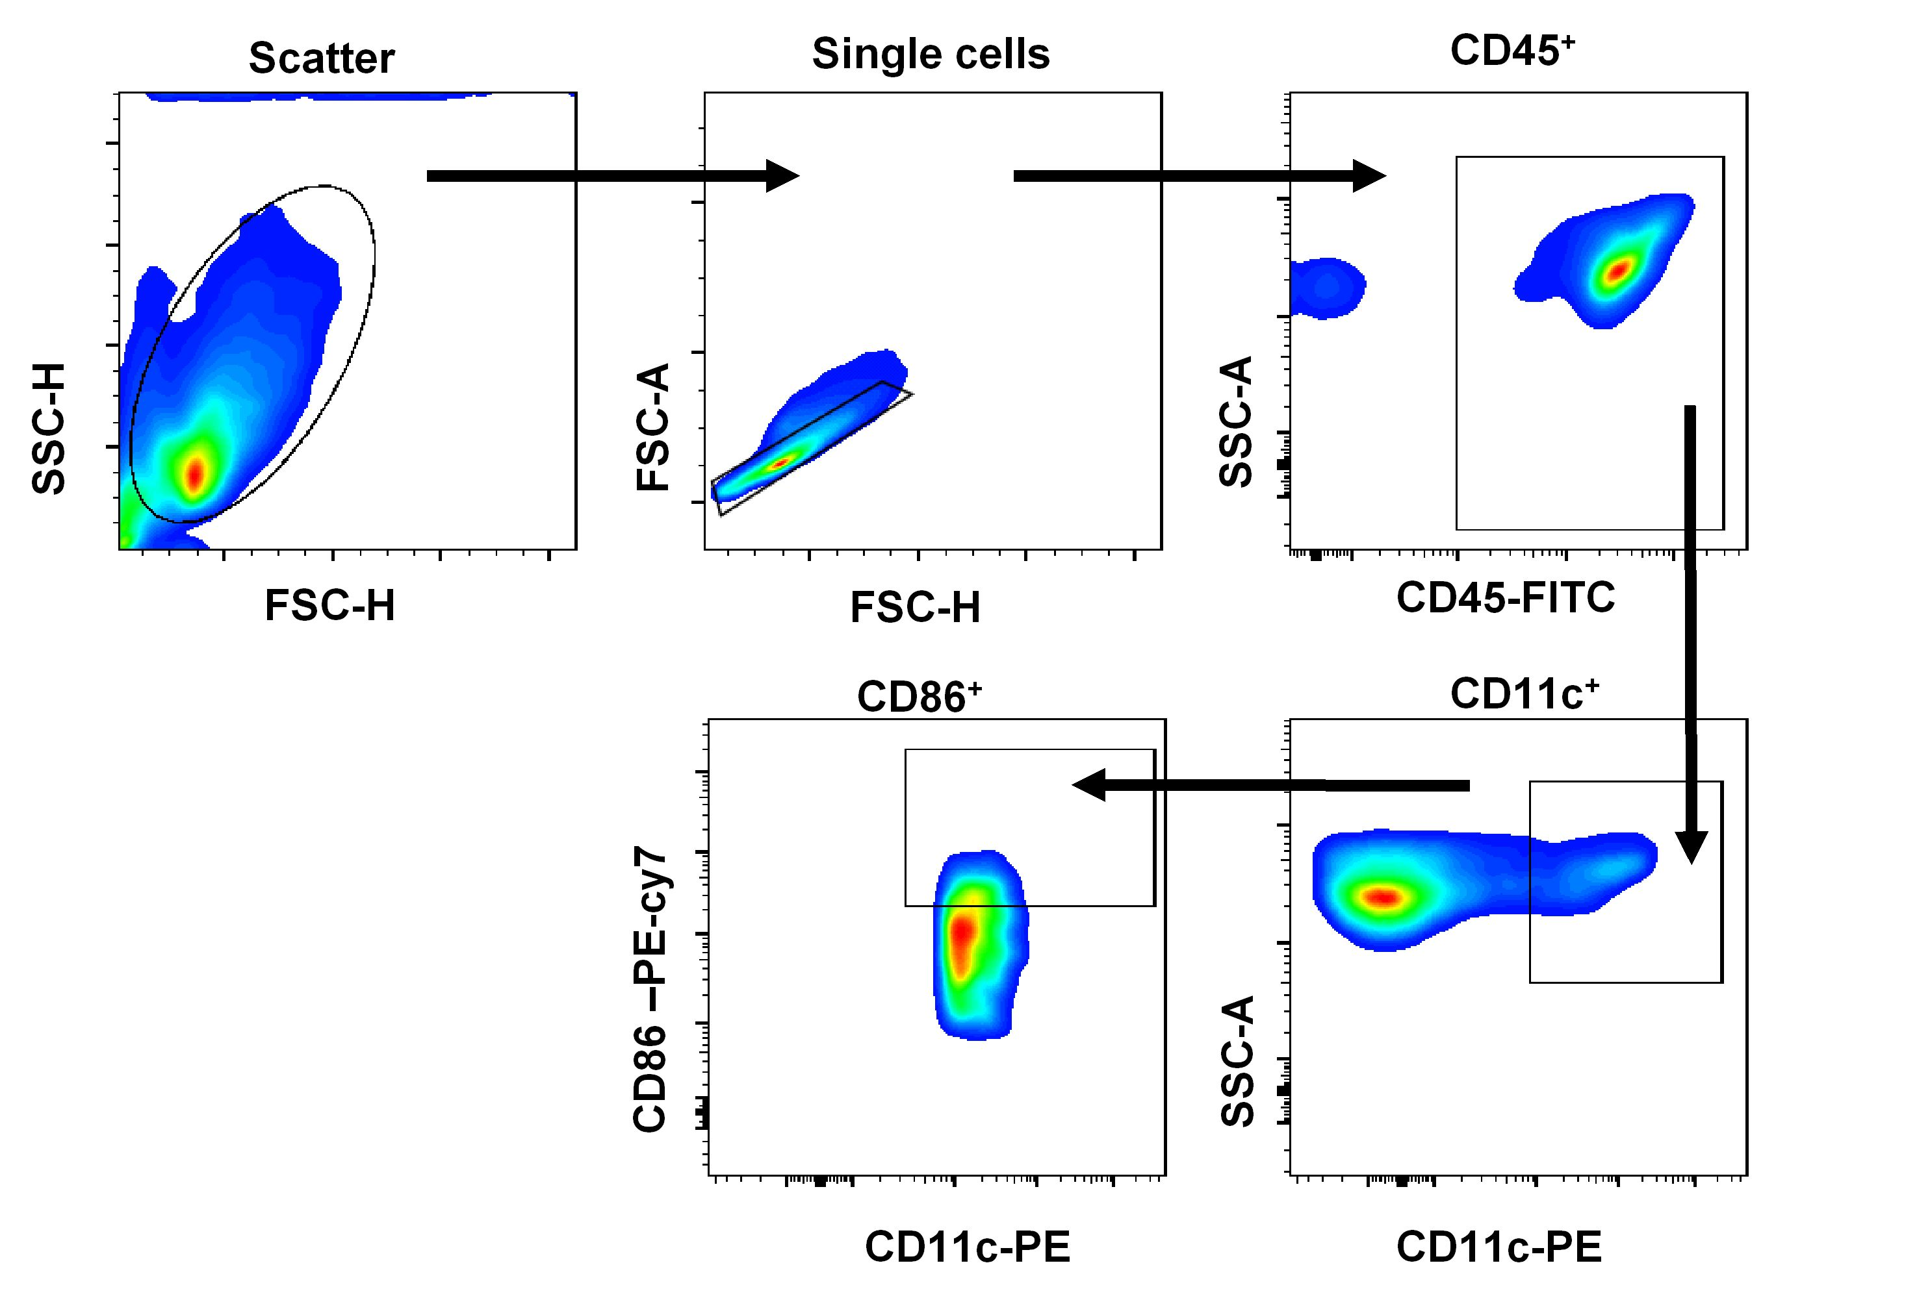 Supplementary Figure 19. Representative flow cytometry gating strategies for CD45⁺CD11c⁺CD86⁺ DCs panel. The experiment was performed twice with similar results.
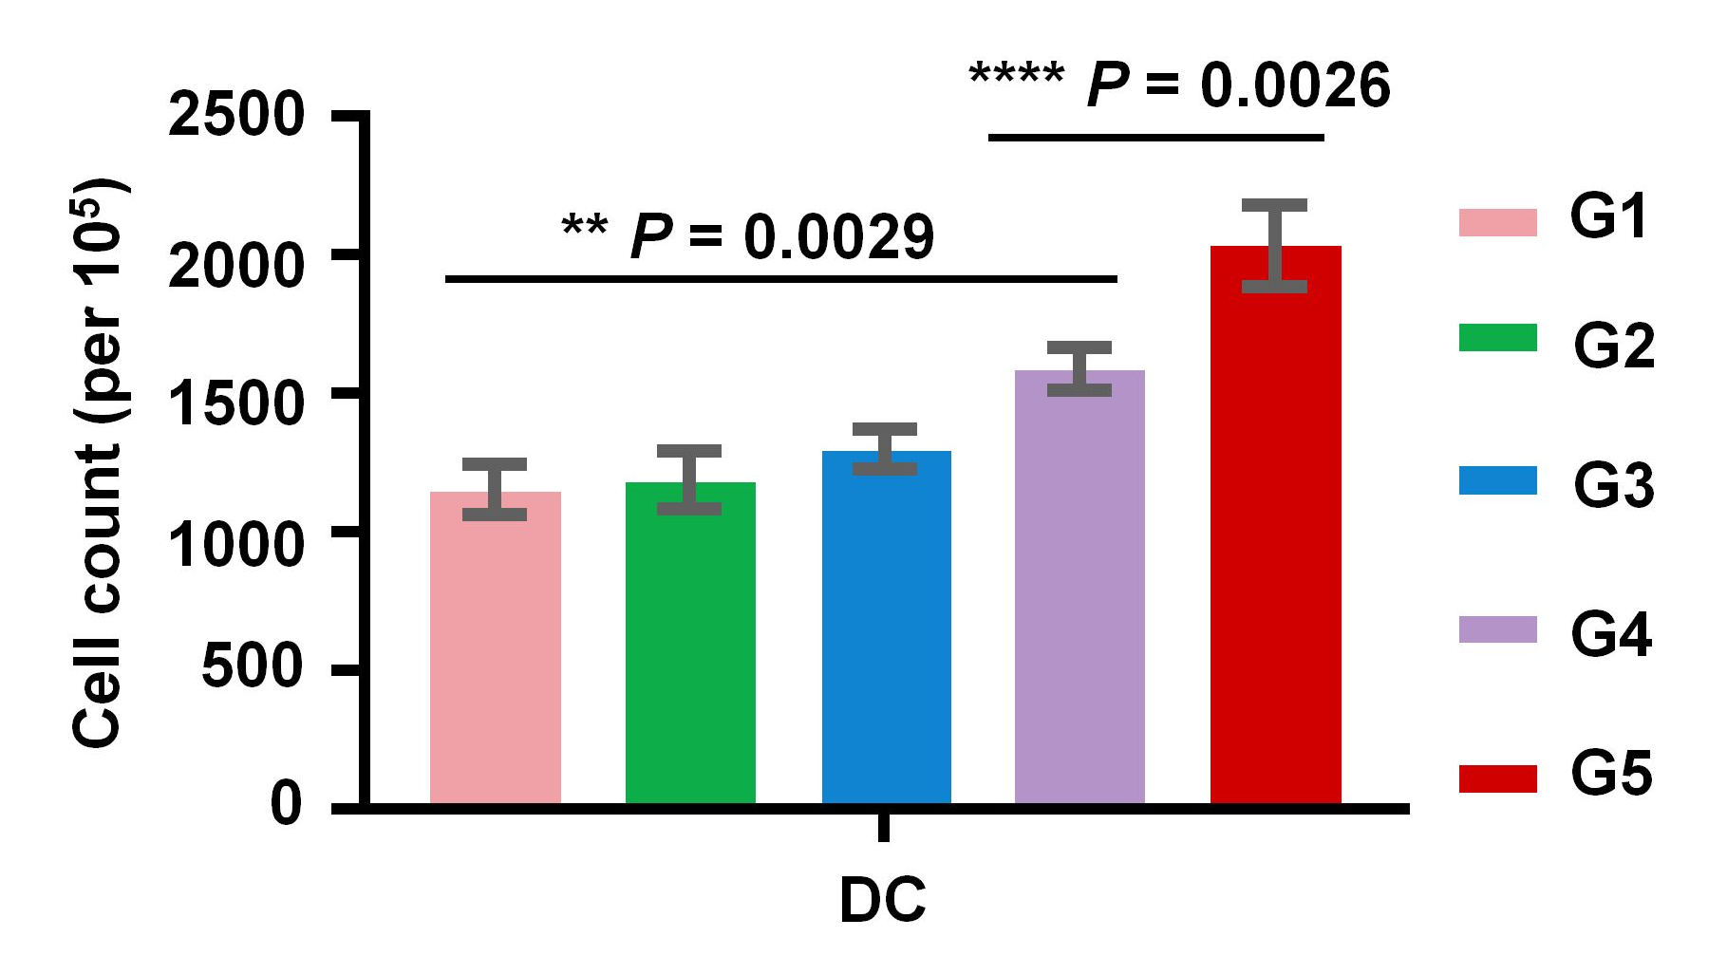
Supplementary Figure 20. The number of DCs per 100,000 lymphocytes. The lymphocytes were from TDLNs of mice 7day after treatment. (G1: PBS, G2: NPNs, G3: RDPNs, G4: diABZIs, G5: RDPNs@diABZIs). n = 3 biologically independent animals per group. Data are presented as means ± s.d. Statistical significance was calculated via One-way ANOVA with Tukey post-hoc test. *P < 0.05, ** P < 0.01, *** P < 0.001, **** P < 0.0001.

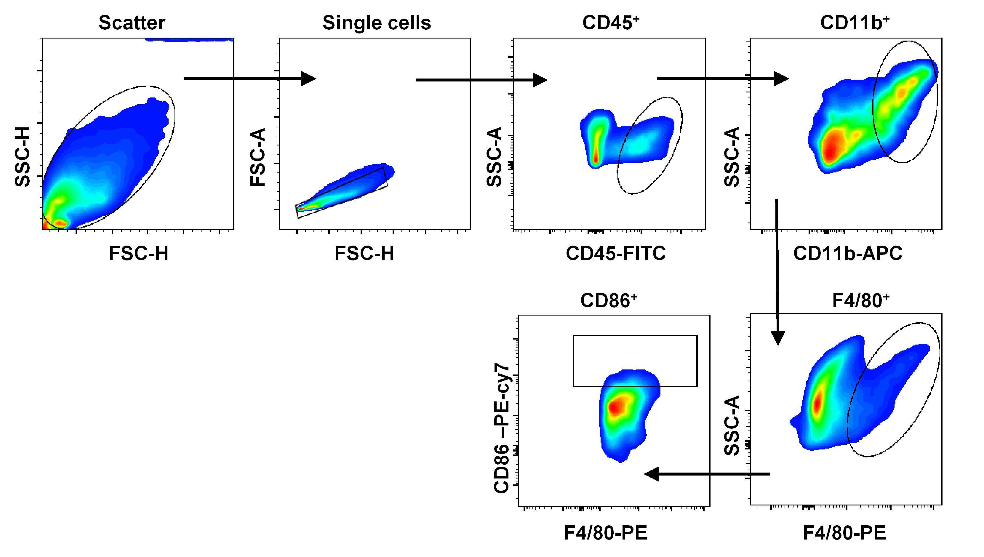
Supplementary Figure 21. Representative flow cytometry gating strategies for CD45⁺CD11b⁺F4/80⁺CD86⁺ M1-like macrophages panel. The experiment was performed twice with similar results.

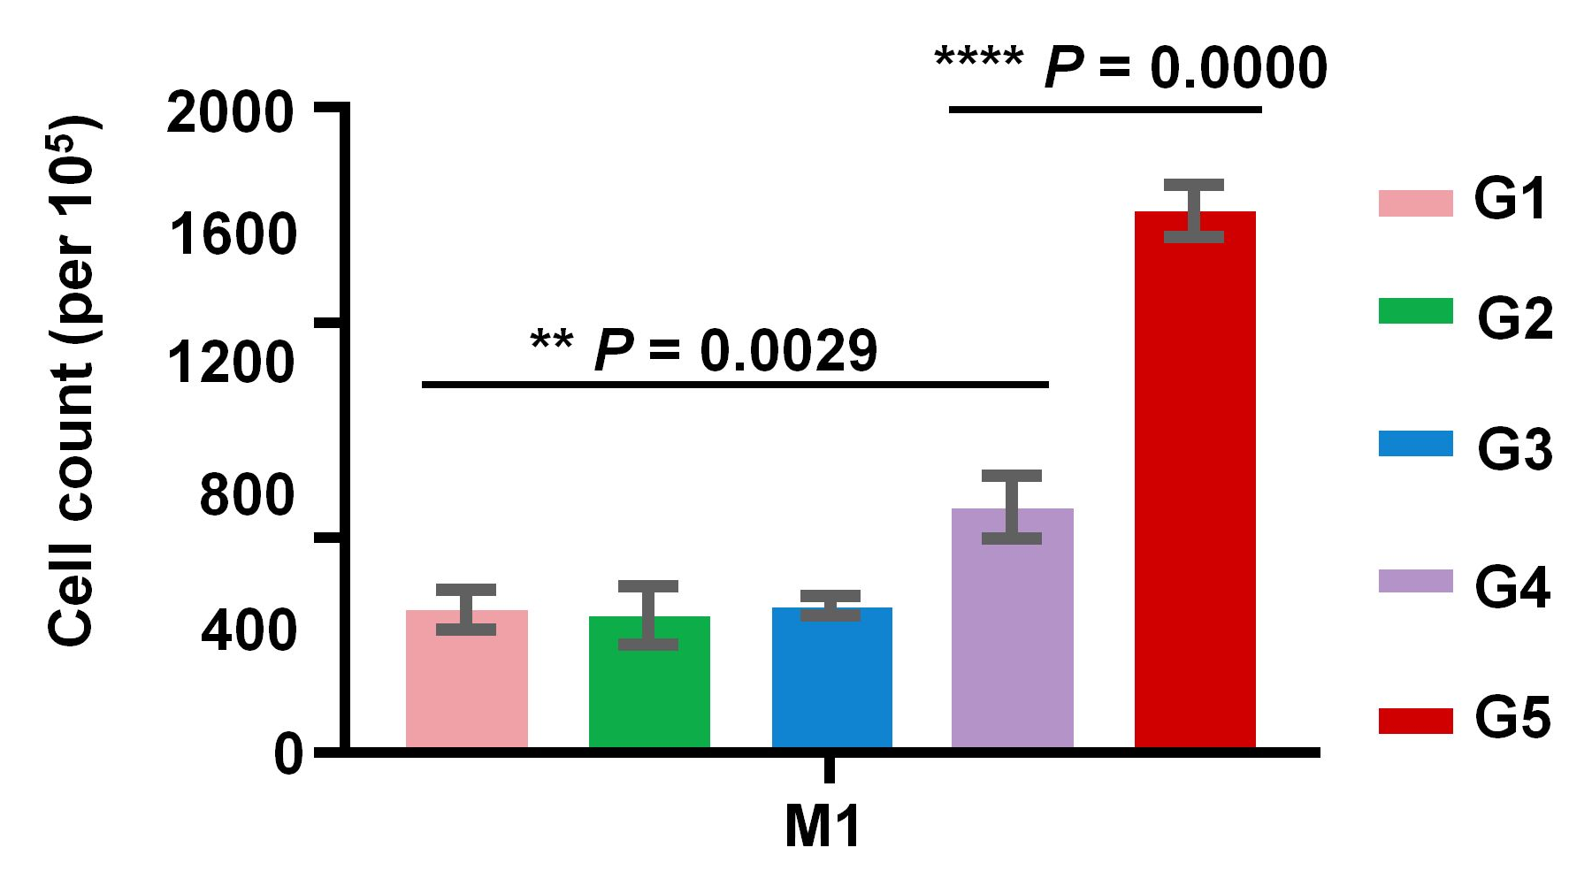

Supplementary Figure 22. The number of M1 per 100,000 tumor cells. The tumor cells were from tumor of mice 7day after treatment. (G1: PBS, G2: NPNs, G3: RDPNs, G4: diABZIs, G5: RDPNs@diABZIs). n = 3 biologically independent animals per group. Data are presented as means ± s.d. Statistical significance was calculated via One-way ANOVA with Tukey post-hoc test. * P < 0.05, ** P < 0.01, *** P < 0.001, **** P < 0.0001.

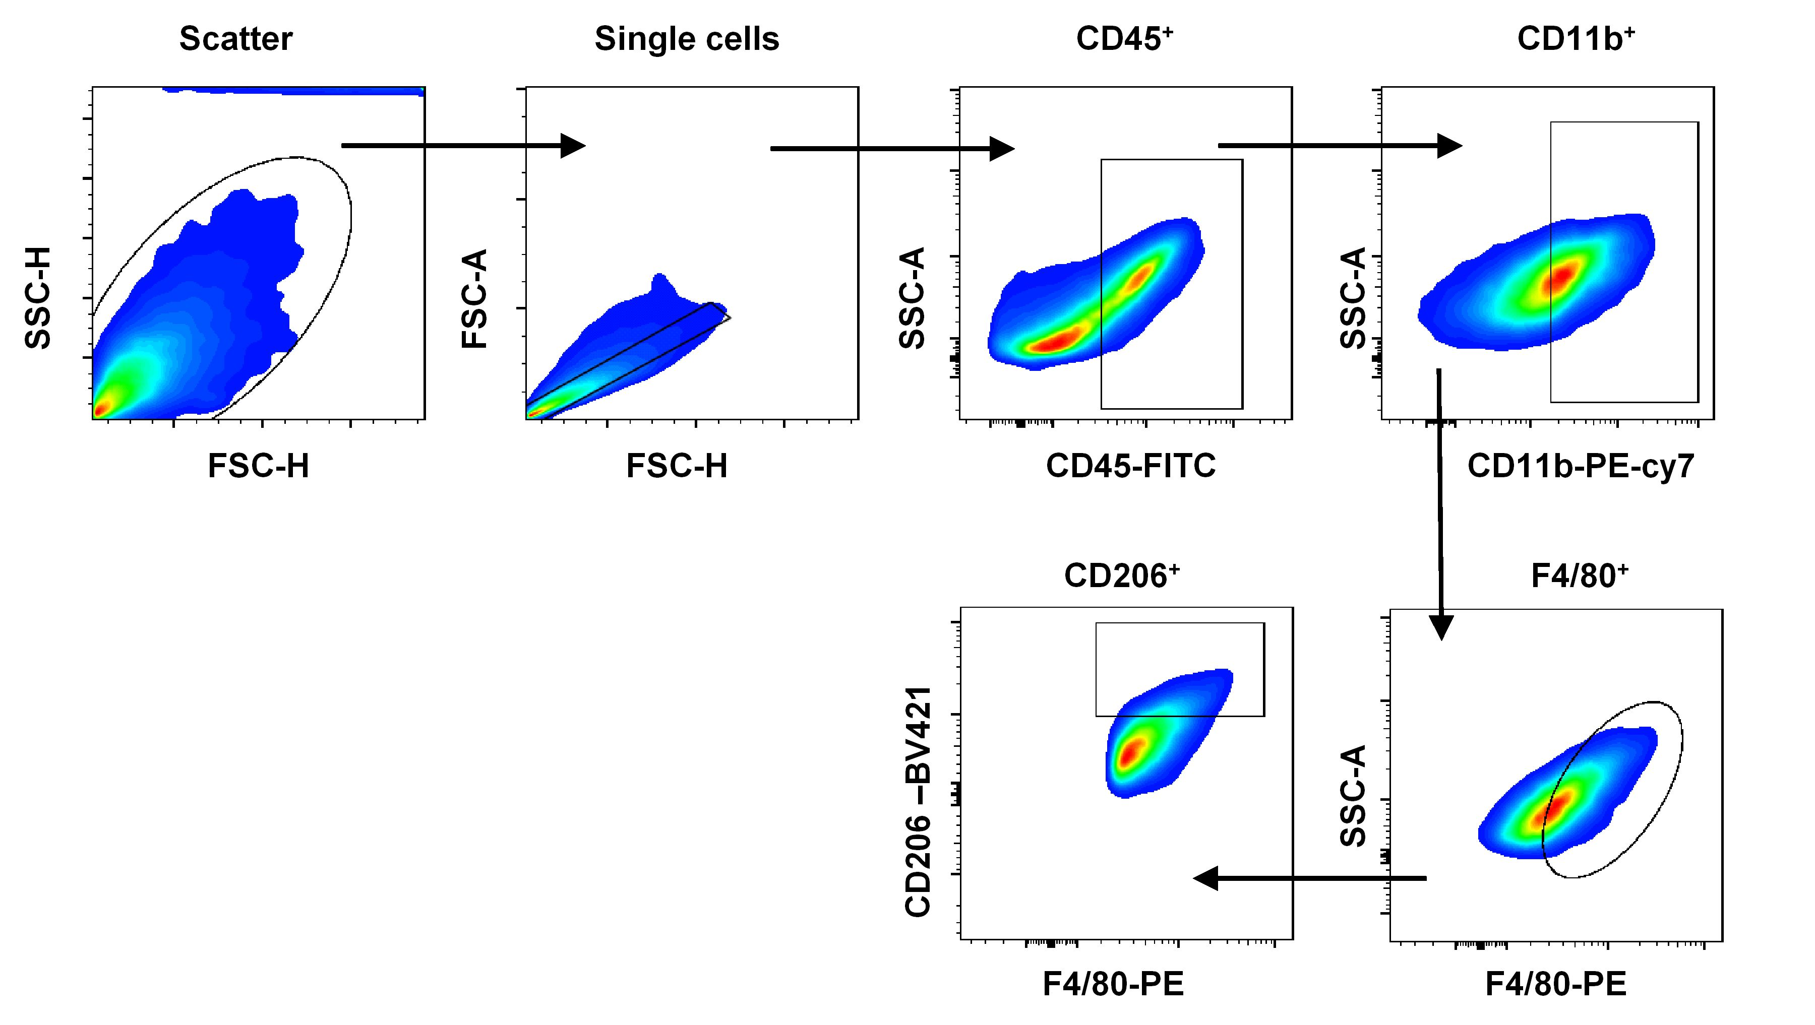
Supplementary Figure 23. Representative flow cytometry gating strategies for CD45⁺CD11b⁺F4/80⁺CD206⁺ M2-like macrophages panel. The experiment was performed twice with similar results.

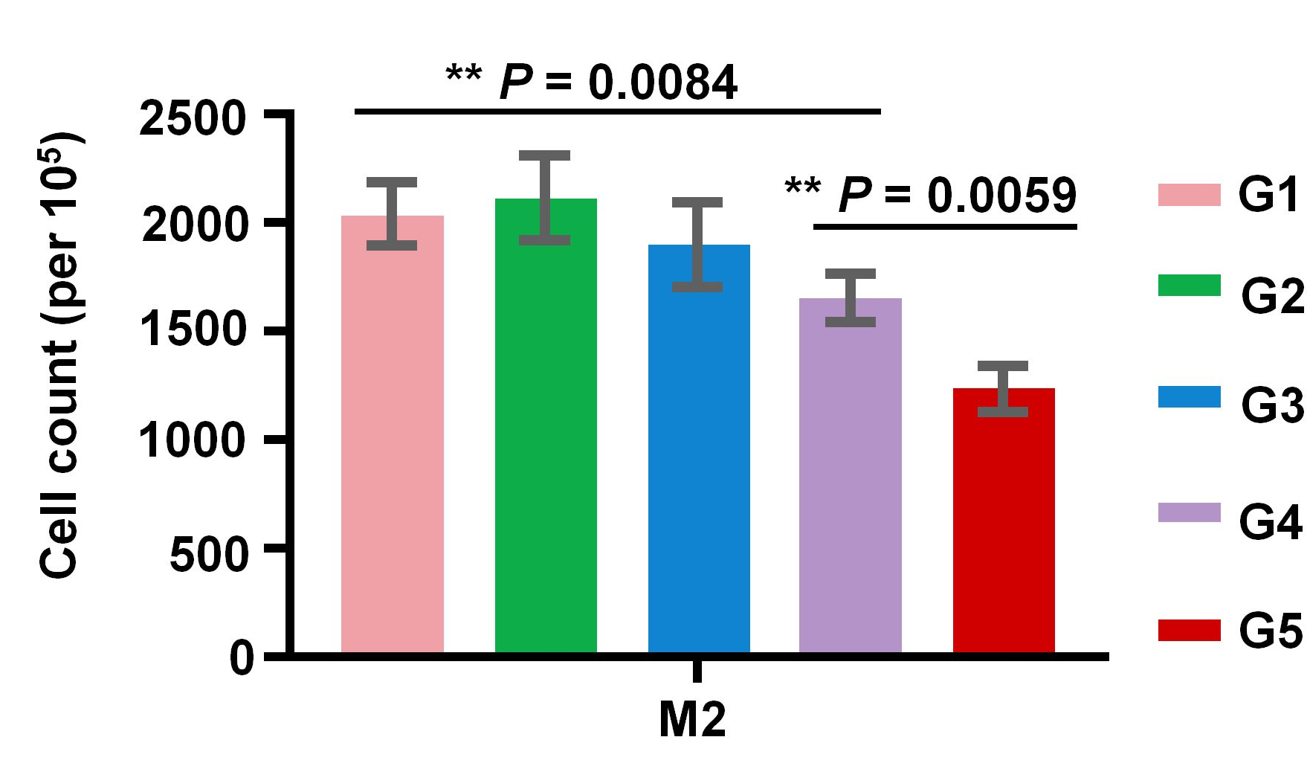
Supplementary Figure 24. The number of M2 per 100,000 tumor cells. The tumor cells were from tumor of mice 7day after treatment. (G1: PBS, G2: NPNs, G3: RDPNs, G4: diABZIs, G5: RDPNs@diABZIs). n = 3 biologically independent animals per group. Data are presented as means ± s.d. Statistical significance was calculated via One-way ANOVA with Tukey post-hoc test. * P < 0.05, ** P < 0.01, *** P < 0.001, **** P < 0.0001.

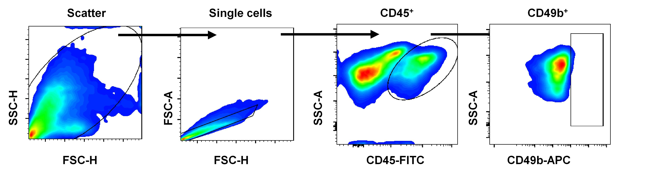
Supplementary Figure 25. Representative flow cytometry gating strategies for CD45 ⁺CD49b⁺ NK cells panel. The experiment was performed twice with similar results.

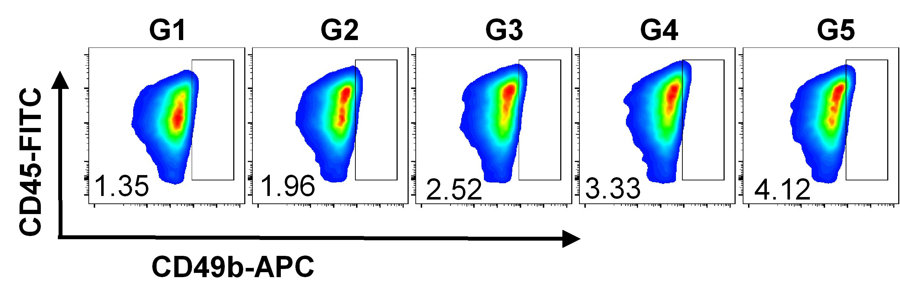
Supplementary Figure 26. Representative flow cytometric plots of NK cells (CD49b⁺) after gating on CD45⁺ cells. (G1: PBS, G2: NPNs, G3: RDPNs, G4: diABZIs, G5: RDPNs@diABZIs).

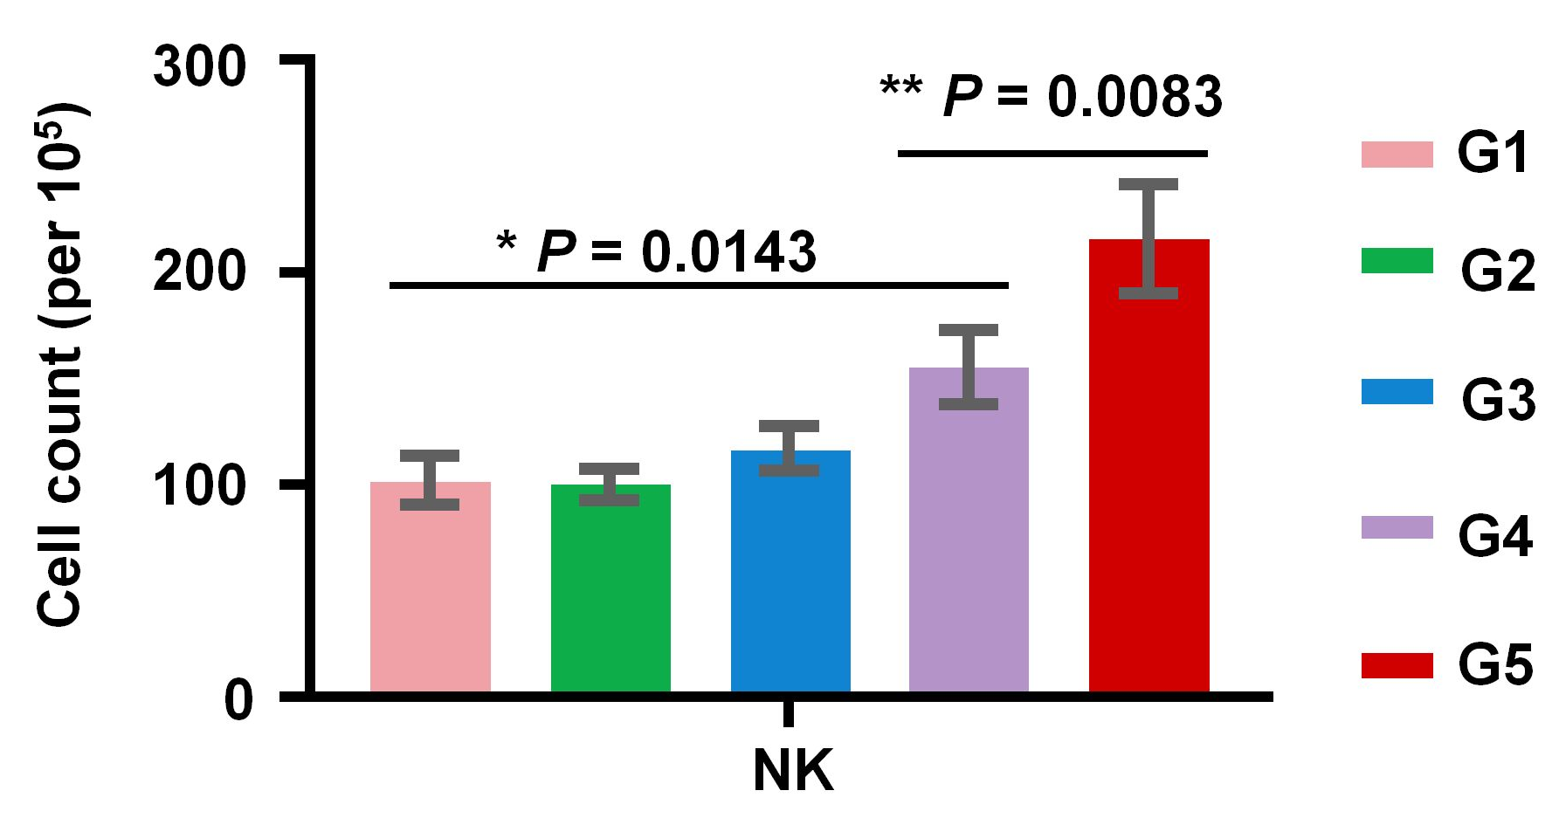
Supplementary Figure 27. The number of NK per 100,000 spleen cells. The spleen cells were from spleen of mice 7day after treatment. (G1: PBS, G2: NPNs, G3: RDPNs, G4: diABZIs, G5: RDPNs@diABZIs). n = 3 biologically independent animals per group. Data are presented as means ± s.d. Statistical significance was calculated via One-way ANOVA with Tukey post-hoc test. * P < 0.05, ** P < 0.01, *** P < 0.001, **** P < 0.0001.

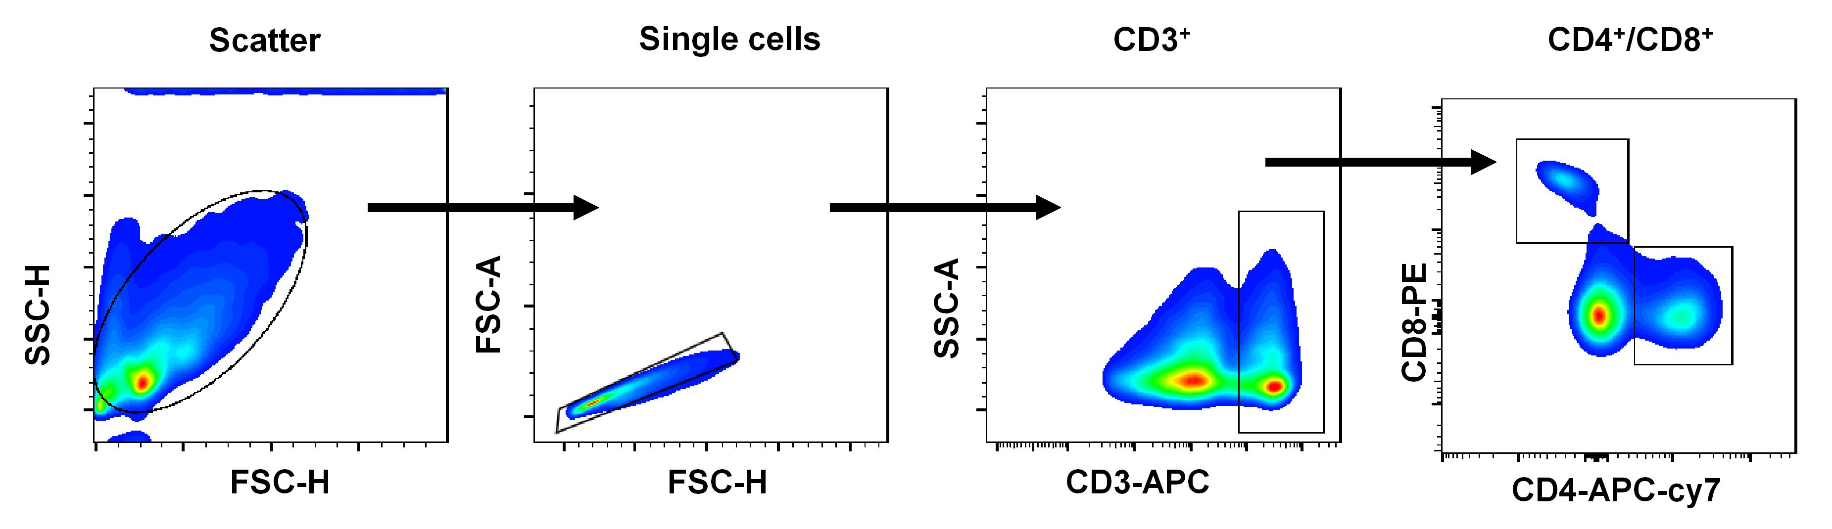
Supplementary Figure 28. Representative flow cytometry gating strategies for CD3⁺ CD4 ⁺ /CD8⁺ T cells panel. The experiment was performed twice with similar results.

Supplementary Figure 29. The number of CD8⁺ T cells per 100,000 tumor cells. The tumor cells were from tumor of mice 7day after treatment. (G1: PBS, G2: NPNs, G3: RDPNs, G4: diABZIs, G5: RDPNs@diABZIs). n = 3 biologically independent animals per group. Data are presented as means ± s.d. Statistical significance was calculated via One-way ANOVA with Tukey post-hoc test. * P < 0.05, ** P < 0.01, *** P < 0.001, **** P < 0.0001.

Supplementary Figure 30. The number of CD4⁺ T cells per 100,000 tumor cells. The tumor cells were from tumor of mice 7day after treatment. (G1: PBS, G2: NPNs, G3: RDPNs, G4: diABZIs, G5: RDPNs@diABZIs). n = 3 biologically independent animals per group. Data are presented as means ± s.d. Statistical significance was calculated via One-way ANOVA with Tukey post-hoc test. * P < 0.05, ** P < 0.01, *** P < 0.001, **** P < 0.0001.

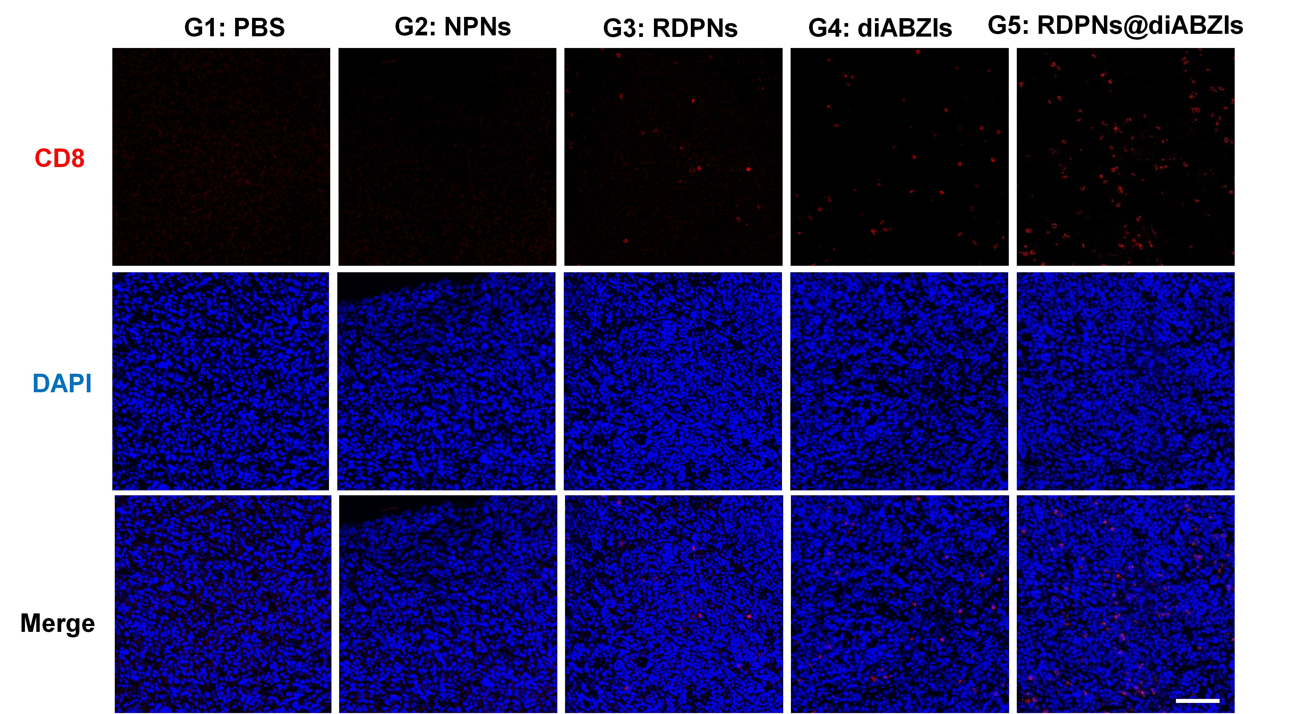
Supplementary Figure 31. Representative immunofluorescence staining of CD8 (red) from cryo-sectioned slides of subcutaneous tumors in different treatment groups (scale bar = 100µm). n = 3 biologically independent samples per group.

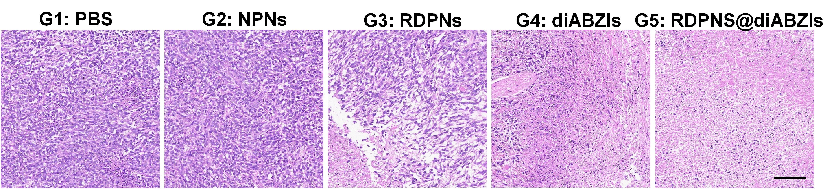
Supplementary Figure 32. Histological analysis of the tumor of mice treated with different treatments. n = 3 biologically independent samples per group. (scale bar = 100µm).

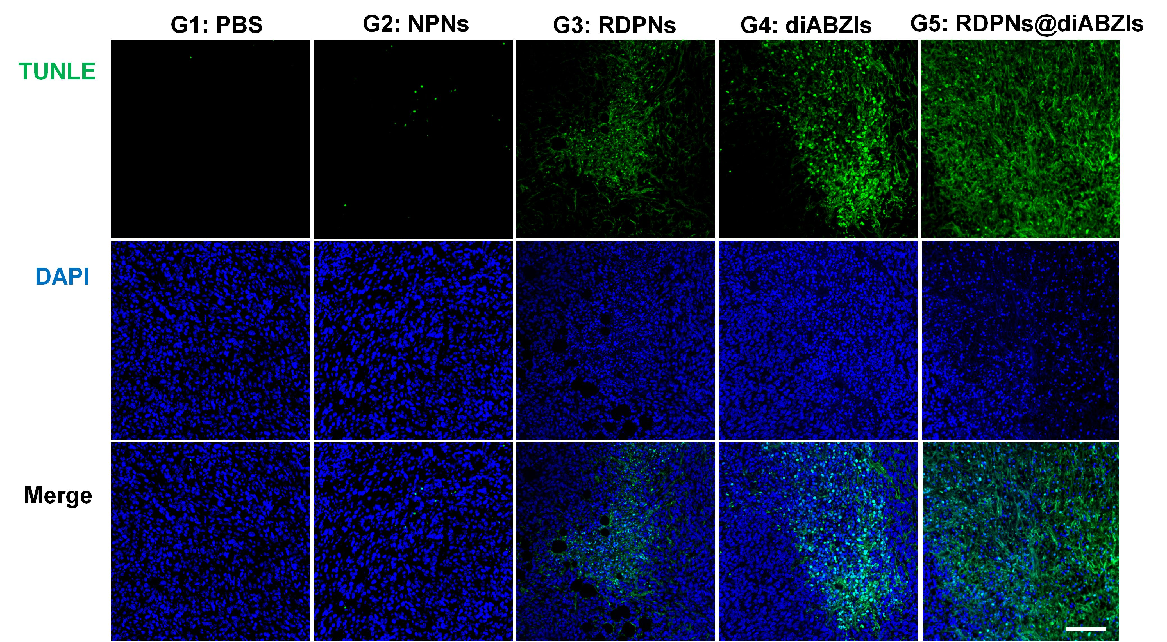
Supplementary Figure 33. Representative immunofluorescence staining of TUNLE (green) from cryo-sectioned slides of subcutaneous tumors in different treatment groups (scale bar = 100µm). n = 3 biologically independent samples per group.

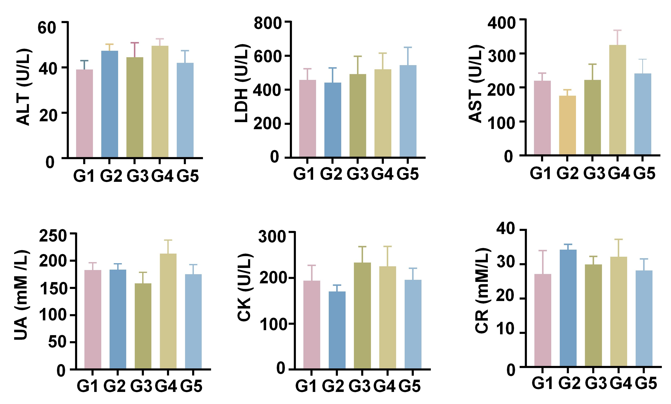
Supplementary Figure 34. Evaluations of serum ALT, LDH, AST, UA, CK and CR in 4T1 tumor-bearing mice after treatment (n = 3 biologically independent samples per group). (G1: PBS, G2: NPNs, G3: RDPNs, G4: diABZIs, G5: RDPNs@diABZIs).

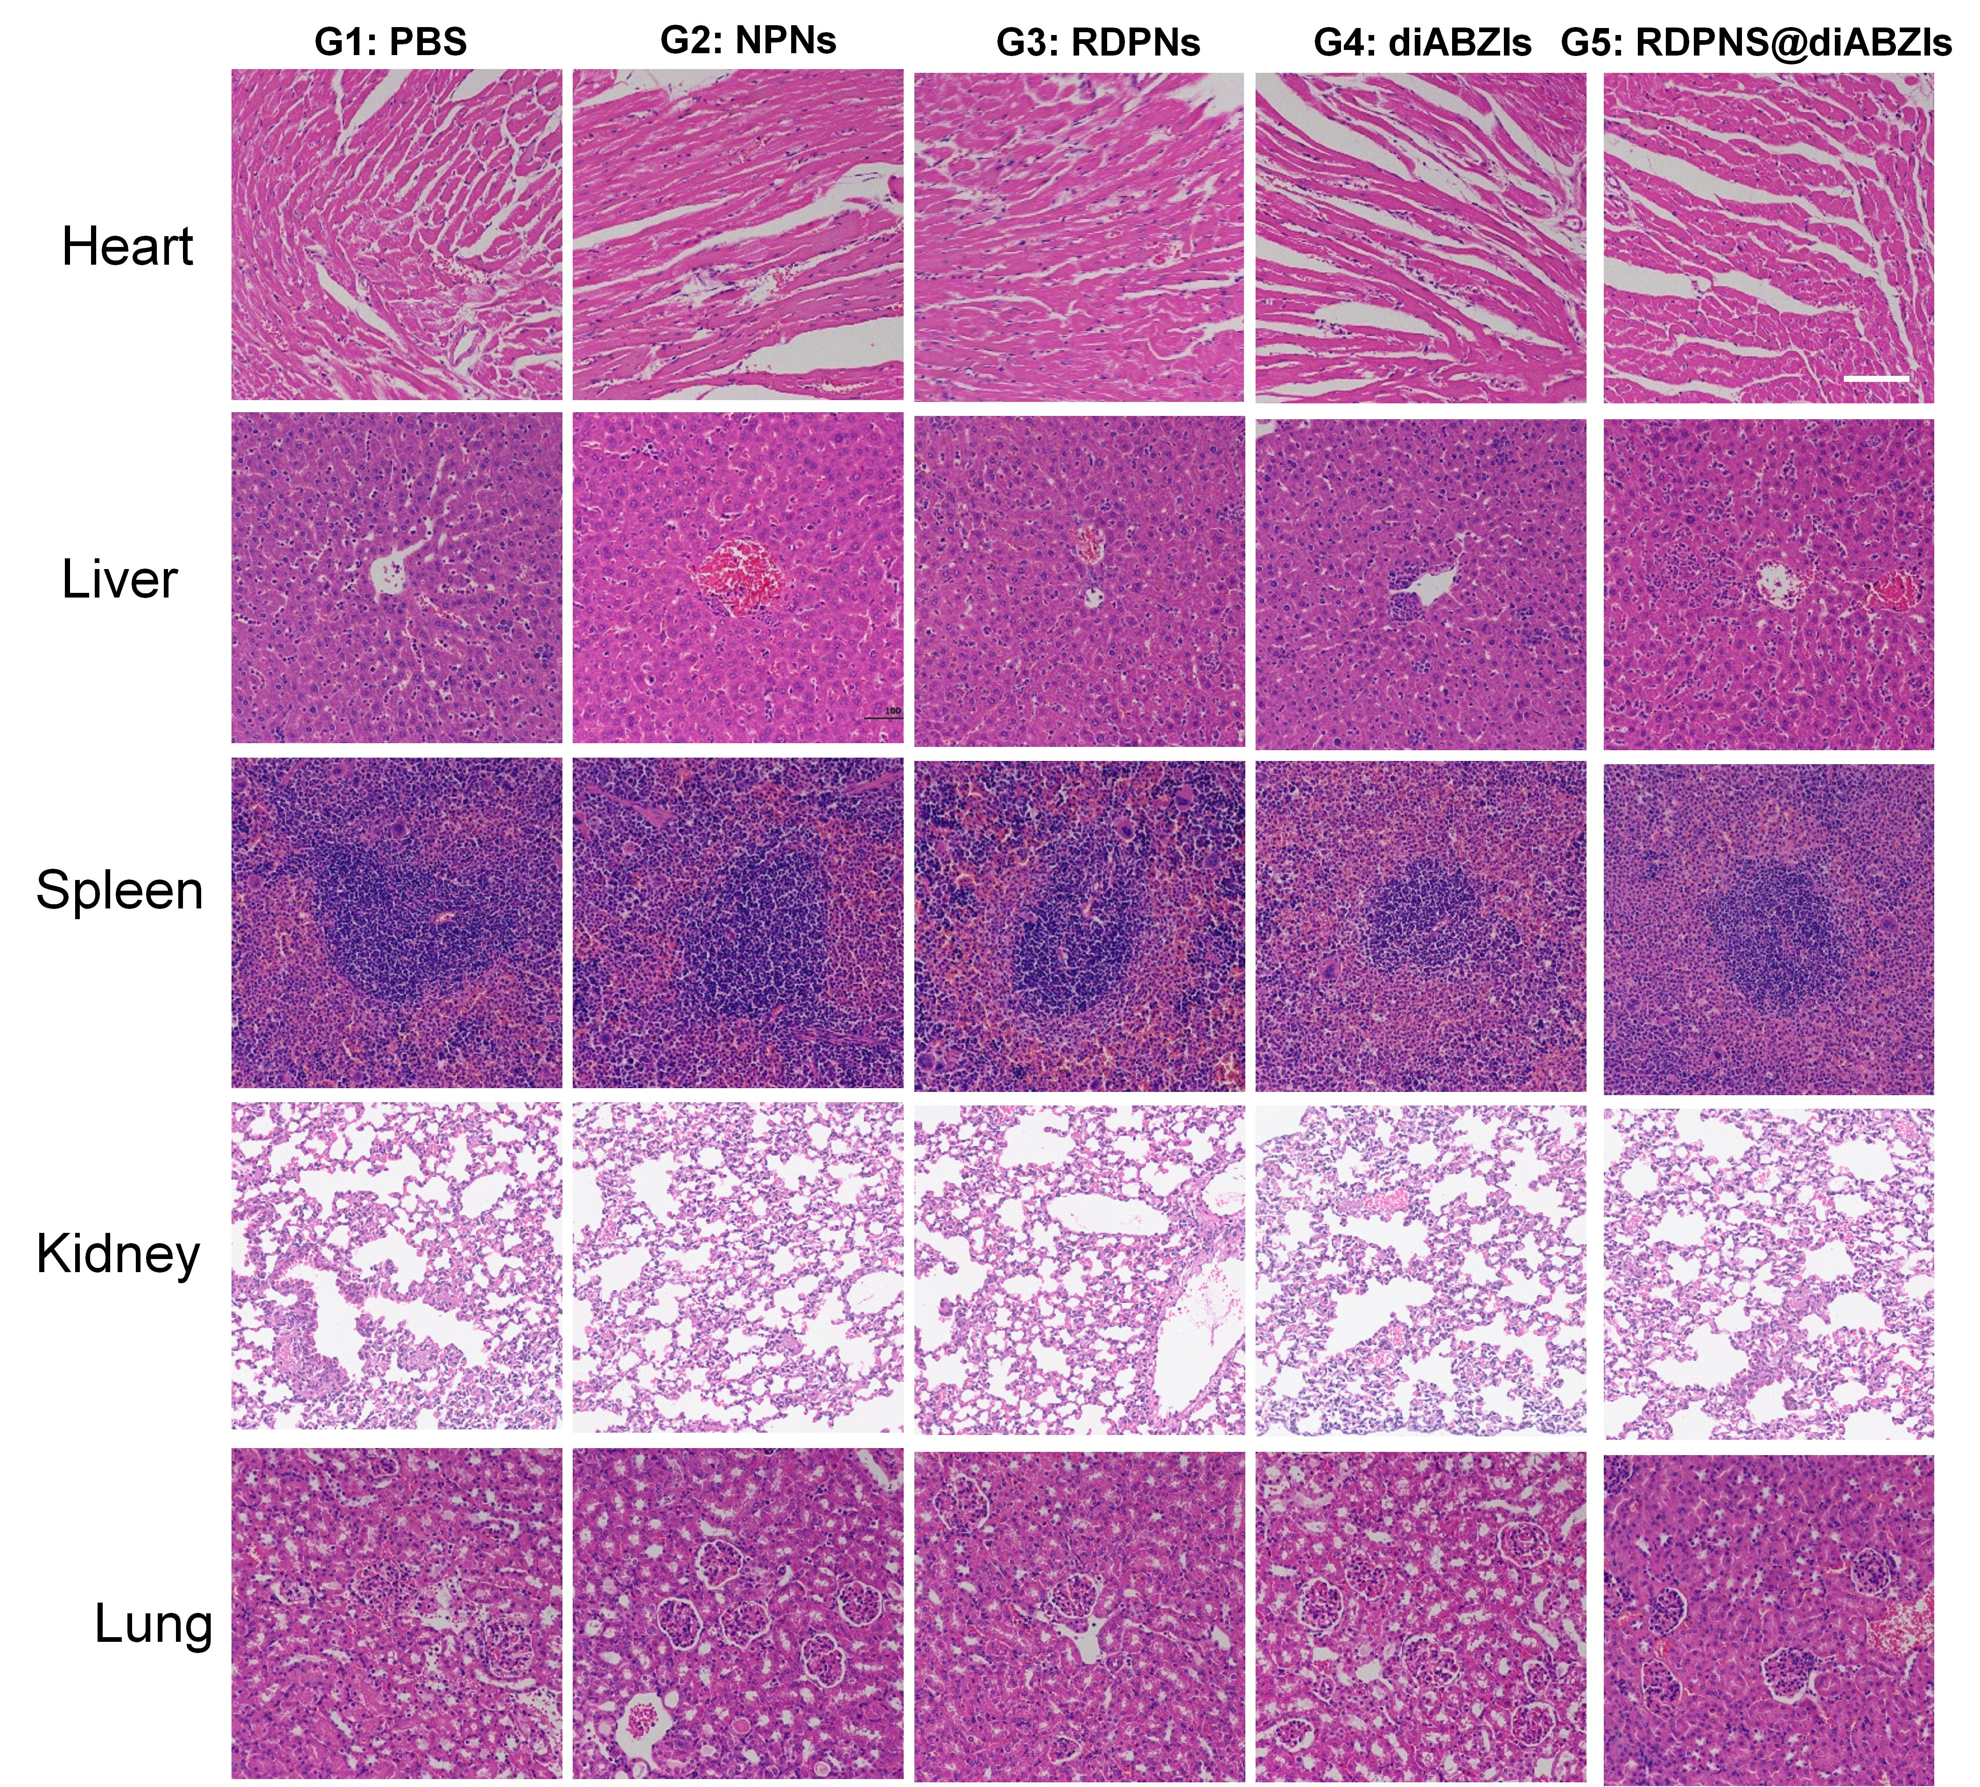
Supplementary Figure 35. Hematoxylin-eosin (HE) staining analysis of the major organs of 4T1 tumor-bearing mice treated with different treatments. (scale bar = 100µm). n = 3 biologically independent samples per group.

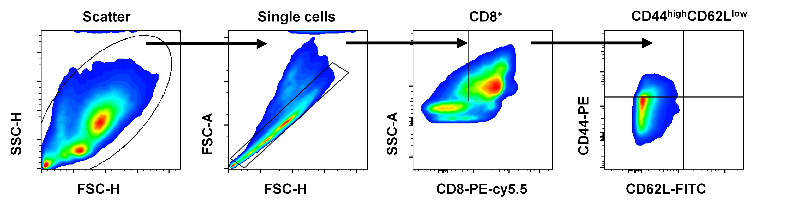
Supplementary Figure 36. Representative flow cytometry gating strategies for CD8⁺CD44^{high}CD62L^{low} memory T cells panel. The experiment was performed twice with similar results.

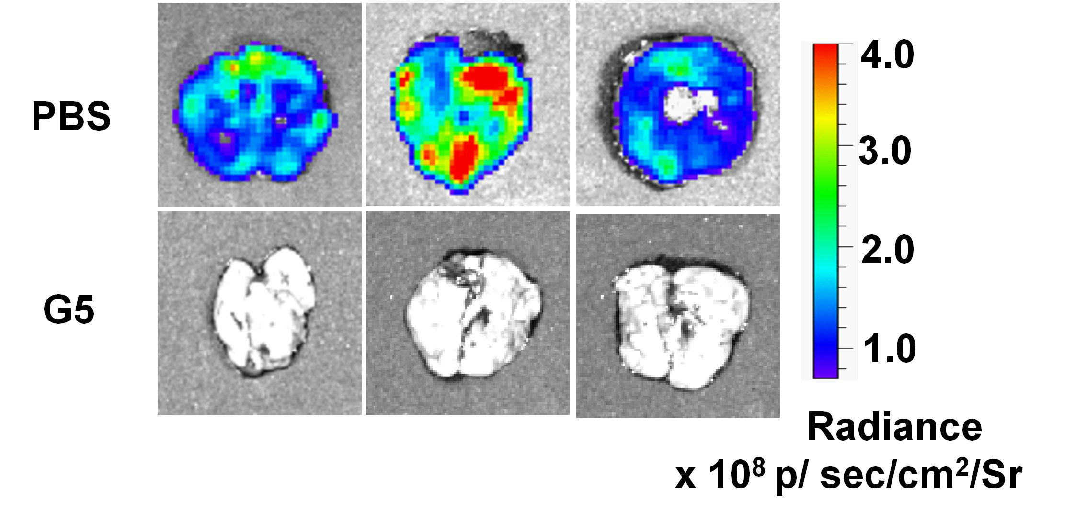
Supplementary Figure 37. Representative bioluminescence images from lungs retrieved from mice after intravenous re-challenge. (G5: RDPNs@diABZIs)

