Supplementary materials for “Historical and future winter chill for temperate fruit and nut trees in Afghanistan”

We projected historical and future winter chill in Afghanistan using long-term daily temperature data from 51 hydrometeorological stations. We used the Dynamic Model for chill quantification, which requires hourly temperature data; therefore, we used the chillR package for the R programming language to process temperature data and apply the Dynamic Model for making chill estimations.
Bias correction
Since the period of observed temperature data was relatively short (2008 to 2020), we used simulated data from 1980 to 2007 from ClimateEngine. We patched the observed data with simulated data to create a continuous dataset from 1980 to 2020. To reduce bias in simulated data and to align it with observed temperature patterns, we applied the QDM method for correcting for biases in daily temperature data for all the stations.
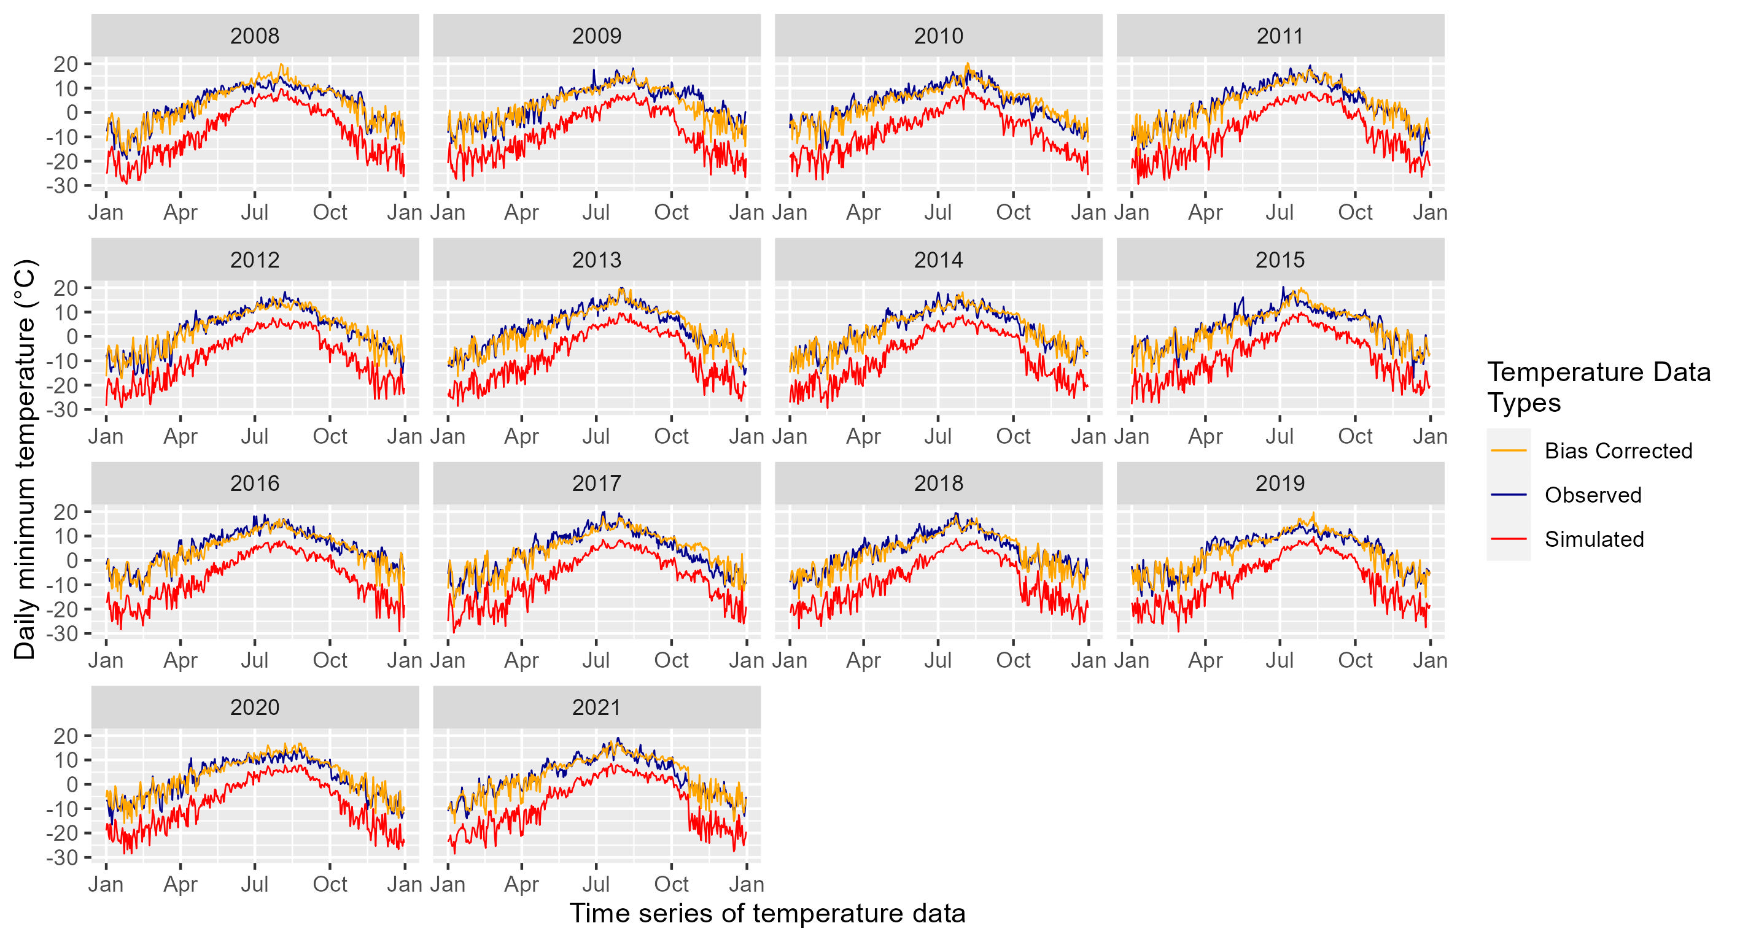Fig. S1 Time series of historical daily minimum temperature data representing the observed, simulated and bias-corrected data from Anjuman station.
For the QDM method, we first compared the observed and simulated data for the period from 2008 to 2020 (the ‘calibration period’). We calculated the inherent bias and then used it to adjust the simulated data to enhance its accuracy relative to observed data. We applied the same bias correction derived from the ‘calibration period’ to correct the historical simulated data (1980 to 2007). We applied this method separately to both long-term daily minimum and maximum temperature data for 51 stations across Afghanistan. Fig. S1 and S2 illustrate the bias correction procedure for the station at Anjuman. Figures for other stations are available online in a public GitHub repository.
(https://github.com/Atifshinwari/Chill_quantification_in_Afghanistan)
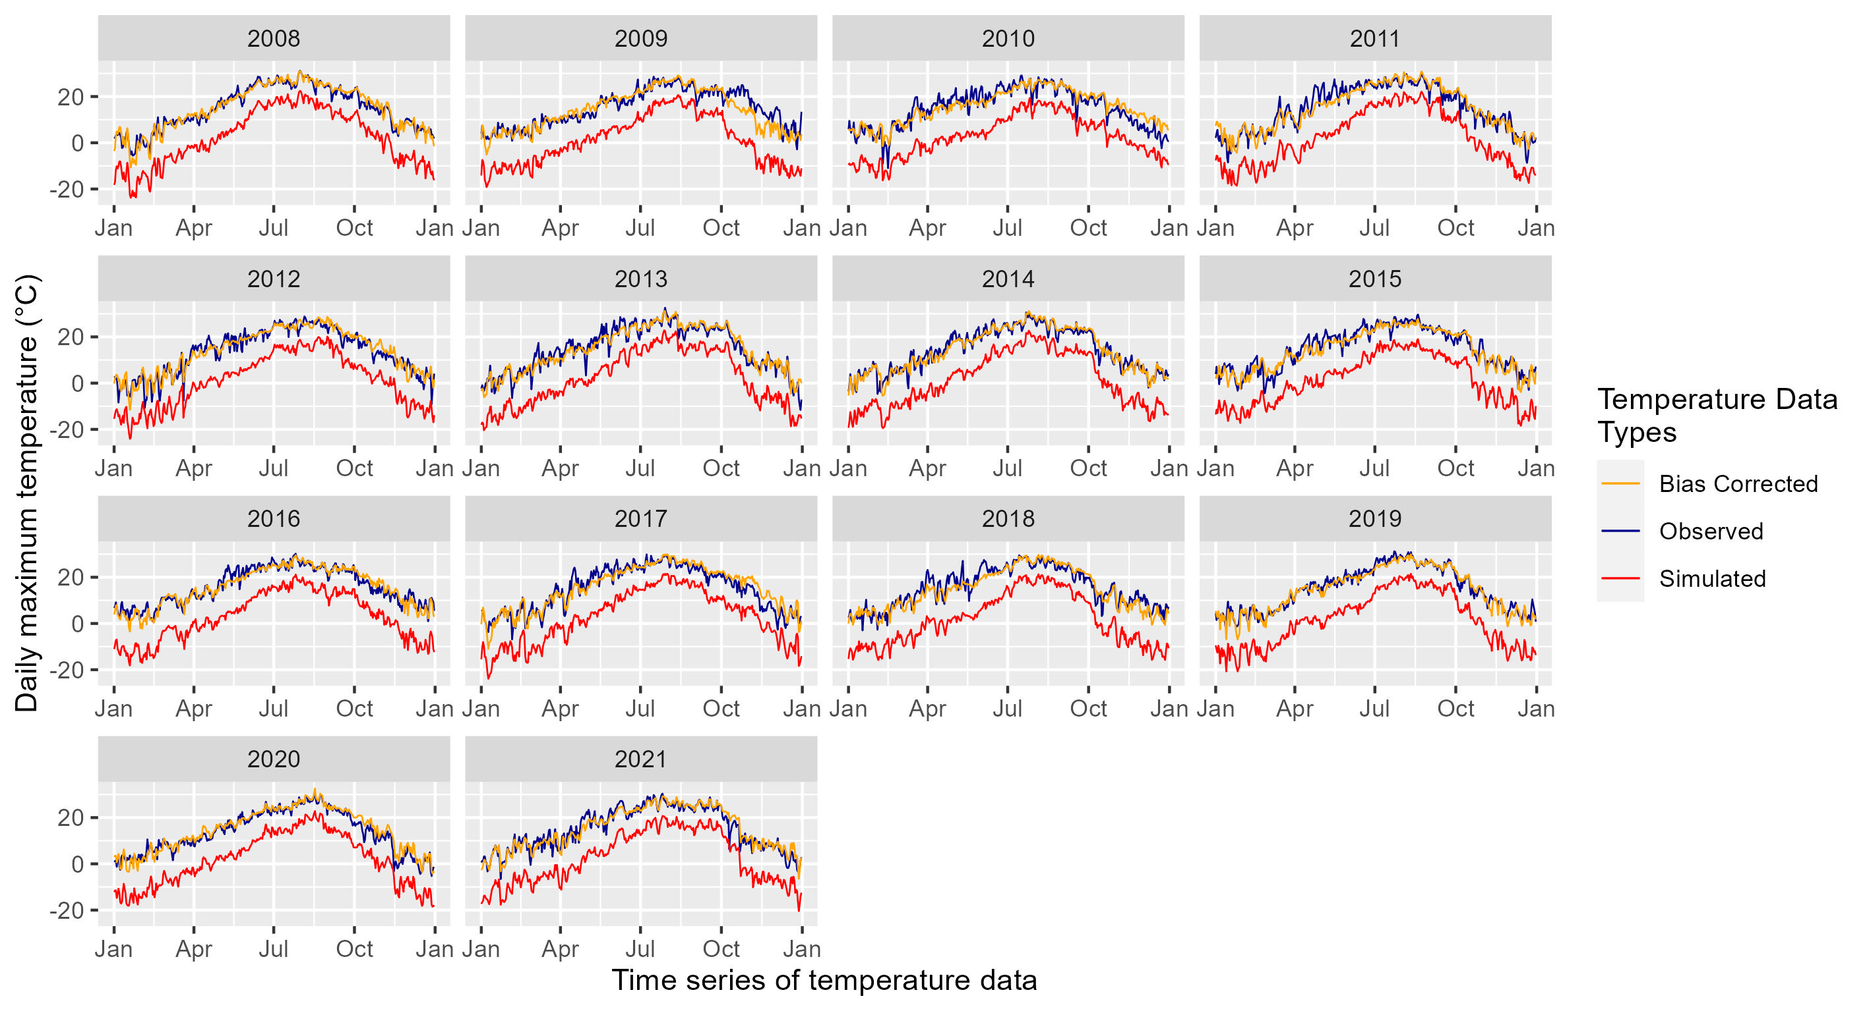Fig. S2 Time series of historical daily minimum temperature data for Anjuman station representing the observed, simulated and bias-corrected data.

Bias correction performance analysis
We evaluated the results of the correction process for all 51 stations using the Root Mean Square Error of Prediction (RMSEP) and the Ratio of Performance to Inter-Quartile distance (RPIQ) before and after bias correction. The results are shown in Fig. S3 and S4.
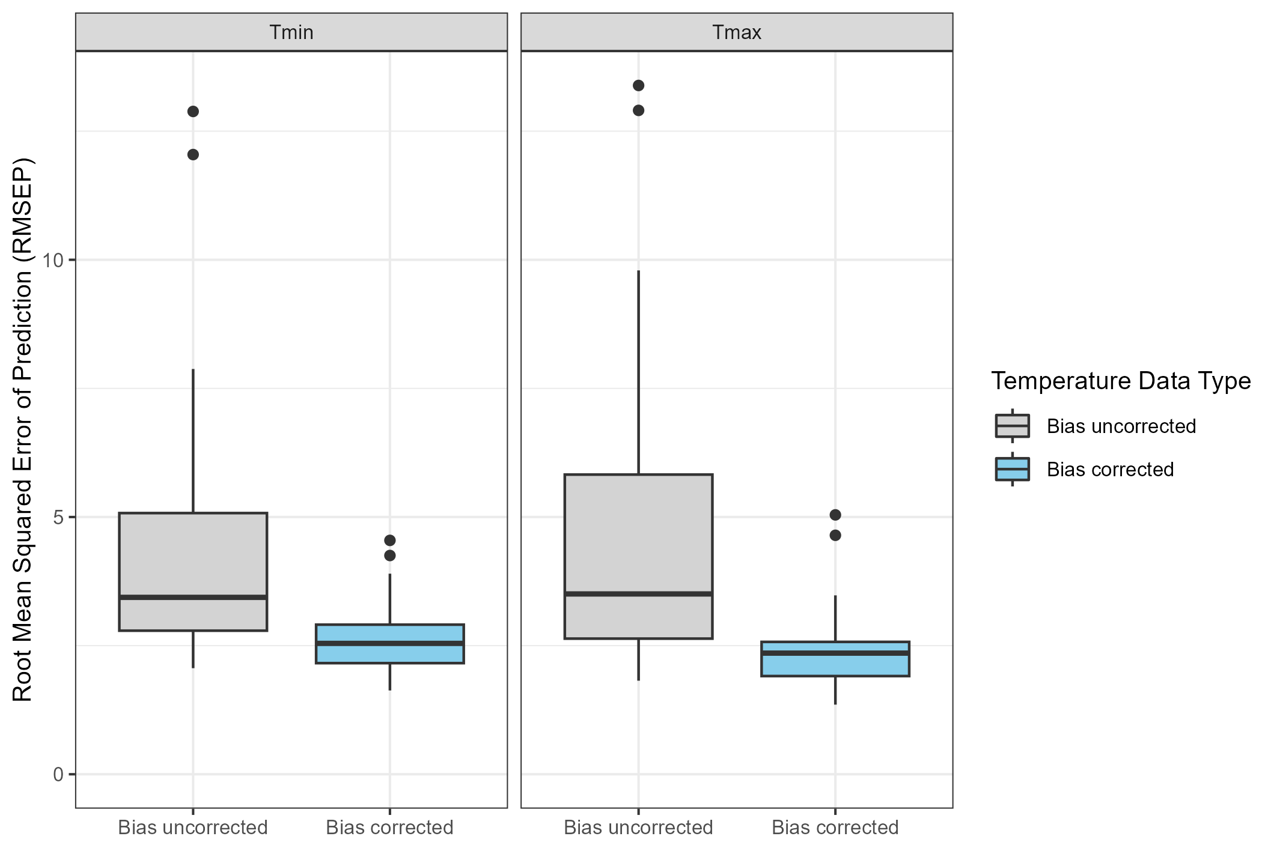
Fig. S3 Root Mean Squared Error of Prediction (RMSEP) before and after bias correction of daily minimum and maximum temperature data for 51 stations.
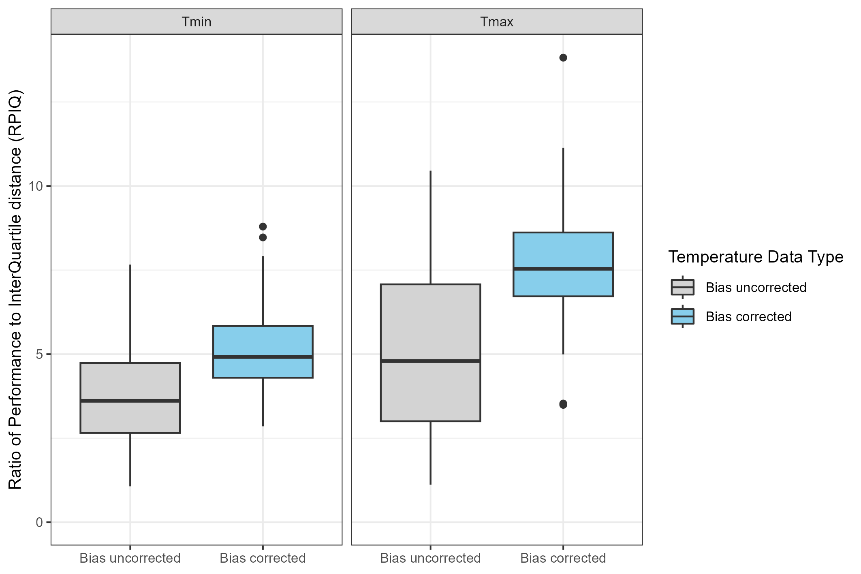
Fig. S4 Ratio of Performance to Inter-Quartile distance (RPIQ) before and after bias correction of daily minimum and maximum temperature data for 51 stations.

Historical and future chill projection
To estimate historical and future chill, we produced 100 synthetic realizations of historical (1980, 1990, 2000, 2010 and 2020) and future scenarios (2035-2065 and 2070-2100) using the RMAWGEN weather generator. For future scenarios, we used four Shared Socioeconomic Pathway (SSP) scenarios (SSP126, SSP245, SSP370, and SSP585) for five General Circulation Models (GCMs) from the Coupled Model Intercomparison Project Phase 6 (CMIP 6). We further calculated Safe Winter Chill (SWC) for both scenarios and timepoints. For better understanding, we documented our results in Tables S1 and S2 separately for historical and future scenarios and also produced chill plots for each station. We divided the stations into six sub-regions including the ‘North’, ‘Northeast’, ‘East’, ‘South’, ‘West’, and ‘Central’ region. This helped in capturing differences in chill change trends across the regions caused by variation in temperature and elevation.
Table S1. Characteristics and trend analysis of Safe Winter Chill (in Chill Portions- CP) for 100 simulated scenarios representing historical climate conditions in 1980 and 2020 and the respective degree of overlap between the simulated chill accumulation distributions. For chill overlap deviation, the + sign indicates that the percentage of simulated chill accumulation totals for 2020 surpasses the range of simulated values for 1980, whereas the - sign indicates that it is below this range.
Sub-regions |  |  |  | Safe Winter Chill (10% quantile) |  | Chill overlap deviation (%) between 1980 and 2020 simulated scenarios
Sub-regions | Station ID | Long. | Lat. | SWC  1980 | SWC  2020 | Chill below  1980 range (2020) | Chill above 1980 range (2020)
North | Qaisar (QSR) | 64.32 | 35.68 | 69 | 75 | 0 | +8
North | Dara-i-Zhwandon (DZN) | 68.07 | 36.17 | 70 | 74 | 0 | +1
North | Rabat-i-Bala (RBA) | 66.96 | 36.58 | 71 | 73 | 0 | +4
North | Tang-i-Tashqurghan (TTN) | 67.70 | 36.66 | 70 | 70 | 1 | -1
North | Chichakto (CCO) | 64.08 | 35.73 | 69 | 73 | 0 | +8
North | Sayad (SYD) | 67.81 | 36.54 | 68 | 71 | 0 | +1
North | Delmarogh (DMH) | 66.72 | 35.96 | 67 | 71 | 0 | +5
North | Nazdik-i-Keshandeh (NKH) | 65.96 | 36.19 | 68 | 72 | 0 | +3
North | Dawlatabad (DBD) | 64.88 | 36.42 | 67 | 69 | 0 | +13
North | Khesht Pul (KPL) | 64.90 | 35.96 | 65 | 68 | 1 | +4
Northeast | Tang-i-Nahrin (TNN) | 69.16 | 36.06 | 70 | 77 | 0 | +6
Northeast | Faizabad (FZD) | 70.56 | 37.11 | 76 | 79 | 0 | +1
Northeast | Baharak (BRK) | 70.89 | 37.00 | 75 | 75 | 0 | +1
Northeast | Pul-i-Bangi (PBI) | 69.21 | 36.73 | 71 | 75 | 0 | 0
Northeast | Khenjan (KJN) | 68.92 | 35.55 | 71 | 75 | 0 | +1
Northeast | Doshi (DSI) | 68.69 | 35.60 | 70 | 73 | 0 | +4
Northeast | Nazdik-i-Taluqan (NTN) | 69.74 | 36.64 | 68 | 72 | 0 | +1
Northeast | Keshem (KSM) | 70.05 | 36.93 | 70 | 73 | 0 | +3
Northeast | Pul-i-Alchin (PAN) | 68.86 | 36.80 | 70 | 72 | 0 | +5
Northeast | Baghlan (BLN) | 68.67 | 36.11 | 69 | 70 | 0 | 0
Northeast | Anjuman (AJN) | 70.68 | 36.02 | 59 | 64 | 0 | +10
Northeast | Eshkashem (EKM) | 71.59 | 36.73 | 37 | 39 | 0 | +1
East | Gardiz (GDZ) | 69.23 | 33.59 | 61 | 69 | 0 | +7
East | Maton (MTN) | 69.08 | 34.83 | 65 | 57 | -1 | 0
East | Asmar (ASR) | 69.00 | 34.69 | 55 | 44 | -41 | +1
East | Nawabad (NBD) | 69.10 | 34.41 | 53 | 39 | -42 | 0
East | Pul-i-Qarghayi (PQI) | 69.94 | 33.35 | 46 | 39 | -21 | 0
East | Pul-i-Behsod (PBD) | 71.12 | 34.82 | 45 | 37 | -2 | 0
East | Dakah (DKH) | 71.20 | 34.92 | 41 | 35 | -6 | +1
South | Tirin (TRN) | 69.66 | 35.28 | 69 | 69 | 0 | 0
South | Nazdik-i-Kandahar (NKR) | 70.46 | 34.44 | 60 | 55 | -21 | 0
South | Lashkargah (LGH) | 71.04 | 34.23 | 56 | 49 | -14 | 1
South | Darwishan (DSN) | 70.24 | 34.55 | 49 | 39 | -15 | 0
West | Tagab-i-Ghaza (TGA) | 62.06 | 32.36 | 67 | 77 | 0 | +10
West | Adraskan (ADN) | 64.35 | 31.58 | 69 | 71 | 0 | +4
West | Pul-i-Hashemi (PHI) | 65.58 | 31.62 | 66 | 67 | 0 | +1
West | Torghundi (TGI) | 62.26 | 33.64 | 65 | 66 | 0 | +3
West | Farah (FRH) | 64.19 | 31.13 | 49 | 42 | -15 | 0
Central | Estalef (ETF) | 68.42 | 33.56 | 74 | 79 | 0 | +2
Central | Bagh-i-Omomi (BOI) | 65.87 | 32.63 | 71 | 78 | 0 | +2
Central | Tang-i-Sayedan (TSN) | 65.75 | 34.55 | 75 | 77 | 0 | +2
Central | Dashte-i-Safid (DSD) | 63.76 | 34.34 | 71 | 75 | 0 | +2
Central | Shakardara (SDA) | 65.25 | 34.52 | 65 | 70 | 0 | +7
Central | Pul-i-Ghazni (PGI) | 67.91 | 35.32 | 65 | 68 | 0 | 0
Central | Keraman (KRN) | 69.29 | 35.15 | 63 | 66 | 0 | +3
Central | Cheghcheran (CCN) | 66.99 | 34.74 | 51 | 61 | 0 | +16
Central | Bamyan (BYN) | 61.94 | 34.34 | 56 | 60 | 0 | +3
Central | Dawlatyar (DYR) | 66.92 | 34.23 | 48 | 54 | 0 | +3
Central | Nazdik-i-Nayak (NNK) | 62.28 | 35.25 | 43 | 49 | 0 | +2
Central | Waras (WRS) | 67.83 | 34.82 | 36 | 42 | 0 | +6
Central | Gardandiwal (GDL) | 68.21 | 34.50 | 23 | 27 | -1 | +1

Table S2. Summary of Safe Winter Chill (SWC) for all future Shared Socioeconomic Pathway (SSP) scenarios and two-time points (2050 and 2085) for 51 weather stations. Long. and Lat. represent the longitude and latitude of each station’s location, respectively. A ˄ sign represents the highest chill value whereas a ˅ sign represents the lowest chill value estimated for their respective SSP scenario and timepoint.
Sub-  regions |  |  |  | 2050 SWC (CP) |  |  |  | 2085 SWC (CP)
Sub-  regions | Station ID | Long. | Lat. | SSP126 | SSP245 | SSP  370 | SSP  585 | SSP  126 | SSP  245 | SSP  370 | SSP  585
North | Qaisar (QSR) | 64.32 | 35.68 | 70 | 71 | 71 | 69 | 68 | 72 | 67 | 67
North | Dara-i-Zhwandon (DZN) | 68.07 | 36.17 | 69 | 71 | 70 | 70 | 68 | 71 | 64 | 64
North | Rabat-i-Bala (RBA) | 66.96 | 36.58 | 66 | 66 | 65 | 65 | 66 | 65 | 57 | 56
North | Tang-i-Tashqurghan (TTN) | 67.70 | 36.66 | 64 | 63 | 60 | 61 | 63 | 59 | 50 | 50
North | Chichakto (CCO) | 64.08 | 35.73 | 65 | 66 | 65 | 66 | 65 | 65 | 59 | 57
North | Sayad (SYD) | 67.81 | 36.54 | 67 | 68 | 67 | 68 | 67 | 68 | 62 | 61
North | Delmarogh (DMH) | 66.72 | 35.96 | 66 | 68 | 66 | 66 | 66 | 67 | 62 | 62
North | Nazdik-i-Keshandeh (NKH) | 65.96 | 36.19 | 66 | 66 | 63 | 65 | 66 | 64 | 60 | 58
North | Dawlatabad (DBD) | 64.88 | 36.42 | 62 | 63 | 60 | 62 | 63 | 61 | 56 | 54
North | Khesht Pul (KPL) | 64.90 | 35.96 | 61 | 61 | 59 | 60 | 61 | 60 | 54 | 53
Northeast | Tang-i-Nahrin (TNN) | 69.16 | 36.06 | 69 | 70 | 69 | 69 | 68 | 70 | 62 | 62
Northeast | Faizabad (FZD) | 70.56 | 37.11 | 71 | 73 | 73 | 72 | 72 | 73 | 66 | 66
Northeast | Baharak (BRK) | 70.89 | 37.00 | 73 | 75 | 75 | 74˄ | 73 | 75 | 71 | 71
Northeast | Pul-i-Bangi (PBI) | 69.21 | 36.73 | 69 | 71 | 68 | 69 | 68 | 68 | 61 | 59
Northeast | Khenjan (KJN) | 68.92 | 35.55 | 68 | 70 | 67 | 68 | 68 | 68 | 61 | 61
Northeast | Doshi (DSI) | 68.69 | 35.60 | 64 | 64 | 61 | 63 | 64 | 62 | 54 | 54
Northeast | Nazdik-i-Taluqan (NTN) | 69.74 | 36.64 | 65 | 67 | 64 | 64 | 66 | 65 | 58 | 57
Northeast | Keshem (KSM) | 70.05 | 36.93 | 67 | 68 | 66 | 66 | 66 | 66 | 58 | 58
Northeast | Pul-i-Alchin (PAN) | 68.86 | 36.80 | 66 | 67 | 64 | 65 | 66 | 65 | 57 | 54
Northeast | Baghlan (BLN) | 68.67 | 36.11 | 65 | 65 | 63 | 65 | 64 | 64 | 57 | 56
Northeast | Anjuman (AJN) | 70.68 | 36.02 | 65 | 67 | 69 | 66 | 64 | 71 | 74 | 74
Northeast | Eshkashem (EKM) | 71.59 | 36.73 | 44 | 46 | 48 | 46 | 45 | 51 | 55 | 55
East | Gardiz (GDZ) | 69.23 | 33.59 | 65 | 69 | 68 | 67 | 66 | 70 | 69 | 69
East | Maton (MTN) | 69.94 | 33.35 | 55 | 54 | 49 | 50 | 55 | 46 | 34 | 33
East | Asmar (ASR) | 71.20 | 34.92 | 44 | 41 | 35 | 38 | 44 | 29 | 20 | 18
East | Nawabad (NBD) | 71.12 | 34.82 | 43 | 40 | 33 | 35 | 42 | 27 | 18 | 17
East | Pul-i-Qarghayi (PQI) | 70.24 | 34.55 | 37 | 34 | 28 | 32 | 37 | 25 | 17 | 16
East | Pul-i-Behsod (PBD) | 70.46 | 34.44 | 34 | 31 | 25 | 27 | 33 | 19 | 12 | 11
East | Dakah (DKH) | 71.04 | 34.23 | 30˅ | 28˅ | 23˅ | 24˅ | 29˅ | 17˅ | 11˅ | 10˅
South | Tirin (TRN) | 65.87 | 32.63 | 65 | 64 | 61 | 62 | 64 | 60 | 52 | 51
South | Nazdik-i-Kandahar (NKR) | 65.58 | 31.62 | 51 | 51 | 48 | 47 | 51 | 44 | 37 | 33
South | Lashkargah (LGH) | 64.35 | 31.58 | 45 | 45 | 41 | 41 | 46 | 37 | 29 | 26
South | Darwishan (DSN) | 64.19 | 31.13 | 40 | 37 | 33 | 33 | 39 | 29 | 22 | 20
West | Tagab-i-Ghaza (TGA) | 63.76 | 34.34 | 68 | 68 | 67 | 67 | 67 | 67 | 60 | 59
West | Adraskan (ADN) | 62.26 | 33.64 | 64 | 64 | 61 | 62 | 64 | 61 | 53 | 51
West | Pul-i-Hashemi (PHI) | 61.94 | 34.34 | 61 | 62 | 58 | 60 | 61 | 59 | 52 | 49
West | Torghundi (TGI) | 62.28 | 35.25 | 62 | 63 | 60 | 62 | 63 | 61 | 57 | 55
West | Farah (FRH) | 62.06 | 32.36 | 39 | 39 | 33 | 35 | 40 | 31 | 23 | 22
Central | Estalef (ETF) | 69.08 | 34.83 | 74˄ | 78˄ | 76˄ | 74˄ | 74˄ | 78˄ | 70 | 71
Central | Bagh-i-Omomi (BOI) | 69.29 | 35.15 | 69 | 70 | 68 | 69 | 69 | 68 | 60 | 59
Central | Tang-i-Sayedan (TSN) | 69.10 | 34.41 | 73 | 76 | 74 | 72 | 73 | 76 | 68 | 68
Central | Dashte-i-Safid (DSD) | 67.91 | 35.32 | 70 | 73 | 71 | 71 | 70 | 72 | 67 | 66
Central | Shakardara (SDA) | 69.00 | 34.69 | 70 | 74 | 73 | 71 | 70 | 75 | 75 | 73
Central | Pul-i-Ghazni (PGI) | 68.42 | 33.56 | 68 | 71 | 70 | 69 | 68 | 72 | 70 | 70
Central | Keraman (KRN) | 69.66 | 35.28 | 68 | 71 | 72 | 69 | 68 | 74 | 77˄ | 75˄
Central | Cheghcheran (CCN) | 65.25 | 34.52 | 60 | 63 | 63 | 62 | 61 | 64 | 65 | 66
Central | Bamyan (BYN) | 67.83 | 34.82 | 62 | 64 | 65 | 63 | 62 | 67 | 67 | 67
Central | Dawlatyar (DYR) | 65.75 | 34.55 | 57 | 58 | 60 | 59 | 57 | 61 | 63 | 63
Central | Nazdik-i-Nayak (NNK) | 66.99 | 34.74 | 52 | 55 | 56 | 54 | 53 | 59 | 62 | 61
Central | Waras (WRS) | 66.92 | 34.23 | 44 | 47 | 47 | 45 | 45 | 50 | 53 | 52
Central | Gardandiwal (GDL) | 68.21 | 34.50 | 34 | 35 | 38 | 37 | 34 | 39 | 47 | 47

Chill projection plots
To capture the trend of chill change over time and notice the variation in chill estimation among General Circulation Models (GCMs), we produced combined plots for both historical and future chill projections. We observed a general increase of chill in the highlands mainly in the central and northeastern regions and a decrease in the lowlands mainly in the eastern and southern plains. Therefore, we classified chill projection plots for all stations based on the sub-regions.
Northern region
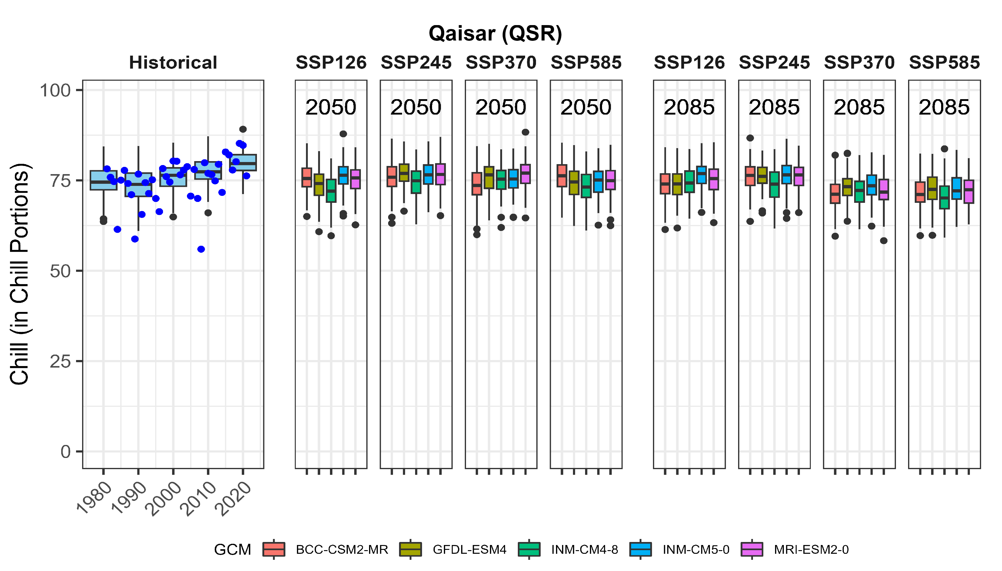
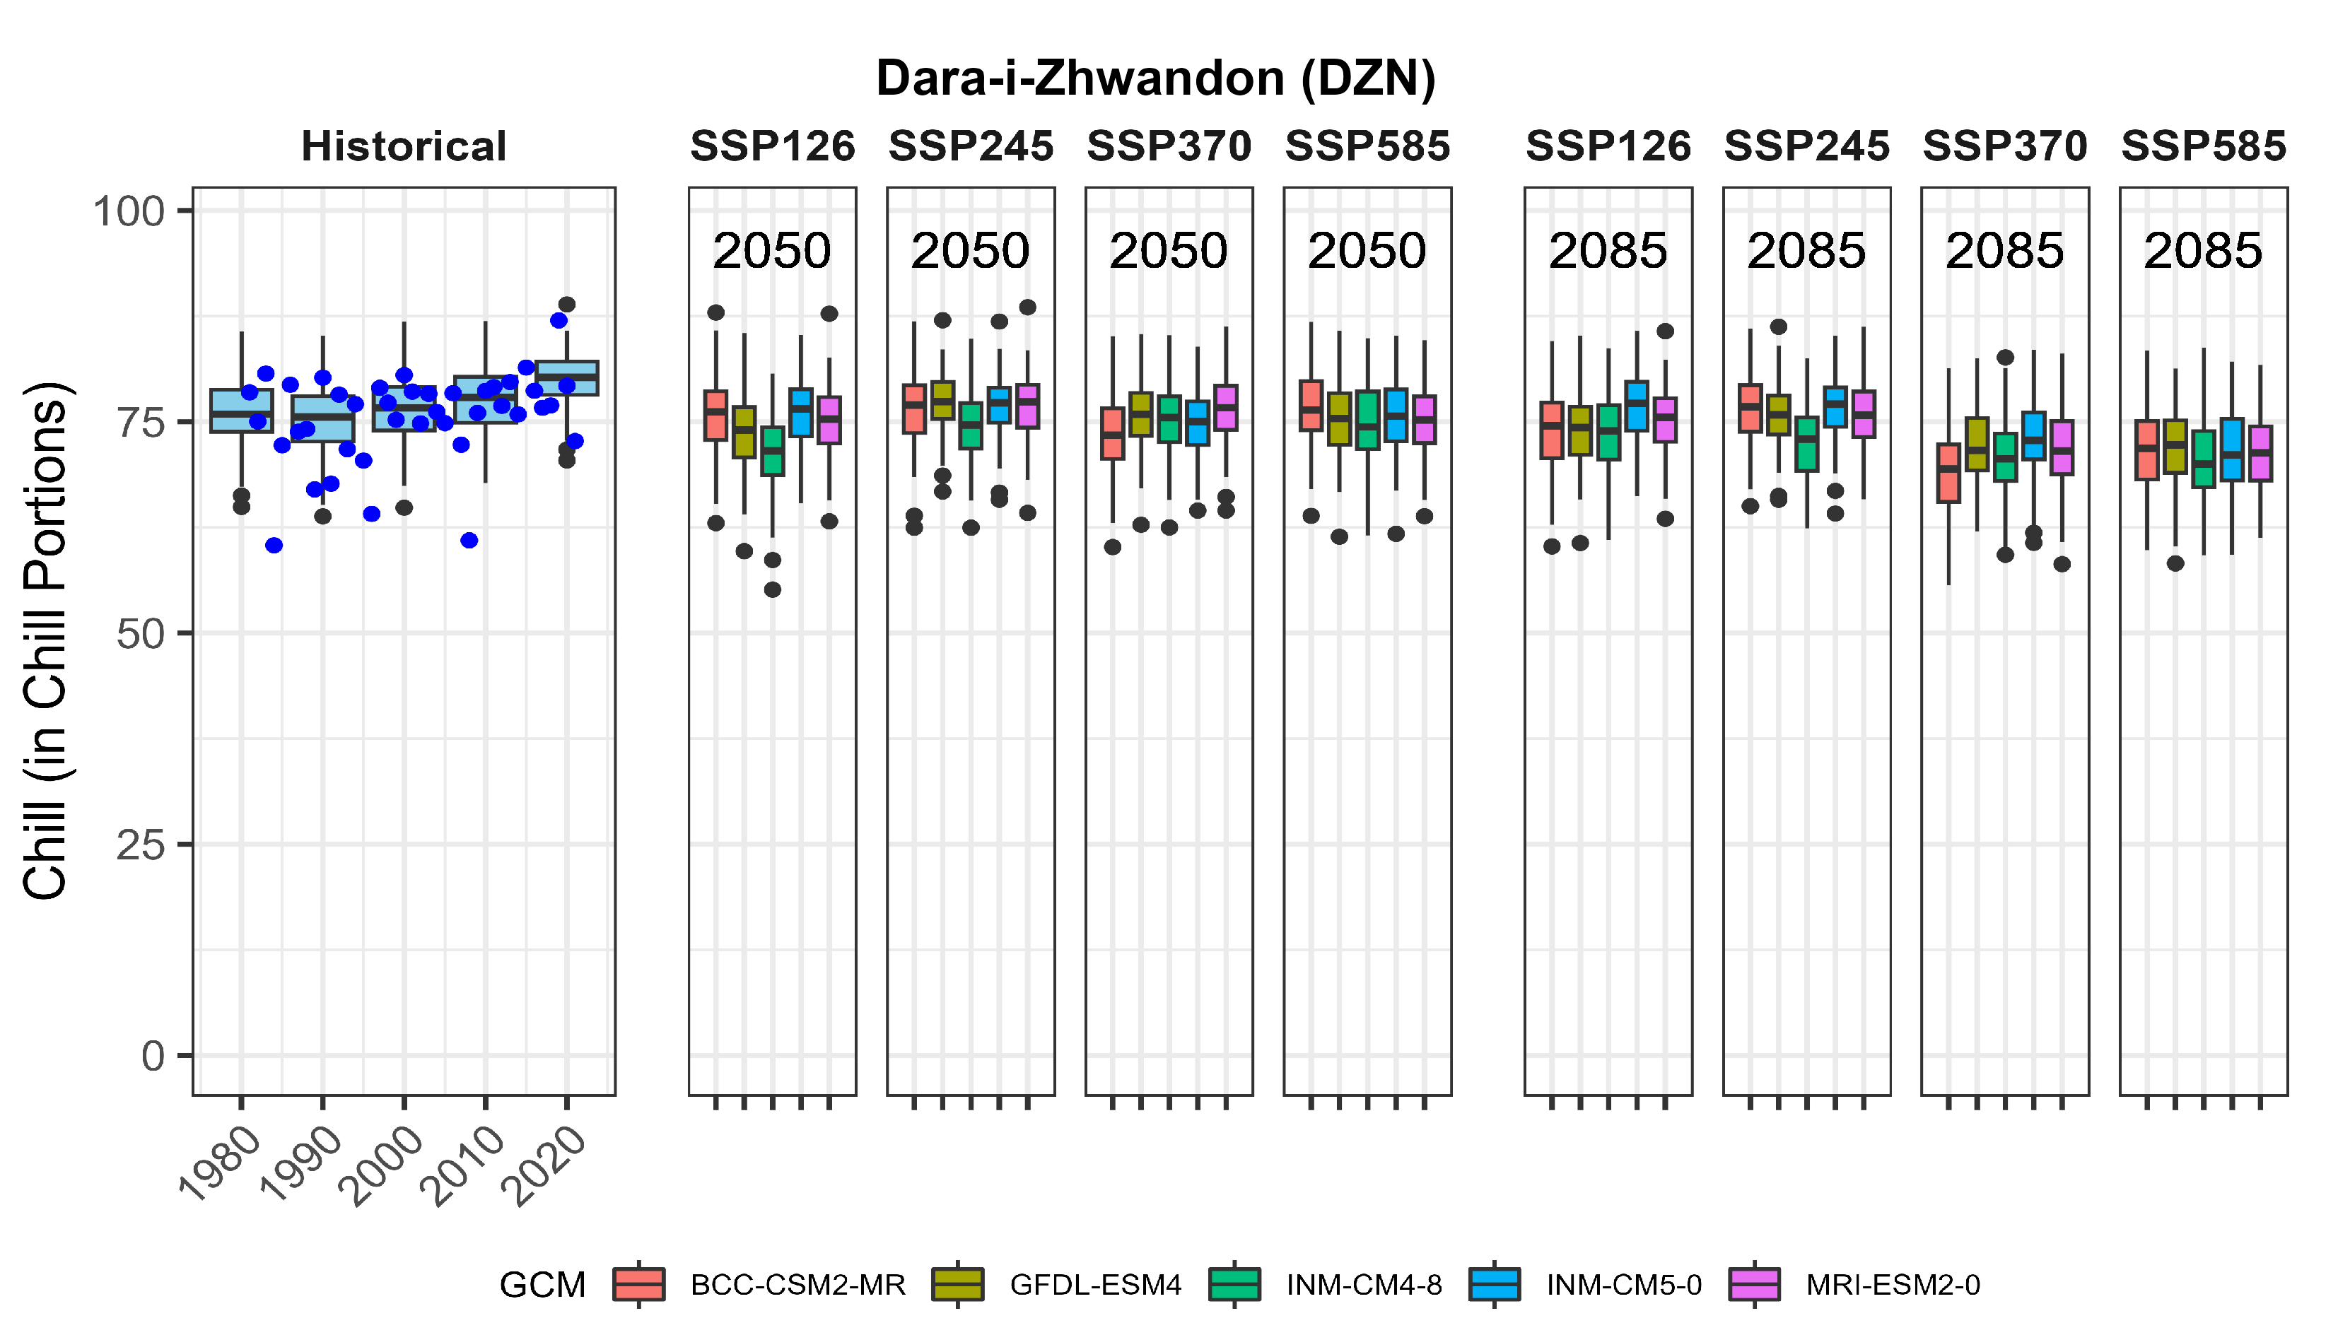
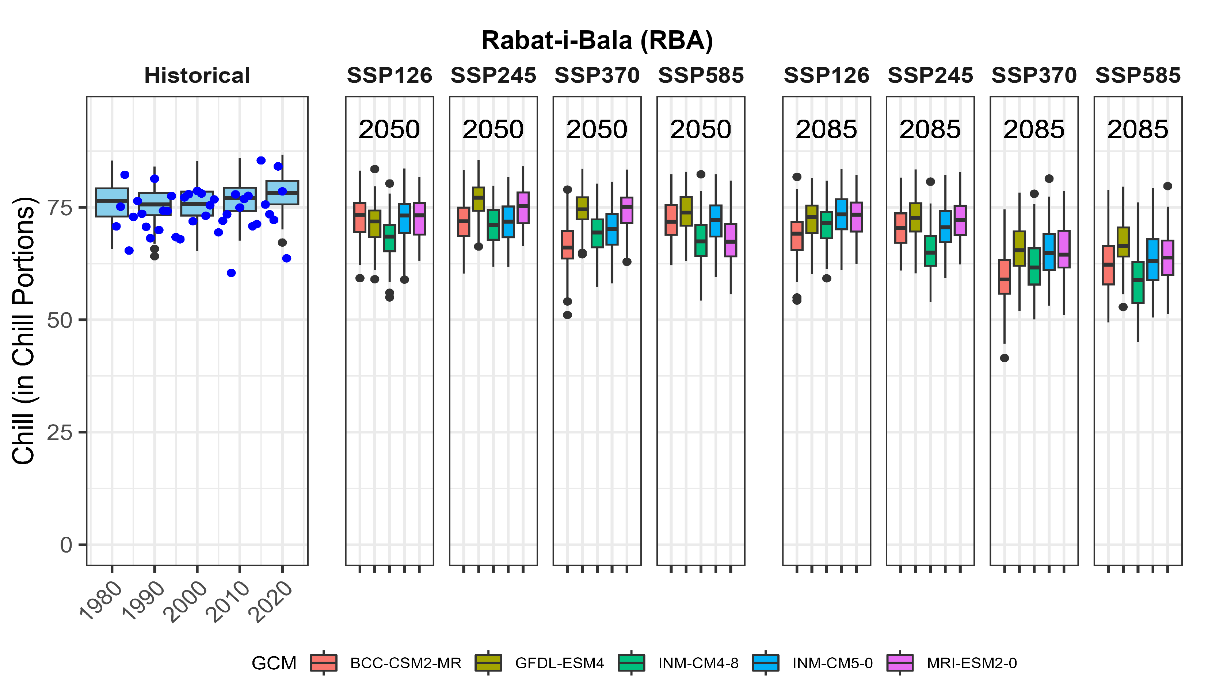
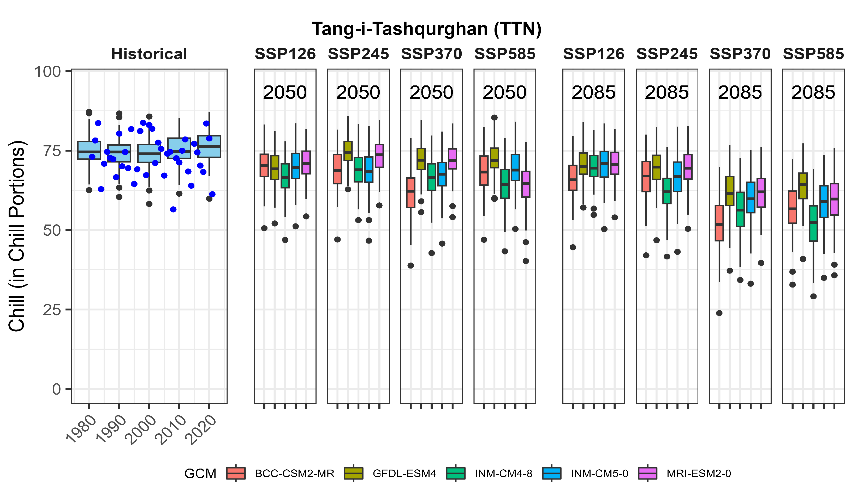
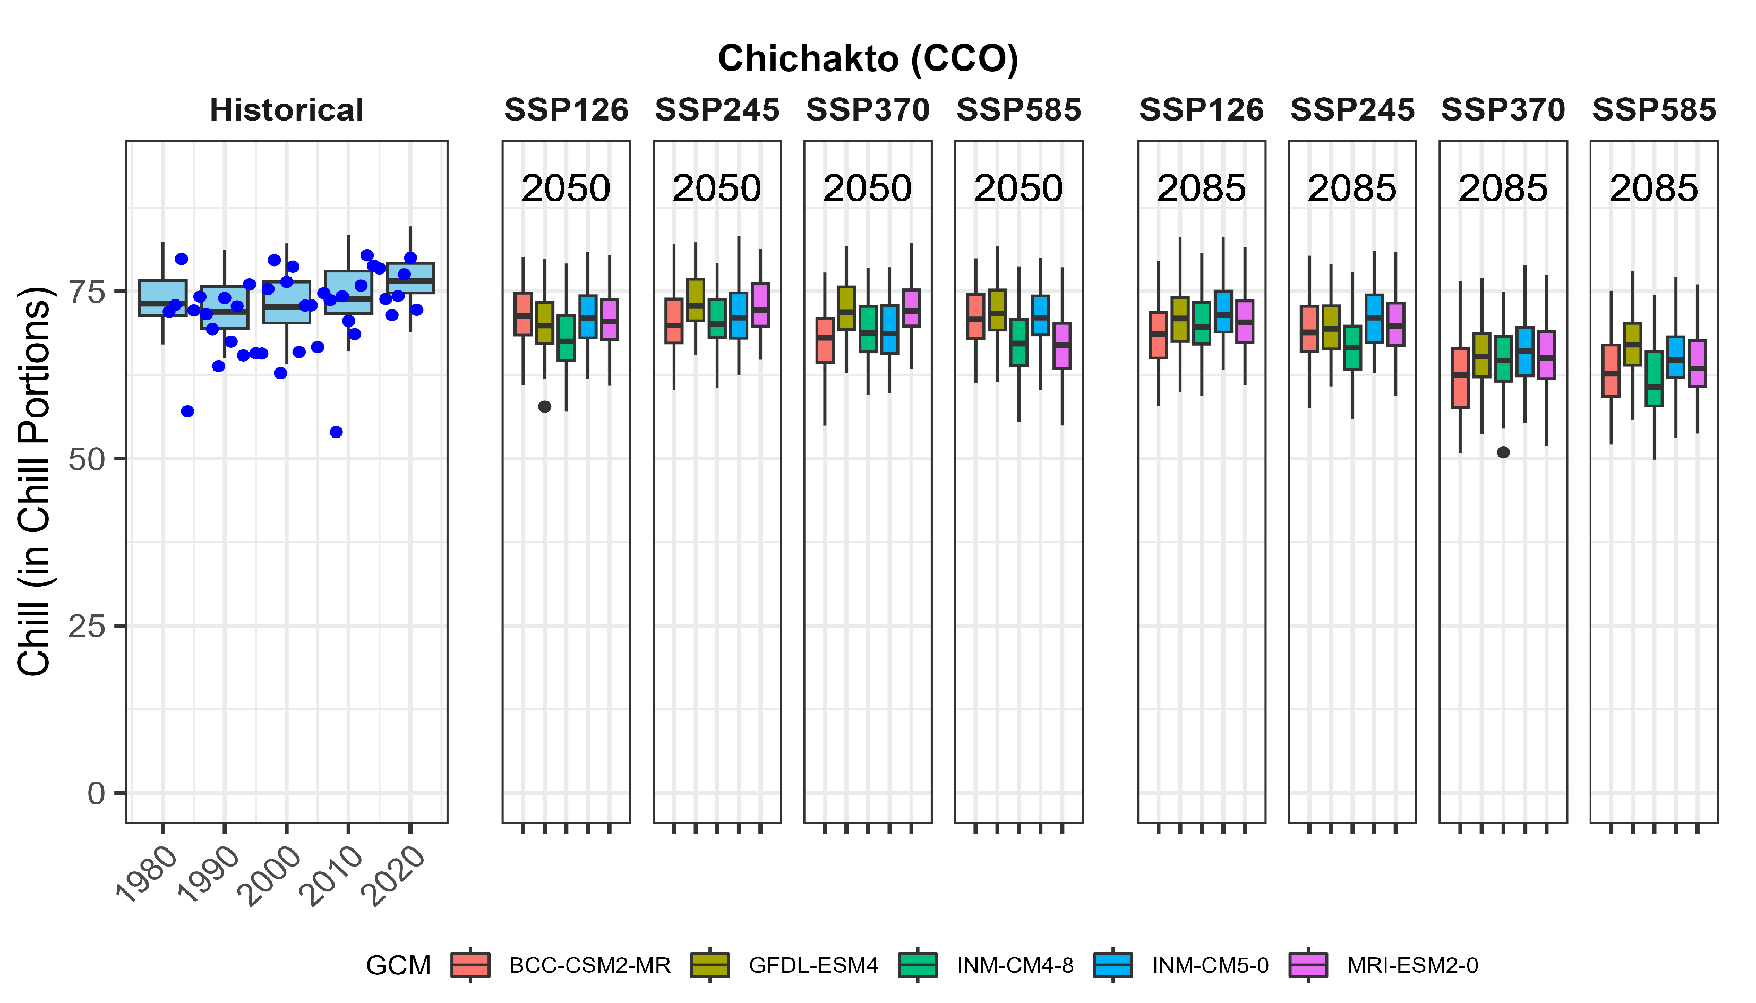
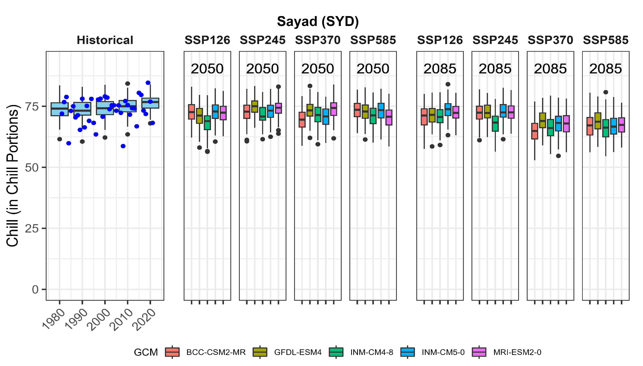
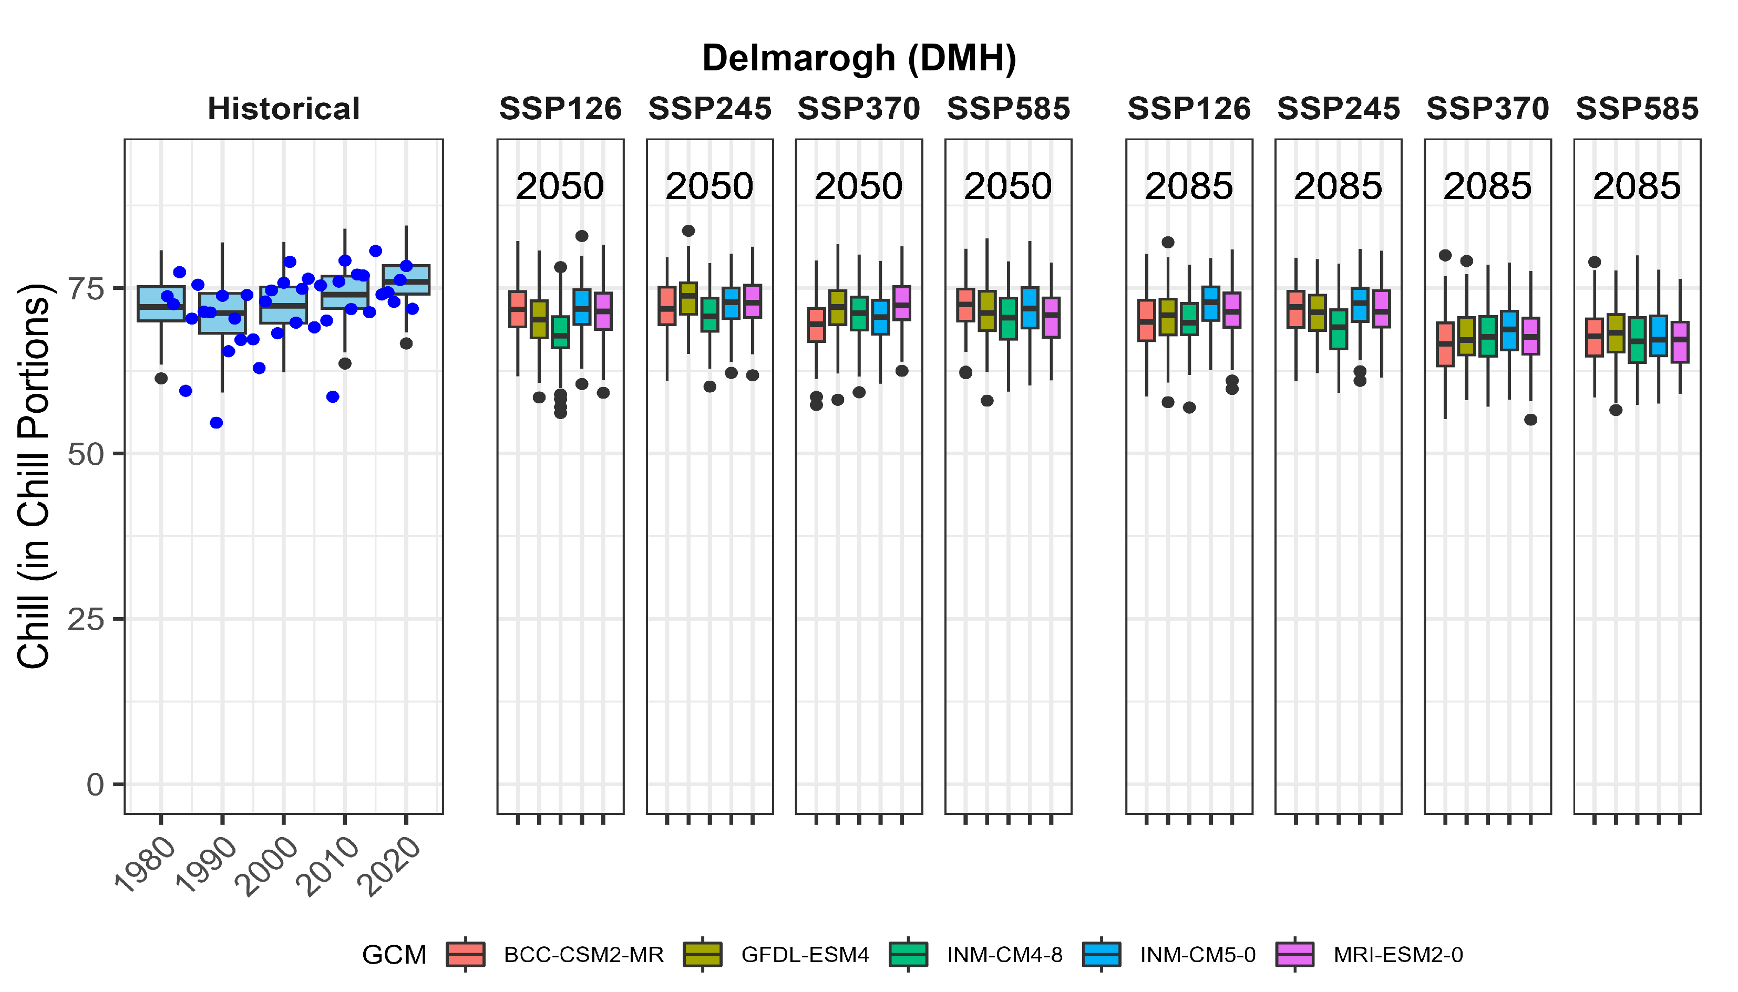
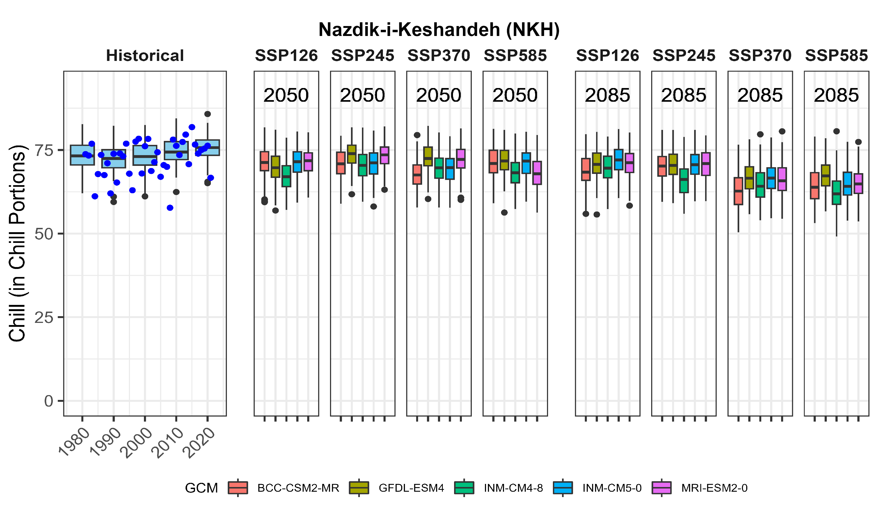
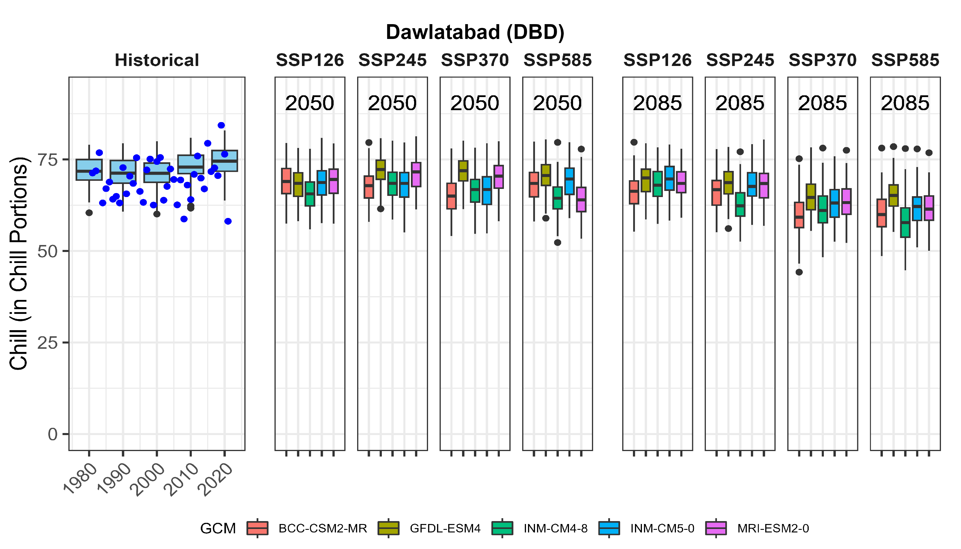
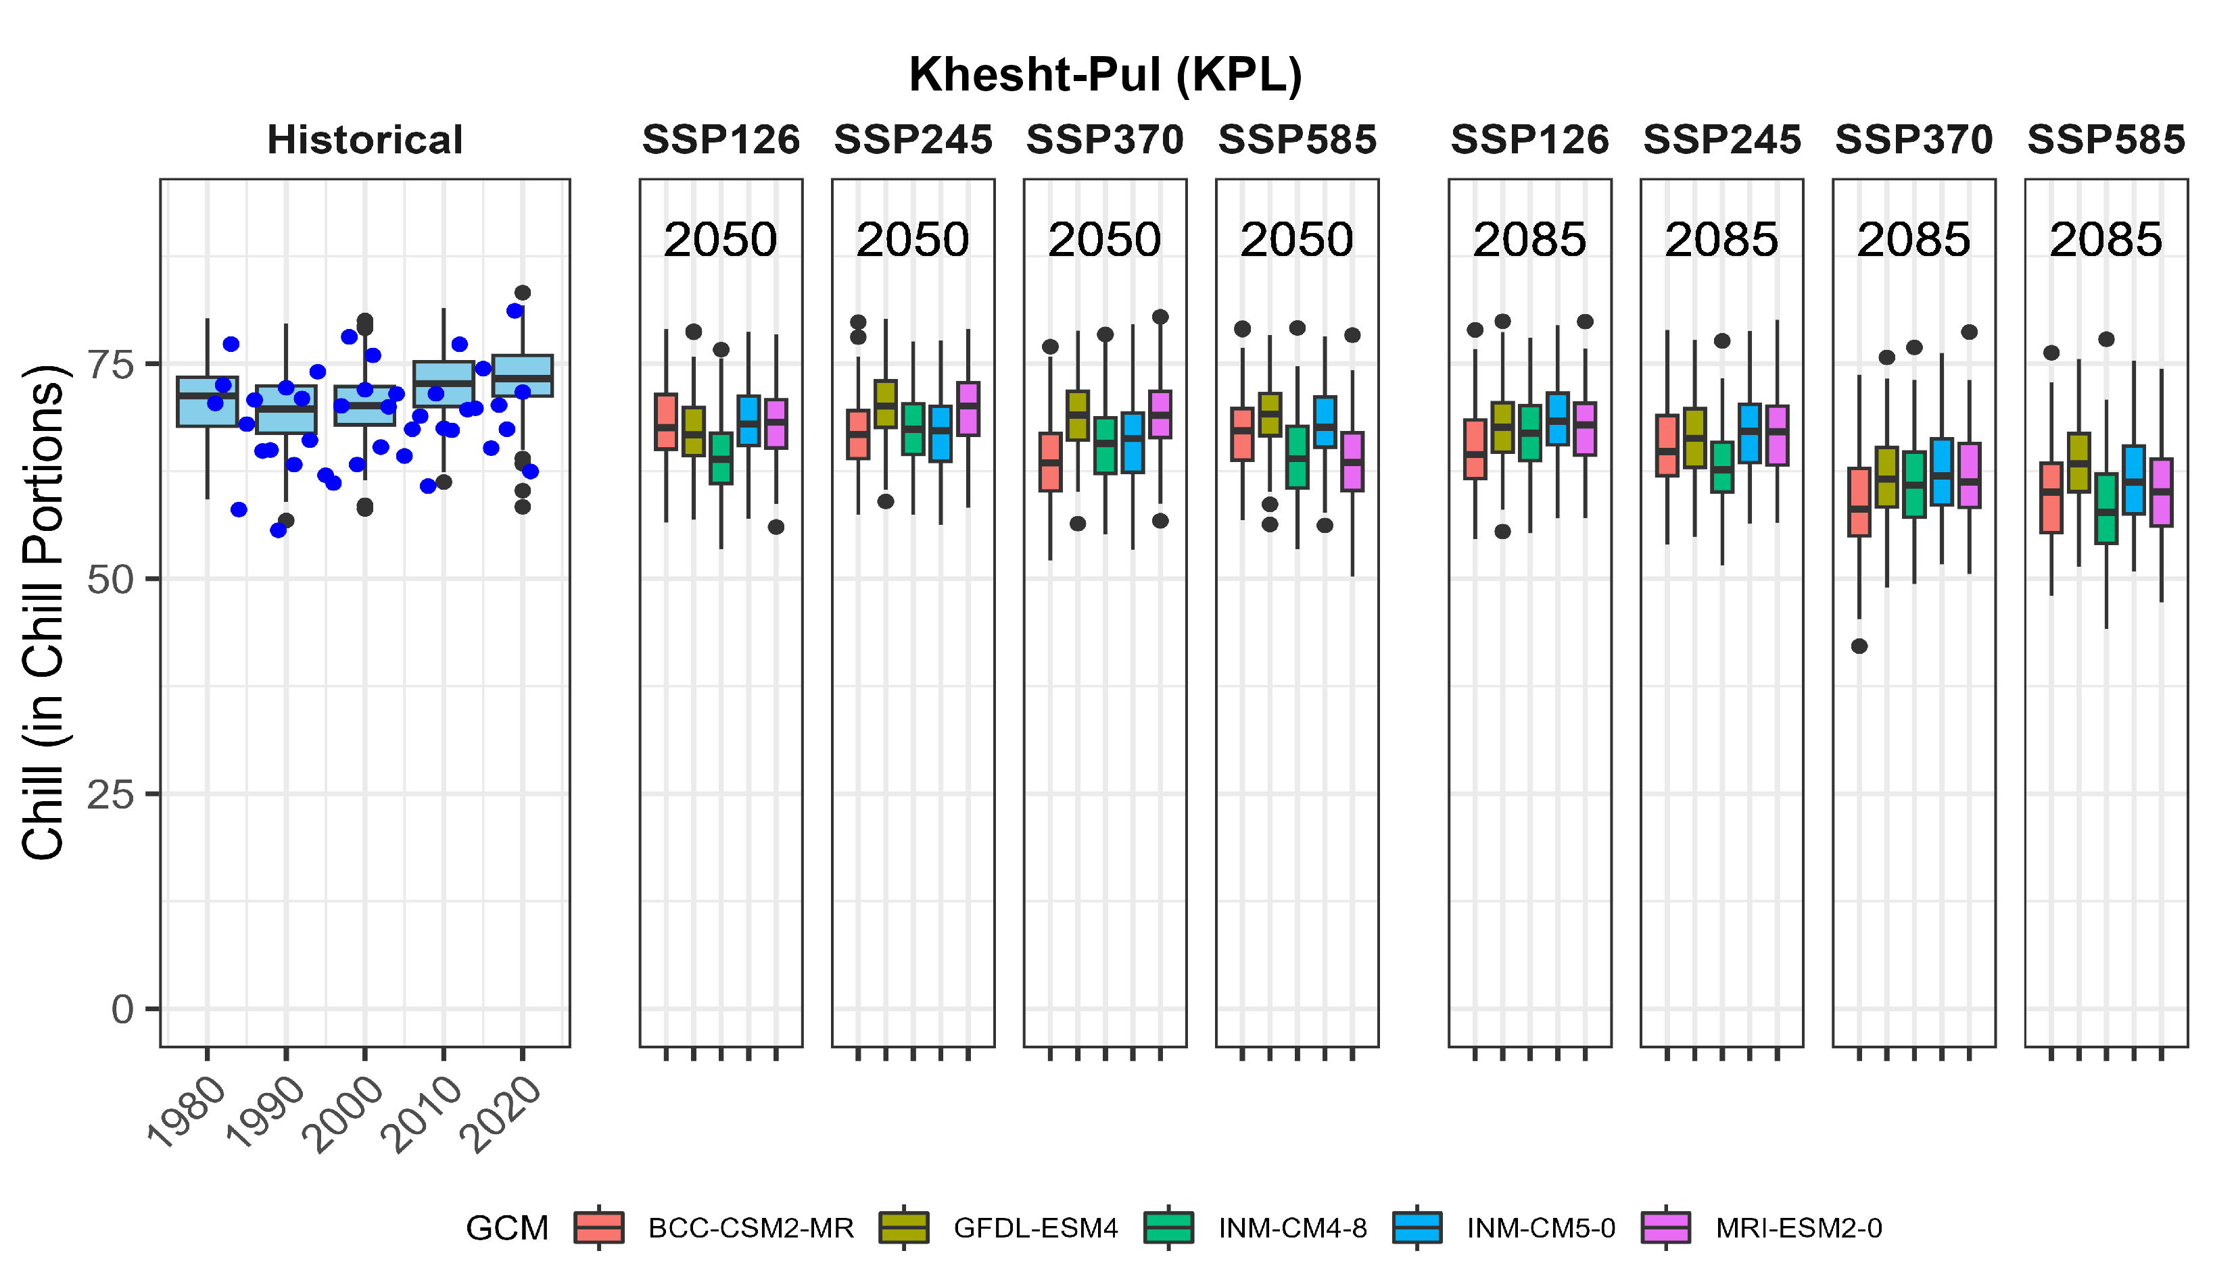

Northeastern region
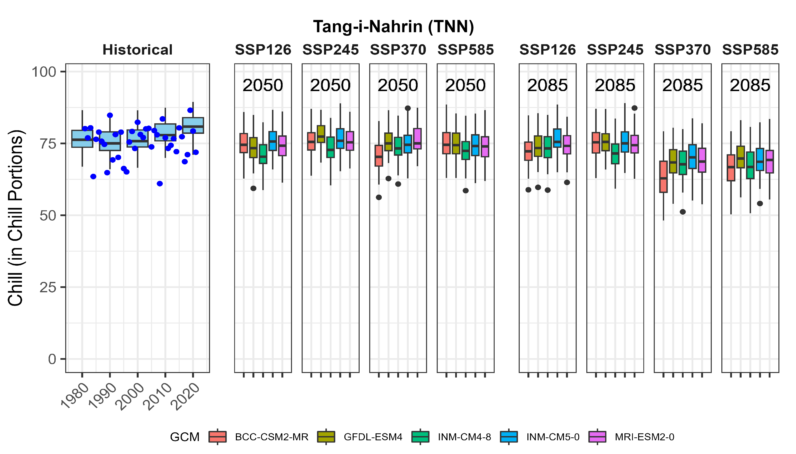
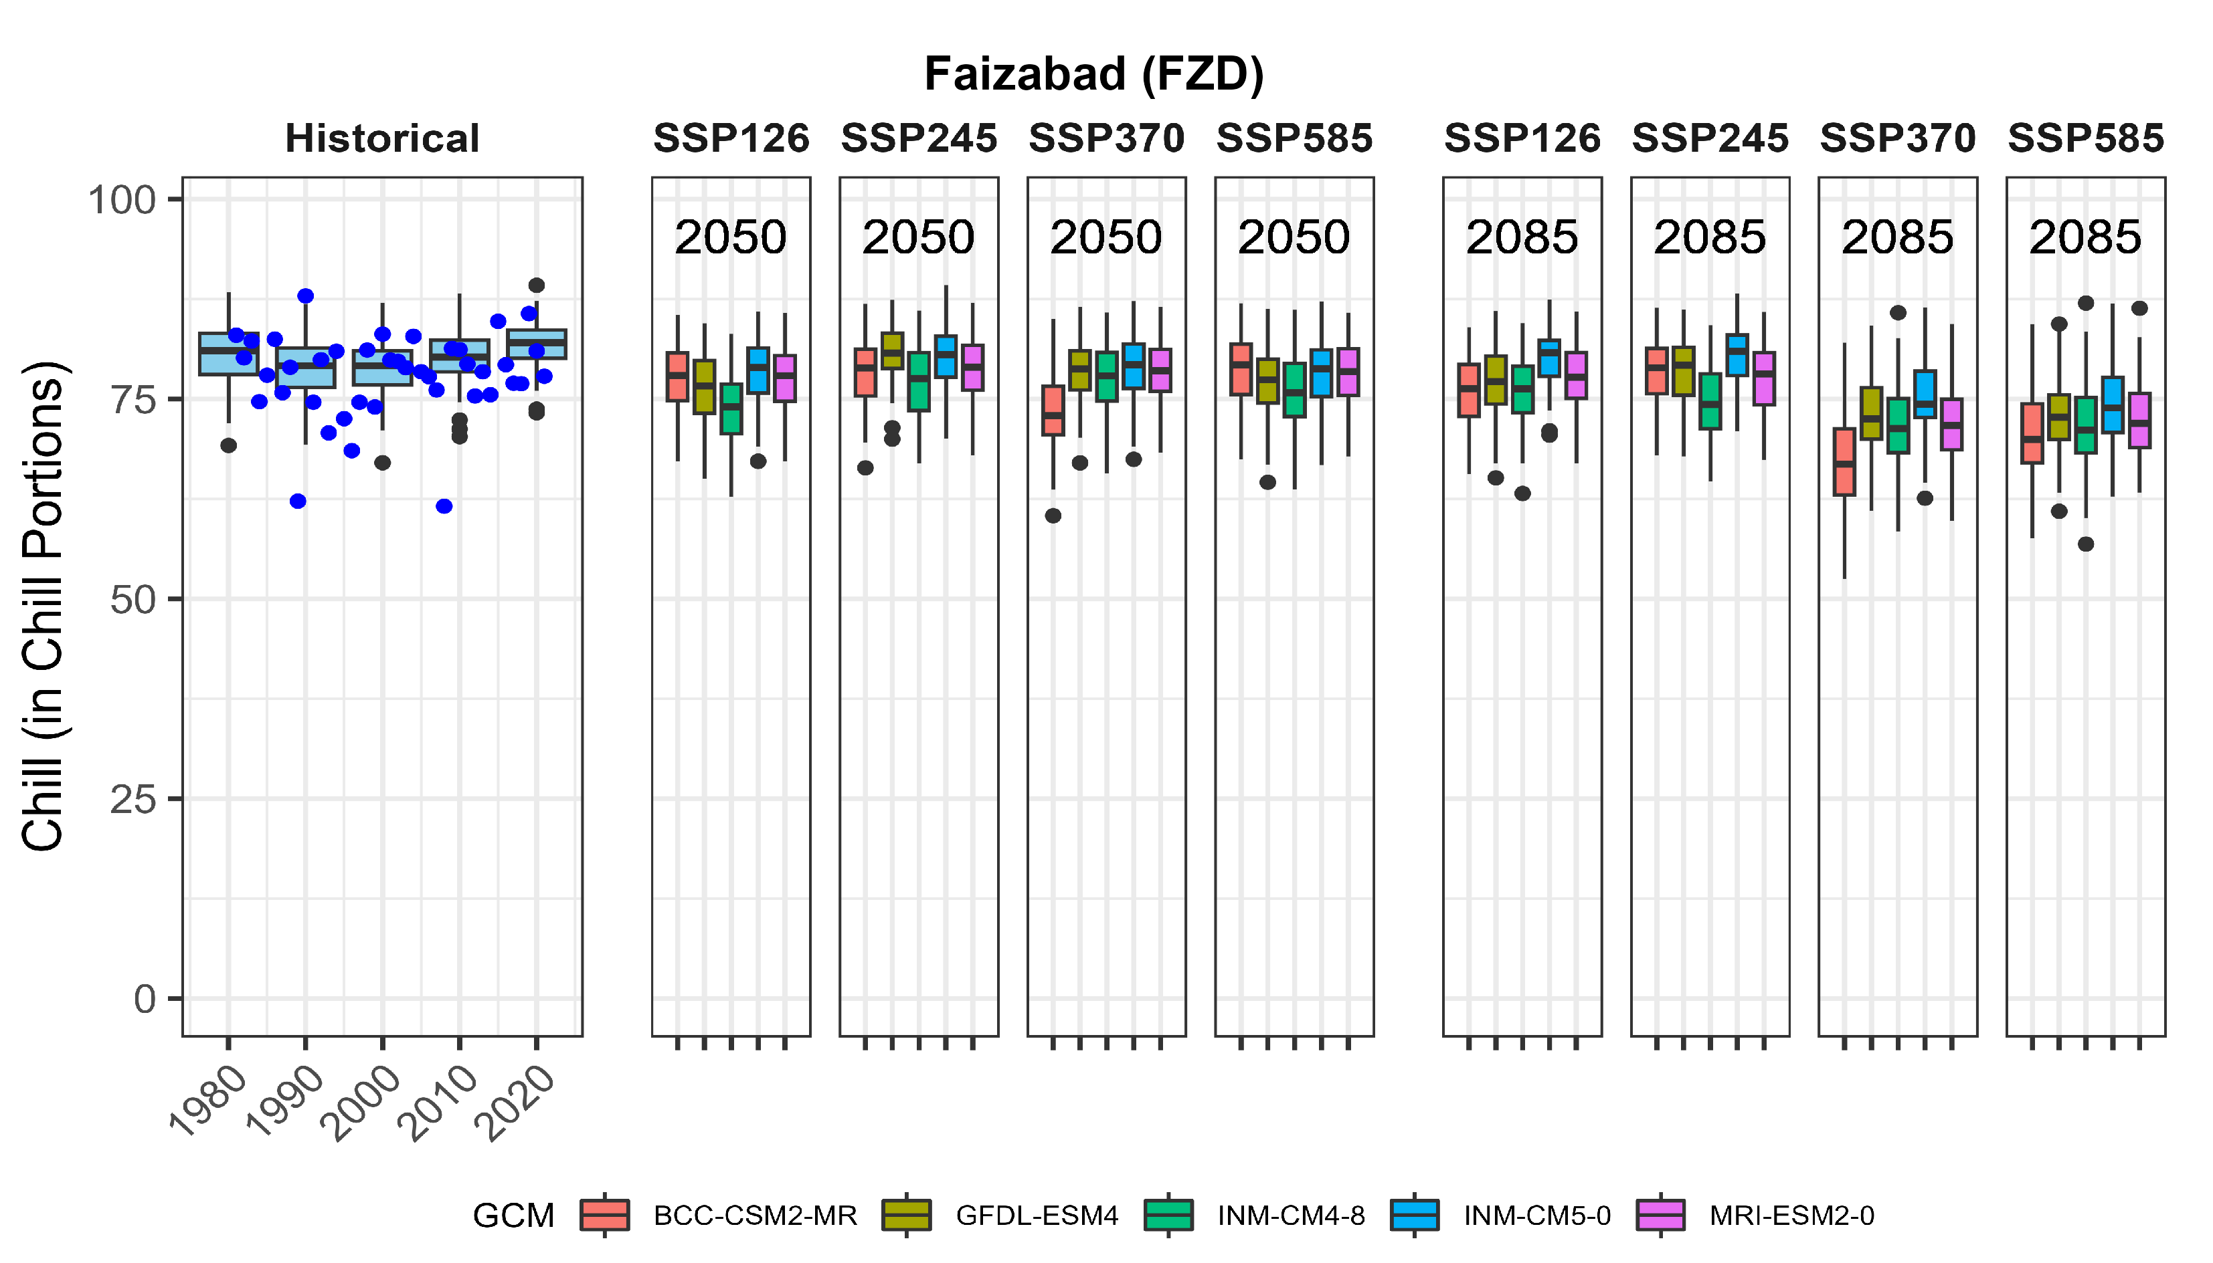
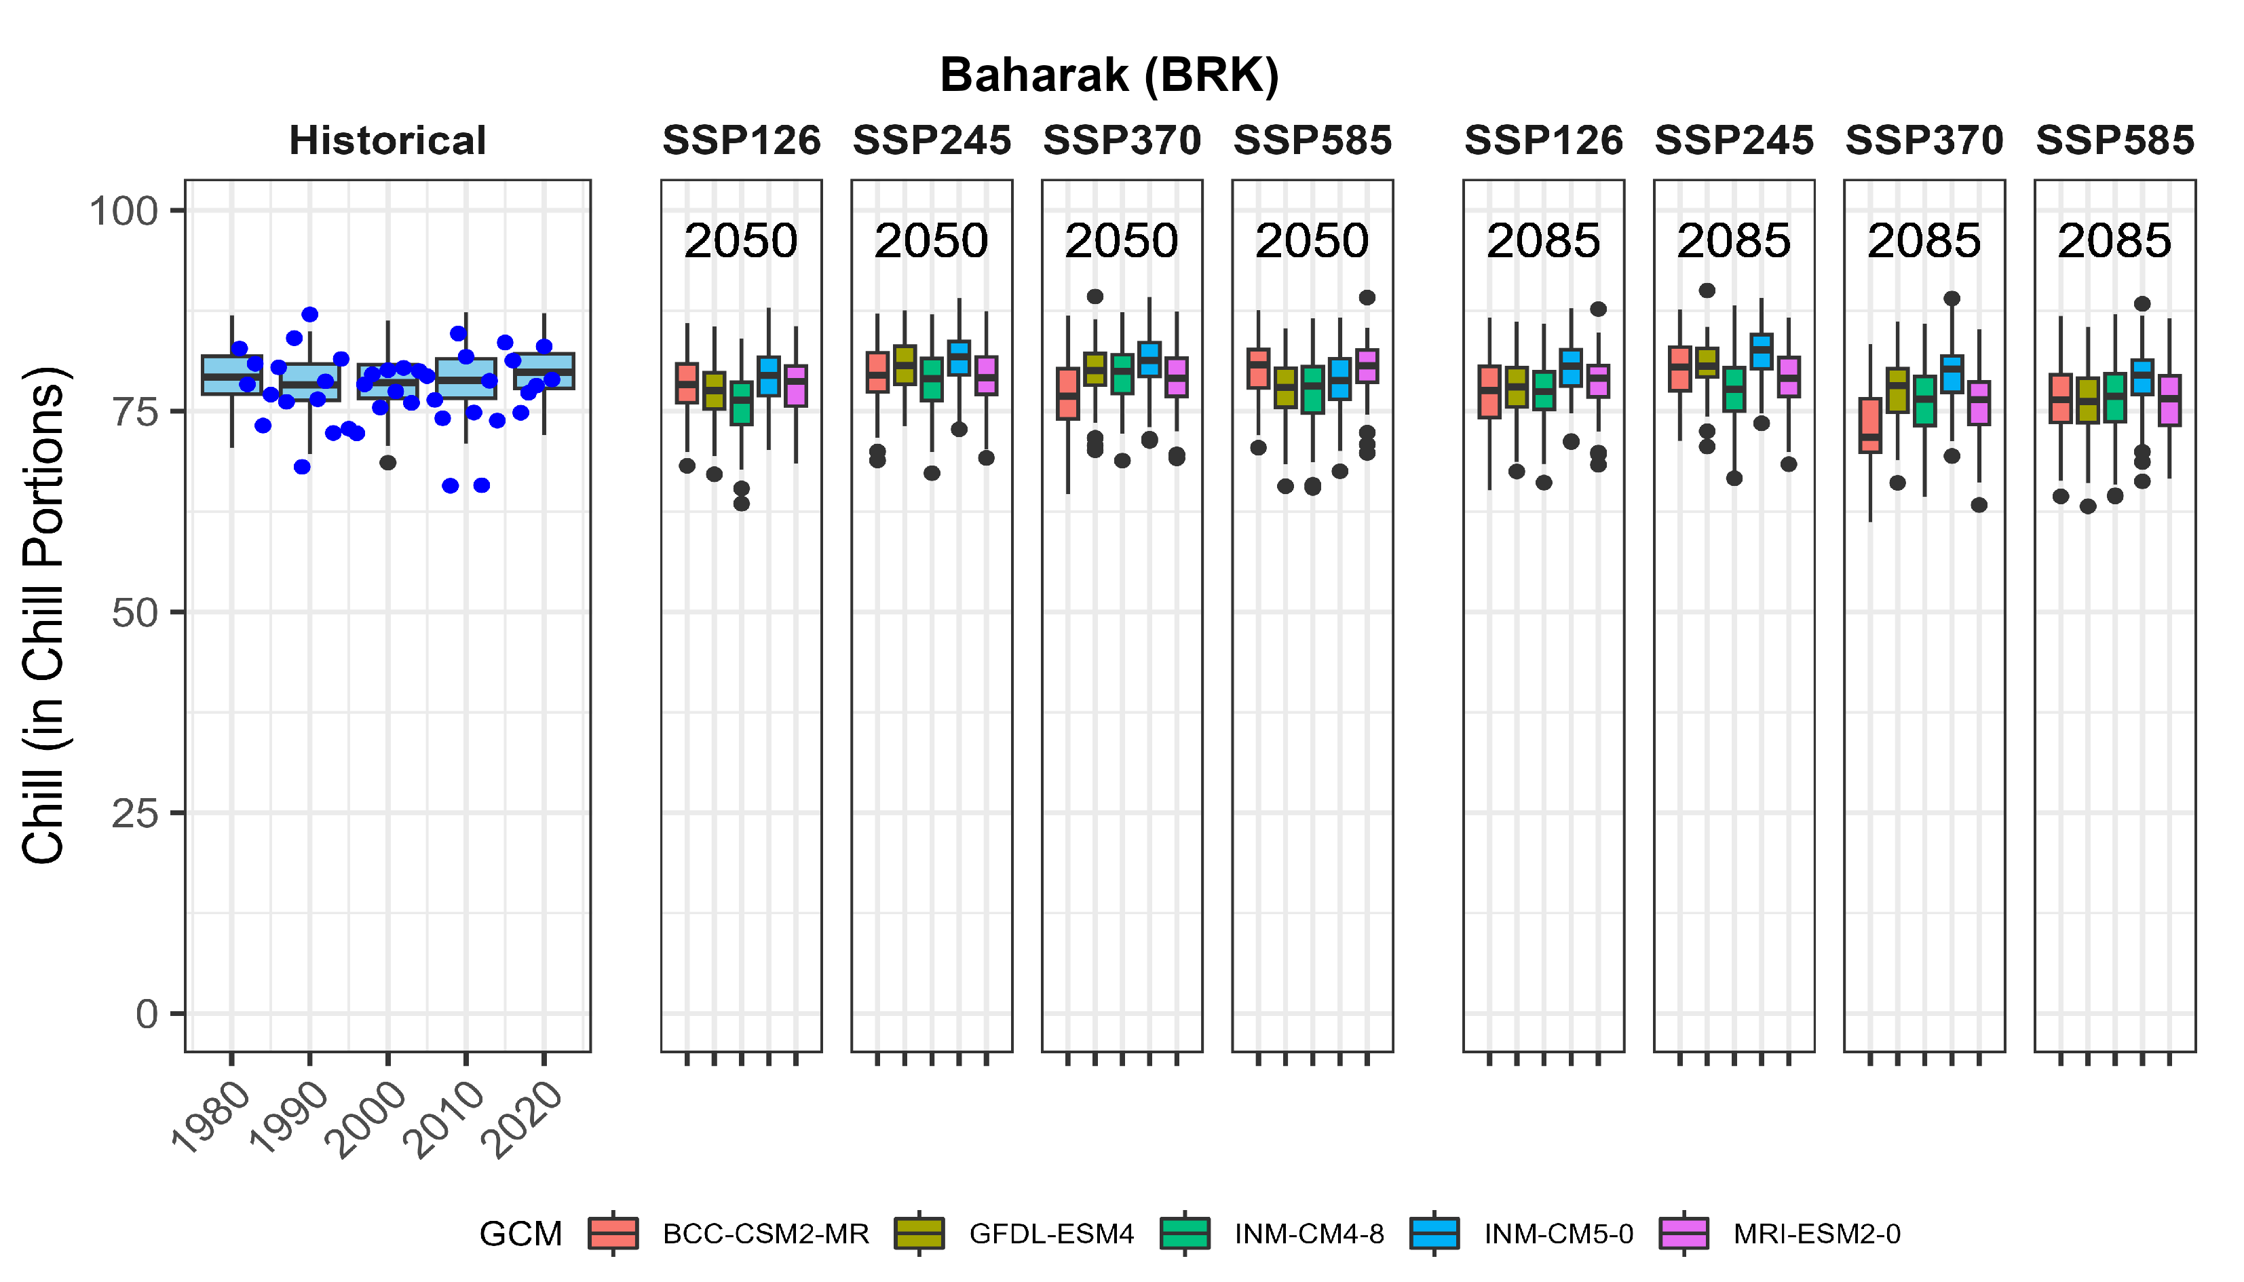
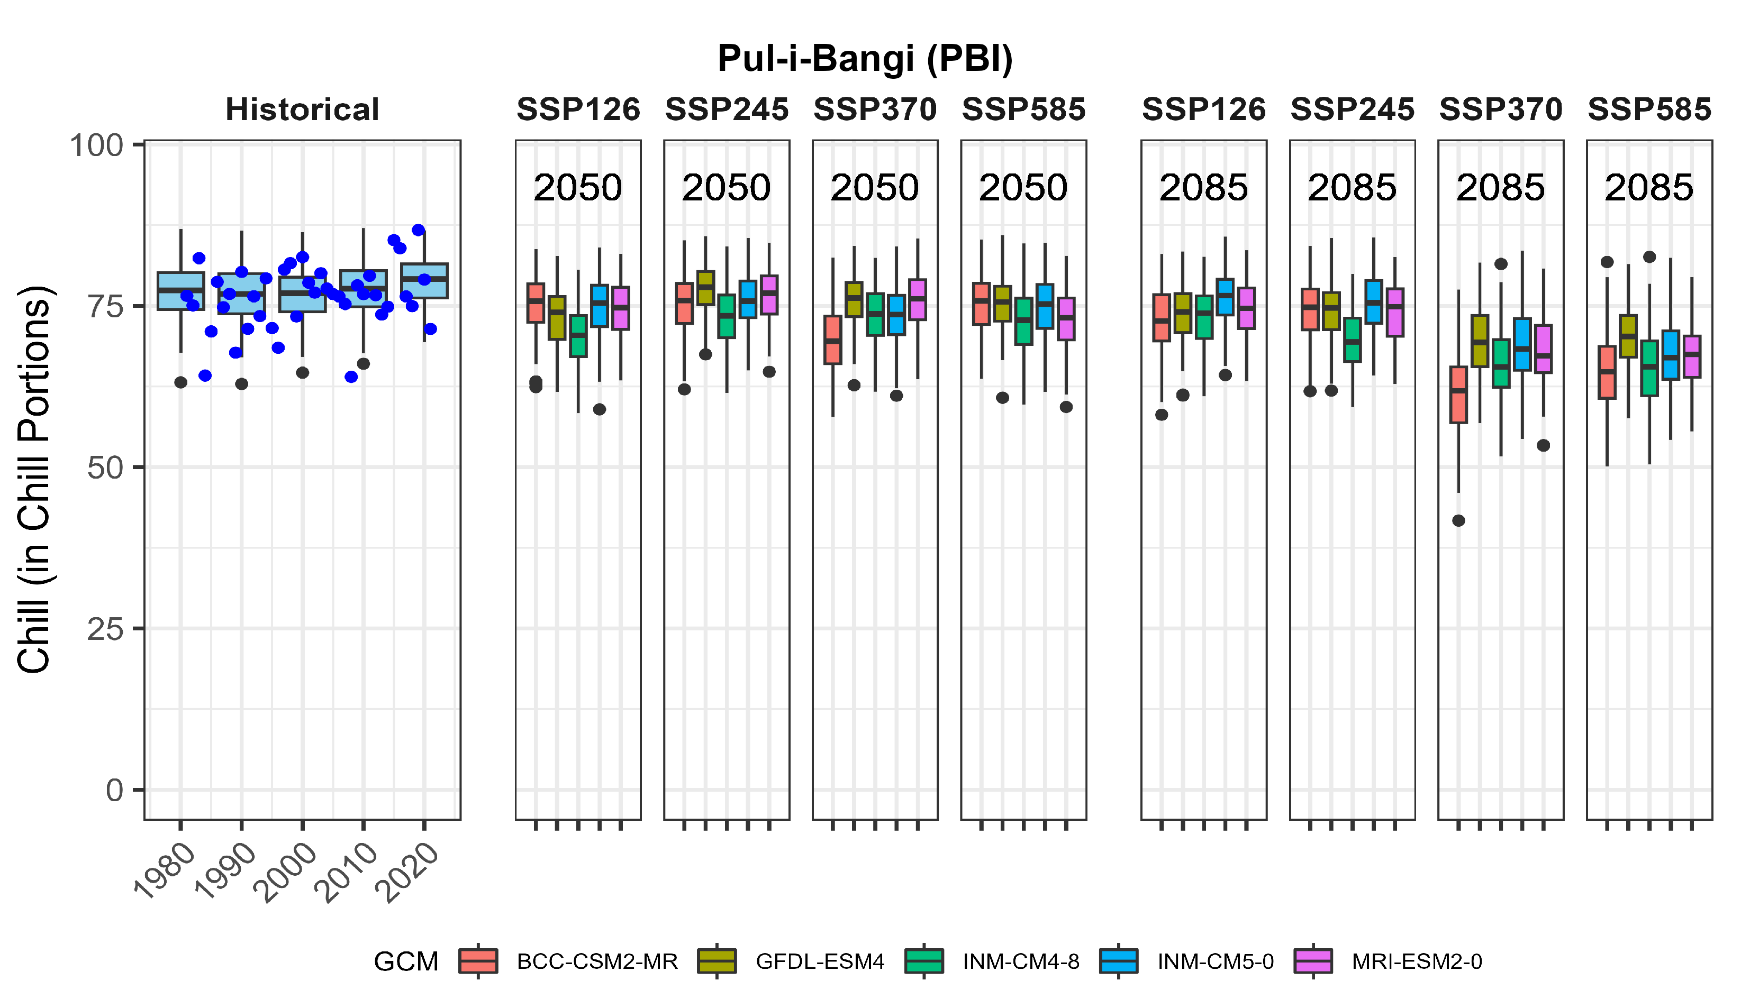
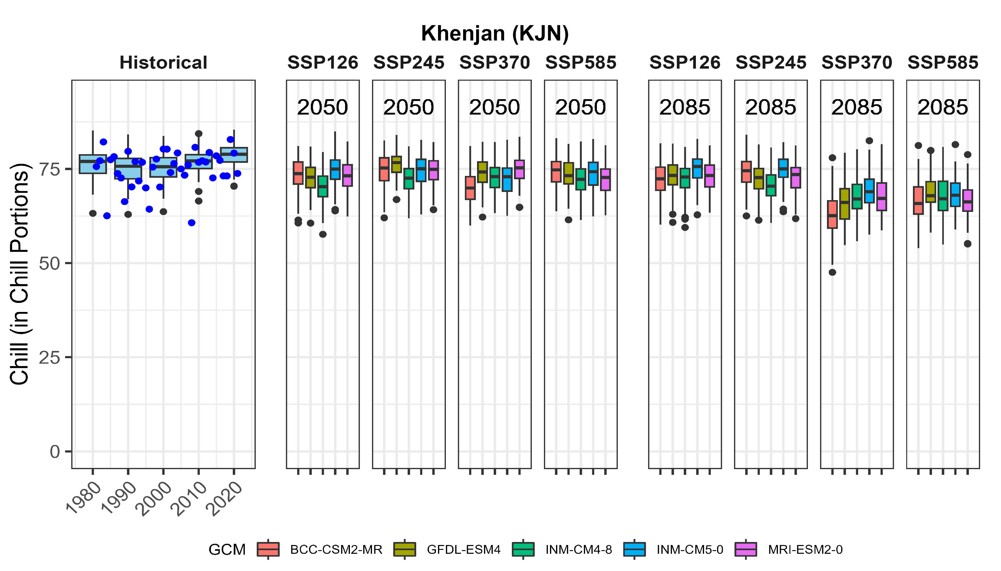
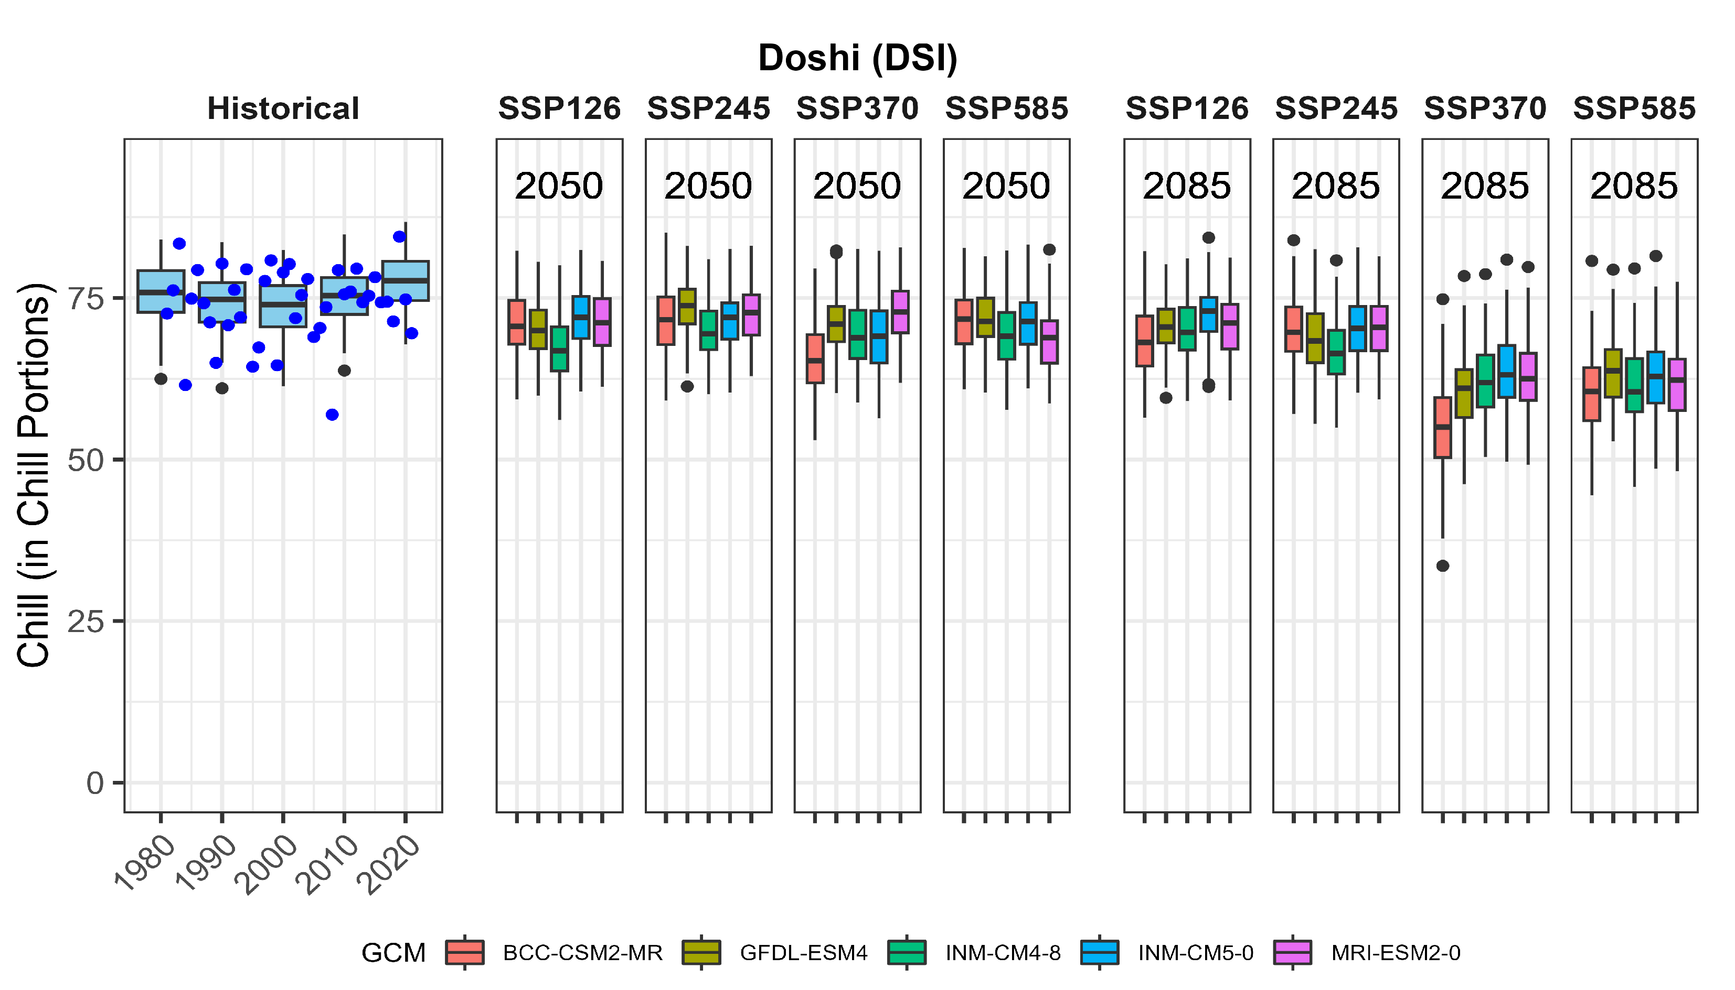
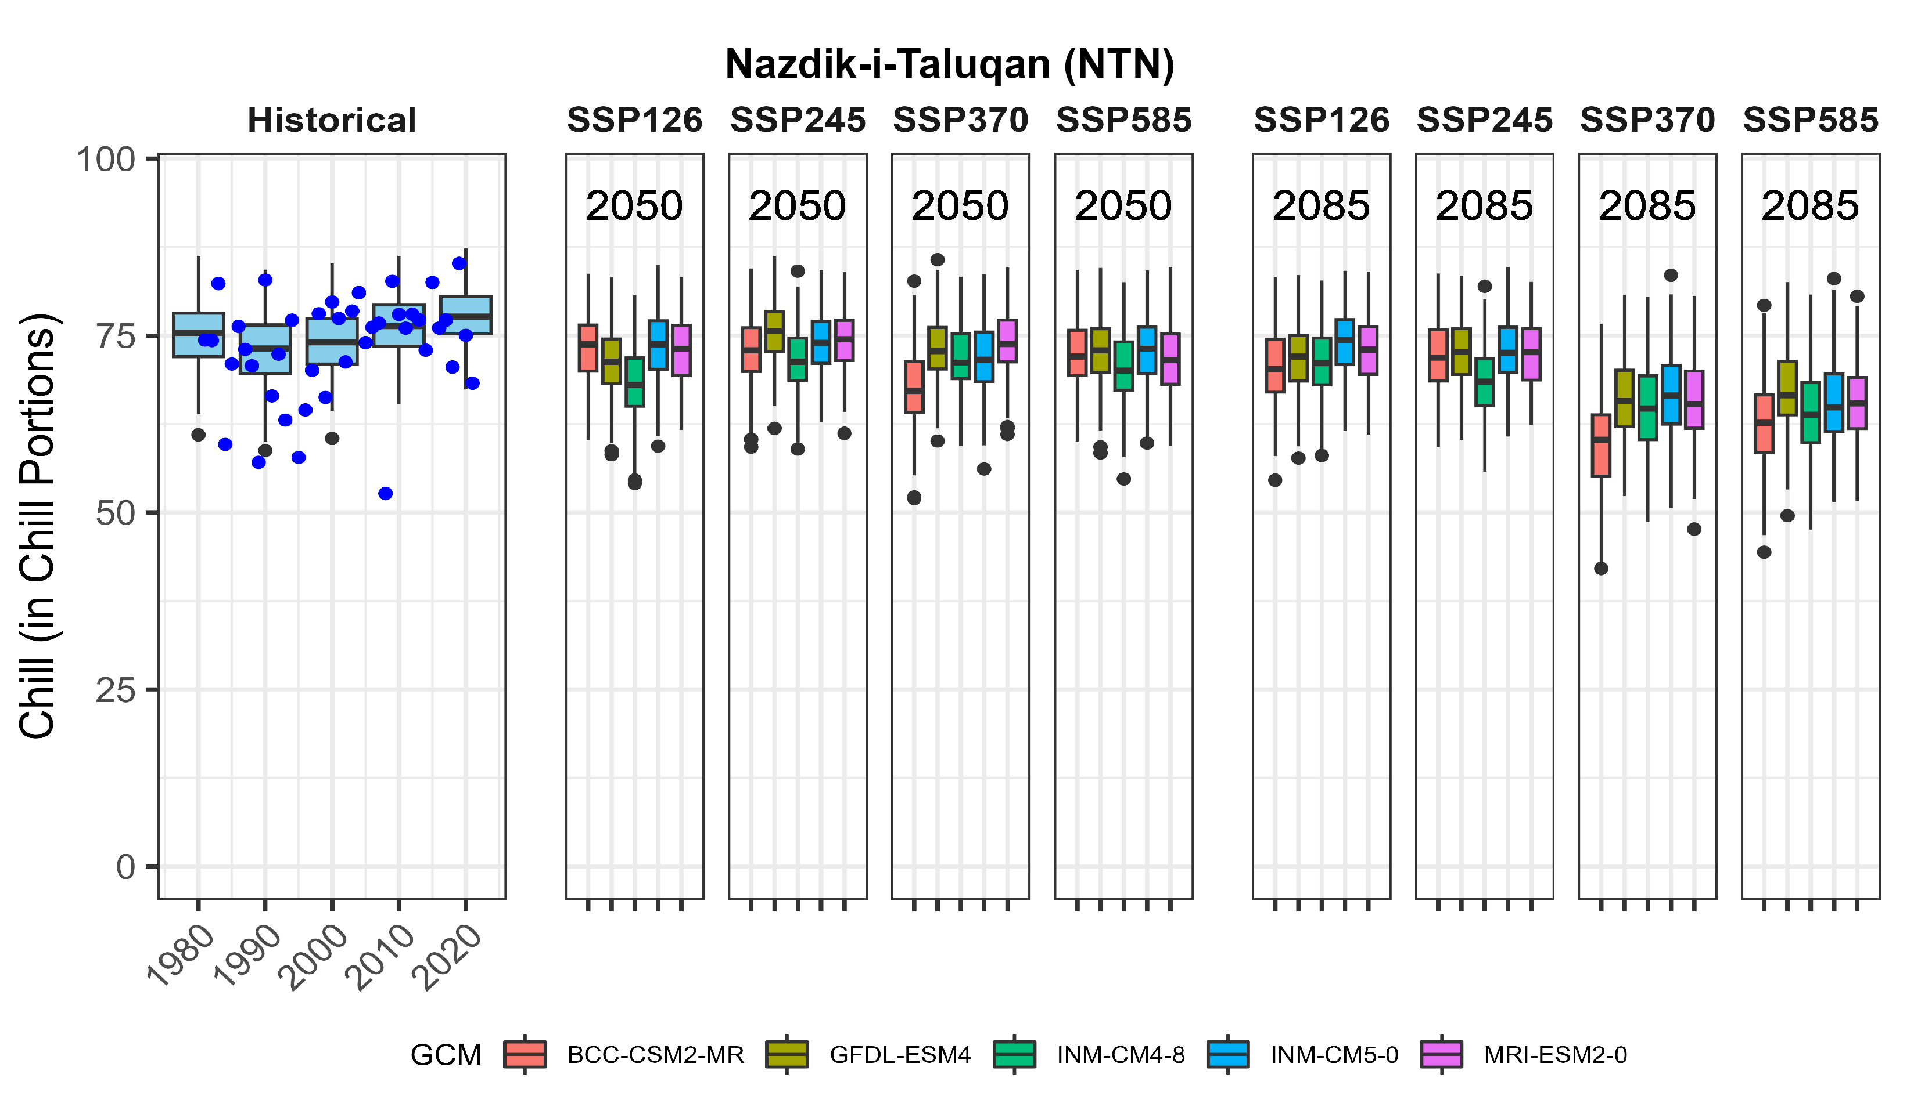
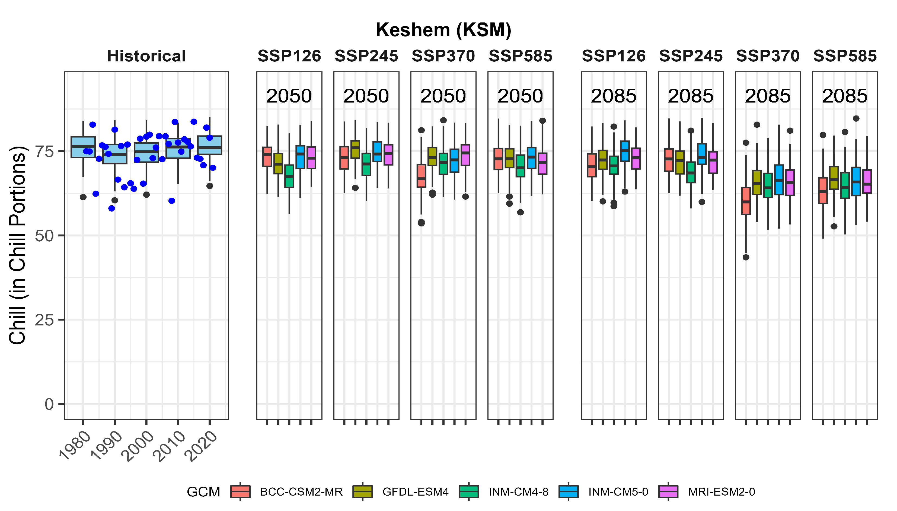
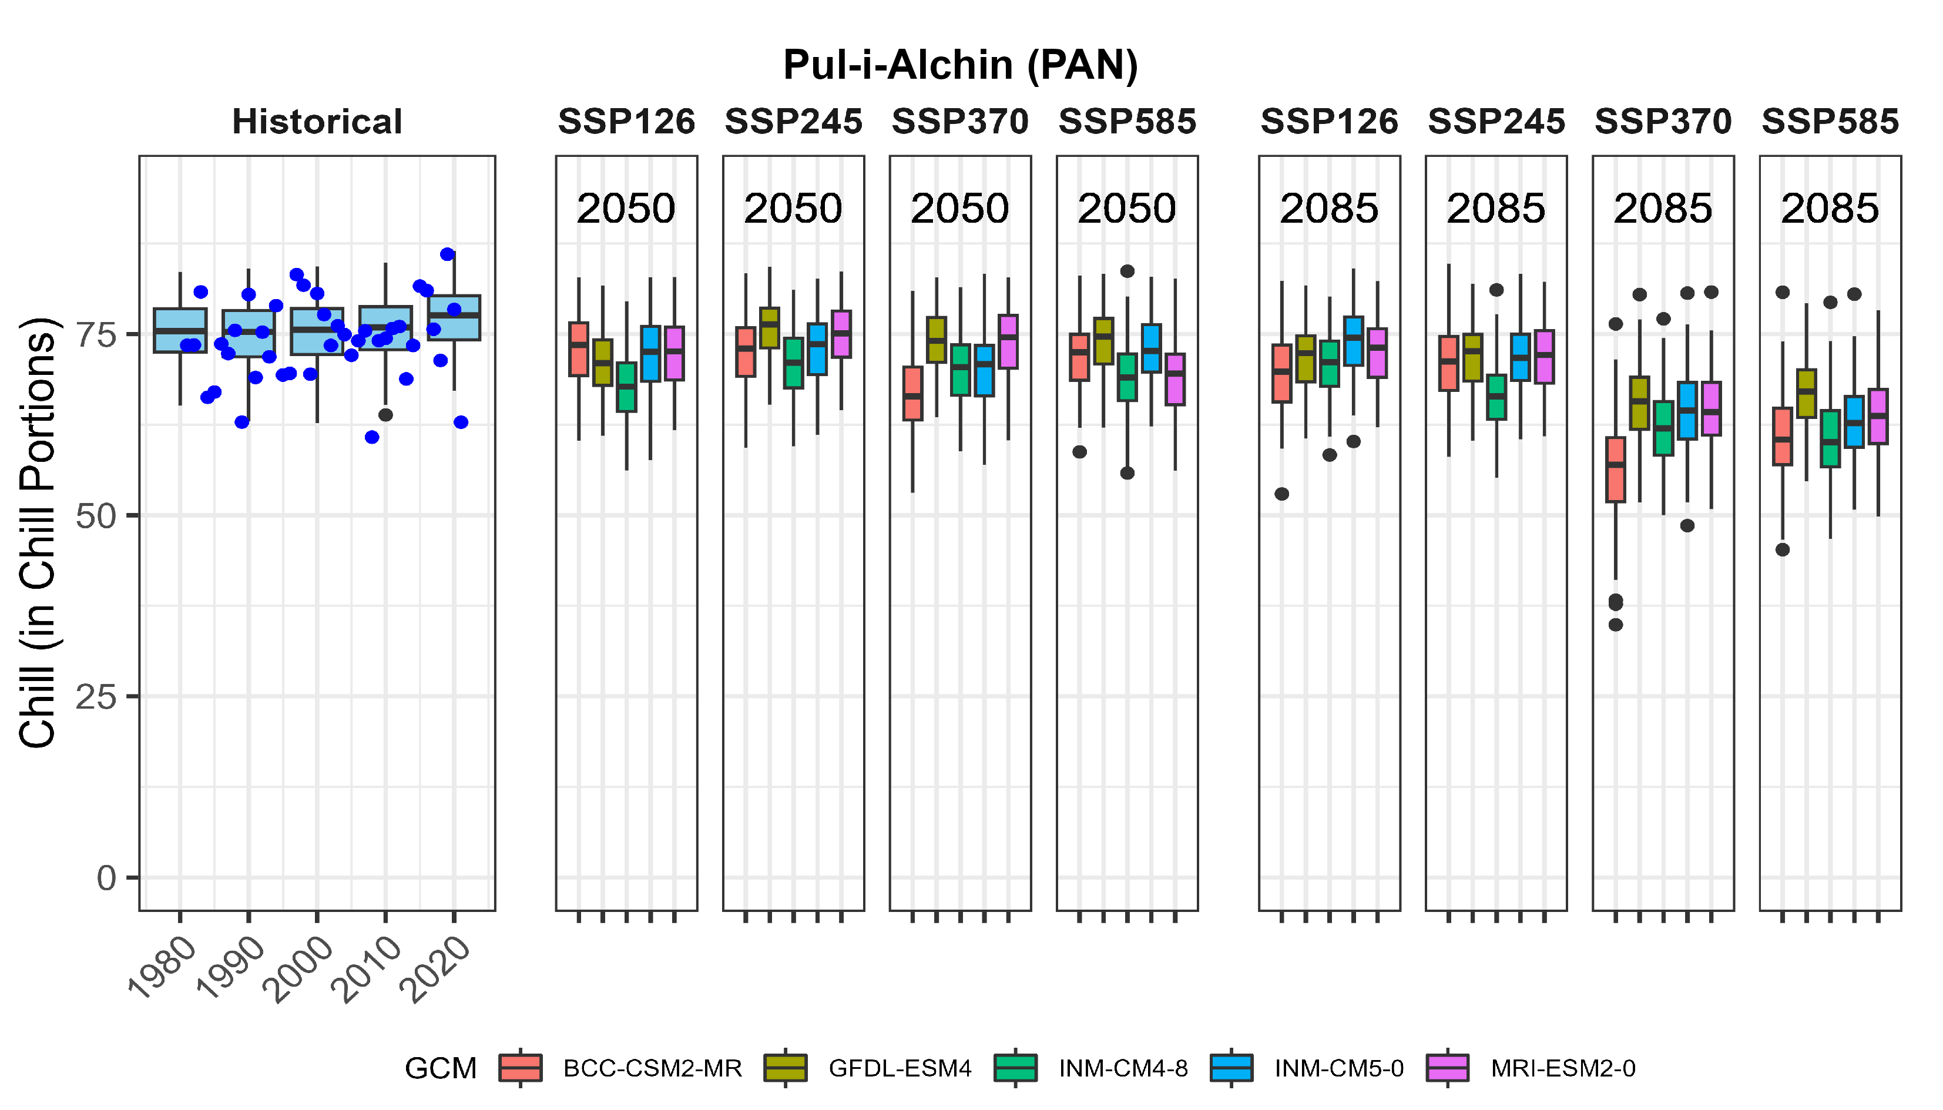
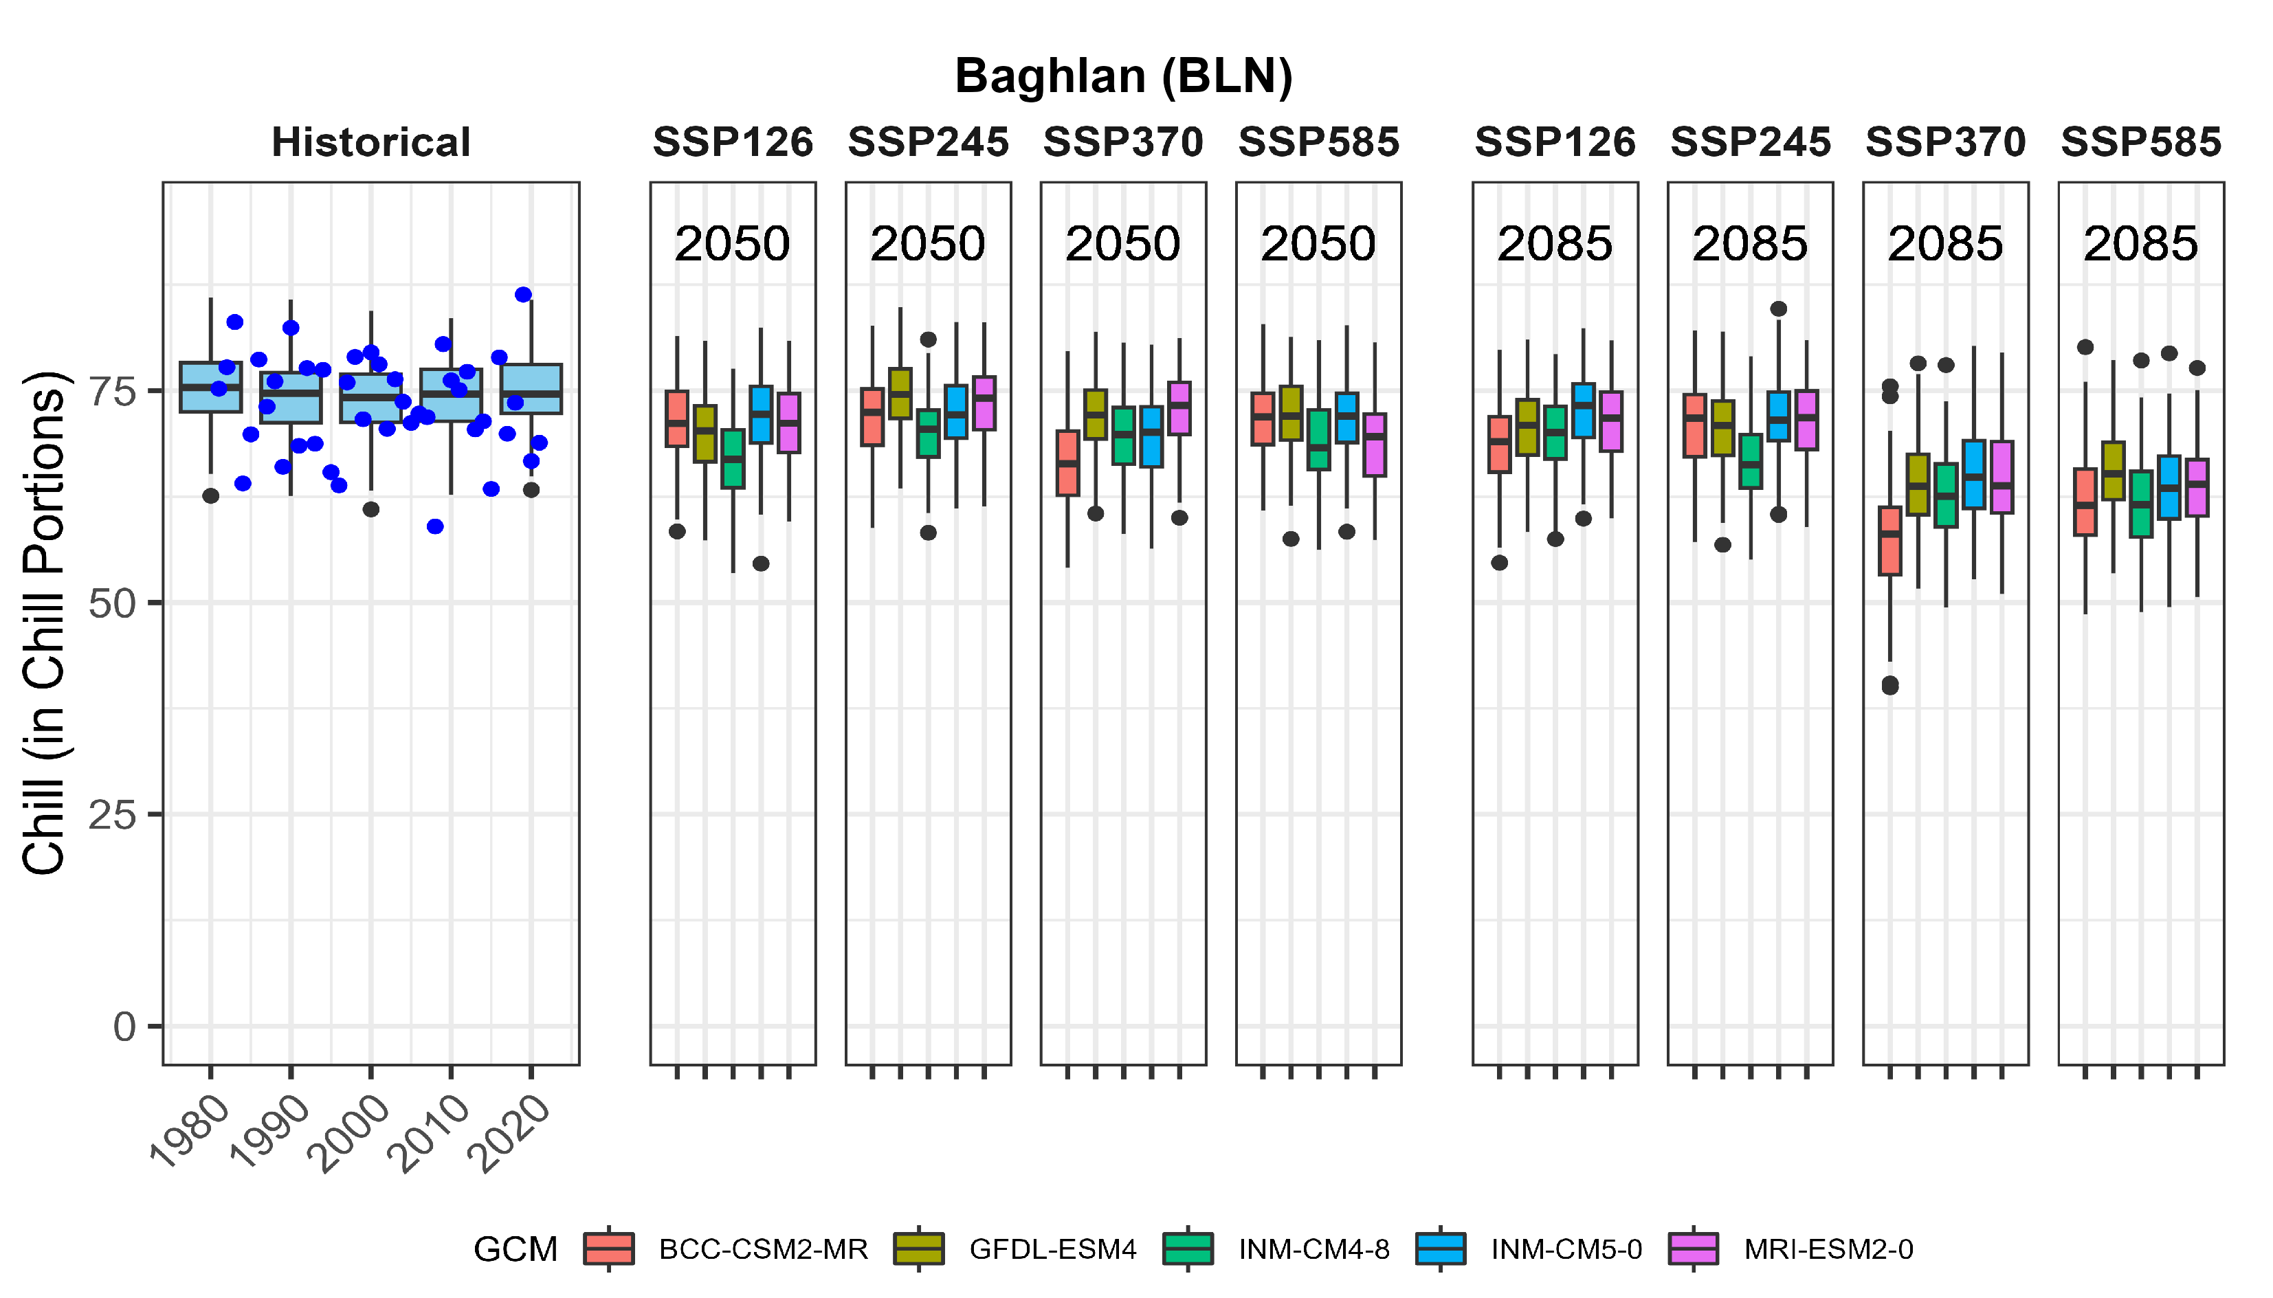
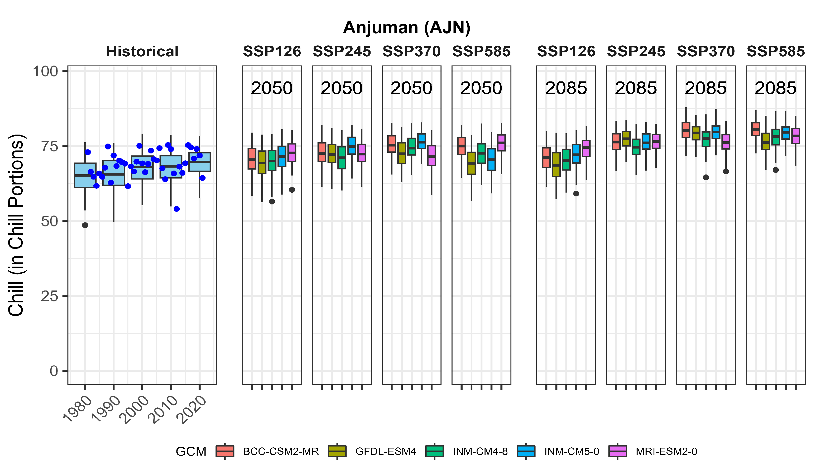
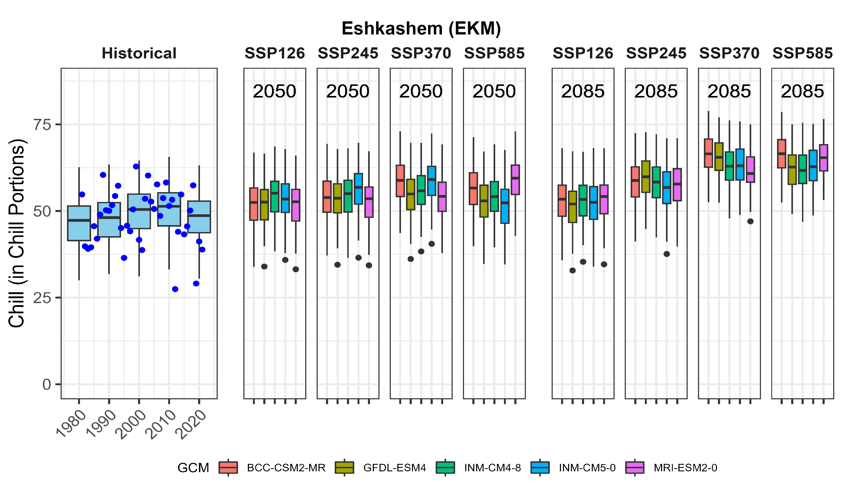
Eastern region
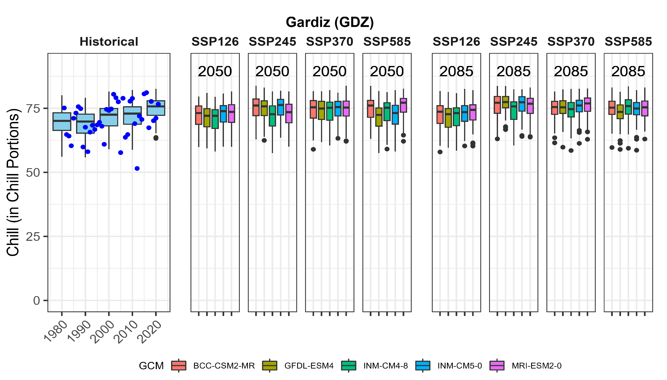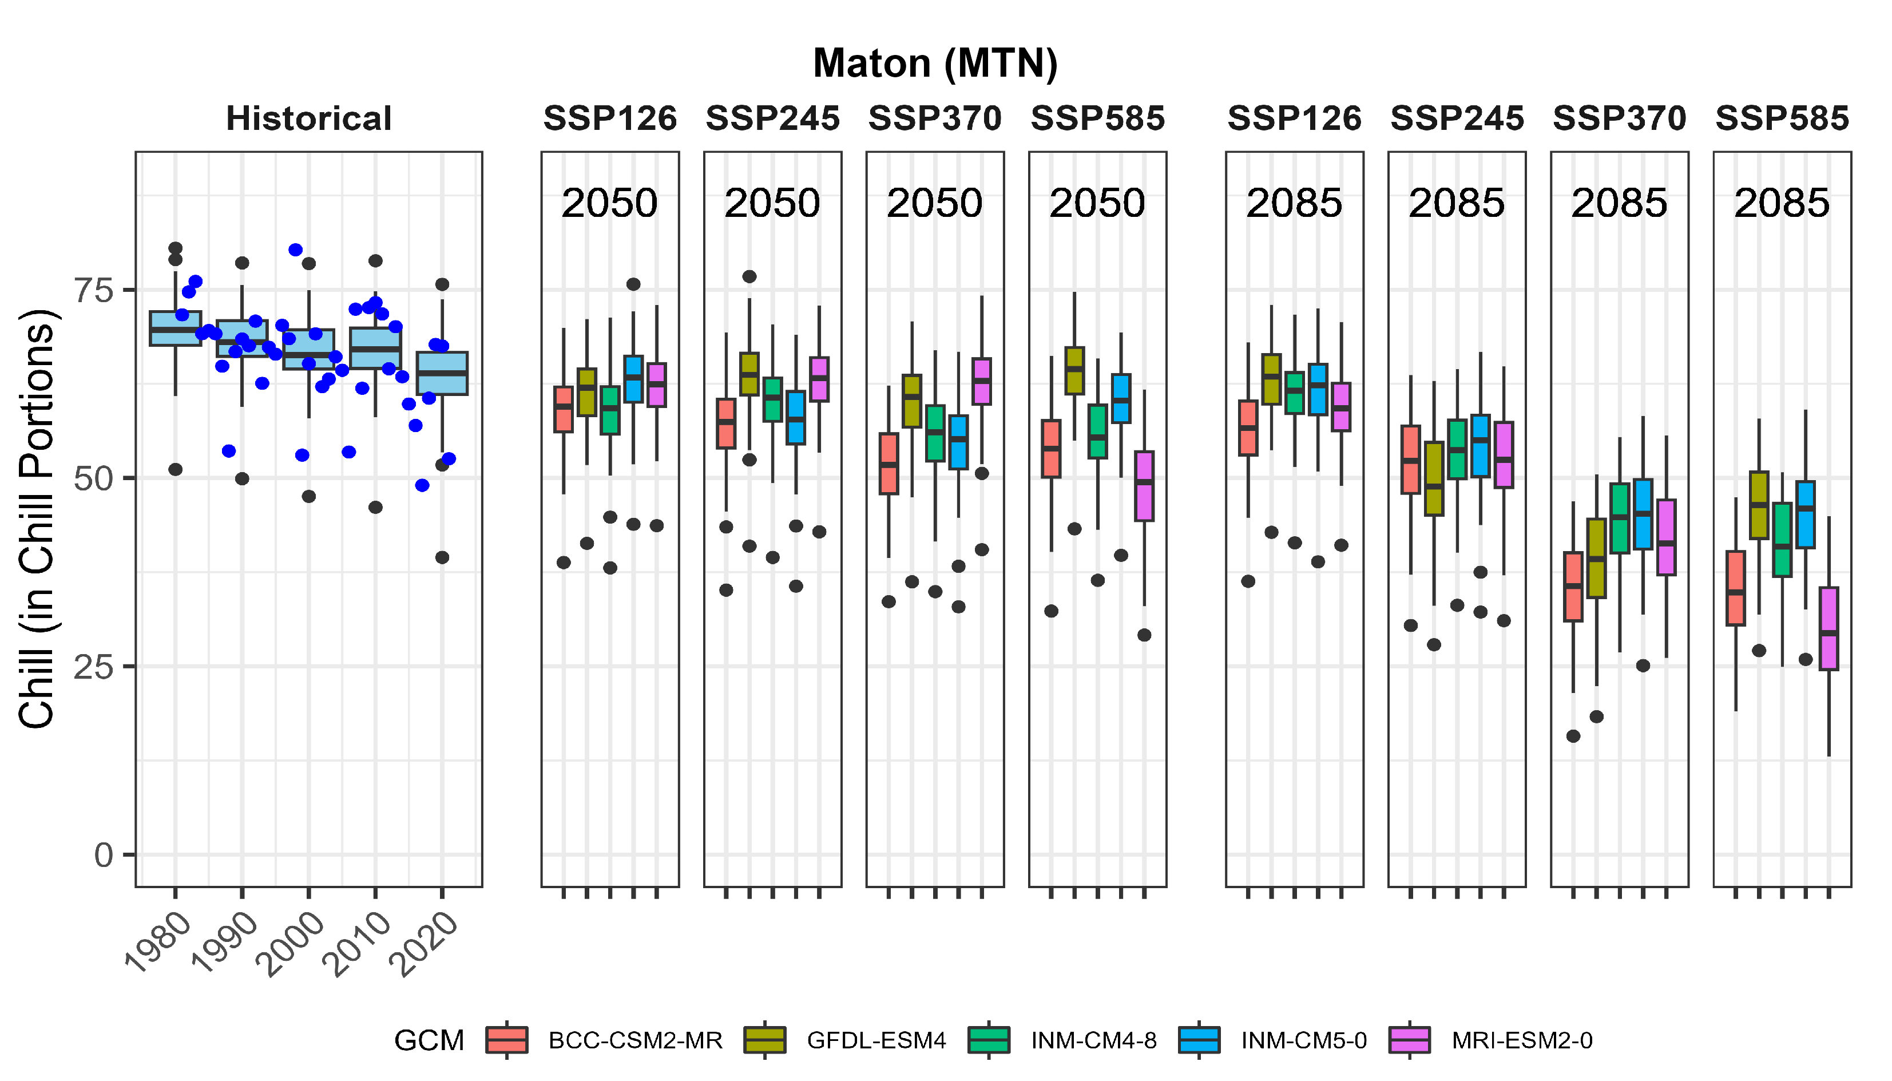
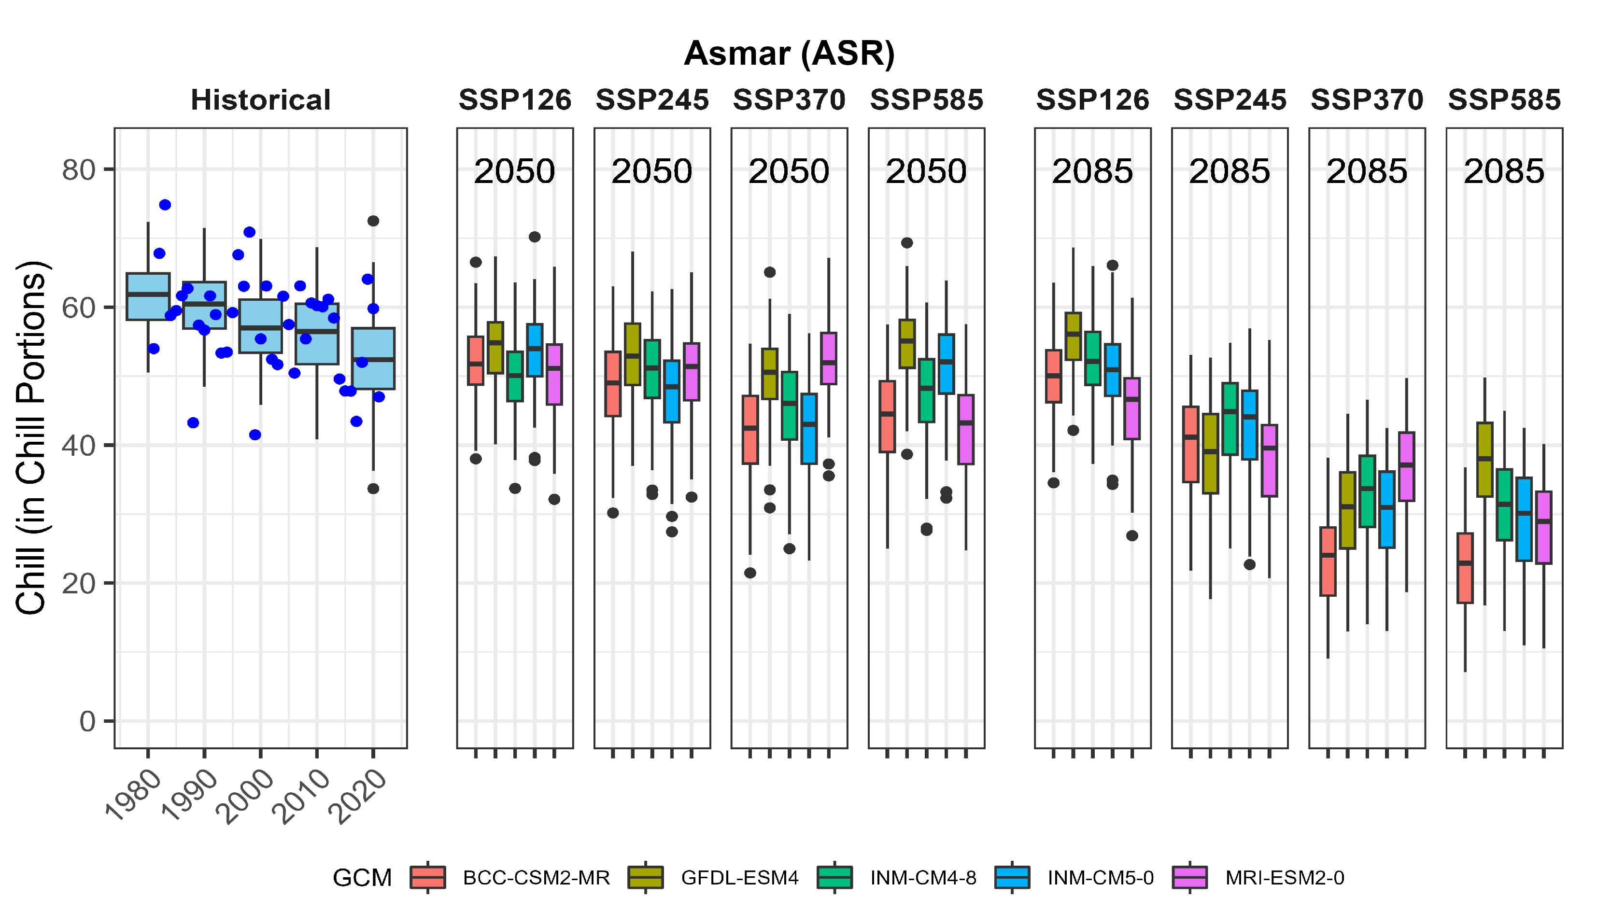
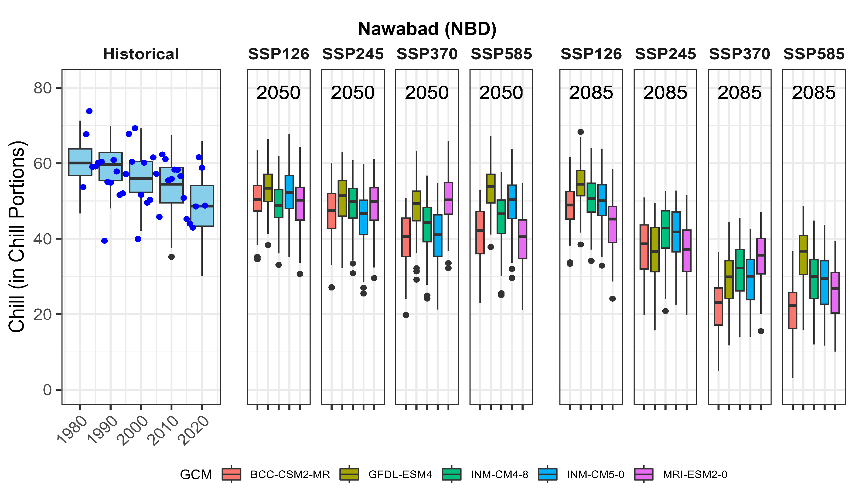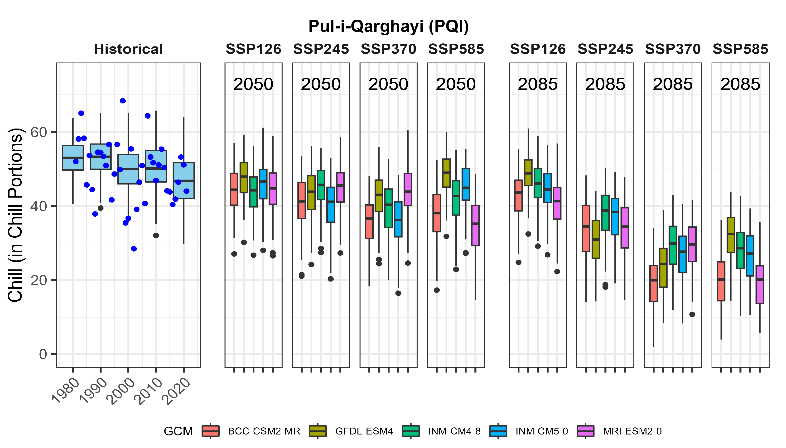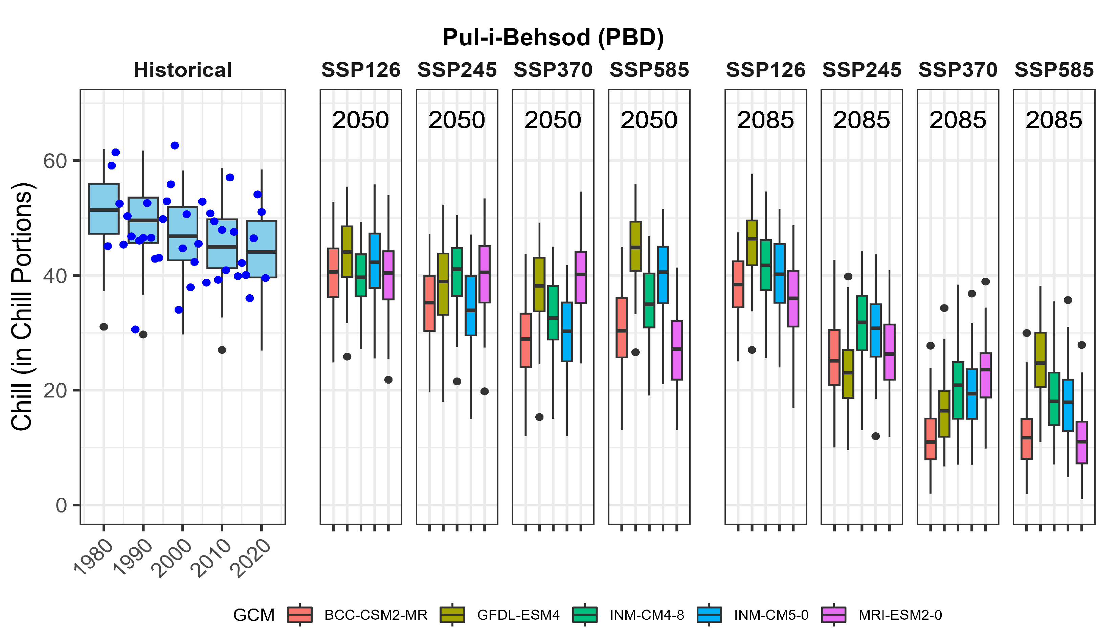
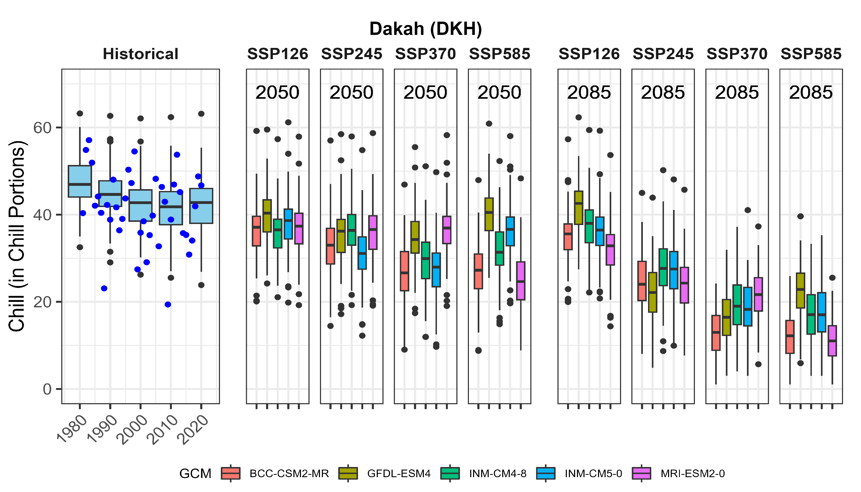
Southern region
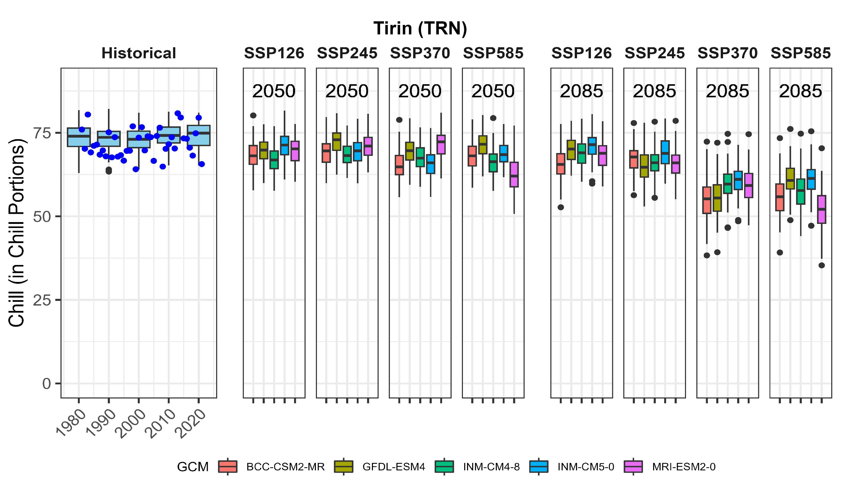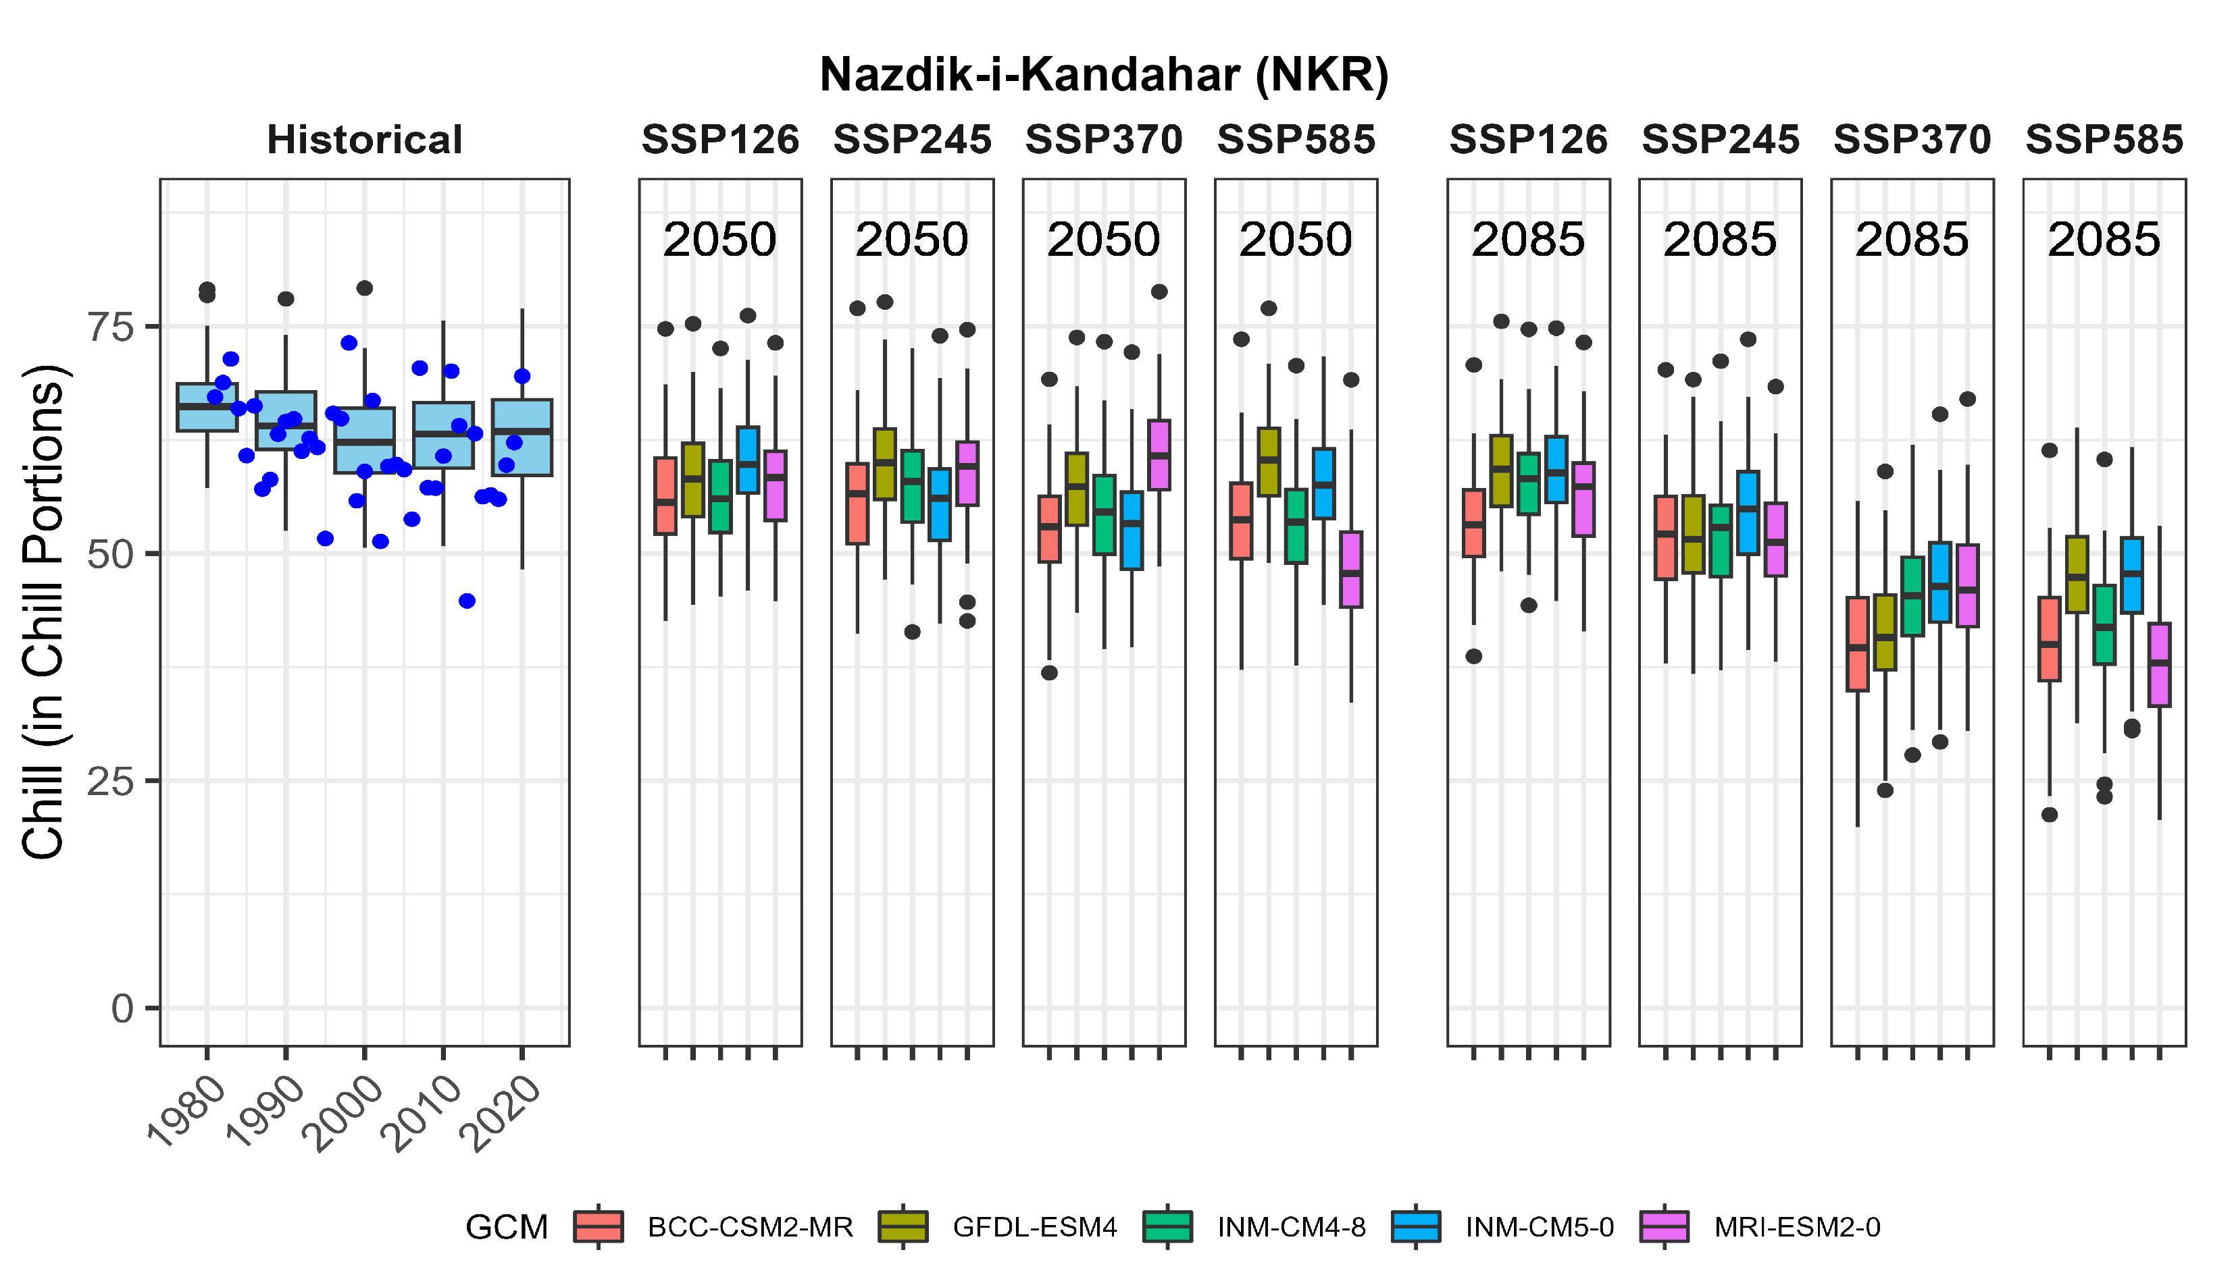
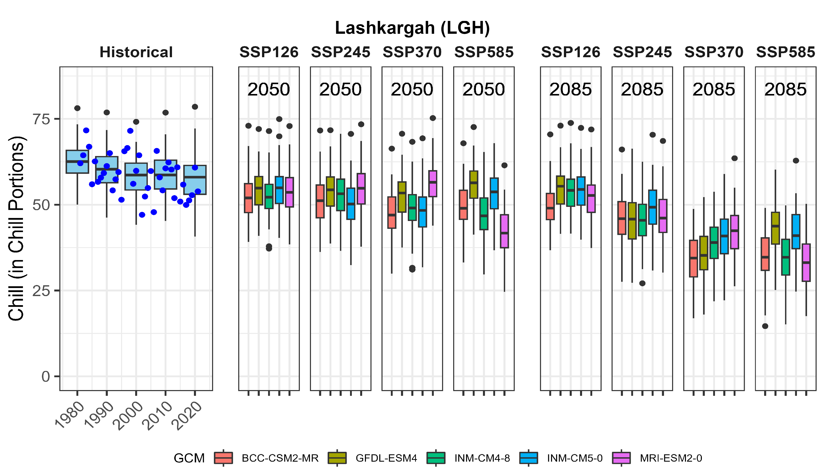
Western region

Central region

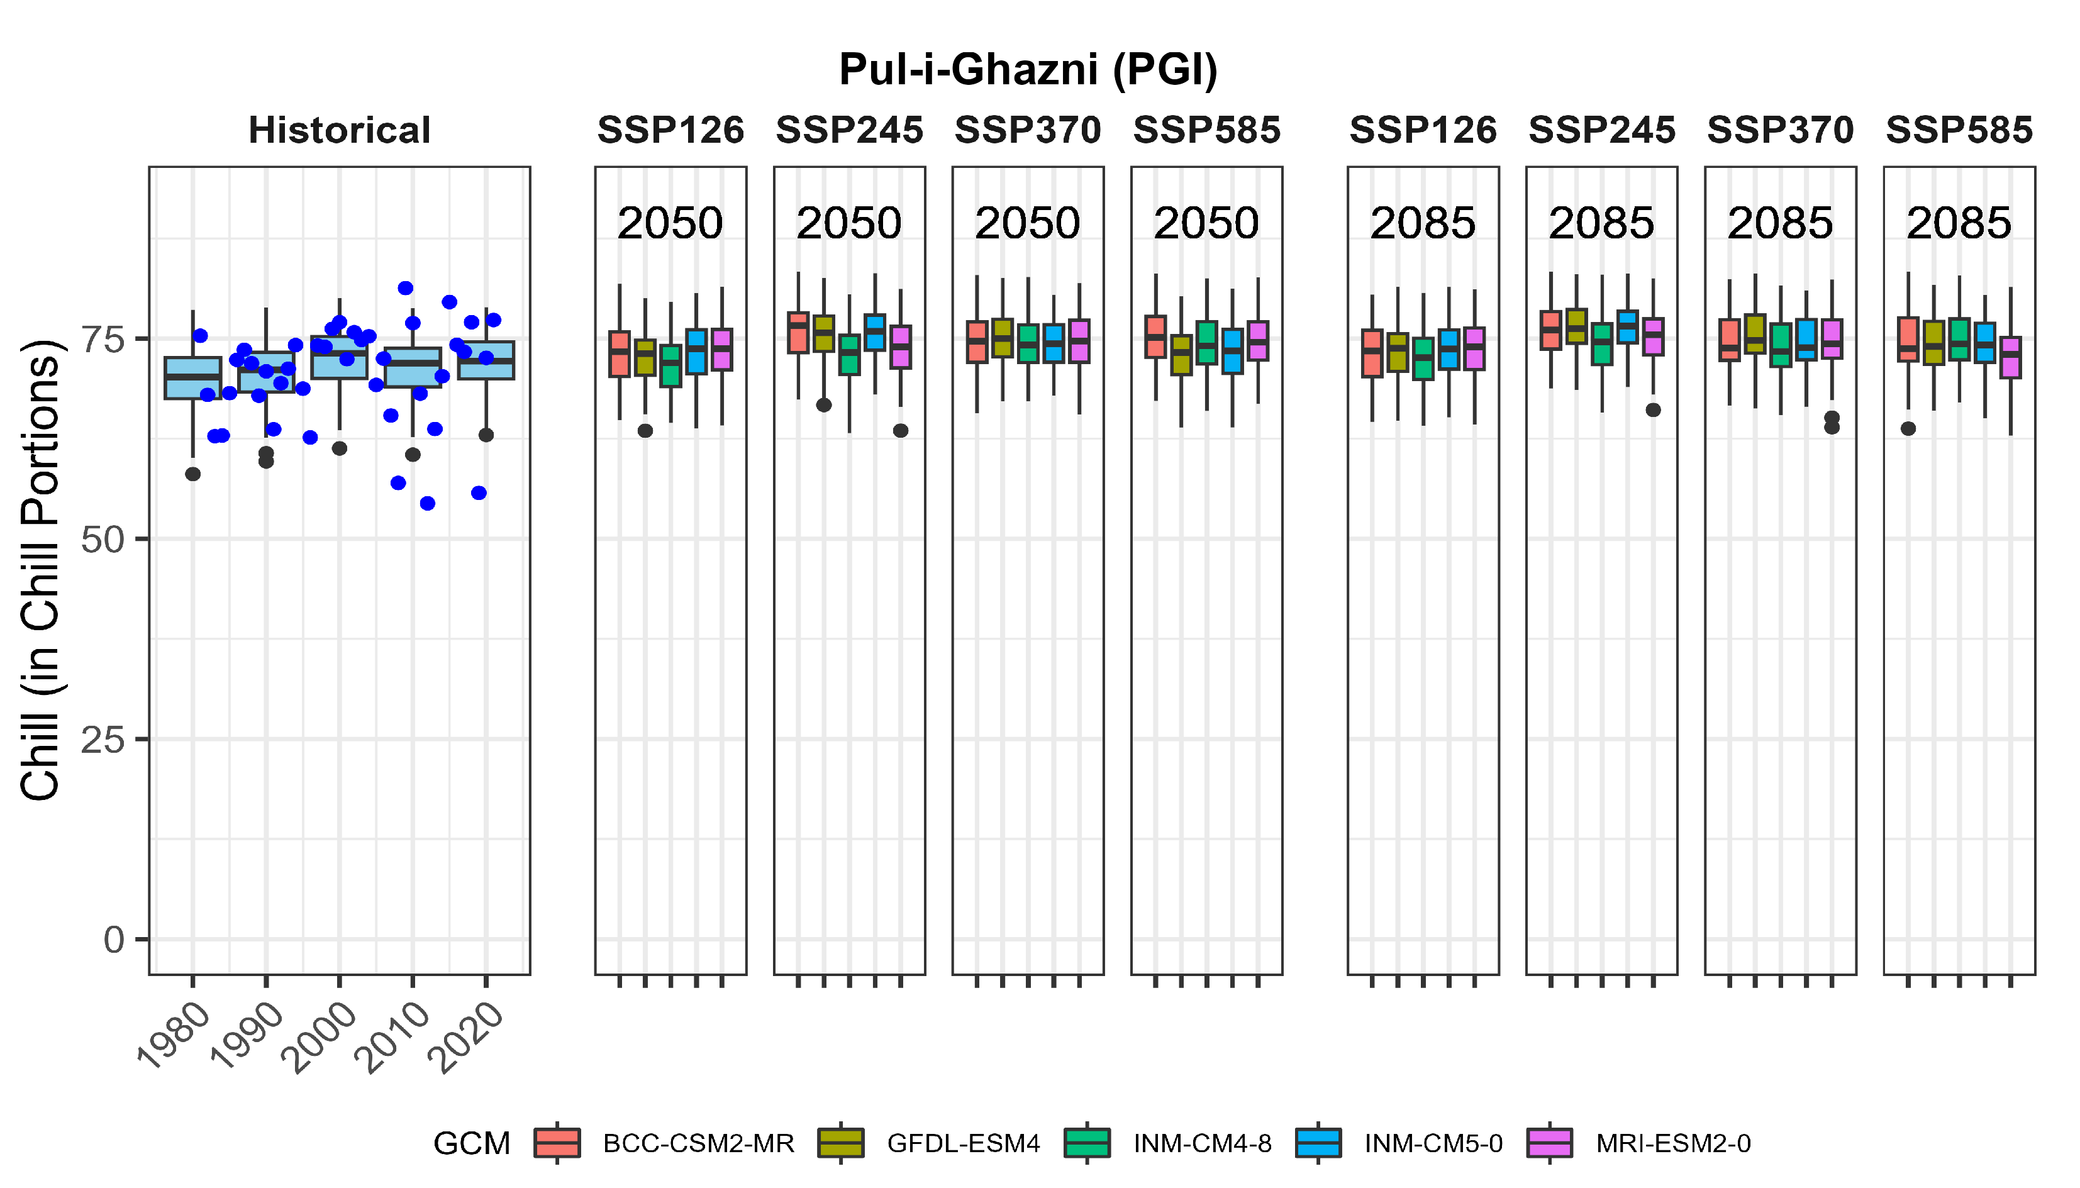

Spatial interpolation for chill estimation across the country
Following the historical and future chill projections for all stations, we extended our results beyond the stations’ locations and estimated chill accumulation across the country. For this purpose, we downloaded gridded daily mean temperature data between 1970 and 2000 from the WorldClim database. We applied Kriging as a spatial interpolation technique. At first, we used the co-variables of minimum and maximum temperature as auxiliary variables to improve the chill surface produced by the Kriging technique. However, we observed unreliable results due to a difference of more than 2°C between the observed temperature data and data from the WorldClim database. For 32 stations, the minimum and maximum temperatures fell outside the 3D correction model (Fig. S5). Finally, we improved the chill surface produced by Kriging interpolation using the mean daily temperature in December as an auxiliary variable. We produced chill maps for the whole country with historical and future SWC projections.
Fig. S5 Stations showing a difference of more than 2°C between the observed temperature data and data from the WorldClim database. On-site data refers to the observed temperature data recorded at the station.

