Supplementary Information for
Adaptive wireless-powered network based on CNN near-field positioning by a full-duplex metasurface
De Xiao Xia¹, Jia Qi Han¹, Ya Jie Mu¹, Lei Guan¹, Xin Wang¹, Xiang Jin Ma¹, Li Hao Zhu¹, Tian Guang Lv¹, Hai Xia Liu¹, Yan Shi¹, Long Li^{1,*}, and Tie Jun Cui^{2,*}
¹ Key Laboratory of High-Speed Circuit Design and EMC of Ministry of Education, School of Electronic Engineering, Xidian University, Xi'an 710071, China
² Institute of Electromagnetic Space and the State Key Laboratory of Millimeter Waves, Southeast University, Nanjing 210096, China
* Corresponding authors. E-mail: lilong@mail.xidian.edu.cn and tjcui@seu.edu.cn

This supplementary information includes:
Supplementary Note 1. Design of the full-duplex metasurface
Supplementary Note 2. Derivation of harmonic generation during rectification
Supplementary Note 3. Design of the receiving terminal
Supplementary Note 4. Optimize the STC matrix based on BPSO
Supplementary Note 5. The system architecture of the transceiver

Supplementary Note 1. Design of the full-duplex metasurface
Supplementary Fig. 1 Full-duplex metasurface. a Explosive view and b top views of meta-atoms at different frequencies. c Top view and d bottom view of its fabricated prototype.

Supplementary Table 1 Parameter Values
Parameters | Values(mm) | Parameters | Values(mm)
H₁ | 3.048 | H₂ | 0.254
P₁ | 25 | P₂ | 12.5
w₁ | 15 | w₂ | 6
l₁ | 12.5 | l₂ | 4.4
t₁ | 2.5 | t₂ | 1.4
g | 0.25 | d | 0.3

The meta-atoms are printed on the substrate of S7136H (ε_{r} = 3.55, tanδ = 0.002). The positive poles of PIN diodes are connected with a DC bias, and the on and off states of PIN diodes are controlled by FPGA. There are two sizes of meta-atoms, as shown in Supplementary Fig. 1a and Fig. 1b. They operate at two different frequencies for transmitting RF power and receiving feedback signals. The main geometric parameters are listed in Supplementary Table 1.
Based on the above meta-atoms, the fabricated full-duplex metasurface is shown in Supplementary Fig. 1c and Fig. 1d. As can be seen, it consists of a 16×16 square array and a 12×2 L-shaped array. They are responsible for different operating frequencies. Besides, the wide-band horn antenna serves as the feed source, which can simultaneously transmit the 5.8 GHz energy and receive the feedback signal at 11.6 GHz. On the back of the metasurface, an FPGA board controls the coding matrix of the array in real-time, by connecting the laptop with serial ports.
Supplementary Note 2. Derivation of harmonic generation during rectification
The nonlinear relationship between voltage and current in a Schottky diode can be expressed as:
where k denotes the Boltzmann’s constant, n is the ideality factor, T is the temperature, q denotes the charge of an electron, and I_{s} is the saturation current¹. Consider a sinusoidal signal V=V_{s}cos(ω₁t) being input to the Schottky diode, and the output response can be decomposed into the Taylor series as
where x₀, x₁, x₂, … are the coefficients of Taylor expansion. Since
and
then
It can be found that the output voltage has DC and AC components at 0, ω₁, 2ω₁, 3ω₁, etc., and the 2nd harmonic can be denoted as
This 2nd harmonic is prominent in the whole harmonic components. It will be extracted and leveraged for positioning.
Supplementary Note 3. Design of the receiving terminal
The layout of the designed antenna is shown in Supplementary Fig. 2a and Fig. 2b. The antenna is a 4×4 array, and each element is a dual-band co-aperture design. The outer square loop is working at 5.8 GHz, while the inner dumbbell-shaped structure is at 11.6 GHz. They are fed through the metallic vias. Under the bottom of the antenna, two power combiners synthesize the 4×4 array into two frequency ports. They are printed on the substrate of S7136H (ε_{r} = 3.55, tanδ = 0.002). The main geometric parameters are listed in Supplementary Table 2.
The design of the harmonic-feedback rectifier is shown in Supplementary Fig. 2c. For convenience, we mark the dimensions directly in the figure. A Schottky diode (MA4E1317, MACOM, Inc.) is used to convert AC to DC. Between the diode and input port, a matching network is designed to reduce the reflection loss. Besides, two radial stubs are used to prevent the fundamental component from flowing to other ports. For the generated 2nd harmonic, we designed a high-pass filter before the output port, enabling a small insertion loss for them. There are two 4.1 mm open-circuited stubs, which are 4/λ of the 2nd harmonic, and they force the 2nd harmonic to flow into the output port. Additionally, the capacitors of C₁ and C₂ serve as DC blocks, and their values are 5.8 pF and 2 pF, respectively. The photographs of the fabricated receiving terminal are shown in Supplementary Fig. 2d and Fig. 2e. As can be seen, it consists of a rectifier, a temperature sensor, a Bluetooth module, and an ADC module.
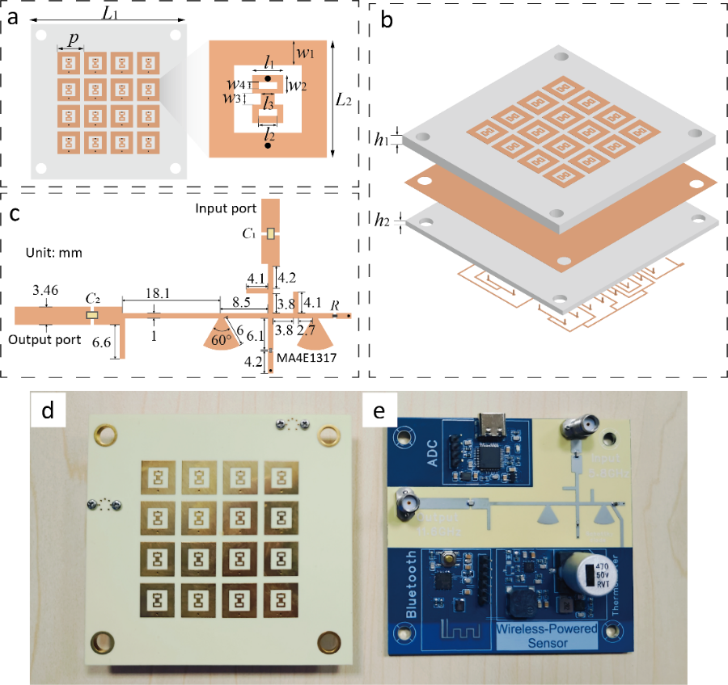
Supplementary Fig. 2 Design of the receiving terminal. a and b are the top view and explosive view of the antenna array. c Layout of the harmonic feedback rectifier. d and e are photographs of the fabricated receiving terminal.
Supplementary Table S2 Parameter Values
Parameters | Values(mm) | Parameters | Values(mm)
L₁ | 74 | L₂ | 10.2
l₁ | 2.7 | l₂ | 1.6
l₃ | 1.2 | p | 12
w₁ | 2.16 | w₂ | 1.6
w₃ | 1.0 | w₄ | 0.6
h₁ | 1.524 | h₂ | 0.254

Supplementary Note 4. Optimize the STC matrix based on BPSO
The optimization of the STC matrix focuses on inducing significant variations in the amplitude distribution of harmonics across different positions, thereby establishing them as notable features for positional coordinates. Consequently, our objective is to minimize the correlation coefficients between different harmonic vectors h(θ, φ, r). Furthermore, to mitigate computational overhead during optimization, we primarily focus on the correlation coefficients in the normal direction. The binary particle swarm optimization (BPSO) algorithm is utilized for generating the STC matrix due to its advantage in binary optimization², and the fitness function is defined as
where u_{ri} is the simplified form of u(0,0,r_{i}), r₁ and r₂ are within the AoI, and ${\left\|⋅\right\|}_{\text{2}}$ denotes the 2-norm of vectors.
Supplementary Note 5. The system architecture of the transceiver
The diagram of the transceiver is shown in Supplementary Fig. 3a. To produce consistent output power, a separate signal generator is used to generate a 5.8 GHz signal, and then the power amplify (PA) enhances the signal power to more than 1 W. By connected with a duplexer, the wide-band horn antenna is simultaneously used to radiate 5.8 GHz high-power signal and receive 11.6 GHz feedback signal. Considering the leakage between the transmitting and receiving channels, we employ a high-pass filter to filter the fundamental frequency. The whole receiving channel is the superheterodyne structure, and two-stage mixing is performed to effectively mitigate signal aliasing interference. The first stage of downconversion is implemented by an outer downconverter (LTC5549, Analog Devices, Inc.), whose output is the intermediate frequency signal at 5.8 GHz. A universal software radio peripheral (USRP B210, ETTUS Research Corporation) is applied to generate the local oscillator (LO) signal for the mixer, and serve as a receiving channel. Indeed, for convenience, the signal generator can also be replaced by this USRP. The photograph of the experimental setup is shown in Supplementary Fig. 3b.
Supplementary Fig. 3 Experimental diagram. a Schematic of the transceiver, which generates a high-power signal at 5.8 GHz and receives an 11.6 GHz feedback signal b Photograph of the experimental setups, where it concludes a signal generator, a PA, a duplex, a high-pass filter, a LNA, a mixer, and a USRP.

Supplementary References
1. Ladan, S. & Wu, K. Nonlinear Modeling and Harmonic Recycling of Millimeter-Wave Rectifier Circuit. IEEE Trans. Microw. Theory Tech. 63, 937–944 (2015).
2. Zhang, L. et al. Space-time-coding digital metasurfaces. Nat. Commun. 9, 4334 (2018).

