Targeted genotyping (90K-SPET) facilitates genome-wide association studies and the prediction of yield-related traits in faba bean (Vicia faba L.)
Antonio Lippolis¹, Salvador A. Gezan², Jorrit Zuidgeest¹, Valeria Cafaro³, Bert-Jan van Dinter⁴, Geert Elzes⁴, Maria-João Paulo⁵, and Luisa M. Trindade^{1*}

This supplementary material (figures) file totaling six pages contains five supplementary figures, Supplementary Figures 1-5.

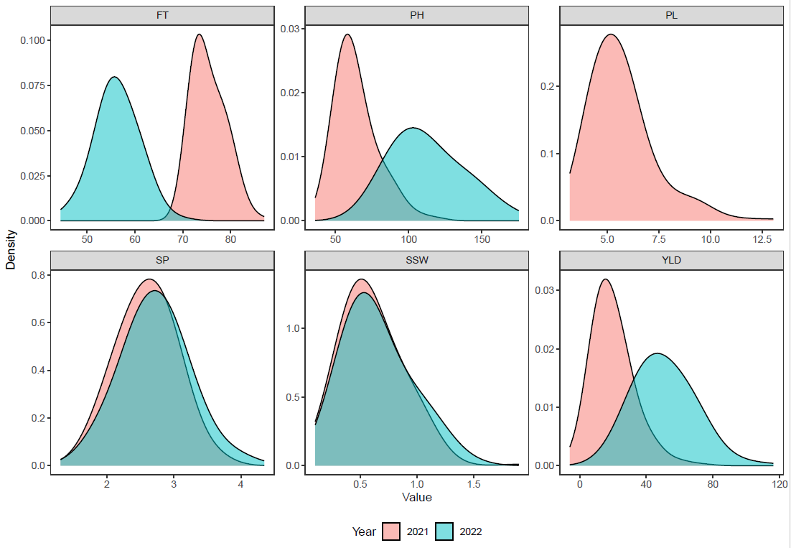
Supplementary Figure 1: Frequency distribution of the phenotypic adjusted data (BLUEs) for flowering time (FT), plant height (PH), pod length (PL), seeds per pod (SP), single seed weight (SSW), and yield (YLD), in 2021 and 2022.

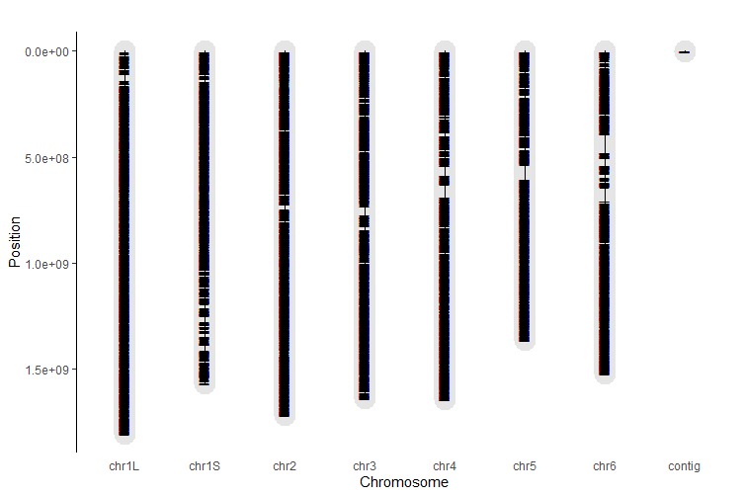
Supplementary Figure 2: SNPs distribution along the six chromosomes of faba bean. The chromosome lengths shown represent the distances covered by the markers and not the actual chromosomes size.

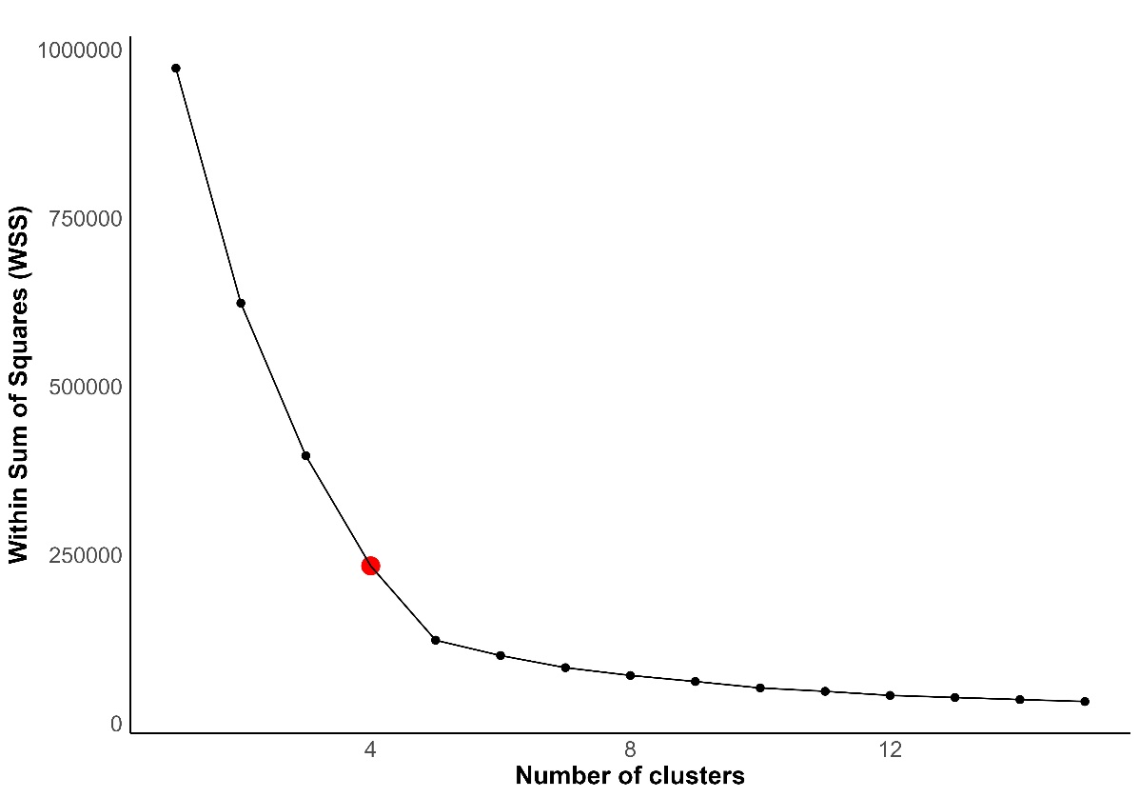

Supplementary Figure 3: Elbow plot showing the relationship between the within-cluster sum of squares (y-axis) and the number of clusters (x-axis). The red dot indicates the most representative number of clusters.

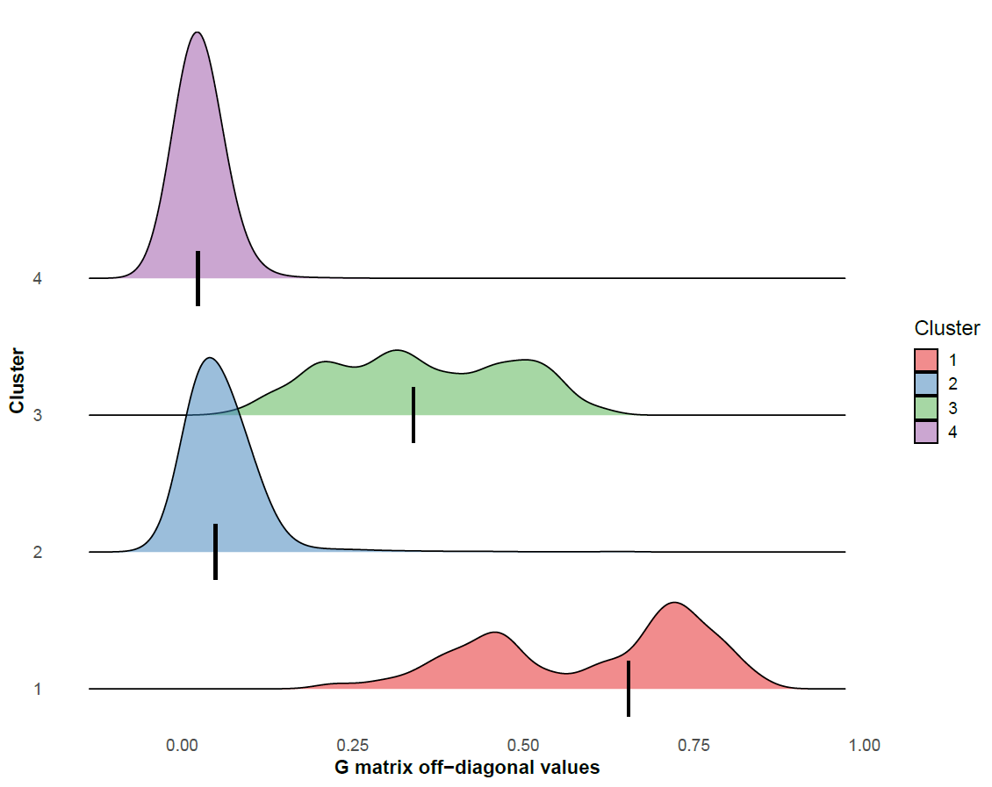

Supplementary Figure 4: Distributions of the off-diagonal values of the genomic relationship matrix (G) by genetic clusters. The short vertical lines in the distribution represent the median values. Cluster 3 and 1 have a higher genetic relationship among accessions than Cluster 2 and 4.

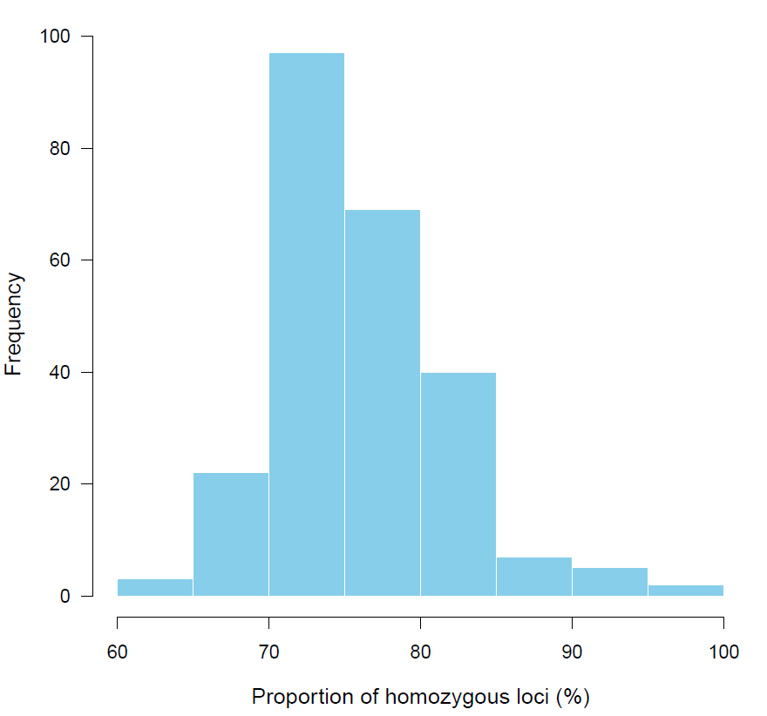
Supplementary Figure 5: Frequency of homozygous loci in the CGN population. The values on the x-axis indicate the proportion of homozygous SNP loci out of the total number of loci (in percentage %). The y-axis shows the number of accessions with a given homozygosity level.

