NKP1 – Supplementary Digital Content

SDC S1: Control cohort flow diagram

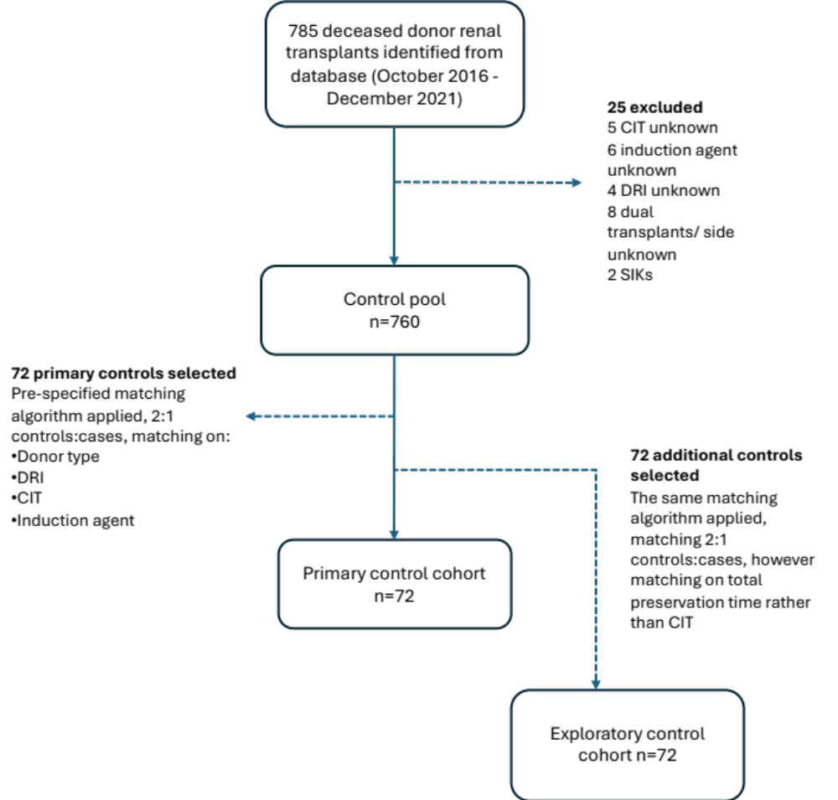

SDC Figure S1: Flow diagram showing selection of the control cohort. CIT: cold ischaemic time. DRI: donor risk index. SIK: simultaneous islet-kidney transplant.

SDC S2: Serious adverse events table
 | NMP ≤6 hours  (N = 20) | NMP 6-12 hours  (N = 12) | NMP 12-24 hours (N = 4) | Total (N = 36)
Number of participants who experienced a serious adverse event during the one-year follow-up period, n (%) | 8 (40.0) | 7 (58.3) | 3 (75.0) | 18 (50.0)
Infection | 3 (15.0) | 1 (8.3) | 3 (75.0) | 7 (19.4)
Biopsy-proven acute rejection | 1 (5.0) | 0 (0.0) | 0 (0.0) | 1 (2.8)
Ureteric complication | 1 (5.0) | 0 (0.0) | 0 (0.0) | 1 (2.8)
Vascular complication | 1 (5.0) | 1 (8.3) | 0 (0.0) | 2 (5.6)
Other | 5 (25.0) | 6 (50.0) | 0 (0.0) | 11 (30.6)
Number of serious adverse events during the one-year follow-up period, n | 17 | 12 | 5 | 34
Infection | 9 | 1 | 5 | 10
Biopsy-proven acute rejection | 1 | 0 | 0 | 1
Ureteric complication | 1 | 0 | 0 | 1
Vascular complication | 1 | 1 | 0 | 2
Other | 5 | 10 | 0 | 15
Number of deaths, n (%) | 1 (8.3) | 0 (0.0) | 0 (0.0) | 1 (2.8%)
Number of graft failures, n (%) | 1 (8.3) | 0 (0.0) | 0 (0.0) | 1 (2.8%)

SDC Table S2: Table detailing the serious adverse events recorded during the follow-up period (first 12 months following transplantation) in the trial cohort. Serious adverse events listed as ‘other’ included musculoskeletal (subacute vertebral compression fracture, n=1; pubic ramus fracture, n=1; gout, n=1); gastro-intestinal (diarrhoea associated with AKI, n=2; GI ulceration/ inflammation/ bleeding, n=2); cardiovascular (heart block, n=1); bleeding related to surgery (n=2); seroma (n=1); pyrexia of unknown origin (n=1); incisional hernia (n=2); and graft failure (n=1). Note that the number of participants with SAEs in each sub-category does not necessarily sum to the total number of participants with an SAE, as participants may have experienced an SAE in more than one sub-category.

SDC S3: NMP microbiology
Organism | Hypothermic transport perfusion fluid (number of cultures) | NMP perfusate (number of cultures) | Notes
E. coli | 2 | 0
Klebsiella oxytoca | 1 | 0
Enterococcus faecium | 1 | 1 | Same case; enterococcus faecium carried through from hypothermic to normothermic perfusate. Recipient given prophylactic course of linezolid; no clinical evidence of related infection.
Candida albicans | 1 | 0
Staphylococcus epidermidis | 3 | 0
Coagulase negative staphylococcus (species not specified) | 4 | 0
Lactobacillus paracasaei | 1 | 0
Lactobacillus rhamnosus | 1 | 1 | Same case; lactobacillus rhamnosus carried through from hypothermic to normothermic perfusate. Recipient not treated, and no clinical evidence of infection.
Weissella cibaria | 1 | 0

SDC Table S3: Table detailing organisms grown in perfusate for the 36 trial cases – data are shown for both the hypothermic preservation fluid that the organ was transported to Oxford in, and the normothermic perfusion fluid used during the intervention.
SDC S4: Clinical outcomes in cases and controls
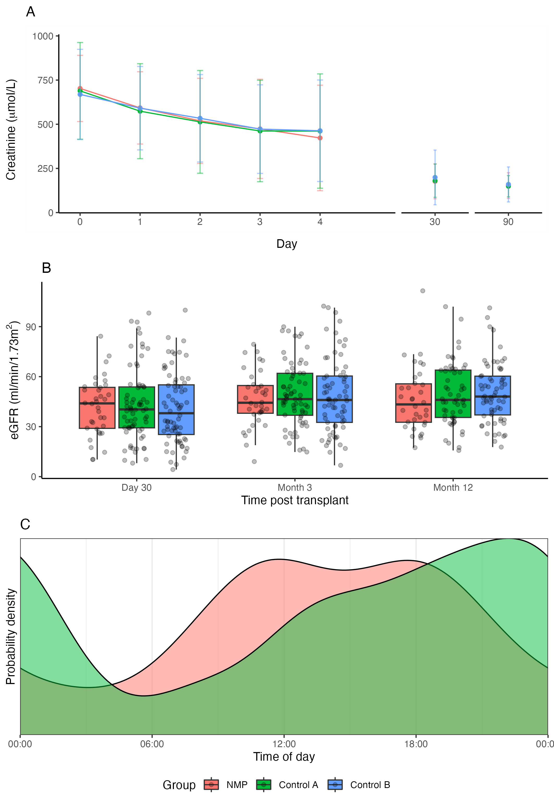
SDC Figure S4: Clinical outcomes seen post transplantation in the cases and controls. Control cohort A was the primary control cohort matched on cold ischaemia time; control cohort B was an additional exploratory cohort matched on total preservation time. A: creatinine (mean±SD) in the first four days post-transplant, at 30 days, and at 90 days. B: calculated eGFR in all three cohorts at 30 days, 3 months, and 12 months post-transplant. C: probability density plot showing time of day of reperfusion in the trial cases, and the primary control cohort.

SDC S5: Additional perfusion biochemistry and machine data
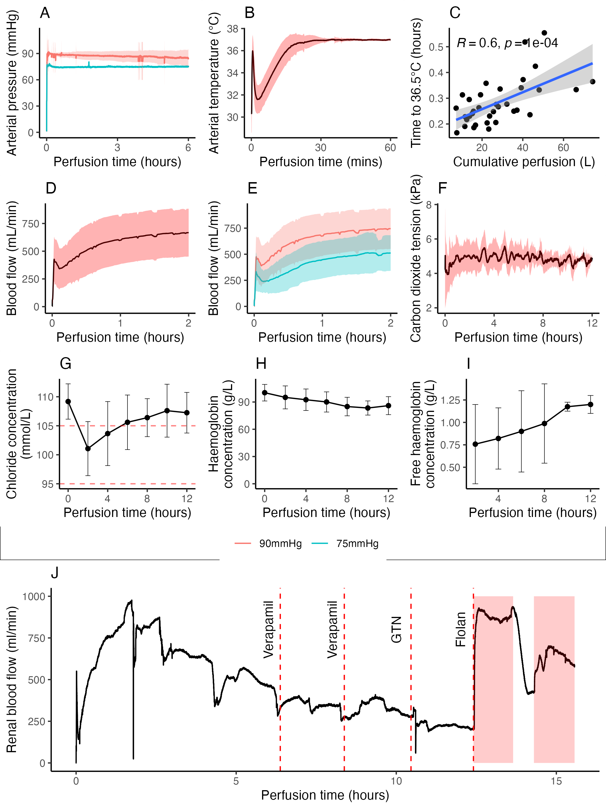
SDC Figure S5: Additional perfusate biochemistry and machine data. A: Pressure during perfusion, split by cohort (first 24 cases perfused at 90mmHg, last 12 cases perfused at 75mmHg). B: perfusate temperature following ex-situ reperfusion (mean±SD). C: time taken to re-warm to 36.5°C, against cumulative perfusion volume to that time. D: renal blood flow during the first two hours of perfusion (mean±SD). E: renal blood flow split by perfusion pressure group (mean±SD). F: carbon dioxide tension in the perfusate during perfusion (mean±SD). G: perfusate chloride concentration during perfusion (mean±SD). H: perfusate total haemoglobin concentration during perfusion (mean±SD). I: perfusate cell-free haemoglobin concentration during perfusion (mean±SD). J: renal blood flow over time for a single case (kidney 30), illustrating effect of different vasodilators.

SDC S6: NMP dose effect (perfusion duration vs outcome)
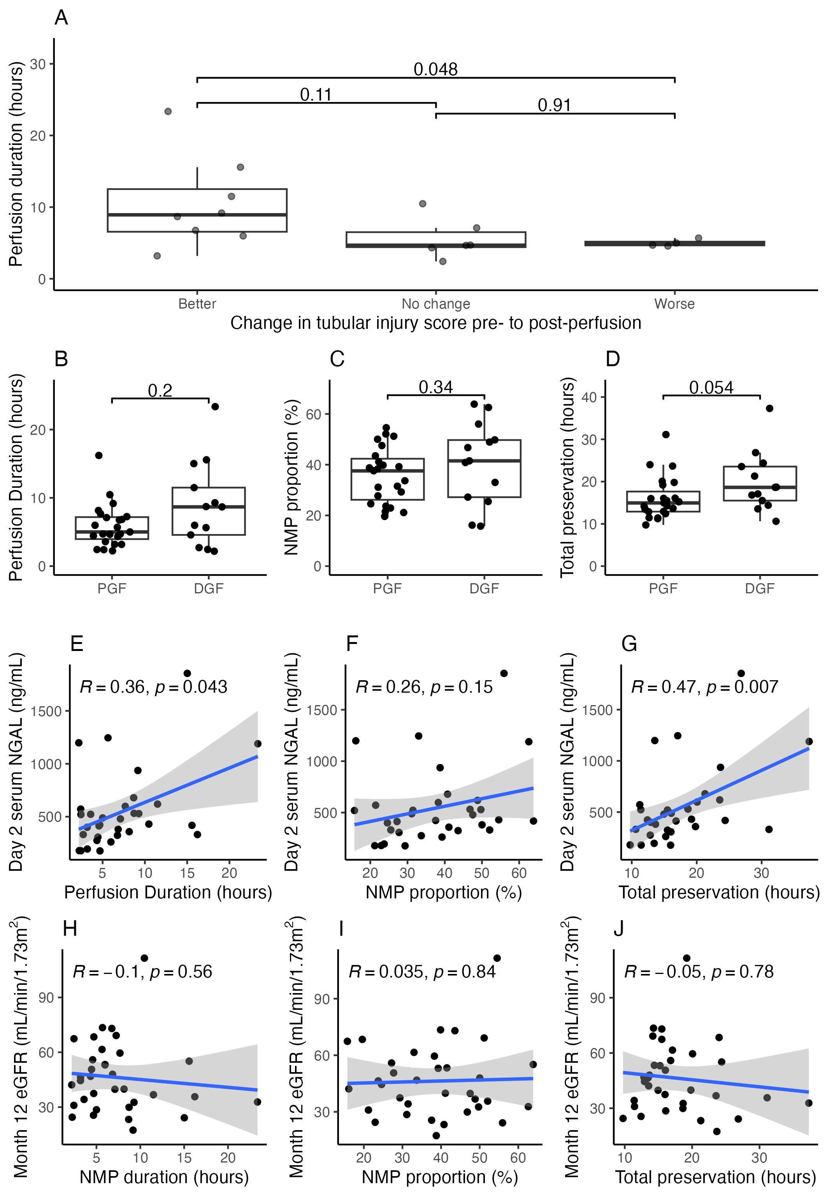
SDC Figure S6: Evaluation of the effect of NMP duration on outcome. A: pre- and post-perfusion biopsies were assessed by an independent pathologist blinded to perfusion duration. Acute tubular injury scores were compared pre- and post-perfusion, and classified as better post-perfusion, unchanged, or worse post-perfusion. B-D: the median perfusion duration (B, Wilcoxon signed-rank test), mean NMP proportion of the total preservation time (C, T-test), and median total preservation time (D, Wilcoxon signed-rank test) was compared between immediate function and DGF groups. E-G: post-transplant day 2 NGAL concentration correlated against perfusion duration (E) NMP proportion of the total preservation time (F), and perfusion duration (G, all by linear regression, Pearson correlation coefficient shown for the proportion, Spearman correlation coefficient shown for the durations). H-j: month 12 eGFR was correlated against perfusion duration (H) NMP proportion of the total preservation time (I), and perfusion duration (J, all by linear regression, Pearson correlation coefficient shown for the proportion, Spearman correlation coefficient shown for the durations).

SDC S7: Additional control cohort demographic data
Variable |  |  | NKP1 | Additional control cohort
Timings
First CIT, hours, median (IQR) |  |  | 8.57 (3.49) | 15.33 (6.36)
Normothermic machine perfusion time, hours, median (IQR) |  |  | 5.83 (4.54) | -
Second CIT, minutes, median (IQR) |  |  | 68.4 (30) | -
Total preservation time, hours, median (IQR) |  |  | 15.74 (6.35) | 15.33 (6.36)
Recipients
Age, years, mean (sd) |  |  | 59.2 (12.0) | 56.1 (13.0)
Sex, male, n (%) |  |  | 24/36 (67%) | 49/72 (68%)
BMI, mean (sd) |  |  | 28.1 (5.8) | 29.4 (6.3)
Dialysis modality, n (%) |  | HD | 22/36 (61%) | 45 (63%)
 |  | PD | 10/36 (28%) | 15 (21%)
 |  | Predialysis | 4/36 (11%) | 12 (17%)
Induction immunosuppression, n (%) | Alemtuzumab |  | 26/36 (72%) | 52/72 (72%)
Induction immunosuppression, n (%) | Basiliximab |  | 10/36 (28%) | 20/72 (28%)
Donors
Donor age, years, mean (sd) |  |  | 54.0 (15.8) | 52.4 (15.1)
Donor type, n (%) |  | DBD | 20/36 (56%) | 40 (56%)
 |  | DCD | 16/36 (44%) | 32 (44%)
Donor sex, male, n (%) |  |  | 23/36 (64%) | 42/72 (58%)
Donor BMI, mean (sd) |  |  | 28.3 (6.4) | 27.2 (5.5)
Donor history of hypertension, yes, n (%) |  |  | 18/36 (50%) | 29/72 (40%)
Donor risk index (DRI), mean (sd) |  |  | 1.36 (0.59) | 1.35 (0.56)
HLAMM group, n (%)* |  | 1 | 0/36 (0%) | 6/68 (9%)
 |  | 2 | 9/36 (25%) | 10/68 15%)
 |  | 3 | 19/36 (53%) | 34/68 (50%)
 |  | 4 | 8/36 (22%) | 18/68 (26%)

SDC Table S7: Demographic data for the addition, exploratory, control cohort matched on total preservation time. CIT: cold ischaemic time. HD: haemodialysis. PD: peritoneal dialysis. IQR: interquartile range. HLAMM: human leucocyte antigen mismatches. DRI: donor risk index.

SDC S8: Additional control cohort outcomes
Variable | NKP1 | Additional control cohort | Comparison
30-day graft survival , n (%) | 36/36 (100%) | 72/72 (100%) | NS
30-day patient survival, n (%) | 36/36 (100%) | 72/72 (100%) | NS
3-month patient survival, n (%) | 36/36 (100%) | 70/72 (97%) | NS
12-month patient survival, n (%) | 35/36 (97%) | 70/72 (97%) | NS
3-month graft survival, n (%) | 36/36 (100%) | 70/70 (100%) | NS
12-month graft survival, n (%) | 34/35 (97%) | 69/70 (99%) | NS
DGF (dialysis, any) - incidence, n (%) | 13/36 (36%) | 25/72 (35%) | NS
fDGF - incidence, n (%) | 18/36 (50%) | 41/69 (59.4%) | NS
Day 2 CRR, mean (SD) | 0.16 (0.20) | 0.09 (0.22) | NS
PNF, n (%) | 0/36 (0%) | 0/72 (0%) | NS
30-day eGFR, mean (SD) | 41.9 (17.4) | 40.9 (21.0) | NS
3-month eGFR, mean (SD) | 46.5 (16.4) | 48.7 (22.4) | NS
12-month eGFR, mean (SD) | 46.3 (19.3) | 50.3 (18.2) | NS
Creatinine gradient (month 3-12), mean (SD) | -2 (46) | -8 (38) | NS
Biopsy-proven acute rejection within 12 months - incidence, n (%) | 1/36 (2.8%) | 5/72 (6.9%) | NS

SDC Table S8: Clinical outcomes for the addition, exploratory, control cohort matched on total preservation time. DGF: delayed graft function. HD: haemodialysis. fDGF: functional delayed graft function (any use of dialysis in the first 7 days post-transplant or failure of creatinine to fall >10% per day for the first three days). CRR: creatinine reduction ratio. PNF: primary non-function. eGFR: estimated glomerular filtration rate.

SDC S9: Additional biomarker data (function)
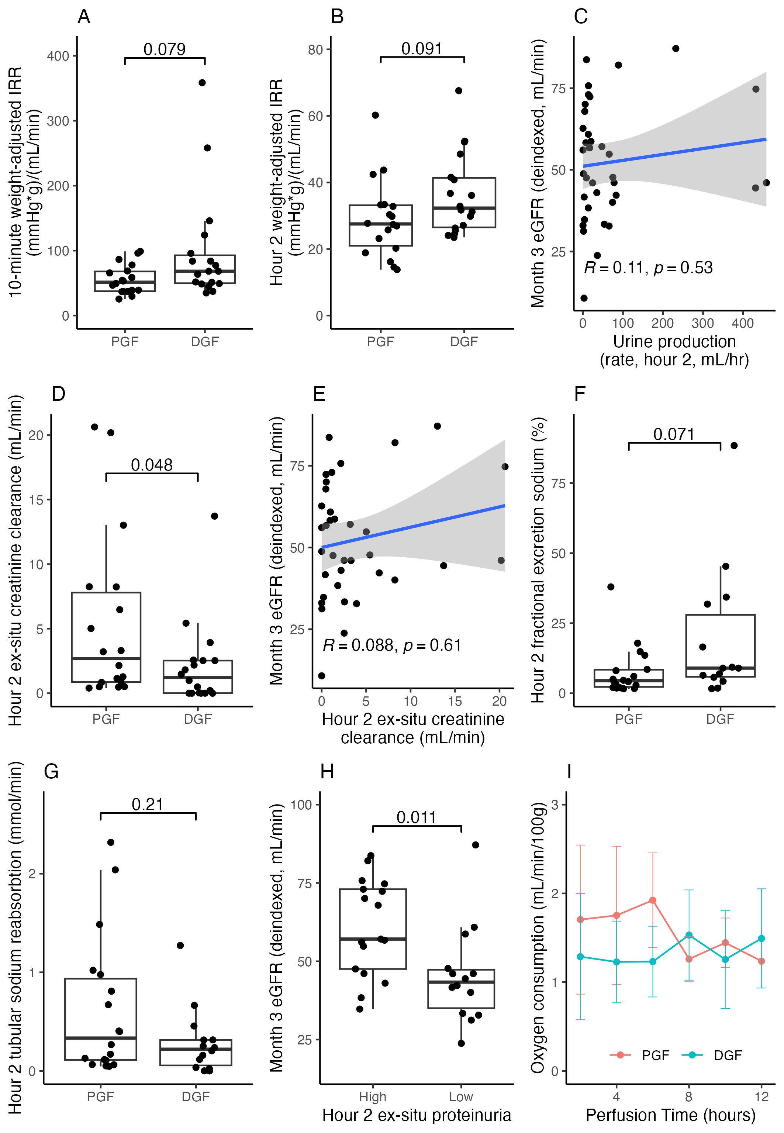
SDC Figure S9: Additional biomarkers (markers of ex-situ renal function). A and B: weight-adjusted vascular resistance measured at minute 10 (A) and hour 2 (B), compared between functional DGF and immediate-function cohorts (Wilcoxon signed-rank tests). C: cumulative urine output to hour 2 correlated against deindexed month 3 eGFR (linear regression, Spearman correlation coefficient shown). D and E: ex-situ creatinine clearance, measured at hour 2, shown against immediate function status (D, Wilcoxon signed-rank test) and month 3 eGFR (E, linear regression, Spearman correlation coefficient shown). F and G: fractional excretion of sodium (F), and the tubular sodium absorption rate (G), both measured at hour 2, split by immediate function status (Wilcox signed-rank tests). H: proteinuria, quantified at hour 2 and dichotomised at ≥4g/L versus <4g/L, shown against deindexed month 3 eGFR (T-test). I: oxygen consumption over time during perfusion, split by immediate function status.

SDC S10: Additional biomarker data (injury)
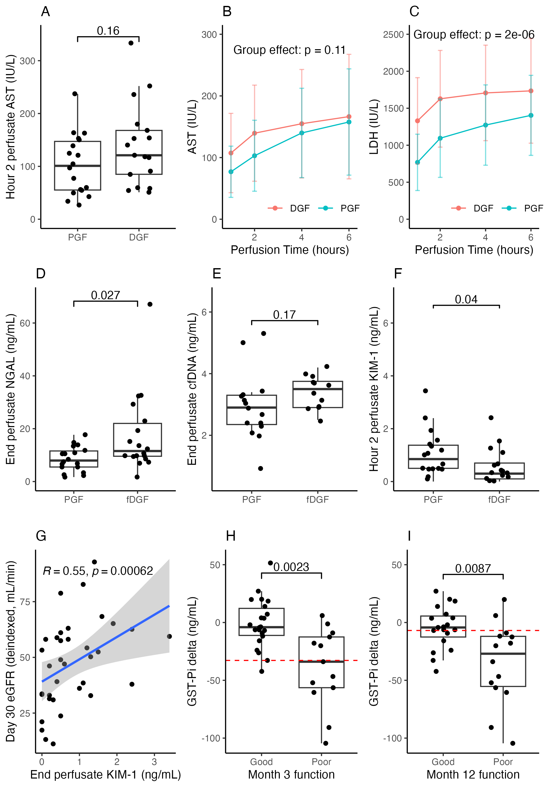

SDC Figure S10: Additional biomarkers (measures of ex-situ renal injury). A and B: perfusate AST, split by immediate function status, measured at hour 2 (A, T-test), and over time during perfusion (B, two-way analysis of variance). C: LDH over time during perfusion (two-way analysis of variance). D-F: NGAL (D), cell-free DNA (E), and KIM-1 (F) measured in the perfusate at the end of perfusion, split by immediate function status (cfDNA – T-tests, NGAL and KIM-1 – Wilcoxon signed-rank tests). G: perfusate KIM-1 (end of perfusion) correlated against day 30 eGFR (linear regression, Spearman correlation coefficient shown). H and I: the trial cohort was divided into good and poor functional groups using an eGFR cut-off of 45mL/min. Delta GST-Pi (difference between perfusate concentration at hour 2 and at the end of perfusion) was compared between these groups at 3- and 12-months post-transplant (T-tests). Red dashed lines indicated classifier cut-offs identified by ROC analysis.

