Supplementary Information for:
The overlapping global distribution of dengue, chikungunya, Zika and yellow fever
Contents
Supplementary Table 1. Data sources and the number of occurrence data extracted from each source 2
Supplementary Table 2. Number of occurrence points for each disease before and after the removal of spatial duplicates (thinning). 3
Supplementary Table 3. Occurrence data for other emerging acute viral infectious diseases. 4
Supplementary Table 4. Covariates included in the models. 5
Supplementary Table 5. Questionnaire for independent validation of preliminary results presented to the Technical Advisory Group on Arbovirus (TAG-Arbovirus) 6
Supplementary Figure 1. Comparing occurrence data for each disease between published and newly added datasets for each disease. 7
Supplementary Figure 2. Occurrence data for all viral diseases which is used in the surveillance model. 8
Supplementary Figure 3. Relative contribution of each covariate in explaining the global surveillance capability (a); partial dependence plots showing the effects of each covariate on the overall response and their 95% confidence intervals (b). 9
Supplementary Figure 4. The degree of uncertainty (interquartile range of 100 predictions) around surveillance capability model predictions. 10
Supplementary Figure 5. Overall and regionally-stratified model performance metrics for the global surveillance capability model, including the Area Under the Curve (AUC), sensitivity, and specificity. 11
Supplementary Figure 6. Spatial map illustrating the model performance of the global surveillance capability model, as measured by the Area Under the Curve (AUC). 12
Supplementary Figure 7. Relative contribution of each covariate in explaining the global environmental suitability for dengue, chikungunya, and Zika (a); partial dependence plots showing the effects of each covariate on the overall response and their 95% confidence intervals (b). 13
Supplementary Figure 8. Model predicted environmental suitability of dengue (a), chikungunya (b), and Zika (c). Areas without a suitable temperature range for transmission have been set to 0. 14
Supplementary Figure 9. A comparison of arbovirus model performance with and without disease-specific thermal suitability included as a covariate. 15
Supplementary Figure 10. The degree of uncertainty (interquartile range of 100 predictions) around dengue (a), chikungunya (b), Zika (c), and yellow fever (d) risk predictions, ranging from 0 (very little uncertainty) to 0.05 (the greatest uncertainty). 16
Supplementary Figure 11. Overall and regionally-stratified model performance metrics for the arbovirus and yellow fever models, including the Area Under the Curve (AUC), sensitivity, and specificity. 17
Supplementary Figure 12. Spatial map illustrating the model performance of the arbovirus (a-c) and yellow fever models (d), as measured by the Area Under the Curve (AUC). 18
Supplementary Figure 13. Relative contribution of each covariate in explaining the global environmental suitability for yellow fever (a); partial dependence plots showing the effects of each covariate on the overall response and their 95% confidence intervals (b). 19
Supplementary Figure 14. A comparison of yellow fever model performance with and without Aedes aegypti included as a covariate. 20
Supplementary Figure 15. Covariates included in the surveillance capability model. 21
Supplementary Figure 16. Covariates included in the arbovirus and yellow fever models. 22
References 23

Supplementary Table 1. Data sources and the number of occurrence data extracted from each source
Disease | Data | Number of occurrence data | Years covered | Source
Acute viral diseases | Published dataset | 69,426 | 2006-2014 | ¹
 | HealthMap | 385,944 | 2006-2019 | www.healthmap.org
Dengue | Published dataset | 13,604 | 1960-2015 | ²
 | HealthMap | 23,527 | 2015-2019 | www.healthmap.org
 | Others | 96 | 2015-2024 | ^{3–8}
Chikungunya | Published dataset | 1,211 | 1952-2015 | ⁹
 | HealthMap | 1,330 | 2015-2019 | www.healthmap.org
 | ProMed mail | 531 | 2015-2022
 | Others | 10,974 | 2015-2024 | ^{10–13}
Zika | Published dataset | 237 | 1953-2016 | ¹⁴
 | HealthMap | 3,398 | 2015-2019 | www.healthmap.org
 | ProMed mail | 773 | 2015-2022
Yellow fever | Published dataset | 1,175 | 1927-2016 | ¹
 | HealthMap | 1,400 | 2015-2019 | www.healthmap.org
 | Others | 105 | 2015-2024 | ^{4,15}

Supplementary Table 2. Number of occurrence points for each disease before and after the removal of spatial duplicates (thinning).
 | Dengue | Chikungunya | Zika | Yellow fever
Before thinning | 37227 | 14046 | 4408 | 2680
After thinning | 5867 | 4727 | 1138 | 1395

Supplementary Table 3. Occurrence data for other emerging acute viral infectious diseases.
Disease | Total occurrence data
Avian influenza H5N1 | 5036
Chicken pox | 4069
Chikungunya | 15113
Common cold | 1452
Crimean-Congo haemorrhagic fever | 940
Dengue | 130907
Eastern equine encephalitis | 2819
Ebola | 63948
Enterovirus infection | 972
Hepatitis A | 4649
Hepatitis B | 2008
Hepatitis C | 4157
Hepatitis D | 70
Hepatitis E | 543
Herpes | 703
HIV/AIDS | 15103
Influenza | 81755
Japanese encephalitis | 1991
La Crosse encephalitis | 148
Lassa fever | 2319
Machupo virus | 12
Marburg fever | 206
Measles | 30252
Mononucleosis | 162
MPOX | 383
Mumps | 5573
Murray Valley encephalitis | 106
Nipah and Nipah-like virus disease | 893
Parvovirus | 1135
Polio | 8062
Powassan | 288
Rabies | 22040
Respiratory syncytial virus | 789
Rift Valley fever | 988
Roseola | 9
Ross River virus | 326
Rotavirus | 1008
Rubella | 1746
Shingles | 191
St. Louis encephalitis | 242
Tick-borne encephalitis | 416
Venezuelan equine encephalitis | 169
Viral meningitis | 863
West Nile fever | 26420
Western equine encephalitis | 2
Yellow fever | 4247
Zika | 10140

Supplementary Table 4. Covariates included in the models.
 | Covariate | Years covered | Original spatial resolution | Data source
Surveillance factors | Gross Domestic Product (5km x 5km and aggregated national level) | 2009-2019 | 1 km | ¹⁶
Surveillance factors | Proportion of urban land | 2010 and 2020 | 1 km | ¹⁷
Surveillance factors | Travel time to healthcare facilities (walking) | 2020 | 1 km | ¹⁸
Surveillance factors | Travel time to cities (>50,000 people, any travel mode) | 2015 | 1 km | ¹⁸
Surveillance factors | Proportion of febrile children who sought treatment at any (public or private) healthcare facility | 2010-2022 | National | ¹⁹
Surveillance factors | Child mortality under five years old | 2013-2020 | National | ^{20,21}
Surveillance factors | Government effectiveness | 2013-2020 | National | ^{21,22}
Surveillance factors | Physicians density | 2010-2018 | National | ^{21,23}
Transmission factors | Temperature suitability for dengue virus transmission | 2010-2020 | 5 km | ²⁴
Transmission factors | Mean temperature of the coldest month | 2010-2020 | 5 km | ²⁵
Transmission factors | Average of annual precipitation | 2010-2020 | 5 km | ²⁵
Transmission factors | Normalized Difference Vegetation Index (NDVI) | 2010-2020 | 5 km | ²⁶
Transmission factors | Dynamic Habitat Indices (DHI) | - | 1 km | ²⁷
Transmission factors | Predicted suitability for Aedes aegypti | 2020 | 5 km | ²⁸
Transmission factors | Predicted suitability for Aedes albopictus* | 2020 | 5 km | ²⁸
Transmission factors | Gross Domestic Product (aggregated national level) | 2009-2019 | National | ¹⁶
Transmission factors | Human population density | 2022 | 5 km | ²⁹
Transmission factors | Predicted suitability for Haemagogus janthinomys** | 2020 | 1 km | ³⁰
Transmission factors | Non-human primate distribution** | 2017 | 5 km | ¹
Transmission factors | Yellow fever vaccination coverage** | 2020 | Admin1 | ³¹
* included in combined dengue, chikungunya, and Zika model only. ** included in yellow fever model only.

Supplementary Table 5. Questionnaire for independent validation of preliminary results presented to the Technical Advisory Group on Arbovirus (TAG-Arbovirus)
Category | # | Question
Data | 1 | Are you aware of any additional locations where any of these arboviral diseases are present?
Surveillance capability map | 2 | Do our estimates of relative surveillance intensity for viral pathogens within and between countries match your expectations?
Surveillance capability map | 3 | Are there any additional drivers of surveillance capability?
Arbovirus maps | 4 | Any areas where any of these diseases are present, but where we predict absence?
Arbovirus maps | 5 | Any areas where any of these diseases are absent, but where we predict presence?
Arbovirus maps | 6 | Additional drivers of arbovirus risk?
Arbovirus maps | 7 | Are there any differences in the distribution of these diseases that we have not captured in these risk maps?

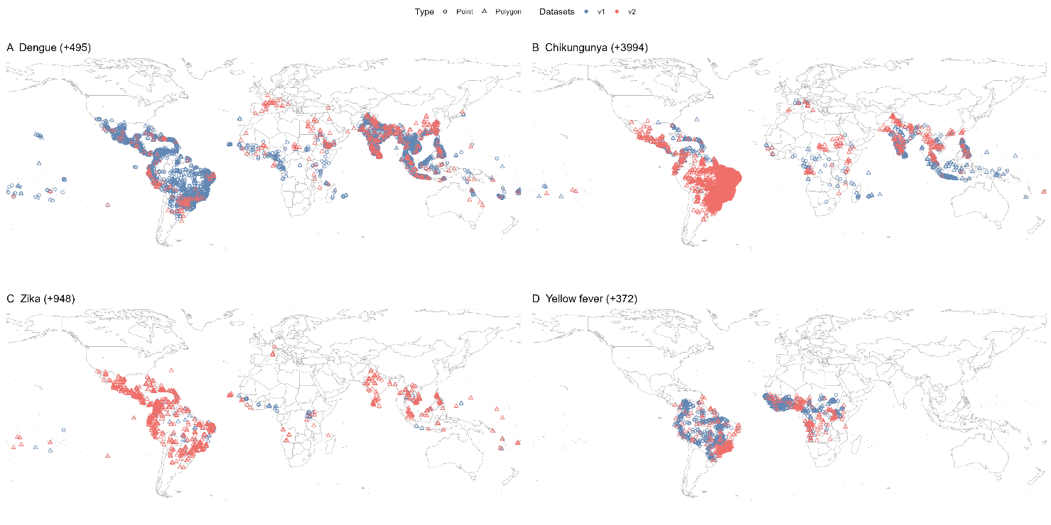

Supplementary Figure 1. Comparing occurrence data for each disease between published and newly added datasets for each disease.
Maps show the unique locations of occurrence data for dengue, chikungunya, Zika, and yellow fever. These data combine existing datasets (blue) with new additions identified through this study (red). The number of newly added unique occurrence locations for each disease is indicated in brackets.

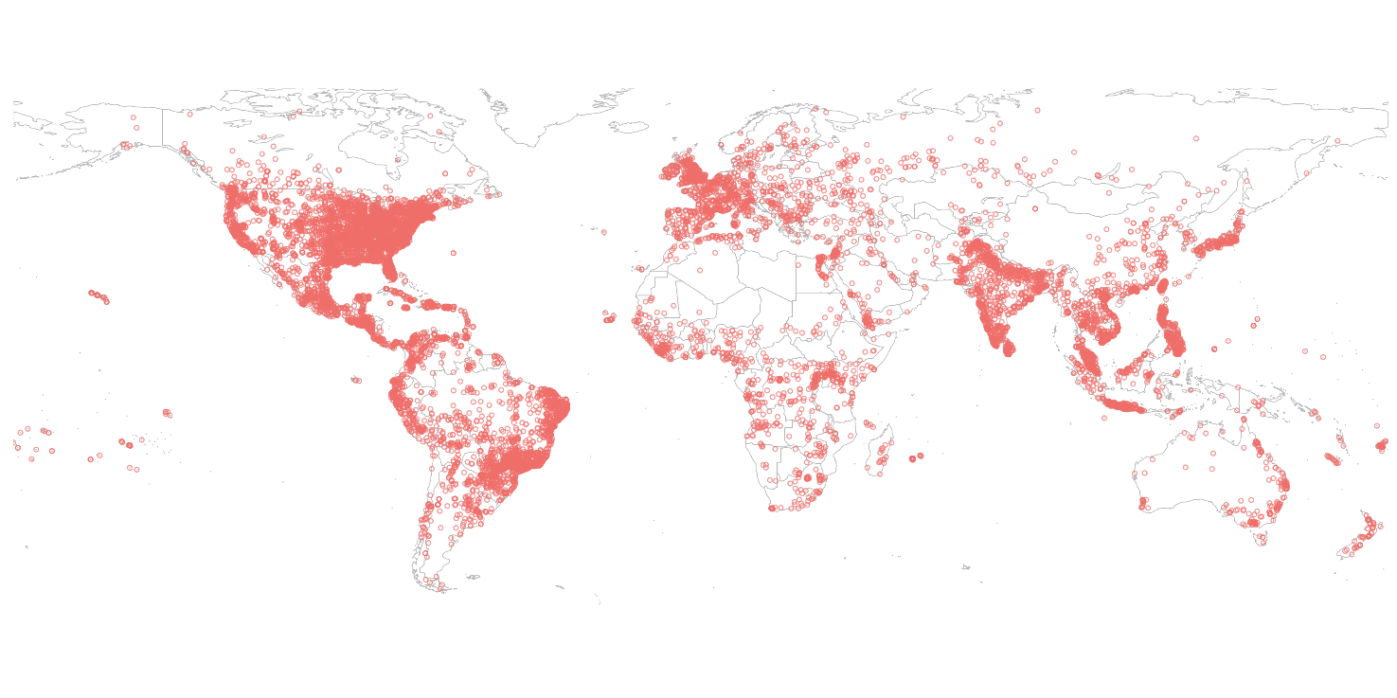

Supplementary Figure 2. Occurrence data for all viral diseases which is used in the surveillance model.

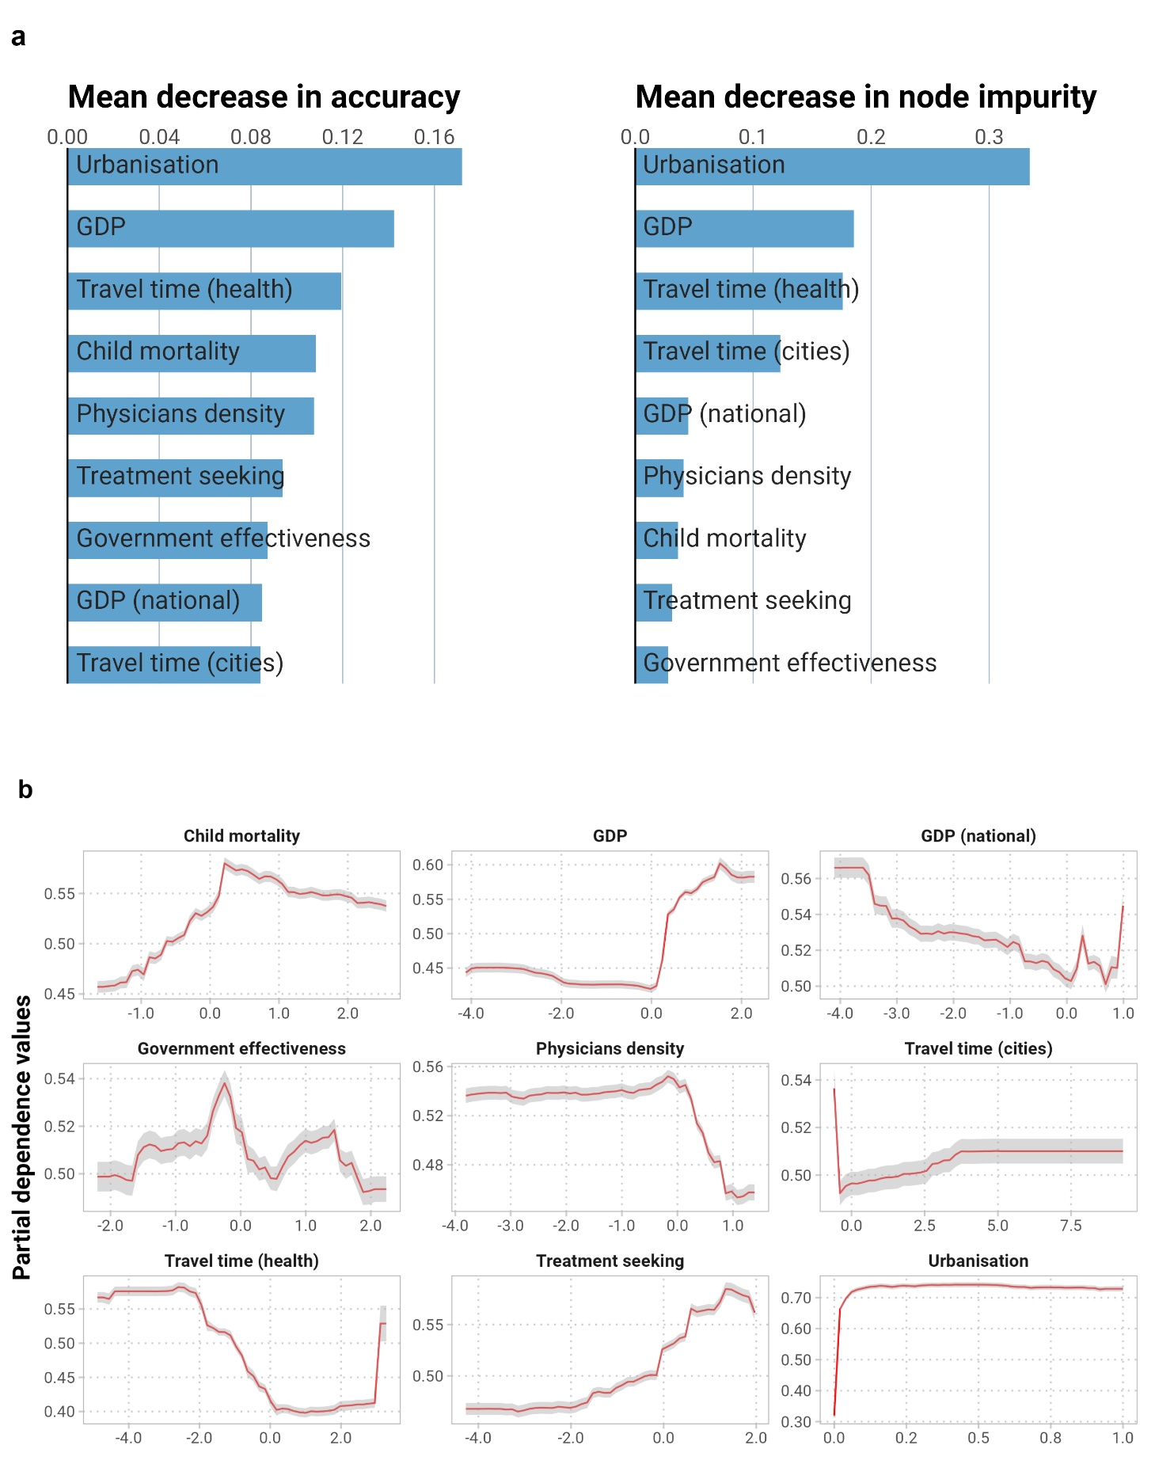

Supplementary Figure 3. Relative contribution of each covariate in explaining the global surveillance capability (a); partial dependence plots showing the effects of each covariate on the overall response and their 95% confidence intervals (b).

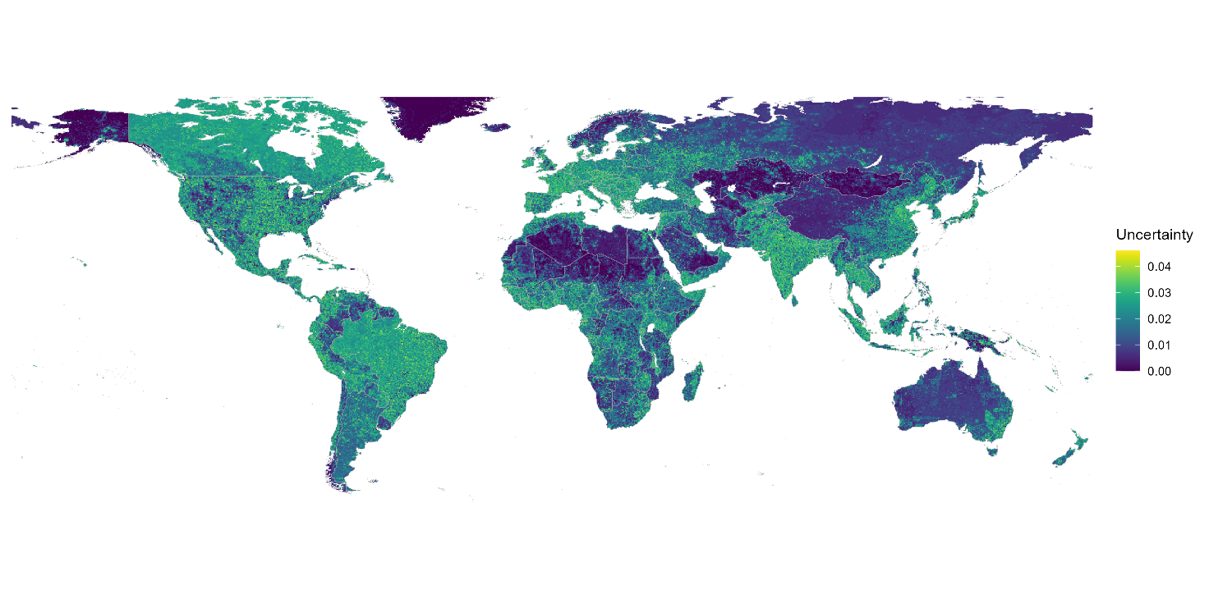

Supplementary Figure 4. The degree of uncertainty (interquartile range of 100 predictions) around surveillance capability model predictions.

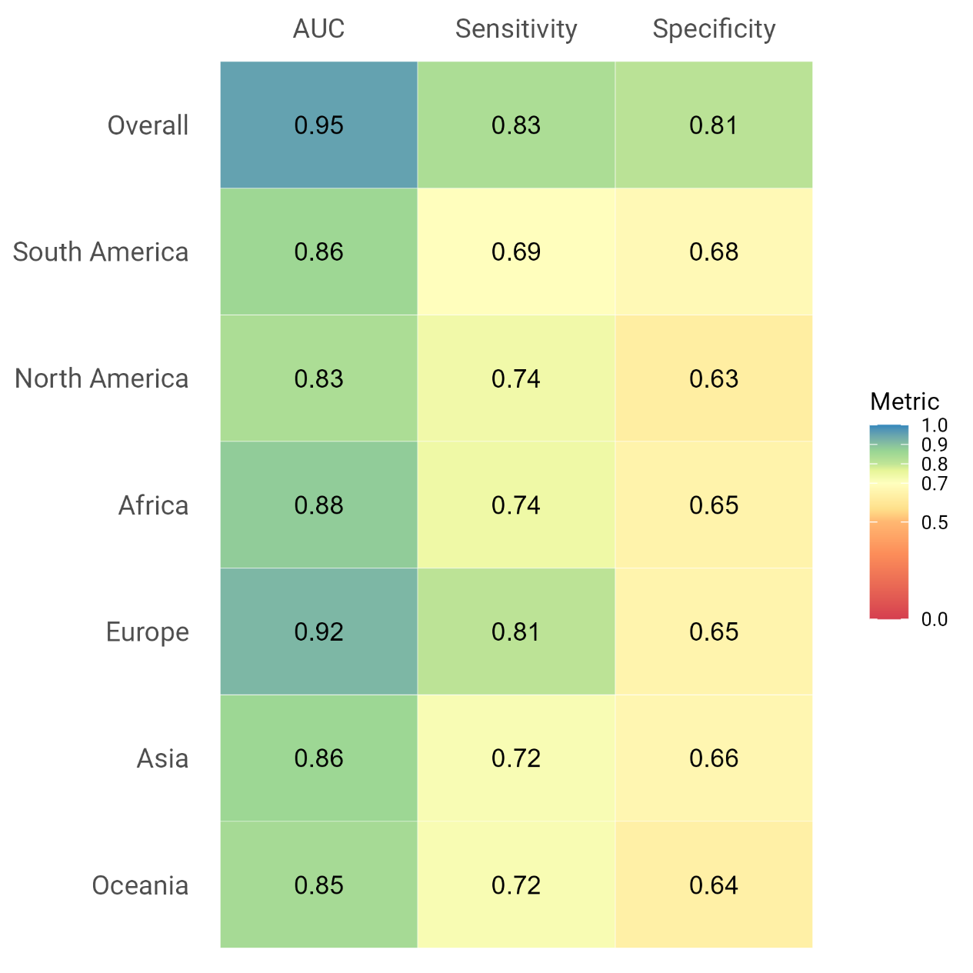

Supplementary Figure 5. Overall and regionally-stratified model performance metrics for the global surveillance capability model, including the Area Under the Curve (AUC), sensitivity, and specificity.

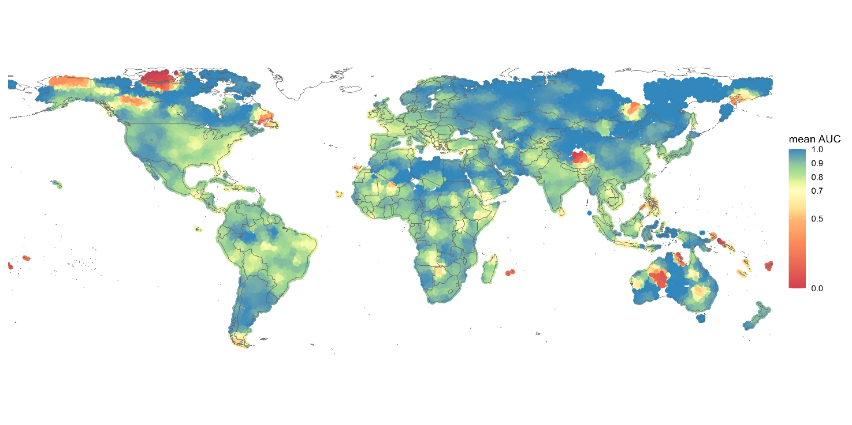

Supplementary Figure 6. Spatial map illustrating the model performance of the global surveillance capability model, as measured by the Area Under the Curve (AUC).

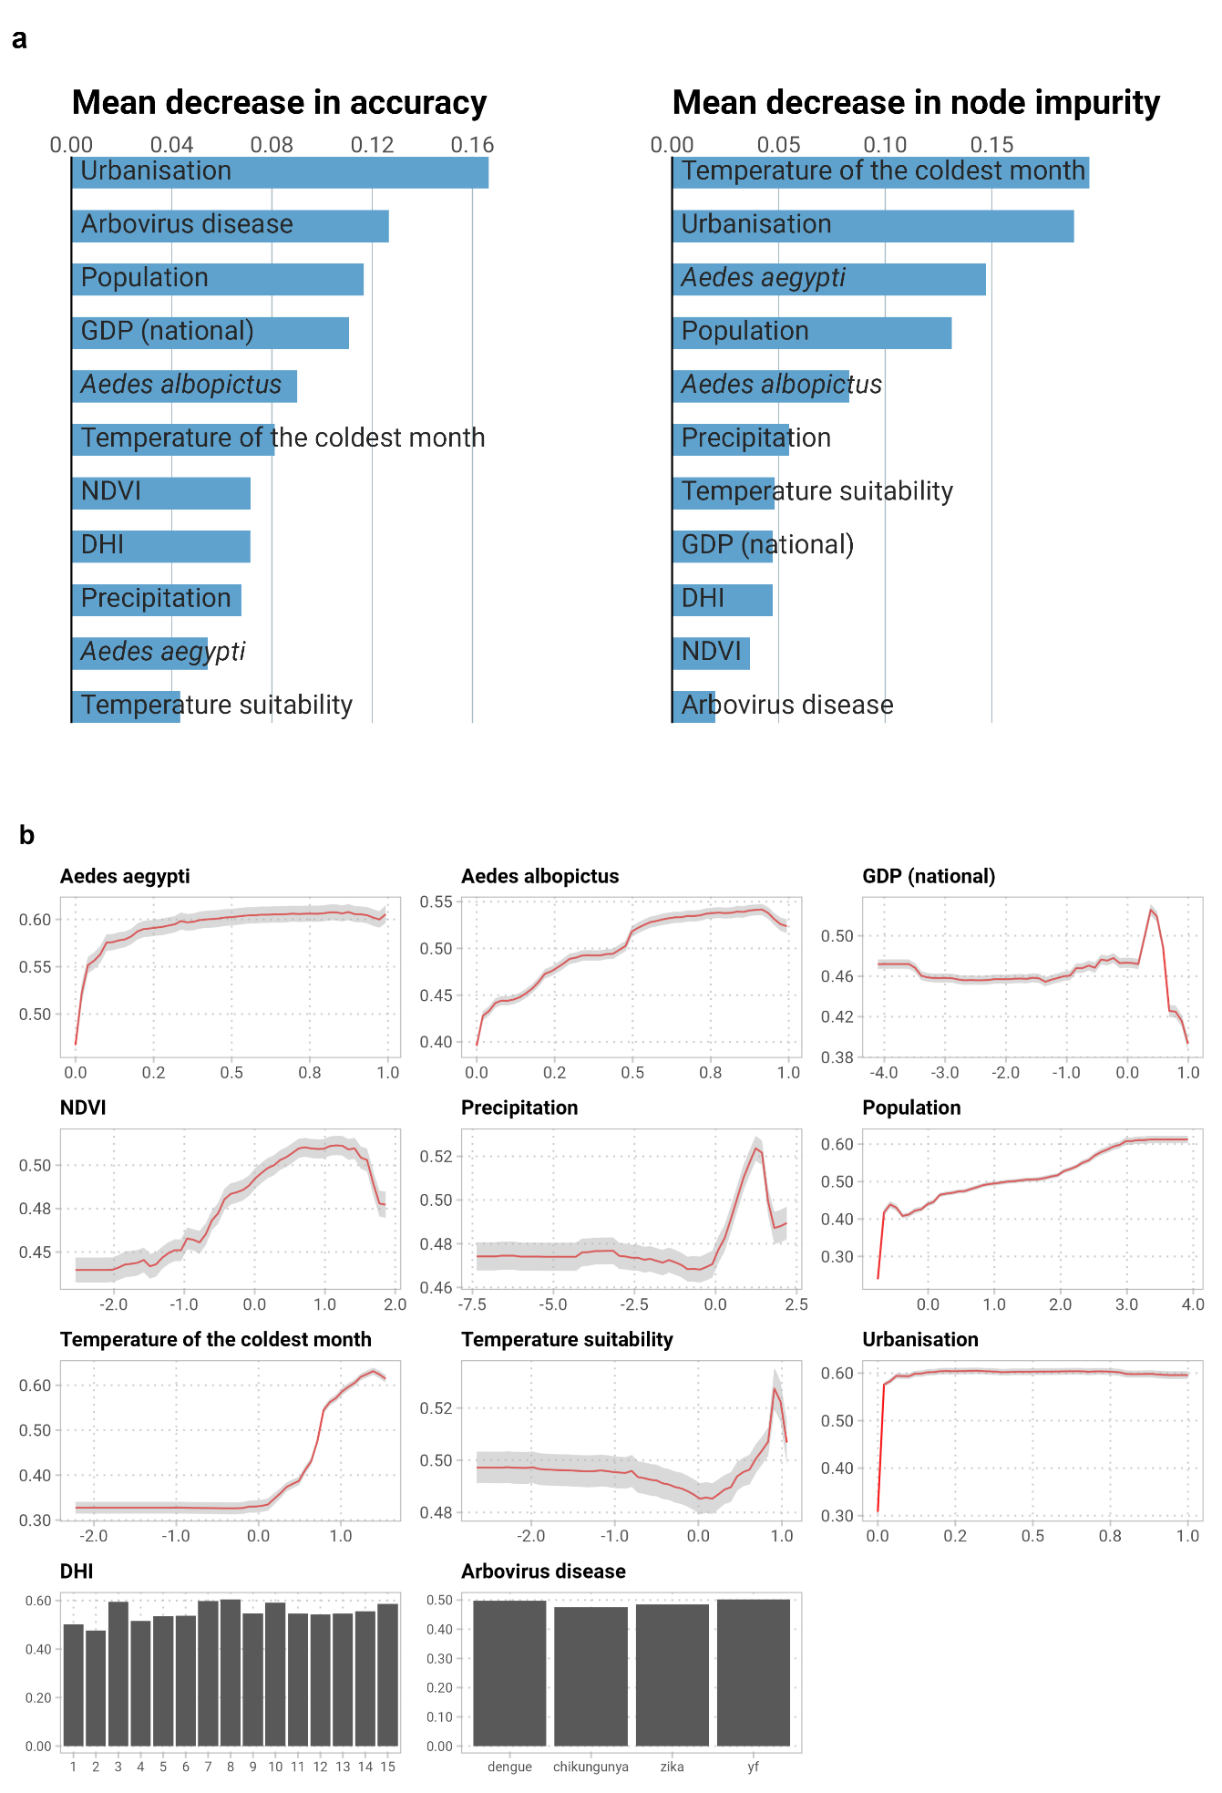

Supplementary Figure 7. Relative contribution of each covariate in explaining the global environmental suitability for dengue, chikungunya, and Zika (a); partial dependence plots showing the effects of each covariate on the overall response and their 95% confidence intervals (b).
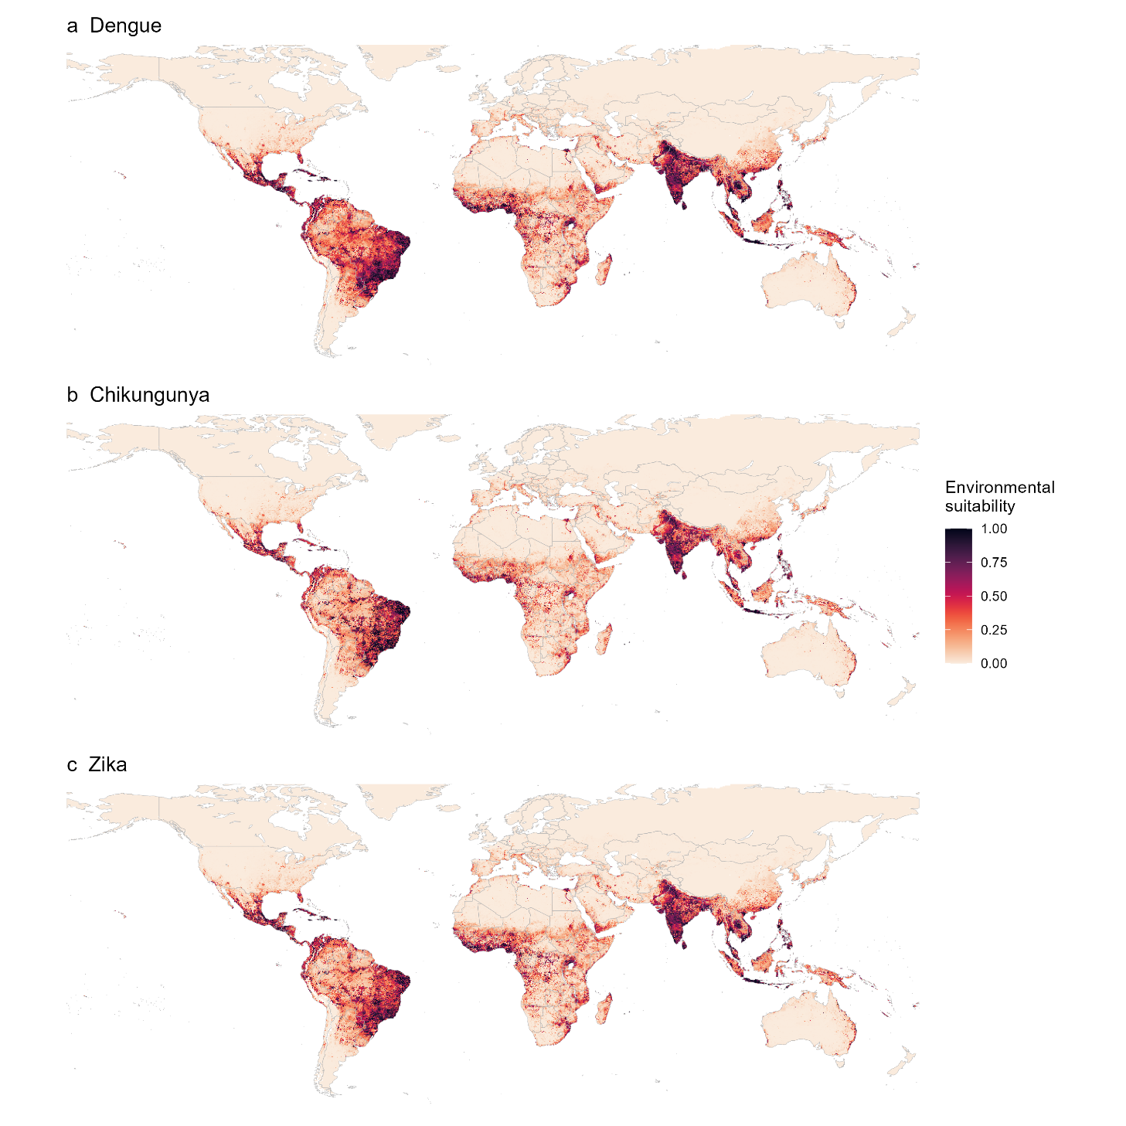

Supplementary Figure 8. Model predicted environmental suitability of dengue (a), chikungunya (b), and Zika (c). Areas without a suitable temperature range for transmission have been set to 0.

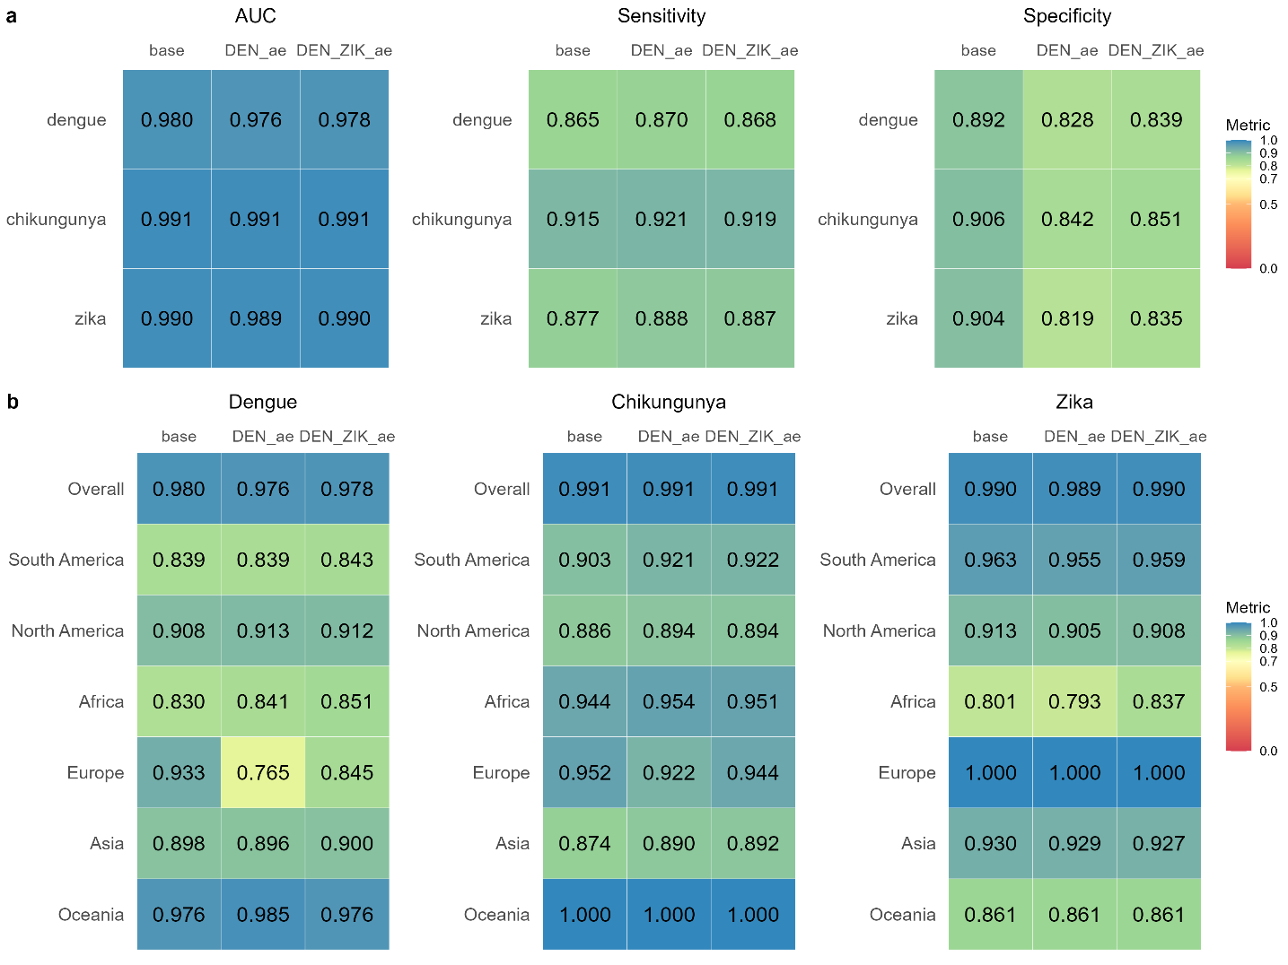

Supplementary Figure 9. A comparison of arbovirus model performance with and without disease-specific thermal suitability included as a covariate.
Heatmaps show the model performance metrics, including Area Under the Curve (AUC), sensitivity and specificity across the world, stratified by disease (a) and AUC only stratified by region and disease (b). We assess the performance of the base model (the model presented throughout the manuscript) against models incorporated alternative specifications between temperature and transmission risk^{32,33}. Specifically, we compare the base model with two variants: one with the temperature suitability layer in the base model replaced by thermal suitability for dengue in Aedes aegypti³⁴ ("DEN_ae") and another including suitability layers for both dengue and Zika in Ae. aegypti ("DEN_ZIK_ae")³⁵. Each model was assessed using a 50-fold block cross-validation approach, as detailed in the main text.

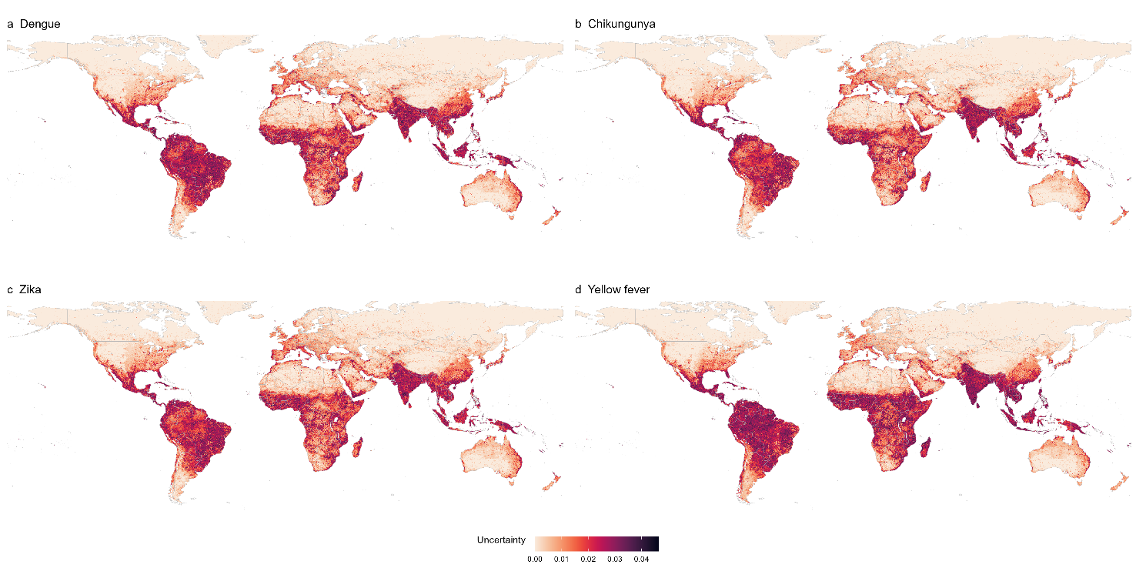

Supplementary Figure 10. The degree of uncertainty (interquartile range of 100 predictions) around dengue (a), chikungunya (b), Zika (c), and yellow fever (d) risk predictions, ranging from 0 (very little uncertainty) to 0.05 (the greatest uncertainty).

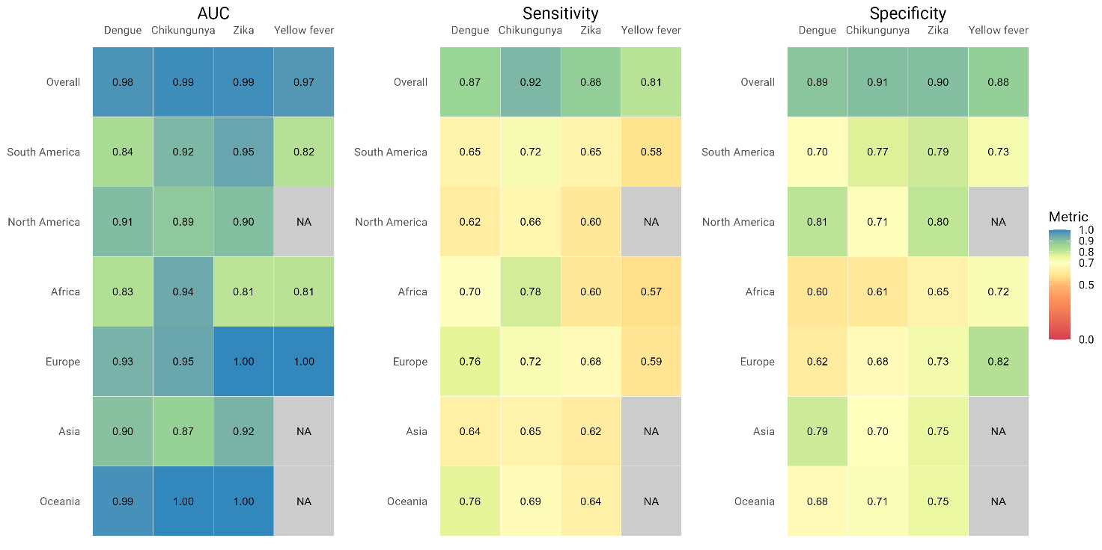

Supplementary Figure 11. Overall and regionally-stratified model performance metrics for the arbovirus and yellow fever models, including the Area Under the Curve (AUC), sensitivity, and specificity.

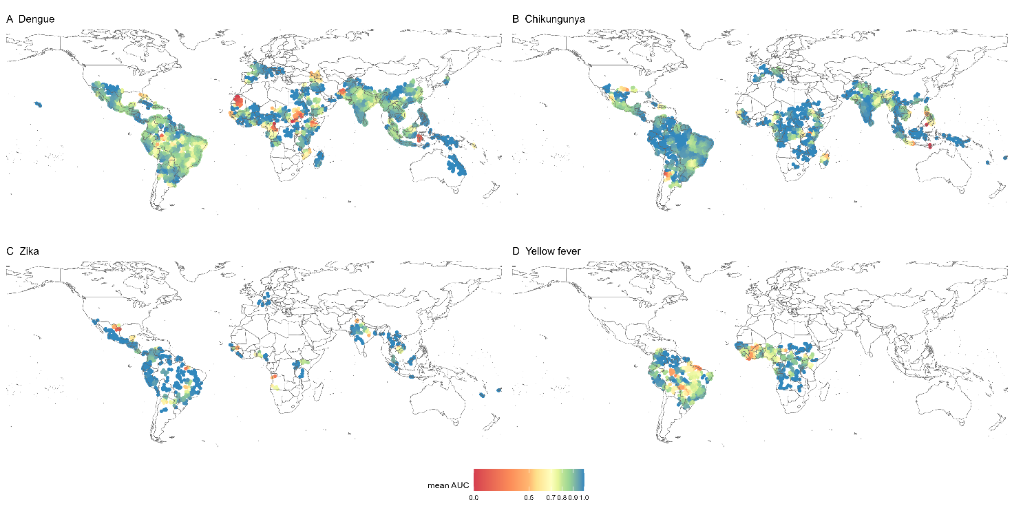

Supplementary Figure 12. Spatial map illustrating the model performance of the arbovirus (a-c) and yellow fever models (d), as measured by the Area Under the Curve (AUC).

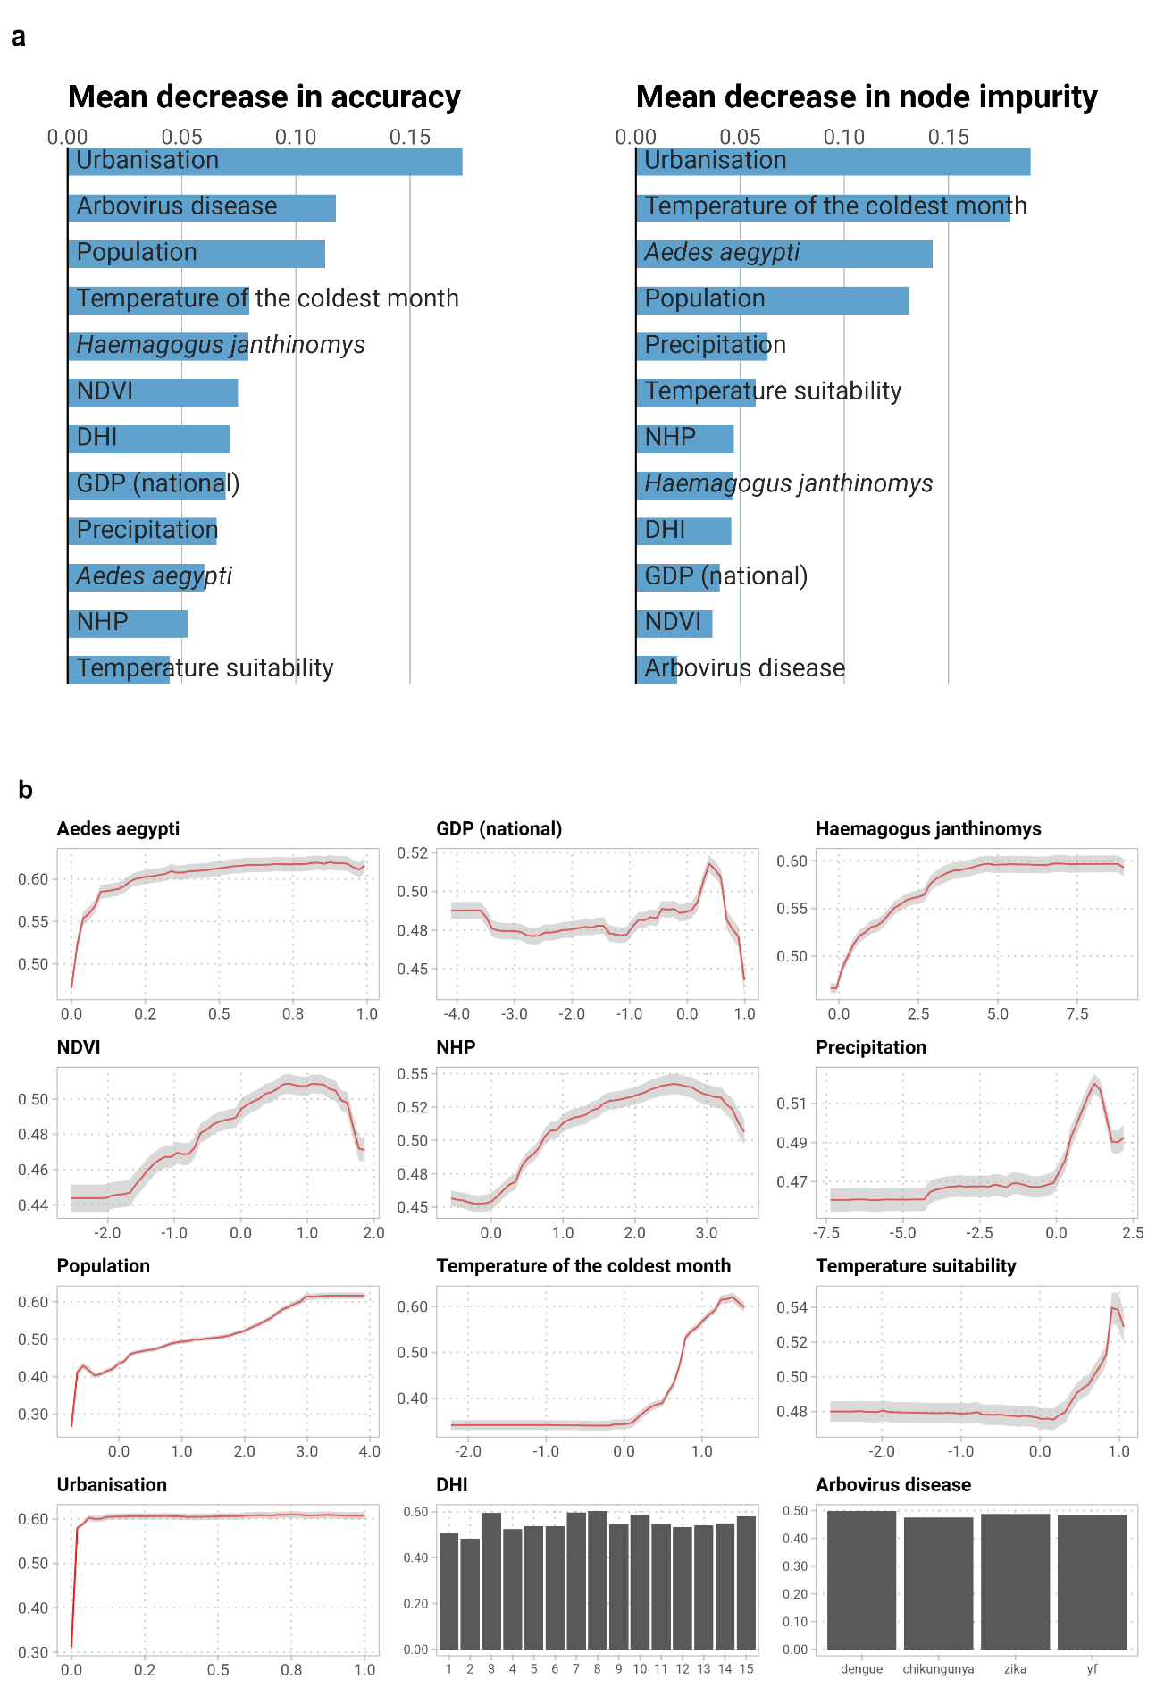

Supplementary Figure 13. Relative contribution of each covariate in explaining the global environmental suitability for yellow fever (a); partial dependence plots showing the effects of each covariate on the overall response and their 95% confidence intervals (b).
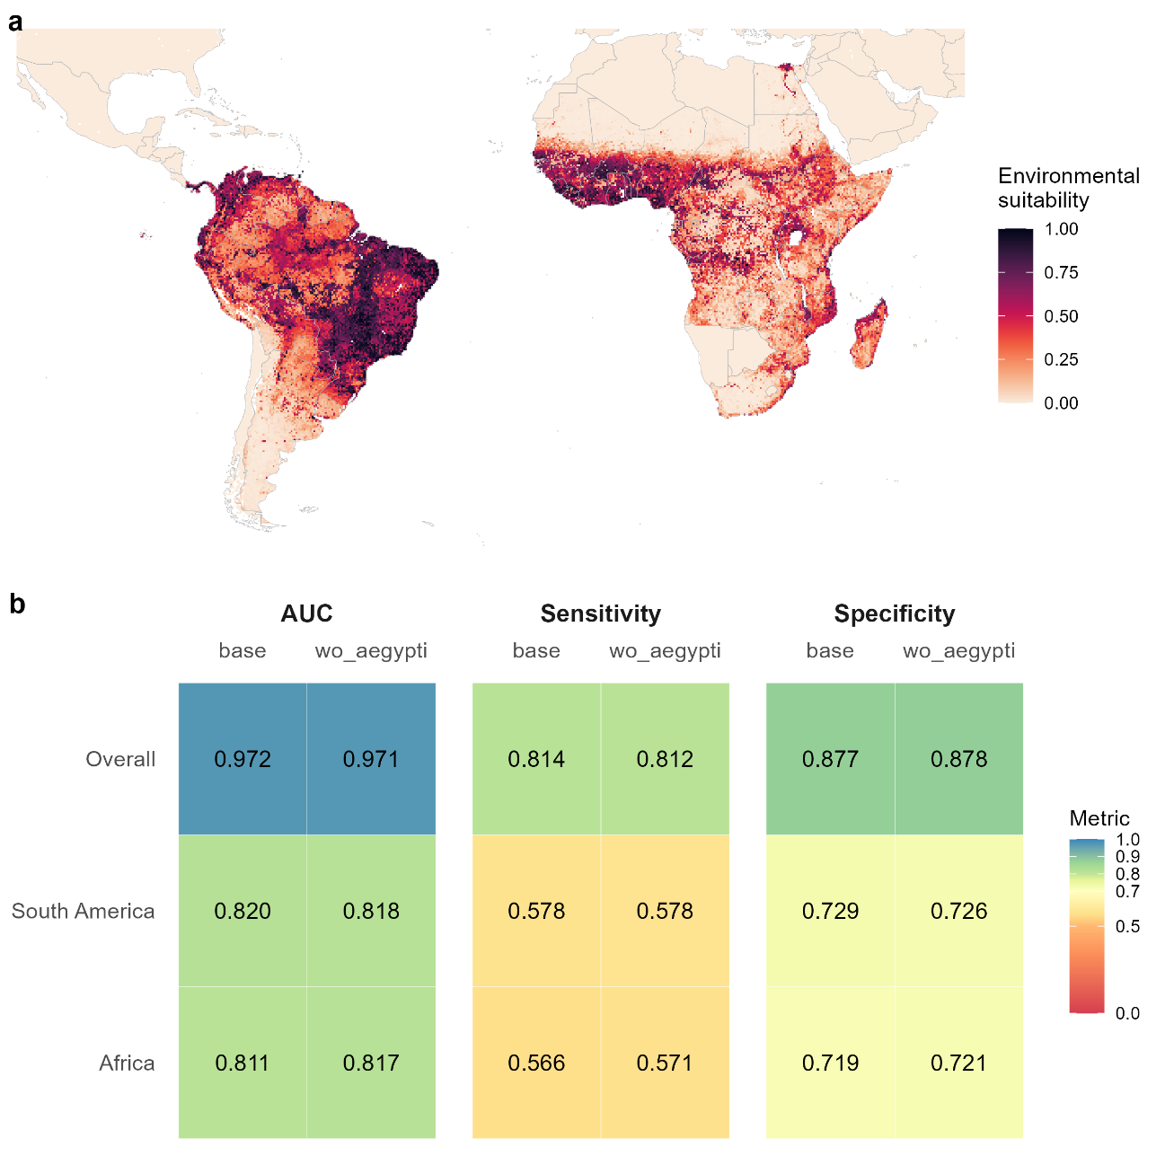

Supplementary Figure 14. A comparison of yellow fever model performance with and without Aedes aegypti included as a covariate.
Predicted environmental suitability of yellow fever after excluding the Aedes aegypti covariate from the yellow fever model (a). Heatmaps show the model performance metrics, including Area Under the Curve (AUC), sensitivity and specificity stratified by region (b). We compare the performance of the base model (as presented in the section “Environmental niche model”) with an alternative version of model without Ae. aegypti covariate (“wo_aegypti”). Each model was assessed using a 50-fold block cross-validation approach, as detailed in the main text.

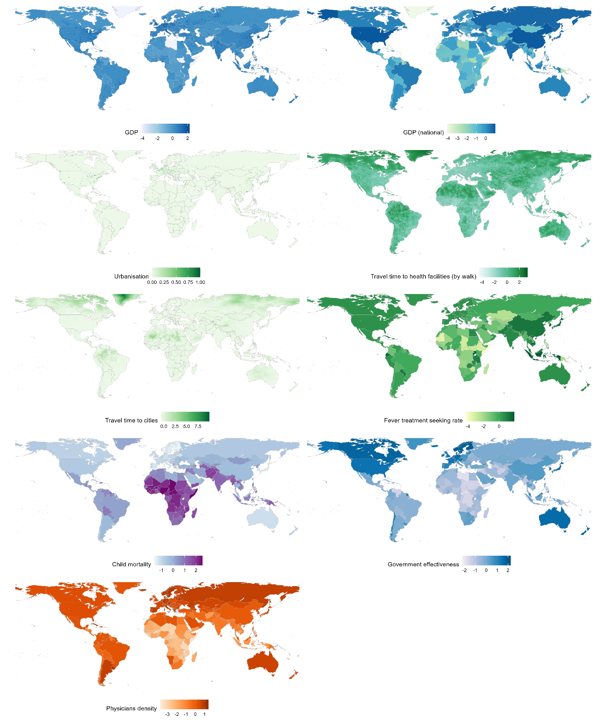

Supplementary Figure 15. Covariates included in the surveillance capability model.

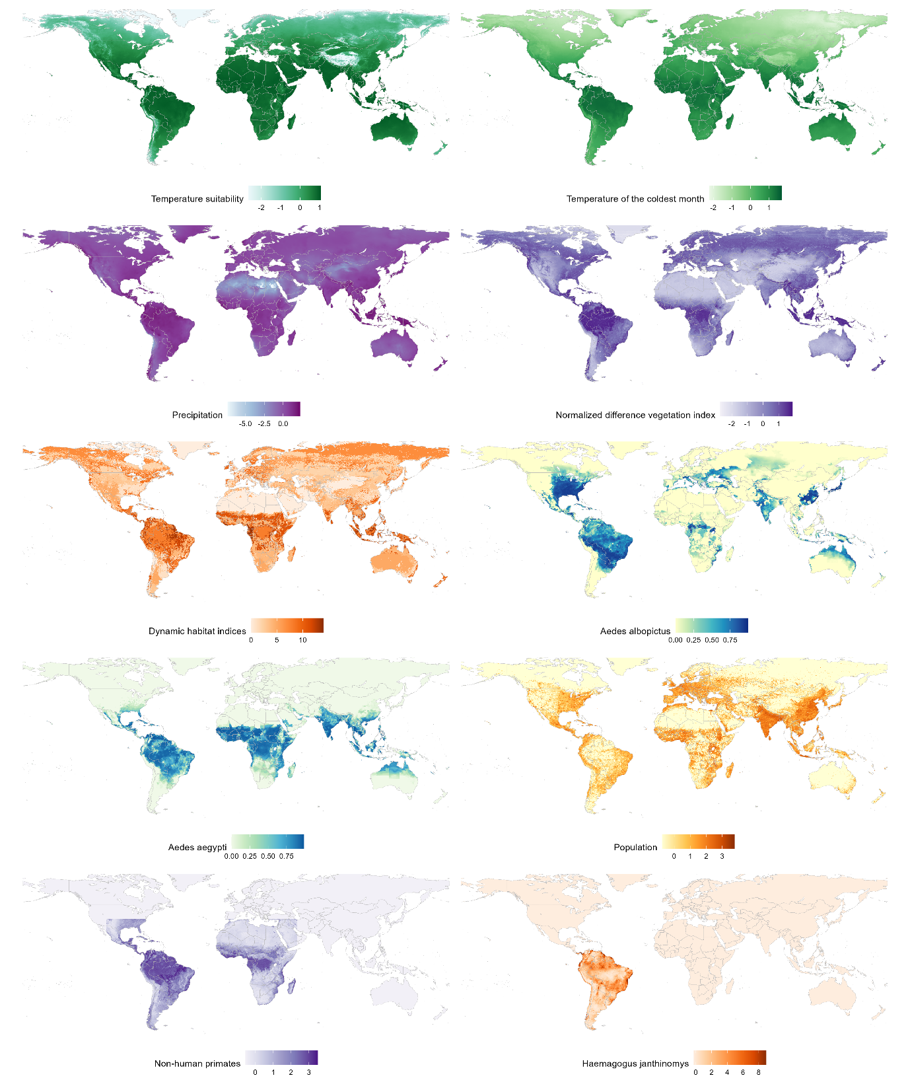

Supplementary Figure 16. Covariates included in the arbovirus and yellow fever models.

References
1. Shearer, F. M. et al. Existing and potential infection risk zones of yellow fever worldwide: a modelling analysis. The Lancet Global Health 6, e270–e278 (2018).
2. Messina, J. P. et al. The current and future global distribution and population at risk of dengue. Nat Microbiol 4, 1508–1515 (2019).
3. ECDC. Autochthonous vectorial transmission of dengue virus in mainland EU/EEA, 2010-present. https://www.ecdc.europa.eu/en/all-topics-z/dengue/surveillance-and-disease-data/autochthonous-transmission-dengue-virus-eueea (2023).
4. Disease Outbreak News. https://www.who.int/emergencies/disease-outbreak-news.
5. Frequent Import and Multiple Sources of Dengue Fever have Changed the Epidemic Situation of the Disease in Fujian Province, China. https://www.besjournal.com/en/article/doi/10.3967/bes2020.016.
6. Ren, J. et al. Epidemiology of Indigenous Dengue Cases in Zhejiang Province, Southeast China. Front Public Health 10, 857911 (2022).
7. Yu, Y., Liu, Y., Ling, F., Sun, J. & Jiang, J. Epidemiological Characteristics and Economic Burden of Dengue in Zhejiang Province, China. Viruses 15, 1731 (2023).
8. Sang, S., Yue, Y., Wang, Y. & Zhang, X. The epidemiology and evolutionary dynamics of massive dengue outbreak in China, 2019. Front. Microbiol. 14, (2023).
9. Nsoesie, E. O. et al. Global distribution and environmental suitability for chikungunya virus, 1952 to 2015. Eurosurveillance 21, 30234 (2016).
10. ECDC. Chikungunya worldwide overview. https://www.ecdc.europa.eu/en/chikungunya-monthly (2023).
11. ECDC. Autochthonous transmission of chikungunya virus in mainland EU/EEA, 2007–present. https://www.ecdc.europa.eu/en/infectious-disease-topics/z-disease-list/chikungunya-virus-disease/surveillance-threats-and (2019).
12. Wu, D. et al. Chikungunya Outbreak in Guangdong Province, China, 2010. Emerg Infect Dis 18, 493–495 (2012).
13. Souza, W. M. de et al. Spatiotemporal dynamics and recurrence of chikungunya virus in Brazil: an epidemiological study. The Lancet Microbe 4, e319–e329 (2023).
14. Messina, J. P. et al. Mapping global environmental suitability for Zika virus. eLife 5, e15272 (2016).
15. Pan American Health Organization / World Health Organization (PAHO/WHO). Epidemiological Update - Yellow fever in the Region of the Americas - 25 April 2023. https://www.paho.org/en/documents/epidemiological-update-yellow-fever-region-americas-25-april-2023 (2023).
16. Chen, J. et al. Global 1 km × 1 km gridded revised real gross domestic product and electricity consumption during 1992–2019 based on calibrated nighttime light data. Sci Data 9, 202 (2022).
17. Gao, J. & O’Neill, B. C. Mapping global urban land for the 21st century with data-driven simulations and Shared Socioeconomic Pathways. Nat Commun 11, 2302 (2020).
18. Weiss, D. J. et al. Global maps of travel time to healthcare facilities. Nature Medicine 2020 26:12 26, 1835–1838 (2020).
19. Nguyen, M. et al. Trends in treatment-seeking for fever in children under five years old in 151 countries from 1990 to 2020. PLOS Global Public Health 3, e0002134 (2023).
20. United Nations Inter-agency Group for Child Mortality Estimation (UN IGME). Levels and Trends in Child Mortality: Report 2022. https://childmortality.org/wp-content/uploads/2023/01/UN-IGME-Child-Mortality-Report-2022.pdf.
21. INFORM Risk - Results and data.
22. Kaufmann, D. & Kraay, A. Worldwide Governance Indicators.
23. World Bank. Physicians (per 1,000 people).
24. Brady, O. J. et al. Global temperature constraints on Aedes aegypti and Ae. albopictus persistence and competence for dengue virus transmission. Parasites & Vectors 7, 338 (2014).
25. Abatzoglou, J. T., Dobrowski, S. Z., Parks, S. A. & Hegewisch, K. C. TerraClimate, a high-resolution global dataset of monthly climate and climatic water balance from 1958–2015. Sci Data 5, 170191 (2018).
26. Didan, K. MOD13C2 MODIS/Terra vegetation indices monthly L3 global 0.05 deg CMG V006. NASA EOSDIS Land Processes DAAC 10, 2015 (2015).
27. Coops, N. C., Kearney, S. P., Bolton, D. K. & Radeloff, V. C. Remotely-sensed productivity clusters capture global biodiversity patterns. Sci Rep 8, 16261 (2018).
28. Kraemer, M. U. G. et al. Past and future spread of the arbovirus vectors Aedes aegypti and Aedes albopictus. Nat Microbiol 4, 854–863 (2019).
29. Sims, K. et al. LandScan Global 2022. Oak Ridge National Laboratory https://doi.org/10.48690/1529167 (2023).
30. Celone, M. et al. An ecological niche model to predict the geographic distribution of Haemagogus janthinomys, Dyar, 1921 a yellow fever and Mayaro virus vector, in South America. PLOS Neglected Tropical Diseases 16, e0010564 (2022).
31. Hamlet, A. et al. POLICI: A web application for visualising and extracting yellow fever vaccination coverage in Africa. Vaccine 37, 1384–1388 (2019).
32. Ryan, S. J., Carlson, C. J., Mordecai, E. A. & Johnson, L. R. Global expansion and redistribution of Aedes-borne virus transmission risk with climate change. PLOS Neglected Tropical Diseases 13, e0007213 (2019).
33. Ryan, S. J. et al. Warming temperatures could expose more than 1.3 billion new people to Zika virus risk by 2050. Glob Chang Biol 27, 84–93 (2021).
34. Ryan, S. Global current Aedes aegypti suitability for dengue transmission at 97.5% CI (5 arc minutes). Harvard Dataverse https://doi.org/10.7910/DVN/NSG5UH (2019).
35. Ryan, S. Global current suitability for Aedes aegypti transmitted Zika at 97.5% CI (5 arc minutes). Harvard Dataverse https://doi.org/10.7910/DVN/TK041G (2020).

