Table S1. Lichen species identified in the present study (n = 115), with their conservation status (CESCC, 2016), total number of occurrences, and proportion of occurrences per habitat type indicated. Conservation status codes.: S5, secure; S4, apparently secure; S3, vulnerable; S4, imperiled; S5, critically Imperiled; SH, possibly extirpated.; SU, unrankable; NA, not applicable/available. Habitat type abbrev.: B, bog; B_B, bog burned; CF, coniferous forest; CF_B, coniferous forest burned; DF, deciduous forest; Fen, Fen; R, Rock.
Lichen species | Conservation status |  | # of occurrences | B | B_B | CF | CF_B | DF | Fen | R
Arctoparmelia centrifuga |  | S5 | 5 | 0.00 | 0.00 | 0.00 | 0.00 | 0.00 | 0.00 | 1.00
Bryoria americana |  | S5 | 25 | 0.12 | 0.12 | 0.56 | 0.08 | 0.04 | 0.04 | 0.04
Bryoria furcellata |  | S5 | 36 | 0.08 | 0.11 | 0.39 | 0.11 | 0.11 | 0.08 | 0.11
Bryoria fuscescens |  | S5 | 24 | 0.08 | 0.08 | 0.58 | 0.13 | 0.04 | 0.04 | 0.04
Bryoria nadvornikiana |  | S5 | 15 | 0.00 | 0.00 | 0.87 | 0.00 | 0.13 | 0.00 | 0.00
Bryoria pikei |  | S5 | 8 | 0.00 | 0.00 | 0.75 | 0.13 | 0.13 | 0.00 | 0.00
Bryoria simplicior |  | S5 | 30 | 0.10 | 0.10 | 0.47 | 0.13 | 0.03 | 0.10 | 0.07
Bryoria trichodes |  | S5 | 19 | 0.11 | 0.05 | 0.58 | 0.05 | 0.00 | 0.05 | 0.16
Calicium glaucellum |  | SU | 1 | 0.00 | 0.00 | 1.00 | 0.00 | 0.00 | 0.00 | 0.00
Calicium parvum |  | SU | 1 | 0.00 | 0.00 | 1.00 | 0.00 | 0.00 | 0.00 | 0.00
Calicium trabinellum |  | S3 | 1 | 0.00 | 0.00 | 1.00 | 0.00 | 0.00 | 0.00 | 0.00
Cetraria ericetorum |  | S5 | 8 | 0.13 | 0.13 | 0.13 | 0.13 | 0.13 | 0.00 | 0.38
Cetraria islandica |  | S5 | 3 | 0.00 | 0.00 | 0.00 | 0.00 | 0.00 | 0.33 | 0.67
Chaenotheca balsamconensis |  | SU | 1 | 0.00 | 0.00 | 0.00 | 1.00 | 0.00 | 0.00 | 0.00
Chaenotheca chrysocephala |  | SU | 2 | 0.00 | 0.00 | 1.00 | 0.00 | 0.00 | 0.00 | 0.00
Chaenothecopsis nana |  | SU | 1 | 0.00 | 0.00 | 1.00 | 0.00 | 0.00 | 0.00 | 0.00
Cladonia amaurocraea |  | S5 | 1 | 0.00 | 0.00 | 0.00 | 0.00 | 0.00 | 0.00 | 1.00
Cladonia arbuscula |  | S5 | 39 | 0.10 | 0.15 | 0.38 | 0.10 | 0.08 | 0.08 | 0.10
Cladonia bacilliformis |  | S3 | 21 | 0.00 | 0.14 | 0.48 | 0.14 | 0.14 | 0.05 | 0.05
Cladonia bellidiflora |  | S5 | 13 | 0.08 | 0.08 | 0.23 | 0.08 | 0.31 | 0.00 | 0.23
Cladonia borealis |  | S5 | 12 | 0.08 | 0.08 | 0.17 | 0.17 | 0.08 | 0.00 | 0.42
Cladonia botrytes |  | S4 | 33 | 0.09 | 0.18 | 0.36 | 0.12 | 0.12 | 0.00 | 0.12
Cladonia carneola |  | S3 | 19 | 0.11 | 0.16 | 0.68 | 0.05 | 0.00 | 0.00 | 0.00
Cladonia cenotea |  | S5 | 37 | 0.11 | 0.16 | 0.41 | 0.11 | 0.14 | 0.03 | 0.05
Cladonia chlorophaea |  | S5 | 12 | 0.08 | 0.08 | 0.58 | 0.00 | 0.08 | 0.00 | 0.17
Cladonia coccifera |  | S5 | 6 | 0.00 | 0.00 | 0.33 | 0.00 | 0.00 | 0.00 | 0.67
Cladonia coniocraea |  | S5 | 19 | 0.00 | 0.16 | 0.47 | 0.11 | 0.26 | 0.00 | 0.00
Cladonia cornuta |  | S5 | 37 | 0.08 | 0.16 | 0.41 | 0.11 | 0.14 | 0.00 | 0.11
Cladonia crispata |  | S5 | 41 | 0.10 | 0.15 | 0.37 | 0.10 | 0.12 | 0.05 | 0.12
Cladonia cristatella |  | S5 | 36 | 0.11 | 0.17 | 0.33 | 0.14 | 0.11 | 0.03 | 0.11
Cladonia cyanipes |  | S4 | 19 | 0.16 | 0.16 | 0.53 | 0.05 | 0.11 | 0.00 | 0.00
Cladonia deformis |  | S5 | 37 | 0.11 | 0.16 | 0.38 | 0.11 | 0.08 | 0.03 | 0.14
Cladonia digitata |  | S5 | 7 | 0.14 | 0.00 | 0.86 | 0.00 | 0.00 | 0.00 | 0.00
Cladonia fimbriata |  | S5 | 7 | 0.00 | 0.00 | 0.43 | 0.00 | 0.29 | 0.00 | 0.29
Cladonia glauca |  | S2 | 6 | 0.00 | 0.17 | 0.67 | 0.00 | 0.00 | 0.00 | 0.17
Cladonia gracilis |  | S5 | 32 | 0.09 | 0.19 | 0.38 | 0.13 | 0.13 | 0.00 | 0.09
Cladonia grayi |  | S4 | 31 | 0.10 | 0.19 | 0.42 | 0.10 | 0.16 | 0.00 | 0.03
Cladonia macilenta |  | S4 | 31 | 0.06 | 0.19 | 0.45 | 0.10 | 0.13 | 0.00 | 0.06
Cladonia macrophylla |  | S5 | 14 | 0.07 | 0.21 | 0.14 | 0.29 | 0.00 | 0.00 | 0.29
Cladonia merochlorophaea |  | S4 | 4 | 0.25 | 0.25 | 0.25 | 0.00 | 0.25 | 0.00 | 0.00
Cladonia multiformis |  | S4 | 6 | 0.00 | 0.00 | 0.50 | 0.00 | 0.33 | 0.00 | 0.17
Cladonia norvegica |  | S1 | 7 | 0.00 | 0.00 | 0.71 | 0.14 | 0.14 | 0.00 | 0.00
Cladonia phyllophora |  | S4 | 2 | 0.00 | 0.00 | 0.00 | 0.00 | 0.00 | 0.00 | 1.00
Cladonia pleurota |  | S5 | 11 | 0.09 | 0.09 | 0.18 | 0.27 | 0.00 | 0.00 | 0.36
Cladonia pyxidata |  | S5 | 4 | 0.00 | 0.00 | 0.25 | 0.00 | 0.00 | 0.00 | 0.75
Cladonia rangiferina |  | S5 | 39 | 0.10 | 0.15 | 0.36 | 0.10 | 0.13 | 0.03 | 0.13
Cladonia rei |  | S4 | 1 | 0.00 | 0.00 | 1.00 | 0.00 | 0.00 | 0.00 | 0.00
Cladonia squamosa |  | S5 | 4 | 0.00 | 0.00 | 0.25 | 0.00 | 0.00 | 0.00 | 0.75
Cladonia stellaris |  | S5 | 22 | 0.18 | 0.09 | 0.50 | 0.09 | 0.00 | 0.05 | 0.09
Cladonia stricta |  | S5 | 1 | 0.00 | 0.00 | 0.00 | 0.00 | 0.00 | 0.00 | 1.00
Cladonia stygia |  | S5 | 19 | 0.21 | 0.16 | 0.53 | 0.00 | 0.00 | 0.11 | 0.00
Cladonia subulata |  | S4 | 5 | 0.00 | 0.40 | 0.20 | 0.00 | 0.00 | 0.00 | 0.40
Cladonia sulphurina |  | S5 | 29 | 0.07 | 0.21 | 0.48 | 0.10 | 0.07 | 0.00 | 0.07
Cladonia symphycarpa |  | S3 | 1 | 0.00 | 0.00 | 0.00 | 0.00 | 0.00 | 0.00 | 1.00
Cladonia uncialis |  | S5 | 31 | 0.10 | 0.19 | 0.42 | 0.13 | 0.00 | 0.00 | 0.16
Cladonia verticillata |  | S5 | 3 | 0.00 | 0.00 | 0.00 | 0.00 | 0.00 | 0.00 | 1.00
Crustose |  | NA | 36 | 0.03 | 0.08 | 0.39 | 0.11 | 0.14 | 0.11 | 0.14
Evernia mesomorpha |  | S5 | 35 | 0.09 | 0.09 | 0.40 | 0.11 | 0.09 | 0.09 | 0.14
Heterodermia galactophylla |  | SH | 2 | 0.00 | 0.00 | 0.00 | 0.00 | 1.00 | 0.00 | 0.00
Hypogymnia bitteri |  | S4 | 6 | 0.00 | 0.00 | 0.83 | 0.00 | 0.17 | 0.00 | 0.00
Hypogymnia incurvoides |  | S1 | 23 | 0.09 | 0.13 | 0.52 | 0.09 | 0.13 | 0.00 | 0.04
Hypogymnia physodes |  | S5 | 37 | 0.08 | 0.14 | 0.38 | 0.11 | 0.11 | 0.08 | 0.11
Hypogymnia pulverata |  | S2 | 1 | 0.00 | 0.00 | 1.00 | 0.00 | 0.00 | 0.00 | 0.00
Hypogymnia vittata |  | S4 | 1 | 0.00 | 0.00 | 0.00 | 0.00 | 0.00 | 0.00 | 1.00
Icmadophila ericetorum |  | S5 | 8 | 0.38 | 0.38 | 0.13 | 0.13 | 0.00 | 0.00 | 0.00
Imshaugia aleurites |  | S4 | 39 | 0.10 | 0.10 | 0.38 | 0.10 | 0.13 | 0.08 | 0.10
Imshaugia placorodia |  | S3 | 30 | 0.10 | 0.10 | 0.43 | 0.13 | 0.00 | 0.10 | 0.13
Melanelia hepatizon |  | S5 | 4 | 0.00 | 0.00 | 0.00 | 0.00 | 0.00 | 0.00 | 1.00
Melanelia sorediata |  | S3 | 1 | 0.00 | 0.00 | 0.00 | 0.00 | 0.00 | 0.00 | 1.00
Melanelia stygia |  | S5 | 2 | 0.00 | 0.00 | 0.00 | 0.00 | 0.00 | 0.00 | 1.00
Melanohalea olivacea |  | S4 | 1 | 0.00 | 0.00 | 0.00 | 0.00 | 1.00 | 0.00 | 0.00
Melanohalea septentrionalis |  | S4 | 13 | 0.00 | 0.31 | 0.23 | 0.08 | 0.31 | 0.00 | 0.08
Montanelia panniformis |  | S4 | 1 | 0.00 | 0.00 | 0.00 | 0.00 | 0.00 | 0.00 | 1.00
Nephroma arcticum |  | S5 | 1 | 0.00 | 0.00 | 0.00 | 0.00 | 1.00 | 0.00 | 0.00
Nephroma bellum |  | S4 | 1 | 0.00 | 0.00 | 1.00 | 0.00 | 0.00 | 0.00 | 0.00
Parmelia sulcata |  | S5 | 38 | 0.05 | 0.13 | 0.39 | 0.08 | 0.13 | 0.08 | 0.13
Parmeliopsis ambigua |  | S5 | 33 | 0.09 | 0.15 | 0.42 | 0.06 | 0.06 | 0.09 | 0.12
Parmeliopsis capitata |  | S4 | 42 | 0.10 | 0.14 | 0.36 | 0.10 | 0.12 | 0.07 | 0.12
Parmeliopsis hyperopta |  | S5 | 44 | 0.09 | 0.14 | 0.34 | 0.09 | 0.11 | 0.11 | 0.11
Peltigera aphthosa |  | S5 | 1 | 0.00 | 0.00 | 1.00 | 0.00 | 0.00 | 0.00 | 0.00
Peltigera didactyla |  | S4 | 2 | 0.00 | 0.00 | 0.00 | 0.00 | 0.50 | 0.00 | 0.50
Peltigera elisabethae |  | S4 | 1 | 0.00 | 1.00 | 0.00 | 0.00 | 0.00 | 0.00 | 0.00
Peltigera extenuata |  | S3 | 3 | 0.00 | 0.00 | 0.67 | 0.00 | 0.00 | 0.00 | 0.33
Peltigera neopolydactyla |  | S4 | 3 | 0.00 | 0.00 | 0.33 | 0.00 | 0.67 | 0.00 | 0.00
Peltigera polydactylon |  | S5 | 3 | 0.00 | 0.67 | 0.33 | 0.00 | 0.00 | 0.00 | 0.00
Peltigera scabrosa |  | S5 | 4 | 0.00 | 0.00 | 0.75 | 0.00 | 0.25 | 0.00 | 0.00
Phaeocalicium compressulum |  | S3 | 7 | 0.00 | 0.14 | 0.57 | 0.14 | 0.14 | 0.00 | 0.00
Phaeophyscia orbicularis |  | S4 | 1 | 0.00 | 0.00 | 0.00 | 0.00 | 1.00 | 0.00 | 0.00
Physcia adscendens |  | S4 | 1 | 0.00 | 0.00 | 0.00 | 0.00 | 1.00 | 0.00 | 0.00
Physcia aipolia |  | S5 | 3 | 0.00 | 0.00 | 0.00 | 0.00 | 1.00 | 0.00 | 0.00
Physciella chloantha |  | S3 | 3 | 0.00 | 0.00 | 0.33 | 0.00 | 0.33 | 0.00 | 0.33
Platismatia glauca |  | S5 | 2 | 0.00 | 0.00 | 1.00 | 0.00 | 0.00 | 0.00 | 0.00
Ramalina roesleri |  | S5 | 1 | 0.00 | 0.00 | 1.00 | 0.00 | 0.00 | 0.00 | 0.00
Stenocybe major |  | S1 | 1 | 0.00 | 0.00 | 1.00 | 0.00 | 0.00 | 0.00 | 0.00
Stereocaulon alpinum |  | S4 | 2 | 0.00 | 0.00 | 0.00 | 0.00 | 0.00 | 0.00 | 1.00
Stereocaulon dactylophyllum |  | S3 | 1 | 0.00 | 0.00 | 0.00 | 0.00 | 0.00 | 0.00 | 1.00
Stereocaulon grande |  | S4 | 4 | 0.00 | 0.00 | 0.25 | 0.00 | 0.00 | 0.00 | 0.75
Stereocaulon paschale |  | S5 | 4 | 0.00 | 0.00 | 0.00 | 0.00 | 0.00 | 0.00 | 1.00
Stereocaulon tomentosum |  | S5 | 2 | 0.00 | 0.00 | 0.00 | 0.00 | 0.50 | 0.00 | 0.50
Tuckermannopsis americana |  | S5 | 40 | 0.10 | 0.10 | 0.38 | 0.10 | 0.13 | 0.08 | 0.13
Tuckermannopsis orbata |  | S4 | 12 | 0.00 | 0.08 | 0.58 | 0.00 | 0.25 | 0.00 | 0.08
Tuckermannopsis sepincola |  | S5 | 43 | 0.09 | 0.14 | 0.33 | 0.09 | 0.12 | 0.12 | 0.12
Umbilicaria deusta |  | S4 | 7 | 0.00 | 0.00 | 0.29 | 0.00 | 0.00 | 0.00 | 0.71
Umbilicaria hyperborea |  | S5 | 6 | 0.00 | 0.00 | 0.17 | 0.00 | 0.00 | 0.00 | 0.83
Umbilicaria muehlenbergii |  | S5 | 2 | 0.00 | 0.00 | 0.00 | 0.00 | 0.00 | 0.00 | 1.00
Umbilicaria polyphylla |  | S4 | 2 | 0.00 | 0.00 | 0.00 | 0.00 | 0.00 | 0.00 | 1.00
Umbilicaria torrefacta |  | S4 | 1 | 0.00 | 0.00 | 0.00 | 0.00 | 0.00 | 0.00 | 1.00
Usnea dasopoga |  | S5 | 10 | 0.10 | 0.00 | 0.90 | 0.00 | 0.00 | 0.00 | 0.00
Usnea hirta |  | S3 | 18 | 0.17 | 0.11 | 0.50 | 0.06 | 0.11 | 0.06 | 0.00
Usnea perplexans |  | S2 | 7 | 0.14 | 0.14 | 0.57 | 0.00 | 0.14 | 0.00 | 0.00
Usnea scabrata |  | S3 | 8 | 0.13 | 0.00 | 0.63 | 0.25 | 0.00 | 0.00 | 0.00
Usnea subfloridana |  | S4 | 12 | 0.17 | 0.00 | 0.67 | 0.00 | 0.08 | 0.00 | 0.08
Usnea substerilis |  | SH | 2 | 0.00 | 0.00 | 0.00 | 0.00 | 0.50 | 0.00 | 0.50
Vulpicida pinastri |  | S5 | 44 | 0.09 | 0.14 | 0.34 | 0.11 | 0.11 | 0.09 | 0.11
Xanthomendoza hasseana |  | S3 | 1 | 0.00 | 0.00 | 0.00 | 0.00 | 1.00 | 0.00 | 0.00

Table S2. Mantel test results based on Pearson’s correlation between lichen species composition (Sørensen’s dissimilarity) and microhabitat-based dissimilarity.
r | Sig | 90% | 95% | 97.50% | 99%
0.2175 | 0.001 | 0.0646 | 0.0828 | 0.1052 | 0.1228

Table S3. Correlation of the community- weighted mean (CWM) traits with the first two NMDs axes, and R² and p- values of their fit in the ordination. Significant p-values are indicated in bold.
Traits | NMDS1 | NMDS2 | R² | p
Family
Parmeliaceae | -0.63613 | -0.77158 | 0.8102 | 0.001
Caliciaceae | 0.46152 | -0.88713 | 0.0684 | 0.824
Coniocybaceae | 0.11527 | -0.99333 | 0.0431 | 0.824
Mycocaliciaceae | 0.61345 | -0.78973 | 0.1344 | 0.634
Cladoniaceae | 0.67796 | 0.7351 | 0.7208 | 0.003
Physciaceae | 0.86912 | -0.4946 | 0.2101 | 0.476
Nephromataceae | 0.89124 | -0.45353 | 0.0698 | 0.766
Peltigeraceae | 0.97752 | 0.21085 | 0.1208 | 0.691
Stereocaulaceae | -0.49621 | 0.8682 | 0.4898 | 0.096
Umbilicariaceae | -0.58368 | 0.81199 | 0.5489 | 0.054
Color
Melanotic | -0.95677 | -0.29084 | 0.4711 | 0.104
Atranorin pale | -0.58447 | -0.81141 | 0.4421 | 0.146
Usnic-yellow | -0.62394 | 0.78147 | 0.0733 | 0.823
Yellow-orange | -0.37787 | -0.92586 | 0.0784 | 0.764
Green | 0.86054 | 0.50939 | 0.7269 | 0.005
Grey-green | 0.89553 | 0.445 | 0.5449 | 0.058
Grey-blue | 0.91915 | -0.39392 | 0.1436 | 0.552
Growth form
Foliose | -0.95012 | -0.31189 | 0.1848 | 0.537
Fruticose | 0.89037 | 0.45523 | 0.1683 | 0.565
Pin | 0.50735 | -0.86174 | 0.1609 | 0.571
Growth habit
Appressed | -0.76884 | -0.63944 | 0.1862 | 0.56
Ascending | -0.62048 | -0.78422 | 0.1513 | 0.605
Erect | 0.72815 | 0.68541 | 0.3352 | 0.248
Pendant | -0.10591 | -0.99438 | 0.3645 | 0.224
Loosely attached | -0.61993 | 0.78466 | 0.1203 | 0.659
Reproduction mode
Sexual | 0.02479 | 0.99969 | 0.4721 | 0.096
Vegetative | -0.28536 | -0.95842 | 0.8279 | 0.001
Both | 0.49312 | 0.86996 | 0.4415 | 0.121
Vegetative reproduction
Soredia | 0.33786 | -0.9412 | 0.627 | 0.023
Isidia | -0.59188 | -0.80603 | 0.7468 | 0.003
Lobules, schizidia or fragments | -0.01309 | 0.99991 | 0.5403 | 0.06
Photobiont type
Cephalo | -0.44615 | 0.89496 | 0.33 | 0.26
Chloro | -0.49757 | -0.86742 | 0.0823 | 0.755
Cyano | 0.96979 | 0.24396 | 0.1312 | 0.658
Non-lichenized | 0.61345 | -0.78973 | 0.1344 | 0.634
Microhabitat affinity
Generalist | 0.80835 | 0.58871 | 0.7053 | 0.005
Saxicolous | -0.59715 | 0.80213 | 0.5738 | 0.035
Epiphyte/Epixylic | -0.19391 | -0.98102 | 0.7495 | 0.003
Terricolous | -0.18596 | 0.98256 | 0.515 | 0.068

Table S4. Community weight means (CMW) of traits averaged per habitat type. Only traits showing significant correlations with NMDS axes are included.
Traits | Bog | Bog burned | Coniferous forest | Coniferous forest burned | Deciduous forest | Fen | Rock
Parmeliaceae | 0.48 ± 0.13 | 0.39 ± 0.12 | 0.5 ± 0.07 | 0.46 ± 0.05 | 0.46 ± 0.08 | 0.82 ± 0.16 | 0.43 ± 0.11
Cladoniaceae | 0.5 ± 0.12 | 0.56 ± 0.09 | 0.46 ± 0.07 | 0.52 ± 0.07 | 0.45 ± 0.1 | 0.18 ± 0.16 | 0.44 ± 0.09
Green | 0.13 ± 0.06 | 0.19 ± 0.04 | 0.16 ± 0.04 | 0.14 ± 0.03 | 0.18 ± 0.05 | 0.03 ± 0.03 | 0.14 ± 0.06
Vegetative  reproduction | 0.44 ± 0.09 | 0.39 ± 0.1 | 0.51 ± 0.04 | 0.44 ± 0.03 | 0.46 ± 0.1 | 0.65 ± 0.13 | 0.35 ± 0.05
Soredia | 0.5 ± 0.05 | 0.53 ± 0.06 | 0.58 ± 0.04 | 0.51 ± 0.05 | 0.53 ± 0.05 | 0.54 ± 0.03 | 0.4 ± 0.02
Isidia | 0.09 ± 0.04 | 0.05 ± 0.04 | 0.09 ± 0.02 | 0.08 ± 0.02 | 0.08 ± 0.04 | 0.14 ± 0.07 | 0.07 ± 0.03
Generalist | 0.31 ± 0.04 | 0.37 ± 0.04 | 0.29 ± 0.05 | 0.32 ± 0.06 | 0.32 ± 0.09 | 0.12 ± 0.1 | 0.25 ± 0.07
Saxicolous | 0 ± 0 | 0 ± 0 | 0 ± 0.01 | 0 ± 0 | 0 ± 0 | 0 ± 0 | 0.14 ± 0.04
Epiphyte/Epixylic | 0.5 ± 0.11 | 0.46 ± 0.11 | 0.58 ± 0.07 | 0.54 ± 0.07 | 0.6 ± 0.1 | 0.82 ± 0.17 | 0.37 ± 0.07

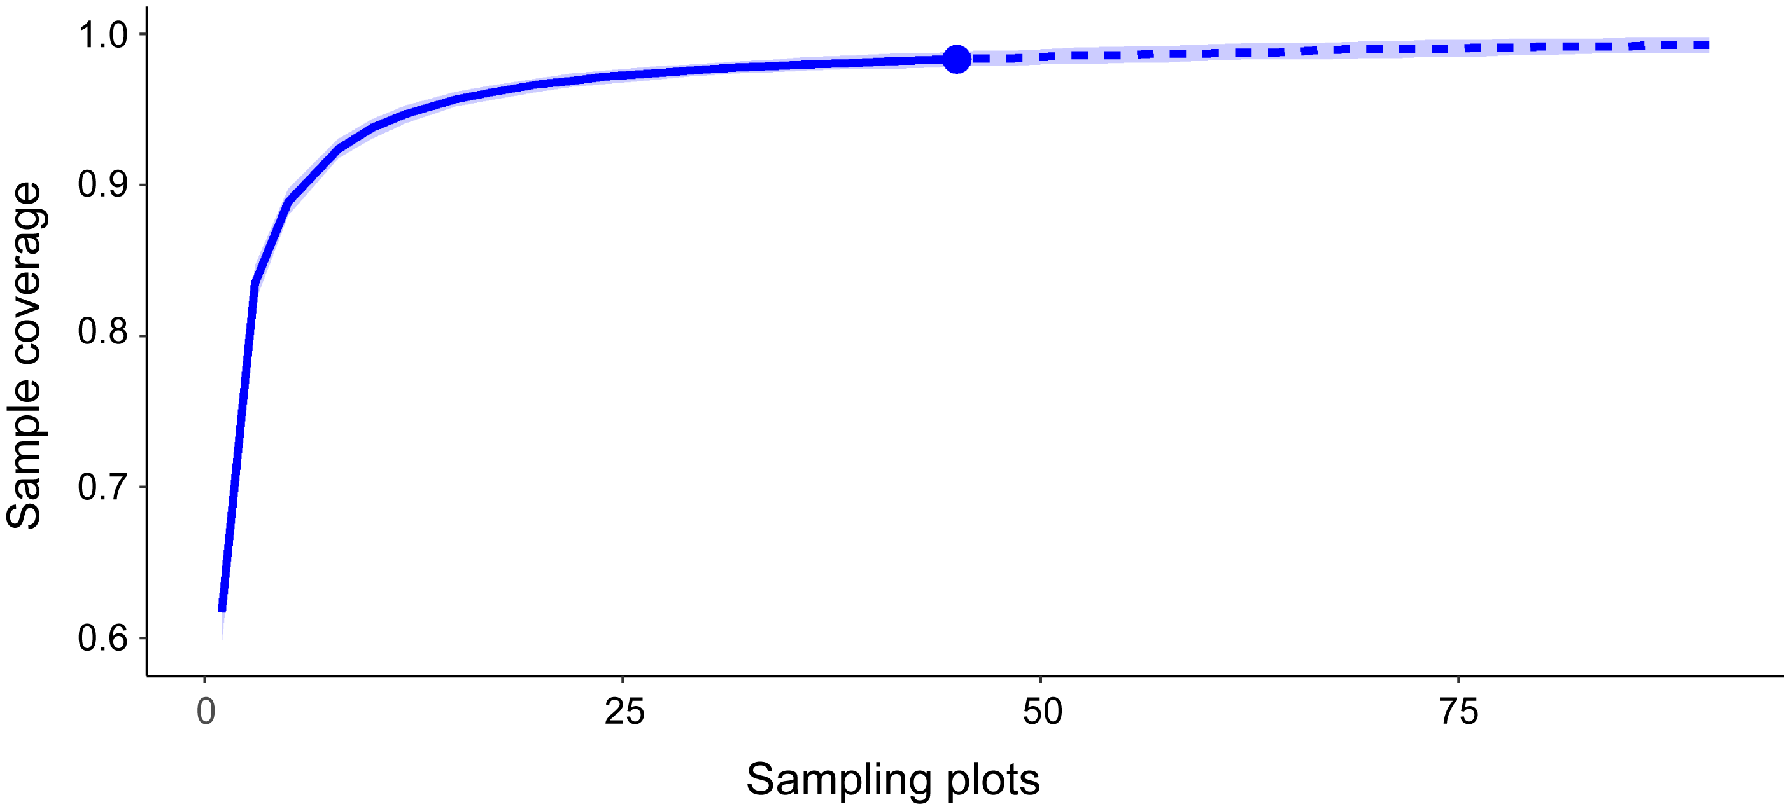
Figure S1. Rarefaction curve showing the sample coverage (percentage of species) as a function of the number of plots sampled (n = 45; outliers included).

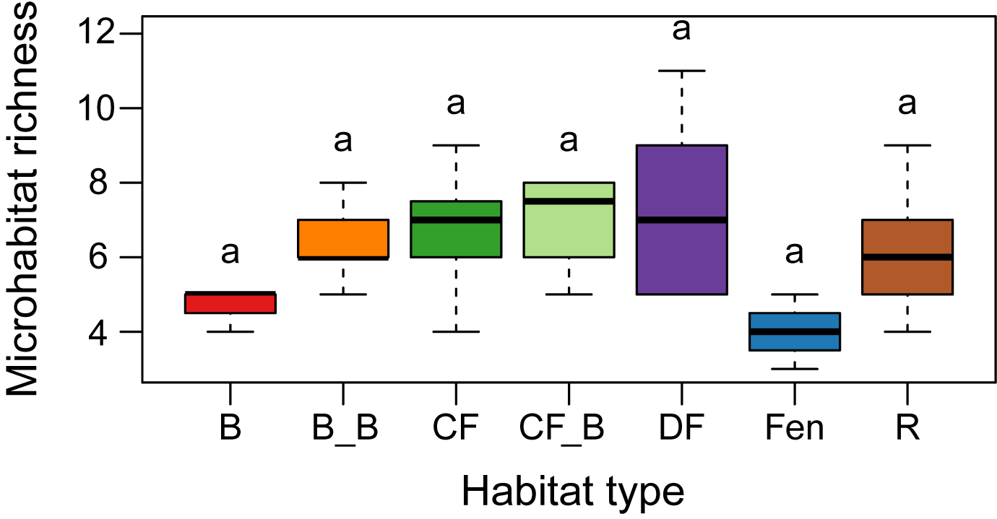
Figure S2. Boxplots of microhabitat richness per habitat type. Different letters indicate significant differences in microhabitat richness among habitat types based on the Tukey test. Outliers were not included. Habitat type abbrev.: B, bog; B_B, bog burned; CF, coniferous forest; CF_B, coniferous forest burned; DF, deciduous forest; Fen, Fen; R, Rock.

Figure S3. Number of lichen species versus the number of different habitat types in which they occur.

