Supplementary Figures

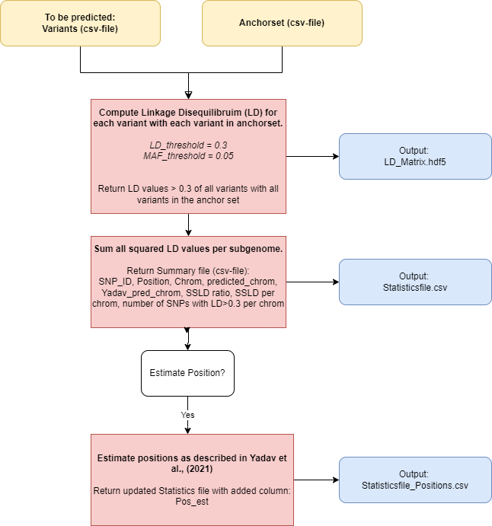

Figure S 1. Schematic overview of the Python pipeline for LD-based chromosome and position prediction with input in yellow boxes, calculation steps in red boxes, and output files in blue boxes.
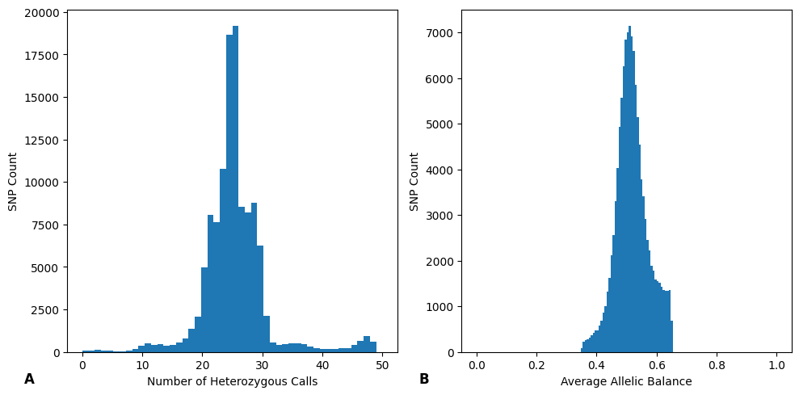
Figure S 2. Histograms of the number of SNPs that are heterozygous in at least Holiday (P1) or Korona (P2) and that have more than 40 heterozygous calls plotted against the total number of heterozygous calls (A) or their Average Allele Balance (B).

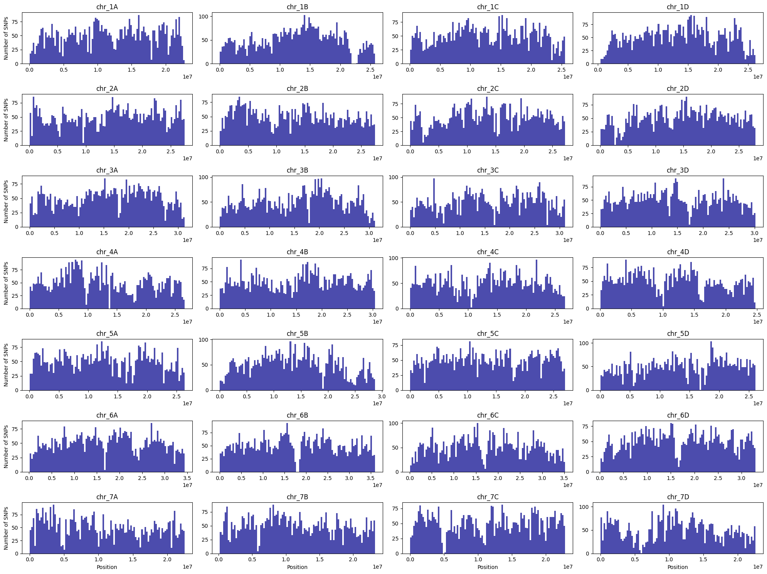
Figure S 3. Distribution of randomly selected SNPs for the anchor set, per chromosome
.
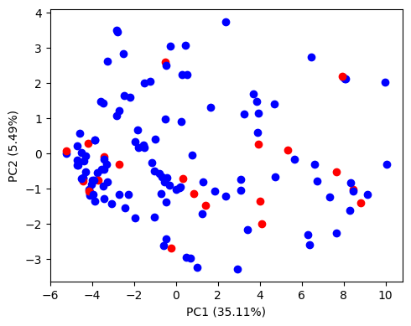
Figure S 4. The first two axes of a Principal Components Analysis on 146 genotypes with 140,000 SNPs from the anchor set. The genotypes for which SER was computed are marked in red.

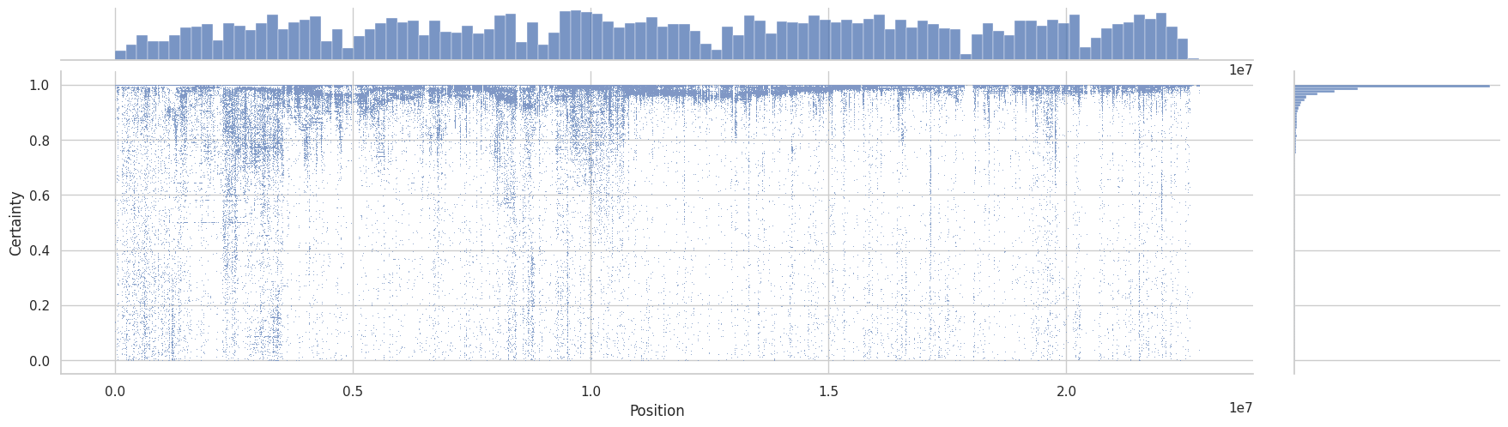
Figure S 5. The ratio of SSLD (y-axis) per single variant versus its physical position (x-axis) on chromosome 1A. The distributions of both axes are also plotted as histograms.

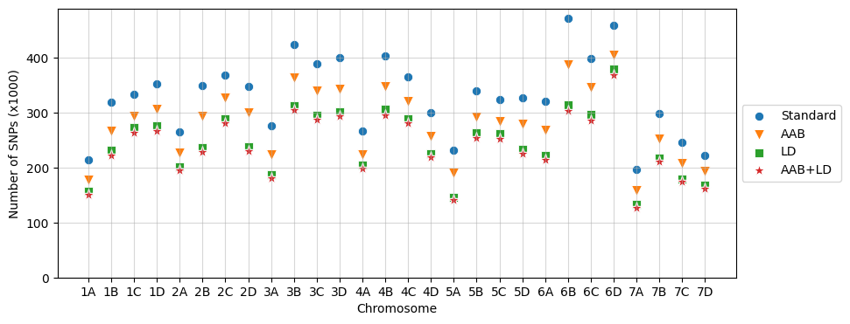
Figure S 6. Number of remaining SNPs per chromosome after using four different filtering methods.

Figure S 7. Average sequencing depth per offspring from the Holiday × Korona population.

