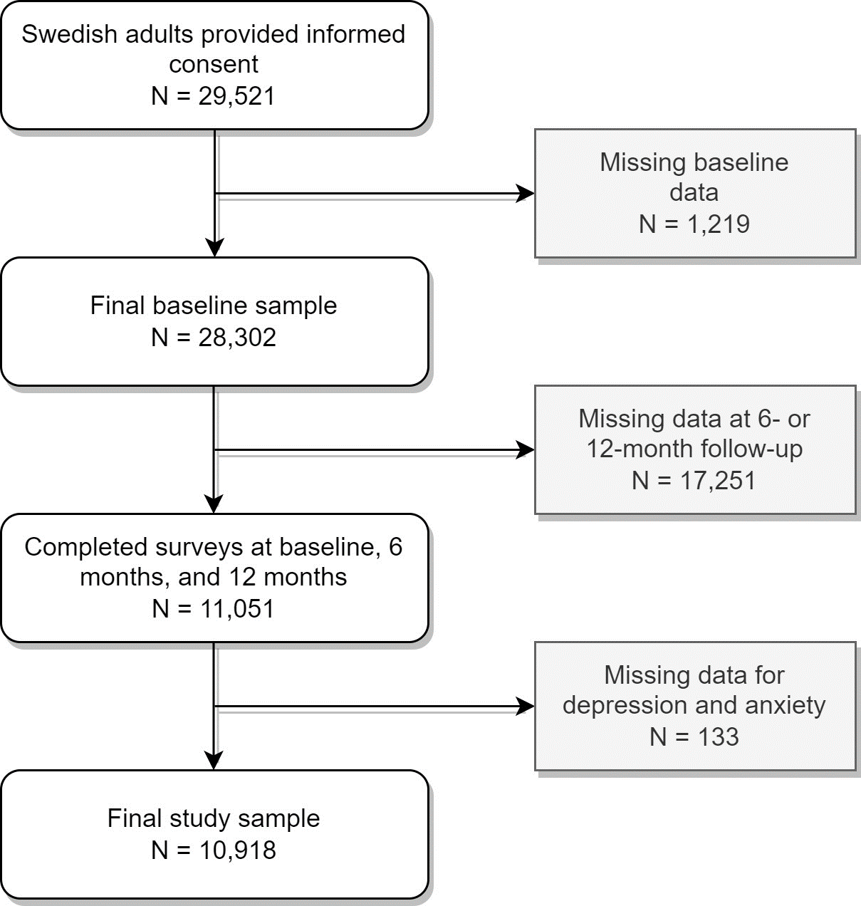
Supplementary Figure 1. Flowchart of the study sample.

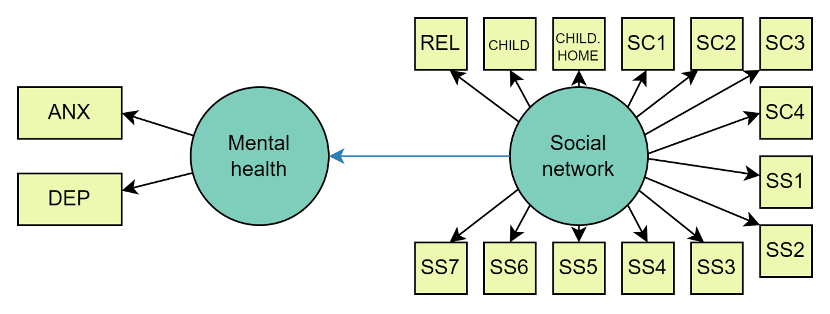
Supplementary Figure 2. Hypothesized cross-sectional structural equation model. ANX = anxiety symptoms; DEP = depressive symptoms; REL = relationship status; CHILD = children; CHILD. HOME = children living at home; SC1 = phone contact; SC2 = social media contact; SC3 = in-person contact; SC4 = left home; SS1 = emotional support from family; SS2 = emotional support from a specific person; SS3 = feeling safe at home; SS4 = family closeness; SS5 = perceived warmth or love from others; SS6 = increased societal cohesion; SS7 = feeling helpful during a crisis

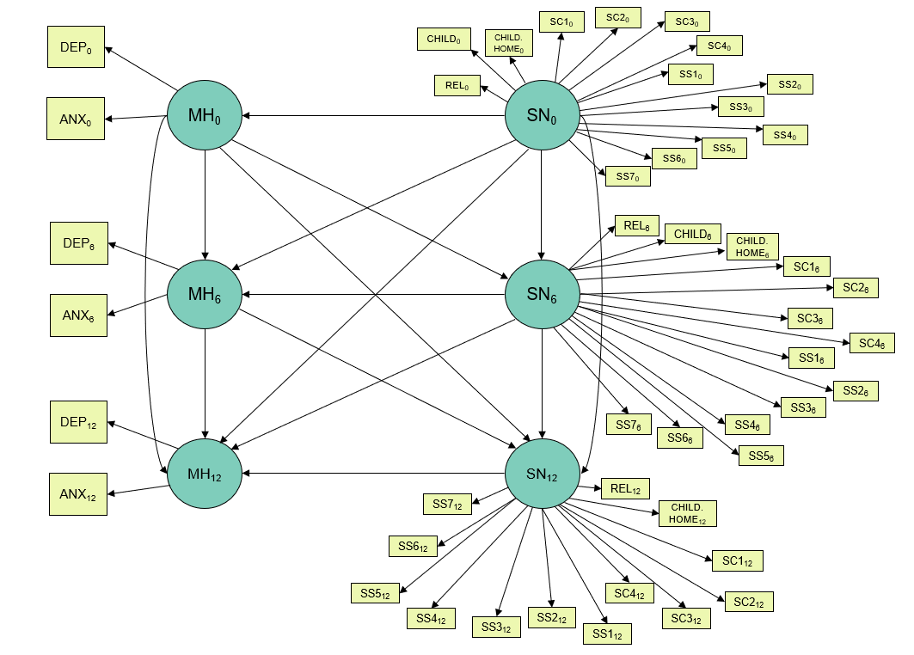
Supplementary Figure 3. Hypothesized dynamic structural equation model at baseline (0), six-month follow-up (6), and 12-month follow-up (12). ANX = anxiety symptoms; DEP = depressive symptoms; MH = mental health; SN = social network; REL = relationship status; CHILD = children; CHILD. HOME = children living at home; SC1 = phone contact; SC2 = social media contact; SC3 = in-person contact; SC4 = left home; SS1 = emotional support from family; SS2 = emotional support from a specific person; SS3 = feeling safe at home; SS4 = family closeness; SS5 = perceived warmth or love from others; SS6 = increased societal cohesion; SS7 = feeling helpful during the crisis
Supplementary Table 1. Description of the social network items included in the baseline, six-month, and one-year follow-up surveys.
Category | Variable Name | Questions | Possible Answers
Family | REL | What is your current relationship status? | Married; cohabitating or other firm relationship; single or divorced; widow
Family | CHILD | Do you have children?† | Yes; no
Family | CHILD.HOME | Does/do your child/any of your children in your household live at home? | Yes; no
Frequency of social contact |  | In the last two weeks, how often have you… | Several times per day; once per day; 5-6 days per week; 3-4 days per week; 1-2 days per week; less than once per week
Frequency of social contact | SC1 | 1. Spoken with your family members, relatives, friends, or neighbors on the phone?
Frequency of social contact | SC2 | 2. Been in contact with your family, relatives, friends, or neighbors via social media?
Frequency of social contact | SC3 | 3. Met your family, relatives, or friends in person?
Frequency of social contact | SC4 | 4. Left your home?
Perceived Social support |  | Do you agree or disagree with the following statements when you think of the last two months? | Do not agree at all; do not agree; do not agree nor disagree; agree a lot; completely agree
Perceived Social support | SS1 | 1. I get the emotional support and help I need from my family.
Perceived Social support | SS2 | 2. I have a specific person I can turn to when I need comforting.
Perceived Social support | SS3 | 3. I feel safe in my home.
Perceived Social support | SS4 | 4. My family is closer to me than before.
Perceived Social support | SS5 | 5. I have felt more warmth/love from others than before.
Perceived Social support | SS6 | 6. I feel that the cohesion in society has increased.
Perceived Social support | SS7 | 7. I feel that I have been helpful to others in the current situation.
†Participants were not asked this question at the one-year follow-up.

Supplementary Table 2. Changes in mental health, social network, and time-varying covariates (N=10,918)
 | Baseline | Six-month follow-up | One-year follow-up
Mental Health
Depressive symptoms
Below cutoff | 9,284 (85.0%) | 9,450 (86.6%) | 9,535 (87.3%)
Above cutoff | 1,634 (15.0%) | 1,468 (13.4%) | 1,383 (12.7%)
Mean (SD) | 4.77 (4.85) | 4.43 (4.81) | 4.25 (4.76)
Median [min, max] | 3 [0, 27] | 3 [0, 27] | 3 [0, 27]
Anxiety symptoms
Below cutoff | 9,833 (90.1%) | 9,880 (90.5%) | 9,944 (91.1%)
Above cutoff | 1,085 (9.9%) | 1,038 (9.5%) | 974 (8.9%)
Mean (SD) | 3.49 (4.19) | 3.40 (4.22) | 3.16 (4.13)
Median [min, max] | 2 [0, 21] | 2 [0, 21] | 2 [0, 21]
Social network
Relationship
Single/divorced or widowed | 2,968 (27.2%) | 2,994 (27.4%) | 2,999 (27.5%)
Married or cohabitating | 7,905 (72.4%) | 7,880 (72.2%) | 7,881 (72.2%)
Missing | 45 (0.4%) | 44 (0.4%) | 38 (0.3%)
Children
No | 3,001 (27.5%) | 2,972 (27.2%) | -
Yes | 7,911 (72.5%) | 7,934 (72.7%) | -
Missing | 6 (0.1%) | 12 (0.1%) | -
Children at home
No | 7,535 (69.0%) | 7,564 (69.3%) | 7,701 (70.5%)
Yes | 3,368 (30.8%) | 3,337 (30.6%) | 3,202 (29.3%)
Missing | 15 (0.1%) | 17 (0.2%) | 15 (0.1%)
Phone contact
Less than once a week | 1,159 (10.6%) | 1,267 (11.6%) | 1,210 (11.1%)
1-2 days a week | 2,513 (23.0%) | 2,619 (24.0%) | 2,530 (23.2%)
3-4 days a week | 1,998 (18.3%) | 1,988 (18.2%) | 1,974 (18.1%)
5-6 days a week | 1,394 (12.8%) | 1,330 (12.2%) | 1,334 (12.2%)
Once a day | 1,739 (15.9%) | 1,842 (16.9%) | 1,778 (16.3%)
Several times a day | 2,056 (18.8%) | 1,837 (16.8%) | 2,030 (18.6%)
Missing | 59 (0.5%) | 35 (0.3%) | 62 (0.6%)
Social media contact
Less than once a week | 1,454 (13.3%) | 1,512 (13.8%) | 1,400 (12.8%)
1-2 days a week | 1,483 (13.6%) | 1,607 (14.7%) | 1,543 (14.1%)
3-4 days a week | 1,616 (14.8%) | 1,660 (15.2%) | 1,673 (15.3%)
5-6 days a week | 1,432 (13.1%) | 1,476 (13.5%) | 1,409 (12.9%)
Once a day | 1,439 (13.2%) | 1,390 (12.7%) | 1,445 (13.2%)
Several times a day | 3,226 (29.5%) | 3,012 (27.6%) | 3,152 (28.9%)
Missing | 268 (2.5%) | 261 (2.4%) | 296 (2.7%)
In-person contact
Less than once a week | 4,533 (41.5%) | 4,602 (42.2%) | 3,487 (31.9%)
1-2 days a week | 2,835 (26.0%) | 2,935 (26.9%) | 3,268 (29.9%)
3-4 days a week | 1,113 (10.2%) | 1,140 (10.4%) | 1,379 (12.6%)
5-6 days a week | 471 (4.3%) | 482 (4.4%) | 592 (5.4%)
Once a day | 466 (4.3%) | 454 (4.2%) | 587 (5.4%)
Several times a day | 1,370 (12.5%) | 1,180 (10.8%) | 1,492 (13.7%)
Missing | 130 (1.2%) | 125 (1.1%) | 113 (1.0%)
Left home
Less than once a week | 209 (1.9%) | 203 (1.9%) | 101 (0.9%)
1-2 days a week | 812 (7.4%) | 799 (7.3%) | 518 (4.7%)
3-4 days a week | 1,119 (10.2%) | 1,059 (9.7%) | 1,066 (9.8%)
5-6 days a week | 1,463 (13.4%) | 1,375 (12.6%) | 1,627 (14.9%)
Once a day | 3,232 (29.6%) | 3,414 (31.3%) | 3,420 (31.3%)
Several times a day | 4,001 (36.6%) | 4,014 (36.8%) | 4,129 (37.8%)
Missing | 82 (0.8%) | 54 (0.5%) | 57 (0.5%)
Emotional support from family
Strongly disagree | 322 (2.9%) | 330 (3.0%) | 353 (3.2%)
Disagree | 1,032 (9.5%) | 1,077 (9.9%) | 1,083 (9.9%)
Do not agree nor disagree | 1,291 (11.8%) | 1,253 (11.5%) | 1,087 (10.0%)
Agree | 3,080 (28.2%) | 3,227 (29.6%) | 3,327 (30.5%)
Strongly agree | 5,072 (46.5%) | 4,914 (45.0%) | 4,920 (45.1%)
Missing | 121 (1.1%) | 117 (1.1%) | 148 (1.4%)
Emotional support from specific person
Strongly disagree | 742 (6.8%) | 749 (6.9%) | 748 (6.9%)
Disagree | 1,096 (10.0%) | 1,086 (9.9%) | 1,036 (9.5%)
Do not agree nor disagree | 992 (9.1%) | 1,083 (9.9%) | 915 (8.4%)
Agree | 2,464 (22.6%) | 2,645 (24.2%) | 2,772 (25.4%)
Strongly agree | 5,502 (50.4%) | 5,226 (47.9%) | 5,303 (48.6%)
Missing | 122 (1.1%) | 129 (1.2%) | 144 (1.3%)
Safety at home
Strongly disagree | 47 (0.4%) | 62 (0.6%) | 68 (0.6%)
Disagree | 145 (1.3%) | 137 (1.3%) | 143 (1.3%)
Do not agree nor disagree | 216 (2.0%) | 256 (2.3%) | 221 (2.0%)
Agree | 1,434 (13.1%) | 1,581 (14.5%) | 1,787 (16.4%)
Strongly agree | 9,027 (82.7%) | 8,851 (81.1%) | 8,648 (79.2%)
Missing | 49 (0.4%) | 31 (0.3%) | 51 (0.5%)
Family closeness
Strongly disagree | 1,158 (10.6%) | 1,010 (9.3%) | 972 (8.9%)
Disagree | 789 (7.2%) | 727 (6.7%) | 678 (6.2%)
Do not agree nor disagree | 5,169 (47.3%) | 5,300 (48.5%) | 5,420 (49.6%)
Agree | 2,035 (18.6%) | 2,175 (19.9%) | 2,122 (19.4%)
Strongly agree | 1,654 (15.1%) | 1,595 (14.6%) | 1,608 (14.7%)
Missing | 113 (1.0%) | 111 (1.0%) | 118 (1.1%)
Love from others
Strongly disagree | 1,703 (15.6%) | 1,631 (14.9%) | 1,495 (13.7%)
Disagree | 1,361 (12.5%) | 1,153 (10.6%) | 1,080 (9.9%)
Do not agree nor disagree | 5,291 (48.5%) | 5,663 (51.9%) | 5,883 (53.9%)
Agree | 1,709 (15.7%) | 1,659 (15.2%) | 1,616 (14.8%)
Strongly agree | 745 (6.8%) | 715 (6.5%) | 712 (6.5%)
Missing | 109 (1.0%) | 97 (0.9%) | 132 (1.2%)
Societal cohesion
Strongly disagree | 2,021 (18.5%) | 2,550 (23.4%) | 2,702 (24.7%)
Disagree | 2,292 (21.0%) | 1,802 (16.5%) | 1,695 (15.5%)
Do not agree nor disagree | 4,330 (39.7%) | 4,899 (44.9%) | 5,067 (46.4%)
Agree | 1,681 (15.4%) | 1,115 (10.2%) | 947 (8.7%)
Strongly agree | 344 (3.2%) | 270 (2.5%) | 225 (2.1%)
Missing | 250 (2.3%) | 282 (2.6%) | 282 (2.6%)
Helpful to others
Strongly disagree | 1,036 (9.5%) | 986 (9.0%) | 965 (8.8%)
Disagree | 2,642 (24.2%) | 2,526 (23.1%) | 2,480 (22.7%)
Do not agree nor disagree | 3,370 (30.9%) | 3,790 (34.7%) | 4,033 (36.9%)
Agree | 2,574 (23.6%) | 2,498 (22.9%) | 2,387 (21.9%)
Strongly agree | 1,130 (10.3%) | 948 (8.7%) | 819 (7.5%)
Missing | 166 (1.5%) | 170 (1.6%) | 234 (2.1%)
Time-varying covariates
Employment
Full-time work | 5,197 (47.6%) | 5,662 (51.9%) | 5,676 (52.0%)
Part-time work | 634 (5.8%) | 575 (5.3%) | 578 (5.3%)
Not working | 696 (6.4%) | 758 (6.9%) | 646 (5.9%)
Retired | 3,036 (27.8%) | 3,229 (29.6%) | 3,348 (30.7%)
Student | 489 (4.5%) | 557 (5.1%) | 550 (5.0%)
Missing | 866 (7.9%) | 137 (1.3%) | 120 (1.1%)
Economic difficulties
Very easy | 7,693 (70.5%) | 7,428 (68.0%) | 7,041 (64.5%)
Quite easy | 1,704 (15.6%) | 1,631 (14.9%) | 1,839 (16.8%)
Neither/nor | 1,149 (10.5%) | 1,408 (12.9%) | 1,582 (14.5%)
Quite difficult | 274 (2.5%) | 316 (2.9%) | 310 (2.8%)
Very difficult | 81 (0.7%) | 95 (0.9%) | 96 (0.9%)
Missing | 17 (0.2%) | 40 (0.4%) | 50 (0.5%)
Previous COVID-19 infection*
No | 2,459 (22.5%) | 3,983 (36.5%) | 3,456 (31.7%)
Yes | 377 (3.5%) | 803 (7.4%) | 366 (3.4%)
Missing | 8,082 (74.0%) | 6,132 (56.2%) | 7,096 (65.0%)
COVID-19 worry
Very much | 757 (6.9%) | 597 (5.5%) | 295 (2.7%)
Somewhat | 2,618 (24.0%) | 1,889 (17.3%) | 1,464 (13.4%)
Neither/nor | 1,953 (17.9%) | 1,596 (14.6%) | 1,606 (14.7%)
A little | 4,029 (36.9%) | 4,257 (39.0%) | 4,772 (43.7%)
Not at all | 1,540 (14.1%) | 2,567 (23.5%) | 2,759 (25.3%)
Missing | 21 (0.2%) | 12 (0.1%) | 22 (0.2%)
Employment change
No change | - | 5,625 (51.5%) | 5,980 (54.8%)
Not relevant | - | 2,077 (19.0%) | 2,193 (20.1%)
Lost job or other negative change | - | 933 (8.5%) | 544 (5.0%)
Positive change | - | 1,242 (11.4%) | 1,346 (12.3%)
Other | - | 984 (9.0%) | 800 (7.3%)
Missing | - | 57 (0.5%) | 55 (0.5%)
*Participants were asked at six-month and one-year follow-ups if they had tested positive for COVID-19 since the last time they took the survey.

Supplementary Table 3. Results from sex-specific analysis showing standardized regression coefficients and model evaluation statistics for cross-sectional structural equation models (women: N=9048; men: N=1870)

 | Baseline |  | Six-month follow-up |  | One-year follow-up
 | Women | Men | Women | Men | Women | Men
Mental health Depression | 1.10* | 1.25* | 0.99* | 0.95* | 0.97* | 1.01*
Mental health Anxiety | 0.63*** | 0.57*** | 0.76*** | 0.82*** | 0.78*** | 0.74***
Social network Family closeness | 0.63* | 0.67* | 0.61* | 0.65* | 0.67* | 0.65*
Social network Warmth from others | 0.90*** | 0.85*** | 0.91*** | 0.91*** | 0.89*** | 0.91***
Social network Societal cohesion | 0.51*** | 0.50*** | 0.51*** | 0.50*** | 0.54*** | 0.49***
Mental health Social network | -0.15*** | -0.12*** | -0.20*** | -0.25*** | -0.22*** | -0.22***
Model Fit
$χ^{2}$/df | 32.45/4*** | 26.45/4*** | 45.55/4*** | 11.81/4 | 54.92/4*** | 9.08/4
CFI | 0.998† | 0.991† | 0.997† | 0.997† | 0.996† | 0.998†
TLI | 0.994† | 0.978† | 0.992† | 0.994† | 0.991† | 0.996†
RMSEA | 0.028† | 0.055 | 0.034† | 0.032† | 0.038† | 0.026†
SRMR | 0.015† | 0.030† | 0.018† | 0.021† | 0.016† | 0.019†
* Coefficients on paths from latent variables to first observed endogenous variables set to normalization constraint of 1 and therefore do not have a p value.
*** p < 0.001
Model 3 was used for baseline analysis.
df: degrees of freedom. CFI: comparative fit index; TLI: Tucker–Lewis index; RMSEA: root mean square error of approximation; SRMR: standardized root mean squared residual.
†Meets the requirement for good model fit.

Supplementary Table 4. Results from sex-specific analysis showing standardized regression coefficients and model evaluation statistics for dynamic structural equation models.
 | Women  N=9048 | Men  N=1870
Baseline
Mental health Depression | 0.90* | 0.87*
Mental health Anxiety | 0.76*** | 0.82***
Social network Family closeness | 0.66* | 0.70*
Social network Warmth from others | 0.85*** | 0.82***
Social network Societal cohesion | 0.52*** | 0.51***
One-year follow-up
Mental health Depression | 0.92* | 0.90*
Mental health Anxiety | 0.81*** | 0.82***
Social network Family closeness | 0.69* | 0.69*
Social network Warmth from others | 0.85*** | 0.85***
Social network Societal cohesion | 0.55*** | 0.52***
Dynamic paths
Mental health (one year) Mental health (baseline) | 0.56*** | 0.66***
Social network (one year) Social network (baseline) | 0.49*** | 0.46***
Model Fit
$χ^{2}$/df | 2277.23/31*** | 488.59/31***
CFI | 0.930 | 0.932
TLI | 0.898 | 0.901
RMSEA | 0.089 | 0.089
SRMR | 0.037† | 0.046†
* Coefficients on paths from latent variables to first observed endogenous variables set to normalization constraint of 1 and therefore do not have a p value.
*** p < 0.001
Model 3 was used for baseline analysis.
df: degrees of freedom. CFI: comparative fit index; TLI: Tucker–Lewis index; RMSEA: root mean square error of approximation; SRMR: standardized root mean squared residual.
†Meets the requirement for good model fit.

Supplementary Table 5. Results from age-specific analysis showing standardized regression coefficients and model evaluation statistics for cross-sectional structural equation models (18-39: N=2398; 40-59: N=4356; 60+: N=4164)

 | Baseline |  |  | Six-month follow-up |  |  | One-year follow-up
 | 18-39 | 40-59 | 60+ | 18-39 | 40-59 | 60+ | 18-39 | 40-59 | 60+
Mental health Depression | 1.12* | 1.12* | 1.21* | 0.98* | 0.98* | 1.03* | 0.97* | 0.97* | 0.97*
Mental health Anxiety | 0.62*** | 0.62*** | 0.57*** | 0.77*** | 0.77*** | 0.72*** | 0.77*** | 0.77*** | 0.76***
Social network Family closeness | 0.64* | 0.64* | 0.67* | 0.62* | 0.62* | 0.61* | 0.66* | 0.66* | 0.70*
Social network Warmth from others | 0.90*** | 0.90*** | 0.88*** | 0.91*** | 0.91*** | 0.91*** | 0.89*** | 0.89*** | 0.89***
Social network Societal cohesion | 0.51*** | 0.51*** | 0.47*** | 0.51*** | 0.51*** | 0.47*** | 0.53*** | 0.53*** | 0.51***
Mental health Social network | -0.15*** | -0.15*** | -0.10*** | -0.21*** | -0.21*** | -0.17*** | -0.22*** | -0.22*** | -0.20***
Model Fit
$χ^{2}$/df | 47.99/4*** | 47.99/4*** | 15.03/4** | 52.95/4*** | 52.95/4*** | 18.55/4*** | 52.70/4*** | 52.70/4*** | 23.1/4***
CFI | 0.997† | 0.997† | 0.998† | 0.997† | 0.997† | 0.998† | 0.997† | 0.997† | 0.997†
TLI | 0.992† | 0.992† | 0.995† | 0.993† | 0.993† | 0.994† | 0.993† | 0.993† | 0.993†
RMSEA | 0.032† | 0.032† | 0.026† | 0.033† | 0.033† | 0.030† | 0.033† | 0.033† | 0.034†
SRMR | 0.017† | 0.017† | 0.016† | 0.018† | 0.018† | 0.018† | 0.015† | 0.015† | 0.016†
* Coefficients on paths from latent variables to first observed endogenous variables set to normalization constraint of 1 and therefore do not have a p value.
** p < 0.01
*** p < 0.001
Model 3 was used for baseline analysis.
df: degrees of freedom. CFI: comparative fit index; TLI: Tucker–Lewis index; RMSEA: root mean square error of approximation; SRMR: standardized root mean squared residual.
†Meets the requirement for good model fit.

Supplementary Table 6. Results from age-specific analysis showing standardized regression coefficients and model evaluation statistics for dynamic structural equation models
 | 18-39  N=2398 | 40-59  N=4356 | 60+  N=4164
Baseline
Mental health Depression | 0.90* | 0.90* | 0.88*
Mental health Anxiety | 0.77*** | 0.77*** | 0.77***
Social network Family closeness | 0.67* | 0.67* | 0.71*
Social network Warmth from others | 0.85*** | 0.85*** | 0.81***
Social network Societal cohesion | 0.52*** | 0.52*** | 0.48***
One year
Mental health Depression | 0.92* | 0.92* | 0.92*
Mental health Anxiety | 0.82*** | 0.82*** | 0.80***
Social network Family closeness | 0.69* | 0.69* | 0.74*
Social network Warmth from others | 0.85*** | 0.85*** | 0.84***
Social network Societal cohesion | 0.54*** | 0.54*** | 0.51***
Dynamic paths
Mental health (one year) Mental health (baseline) | 0.58*** | 0.58*** | 0.58***
Social network (one year) Social network (baseline) | 0.48*** | 0.48*** | 0.50***
Model Fit
$χ^{2}$/df | 2713.71/31*** | 2713.71/31*** | 1023.46/31***
CFI | 0.931 | 0.931 | 0.931
TLI | 0.899 | 0.899 | 0.900
RMSEA | 0.089 | 0.089 | 0.088
SRMR | 0.038† | 0.038† | 0.040†
* Coefficients on paths from latent variables to first observed endogenous variables set to normalization constraint of 1 and therefore do not have a p value.
*** p < 0.001
Model 3 was used for baseline analysis.
df: degrees of freedom. CFI: comparative fit index; TLI: Tucker–Lewis index; RMSEA: root mean square error of approximation; SRMR: standardized root mean squared residual.
†Meets the requirement for good model fit.

