Supporting information
Hybrid polyimide foams with hyperbranched organosilicon for high-temperature sound absorption
Yang Xu¹, Luwei Bo¹, Yandong Wang¹, Haocheng Xu¹, Xiaolin Jiang¹, Zhaobo Wei¹, Kai Xi*^{,1}
Corresponding author: Kai Xi, *E-mail address: xikai@nju.edu.cn
¹ MOE Key Laboratory of High-Performance Polymer Materials and Technology School of Chemistry and Chemical Engineering, Nanjing University, Nanjing, Jiangsu 210023, China

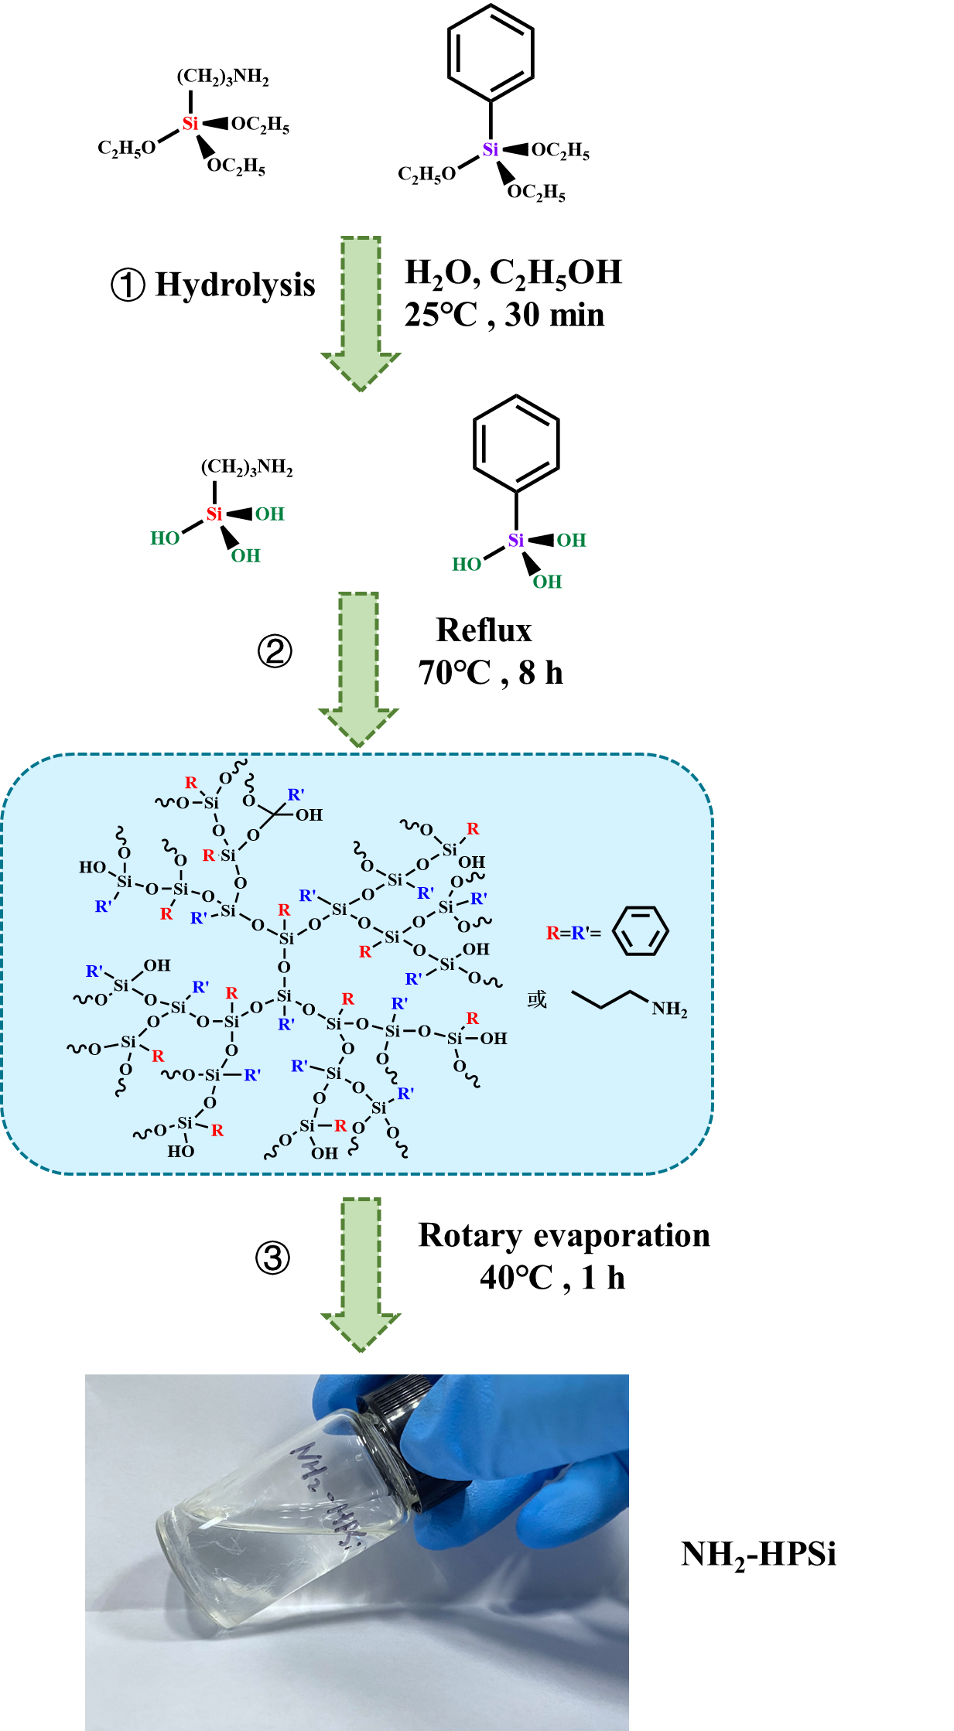
Fig S1 the synthesis route of NH₂-HBPSi

Table S1 the specific ratios of various PEAS
 | ODA/mol | NH₂-HBPSi/mol | BTDA/mol | CH₃OH/mol | THF/mol
PAES | 0.1 | - | 0.1 | 1 | 0.5
PEAS_{HBPSi}-1 | 0.0889 | 0.0111 | 0.1 | 1 | 0.5
PEAS_{HBPSi}-2 | 0.0857 | 0.0143 | 0.1 | 1 | 0.5
PEAS_{HBPSi}-3 | 0.08 | 0.02 | 0.1 | 1 | 0.5
PEAS_{HBPSi}-4 | 0.0667 | 0.0333 | 0.1 | 1 | 0.5

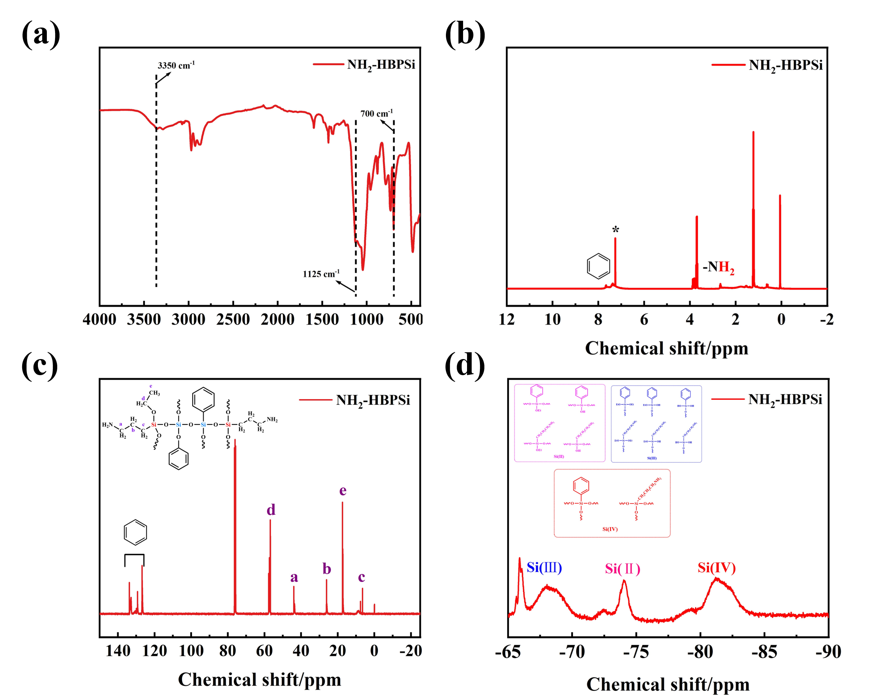
Fig S2 (a) FTIR spectra of NH₂-HBPSi (b) ¹H NMR spectra of NH₂-HBPSi (c) the ¹³C NMR spectra of NH₂-HBPSi (d) ²⁹Si NMR spectra of NH₂-HBPSi

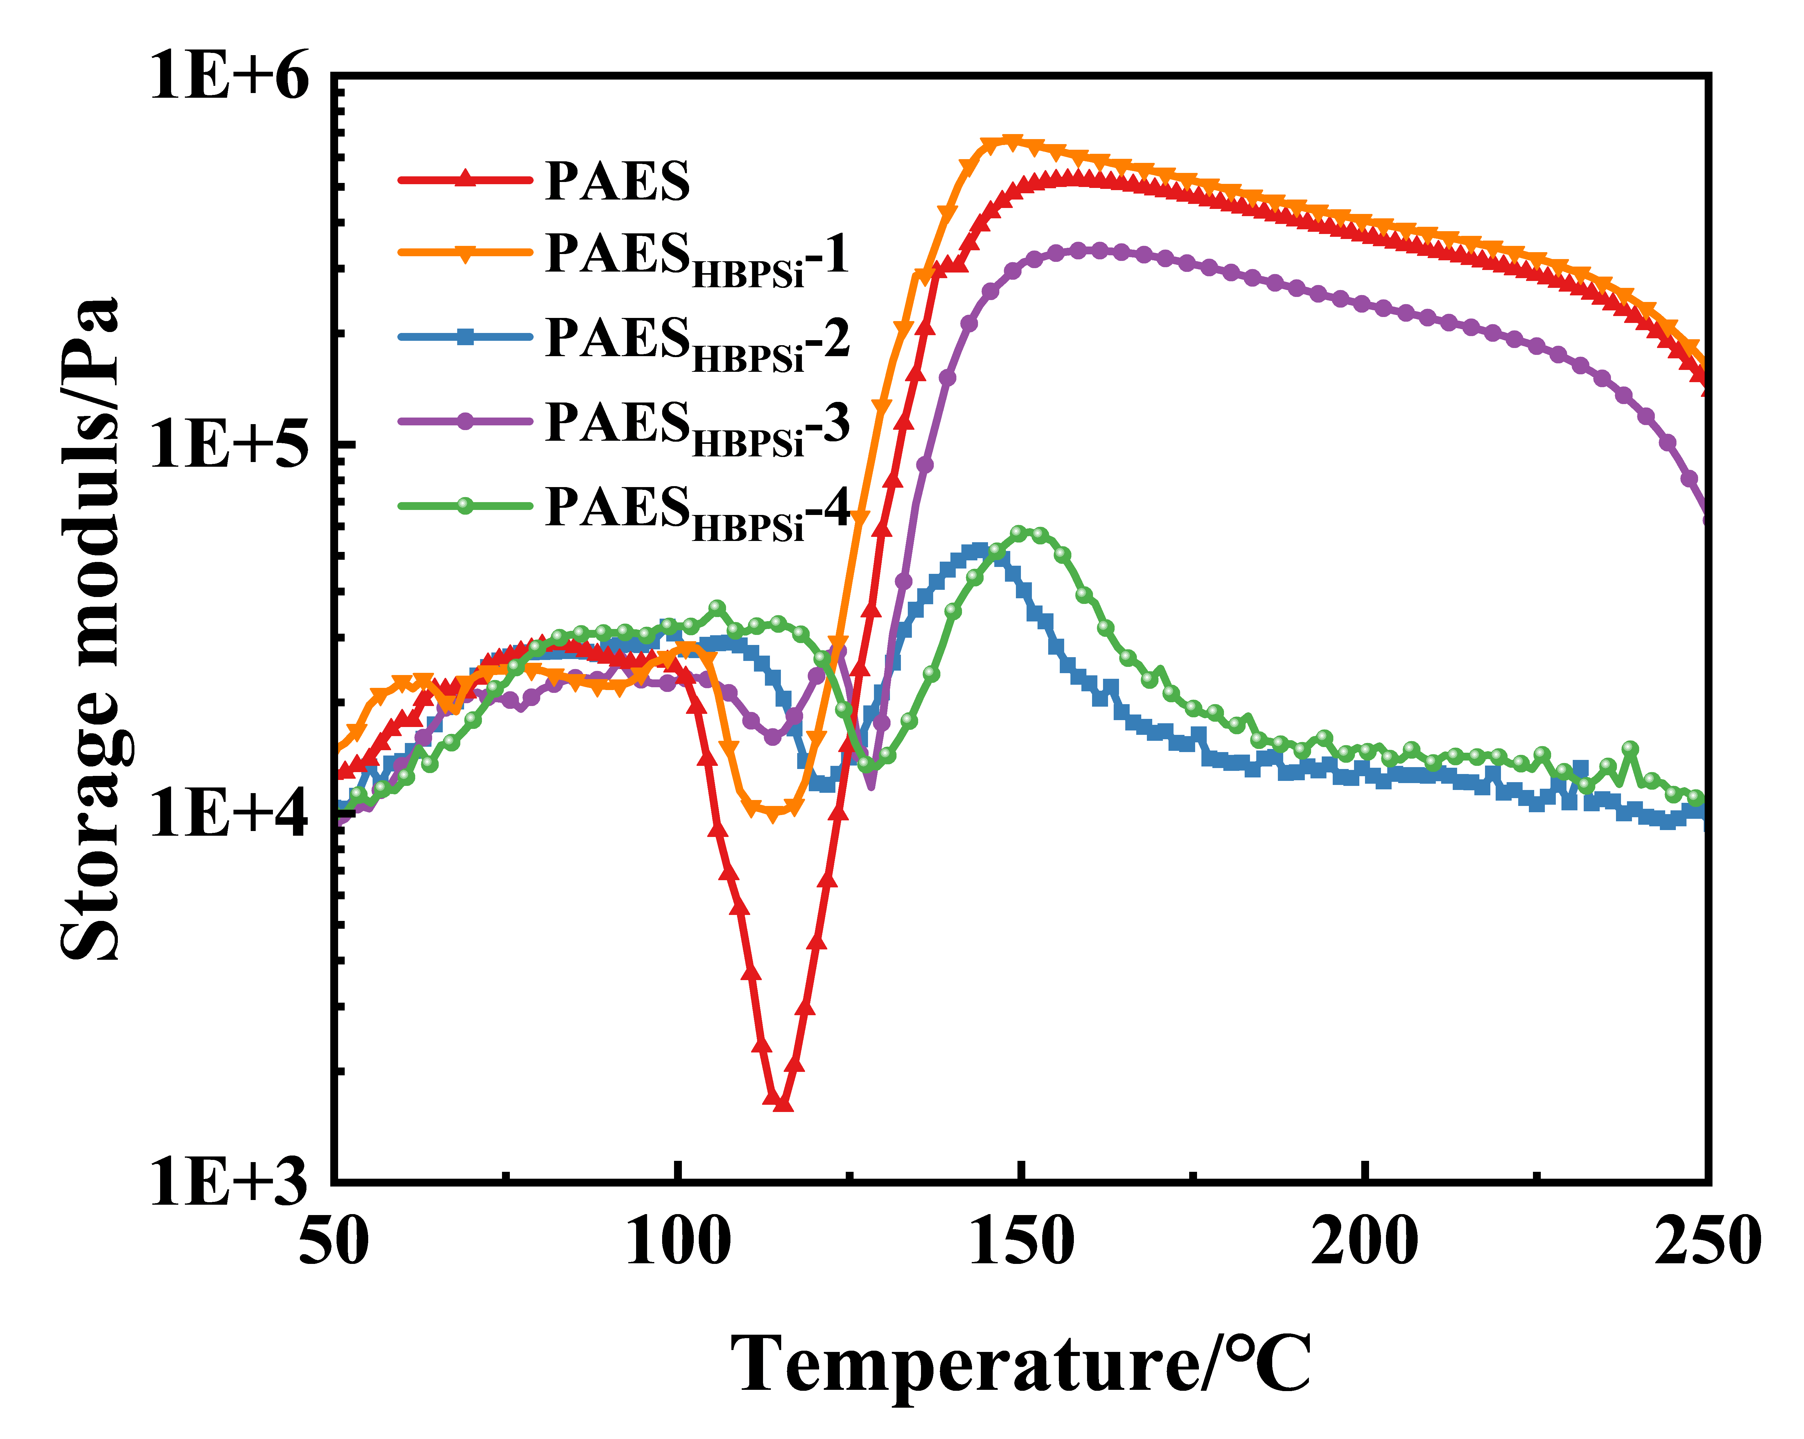
Fig S3 storage modulus of PAESs with diverse NH₂-HBPSi
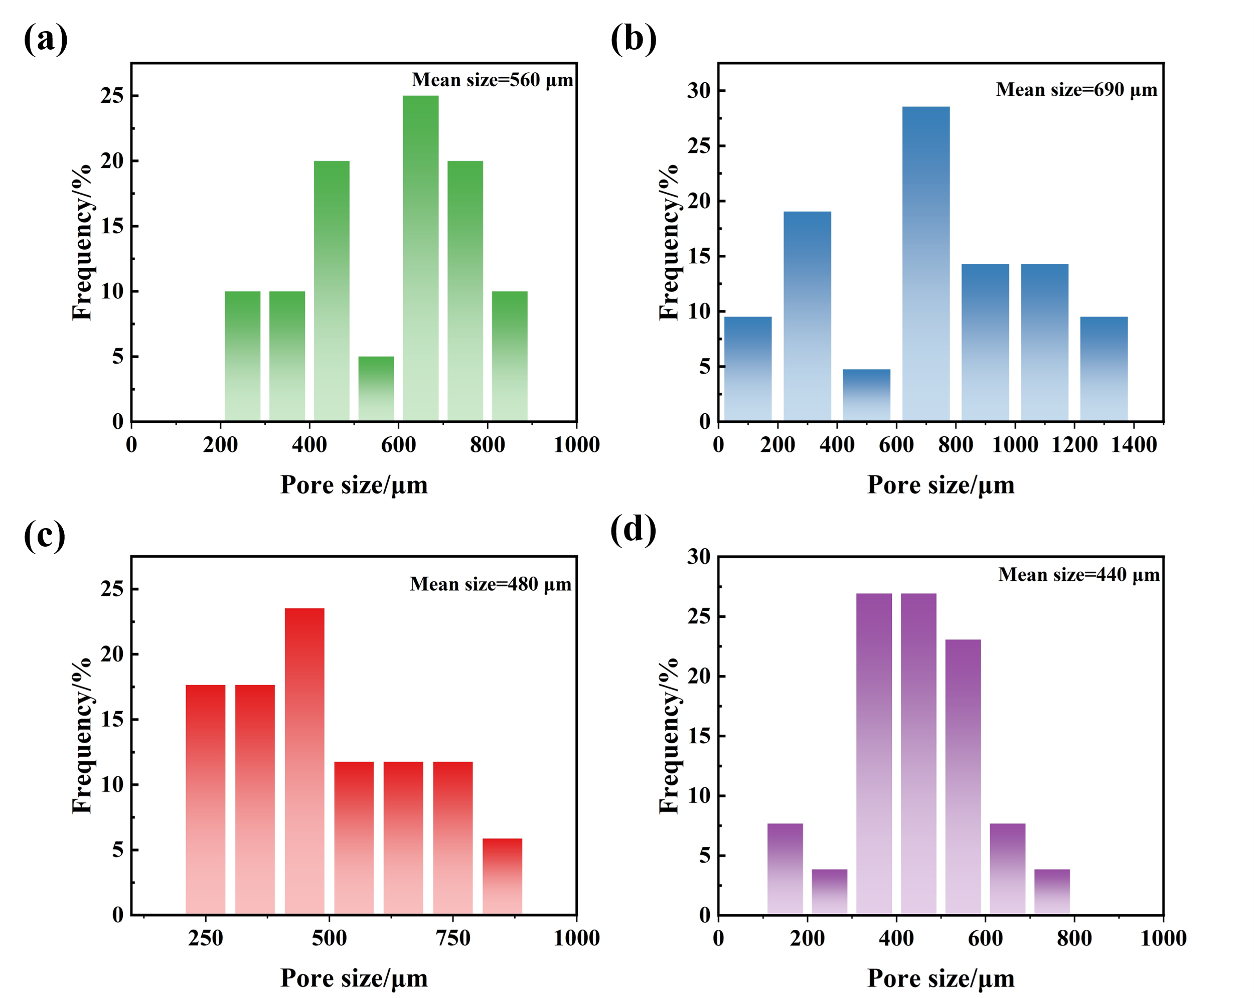
Fig S4 The average cell diameters of different PIFs (a) PIF_{HBPSi}-1 (b) PIF_{HBPSi}-2 (c) PIF_{HBPSi-}3 (d) PIF_{HBPSi}-4
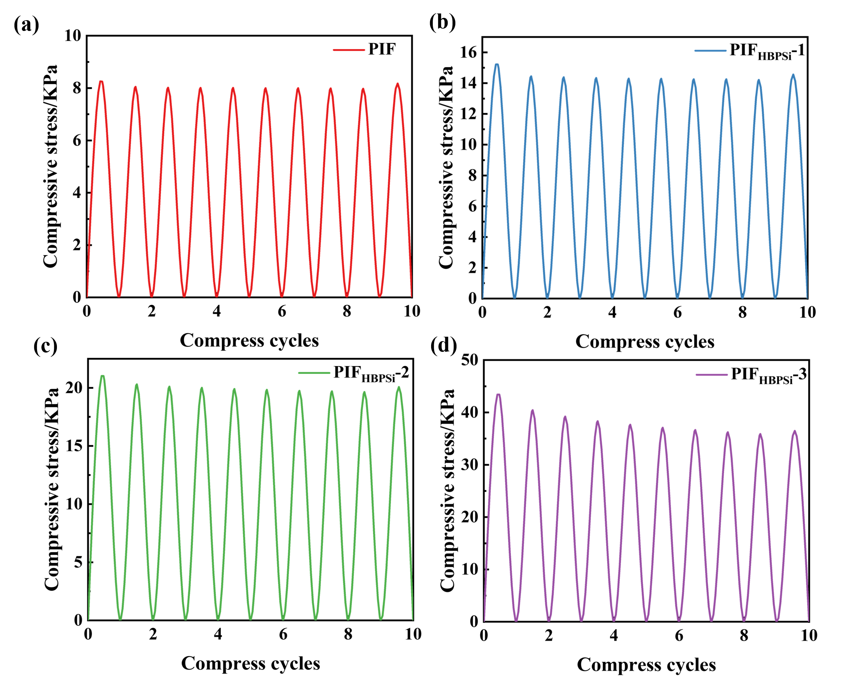
Fig S5 (a) the plot of strain-stress at a strain of 10% for PIF (b) the plot of strain-stress at a strain of 10% for PIF_{HBPSi}-1 (c) the plot of strain-stress at a strain of 10% for PIF_{HBPSi}-2 (d) the plot of strain-stress at a strain of 10% for PIF_{HBPSi}-3

Table S2 the characteristic thermal analysis data of various PIFs
Samples | N₂ atmosphere |  |  |  | Air atmosphere
Samples | T_{5%}(℃) | T_{max}(℃) | R₁₀₀₀ (%) | T_{5%}(℃) |  | T_{max}(℃) | R₁₀₀₀(%)
PIF | 553.08 | 577 | 54.65 | 501.16 |  | 606 | 0
PIF_{HBPSi}-1 | 540.1 | 594 | 55.68 | 499.2 |  | 599 | 3.59
PIF_{HBPSi}-2 | 538.2 | 593 | 56.85 | 501.2 |  | 611.2 | 4.72
PIF_{HBPSi}-3 | 537.1 | 595 | 57.10 | 494.1 |  | 597 | 5.61
PIF_{HBPSi}-4 | 521.08 | 591 | 59.42 | 477.2 |  | 613.1 | 12.44

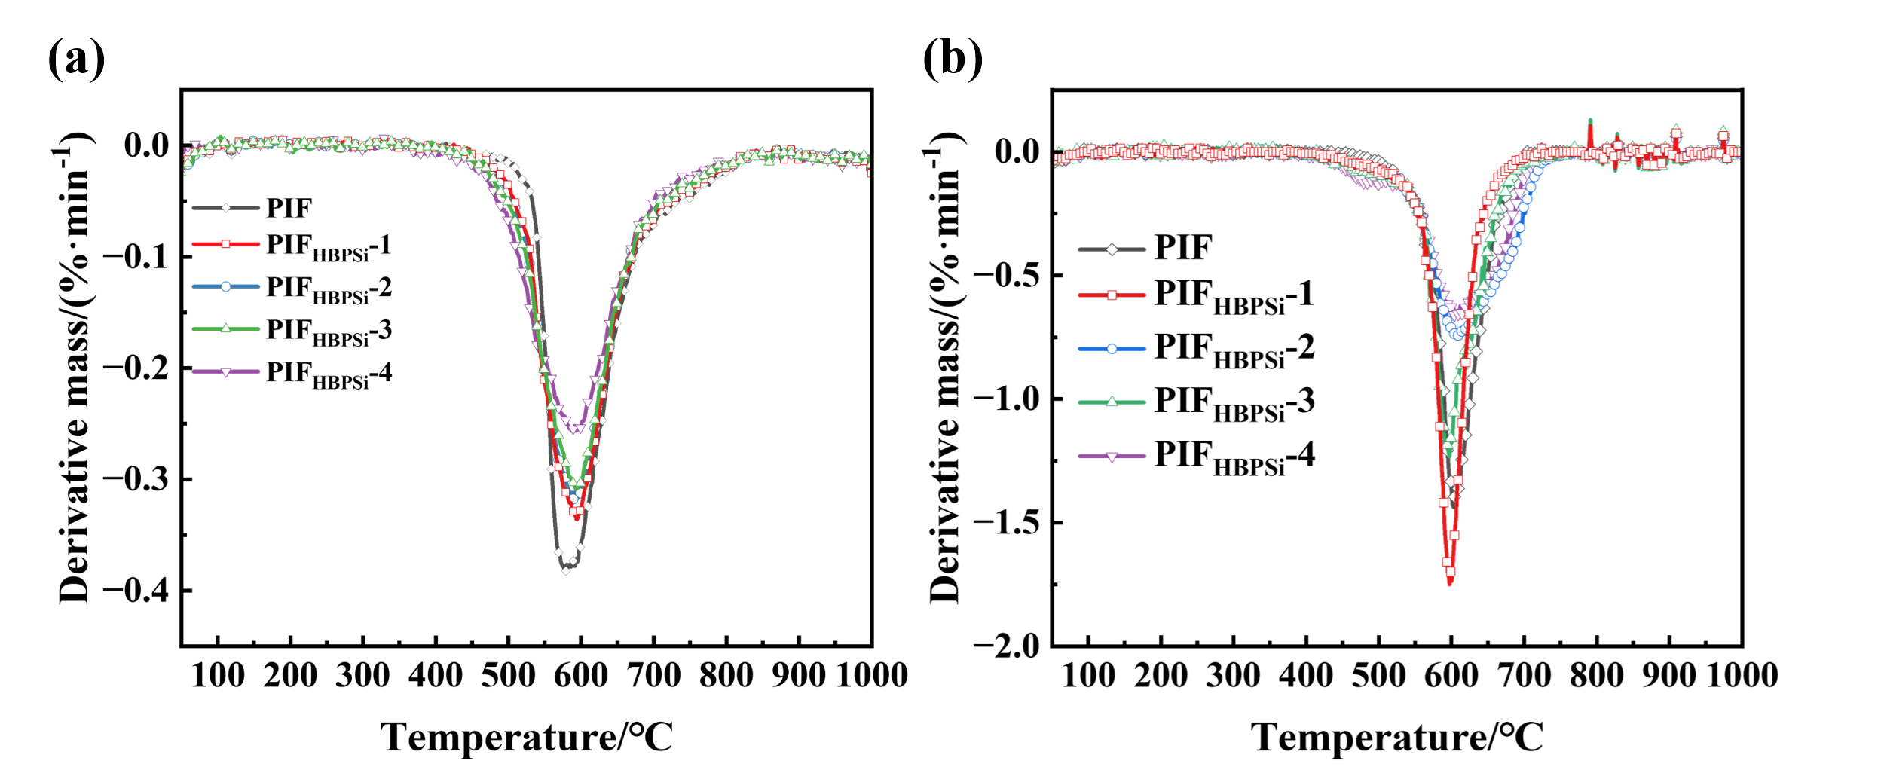
Fig S6 The DTG of various PIFs (a) N₂ atmosphere (b) air atmosphere

Table S3 LOI and cone calorimetric data for various PIFs
Sample | LOI (%) | THR (kJ/g) | PHRR (W/g) | TSP (m²) | Residue (%)
PIF | 39.2 | 12.07 | 50.74 | 0.11 | 0.21
PIF_{HBPSi}-1 | 40.3 | 10.95 | 54.24 | 0.12 | 4.59
PIF_{HBPSi}-2 | 44.1 | 8.60 | 47.5 | 0.14 | 6.21
PIF_{HBPSi}-3 | 44.5 | 7.76 | 46.17 | 0.19 | 6.51
PIF_{HBPSi}-4 | 45.9 | 17.11 | 62.97 | 0.22 | 21.2

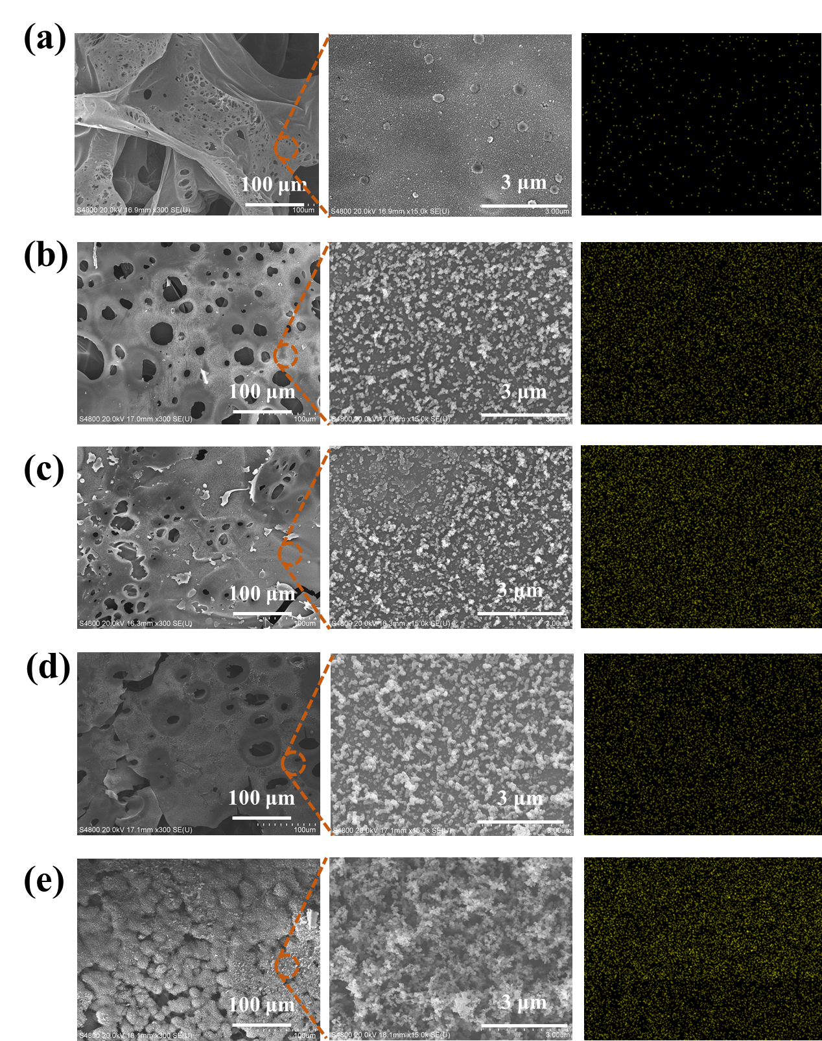
Fig S7 SEM and EDX images of various PIFs after the cone calorimeter PIF (a) PIF (b) PIF_{HBPSi}-1 (c) PIF _{HBPSi}-2 (d) PIF _{HBPSi}-3 (e) PIF _{HBPSi}-4

