Supplementary material to:
Positive influence of apple trees on soil chemical and biological activity in an agroecological garden orchar system
T. Ramananjatovo^{1,*}, R. Guénon¹, J. Peugeot¹, E. Chantoiseau¹, M. Delaire², G. Buck-Sorlin², P. Guillermin² and P. Cannavo¹
Submitted to: Agroforestry Systems

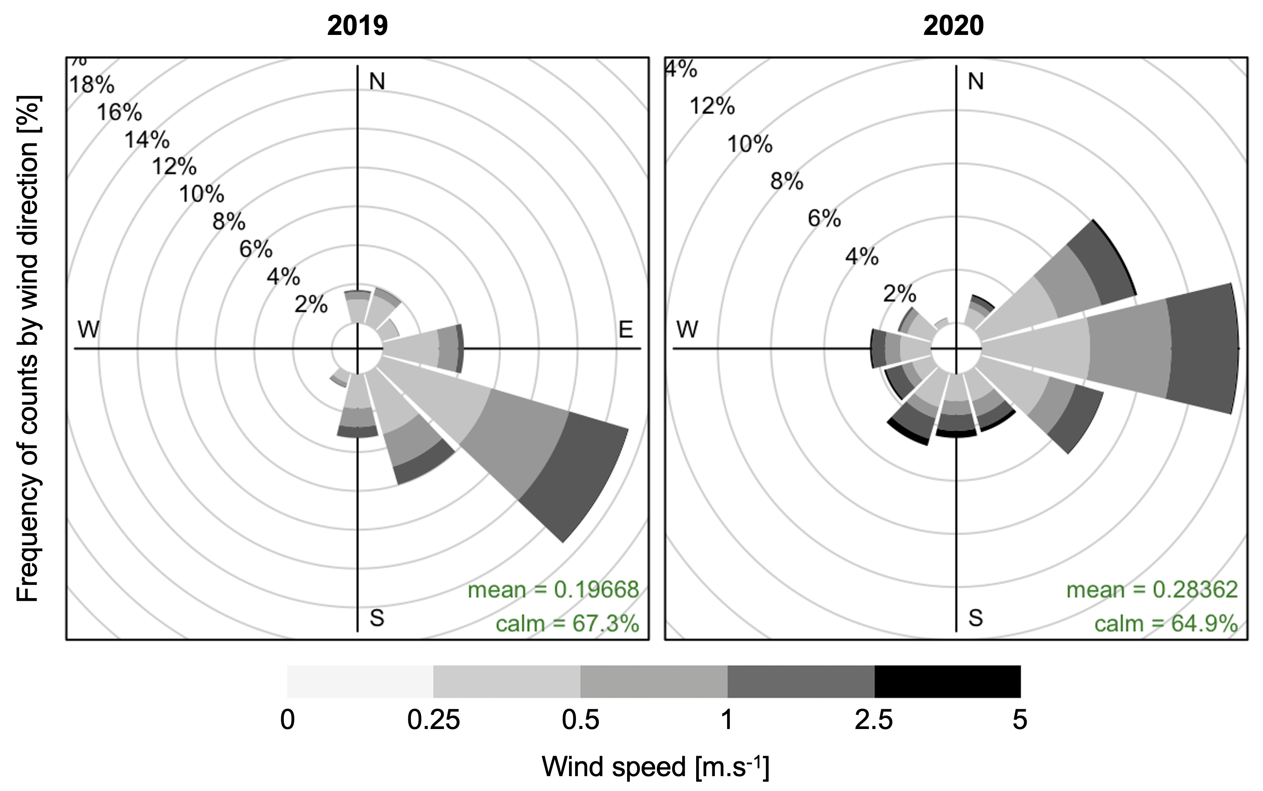
Figure S1. Wind speed and wind direction recorded during the litter collection period (October to December) in 2019 and 2020.

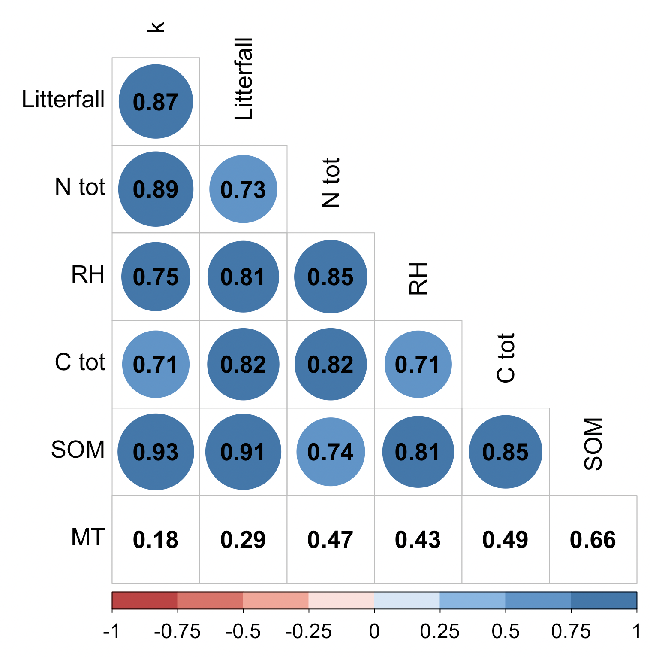
Figure S2. Pearson correlation matrix between the decomposition rate and the studied variables. Cells in blank indicate non-significant correlations (α = 5%). k: decomposition rate, N tot: soil total N content, RH: relative humidity inside the litterbags, C tot: soil total C content, SOM: soil organic matter content, MT: mean temperature inside the litterbags.
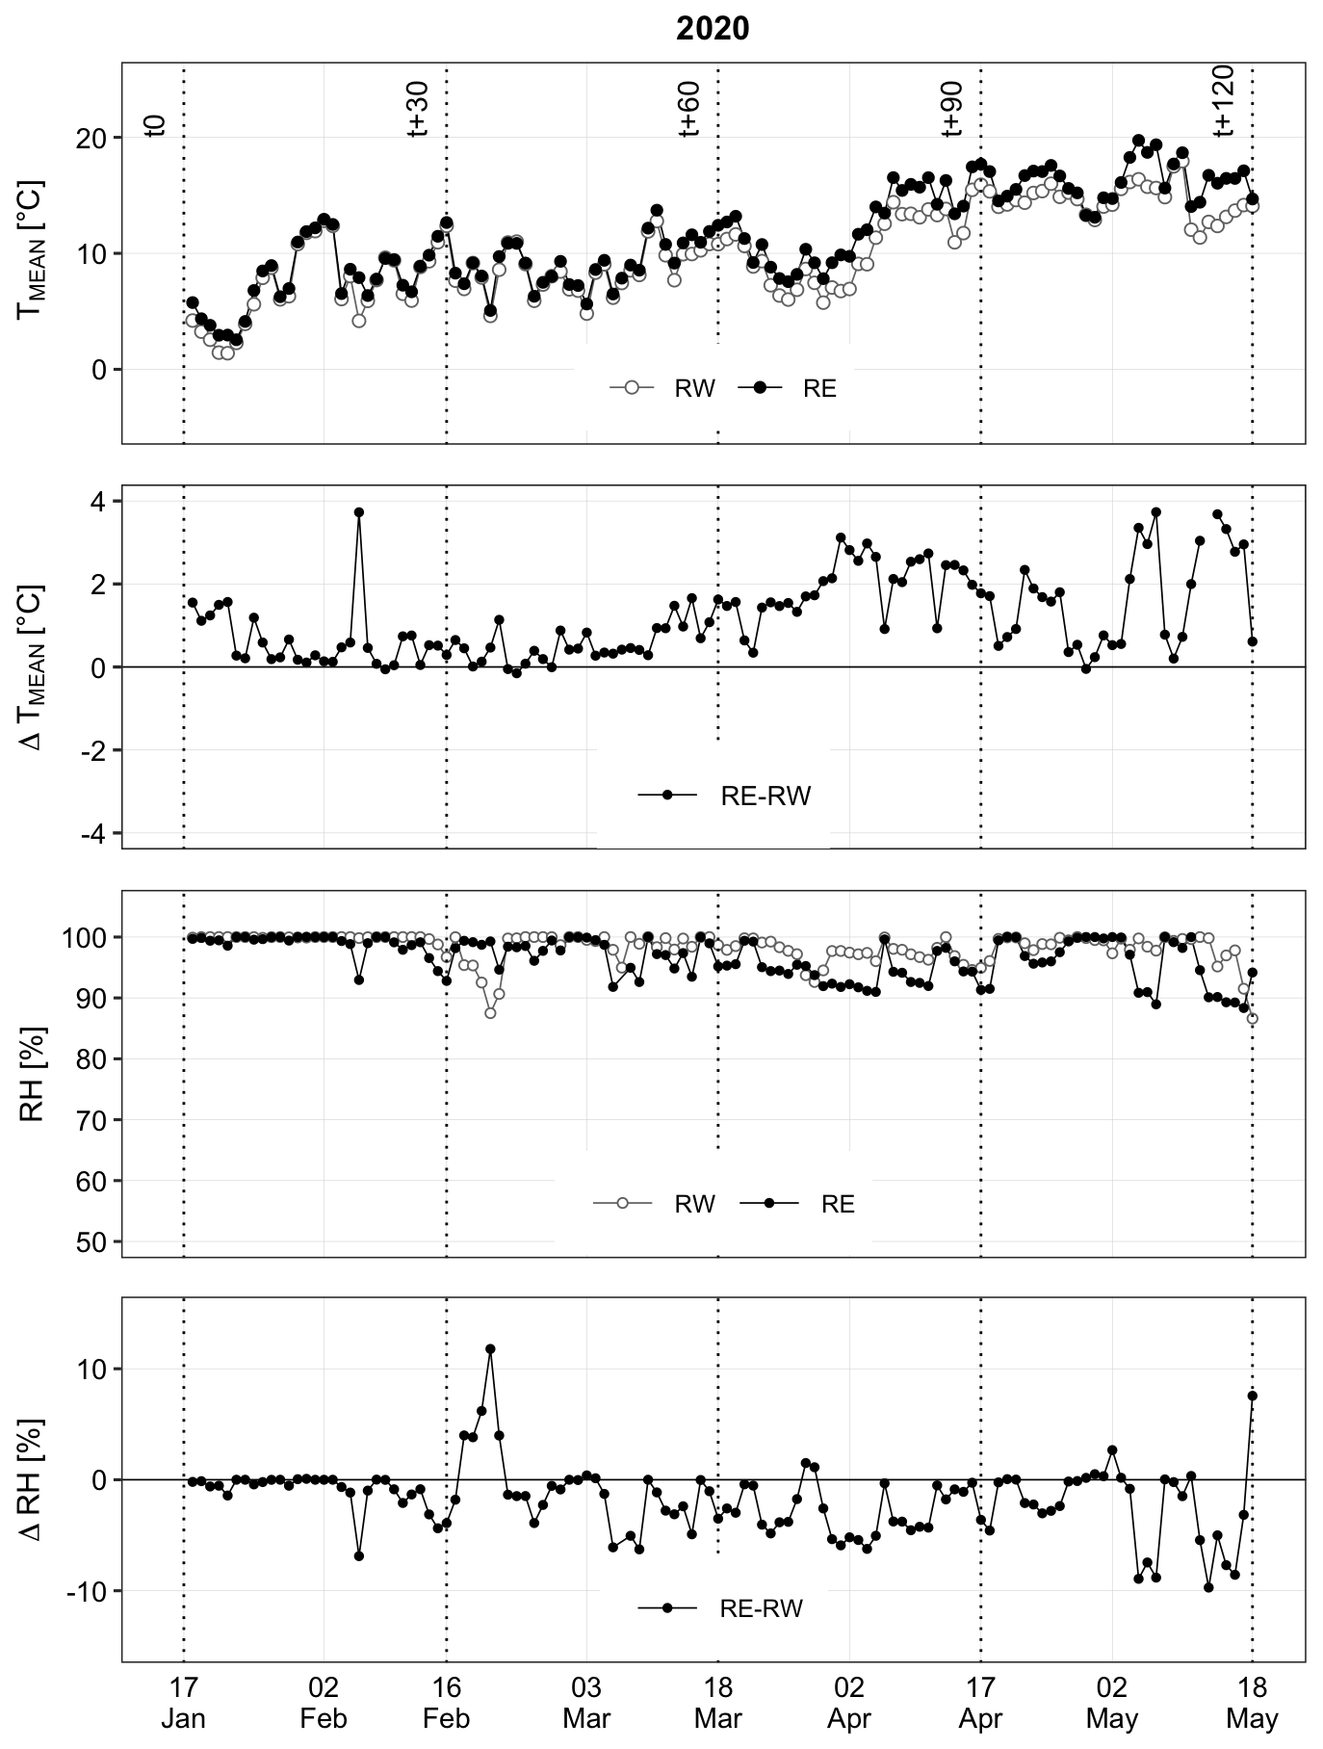
Figure S3. Daily temperature and relative humidity measured inside the litterbags installed under RW and RE in 2020.
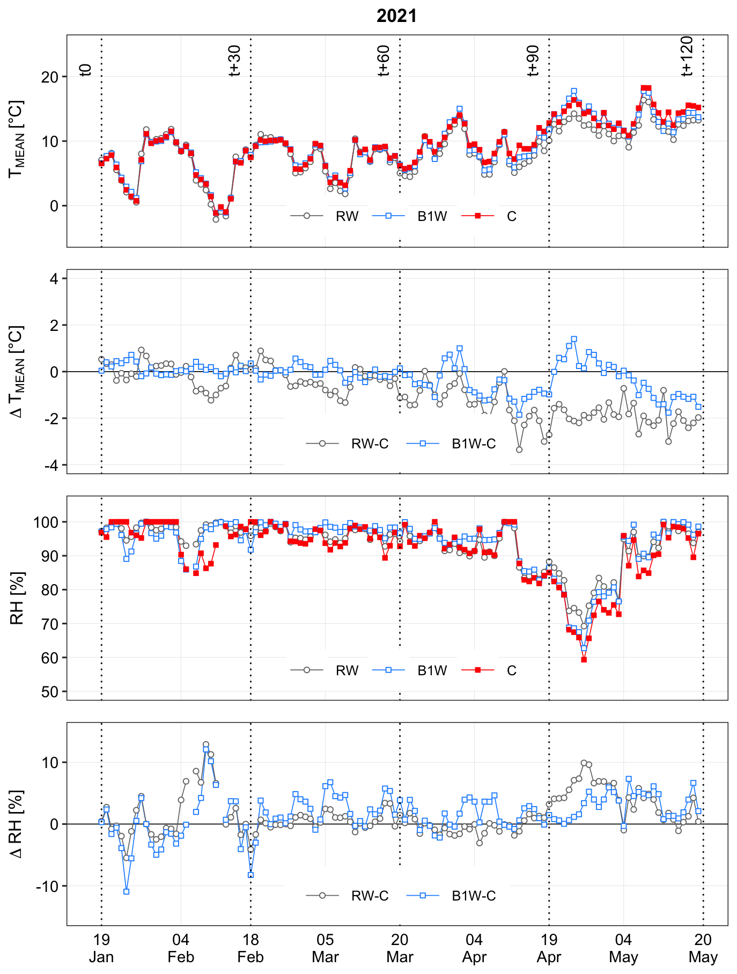
Figure S4. Daily temperature and relative humidity measured inside the litterbags installed under RW and in the B1W and C beds in 2021.

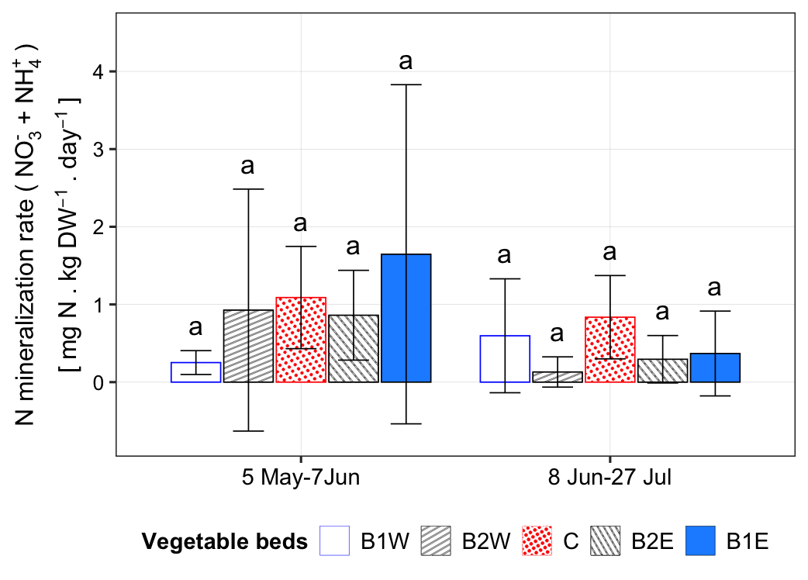
Figure S5. Organic N mineralization rate in each vegetable bed during the 2021 measurement campaigns. Error bars represent the standard deviation of the mean (n = 3). For each period, bars with the same letters are not significantly different from each other (p < 0.05, Tukey HSD test).
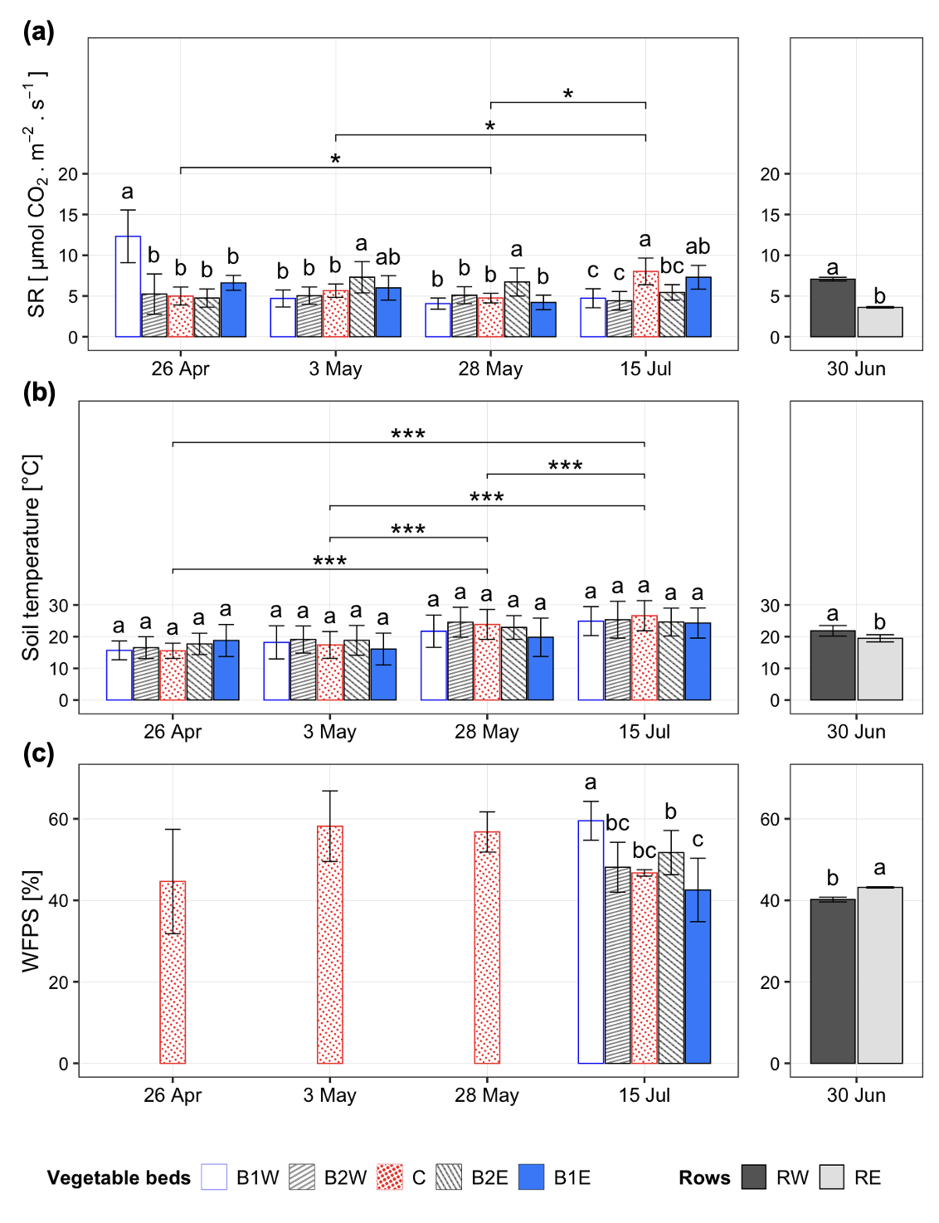
Figure S6. Daily CO2 flux (a), average temperature (b) and soil water saturation at 5 cm depth (c) in each vegetable bed and each apple tree row at each measurement date. Error bars represent the standard deviation of the mean related to the evolution of the variable during the measurement time (9am-4pm). For each date, bars with the same letters are not significantly different (p < 0.05, Tukey HSD test). * p<0.05, *** p<0.001.

