Supplementary materials
Roseateles cavernae sp. nov.，a bacterium isolated from freshwater of the Old Huanglong Cave in Yunnan province, south-west China
Yu-Man Zhang^{1, 2}· Qian Jiang¹· Mu-Yao Li³· Qing-Yu Miao¹· Yi-Qing Li¹· Min Yin⁴· Cui-Ping Miao¹· Shu-Kun Tang^{1, 5}
¹ The Key Laboratory for Microbial Resources of Ministry of Education, Yunnan Institute of Microbiology, Yunnan University, Kunming, Yunnan 650091, PR China
² Zhejiang Provincial People´s Hospital Bijie Hospital, Bijie 551700, PR China
³ Faculty of Innovation Engineering-School of Computer Science and Engineering, Macau University of Science and Technology, Macau 999078, PR China
⁴ School of Medicine, Yunnan University, Kunming 650091, PR China
⁵ Yunnan Key Laboratory of Fermented Vegetables, Honghe, 661100, People's Republic of China

Correspondence: Cui-Ping Miao
cpmiao@ynu.edu.cn
Shu-Kun Tang
tangshunkun@ynu.edu.cn
Yu-Man Zhang and Qian Jiang have contributed equally to this work.
Keywords: Roseateles cavernae sp.nov. · Novel species · Polyphasic taxonomy · Freshwater bacteria
The 16S rRNA gene and the draft genome sequences have been deposited at DDBJ/ENA/GenBank under accession numbers PP813686 and JBDPLH000000000.
Eight supplementary figures and four supplementary tables are available with the online version of this article.

Fig. S1 Neighbour-joining tree based on 16S rRNA gene sequences, showing the phylogenetic placements of strains YIM B04394^{T} and the related species of the genus Roseateles. Ideonella dechloratans CCUG 30977^{T} and Ideonella paludus KCTC 32238^{T} were used as an outgroup. Only bootstrap values (based on 1000 replicates) higher than 50 % are shown at the branch points. Bar, 0.005 substitutions per nucleotide position.
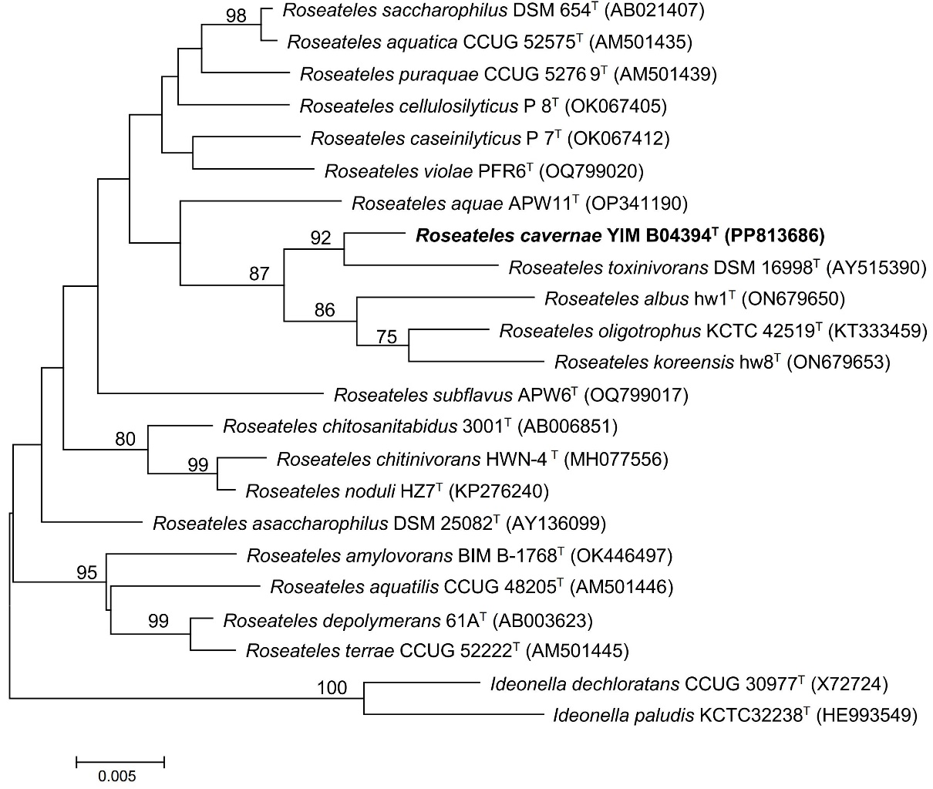

Fig. S2 Maximum-likelihood phylogenetic tree showing the relationships between strain YIM B04394^{T} and the related species in the genus Roseateles. Ideonella dechloratans CCUG 30977^{T} and Ideonella paludus KCTC 32238^{T} were used as an outgroup. Only bootstrap values (based on 1000 replicates) higher than 50% are shown at the branch points. Bar, 0.01 substitutions per nucleotide position.

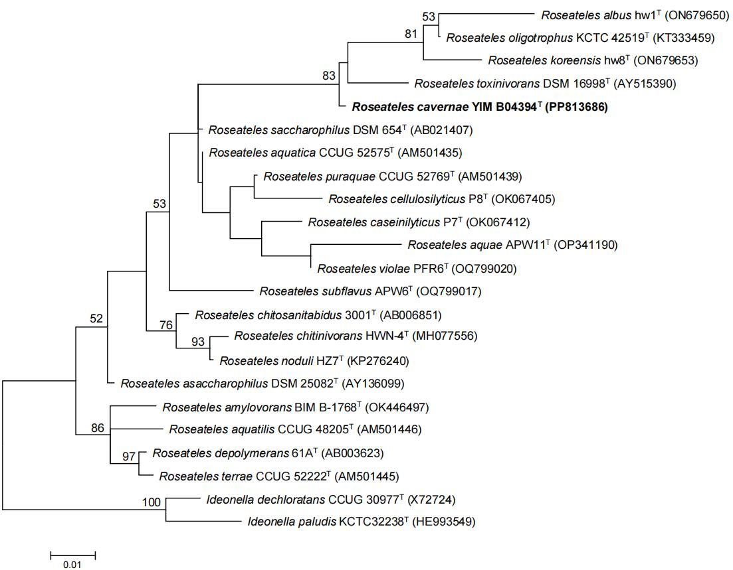

Fig. S3 Maximum-parsimony phylogenetic tree showing the relationships between strain YIM B04394^{T} and the related species of the genus Roseateles. Ideonella dechloratans CCUG 30977^{T} and Ideonella paludus KCTC 32238^{T} were used as an outgroup. Numbers at nodes indicate percentages of 1000 bootstrap resamplings; only values above 50% are shown. Bar, 5.
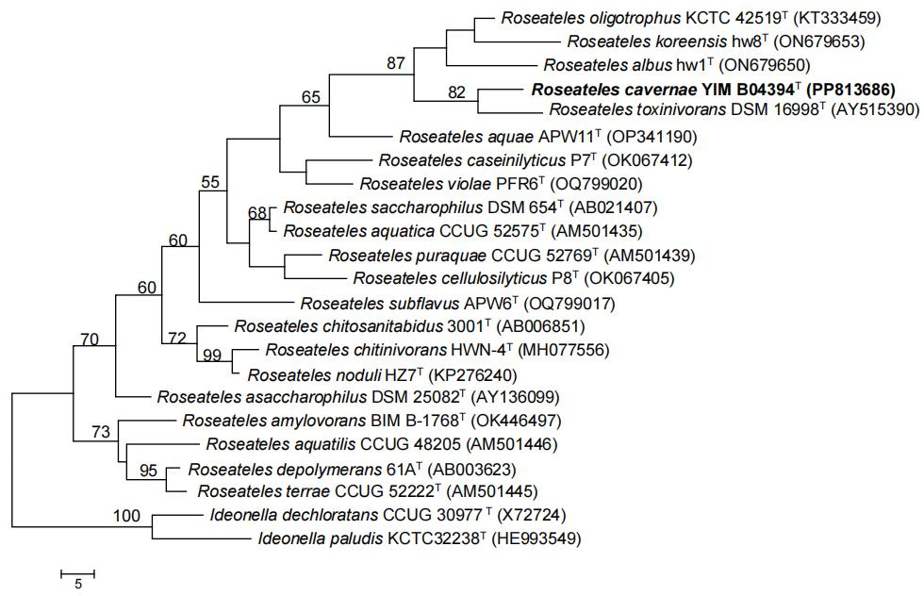

Fig. S4 Circular genome maps of YIM B04394^{T} (from outer to inner): 1, Genome size; 2-3, CDS on positive and negative strands, and different colors indicate the functional classification of different COGs of CDS; 4, rRNA and tRNA; 5, GC content; 6, GC-Skew value.

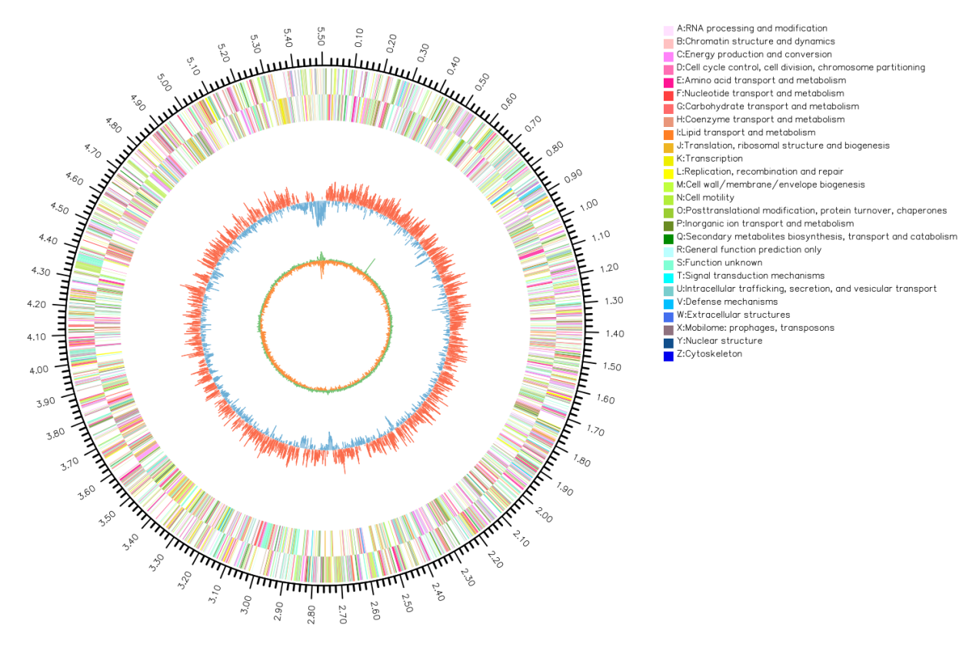

Fig. S5 The distribution of genes associated with general COG functional classification in strain YIM B04394^{T}

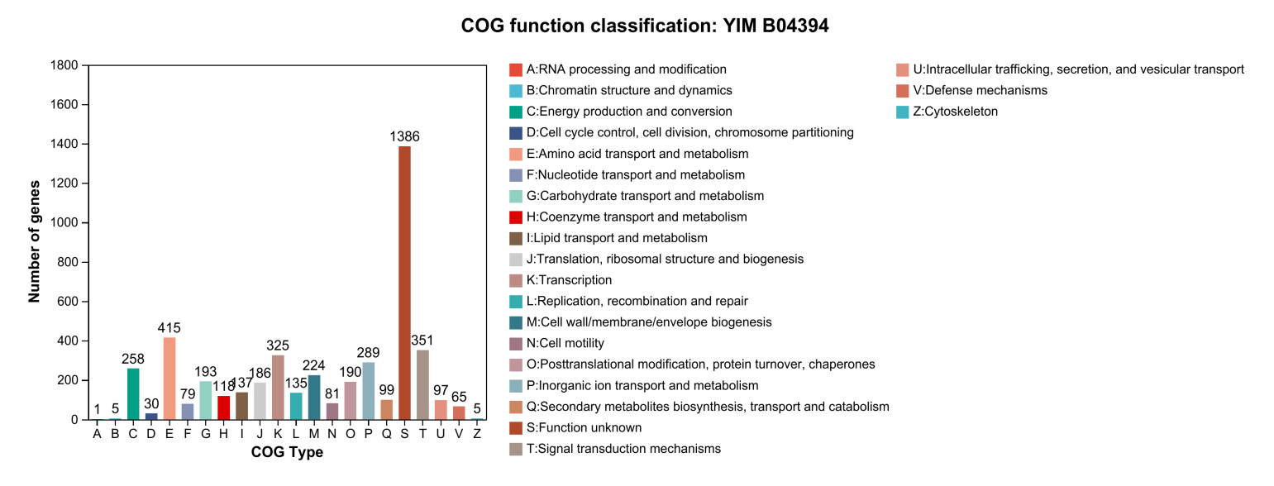
Fig. S6 Number of genes associated with carbohydrate-active enzymes of strain YIM B04394^{T}. CE: carbohydrate esterases, GT: glycosyl transferases, GH: glycoside hydrolases, AA: auxiliary activities, PL: polysaccharide lyases, CBM: carbohydrate-binding modules.
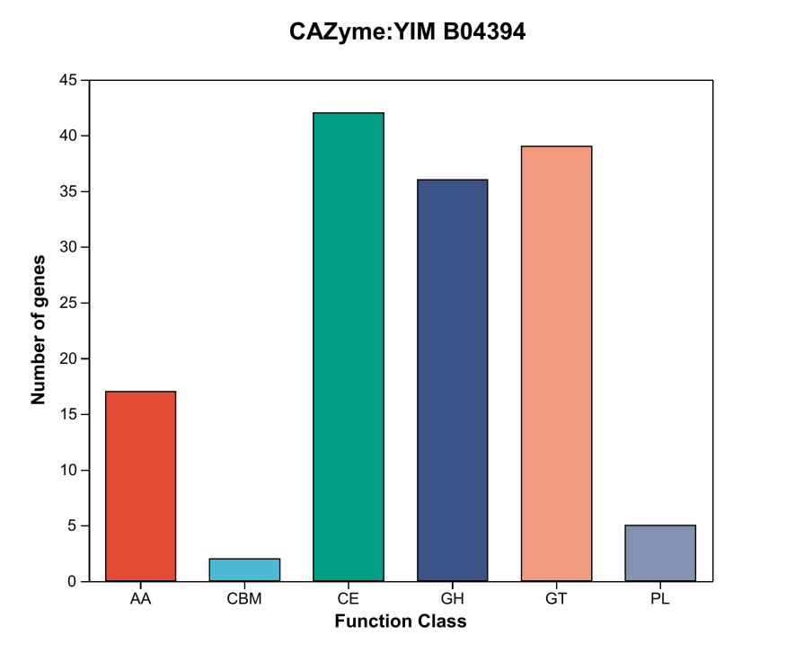
Fig. S7 Number of genes associated with KEGG-based functional classification in strains YIM B04394^{T}. The vertical coordinate indicates the level 2 hierarchical classification of the KEGG pathway, and the horizontal coordinate indicates the number of genes under the annotated classification. The different bar colors represent the level 1 classification of the KEGG pathway. The rightmost bar indicates the number of genes under different level 1 categories.

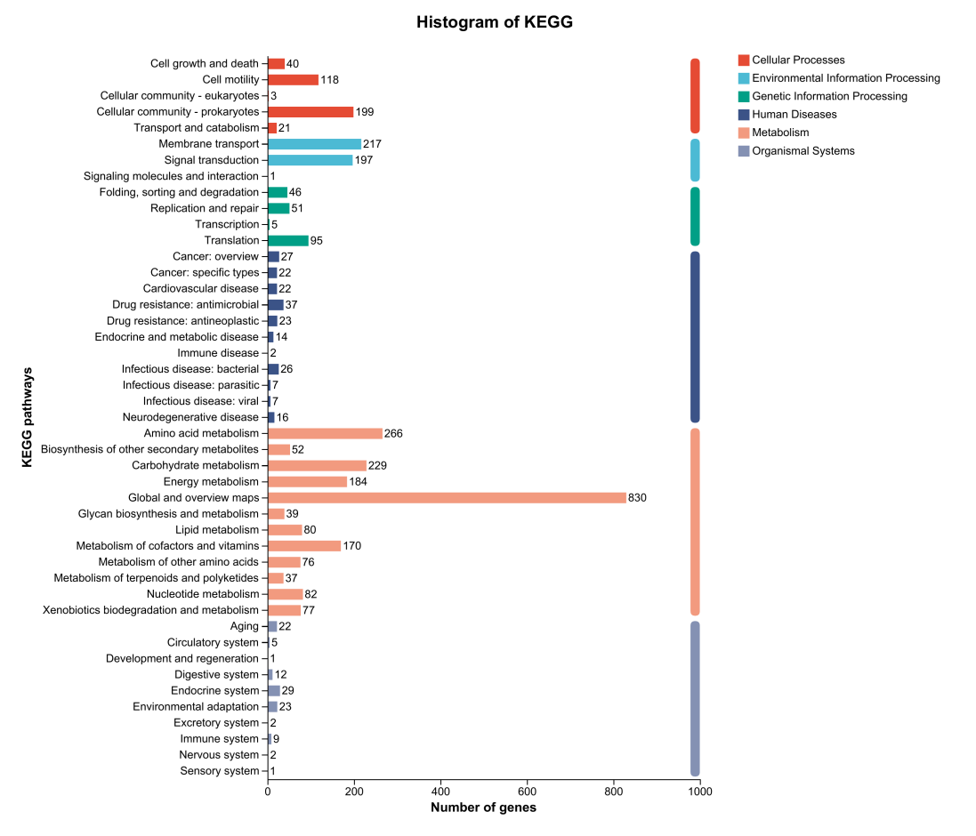

Fig. S8 Polar lipid profile of strain YIM B04394^{T} separated by two-dimensional TLC and detected with A: molybdophosphoric acid, B: molybdenum blue spray reagent, C: ninhydrin reagent, D: α-naphthol. DPG, diphosphatidylglycerol; PE, phosphatidylethanolamine; PL, unidentified phospholipid;
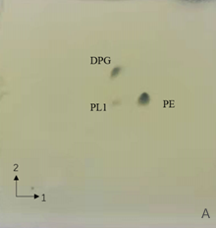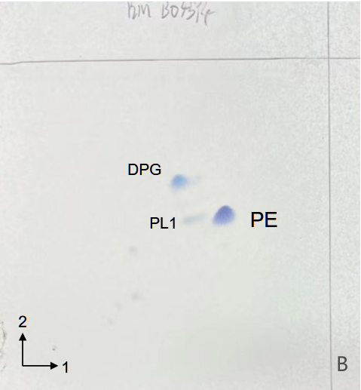
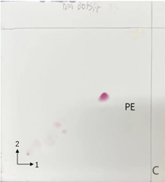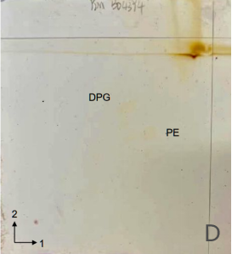

Table S1 The analysed AntiSMASH results of the genome of strain YIM B04394^{T} and other reference strains. Strains: 1, Strain YIMB04394^{T}; 2, R. toxinivorans DSM 16998^{T}; 3, Roseateles asaccharophilus DSM 25082^{T}
Analysis class | 1 | 2 | 3
Gene cluster | 6 | 8 | 5
Type：
Terpene | 1 | 2 | 0
N-acyl amino acid | 2 | 2 | 1
Hydrogen cyanide | 1 | 1 | 0
NRPS | 0 | 0 | 1
Ripp-like | 1 | 1 | 1
PRE-containing | 0 | 0 | 1
Hserlactone | 0 | 0 | 1
Betalactone | 0 | 1 | 0
NAPAA | 0 | 0 | 0

Table S2 The Biolog GEN III MicroPlate tests of strain YIM B04394^{T}
All data were from this study. +, Positive; -, Negative.
Characteristic | YIM B04394^{T} | Characteristic | YIM B04394^{T}
Negative Control | - | L-Arginine | -
Dextrin | + | L-AsparticAcid | -
D-Maltose | + | L-GlutamicAcid | -
D-Trehalose | - | L-Histidine | +
Gentiobiose | - | L-Pyroglutamic Acid | +
Sucrose | + | L-Serine | +
D-Turanose | - | Pectin | +
Stachyose | - | D-Galacturonic Acid | +
D-Raffinose | + | L-Galactonic Acid | +
α-D-Lactose | + | D-GlLuaccotnoince Acid | +
D-Melibiose | - | D-Glucuronic Acid | +
β-Methyl-D Glucoside | - | Glucuronamide | -
D-Salicin | + | Mucic Acid | -
N-Acetyl-D Glucosamine |  | Quinic Acid | -
N-Acetyl-Dgalactosamine | + | D-Saccharic Acid | -
N-Acetyl | - | p-Hydroxy-Phenylacetic | +
α-D-Glucose | - | MethylAcPidyruvate | +
D-Mannose | + | D-LacticAcid Methyl | +
D-Fructose | + | L-LaEcstitcer Acid | +
D-Galactose | - | Citric Acid | +
3-Methyl Glucose | - | α-Keto-Glutaric Acid | -
D-Fucose | - | D-Malic Acid | -
L-Rhamnose | - | L-Malic Acid | -
D-Sorbitol | - | Bromo-Succinic Acid | -
D-Mannitol | - | Tween 40 | +
D-Arabitol | + | γ-Amino-Butryric Acid | +
Characteristic | YIM B04394^{T} | Characteristic | YIM B04394^{T}
myo-Inositol | + | α-Hydroxy-Butyric Acid | +
Glycerol | + | β-Hydroxy-D,Lbutyric | +
D-Glucose-6-PO4 | - | α-Keto-Butyric Acid | -
D-Fructose-6-PO4 | - | Acetoacetic Acid | -
D-Aspartic Acid | - | Propionic Acid | -
D-Serine | - | Acetic Acid | +
Positive Control | + | Formic Acid | -
pH6 | + | Lincomycin | +
pH5 | - | Guanidine HCl | -
1%NaCl | + | Niaproof 4 | -
4%NaCl | - | Vancomycin | +
8%NaCl | - | Tetrazolium Violet | +
1%Sodium Lactate | - | Tetrazolium Blue | +
Fusidic Acid | - | Nalidixic Acid | -
Rifamycin SV | + | Lithium Chloride | -
Troleandomycin | - | Potassium Tellurite | -
Minocycline | - | Aztreonam | +
Gelatin | - | Sodium Butyrate | -
Glycyl-L-Proline | + | Sodium Bromate | -
L-Alanine | +

Table S3 The antibiotic susceptibility results of strains YIM B04394^{T}.
All data were from this study .1, strain YIM B04394^{T}. +, sensitive; -, unsensitive.
antibiotic (content) | YIM B04394^{T}
penicillin G (10 μg) | +
gentamicin sulfate (10 μg) | +
erythromycin (15 μg) | -
penicillin (10 μg) | -
streptomycin (10 μg) | -
ciprofloxaci (10 μg) | -
tetracycline (30 μg) | +
vancomycin (10 μg) | -
novobiocin (30 μg) | +
tobramycin (10 μg) | +
bacitracin (30 μg) | -
cefoxitin (15 μg) | +
clindamycin (10 μg) | -
kanamycin (15 μg) | +

Table S4 Cellular fatty acid profiles of the strain YIM B04394^{T} and closely associated species.
Strains: 1, YIM B04394^{T}, data are from this study, which were acquired under identical experimental conditions as those applied to the reference strains; 2, R. toxinivorans DSM 16998^{T}, data cited from Rapala et al. (2005) and Park et al. (2023); 3，Roseateles asaccharophilus DSM 25082^{T}, data cited from Gomila et al. (2010).
Fatty acid | 1 | 2 | 3
C_{12:0} | 2.32 | TR | 2.6
C_{14:0} | TR | 1.3 | 2.0
C_{16:0} | 29.09 | 20.3 | 23.5
C_{17:0} | 6.31 | 1.5 | TR
C_{18:0} | 3.29 | - | TR
C_{17:1} ω6c | 0.89 | 5.5 | TR
C_{17:1} ω8c | 5.28 | - | TR
C_{18:1} ω9c | 1.21 | - | TR
Summed feature 2* | 1.74 | - | -
Summed feature 3* | 37.36 | 1.6 | -
Summed feature 8* | 9.83 | - | -

＊:Summed feature 2 comprises C_{14:0} 3OH and/or iso-C_{16:1}; Summed feature 3 comprises C_{16:1} ω7c and/or C_{16:1} ω6c; summed feature 8 comprises C_{18:1} ω6c and/or C_{18:1} ω7c. TR, the amount is less than 1.0% of the total. –, not detected.
References
Gomila M, Pinhassi J, Falsen E, Moore ERB, Lalucat J (2010) Kinneretia asaccharophila gen. nov., sp. nov., isolated from a freshwater lake, a member of the Rubrivivax branch of the family Comamonadaceae. Int J Syst Evol Microbiol 60(Pt 4):809-814
Rapala J, Berg KA, Lyra C, Niemi RM, Manz W, Suomalainen S, Paulin L, Lahti K (2005) Paucibacter toxinivorans gen. nov., sp. nov., a bacterium that degrades cyclic cyanobacterial hepatotoxins microcystins and nodularin. Int J Syst Evol Microbiol 55(Pt 4):1563-1568

Park S, Kim I, Chhetri G, So Y, Jung Y, Woo H, Seo T (2023) Roseateles albus sp. nov., Roseateles koreensis sp. nov. and Janthinobacterium fluminis sp. nov., isolated from freshwater at Jucheon River, and emended description of Roseateles aquaticus comb. nov. Int J Syst Evol Microbiol 73(9):006043

