Supplemental figure and tables

Supplemental figure
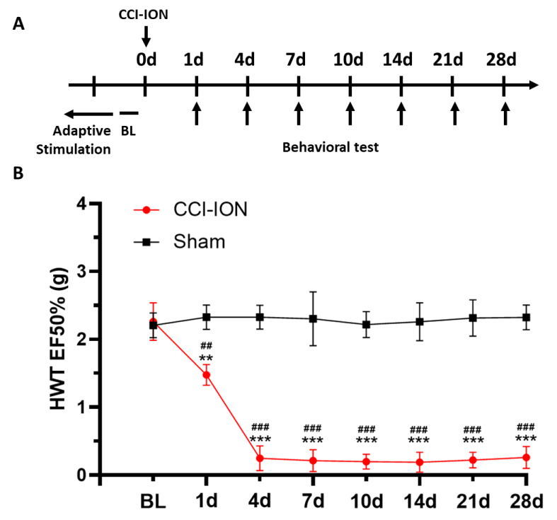
Fig. S1 A) Schedule for animal modeling and behavioral test. B) HWT EF50% of CCI-ION or Sham mice from baseline (BL) to post-surgery 28 days (two-way ANOVA, n = 6, vs. BL).

Supplemental tables
Table S1 Sequences of siRNAs used in this study
siRNA | Sequences (5'→3')
si-4930544M13Rik-201 | sense: CUCAGUGGCUUCAAGUAAATT
si-4930544M13Rik-201 | antisense: UUUACUUGAAGCCACUGAGTT
si-NC | sense: UUCUCCGAACGUGUCACGUTT
si-NC | antisense: ACGUGACACGUUCGGAGAATT

Table S2 Sequences of primers used in this study
Gene name | Primer sequences (5'→3')
4930544M13Rik-201-F | CGCTCGCATTCCCAATTCAG
4930544M13Rik-201-R | TGAGGTTCTCCATGCTCAGG
Gapdh-F | AACAGCAACTCCCACTCTTC
Gapdh-R | CCTCTCTTGCTCAGTGTCCT
Cacna2d1-F | CTTCGCCCGTCACTATCAAGT
Cacna2d1-R | CCAGTTGGCGTGCATTGTTG
Gal-F | GGCAGCGTTATCCTGCTAGG
Gal-R | CTGTTCAGGGTCCAACCTCT
Hnrnpa2b1-F | CAGGGTAGTTGAGCCAAAACG
Hnrnpa2b1-R | TTCCAGACTGCCTATCGGTAA

Table S3 Primary and secondary antibodies mentioned in this study
Antibody name | Catalog number | Host species | dilution ratio | Company
Cacna2d1 | sc-271697 | mouse | 1:200 | Santa Cruz, USA
hnRNPA2B1 | 14813-1-AP | rabbit | 1:500 | Proteintech, China
AlexaFluor®594 | SA00013-4 | goat anti-rabbit | 1:500 | Proteintech, China
AlexaFluor®488 | SA00013-1 | goat anti-mouse | 1:500 | Proteintech, China
AlexaFluor®594 | SA00013-3 | goat anti-mouse | 1:500 | Proteintech, China
AlexaFluor®488 | SA00013-2 | goat anti-rabbit | 1:500 | Proteintech, China

Table S4 Sequences of Cy3-labeled FISH probes used in this study
Target gene | Sequences of probes
4930544M13Rik-201 | ATGGACAAAGGG+TGAAGACCGC+TAATC  CTGTAGGGCTGTAGAC+TGGATTGTGC  GT+TGGCTGAAT+TGGGAATGCGA
18S | CTGCCTTCCTTGGATGTGGTAGCCGTTTC
U6 | TTTGCGTGTCATCCTTGCG
NC | TGCTTTGCACGGTAACGCCTGTTTT
Note: + indicates the LNA modification.

