Supplementary Tables

Supplementary Table 1: Complete list of MHC-Supertypes with corresponding MHC-DRB-alleles
Supertype | Assigned alleles
ST01 | DRB*01, DRB*41, DRB*56
ST02 | DRB*03, DRB*06, DRB*31, DRB*38, DRB*39, DRB*43, DRB*47, DRB*50, DRB*59
ST03 | DRB*07, DRB*20
ST04 | DRB*09, DRB*16, DRB*25
ST05 | DRB*10, DRB*26, DRB*58
ST06 | DRB*12, DRB*29, DRB*42, DRB*48, DRB*65
ST07 | DRB*17, DRB*18, DRB*37
ST08 | DRB*11, DRB*32, DRB*55, DRB*62
ST09 | DRB*13
ST10 | DRB*14
ST11 | DRB*36, DRB*68
ST12 | DRB*35

Supplementary Table 2: Complete list of MHC-haplotypes with corresponding MHC-DRB alleles.

Haplotype | Assigned alleles
A | DRB*02
B | DRB*01, DRB*03
C | DRB*04
D | DRB*05, DRB*09
E | DRB*01, DRB*06
F | DRB*01, DRB*10, DRB*13
G | DRB*02, DRB*11, DRB*12
H | DRB*05, DRB*17
I | DRB*01
J | DRB*03
K | DRB*04, DRB*16
L | DRB*05, DRB*18, DRB*20
M | DRB*04, DRB*20
N | DRB*01, DRB*10
O | DRB*05, DRB*16
P | DRB*05, DRB*18
Q | DRB*06
R | DRB*05
S | DRB*01, DRB*03, DRB*06
T | DRB*09
U | DRB*16
V | DRB*10, DRB*13
W | DRB*01, DRB*02
X | DRB*02, DRB*09
Y | DRB*01, DRB*04
Z | DRB*05, DRB*13, DRB*18
AA | DRB*11, DRB*12
AB | DRB*01, DRB*11
AC | DRB*01, DRB*04
AD | DRB*17
AE | DRB*02, DRB*11
AF | DRB*11
AG | DRB*02, DRB*12

Supplementary Table 3 - 6: Excel tables with complete model outputs for all susceptibility, progression, resilience and mortality models.
Supplementary Tables 3
Supplementary Tables 3. Final model based on the averaged results of the most competitive models (<ΔAIC<2.00) testing what factors influence TB susceptibility; each response variable was tested in a set of models that included alleles/STs/haplotypes separately; p-values were corrected for multiple testing and shown in brackets. Blackened out cells indicate explanatory variables not retained in the most competitive models.
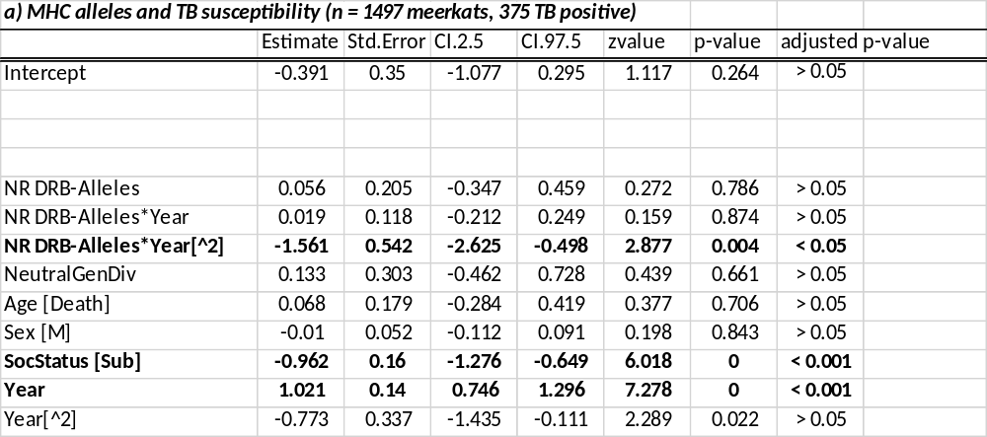

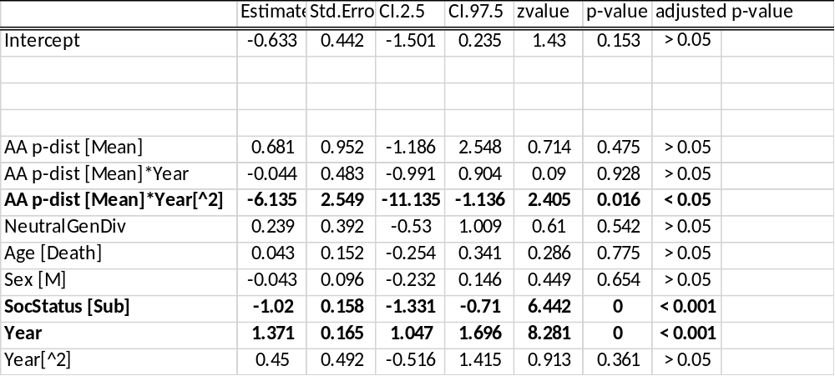

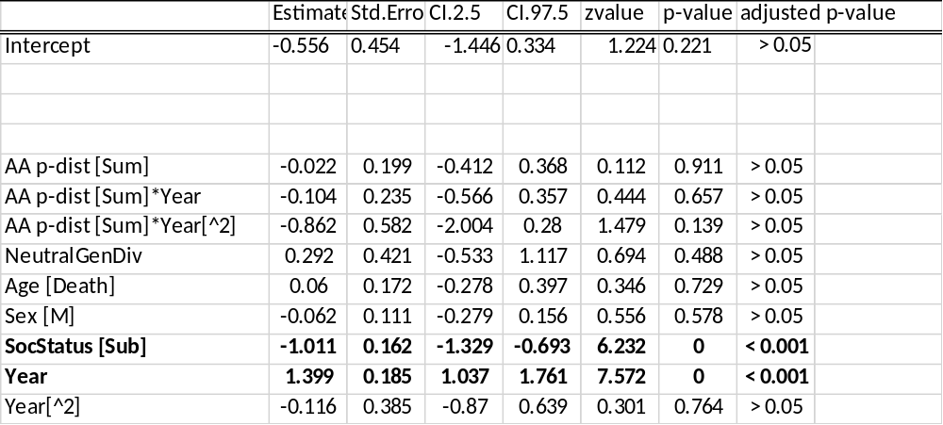

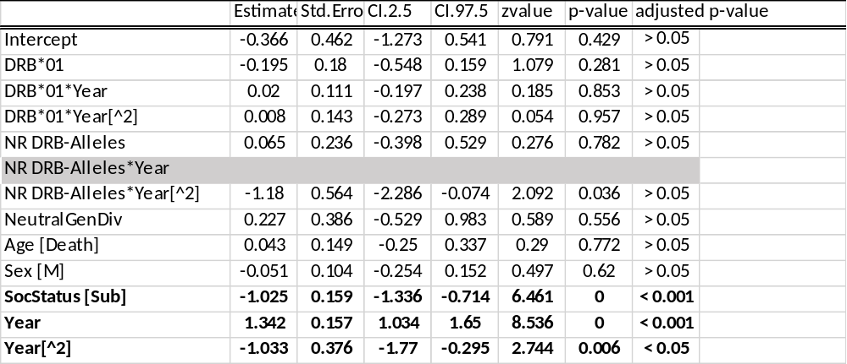

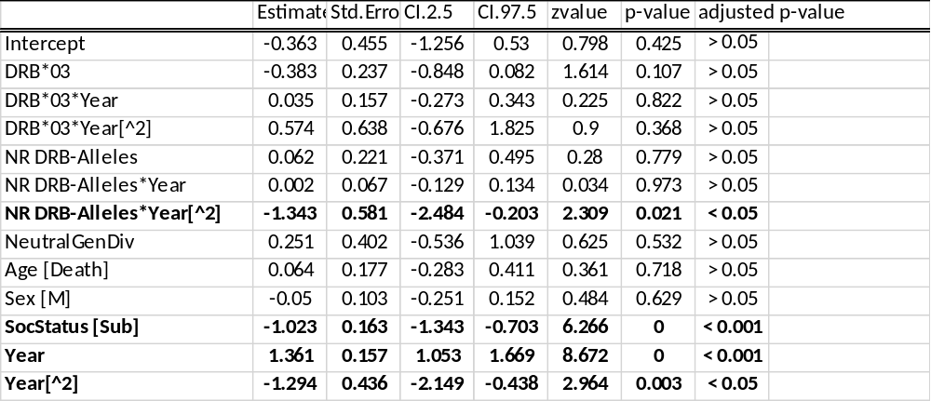

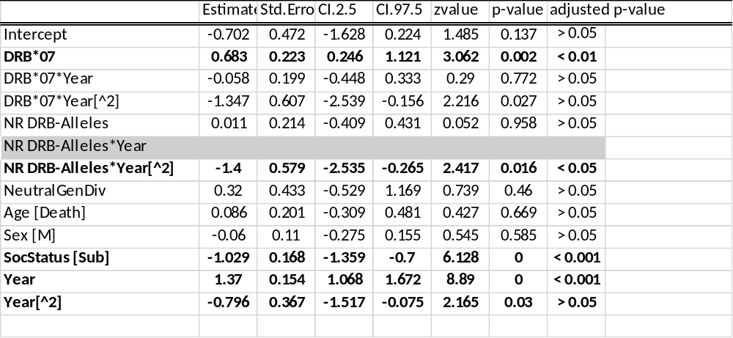
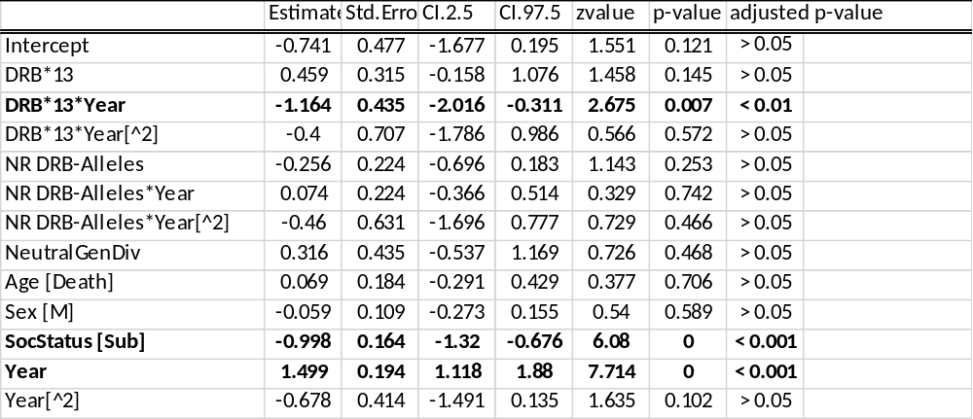

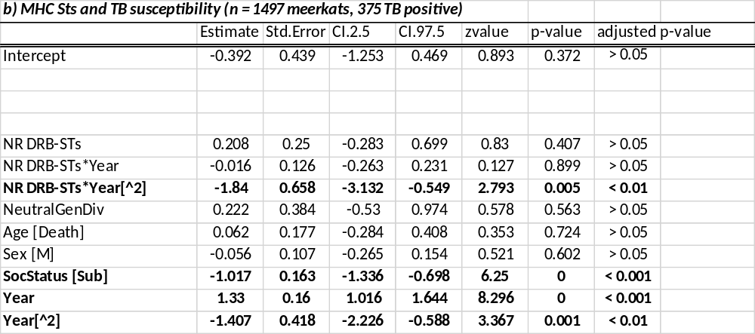

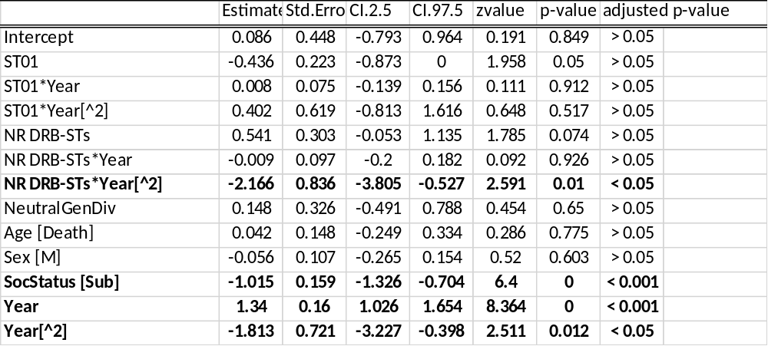

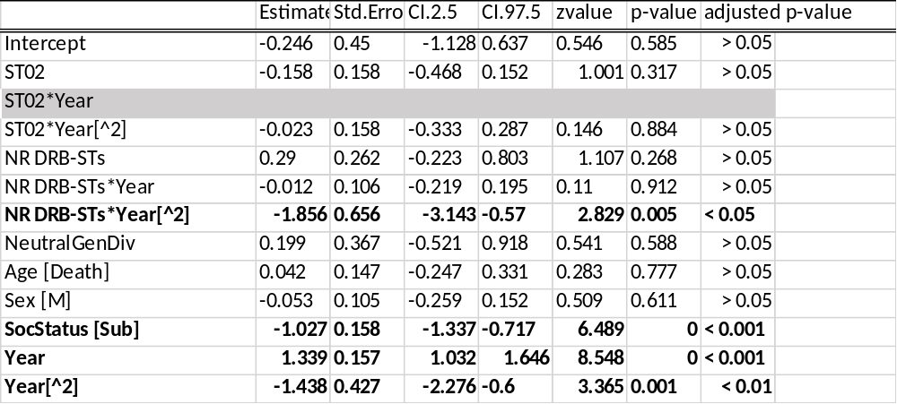

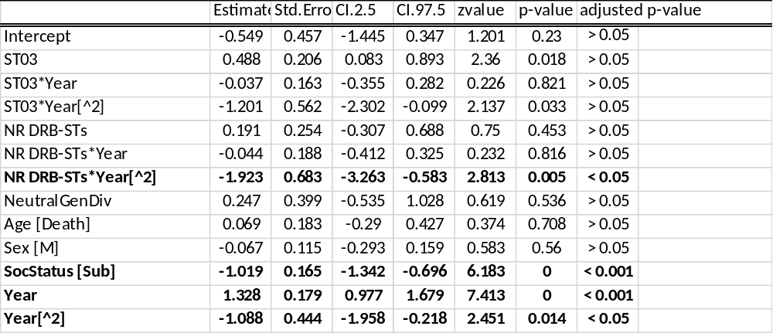

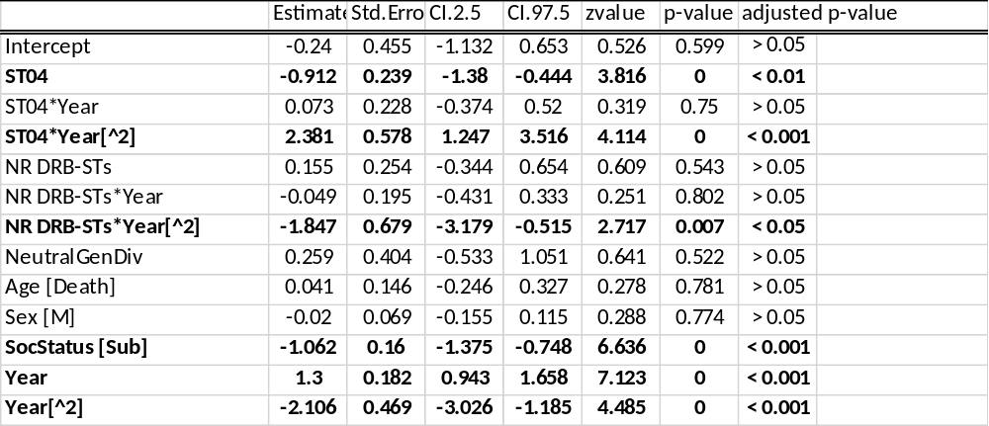

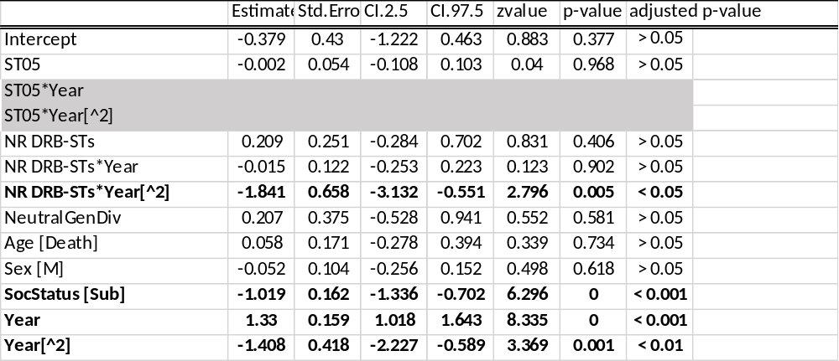

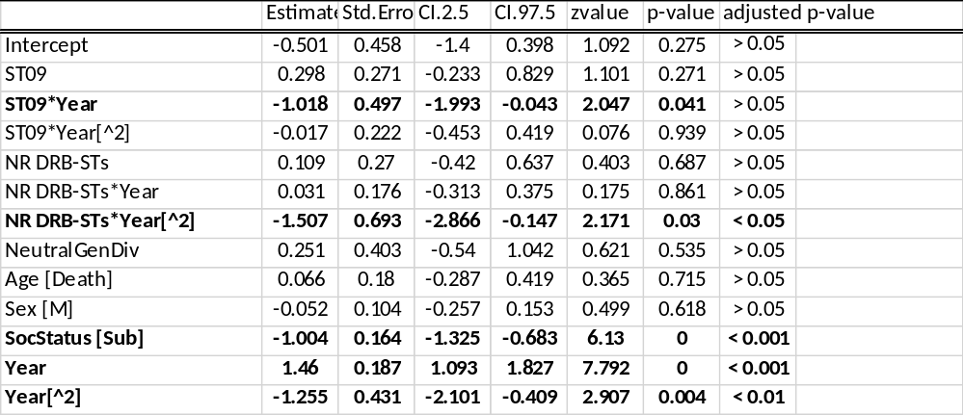

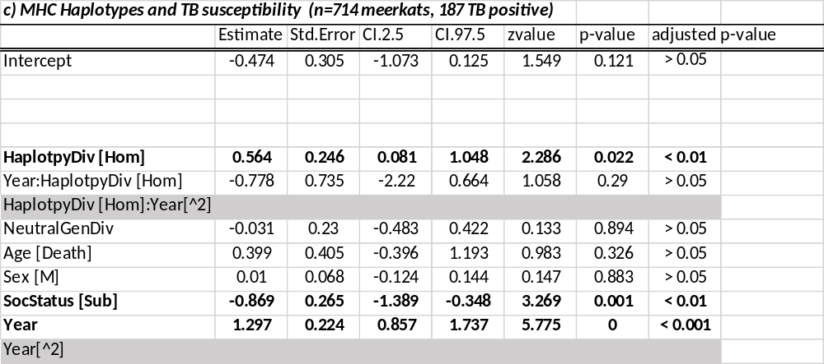
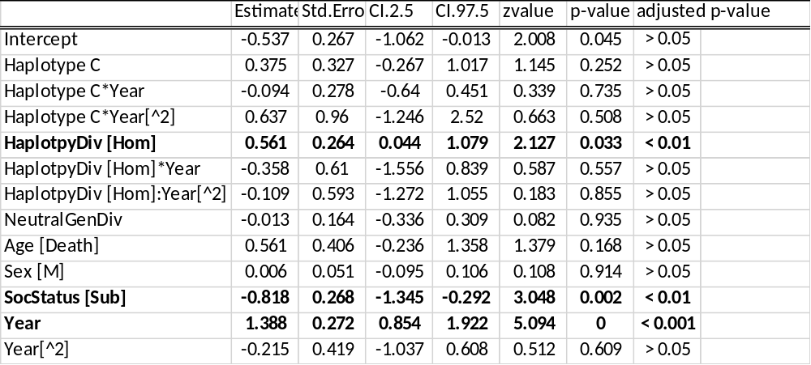

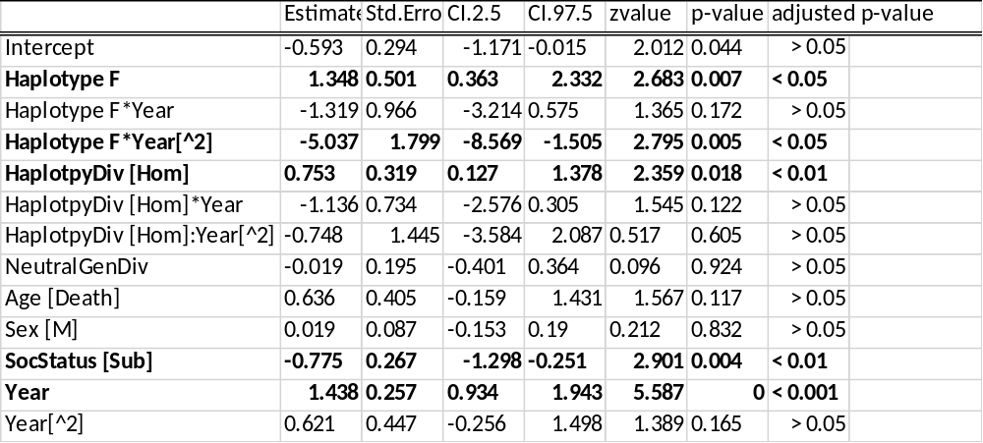

Supplementary Tables 4. Final model based on the averaged results of the most competitive models (<ΔAIC<2.00) testing what factors influence TB resilience; each response variable was tested in a set of models that included alleles/STs/haplotypes separately; p-values were corrected for multiple testing and shown in brackets. Blackened out cells indicate explanatory variables not retained in the most competitive models. 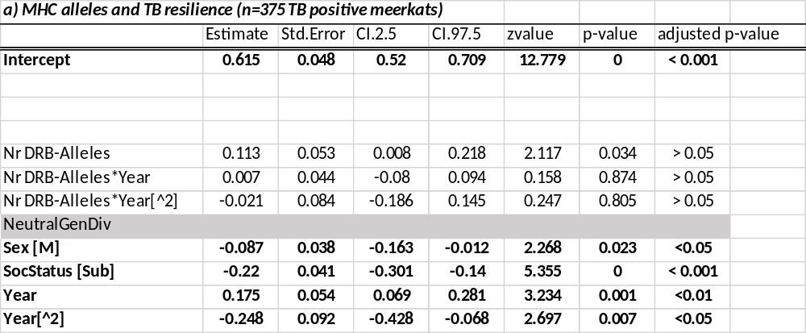
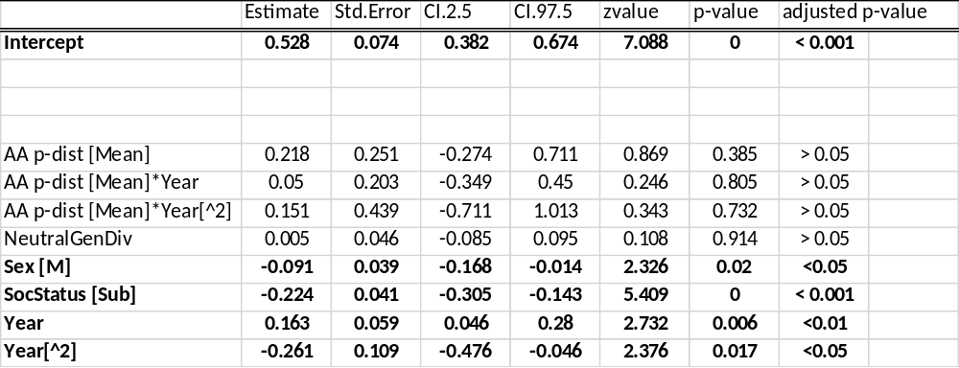
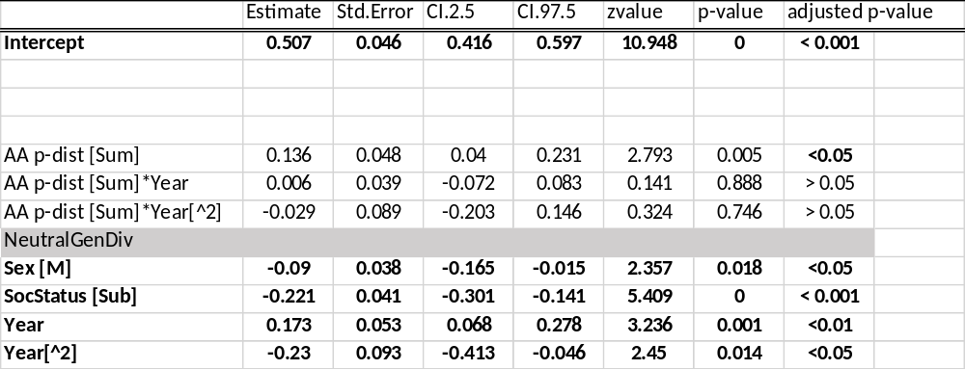
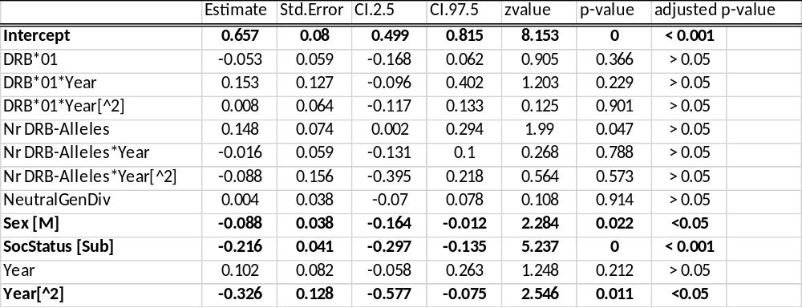
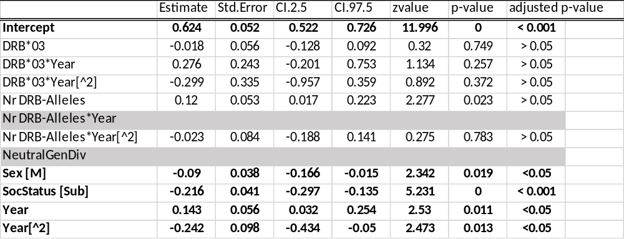
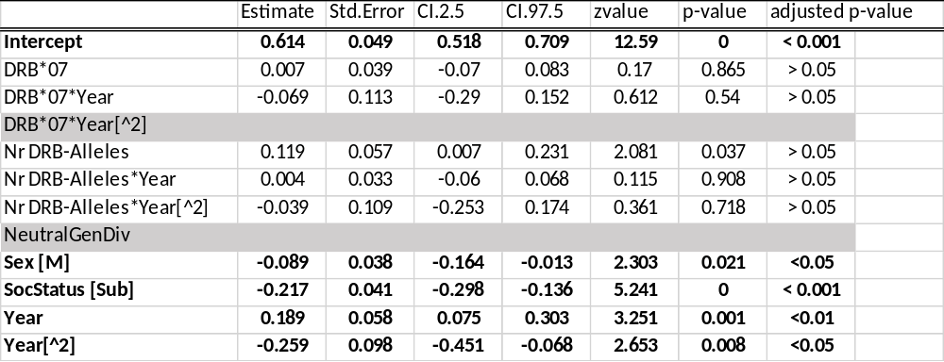
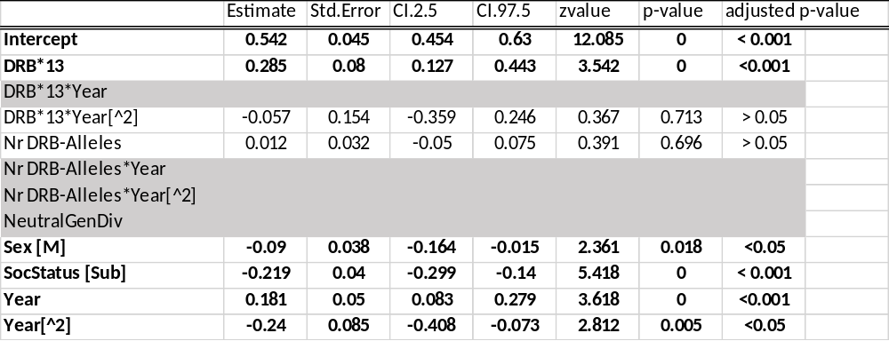

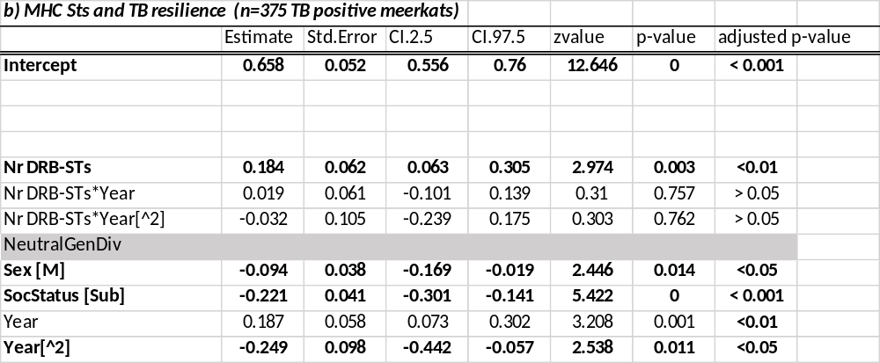

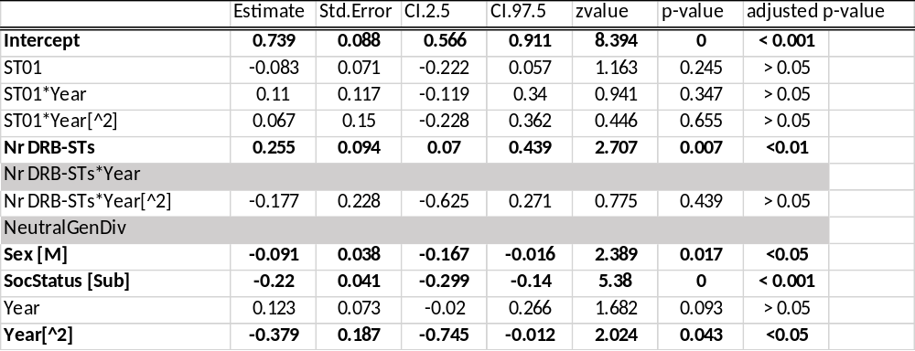
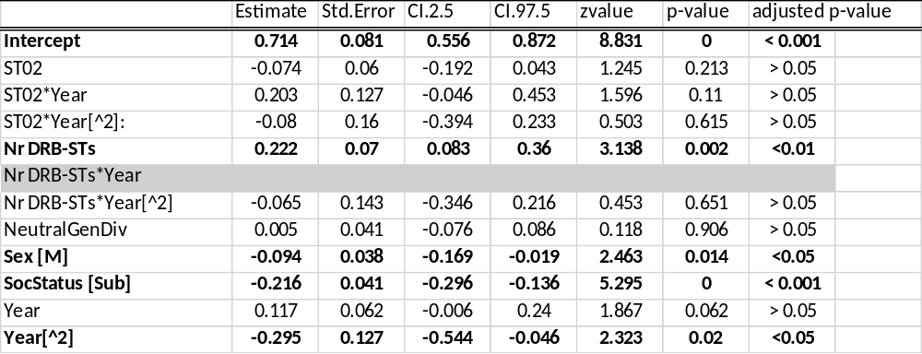
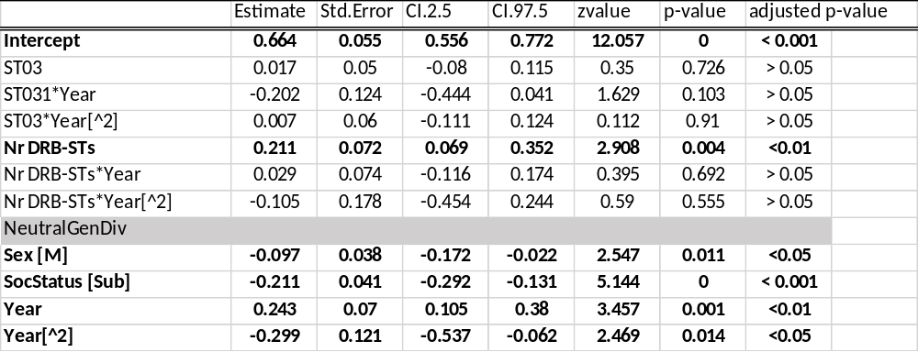
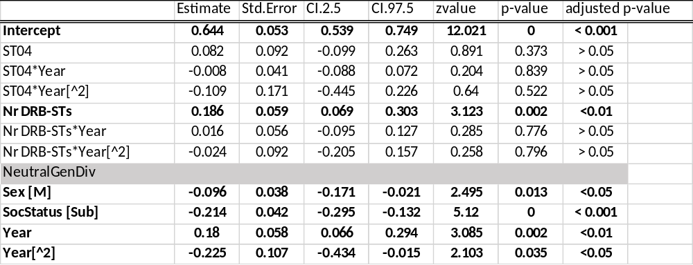

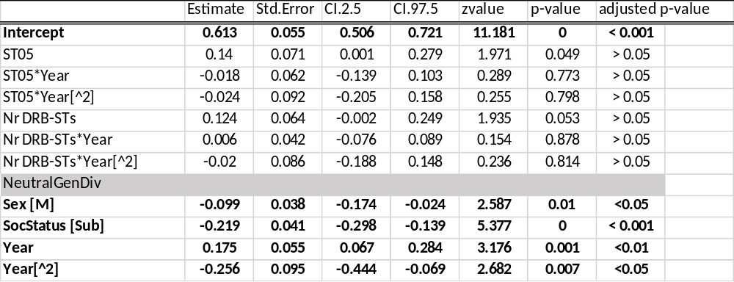
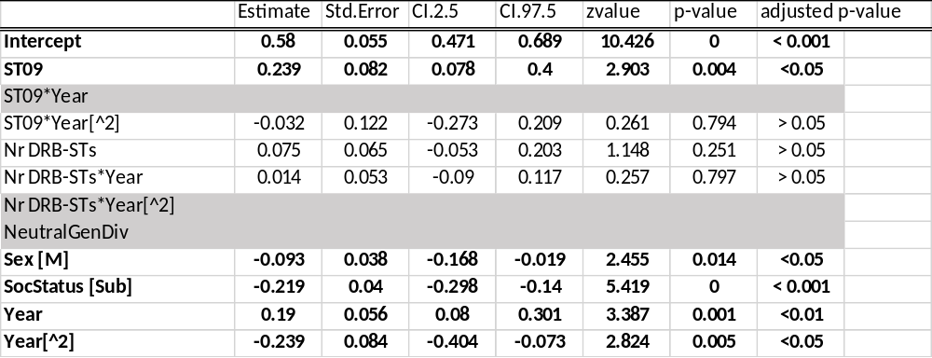

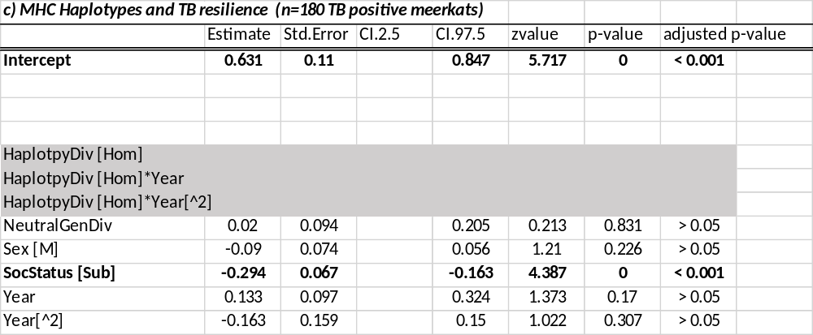

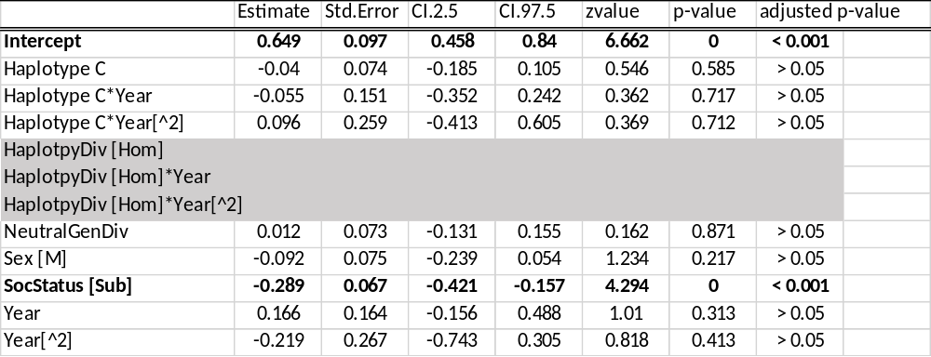
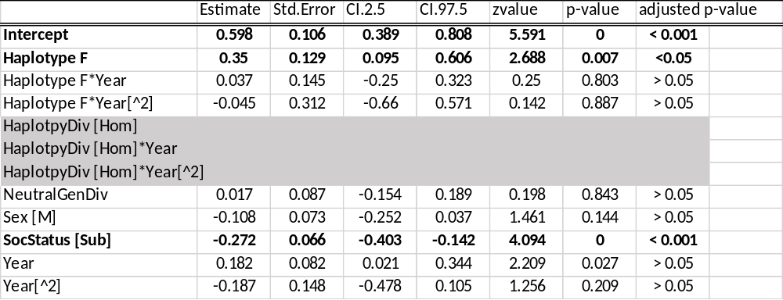

Supplementary Tables 5. Final model based on the averaged results of the most competitive models (<ΔAIC<2.00) testing what factors influence TB progression; each response variable was tested in a set of models that included alleles/STs/haplotypes separately; p-values were corrected for multiple testing and shown in brackets. Blackened out cells indicate explanatory variables not retained in the most competitive models.
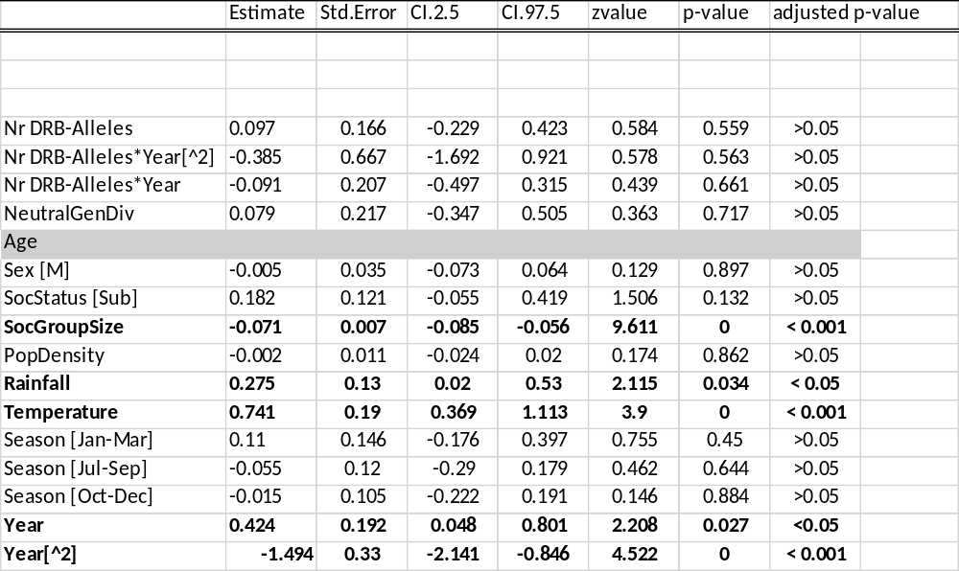

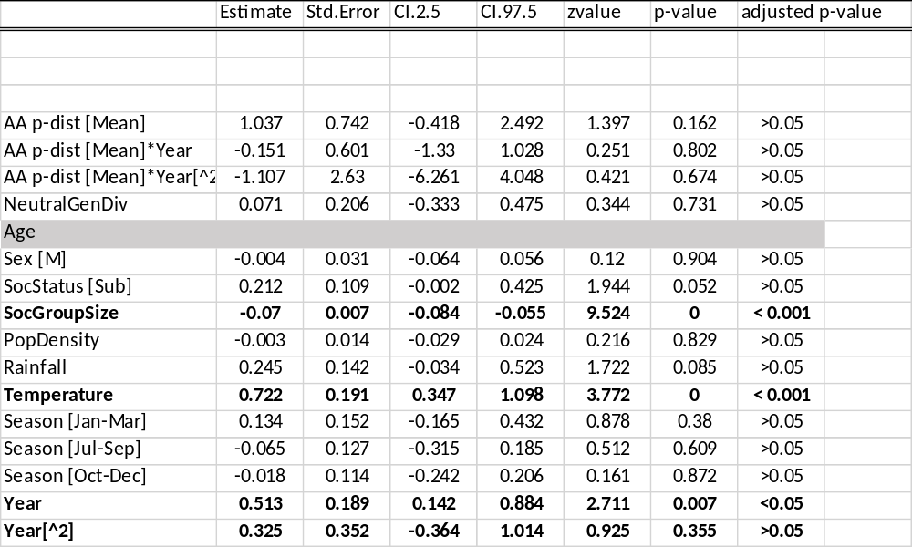

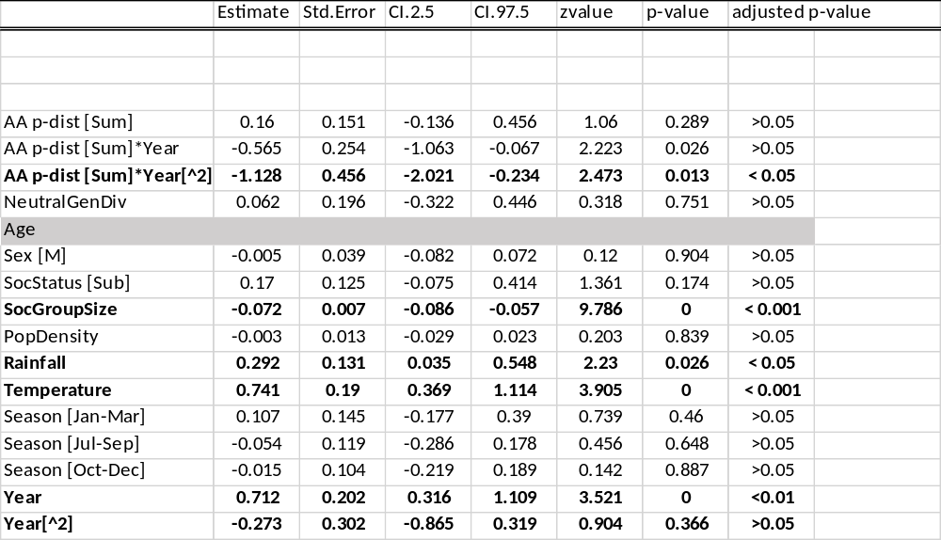

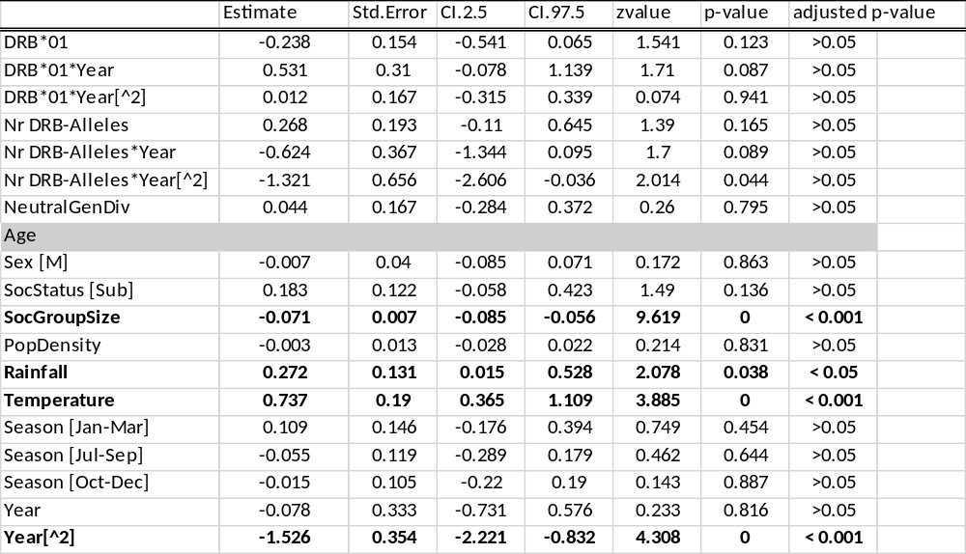

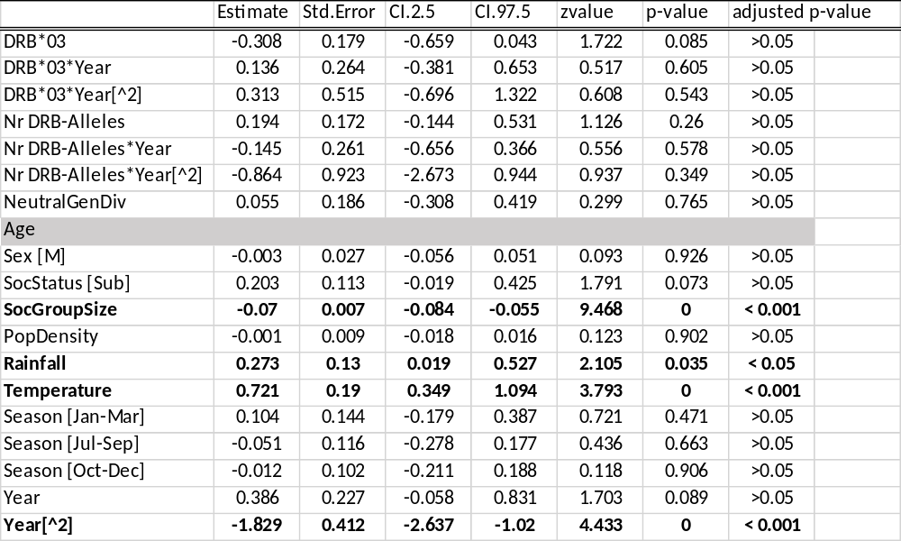

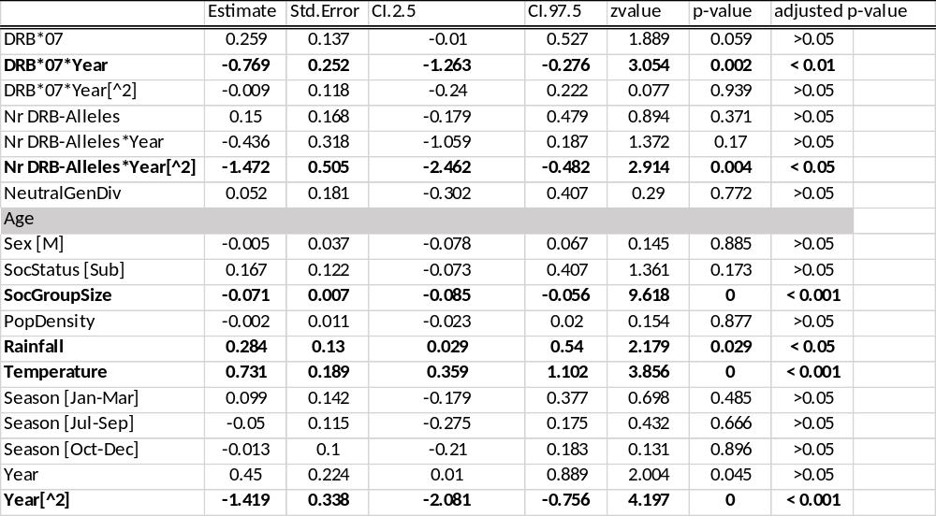

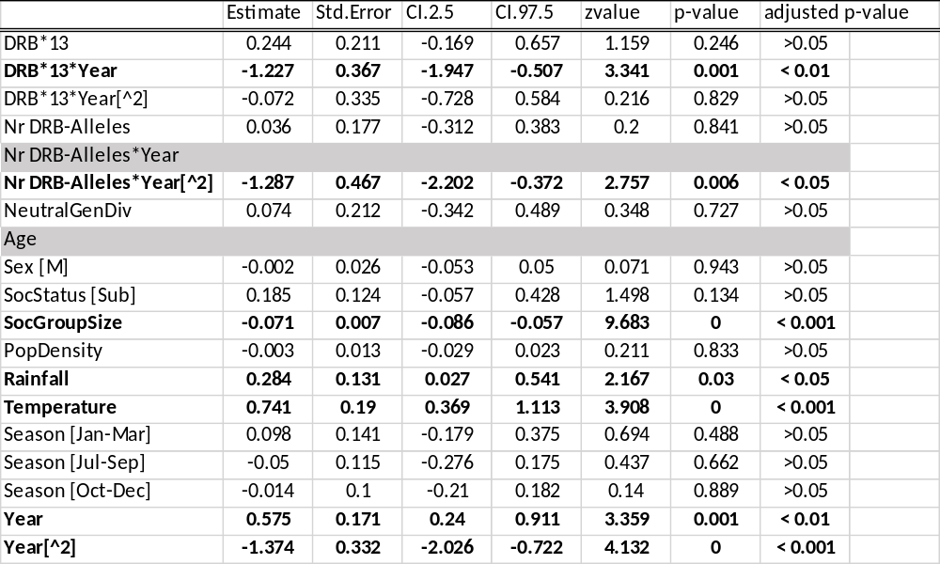

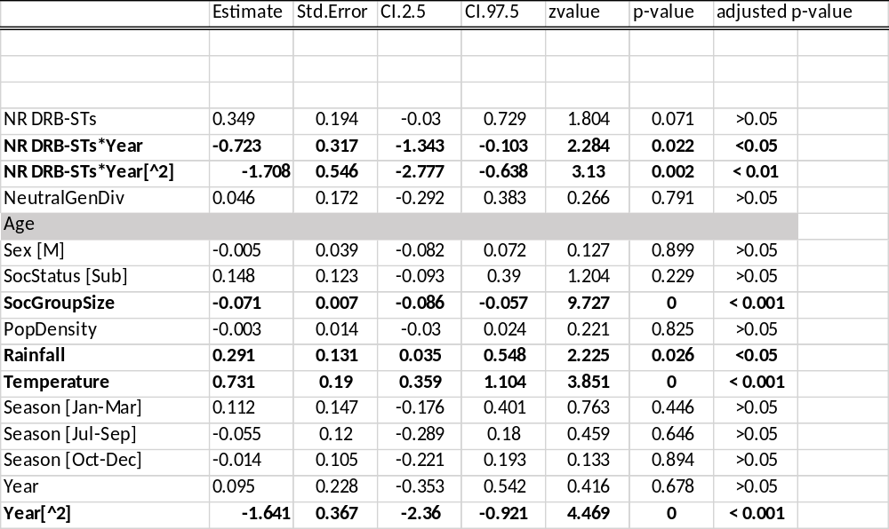
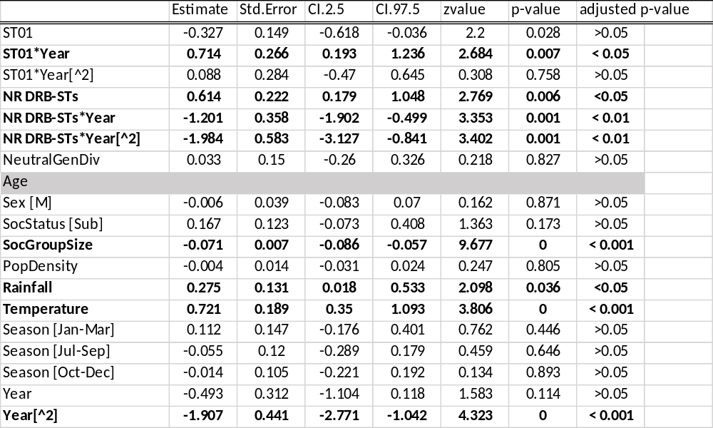

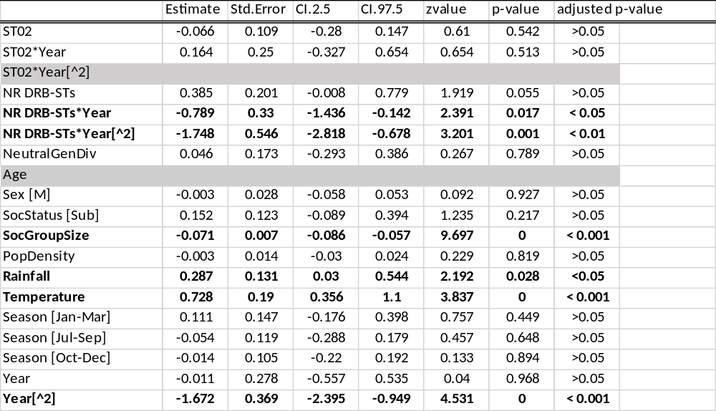

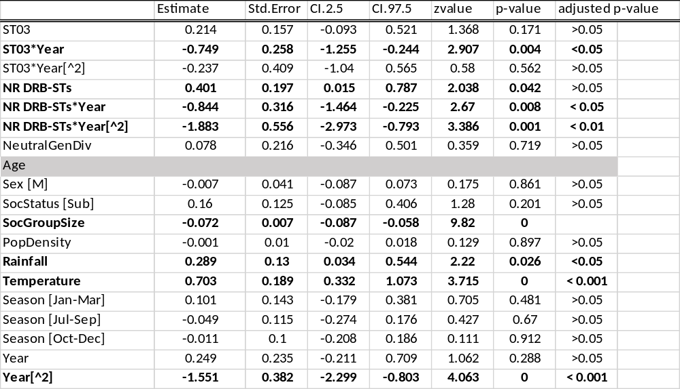

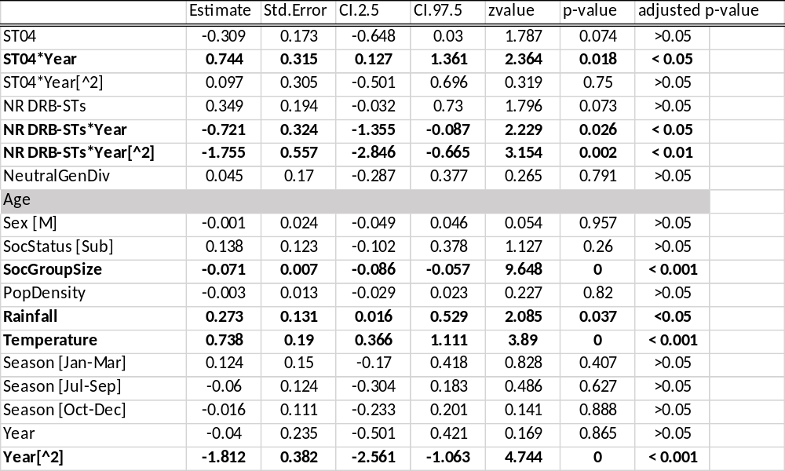

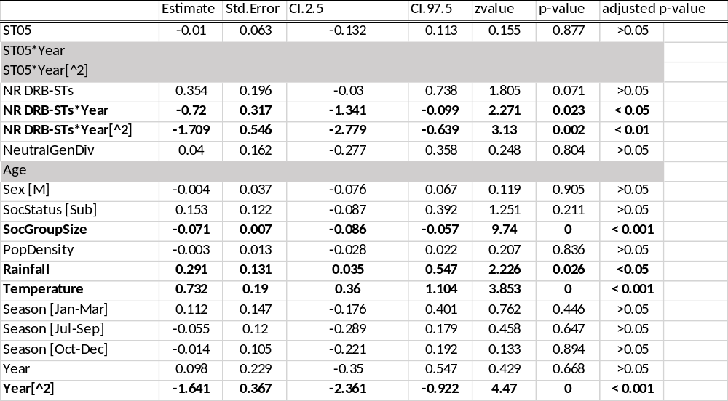

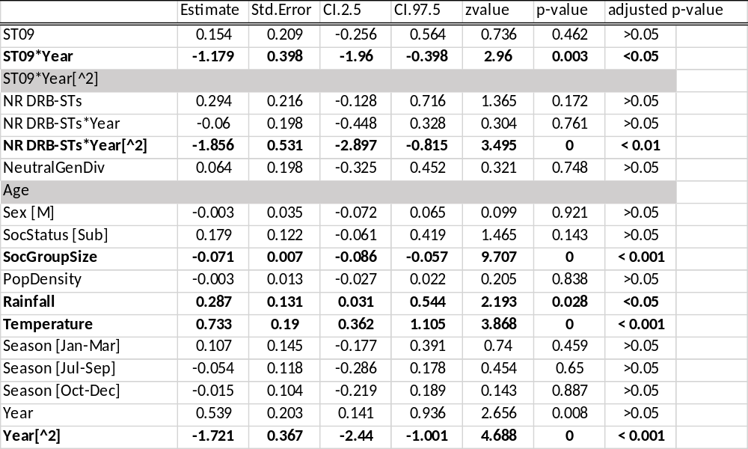

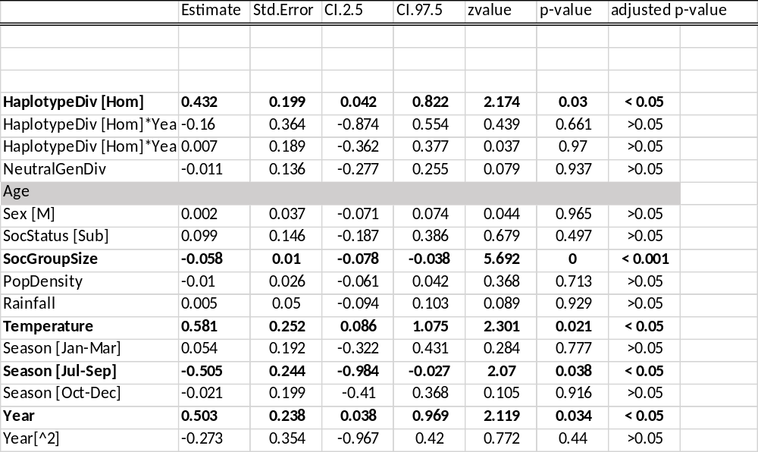

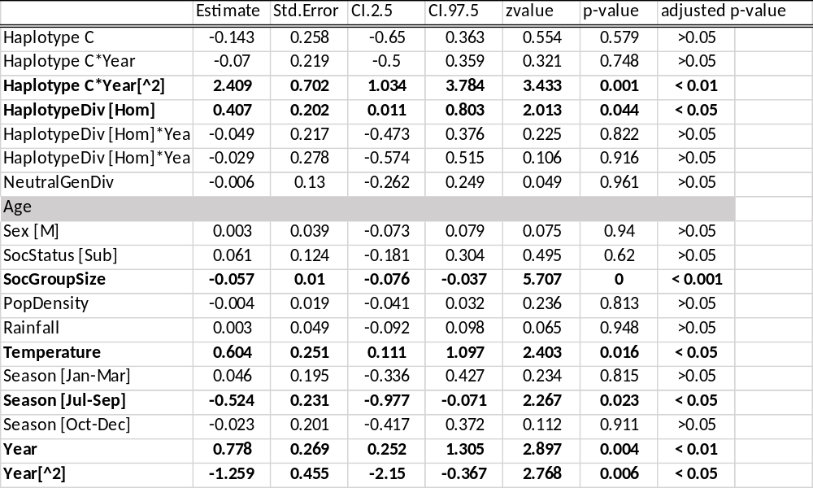

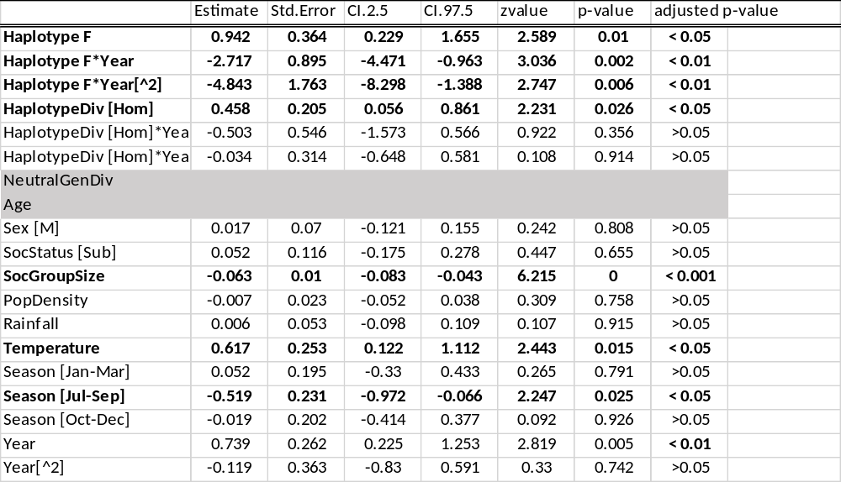

Supplementary Tables 6. Final model based on the averaged results of the most competitive models (<ΔAIC<2.00) testing what factors influence meerkat mortality; each response variable was tested in a set of models that included alleles/STs/haplotypes separately; p-values were corrected for multiple testing and original p-values as well as corrected significance levels are included. Greyed out cells indicate explanatory variables not retained in the most competitive models.

