Appendix

Description of the Different Blocks in the Intervention
In the introduction before the intervention, the denominator of the fraction fitted to the division of the number line of length 1; in block 1 (the first intervention block) the division of the fraction had to be altered (by expanding and reducing the fraction) to place it on the number line; in block 2 the length of the number line exceeded 1 additionally; in block 3 ticks on the number line were missing in addition; in block 4 fractions had to be placed on an empty number line.

Figure 1
Sample Item for AST
A
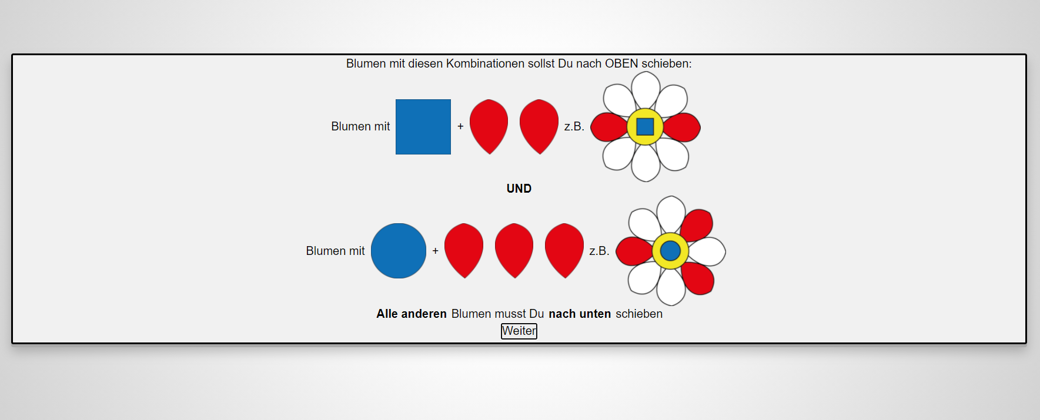
B
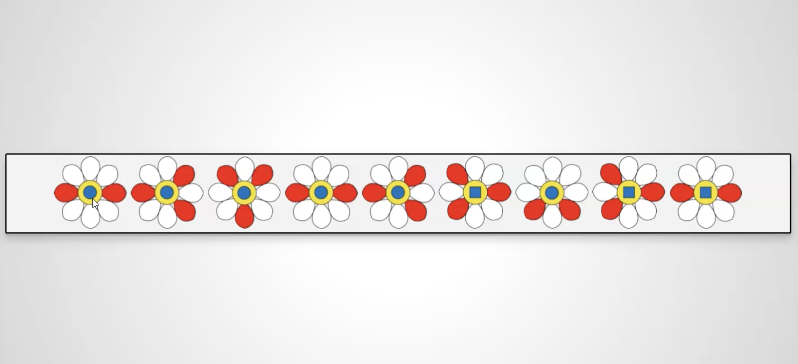
Note. A displays the rules by which students have to sort the flower stimuli. Flowers with a blue square and two red leaves, as well as flowers with a blue circle and three red leaves, need to be sorted up, while all other flowers need to be sorted down. B shows an example of tasks where students need to sort the flowers either up or down as fast as possible according to the rule explained to them before. They have three minutes to complete as many items as possible.

Figure 2
Sample Item for DESIGMA Construction-Based Figural Matrices Task
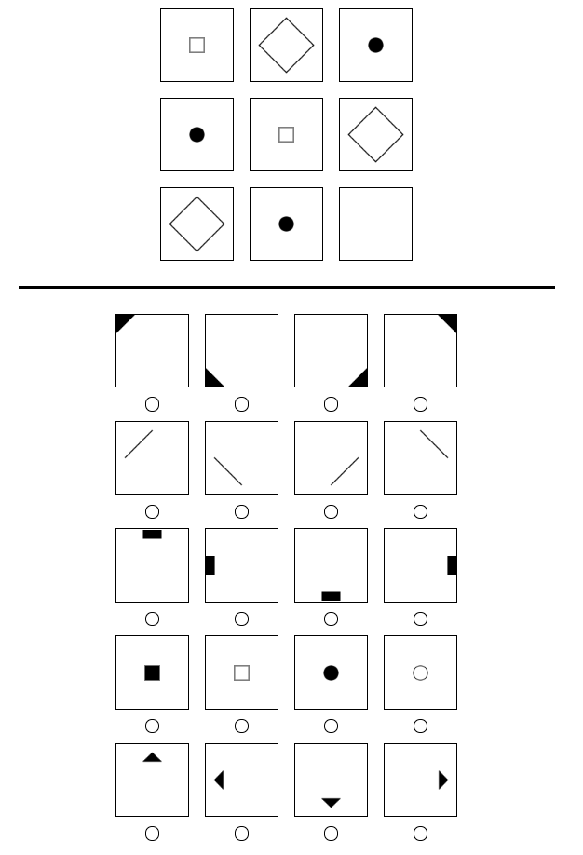
Note. Students must choose all necessary items from
below to construct the answer for the ninth field above.
Notably, there are no distractor answers,
but the students had to compile the solution without guessing.

Figure 3
Sample Item for Paper-Folding-Test
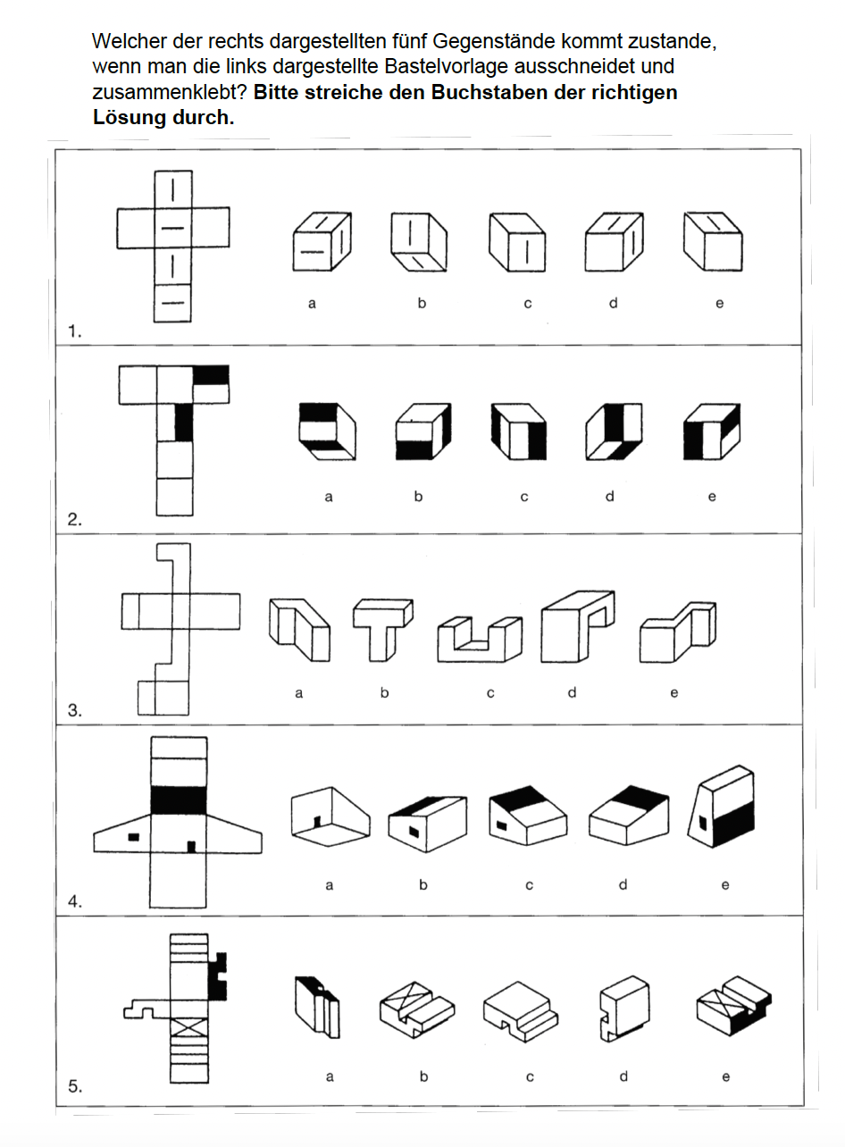

Table A1
Results of the Games-Howell Post-Hoc Test
 |  | 1 | 2 | 3
Inattentive Unfavorable (1) |  | __ | -7.21** | -20.2***
Attentive Unfavorable (2) |  |  | __ | -13.0***
Favorable (3) |  |  |  | __
Note. ** p < .01, *** p < .001

Table A2
Means, Standard Deviations and ANOVAS for (Prior) Fraction on Number Line Knowledge
 | Inattentive Unfavorable |  |  | Attentive Unfavorable |  |  | Favorable |  |  | df | F
 | n | M | SD | n | M | SD | n | M | SD
Pre-Test | 89 | 0.21 | 0.12 | 112 | 0.20 | 0.13 | 74 | 0.04 | 0.06 | (2, 175) | 97.9***
Post-Test | 89 | 0.14 | 0.10 | 114 | 0.09 | 0.07 | 74 | 0.05 | 0.03 | (2, 153) | 82.5***
Note. For Pre- and Post-Test: The higher the value, the worse is the performance.
*** p <.001

