Supplementary Information for

Understanding intraseasonal propagating oscillation in air temperature and its association with heatwaves over Eurasia during boreal summer

Zhanqiu Gong^{1*}, Shoshiro Minobe^{1,2}

1. Department of Natural History Sciences, Graduate School of Science, Hokkaido University, Sapporo, Japan

2. Department of Earth and Planetary Sciences, Faculty of Science, Hokkaido University, Sapporo, Japan

* Corresponding author:

Zhanqiu Gong,

Email: zhanqiu.gong.a0@elms.hokudai.ac.jp

Department of Natural History Sciences, Graduate School of Science, Hokkaido University, Sapporo, Japan

Submitted to Geoscience Letters

July, 2024
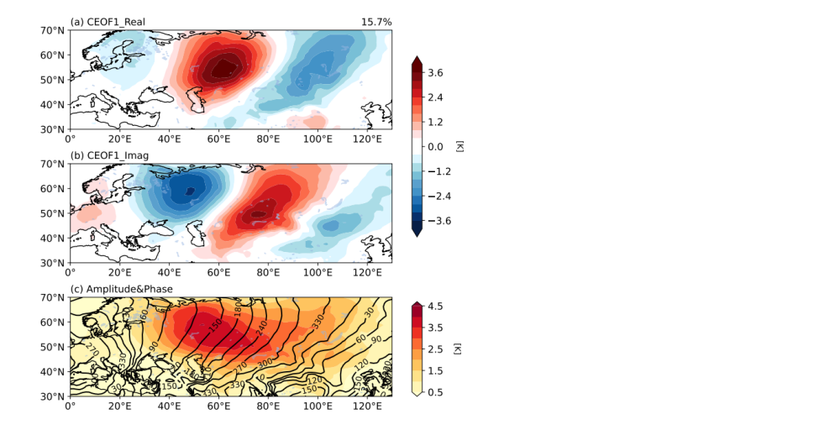
Supplementary Fig. 1 | Same as Figure 1 but for the 2-m air mean temperature anomalies.

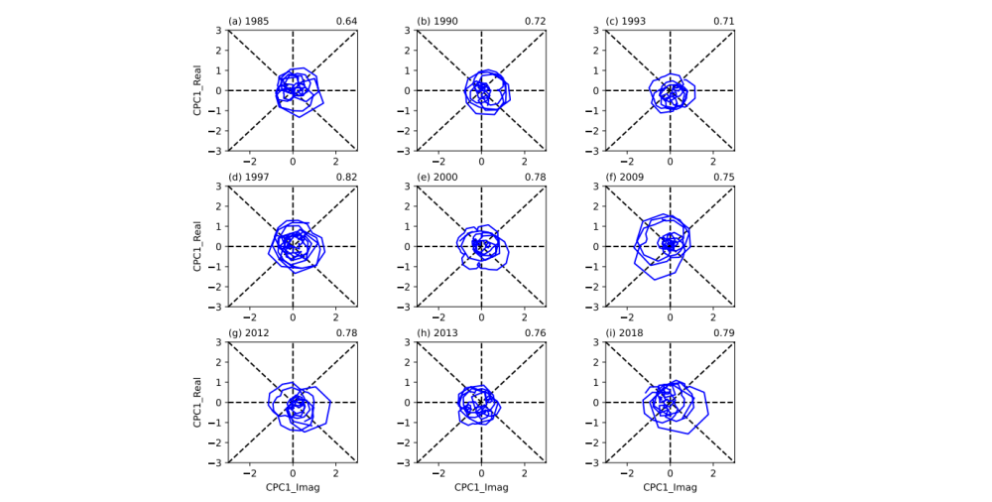
Supplementary Fig. 2 | Same as Figure 4 but for years at (a) 1985, (b) 1990, (c) 1993, (d) 1997, (e) 2000, (f) 2009, (g) 2012, (h) 2013, (i) 2018 with weak values of the metric.

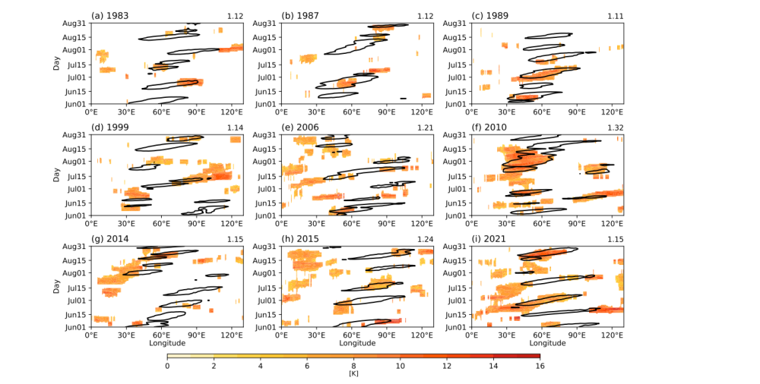
Supplementary Fig. 3 | Same as Figure 5 but for different HW condition defined as at least six consecutive days with 2-m maximum air temperature exceeding the 90th percentile threshold.

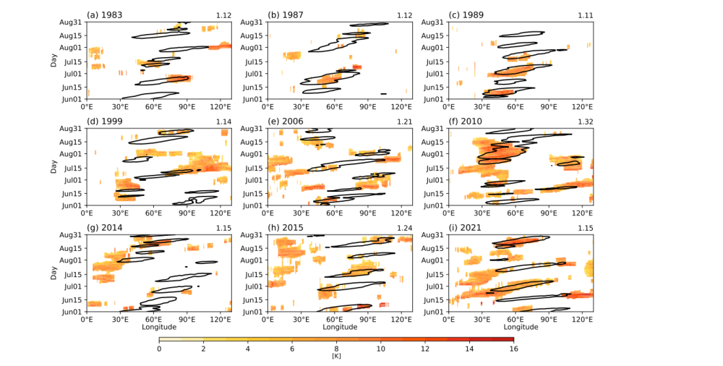
Supplementary Fig. 4 | Same as Figure 5 but for different HW condition defined at least six consecutive days with 2-m mean air temperature exceeding the 90th percentile threshold.

