Scientific Reports – Open Access
Supplemental Materials
Research Article:
Crucial Aspects for Maintaining rAAV Stability
Johannes Lengler¹, Miruna Gavrila¹, Janina Brandis², Kristina Palavra¹, Felix Dieringer¹, Sabine Unterthurner¹, Felix Fuchsberger¹, Barbara Kraus¹ and Juan A. Hernandez Bort^{1,3,*}
¹Gene Therapy Process Development, Baxalta Innovations GmbH, a part of Takeda companies, Uferstraße 15, A-2304, Orth an der Donau, Austria
²Drug Product Development EU, Baxalta Innovations GmbH, a part of Takeda companies, Industriestrasse 72, A-1221, Vienna, Austria
³Department of Analytical Chemistry, University of Vienna, Vienna, 1090, Austria
*Correspondence should be addressed to Juan A. Hernandez Bort, PhD (hernandezj76@univie.ac.at )

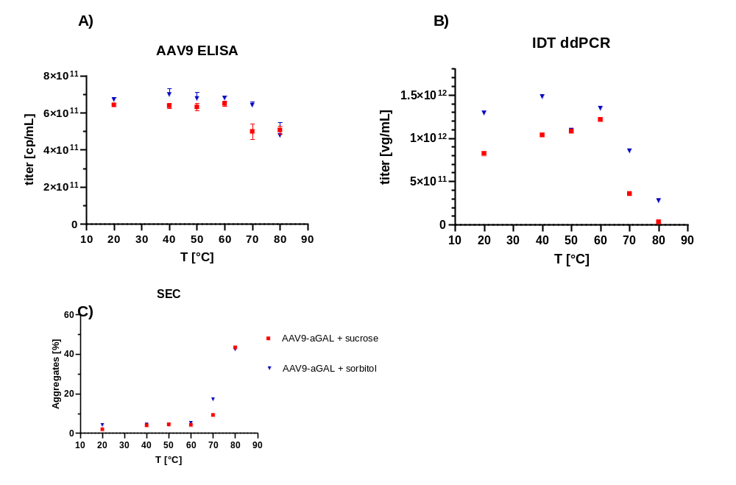

Suppl. Figure 1: Addition of sucrose and sorbitol protects AAV9-aGAL from thermal stress: AAV9 sample material of project AAV9-B in Fig 2 was diluted 1:20 in either 50% sucrose or 50% sorbitol phosphate saline buffer at pH=7.4 and subjected to the indicated temperature as described before in Fig2. Samples were subjected to: A) AAV9 ELISA for capsid concentration cp/mL and integrity, symbols represent average of n=3 technical replicates ± SD.B) ddPCR for vector genome concentration vg/mL and integrity, symbols represent average of n=2 technical replicates ± SD.C) size exclusion chromatography for % of aggregates. The concentration of AAV9 capsids still intact at 80°C (5e11 cp/mL) was similar to the leftover concentration in Fig 2A with sucrose (6e11 cp/mL) suggesting these are residual capsids present as aggregates or re-folded during cooling of the solution.

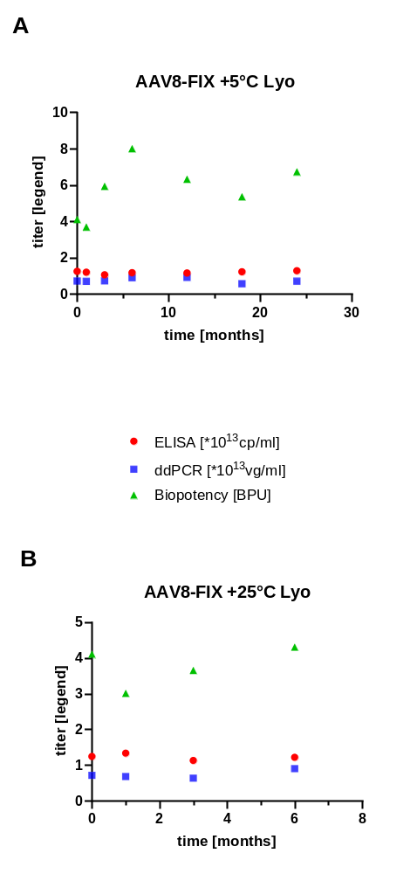
Suppl. Figure 2: Stability of lyophilized AAV8-FIX vector was observed at A) 4°C for 24 months and B) 25°C for 6 months. For this purpose, the vector genome titer (vg/ml, squares) were determined by ddPCR and the capsid titer (cp/ml, circles) by anti-AAV8 ELISA. The biopotency (BPU, triangles) was measured by FIX transgene activity.

Suppl. Figure 3: A vector control material (VCM) was measured relative to the vector standard. Every data point indicates one experiment.

Suppl. Table 1. Sequences of DNA oligonucleotides and used fluorescence and quencher for probes (Microsynth AG, Austria and Thermo Fisher Scientific, Austria)

Project | Type | Primer and Probe Sequence; 5’-3’
AAV8-FIX | Forward Primer | GGC ATC TAC ACC AAA GTC TCC AG
AAV8-FIX | Reverse Primer | CAG CGA GCT CTA GGC ATG CT
AAV8-FIX | Probe | 6FAM-AGA CCA AGC TGA CCT GAT-MGBNFQ
AAV8-FVIII | Forward Primer | CAG AGG GAG ATC ACC AGG AC
AAV8-FVIII | Reverse Primer | CTC CAC AGC AGC AAT GAA GT
AAV8-FVIII | Probe | 6FAM-ACG AGG ACG AGA ACC AGA GC-MGBNFQ
AAV9-aGAL | Forward Primer | CCC CGT GTG AAC GAT TGG T
AAV9-aGAL | Reverse Primer | CGT ATT TCC CGT TTA GGC TTT CG
AAV9-aGAL | Probe | 6FAM-AAC CCG GTG TCC TGT GAG-MGBNFQ
AAV9-GAA | Forward Primer | CCC CGT GTG AAC GAT TGG T
AAV9-GAA | Reverse Primer | CGT ATT TCC CGT TTA GGC TTT CG
AAV9-GAA | Probe | 6FAM-AAC CCG GTG TCC TGT GAG-MGBNFQ
AAV8/AAV9-ITR | Forward Primer | GGA ACC CCT AGT GAT GGA GTT
AAV8/AAV9-ITR | Reverse Primer | CGG CCT CAG TGA GCG A
AAV8/AAV9-ITR | Probe | VIC-CAC TCC CTC TCT GCG CGC TCG-MGBNFQ

