supplementary materials
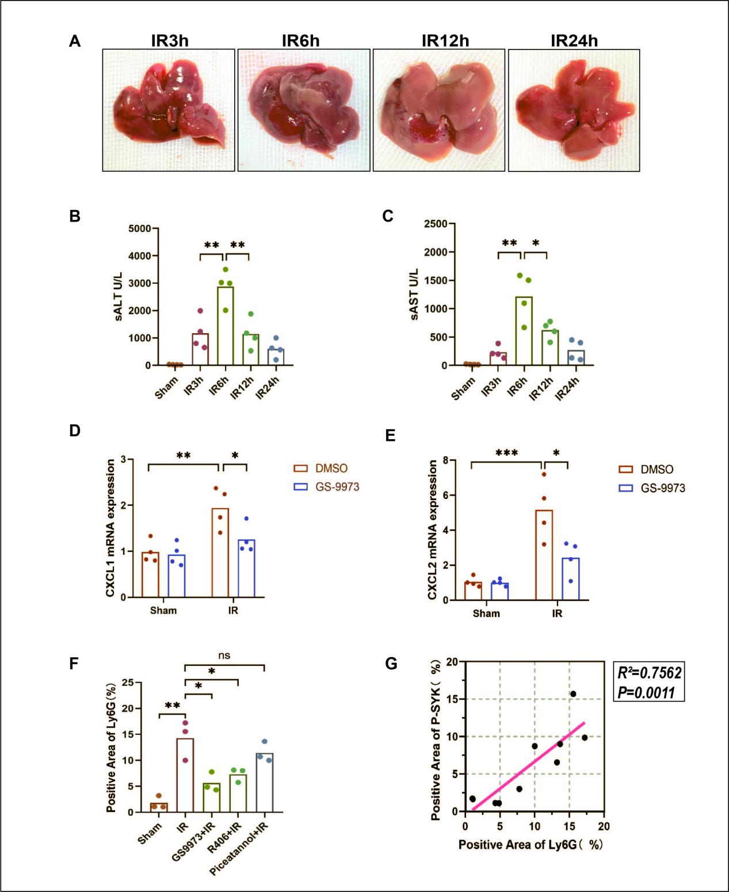
Fig S1A-C After 90 minutes of hepatic ischemia in mice, liver tissue was obtained at different time points after reperfusion to measure serum ALT and AST levels (n=4). D,E The mice were intraperitoneally injected with GS-9973 before operation, and the mRNA levels of CXCL1 and CXCL2 in liver tissues were detected by qPCR 6h after liver IR (n=4).F The expression of Ly6G in mouse liver sections was detected by immunohistochemistry (n=3).G Correlation analysis on the positive areas of P-SYK and Ly6G in immunohistochemistry (n=10).*p < 0.05，**p < 0.01，***p < 0.001.

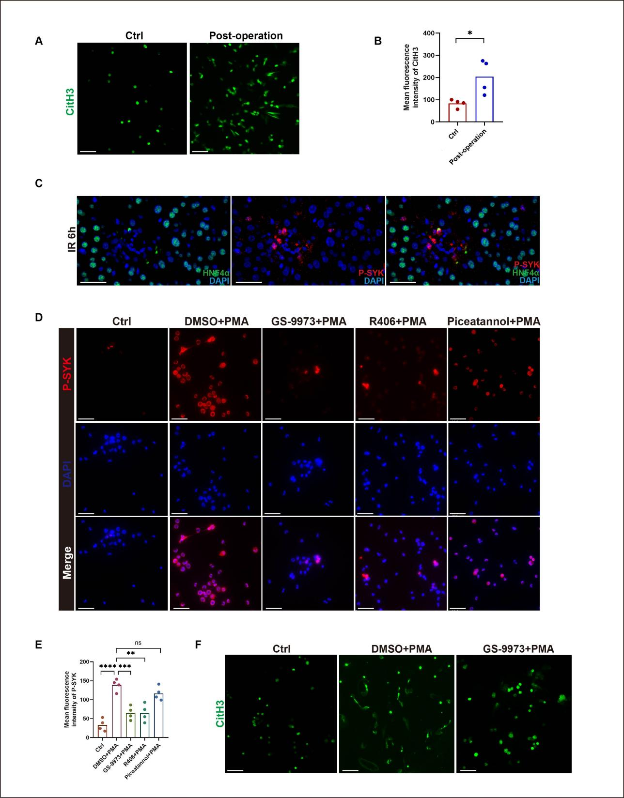
Fig S2 A,B Collect liver tissue from mice underwent IR surgery,isolate neutrophils,observe the expression of CitH3 under fluorescence microscopy,and quantify the fluorescence intensity.Scale bars,50μm (n=4).C Immunofluorescence was conducted to detect the co-localization of P-SYK and HNF4α in the liver of mice after 6h of ischemia-reperfusion.Scale bars,40μm (n=4).D,E Murine bone marrow neutrophils were isolated, and the expression of P-SYK in response to PMA stimulation under the treatment of three SYK inhibitors was detected by fluorescence microscopy and quantified the fluorescence intensity.Scale bars,50μm (n=4).F Neutrophils were isolated from peripheral blood of patients one day before surgery, pretreated with GS-9973 or DMSO for 2 hours, and then stimulated with PMA for 3h. The expression of CitH3 was detected by fluorescence microscopy.Scale bars,50μm (n=4).*p < 0.05，**p < 0.01，***p < 0.001,****p < 0.0001.
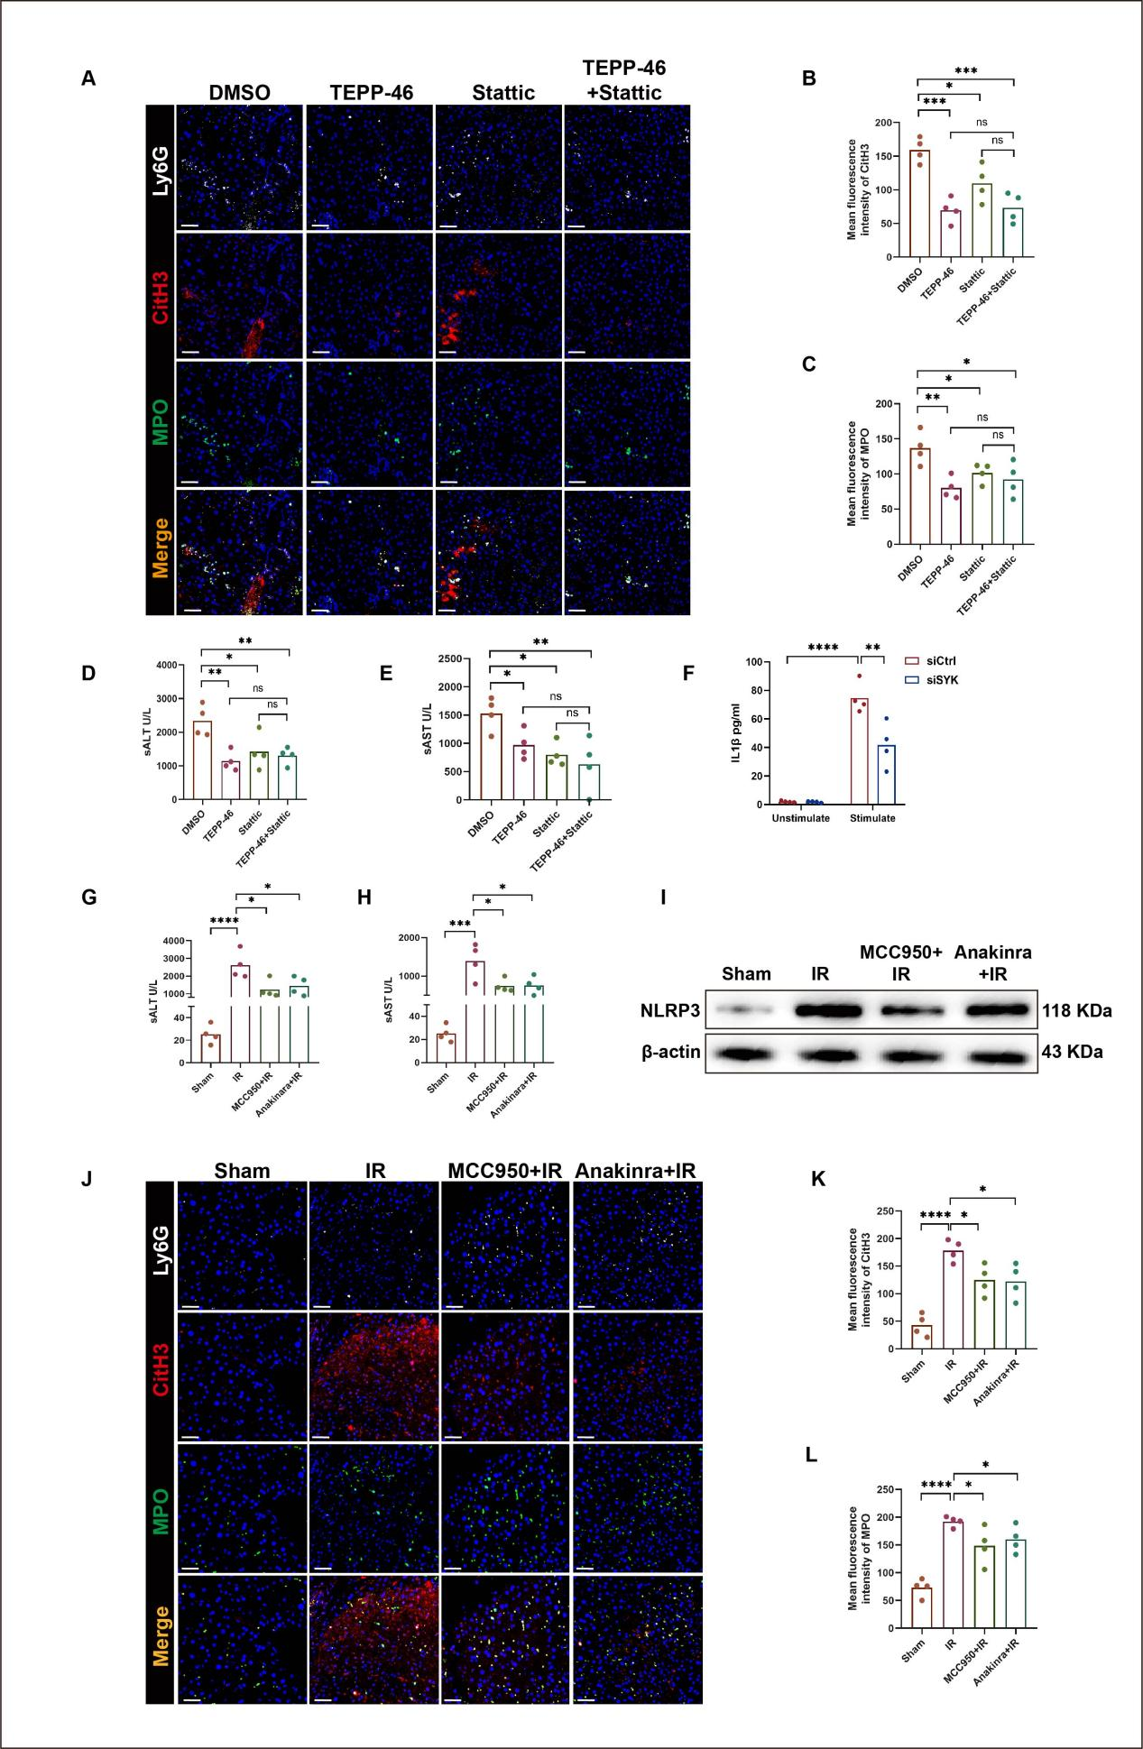
FigS3 A Mice were intraperitoneally injected with TEPP-46(30mg/kg) or Stattic(10mg/kg) before IR surgery, and liver tissue was obtained after 6 hours of reperfusion.The expression of Ly6G, CitH3, and MPO in liver tissue was detected by immunofluorescence.Scale bars,20μm (n=4).B,C Quantification of the fluorescence intensity of CitH3 and MPO in figure A.D,E The levels of serum ALT and AST in mice (n=4).F Raw264.7 cells were transfected with siSYK and stimulated with 1ug/ml LPS for 6h. ELISA was used to detect the level of IL1β in the culture medium (n=4).G,H The mice were intraperitoneally injected with MCC950(20mg/kg) and Anakinara(20mg/kg) before liver IR, and serum ALT and AST levels were measured 6 hours after reperfusion (n=4).I Western Blot was performed to detect the expression of NLRP3 in liver tissue (n=4).J Immunofluorescence staining was conducted to detect the expression of Ly6G, MPO, and CitH3 in the liver tissue of mice treated with MCC950 or Anakinra before surgery.Scale bars,20μm (n=4).K,L The expression levels of MPO and CitH3 were quantified (n=4).*p < 0.05，**p < 0.01，***p < 0.001,****p < 0.0001.

Primers(mice)

Gene | Forward | Reverse
SYK | TCTTACAAGCCAGATGGGCTA | GGCTTTGGGAAGGAGTAGGA
TNFα | GGTGCCTATGTCTCAGCCTCTT | GCCATAGAACTGATGAGAGGGAG
IL1β | TGGACCTTCCAGGATGAGGACA | GTTCATCTCGGAGCCTGTAGTG
IL10 | CGGGAAGACAATAACTGCACCC | CGGTTAGCAGTATGTTGTCCAGC
CXCL1 | TCCAGAGCTTGAAGGTGTTGCC | AACCAAGGGAGCTTCAGGGTCA
CXCL2 | CATCCAGAGCTTGAGTGTGACG | GGCTTCAGGGTCAAGGCAAACT
IL6 | TACCACTTCACAAGTCGGAGGC | CTGCAAGTGCATCATCGTTGTTC
TGFβ | TGATACGCCTGAGTGGCTGTCT | CACAAGAGCAGTGAGCGCTGAA
β-actin | GGAGATTACTGCCCTGGCTCCTA | GACTCATCGTACTCCTGCTTGCTG

