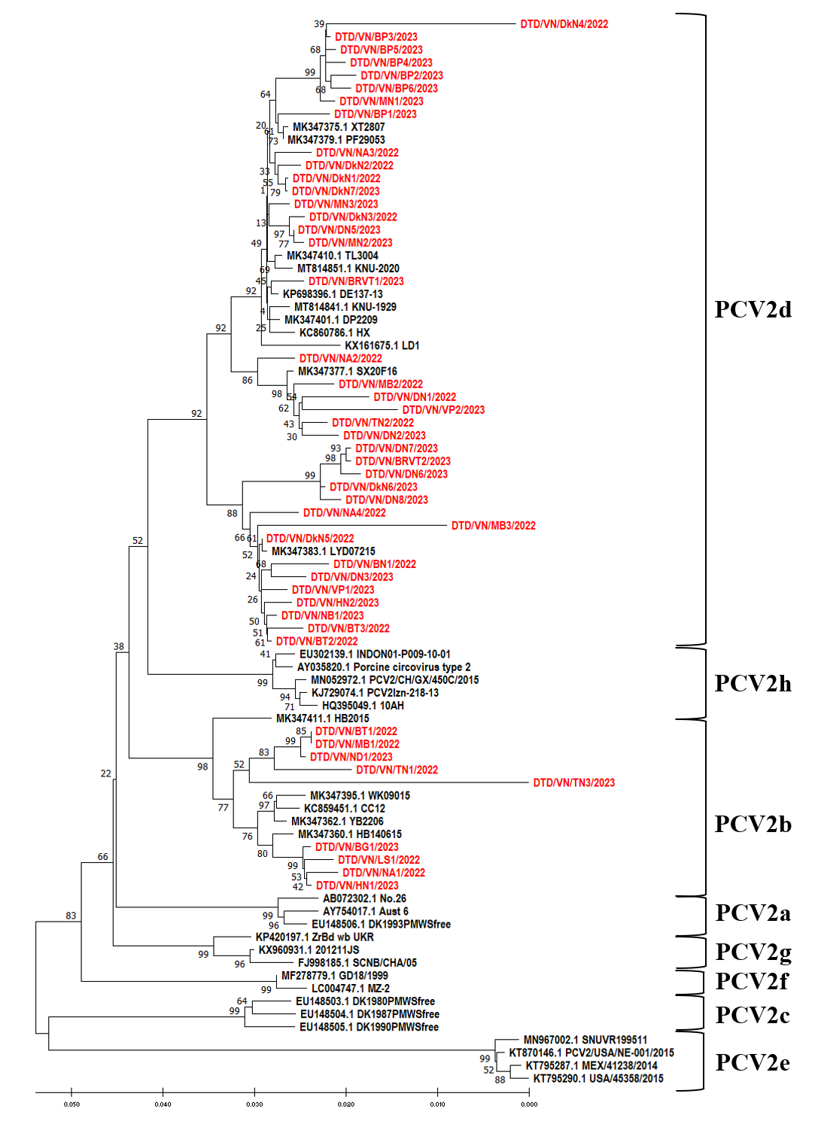
Figure S1. Neighbor-joining phylogenomic analysis with PCV2 genomes closely related to 47 sequenced genomes from this study

Table S1. Positively selected sites in Capsid protein according to the HyPhy methods
 | FUBAR |  |  | FEL |  |  |  | SLAC |  |  | MEME
Codon | Alpha | Beta | Post.prob. | Alpha | Beta | LRT | Prob. | dS | dN | Prob | W+ (b+) | Prob.
8 | 0.648 | 4.488 | 0.973 | 0.000 | 1.878 | 2.339 | 0.126 | 0.000 | 4.864 | 0.142 | 1.870 | 0.150
13 | 0.639 | 1.912 | 0.882 | 0.000 | 0.916 | 1.178 | 0.278 | 0.000 | 2.371 | 1.000 | 40.250 | 0.000
30 | 0.496 | 2.145 | 0.942 | 0.000 | 1.596 | 4.723 | 0.030 | 0.000 | 3.015 | 0.088 | 18.770 | 0.030
59 | 4.618 | 6.125 | 0.468 | 2.226 | 1.943 | 0.044 | 0.834 | 6.195 | 6.120 | 0.628 | 28.400 | 0.000
63 | 0.956 | 3.026 | 0.906 | 0.523 | 1.366 | 1.058 | 0.304 | 1.401 | 4.870 | 0.181 | 1.370 | 0.310
68 | 1.205 | 2.058 | 0.711 | 0.723 | 0.880 | 0.039 | 0.843 | 0.523 | 2.714 | 0.607 | 1439.500 | 0.000
88 | 0.601 | 2.189 | 0.906 | 0.000 | 1.247 | 2.210 | 0.137 | 0.000 | 3.948 | 0.238 | 27.710 | 0.000
89 | 0.506 | 3.155 | 0.984 | 0.000 | 1.596 | 4.723 | 0.030 | 0.000 | 3.948 | 0.044 | 7.210 | 0.020
113 | 2.588 | 0.622 | 0.131 | 1.128 | 0.278 | 1.787 | 0.181 | 3.194 | 1.033 | 0.952 | 251.830 | 0.000
138 | 1.031 | 0.873 | 0.481 | 0.841 | 0.491 | 0.198 | 0.656 | 1.742 | 1.488 | 0.784 | 46.850 | 0.010
140 | 0.497 | 0.712 | 0.665 | 0.000 | 0.442 | 1.293 | 0.255 | 0.000 | 0.996 | 0.449 | 13.330 | 0.020
169 | 2.955 | 7.271 | 0.804 | 1.543 | 3.176 | 1.231 | 0.267 | 3.896 | 8.259 | 0.149 | 16.210 | 0.010
190 | 0.767 | 4.923 | 0.982 | 0.403 | 2.041 | 3.626 | 0.057 | 1.013 | 4.969 | 0.079 | 2.050 | 0.080
191 | 0.429 | 2.087 | 0.956 | 0.000 | 0.898 | 4.880 | 0.027 | 0.000 | 3.106 | 0.083 | 0.900 | 0.040

