Supplemental information.
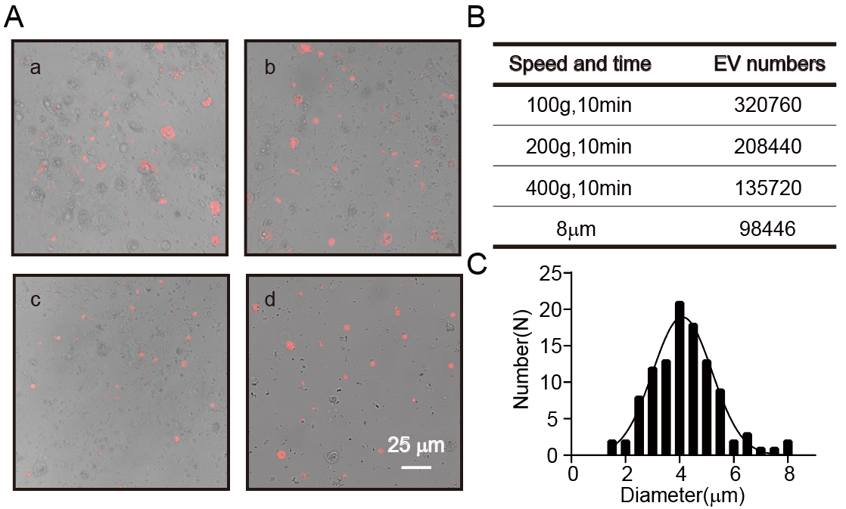
Fig. S1 Purification of 2-E-EVs
(A) Representative images of purified fraction after each step in Fig. 1A. (B) The enrichment of 2-E-EVs at each step. (C) Particle size statistics of purified 2-E-EVs

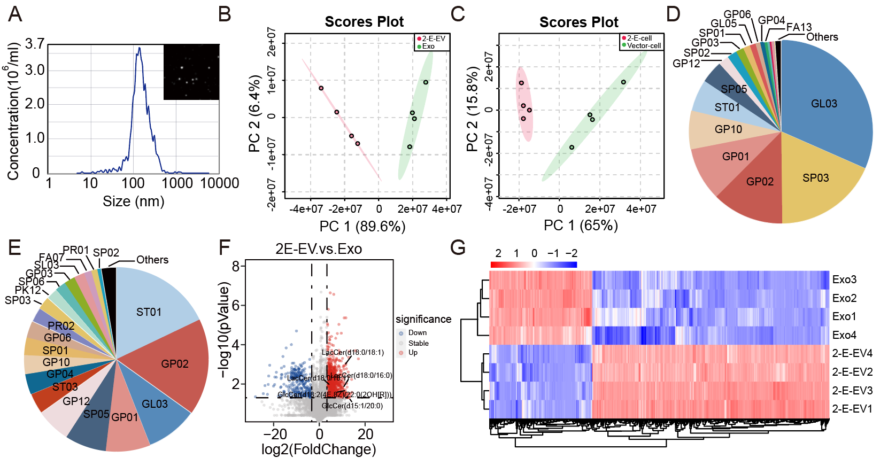
Fig. S2 2-E-EVs and exosomes have distinct lipid compositions.
(A) NTA analysis of purified exosomes. (B) PCA of 2-E-EVs and exosomes generated from Vero E6 cells. (C) PCA of 2-E-transfected and vector-transfected cells. (D) Distribution of lipid molecular species in the 2-E-EVs, abbreviations in the pictures are lipids categories in KEGG. (E) Distribution of lipid molecular species in the exosomes. (F) Volcano plots display differentially expressed lipids between 2-E-EVs and exosomes. (G) Heatmap with hierarchical clustering of differentially expressed lipids (FC > 2, p < 0.05) in the 2-E-EVs and exosomes group

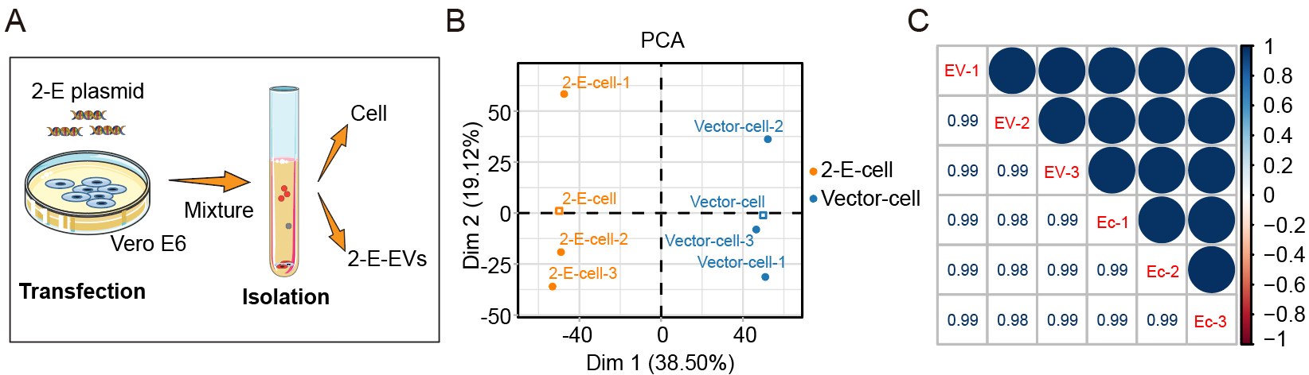
Fig. S3 Quality Assessments for Proteomics.
(A) Proteomics workflow of Vero E6 cells and 2-E-EVs. (B) Principal Component Analysis (PCA) shows the global similarities and differences of the experiments and replicates. (C) The coefficient of variance for each condition shows high quantitative reproducibility between biological replicates in 2-E-cells and 2-E-EVs samples

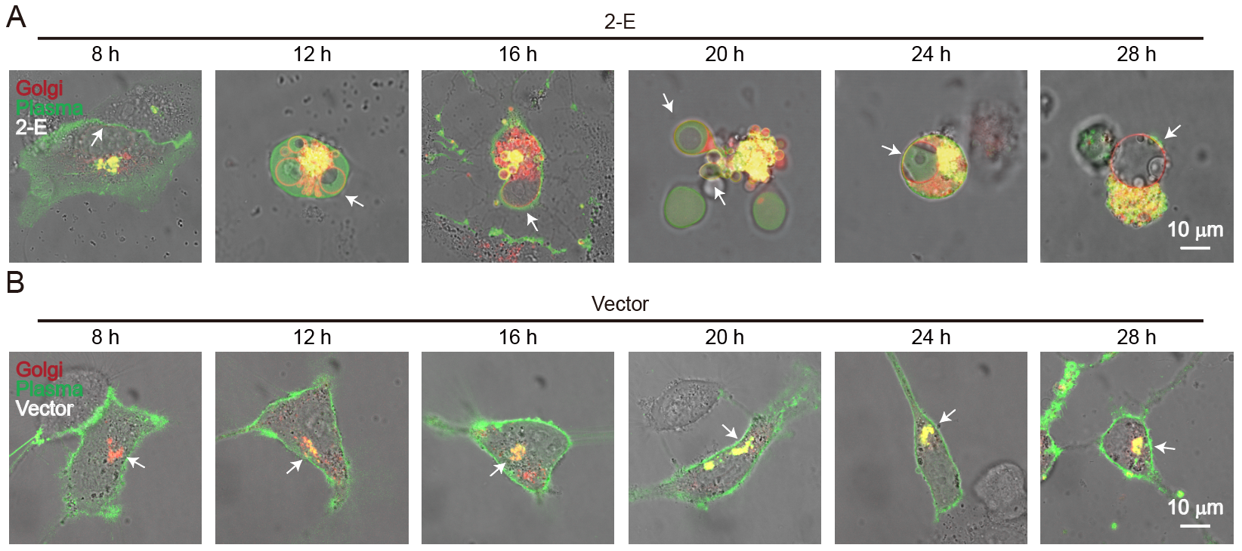
Fig.S4 2-E expression triggers morphology change of Golgi apparatus.
(A) Representative images of morphological changes of Vero E6 cells after transfecting with 2-E (with bright field). Golgi-derived vesicles are indicated by arrows. (B) Representative images of morphological changes of Vero E6 cells after transfecting with pcDNA3.1 (with bright field). Golgi apparatus is indicated by arrows.

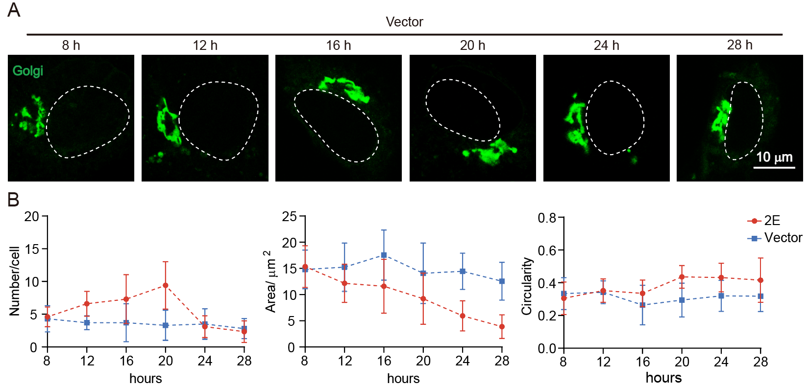
Fig. S5 2-E-EV formation and Golgi fragmentation occur after 2-E expression.
(A) Representative images of Vero E6 cells after transfecting with vector, and detailed Golgi body morphology were monitored every four hours for eight hours post-transfection. The dotted lines in the pictures mark the nucleus. (B) Quantification of Golgi fragments 20 h post-transfection, quantitative indicators include number, area, and circularity. The mean ± SEM is shown

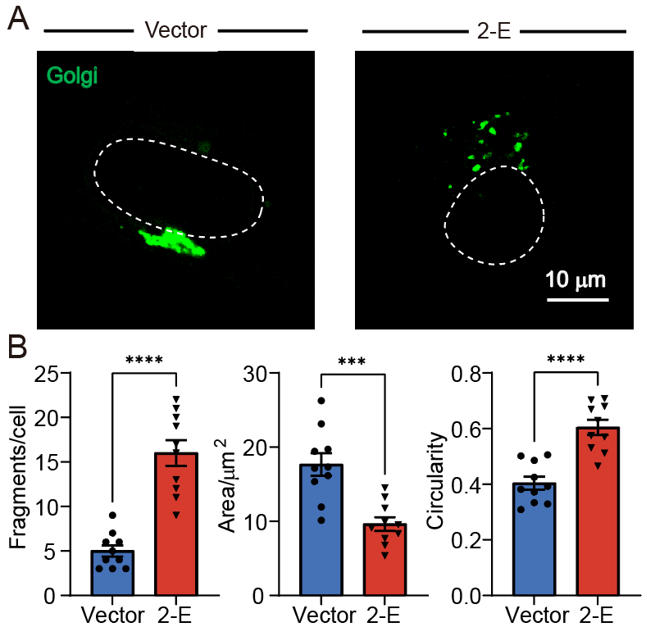
Fig. S6 2-E triggers Golgi fragmentation in Hela cells.
(A) Representative images of Hela cells transfected with Golgi-GFP (green) and 2-E/Vector, dotted lines in the pictures mark the nucleus. (B) Quantification of Golgi fragments 20 h post-transfection, quantitative indicators include number, area, and circularity. The mean ± SEM is shown. * p < 0.05, ** p < 0.01, *** p < 0.001, **** p < 0.0001; unpaired Student’s t-test.

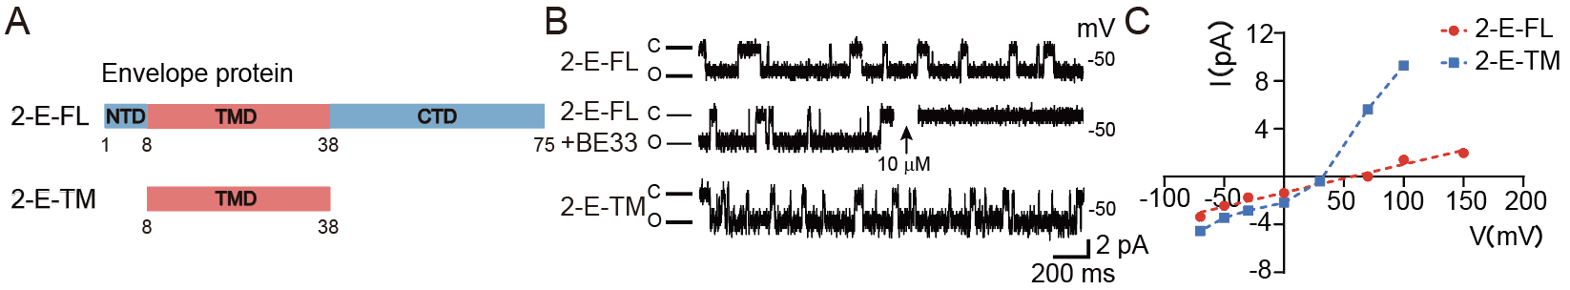
Fig. S7 2-E-TM is an increased channel activity truncated body.
(A) Structural domain of 2-E-FL and 2-E-TM, numbers indicate corresponding amino acid in 2-E sequence. (B) Single-channel current recording of 2-E, 2-E with additional 10 μM BE-33, (“C” means Closed; “O” means Open). (C) I-V curve of 2-E-FL and 2-E-TM

