Supplemental Information

Synchronized dual-site electrical stimulation for treating lower urinary tract dysfunction after spinal cord injury

Jun Li^{1,4}, Guoxian Deng², Xianping Li², Lingxuan Yin³, Chunhui Yuan², Wei Shao³, Yuangui Chen², Junan Yan^{1,2,4}, Jiwei Yao^{2,5}

SUPPLEMENTALINFORMATION

INVENTORY OF SUPPLEMENTAL INFORMATION

Supplemental Figures and Legends
Supplementary Figure 1 (related to Figure 1)
Supplementary Figure 2 (related to Figure 2 )
Supplementary Figure 3 (related to Figure 3)
Supplementary Figure 4 (related to Figure 4)
Supplementary Figure 5 (related to Figure 5)

SUPPLEMMENTAL FIGURES AND LEGENDS

Supplementary Figure 1 Characteristics of bladder pressure and EUS-EMG activity during reflective urination
a Quantification of the latency in panel A. n = 12 mice. b Quantification of the ∆P in panel A. n = 12 mice. c Enlarged representation of the blue dashed line box in panel Figure 1B (left). Time-frequency curve after performing spectral analysis of the enlarged EMG data (right).
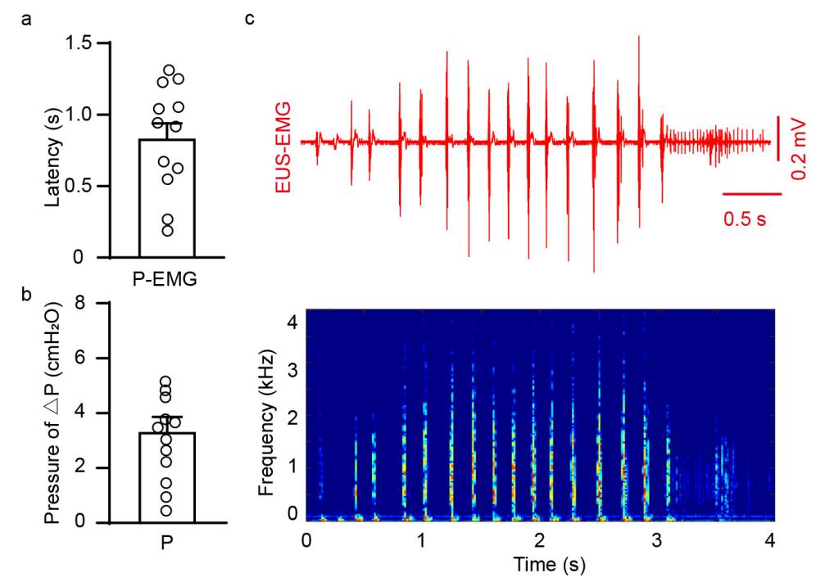

Supplementary Figure 2 Schematic and representative imaging of CTB555 injection and PN stimulation in EUS
a Schematic of CTB555 injection into the EUS. b Representative images showing transverse sections of the urethral sphincter, PN, and thoracic spinal cord, labeled with CTB555. c Schematic of the PN stimulation experiment.
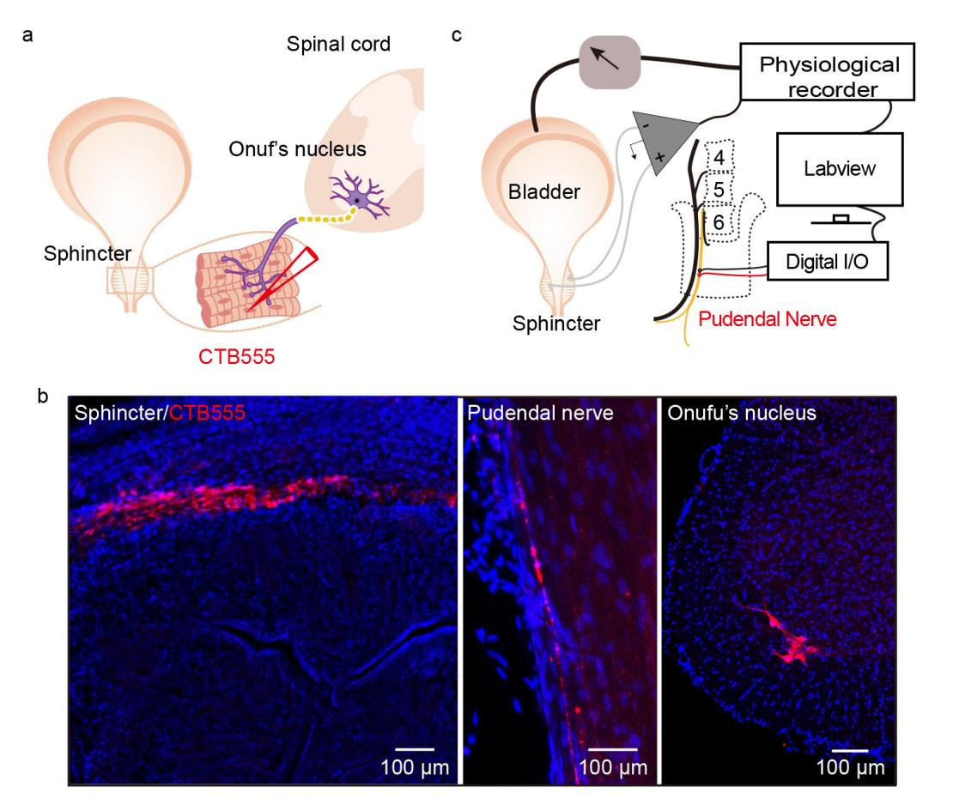

Supplementary Figure 3 Schematic and morphological study of bladder wall and MPG stimulation in mice
a Schematic of the injection of CTB555 into the bladder wall. b Experimental scheme for electrical stimulation of the MPG while simultaneously monitoring intravesical pressure (IVP) and EUS-EMG. c,d Representative images of transverse sections of the bladder tissue and major pelvic ganglion (MPG), labeled with CTB555. n = 9 mice.
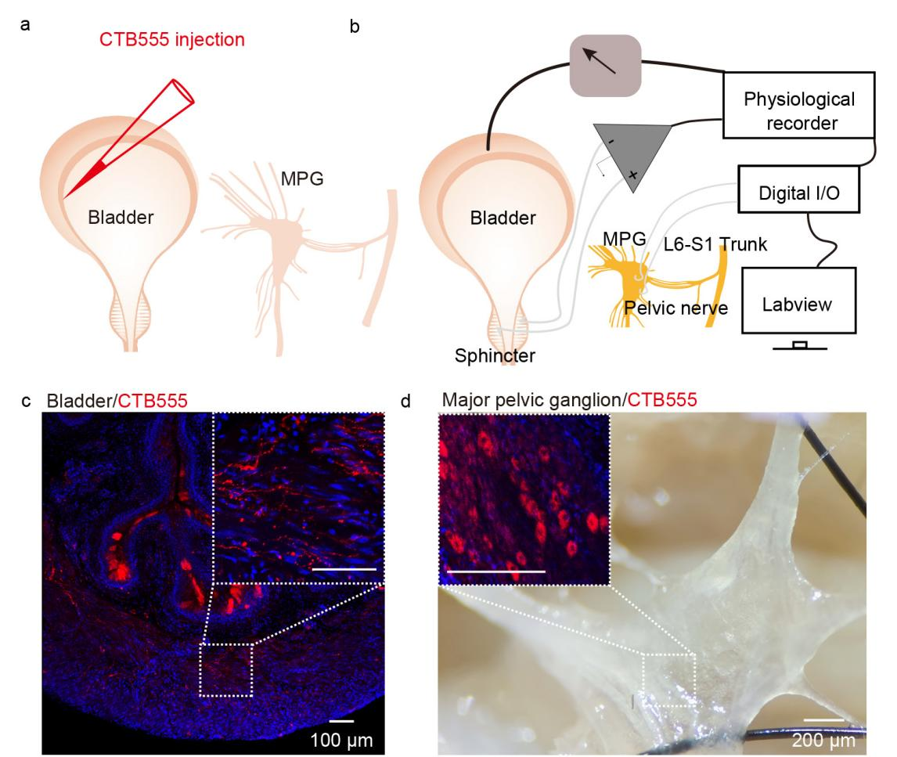
Supplementary Figure 4 T10 SCI Model and staining of spinal cord
a Schematic of a mouse model for complete spinal cord injury at the T10 level. b Representative images showing spinal cord sections stained with anti-NeuN and anti-GFAP.
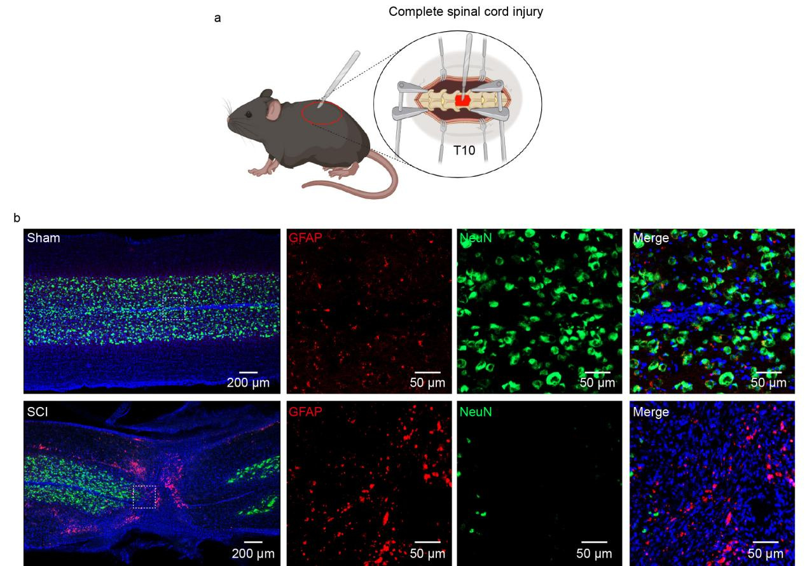
Supplementary Figure 5 Quantification of bladder pressure change
a Quantification of the variation in IVP (∆P). n = 9 mice for each group. Student’s t test (two-tailed, paired). ***p < 0.001.
