Supplementary information
Glacier retreat induces contrasting shifts in bacterial biodiversity patterns in glacial lake water and sediments
Keshao Liu^{1^}, Qi Yan^{2^}, Xuezi Guo^{1, 3^}, Wenqiang Wang^{2, 4}, Zhihao Zhang^{1, 3}, Mukan Ji², Feng Wang¹, and Yongqin Liu^{1, 2}*

¹ State Key Laboratory of Tibetan Plateau Earth System, Environment and Resources (TPESER), Institute of Tibetan Plateau Research, Chinese Academy of Sciences, Beijing 100101, China
² Center for the Pan-Third Pole Environment, Lanzhou University, Lanzhou, 730000, China
³ University of Chinese Academy of Sciences, Beijing, 100101, China
⁴ College of ecology, Lanzhou University, Lanzhou, 730000, China
^ Keshao Liu and Qi Yan contributed equally to this study.

* Corresponding author:
Yongqin Liu,
E-mail: yqliu@itpcas.ac.cn
State Key Laboratory of Tibetan Plateau Earth System, Environment and Resources (TPESER), Institute of Tibetan Plateau Research, Chinese Academy of Sciences, Beijing 100101, China.

Running title: Bacterial communities in glacial lakes

Table S1 Summary of environment characteristics of water and sediment samples in this study.
Sampling  sites | Longitude  (°E) | Latitude  (°N) | Altitude  (m) | Lake area  (m²) | GI | Water samples |  |  |  |  |  |  |  |  | Sediment samples
 |  |  |  |  |  | pH | Temp  (℃) | Con  (μs/cm) | TDS  (mg/L) | DOC  (mg/L) | TN  (mg/L) | SO₄²⁻  (mg/L) | NO₃⁻  (mg/L) |  | pH | Con  (μs/cm) | NH₄⁺-N  (mg/kg) | NO₃⁻-N  (mg/kg) | TN  (mg/g) | TP  (mg/g) | TC  (mg/g)
L1-1 | 90.197 | 29.867 | 5590 | 420 | 0.973 | 9.12 | 1.8 | 16 | 7 | 0.58 | 0.09 | 0.15 | 0.02 |  | 7.56 | 148.9 | 34.3 | 2.33 | 1.053 | 0.424 | 8.971
L1-2 | 90.197 | 29.867 | 5590 | 420 | 0.973 | 9.09 | 1.8 | 22 | 10 | 0.72 | 0.17 | 0.53 | 0.10 |  | 7.64 | 108.4 | 57.46 | 2.805 | 1.129 | 0.413 | 8.493
L1-3 | 90.197 | 29.867 | 5590 | 420 | 0.972 | 8.92 | 1.4 | 27 | 14 | 0.62 | 0.21 | 0.64 | 0.12 |  | 7.42 | 117.3 | 4.89 | 3.015 | 0.354 | 0.173 | 3.622
L1-4 | 90.197 | 29.867 | 5592 | 420 | 1.000 | 8.85 | 2.8 | 23 | 13 | 0.60 | 0.18 | 2.23 | 0.24 |  | 7.54 | 104.3 | 38.83 | 3.335 | 0.772 | 0.379 | 7.245
L2-1 | 90.202 | 29.866 | 5523 | 4253 | 0.970 | 8.6 | 10.5 | 63 | 32 | 0.61 | 0.16 | 2.34 | 0.09 |  | 7.56 | 156.1 | 4.805 | 2.71 | 0.264 | 0.683 | 1.587
L2-2 | 90.202 | 29.866 | 5528 | 4253 | 1.000 | 8.89 | 9.9 | 58 | 29 | 0.69 | 0.18 | 2.14 | 0.09 |  | 6.95 | 112.6 | 0.955 | 3.08 | 0.148 | 0.448 | 2.200
L2-3 | 90.203 | 29.866 | 5533 | 4253 | 0.865 | 8.67 | 10 | 66 | 33 | 0.60 | 0.17 | 2.48 | 0.11 |  | 7.48 | 137.9 | 1.065 | 3.055 | 0.166 | 0.47 | 0.465
L2-4 | 90.202 | 29.866 | 5530 | 4253 | 0.947 | 8.67 | 9.5 | 67 | 32 | 0.49 | 0.16 | 2.07 | 0.10 |  | 7.51 | 125.7 | 2.28 | 2.29 | 0.239 | 0.509 | 2.477
L3-1 | 90.189 | 29.861 | 5592 | 7240 | 0.964 | 8.92 | 1.9 | 79 | 40 | 0.42 | 0.11 | 5.70 | 0.07 |  | 6.95 | 92.2 | 0.815 | 2.855 | 0.171 | 0.119 | 2.555
L3-2 | 90.188 | 29.861 | 5593 | 7240 | 0.890 | 8.74 | 2.4 | 92 | 46 | 0.56 | 0.50 | 3.86 | 0.27 |  | 7.61 | 135.0 | 1.615 | 2.455 | 0.222 | 0.275 | 1.285
L3-3 | 90.188 | 29.861 | 5592 | 7240 | 0.896 | 8.73 | 2.4 | 120 | 60 | 0.45 | 0.24 | 11.68 | 0.20 |  | 6.82 | 131.3 | 1.265 | 2.795 | 0.258 | 0.356 | 2.182
L4-1 | 90.184 | 29.859 | 5489 | 803 | 0.647 | 8.57 | 4.2 | 110 | 55 | 0.50 | 0.33 | 6.86 | 0.35 |  | 7.1 | 104.0 | 1.44 | 2.93 | 0.59 | 0.326 | 5.472
L4-2 | 90.184 | 29.859 | 5485 | 803 | 0.646 | 8.67 | 3.6 | 107 | 53 | 0.65 | 0.33 | 6.88 | 0.34 |  | 6.78 | 95.6 | 6.515 | 2.605 | 0.682 | 0.291 | 7.602
L4-3 | 90.185 | 29.859 | 5487 | 803 | 0.680 | 8.49 | 4.3 | 110 | 55 | 0.46 | 0.33 | 6.76 | 0.35 |  | 6.91 | 150.3 | 9.365 | 2.405 | 0.884 | 0.366 | 10.54
L5-1 | 90.184 | 29.856 | 5450 | 7781 | 0.542 | 8.37 | 6.8 | 116 | 58 | 0.54 | 0.32 | 5.99 | 0.16 |  | 7.09 | 67.2 | 2.22 | 3.98 | 2.013 | 0.37 | 22.26
L5-2 | 90.184 | 29.855 | 5447 | 7781 | 0.535 | 8.36 | 7.7 | 116 | 58 | 0.68 | 0.23 | 6.43 | 0.21 |  | 7.37 | 60.5 | 2.11 | 2.66 | 0.828 | 0.335 | 7.512
L5-3 | 90.183 | 29.855 | 5447 | 7781 | 0.505 | 8.34 | 7.8 | 115 | 58 | 0.59 | 0.32 | 7.58 | 0.32 |  | 6.88 | 105.4 | 6.29 | 2.92 | 1.837 | 0.363 | 17.56
L6-1 | 90.184 | 29.872 | 5451 | 58651 | 0.493 | 8.52 | 7.3 | 145 | 73 | 0.71 | 0.23 | 8.29 | 0.16 |  | 6.74 | 85.8 | 1.04 | 3.82 | 0.287 | 0.145 | 2.372
L6-2 | 90.184 | 29.871 | 5453 | 58651 | 0.468 | 8.42 | 7.8 | 146 | 73 | 0.55 | 0.21 | 8.26 | 0.16 |  | 7.24 | 92.3 | 1.515 | 7.685 | 0.703 | 0.24 | 8.141
L6-3 | 90.183 | 29.871 | 5453 | 58651 | 0.460 | 8.35 | 8 | 146 | 73 | 0.51 | 0.23 | 8.00 | 0.13 |  | 7.36 | 68.3 | 1.455 | 3.365 | 0.477 | 0.22 | 3.855
L6-4 | 90.184 | 29.873 | 5452 | 58651 | 0.466 | 8.34 | 8.1 | 143 | 72 | 0.61 | 0.24 | 3.52 | 0.06 |  | 6.83 | 120.9 | 2.325 | 18.7 | 1.253 | 0.365 | 13.49
L7-1 | 90.192 | 29.887 | 5417 | 12391 | 0.290 | 8.71 | 9.7 | 48 | 24 | 1.29 | 0.22 | 0.14 | 0.13 |  | 7.38 | 78.2 | 4.71 | 2.805 | 1.351 | 0.372 | 11.75
L7-2 | 90.192 | 29.887 | 5416 | 12391 | 0.285 | 8.73 | 8.9 | 48 | 24 | 1.42 | 0.25 | 0.14 | 0.14 |  | 7.14 | 113.9 | 64.17 | 1.875 | 2.614 | 0.396 | 26.58
L7-3 | 90.191 | 29.887 | 5416 | 12391 | 0.283 | 8.66 | 7.4 | 42 | 21 | 1.41 | 0.33 | 0.10 | 0.09 |  | 7.16 | 159.9 | 38.83 | 2.035 | 6.783 | 0.536 | 75.6

Temp: temperature; Con: conductivity; TDS: total dissolved solids; DOC: dissolved organic carbon; TN: total nitrogen; TP: total phosphorus; TC: total carbon.

Table S2 Relationships of the bacterial communities (at the genera level) and GI in water and sediment samples as indicated by spearman correlation analysis.
Genera | phylum | Water | Sediment
g__Longivirga | Actinobacteriota | -0.22** | -0.32*
g__Tetrasphaera | Actinobacteriota | -0.46** | -0.45**
g__Edaphobaculum | Bacteroidota | -0.34** | -0.69*
g__Arcicella | Bacteroidota | 0.67** | 0.67**
g__RBG-13-54-9 | Chloroflexi | -0.33* | -0.51**
g__Syntrophorhabdus | Desulfobacterota | -0.35* | -0.31***
g__Gemmatimonas | Gemmatimonadota | 0.60* | -0.32**
g__Schlesneria | Planctomycetota | -0.41** | -0.61*
g__Roseococcus | Proteobacteria | -0.58*** | -0.37***
g__Roseomonas | Proteobacteria | 0.58* | 0.73**
g__Phenylobacterium | Proteobacteria | 0.58* | -0.35**
g__UKL13-1 | Proteobacteria | -0.29* | -0.32*
g__Pseudolabrys | Proteobacteria | -0.35* | -0.57***
g__Delftia | Proteobacteria | -0.35* | 0.46*
g__Rhizobacter | Proteobacteria | 0.70* | -0.60***
g__Ellin6067 | Proteobacteria | 0.69** | -0.69*
g__Undibacterium | Proteobacteria | 0.64* | -0.33*
g__Terrimicrobium | Verrucomicrobiota | -0.57*** | -0.48***
Asterisks indicate significant correlation in Spearman’s rank correlation test (*P < 0.05, **P < 0.01, ***P < 0.001)

Table S3 Summary of alpha diversity indices of bacterial community across water and sediment.
Alpha diversity | Lakes | Water |  |  | Sediment
Alpha diversity | Lakes | Mean | SE |  | Mean | SE
Richness | Lake 1 | 364 | 18 |  | 575 | 54
Richness | Lake 2 | 251 | 7 |  | 664 | 46
Richness | Lake 3 | 429 | 36 |  | 730 | 12
Richness | Lake 4 | 440 | 10 |  | 1045 | 62
Richness | Lake 5 | 228 | 16 |  | 1144 | 15
Richness | Lake 6 | 220 | 16 |  | 1123 | 49
Richness | Lake 7 | 323 | 19 |  | 910 | 38
Shannon | Lake 1 | 6.00 | 0.18 |  | 7.08 | 0.22
Shannon | Lake 2 | 5.16 | 0.18 |  | 6.88 | 0.45
Shannon | Lake 3 | 5.69 | 0.14 |  | 7.38 | 0.44
Shannon | Lake 4 | 5.51 | 0.61 |  | 8.74 | 0.26
Shannon | Lake 5 | 3.67 | 0.42 |  | 9.06 | 0.30
Shannon | Lake 6 | 5.00 | 0.12 |  | 8.80 | 0.27
Shannon | Lake 7 | 4.46 | 0.17 |  | 8.59 | 0.15

Table S4 The topological features of co-occurrence networks for water and sediment.
 |  |  | Water |  |  | Sediment
 |  |  | HGL | LGL |  | HGL | LGL
Empirical  networks | Nodes |  | 166 | 84 |  | 309 | 555
Empirical  networks | Edges |  | 1052 | 180 |  | 884 | 2419
Empirical  networks | Average degree |  | 14.5 | 5.96 |  | 8.4 | 12.5
Empirical  networks | Modularity |  | 0.47 | 0.64 |  | 0.79 | 0.63
Empirical  networks | Density |  | 0.08 | 0.05 |  | 0.02 | 0.02
Empirical  networks | Clustering coefficient |  | 0.607 | 0.606 |  | 0.57 | 0.44
Empirical  networks | Average path length |  | 2.96 | 1.97 |  | 5.90 | 4.59
Empirical  networks | Power-law model |  | 0.87 | 0.95 |  | 0.95 | 0.90
Empirical  networks | Log (Betweenness centrality+1) |  | 1.12±1.01 | 0.41±0.55 |  | 1.35±1.32 | 1.89±1.30
Empirical  networks | Log (Eigenvector centrality+1) |  | 0.08±0.10 | 0.06±0.09 |  | 0.03±0.07 | 0.05±0.07
Random  networks |  | Average clustering coefficient | 0.08±0.004 | 0.05±0.01 |  | 0.02±0.006 | 0.02±0.01
 |  | Average path length | 2.27±0.004 | 3.14±0.05 |  | 3.47±0.013 | 3.15±0.004
 |  | Modularity | 0.13±0.004 | 0.43±0.015 |  | 0.39±0.006 | 0.30±0.004

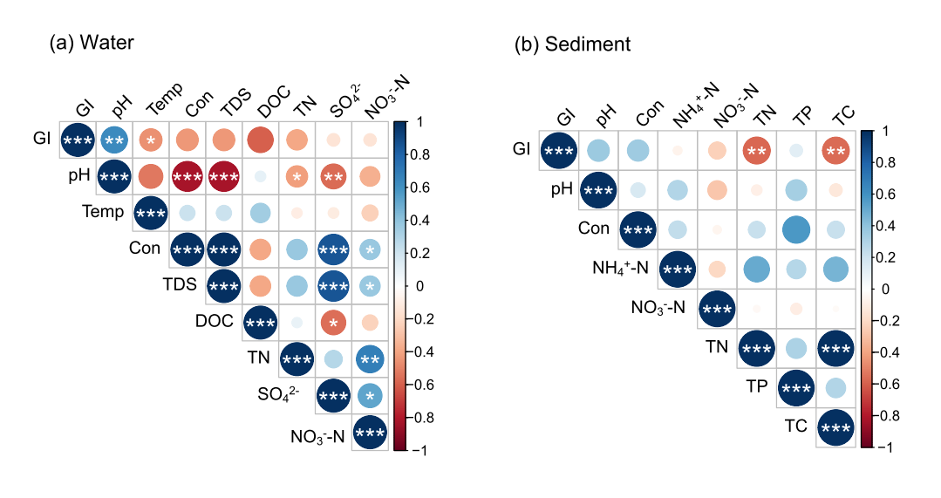
Figure S1. Spearman correlations between the glacier index (GI) and environmental factors in water (a) and sediment (b) of studying glacial lakes. Temp: temperature; Con: conductivity; TDS: total dissolved solids; DOC: dissolved organic carbon; TN: total nitrogen; TP: total phosphorus; TC: total carbon. *P < 0.05, **P < 0.01, ***P < 0.001.

Figure S2. Relative abundance of the dominant bacterial phyla/classes (relative abundance > 1% in at least one sample) in water (a) and sediment (b) samples of studying glacial lakes.

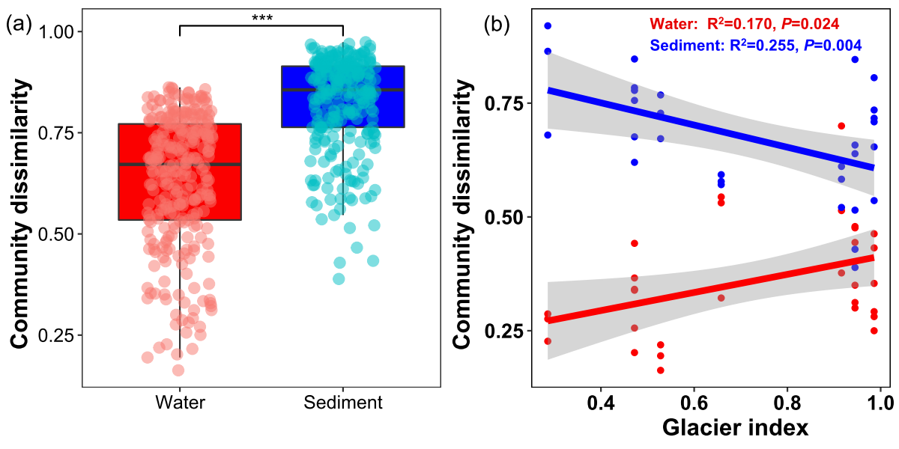
Figure S3. Comparison of β diversity in water and sediment. (a) Comparison of bacterial community dissimilarity in water and sediment. (b) Relationships between community dissimilarity and the glacier index (GI) in water and sediment. Asterisks represent significance (∗∗∗, P < 0.001).

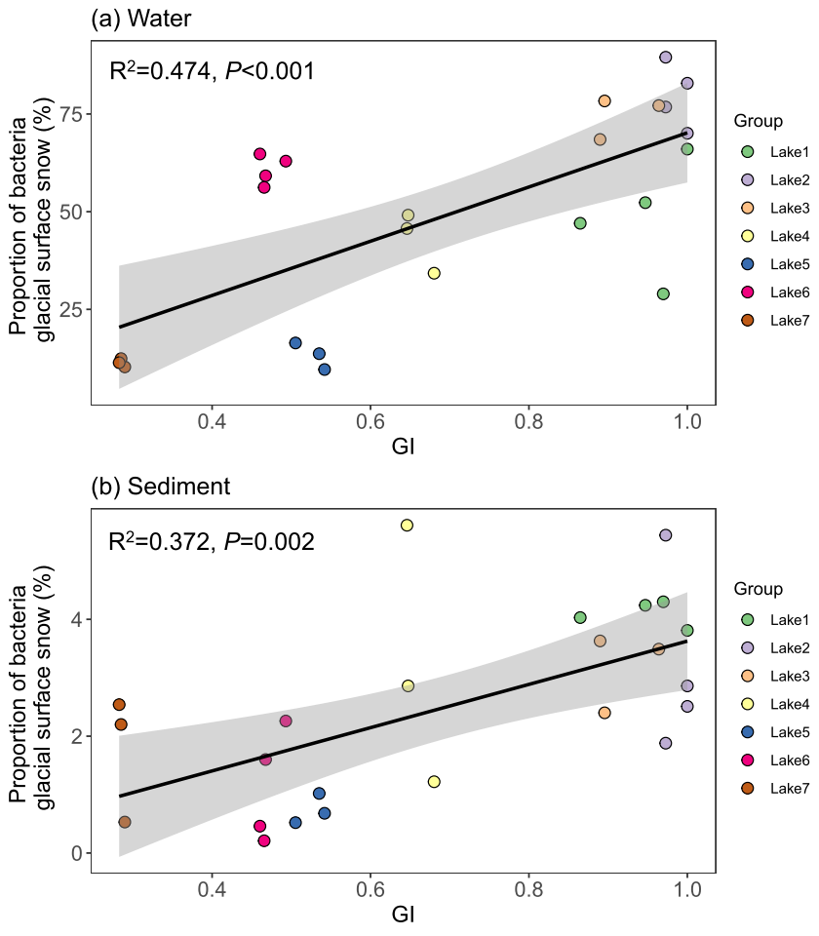
Figure S4. Linear relationship between the glacier index (GI) and the proportion of bacteria from glacial surface snow in water (a) and sediment (b). Each data point represents a lake site and colored according to their geographical location. The shaded areas represent the 95% confidence intervals of the model fits.

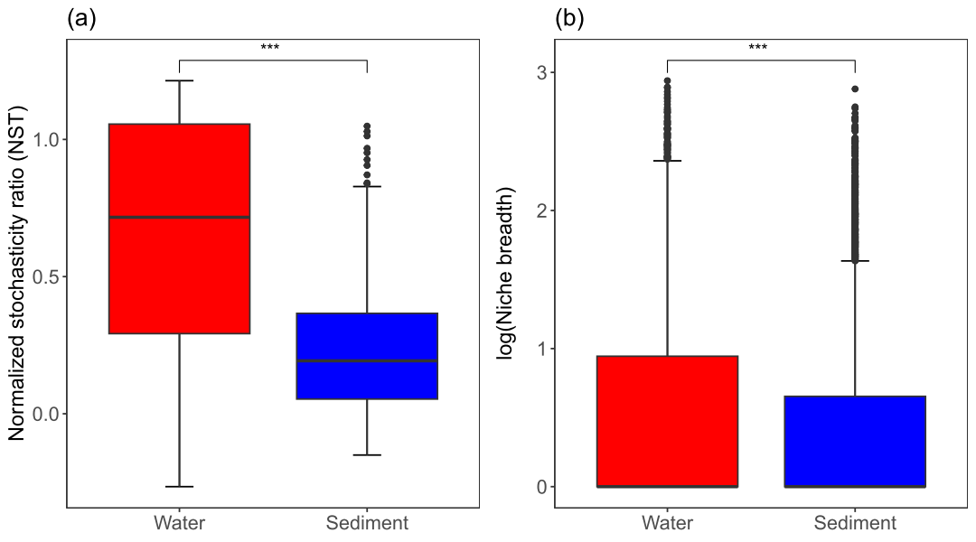
Figure S5. Ecological processes shaping the bacterial community assembly in water and sediment of glacial lakes. (a) The ecological stochasticity in bacterial community assembly estimated by normalized stochasticity ratio. (b) Mean habitat niche breadth from all taxa in each sample (Bcom) of bacterial communities in water and sediment of glacial lakes. Asterisks represent significance (∗∗∗, P < 0.001).

