Supplementary figures and tables
Supplementary figures.
Figure S1. DFS in the subgroup of patients with stage II or IIIA NSCLC. (a) Kaplan-Meier estimates of DFS for patients with stage II disease. (a) Kaplan-Meier estimates of DFS for patients with stage IIIA disease. DFS, disease-free survival; NSCLC, non-small cell lung cancer; HR, hazard ratio; CI, confidence interval.
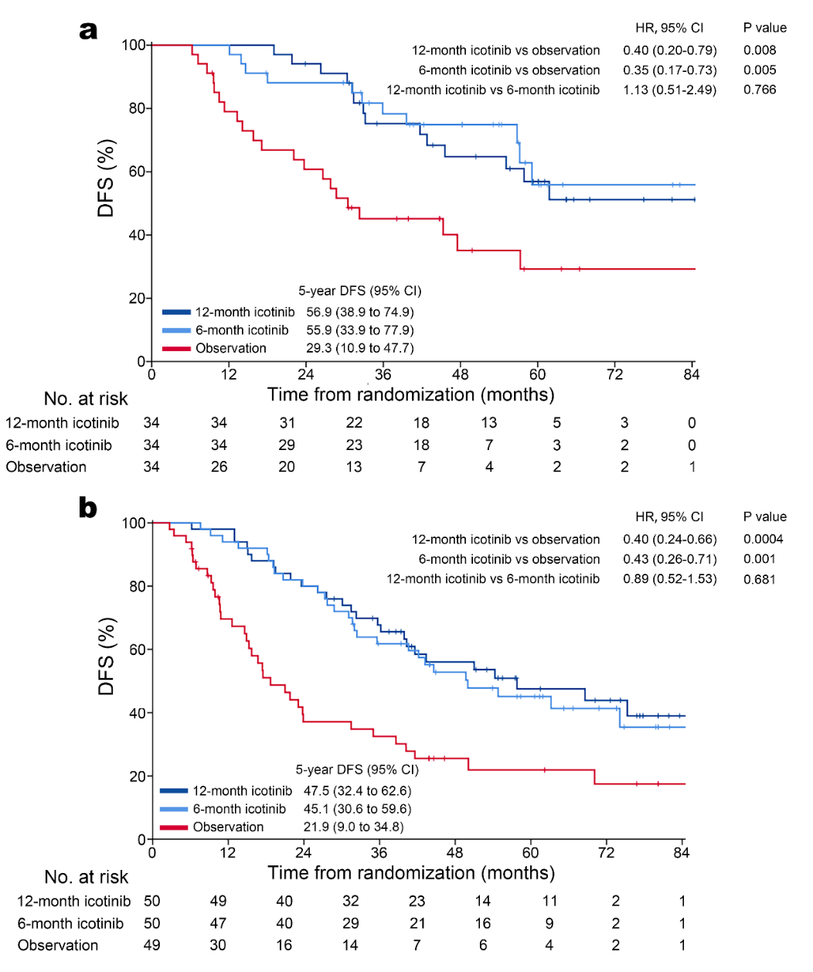

Figure S2. Kaplan-Meier estimates of BMFS by the investigator in the ITT population. BMFS, brain metastasis-free survival; HR, hazard ratio; CI, confidence interval; ITT, intention-to-treat.

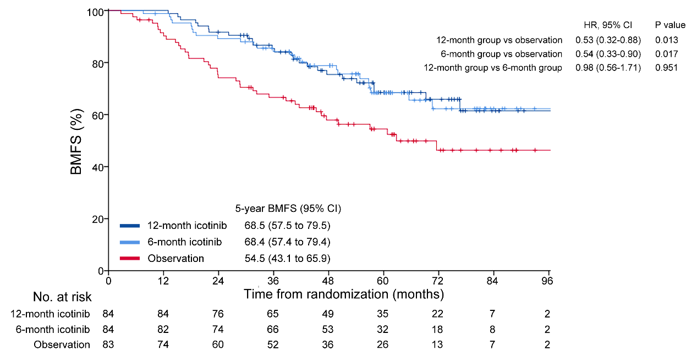

Figure S3. Forest plots of OS by subgroup.
(a) Subgroup analyses of OS for 12-month icotinib versus observation. (b) Subgroup analyses of OS for 6-month icotinib versus observation. Subgroups were either pre-planned (sex, stage, and EGFR mutation type) or post hoc (age, smoking history, N stage, and side). OS, overall survival; HR, hazard ratio; CI, confidence interval; EGFR, epidermal growth factor receptor.
Supplementary tables.
Table S1. Adjuvant chemotherapy regimens and cycles.
 | Icotinib of 12 months (n=84) | Icotinib of 6 months (n=84) | Observation (n=83)
Chemotherapy cycles
Four | 68 (81.0) | 66 (78.6) | 67 (80.7)
Three | 6 (7.1) | 7 (8.3) | 7 (8.4)
Two | 10 (11.9) | 11 (13.4) | 9 (10.8)
Chemotherapy regimens
Pemetrexed/carboplatin | 59 (70.2) | 60 (71.4) | 57 (68.7)
Vinorelbine/carboplatin | 18 (21.4) | 18 (21.4) | 19 (22.9)
Gemcitabine/carboplatin | 5 (6.0) | 5 (6.0) | 4 (4.8)
Docetaxel/carboplatin | 2 (2.4) | 1 (1.2) | 3 (3.6)
Data are presented as n (%).

Table S2. Treatment duration of icotinib.
 | Icotinib of 12 months (n=84) | Icotinib of 6 months (n=84)
Completed treatmentª | 65 (77.4) | 66 (78.6)
Did not complete treatment | 19 (22.6) | 18 (21.4)
Duration of icotinib
≥1 day, <1 month | 1 (1.2) | 2 (2.4)
≥1 month, <2 months | 1 (1.2) | 2 (2.4)
≥2 months, <3 months | 1 (1.2) | 0
≥3 months, <4 months | 2 (2.4) | 4 (4.8)
≥4 months, <5 months | 0 | 3 (3.6)
≥5 months, <6 months | 2 (2.4) | 9 (10.7)
≥6 months, <7months | 0 | 43 (51.2)
≥7 months, <8 months | 3 (3.6) | 12 (14.3)
≥8 months, <9 months | 1 (1.2) | 4 (4.8)
≥9 months, <10 months | 2 (2.4) | 2 (2.4)
≥10 months, <11 months | 4 (4.8) | 1 (1.2)
≥11 months, <12 months | 8 (9.5) | 1 (1.2)
≥12 months, <13 months | 47 (60.0) | 1 (1.2)
≥13 months, <18 months | 11 (13.1) | 0
≥18 months | 1 (1.2) | 0
Data are presented as n (%).
ªIcotinib treatment of greater than or equal to 11.8 months in the 12-month group, and 5.8 months in the 6-month group were deemed as completion of study treatment.

Table S3. Treatment effect of 12-month icotinib over 6-month icotinib on DFS in subgroup analyses.
Variables | Subgroup | N (%) | HR (95 CI) | P value
Total |  | 168 | 0.97 (0.62-1.51) | 0.887
Age | ≥65 | 34 (20.2) | 0.43 (0.15-1.17) | 0.098
 | ＜65 | 134 (79.8) | 1.22 (0.74-2.00) | 0.434
Gender | Male | 59 (35.1) | 0.75 (0.36-1.55) | 0.436
 | Female | 109 (64.9) | 1.12 (0.64-1.95) | 0.701
Smoking history | Yes | 23 (13.7) | 0.74 (0.29-1.93) | 0.538
 | No | 145 (86.3) | 1.03 (0.63-1.70) | 0.898
Side | Left | 75 (44.6) | 0.68 (0.37-1.25) | 0.214
 | Right | 93 (55.4) | 1.41 (0.73-2.75) | 0.309
Stage | II | 68 (40.5) | 1.13 (0.51-2.49) | 0.766
 | IIIA | 100 (59.5) | 0.89 (0.52-1.53) | 0.681
N stage | 0 or 1 | 76 (45.2) | 1.14 (0.54-2.42) | 0.734
 | 2 | 92 (54.8) | 0.89 (0.52-1.55) | 0.686
EGFR mutation | Exon 19 del | 93 (55.4) | 0.81 (0.44-1.50) | 0.502
 | Exon 21 L858R | 75 (44.6) | 1.17 (0.61-2.24) | 0.629
Abbreviations: DFS, disease-free survival; N, number; HR, hazard ratio; CI, confidence interval; EGFR, epidermal growth factor receptor.

Table S4. Types of first disease relapse.
Type | Icotinib of 12 months (n=84) | Icotinib of 6 months (n=84) | Observation  (n=83)
Relapse without death | 30 (35.7) | 30 (35.7) | 45 (54.2)
Local only | 16 (19.0) | 18 (21.4) | 22 (26.5)
Distant only | 11 (13.1) | 10 (11.9) | 17 (20.5)
Local and distant | 3 (3.6) | 4 (4.8) | 6 (7.2)
Data are presented as n (%).

Table S5. Site(s) of first disease relapse.
Site | Icotinib of 12 months (n=84) | Icotinib of 6 months (n=84) | Observation (n=83)
Lung | 11 (13.1) | 12 (14.3) | 20 (24.1)
Brain | 10 (11.9) | 12 (14.3) | 15 (18.1)
Lymph nodes | 7 (8.3) | 6 (7.1) | 12 (14.5)
Bone | 5 (6.0) | 4 (4.8) | 8 (9.6)
Pleura | 3 (1.2) | 2 (2.4) | 6 (7.2)
Liver | 1 (1.2) | 1 (1.2) | 3 (1.2)
Adrenal | 1 (1.2) | 0 | 1 (1.2)
Data are presented as n (%). Some patients had more than one site of relapse.

Table S6. Summary of the first subsequent therapy.
Subsequent therapy | Icotinib of 12 months | Icotinib of 6 months | Observation
Patients who experienced a DFS event | 40 | 39 | 56
EGFR-TKI
Osimertinib | 9 (22.5) | 8 (20.5) | 5 (8.9)
Aumolertinib | 5 (12.5) | 2 (5.1) | 2 (3.6)
Furmonertinib | 3 (7.5) | 2 (5.1) | 2 (3.6)
Icotinib | 2 (5.0) | 4 (10.3) | 24 (42.9)
Gefitinib | 2 (5.0) | 3 (7.7) | 5 (8.9)
Erlotinib | 1 (2.5) | 3 (7.7) | 2 (3.6)
Afatinib | 1 (2.5) | 4 (10.3) | 3 (5.4)
Chemotherapy | 4 (10.0) | 3 (7.7) | 1 (1.8)
Apatinib | 1 (2.5) | 1 (2.6) | 0
Anlotinib | 0 | 3 (7.7) | 1 (1.8)
Crizotinib | 1 (2.5) | 0 | 0
Bevacizumab | 1 (2.5) | 0 | 0
PD-1/PD-L1 inhibitors | 0 | 1 (2.6) | 0
Radiotherapy | 2 (5.0) | 2 (5.1) | 1 (1.8)
No subsequent therapyª | 11 (27.5) | 10 (25.6) | 12 (21.4)
Data are presented as n (%). Percentages of patients were calculated from the number of patients who experienced a DFS event. Some patients had more than one first subsequent therapy.
ªIncluding patients who died without relapse.
Abbreviations: DFS, disease-free survival; EGFR, epidermal growth factor receptor; TKI, tyrosine kinase inhibitor; PD-1, programmed cell death protein-1; PD-L1, programmed cell death-ligand 1.

Table S7. Summary of adverse events.
AE | Icotinib of 12 months  (n=84) | Icotinib of 6 months (n=84) | Observation (n=83)
Any AE | 65 (77.4) | 62 (73.8) | 45 (54.2)
Any AE ≥ grade 3 | 7 (8.3) | 5 (5.9) | 2 (2.4)
Any AE leading to treatment discontinuation | 4 (4.8) | 3 (3.6) | 0
Any AE leading to dose reduction | 0 | 0 | 0
Fatal AE | 0 | 0 | 0
Data are presented as n (%). AE, adverse event. All adverse events were assessed according to the National Cancer Institute Common Terminology Criteria for Adverse Events, version 4.0.

