Supplementary Materials for

Charging Dynamic of Graphene Oxide-Water Interface Dominated by Sulfate Groups

Mohsen Moazzami Gudarzi ^{1,2†*}, Mohamad Ali Sanjari Shahrezaei ^{3†}, Mohammad Hosseini ³ , Seyed Hamed Aboutalebi ^{3,4*}
¹ National Graphene Institute, University of Manchester, Manchester, M13 9PL UK
² Department of Physics and Astronomy, School of Natural Sciences, The University of Manchester, Manchester, M13 9PL UK
³ Condensed Matter National Laboratory, Institute for Research in Fundamental Sciences (IPM), Tehran, 19395-5531, Iran
⁴ Institute for Superconducting and Electronic Materials, AIIM Facility, Innovation Campus, University of Wollongong, North Wollongong, NSW, 2522, Australia
*Correspondence to: mohsen.moazzamigudarzi@manchester.ac.uk, sha942@uowmail.edu.au

This PDF file includes:
Supplementary Text
Figs. S1 to S6
Tables S1 to S2
References (1 to 54)

Supplementary Text

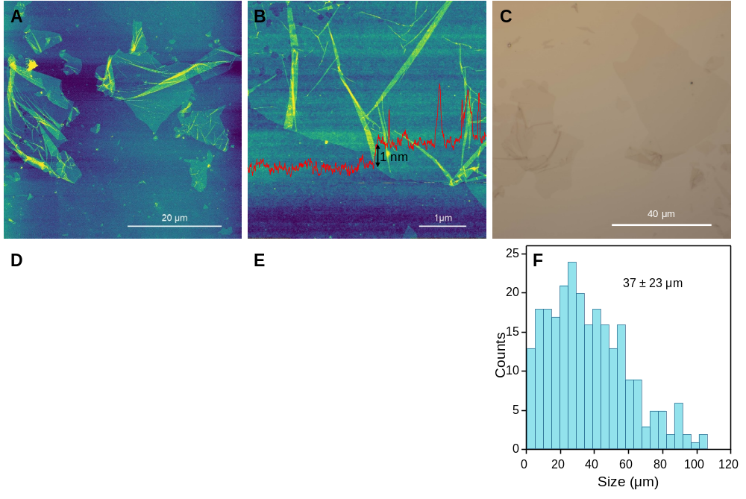
Figure S1. Characterization and size distribution of graphene Oxide (GO) Sheets. We investigated the size distribution of graphene oxide (GO) nanosheets using atomic force microscopy (AFM), optical microscopy (OM), and field emission scanning electron microscopy (FESEM). In all characterization methods, we deposited GO sheets onto silicon wafers following the procedure outlined in the materials and methods section. AFM images in Panels (A) and (B) reveal exfoliation down to a monolayer. The consistent contrast between GO nanosheets and the silicon substrate is evident in both the optical micrograph (Panel C) and FESEM images (Panels D and E), confirming the prevalence of monolayer GO. Additionally, Panel (F) displays the size distribution of GO obtained by combining all three techniques.

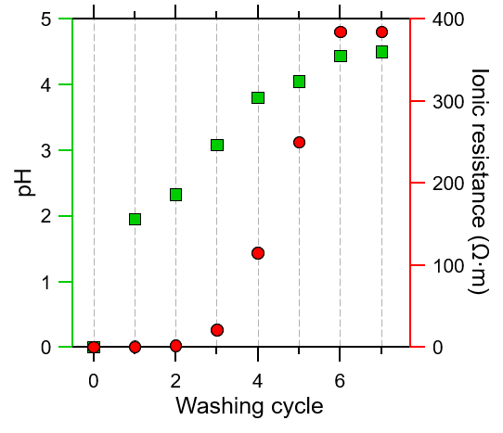

Figure S2. GO supernatant pH and Ionic resistance evolution. The pH (represented by green squares) and ionic resistance (indicated by red circles) in the supernatant of graphene oxide (GO) change during the centrifugation and subsequent re-dispersion process in pure water. After each washing cycle, both pH and ionic resistance increase until they reach a semi-plateau. Note that the reference point for zero washing cycles has been arbitrarily set at zero for both pH and ionic resistance.

S1. Modeling pH and osmotic pressure data:
In Figures 1B and 1C, we present the pH and osmotic pressure of graphene oxide (GO) dispersions obtained using the same oxidation and purification method. We propose that the observed large osmotic pressure (Π) in GO dispersions results from a high concentration of protons, which essentially serve as GO sheets’ counterions. Consequently, this phenomenon also leads to the observation of low pH values in relatively dilute GO dispersions (as shown in Figure 1B).
We modelled Π using eqs. (1) and (2). We made the assumption that any background salt in the dispersion originates either from background ionic impurities or from ionic impurities released by GO. Consequently, we estimated the total salt concentration as follows:
​$c_{s}=​c_{s_{0}}+α∙Z∙c_{GO}$ (S1)
Here:
$​c_{s_{0}}$ represents the concentration of background ionic impurities.
The coefficient $α$ reflects the fraction of ionic impurities released into the dispersion from GO due to the hydrolysis of organosulfate.
$Z$ represents the number of electrons.
We then calculated the pH from the total concentration of proton (i.e. $c_{s}+Z∙c_{GO}$).
We set $c_{s_{0}}$= 1.3×10⁻⁶ M which is computed from the saturating pH of very dilute GO (i.e. pH=5.9, see Figure 1B). This likely results from carbonic acid impurity. To compute $α$, we monitored pH of 0.027 L of GO dispersion (4.7 g/L) in contact with 1.02 L of water through a semipermeable membrane. The pH of the GO dispersion increased from 2.36 to 2.42 (after 24 hours), corresponding to a loss of 15.2 μM of proton. We approximated $α≈1-{10}^{2.42-2.36}≈0.13$, consistent with recent findings of Halbig et al.(1) We note that the surface charge density of GO can change upon hydrolysis and may not be exactly the same for two batches of samples. Since we used the same batch of GO for both pH and osmotic pressure measurements, we fit both sets of data using equations (1) and (2) with the specified parameters. The only fitting parameter is the surface charge density ($σ$). We employed diffuse layer model accounting for multisite proton adsorption to compute $σ$ as a function of pH and $c_{s_{0}}$. Further details are provided in the next section. Using ${pK}_{a}$ of organosulfate groups as the only fitting parameter, we fitted both pH and Π versus GO concentration.

S2. Modeling the surface charge density of GO:
Surface charge density ($σ$) of GO is governed by the protonation equilibrium of different active sites within its structure. Regardless of the origin of such sites, the law of mass action relates the corresponding surface density ($Γ_{i}^{0}$) of these sites to the deprotonated density through an equilibrium constant (${pK}_{a_{i}}$).(2) In the presence of multiple types of ionizable sites, the general expression for the surface charge density is as follows (2):
$σ=e\sum_{i}{Γ_{i}^{0}(\frac{1}{1+{10}^{(pH-{pK}_{a_{i}})}e^{(\frac{ψ_{0}}{β})}})}$, (S2)
Where $ψ_{0}$ and $e$ represent surface potential and elementary charge, respectively and $β$ denotes the thermal voltage ($\frac{k_{B}T}{e}$). The analytical expression derived from the Poisson-Boltzmann (PB) equation that relates $σ$ to $ψ_{0}$ in the presence of symmetric electrolytes is:
$σ=2εε_{0}κβsinh⁡(\frac{ψ_{0}}{2β})$, (S3)
Where $ε_{0}$ represents the vacuum permittivity, $ε$ is dielectric constant and $κ^{-1}$ is the Debye length, defined as:
$κ=\sqrt{\frac{2eI}{εε_{0}β}}$ , (S4)
Where $I$ represents the ionic strength of electrolyte.
We considered four types of active sites contributing to the surface charges at the GO-water interface. In addition to organosulfate groups, we included three other types: two accounting for carboxyl groups and one for hydroxyl groups in GO. It is commonly assumed that carboxyl groups in proximity to hydroxyl groups are more acidic and possess smaller${pK}_{a}$ values.(3) We used average values for the ${pK}_{a}$ of these three oxygen groups reported in the literature (Table S1). (3-5) Their corresponding $Γ^{0}$ are taken from ref.(5) Variation in these parameters play a minor role in surface charge density of GO dispersions, as the pH is acidic. Both $Γ^{0}$ and ${pK}_{a}$ of the organosulfate groups are unknown. The content of these groups changes overtime due to hydrolysis, generating additional hydroxyl groups.(1) Here, we calculated $Γ^{0}$ using the elemental analysis data of the sample we used for pH and osmotic pressure measurements. We found 3.03 wt.% sulfur in the sample corresponding to 54 mC·m⁻². The ${pK}_{a}$ of organosulfate groups is not precisely defined, although they exhibit strong acidity.(6) Therefore, we treated ${pK}_{a}$ of these site as a fitting parameter to fit pH and osmotic pressure data. Our best fit yielded a ${pK}_{a}$ value of 1.2, consistent with the highly acidic nature of these sites. Table S1 summarizes the ${pK}_{a}$ and $Γ^{0}$ values for all four sites used in our model.

Table S1. Parameters for the Diffuse Layer Model, eq.(S1). See Figure 3A for more details.
 | $${pK}_{a}$$ | $Γ^{0}$ (mC·m⁻²)
Organosulfate groups | 1.2 | 54
Carboxyl type I | 4 | 40
Carboxyl type II | 6.5 | 70
Hydroxyl | 9.5 | 125

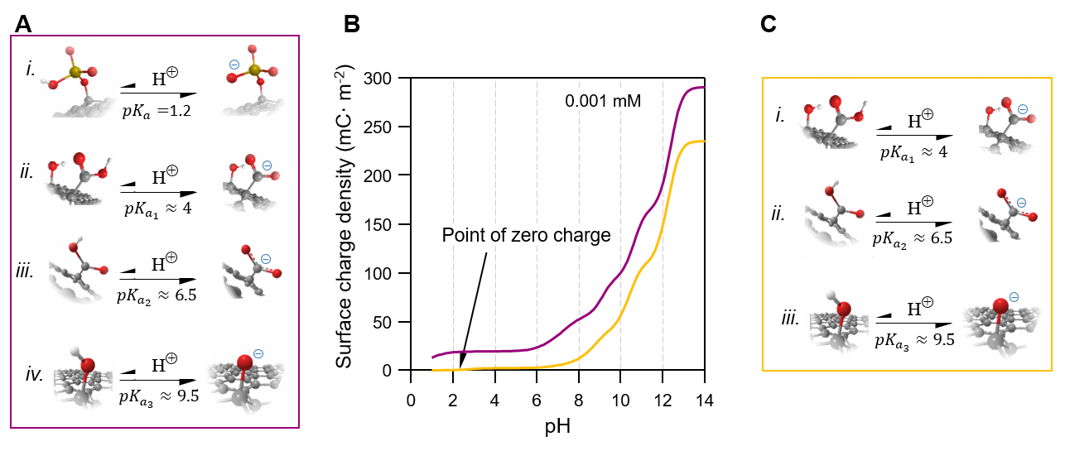
Figure S3. Analysis of surface charge density (σ) of GO in the absence of sulfate groups at low salt regime. Panel (A) illustrates four distinct types of active sites contributing to the surface charge of graphene oxide (GO) as considered in our model. Panel (B) displays the model outcomes for two scenarios: one where all four sites are considered (indicated by the purple line) and another where sulfates are ignored (depicted by the orange line), as shown in Panel (C).

S3. Estimation of hydrolysis activation energy of organosulfate groups in GO:
Organosulfate groups undergo hydrolysis upon exposure to water. This reaction leaves hydroxyl groups in GO structure and releases sulfuric acid into the aquatic medium. We estimated the activation energy for this reaction based on the data reported by Halbig et al.(1) They quantified the amount of sulfur released from GO into water over time at various temperatures (See Figure 4D and 4D in (1)). Based on the sulfur content in GO (3.91 wt. %) and the concentration of the GO dispersion (0.6 mg/ml), we calculated the initial sulfur content of 0.733 mM. In Figure S4A, we plotted the organosulfate concentration versus time. The reaction rate constant was then determined for each temperature. From these data we extracted the activation energy using the Arrhenius equation (Figure S4B). We note that the hydrolysis of organosulfates can be catalyzed by acids.(7)
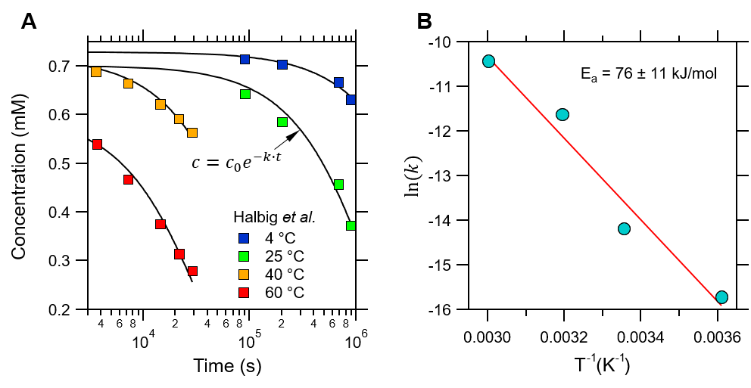
Figure S4. Determining the activation energy for organosulfate hydrolysis in GO. Panel (A) shows the data reported by Halbig et al. The original work reports sulfur concentration released from GO (product of reaction). We converted those data to sulfur concentration bound to GO using the GO concentration (0.6 mg/ml) and the sulfur content in GO (3.91 wt.%). We then fit these data to an exponential function (black lines) to obtain the reaction rate ($k$) at different temperature. Panel (B) shows logarithms of $k$ [s⁻¹] as a function of the reciprocal temperature. From the linear fit (red line), an activation energy of 76 ± 11 kJ/mol is estimated.

S4. Modeling interactions between two GO sheets:
The total pressure ($Π_{t}$) between two adjacent GO sheets is assumed to be the sum of three main forces, namely electrical double layer (EDL), van der Waals (vdW) and undulation (U) forces:
$Π_{t}=Π_{EDL}+Π_{vdW}+Π_{U}$. (S5)
We ignored hydration forces which are only significant at very short distances. In dispersions containing only GO, the protons dissociated from GO are the only species screening the EDL. The PB equation, at large distance, can be analytically approximated(8):
$Π_{EDL}=\frac{π}{2}\frac{k_{B}T}{l_{B}{(d+2l_{GC})}^{2}}- k_{B}T(1+Z{)c}_{GO}$. (S6)
We approximated vdW forces between two GO sheets using the expression for two plates of thickness of $t$ interacting at separation distance of $d$ (9):
$Π_{vdW}=-\frac{H}{6π}(\frac{1}{d^{3}}+\frac{1}{{\left(d+2t\right)}^{3}}-\frac{2}{{\left(d+t\right)}^{3}})$, (S7)
Where $H$ represents the Hamaker constant, estimated from the Lifshitz theory (9):
$H(d)=\frac{3k_{B}T}{2}\sum_{n=1}^{∞}{R_{n}(d)\sum_{s=1}^{∞}{\frac{∆^{2s}}{s^{3}}}}$, (S8)
$∆=\frac{ε_{GO}\left(iξ_{n}\right)-ε_{water}\left(iξ_{n}\right)}{ε_{GO}\left(iξ_{n}\right)+ε_{water}\left(iξ_{n}\right)}$, (S9)
Where $ε_{i}$ represents the dielectric function at imaginary frequencies (Figure S5A) and
$ξ_{n}=\frac{2πnk_{B}T}{ℏ}$, (S10)
$R_{n}\left(d\right)=(1+\frac{2dξ_{n}\sqrt{ε_{water}(iξ_{n})}}{c})e^{-\frac{2dξ_{n}\sqrt{ε_{water}(iξ_{n})}}{c}}$, (S11)
Where $c$ is speed of light. Note that we ignored the zero-term frequency in our calculations as this term is small and is mostly screened in the presence of salts(9). We used the experimental optical constants of water compiled in our previous work to compute $ε_{water}$ (Figure S5A).(10) For GO, we used the modified harmonic oscillator model introduced in our previous work.(10) We ignored optical anisotropy and bands in infrared regions. The electronic dielectric constant and optical band gap of GO is approximated from Schwenzer et al. to be 3.5, 3.7 eV, respectively.(11) The density and the chemical formula of GO is estimated as C₅O₂ and 1.8 g·cm⁻³, respectively, as discussed in section S5.(12) We found non-retarded Hamaker constant of $≅$ 27×10⁻²¹ J (Figure S5B).

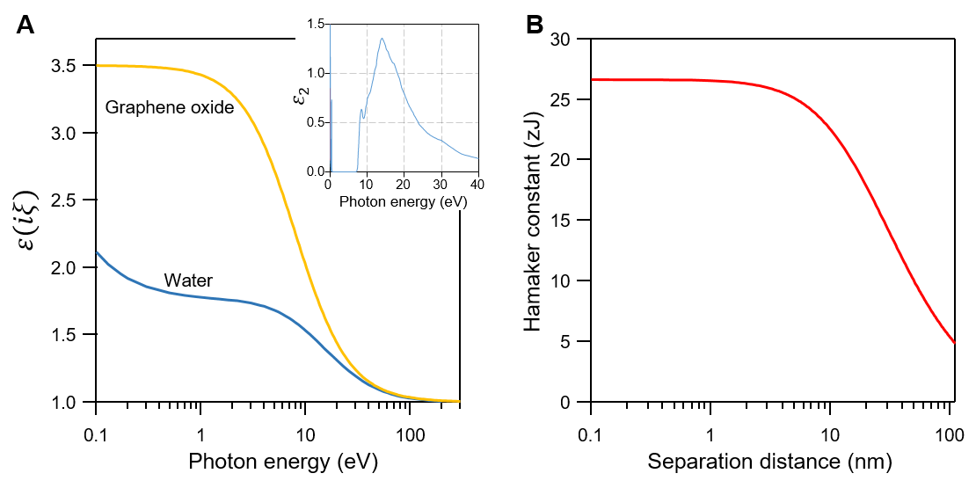
Figure S5. Calculation of van der Waals interaction between GO nanosheets through water. Panel (A) displays the dielectric function of water and graphene oxide (GO) in imaginary frequencies as a function of photon energy. The water data are obtained from numerical calculations based on the experimental imaginary part of the dielectric function of water (shown in the inset). Further details are provided in our previous work (10). The GO data are computed using the modified harmonic oscillator model, as discussed in the text. Additionally, Panel (B) illustrates the calculated Hamaker constant as a function of the separation distance between GO nanosheets.

The undulation pressure is approximated using the expression derived by Helfrich (13):
$Π_{U}=\frac{3π^{2}{(k_{B}T)}^{2}}{64κ_{b}d^{3}}$, (S12)
Where $κ_{b}$ represents the bending modulus of GO approximately equal to $k_{B}T$ (14).
We approximated the thickness of the double layer around GO for a given concentration using the following equation:
$Π_{t}\left(d_{EDL}\right)=0$. (S13)
We then compared the $d_{EDL}$ obtained from above model with the interlayer layer spacing of GO sheets at different volume fraction (Figure 4D,E). Note that the interlayer spacing depends on the effective packing factor, $θ$, which can be estimated from the experimental data (Figures 4A and S6).
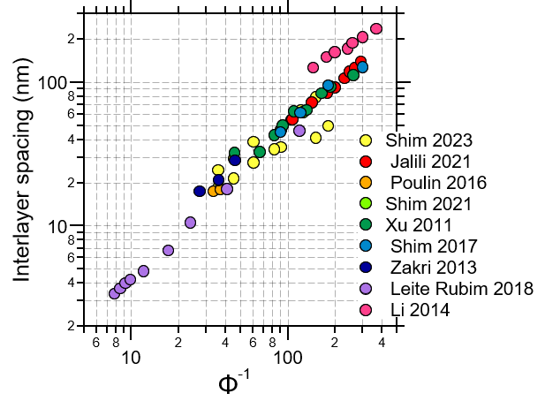
Figure S6. Reported average interlayer spacing between GO sheets as a function of reciprocal of volume fraction ($Φ^{-1}$), as shown in Figure 4A of the main text. Data collected from nine different reports exhibit reasonable agreement with each other. The sources of the data are Shim 2023(15), Jalili 2021(16), Poulin 2016(14), Shim 2021(17), Xu 2011(18), Shim 2017(19), Zakri 2013(20), Leite Rubim 2018(21), Li 2014(22).

S5. Approximation of specific surface area of GO:
The specific surface area of graphene oxide (GO) is influenced by its chemical composition and density. However, due to the amorphous and dynamic nature of GO, neither of these factors is precisely defined. For the purpose of our analysis, we assume that the empirical formula for GO is C₅O₂ (ignoring hydrogen and sulfur). Additionally, we adopt a dehydrated GO thickness of 6.5Å.(23) If we consider graphite oxide as a ‘swollen’ form of graphite primarily in the C-direction, then the density of graphite oxide can be estimated:
$ρ_{GO}=\frac{m_{GO}}{m_{graphite}}\frac{d_{graphite}}{d_{GO}}ρ_{graphite}$ (S14)
The density of graphite is 2.26 g·cm⁻³ and its d-spacing is 3.36 Å, respectively.(24) Therefore, $ρ_{GO}$ can be calculated to be approximately around 1.8 g·cm⁻³. Therefore, the specific surface area of GO is $\frac{2}{d_{GO}∙ρ_{GO}}≈1700$ m²·g⁻¹.

Table S2. List of papers where zeta potential data of GO are extracted from. Note that if electrophoretic mobility values were reported, we converted them to zeta potential using Smoluchowski equation.
Ref. | Title
(25) | Adsorption and co-adsorption of graphene oxide and Ni(II) on iron oxides: A spectroscopic and microscopic investigation
(26) | Adsorption characteristics and behaviors of graphene oxide for Zn(II) removal from aqueous solution
(27) | Adsorption of Ca²⁺ on single layer graphene oxide
(28) | Aggregation, Adsorption, and Morphological Transformation of Graphene Oxide in Aqueous Solutions Containing Different Metal Cations
(29) | Aqueous Colloidal Stability of Graphene Oxide and Chemically Converted Graphene
(30) | Complex Roles of Solution Chemistry on Graphene Oxide Coagulation onto Titanium Dioxide: Batch Experiments, Spectroscopy Analysis and Theoretical Calculation
(31) | Deposition Kinetics of Graphene Oxide on Charged Self-Assembled Monolayers
(32) | Enabling Graphene Oxide Nanosheets as Water Separation Membranes
(33) | Evaporation-Induced Crumpling of Graphene Oxide Nanosheets in Aerosolized Droplets: Confinement Force Relationship
(34) | Facile Graphene Oxide Preparation by Microwave-Assisted Acid Method
(35) | Facile synthesis of water soluble reduced graphene oxide with a high concentration and its application in printable micro-supercapacitors
(36) | Graphene oxide for high-efficiency separation membranes: Role of electrostatic interaction
(37) | Graphene Oxide Nanocolloids
(38) | Heteroaggregation of Graphene Oxide with Minerals in Aqueous Phase
(39) | Highly conductive chemically converted graphene prepared from mildly oxidized graphene oxide
(40) | Insights into key factors controlling GO stability in natural surface waters
(41) | New Insight into the Aggregation of Graphene Oxide Using Molecular Dynamics Simulations and Extended Derjaguin–Landau–Verwey–Overbeek Theory
(42) | Noncovalent Magnetic Control and Reversible Recovery of Graphene Oxide Using Iron Oxide and Magnetic Surfactants
(43) | Processable aqueous dispersions of graphene nanosheets
(44) | Quantitative characterization of colloidal assembly of graphene oxide-silver nanoparticle hybrids using aerosol differential mobility-coupled mass analyses
(45) | Revisit the adsorption of aromatic compounds on graphene oxide: Roles of oxidized debris
(46) | Salt concentration, pH and pressure controlled separation of small molecules through lamellar graphene oxide membrane
(47) | Size Fractionation of Graphene Oxide Sheets by pH-Assisted Selective Sedimentation
(48) | Spectroscopic and theoretical studies on the counterion effect of Cu(ii) ion and graphene oxide interaction with titanium dioxide
(49) | Strict molecular sieving over electrodeposited 2D-interspacing-narrowed graphene oxide membranes
 | Sulfur Species in Graphene Oxide
  (50)
(51) | Synthesis of graphene oxide nanosheets for the removal of Cd(II) ions from acidic aqueous solutions
(52) | Tunable assembly of graphene oxide surfactant sheets: wrinkles, overlaps and impacts on thin film properties
(53) | Tuning nanostructure of graphene oxide/polyelectrolyte LbL assemblies by controlling pH of GO suspension to fabricate transparent and super gas barrier film
(3) | Understanding Aqueous Dispersibility of Graphene Oxide and Reduced Graphene Oxide through pKa Measurements
(54) | Wastewater injection, aquifer biogeochemical reactions, and resultant groundwater N fluxes to coastal waters: Kā'anapali, Maui, Hawai'i

1. C. E. Halbig, B. Mukherjee, S. Eigler, S. Garaj, Origin of Oxygen in Graphene Oxide Revealed by 17O and 18O Isotopic Labeling. Journal of the American Chemical Society, (2024).
2. G. Trefalt, S. H. Behrens, M. Borkovec, Charge Regulation in the Electrical Double Layer: Ion Adsorption and Surface Interactions. Langmuir 32, 380-400 (2016).
3. B. Konkena, S. Vasudevan, Understanding Aqueous Dispersibility of Graphene Oxide and Reduced Graphene Oxide through pKa Measurements. The Journal of Physical Chemistry Letters 3, 867-872 (2012).
4. E. S. Orth et al., pKa determination of graphene-like materials: Validating chemical functionalization. Journal of Colloid and Interface Science 467, 239-244 (2016).
5. D. V. Andreeva et al., Two-dimensional adaptive membranes with programmable water and ionic channels. Nature Nanotechnology 16, 174-180 (2021).
6. Y. Zhang et al., Joint Impacts of Acidity and Viscosity on the Formation of Secondary Organic Aerosol from Isoprene Epoxydiols (IEPOX) in Phase Separated Particles. ACS Earth and Space Chemistry 3, 2646-2658 (2019).
7. M. Nakagaki, S. Yokoyama, Acid-catalyzed hydrolysis of sodium dodecyl sulfate. Journal of pharmaceutical sciences 74, 1047-1052 (1985).
8. M. Moazzami-Gudarzi et al., Interplay between depletion and double-layer forces acting between charged particles in solutions of like-charged polyelectrolytes. Physical review letters 117, 088001 (2016).
9. V. A. Parsegian, Van der Waals forces: a handbook for biologists, chemists, engineers, and physicists. (Cambridge University Press, 2005).
10. M. Moazzami Gudarzi, S. H. Aboutalebi, Self-consistent dielectric functions of materials: Toward accurate computation of Casimir–van der Waals forces. Science Advances 7, eabg2272 (2021).
11. B. Schwenzer, T. C. Kaspar, Y. Shin, D. W. Gotthold, Spectroscopic Study of Graphene Oxide Membranes Exposed to Ultraviolet Light. The Journal of Physical Chemistry C 120, 12559-12567 (2016).
12. M. M. Gudarzi, Colloidal Stability of Graphene Oxide: Aggregation in Two Dimensions. Langmuir 32, 5058-5068 (2016).
13. W. Helfrich, Steric interaction of fluid membranes in multilayer systems. Zeitschrift für Naturforschung A 33, 305-315 (1978).
14. P. Poulin et al., Superflexibility of graphene oxide. Proceedings of the National Academy of Sciences 113, 11088-11093 (2016).
15. Y. H. Shim, E. H. Cho, S. Y. Kim, Unifying dispersion properties of graphene oxide suspensions via interlayer spacing control: Insights for universal 2D colloid behavior. Carbon 215, 118473 (2023).
16. A. R. Jalili et al., Liquid Crystal-Mediated 3D Printing Process to Fabricate Nano-Ordered Layered Structures. ACS Applied Materials & Interfaces 13, 28627-28638 (2021).
17. Y. H. Shim, H. Ahn, S. Lee, S. O. Kim, S. Y. Kim, Universal alignment of graphene oxide in suspensions and fibers. ACS nano 15, 13453-13462 (2021).
18. Z. Xu, C. Gao, Graphene chiral liquid crystals and macroscopic assembled fibres. Nature communications 2, 571 (2011).
19. Y. H. Shim, K. E. Lee, T. J. Shin, S. O. Kim, S. Y. Kim, Wide concentration liquid crystallinity of graphene oxide aqueous suspensions with interacting polymers. Materials Horizons 4, 1157-1164 (2017).
20. C. Zakri et al., Liquid crystals of carbon nanotubes and graphene. Philosophical Transactions of the Royal Society A: Mathematical, Physical and Engineering Sciences 371, 20120499 (2013).
21. R. Leite Rubim et al., Highly confined stacks of graphene oxide sheets in water. The European Physical Journal E 41, 1-10 (2018).
22. P. Li et al., Tunable lyotropic photonic liquid crystal based on graphene oxide. ACS photonics 1, 79-86 (2014).
23. A. Iakunkov, A. V. Talyzin, Swelling properties of graphite oxides and graphene oxide multilayered materials. Nanoscale 12, 21060-21093 (2020).
24. M. Moazzami Gudarzi, S. H. Aboutalebi, Mapping the Binding Energy of Layered Crystals to Macroscopic Observables. Advanced Science 9, 2204001 (2022).
25. G. Sheng et al., Adsorption and co-adsorption of graphene oxide and Ni(II) on iron oxides: A spectroscopic and microscopic investigation. Environ Pollut 233, 125-131 (2018).
26. H. Wang et al., Adsorption characteristics and behaviors of graphene oxide for Zn(II) removal from aqueous solution. Applied Surface Science 279, 432-440 (2013).
27. A. Terracciano, J. Zhang, C. Christodoulatos, F. Wu, X. Meng, Adsorption of Ca(2+) on single layer graphene oxide. J Environ Sci (China) 57, 8-14 (2017).
28. K. Yang, B. Chen, X. Zhu, B. Xing, Aggregation, Adsorption, and Morphological Transformation of Graphene Oxide in Aqueous Solutions Containing Different Metal Cations. Environmental Science & Technology 50, 11066-11075 (2016).
29. S. Kashyap, S. Mishra, S. K. Behera, Aqueous Colloidal Stability of Graphene Oxide and Chemically Converted Graphene. Journal of Nanoparticles 2014, 640281 (2014).
30. S. Yu et al., Complex Roles of Solution Chemistry on Graphene Oxide Coagulation onto Titanium Dioxide: Batch Experiments, Spectroscopy Analysis and Theoretical Calculation. Scientific Reports 7, 39625 (2017).
31. I. C. Chen, M. Zhang, Y. Min, M. Akbulut, Deposition Kinetics of Graphene Oxide on Charged Self-Assembled Monolayers. The Journal of Physical Chemistry C 120, 8333-8342 (2016).
32. M. Hu, B. Mi, Enabling Graphene Oxide Nanosheets as Water Separation Membranes. Environmental Science & Technology 47, 3715-3723 (2013).
33. W.-N. Wang, Y. Jiang, P. Biswas, Evaporation-Induced Crumpling of Graphene Oxide Nanosheets in Aerosolized Droplets: Confinement Force Relationship. The Journal of Physical Chemistry Letters 3, 3228-3233 (2012).
34. M. M. Viana et al., Facile graphene oxide preparation by microwave-assisted acid method. Journal of the Brazilian Chemical Society 26, 978-984 (2015).
35. H. Su et al., Facile synthesis of water soluble reduced graphene oxide with a high concentration and its application in printable micro-supercapacitors. Sustainable Energy & Fuels 1, 1601-1610 (2017).
36. G. Liu et al., Graphene oxide for high-efficiency separation membranes: Role of electrostatic interactions. Carbon 110, 56-61 (2016).
37. J. Luo et al., Graphene Oxide Nanocolloids. Journal of the American Chemical Society 132, 17667-17669 (2010).
38. J. Zhao, F. Liu, Z. Wang, X. Cao, B. Xing, Heteroaggregation of Graphene Oxide with Minerals in Aqueous Phase. Environmental Science & Technology 49, 2849-2857 (2015).
39. Y. Xu, K. Sheng, C. Li, G. Shi, Highly conductive chemically converted graphene prepared from mildly oxidized graphene oxide. Journal of Materials Chemistry 21, 7376-7380 (2011).
40. Y. Gao et al., Insights into key factors controlling GO stability in natural surface waters. Journal of Hazardous Materials 335, 56-65 (2017).
41. H. Tang et al., New insight into the aggregation of graphene oxide using molecular dynamics simulations and extended Derjaguin–Landau–Verwey–Overbeek theory. Environmental science & technology 51, 9674-9682 (2017).
42. T. M. McCoy, P. Brown, J. Eastoe, R. F. Tabor, Noncovalent Magnetic Control and Reversible Recovery of Graphene Oxide Using Iron Oxide and Magnetic Surfactants. ACS Applied Materials & Interfaces 7, 2124-2133 (2015).
43. D. Li, M. B. Müller, S. Gilje, R. B. Kaner, G. G. Wallace, Processable aqueous dispersions of graphene nanosheets. Nature nanotechnology 3, 101-105 (2008).
44. T. P. Nguyen, W.-C. Chang, Y.-C. Lai, T.-C. Hsiao, D.-H. Tsai, Quantitative characterization of colloidal assembly of graphene oxide-silver nanoparticle hybrids using aerosol differential mobility-coupled mass analyses. Analytical and Bioanalytical Chemistry 409, 5933-5941 (2017).
45. S. Zhang, W. Li, H. Tang, T. Huang, B. Xing, Revisit the adsorption of aromatic compounds on graphene oxide: Roles of oxidized debris. Chemical Engineering Journal 450, 137996 (2022).
46. H. Huang et al., Salt concentration, pH and pressure controlled separation of small molecules through lamellar graphene oxide membranes. Chemical Communications 49, 5963-5965 (2013).
47. X. Wang, H. Bai, G. Shi, Size Fractionation of Graphene Oxide Sheets by pH-Assisted Selective Sedimentation. Journal of the American Chemical Society 133, 6338-6342 (2011).
48. S. Yu et al., Spectroscopic and theoretical studies on the counterion effect of Cu(ii) ion and graphene oxide interaction with titanium dioxide. Environmental Science: Nano 3, 1361-1368 (2016).
49. B. Qi et al., Strict molecular sieving over electrodeposited 2D-interspacing-narrowed graphene oxide membranes. Nature Communications 8, 825 (2017).
50. S. Eigler, C. Dotzer, F. Hof, W. Bauer, A. Hirsch, Sulfur Species in Graphene Oxide. Chemistry – A European Journal 19, 9490-9496 (2013).
51. X. Xue, J. Xu, S. A. Baig, X. Xu, Synthesis of graphene oxide nanosheets for the removal of Cd(II) ions from acidic aqueous solutions. Journal of the Taiwan Institute of Chemical Engineers 59, 365-372 (2016).
52. L. J. Cote, J. Kim, Z. Zhang, C. Sun, J. Huang, Tunable assembly of graphene oxide surfactant sheets: wrinkles, overlaps and impacts on thin film properties. Soft Matter 6, 6096-6101 (2010).
53. J.-T. Chen et al., Tuning nanostructure of graphene oxide/polyelectrolyte LbL assemblies by controlling pH of GO suspension to fabricate transparent and super gas barrier films. Nanoscale 5, 9081-9088 (2013).
54. J. K. Fackrell, C. R. Glenn, B. N. Popp, R. B. Whittier, H. Dulai, Wastewater injection, aquifer biogeochemical reactions, and resultant groundwater N fluxes to coastal waters: Kā'anapali, Maui, Hawai'i. Marine Pollution Bulletin 110, 281-292 (2016).

