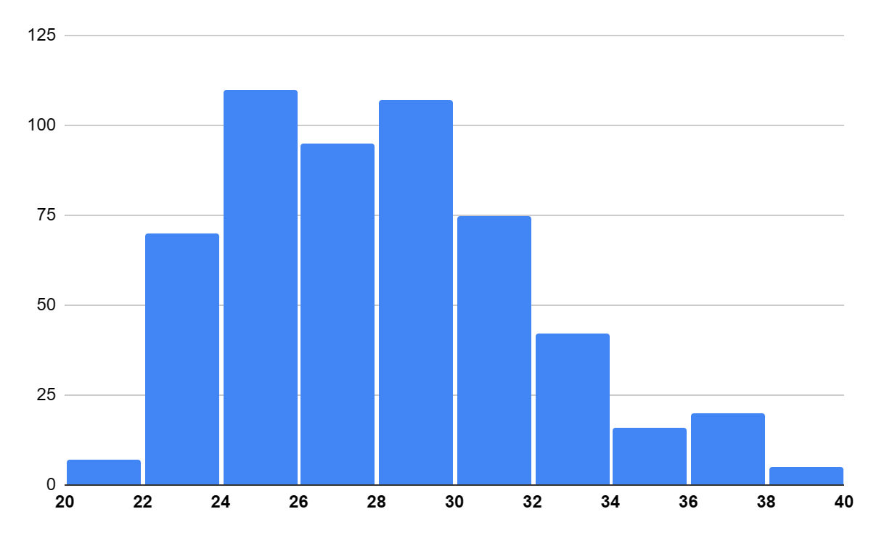
Chart 1: Age distribution of respondents
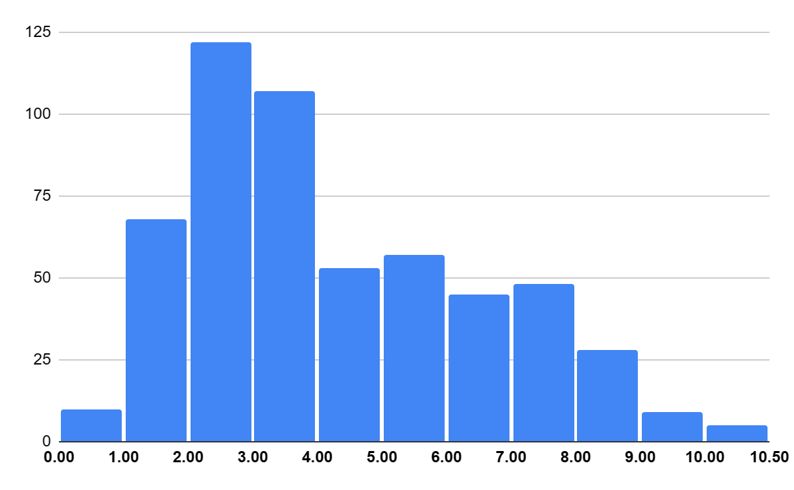
Chart 2: Duration of unsalaried work in years.
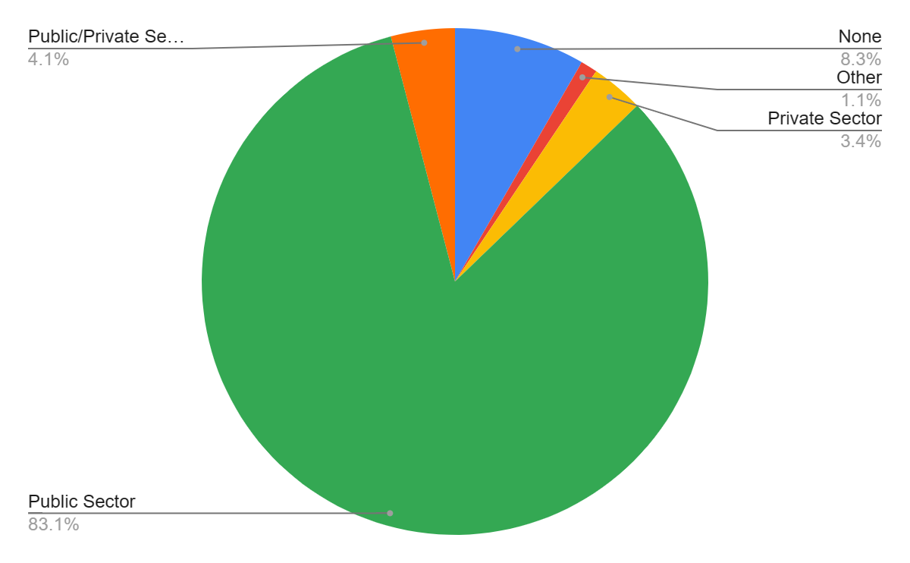
Chart 3: Expectations from voluntary work
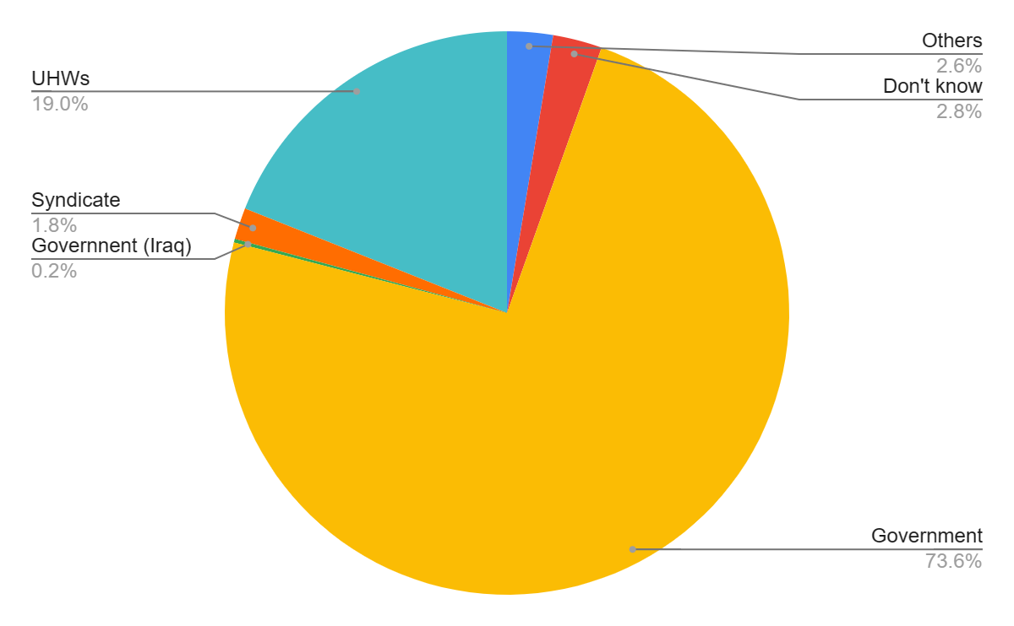
Chart 4: Who is responsible for UHW issues

