Title: Climate-driven succession in marine microbiome biodiversity and biogeochemical function
Authors: Alyse A. Larkin¹, Melissa L. Brock², Adam Fagan¹, Allison Moreno¹, Lauren Lees², Stacy Suarez Cham², Skylar Gerace¹, and Adam Martiny^{1,2}
¹Department of Earth System Science, University of California, Irvine,
²Department of Ecology and Evolutionary Biology, University of California, Irvine
Running title: Long-term ocean microbiome succession

Supplementary Information

Additional Sequencing Methods
31 metagenomic libraries were sequenced from samples collected in 2021. A Nextera DNA Flex Library Prep Kit (Illumina) was used to prepare sequence libraries using a low-volume methodology based on Adams et al. (2020). Tagmentation was performed with 25-500 ng of DNA in 5 µL reactions (1 µL bead-linked transposons, 1 µL tagmentation buffer,final volumes adjusted with nuclease-free water) incubated at 55°C for 15 m with a 100°C heated lid. A total of 1 µL tagment stop buffer was immediately added to each library then incubated at 37°C for 15 m with a 100°C heated lid. Libraries were placed on a 96-well magnetic plate until solutions were clear. Supernatant was discarded and bead-linked transposons were washed with a tagment wash buffer (20 µL) three times. Next, the bead-linked transposons were combined with PCR mix (2.75 µL nuclease-free water, 0.5 µL KAPA-PCR-F primer (AAT GAT ACG GCG ACC ACC G*A; 10 µM), 0.5 µL KAPA-PCR-R primer (CAA GCA GAA GAC GGC ATA CG*A; 10 µM), 2.5 µL custom Nextera DNA-style 8 bp unique dual index barcodes, and 6.25 µL KAPA KiFi HotStart ReadyMix (2X)). The I7 index sequence is 5′-CAA GCA GAA GAC GGC ATA CGA GAT [NNN NNN NN]G TCT CGT GGG CTC GG-3′, and the I5 index sequence is 5′-AAT GAT ACG GCG ACC ACC GAG ATC TAC AC[N NNN NNN N]TC GTC GGC AGC GTC-3′. PCR barcoding was performed using the following reaction: 72°C for 3 m, 98°C for 3 m, followed by 12 cycles of: 98°C for 45 s, 62°C for 30 s, 72°C for 2 m, and a final extension step at 72°C for 1 m. After PCR, libraries were placed on a magnetic stand until the supernatant was clear. The supernatant was then quantified using a Qubit dsDNA HS Assay kit and a Synergy 2 Microplate Reader and equimolar concentrations of each library were pooled.

A two-step magnetic bead selection protocol was used for size selection. First, 45 µL of pooled libraries were incubated at room temperature with 56 µL of sample purification beads and 29 µL of nuclease-free water for 5 m. Second, 120 µL of supernatant from the first reaction was incubated with 12 µL of sample purification beads at room temperature for 5 minutes. The supernatant was removed and sample purification beads were washed two times with 200 µL of 80% ethanol. A total of 32 µL of resuspension buffer was added to the purification beads and incubated in a water bath at 50°C for 5 m to ensure complete elution of the pooled library. Quantification of the final library was performed using a Qubit dsDNA HS Assay and Qubit fluorometer and via KAPA qPCR. A 2100 Bioanalyzer high sensitivity DNA trace was used to determine fragment size distribution. Finally, the pooled library was sequenced (150 bp, paired-end) on one lane of an Illumina NovaSeq 6000 S4 flow cell. Sequencing produced a total of 0.259 Tbp with an average of 8.36 Gbp/sample.

References
Adams E, Wandro S, Avelar-Barragan J, Oliver A, and K Whiteson. 2020. Low Volume Methodology for Nextera DNA Flex Library Prep Kit (96 Samples). protocols.io: https://dx.doi.org/10.17504/protocols.io.be6rjhd6
Figures

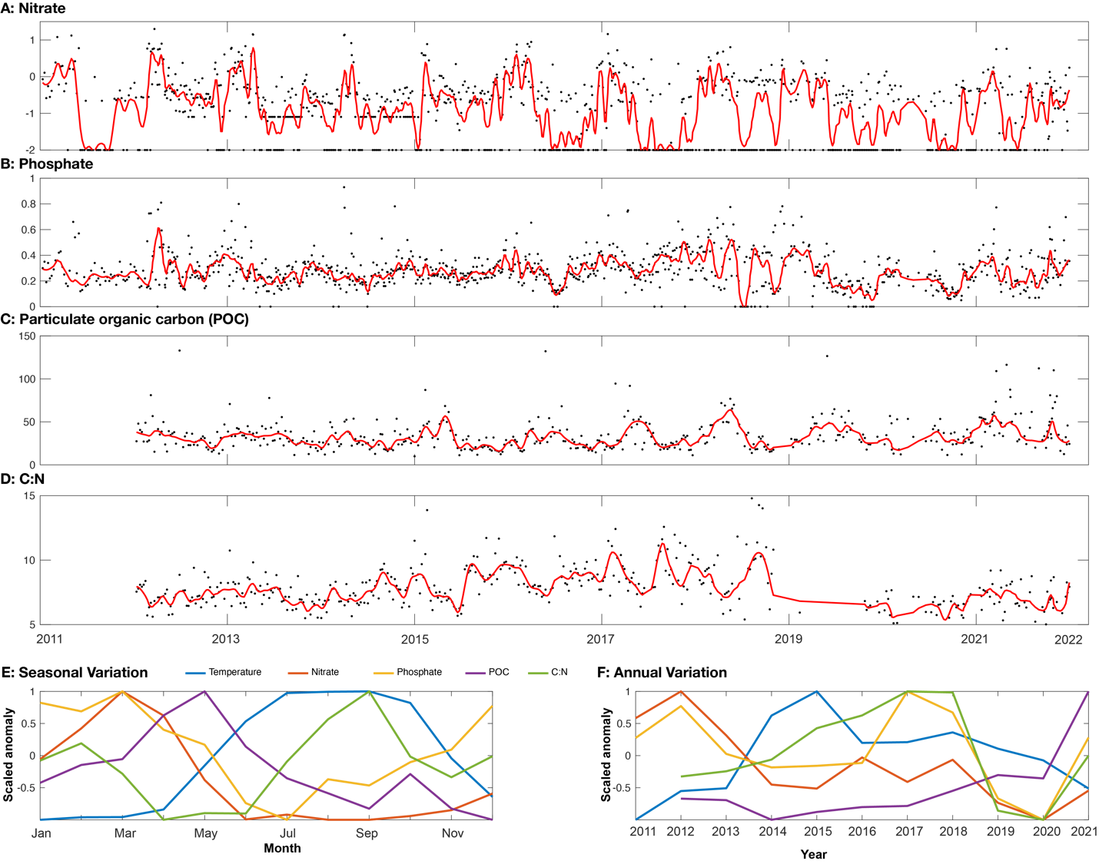
Extended Data Fig. 1. Additional environmental dynamics at MiCRO. A: Nitrate (µM). B: Phosphate (µM). C: Particulate organic carbon (POC, µM). D: Particulate organic carbon-to-nitrogen ratio (C:N, mol:mol). E: Monthly anomaly in temperature, nitrate and phosphate, POC, and C:N. F: 2011 to 2021 annual anomalies in temperature, nitrate and phosphate, POC, and C:N. Anomalies were scaled from -1 to 1. Red lines represent a moving average using ‘Robust Loess’ with a window size = 15.

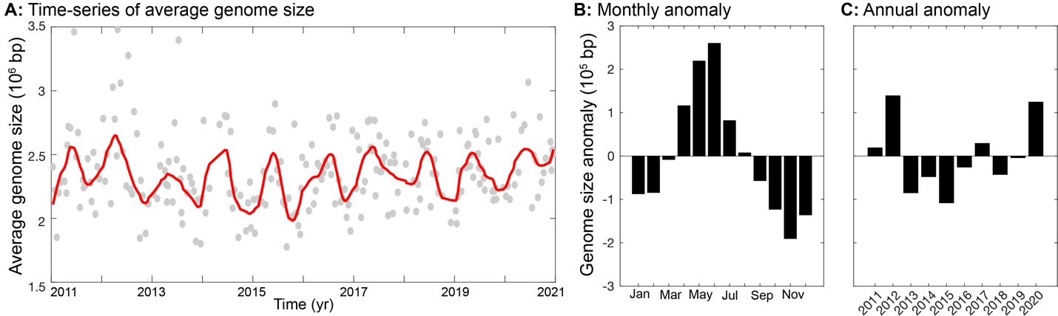

Extended Data Fig. 2. Seasonal and interannual changes in average genome size. A: Time-series of average genome size. Red line represents the moving average calculated using ‘Robust Loess’ and window size = 20. B: Monthly anomaly in genome size. C: Annual anomaly in genome size.

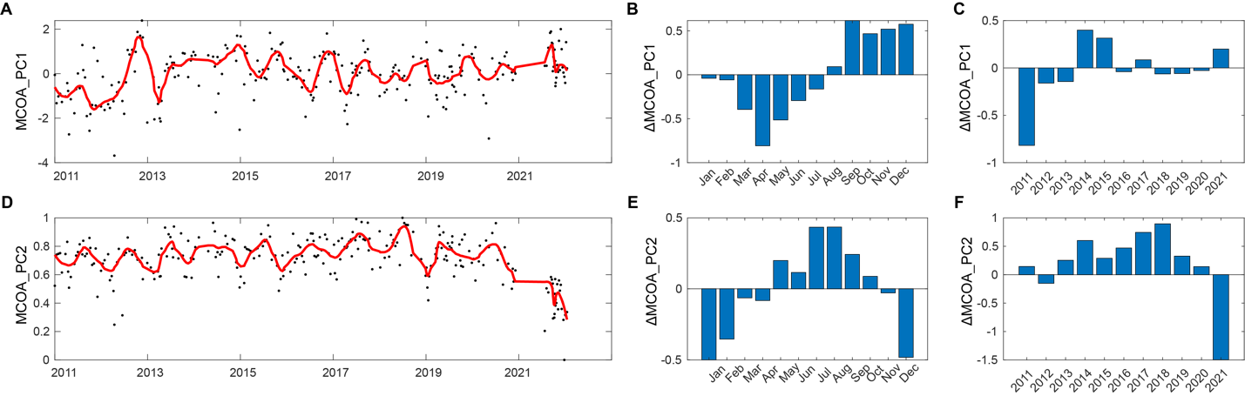

Extended Data Fig. 3. Seasonal and long-term succession in microbial community using Multi-table Co-Inertia Analysis (MCOA). A: Time-series of the first principal component (MCOA_PC1, 35% variance). Monthly (B) and interannual (C) anomaly in MCOA_PC1. D: Time-series of the second principal component (MCOA_PC2, 16% variance). Monthly (E) and interannual (F) anomaly in MCOA_PC2. The MCOA analysis includes gene annotations from KEGG, COG, PFam, and TIGRfam as well as taxonomic variation.

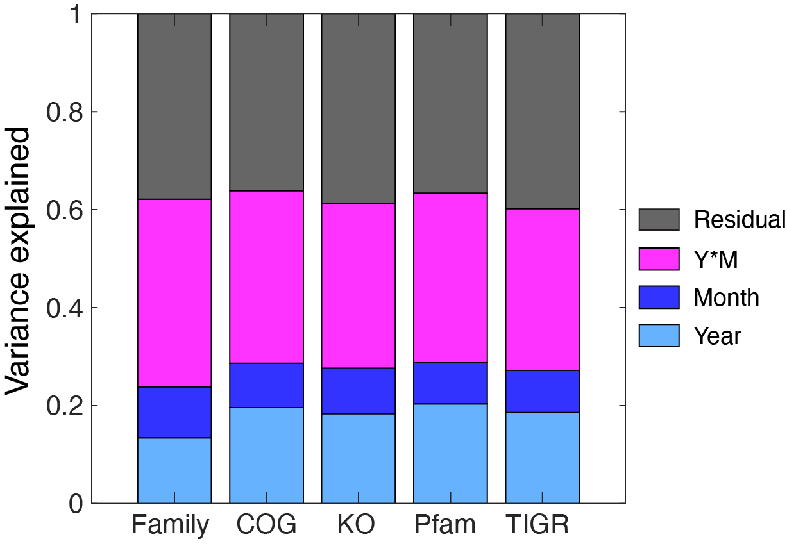

Extended Data Fig. 4. Community compositional variance attributed to interannual and seasonal variation. Compositional variance is estimated using PERMANOVA with sampling ‘Year’ and ‘Month’ as factors plus interactions. Composition was estimated using the frequency of taxonomic groups at family level as well as functional genes classified with COG, KEGG Orthologs, Pfam, or TIGR families. The mean compositional variance attributed to interannual plus seasonal changes was 62%.
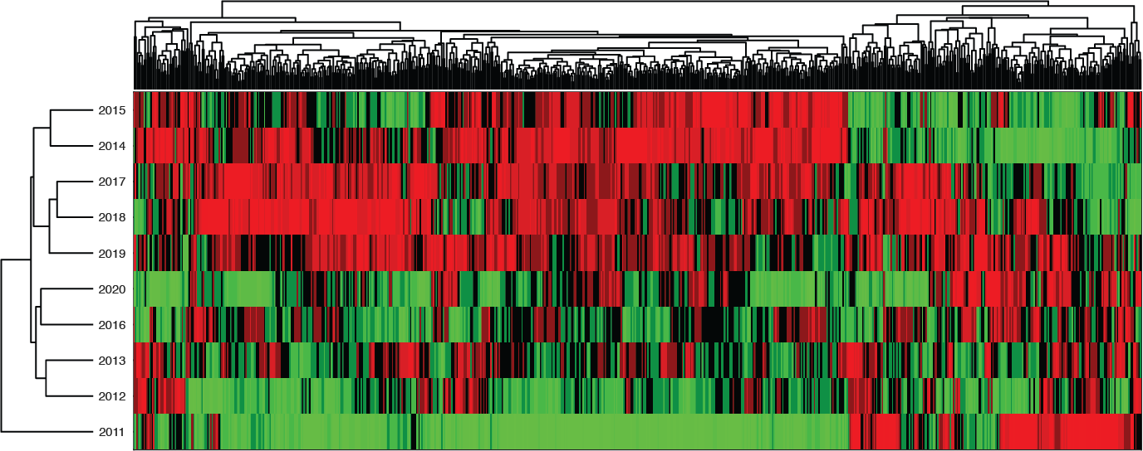

Extended Data Fig. 5. Clustergram of interannual microbiome potential. The annual anomaly for KEGG ortholog was estimated and then grouped using hierarchical clustering analysis. Green indicates relatively more frequent, and red indicates relatively less frequent genes.

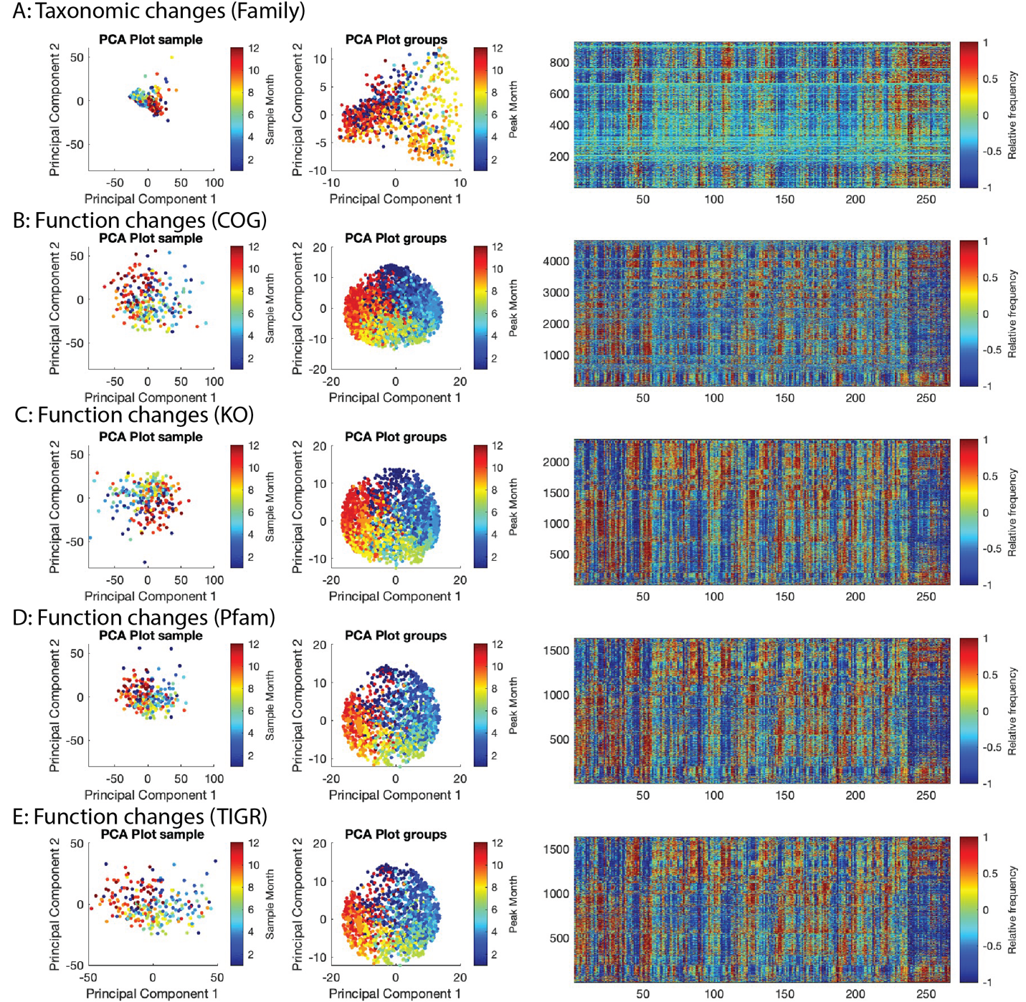

Extended Data Fig. 6. Seasonal and long-term succession in microbial community functional potential across annotation systems. Each row includes the temporal dynamics of community taxonomy or functional potential, where sample similarity was estimated from Z-score normalized relative abundances using PCA (each point represents a sample); the integrated community taxonomic or functional similarity using multi-table co-inertia analysis (MCOA) (each point represents a gene or taxa); and, the time-series of taxa or genes annotated with an ortholog system, where the frequency of each annotation was Z-score normalized across time.

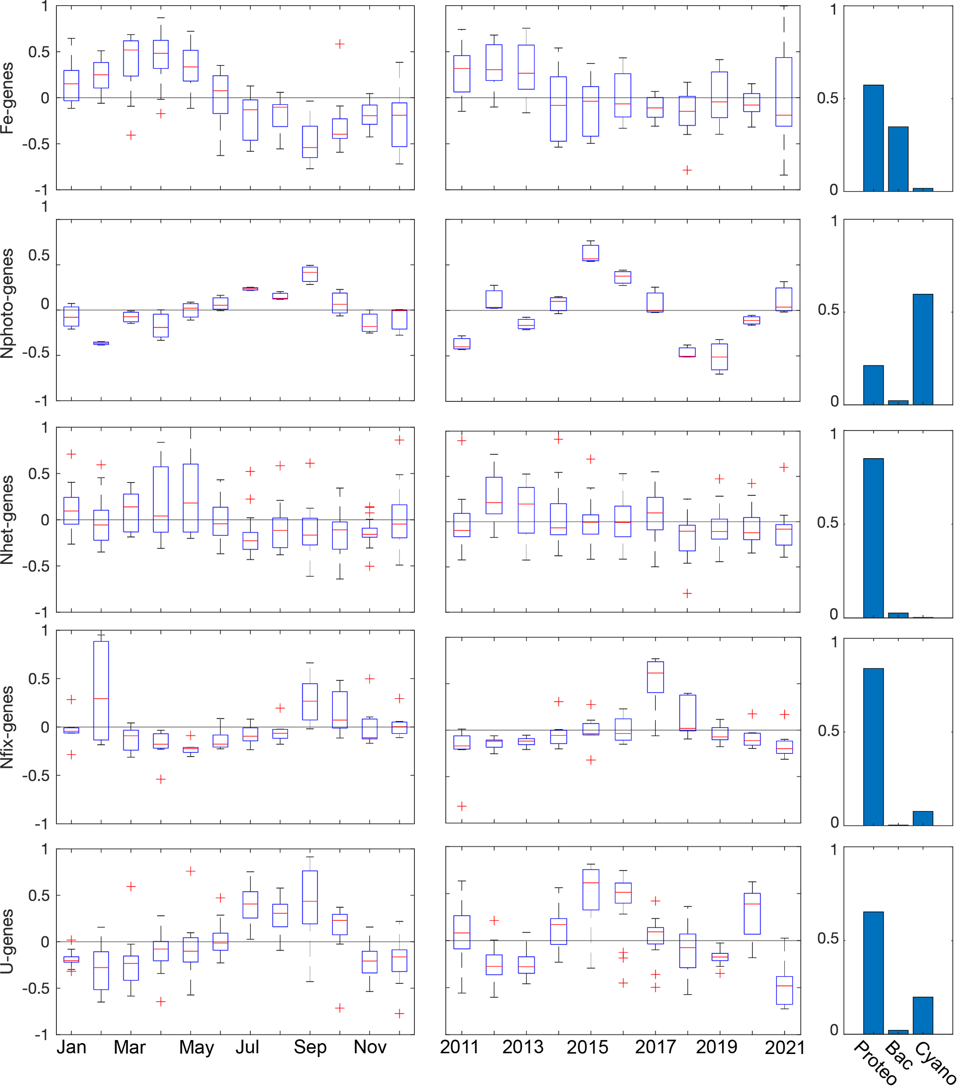
Extended Data Fig. 7. Detailed analysis of nutrient stress genes (Fe and N) and their phylogenetic origin.

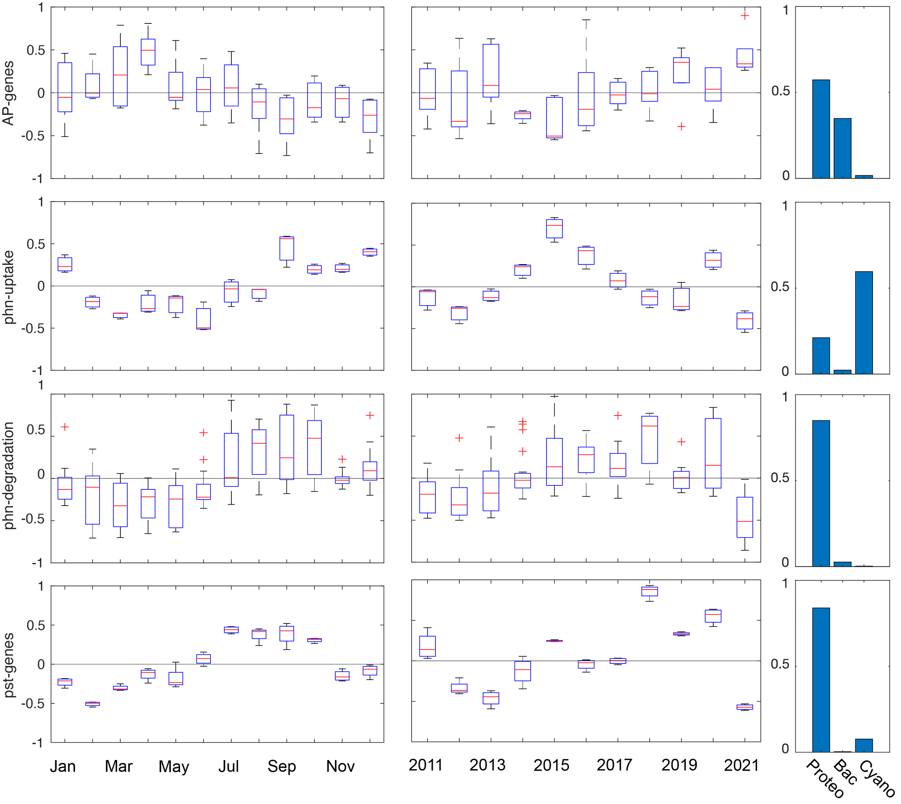

Extended Data Fig. 8. Detailed analysis of nutrient stress genes (P) and their phylogenetic origin.

