Supplementary Material for
Evaluation of extreme precipitation events as simulated by CMIP6 models over Central Africa: spatial variability
Crépin K. Komelo^{1,2,∗}, Thierry C. Fotso-Nguemo^{3,4}, Zakariahou Ngavom^{1,4},
Abdon K. Dessacka^{1,2}, Thierry N. Taguela^{1,5}, Zéphirin D. Yepdo³, Jean P. Nghonda^{3,6},
Arona Diedhiou^{4,7}, David Monkam⁸ and Clément Tchawoua⁹
¹Laboratory for Environmental Modelling and Atmospheric Physics (LEMAP), Department of Physics,
Faculty of Science, University of Yaounde 1, P.O. Box 812 Yaounde, Cameroon
²Department of Physics, Faculty of Science, University of Bangui, P.O. Box 1450 Bangui, Central African Republic
³Climate Change Research Laboratory (CCRL), National Institute of Cartography,
P.O. Box 157 Yaounde, Cameroon
⁴Laboratoire Mixte International “Nexus Climat-Eau-Énergie-Agriculture en Afrique de l’Ouest et Services Climatiques” (LMI NEXUS), Université Félix Houphouët-Boigny, P.O. Box 463 Abidjan, Côte d’Ivoire
⁵Department of Earth and Environmental Sciences, University of Illinois Chicago, IL, USA
⁶Department of Geography, Higher Teacher Training College, University of Maroua,
P.O. Box 55 Maroua, Cameroon
⁷University of Grenoble Alpes, IRD, CNRS, Grenoble INP, IGE, 38000 Grenoble, France
⁸Department of Physics, Faculty of Science, University of Douala, P.O. Box 24157 Douala, Cameroon
⁹Laboratory of Mechanics, Department of Physics, Faculty of Science, University of Yaounde 1,
P.O. Box 812, Yaounde, Cameroon

Contents of this file
Table S1
Figures S1 to S5

*Corresponding author: Crépin K. Komelo (crepinjuniorkomelo@gmail.com)
Table S1: Summary of the sixteen GCMs used in the framework of the CMIP6 initiative
 | Model name | Institute ID | Resolution  (Lon $×$Lat) | References
1 | ACCESS-CM2 | Commonwealth Scientific and Industrial Research Organization, Aspendale, Australia | 1.88° $×$ 1.25° | Bi et al. (2020)
2 | BCC-CSM2-MR | Beijing Climate Center, Beijing, China | 1.13° $×$ 1.13° | Wu et al. (2020)
3 | CanESM5 | Canadian Centre for Climate Modelling and Analysis, Victoria, Canada | 2.81° $×$ 2.81° | Swart et al. (2019)
4 | CESM2 | National Center for Atmospheric Research, Boulder, USA | 1.25° $×$0.94° | Danabasoglu (2019a)
5 | CESM2-WACCM | National Center for Atmospheric Research, Boulder, USA | 1.25° $×$ 0.94° | Danabasoglu (2019b)
6 | E3SM-2-0 | Department of Energy's Energy Exascale Earth System Model, USA | 1.00° $×$ 1.00° | Golaz et al. (2022)
7 | EC-Earth3 | EC-Earth Consortium | 0.70° $×$0.70° | Döscher et al. (2021)
8 | GFDL-ESM4 | Geophysical Fluid Dynamics Laboratory, Princeton, USA | 1.25° $×$ 1.00° | Horowitz et al. (2018)
9 | HadGEM3-GC31-LL | Met Office Hadley Centre, Exeter, UK | 1.88° $×$ 1.25° | Williams et al. (2021)
10 | INM-CM5-0 | Institute for Numerical Mathematics, Moscow, Russia | 2.00° $×$1.50° | Volodin et al. (2019)
11 | IPSL-CM6A-LR | Institut Pierre Simon Laplace, Paris, France | 2.50° $×$ 1.27° | Boucher et al. (2020)
12 | MIROC6 | The University of Tokyo, Chiba, Japan | 1.41° $×$1.41° | Tatebe et al. (2019)
13 | MPI-ESM1-2-LR | Max Planck Institute for Meteorology, Hamburg, Germany | 1.88° $×$1.88° | Schupfner et al. (2021)
14 | MRI-ESM2-0 | Meteorological Research Institute, Tsukuba, Japan | 1.13° $×$1.13° | Yukimoto et al. (2019)
15 | NorESM2-LM | Norwegian Meteorological Institute, Oslo, Norway | 2.50° $×$ 1.89° | Seland et al. (2019)
16 | UKESM1-0-LL | Met Office Hadley Centre, Exeter, UK | 1.88° $×$ 1.25° | Tang et al. (2019)

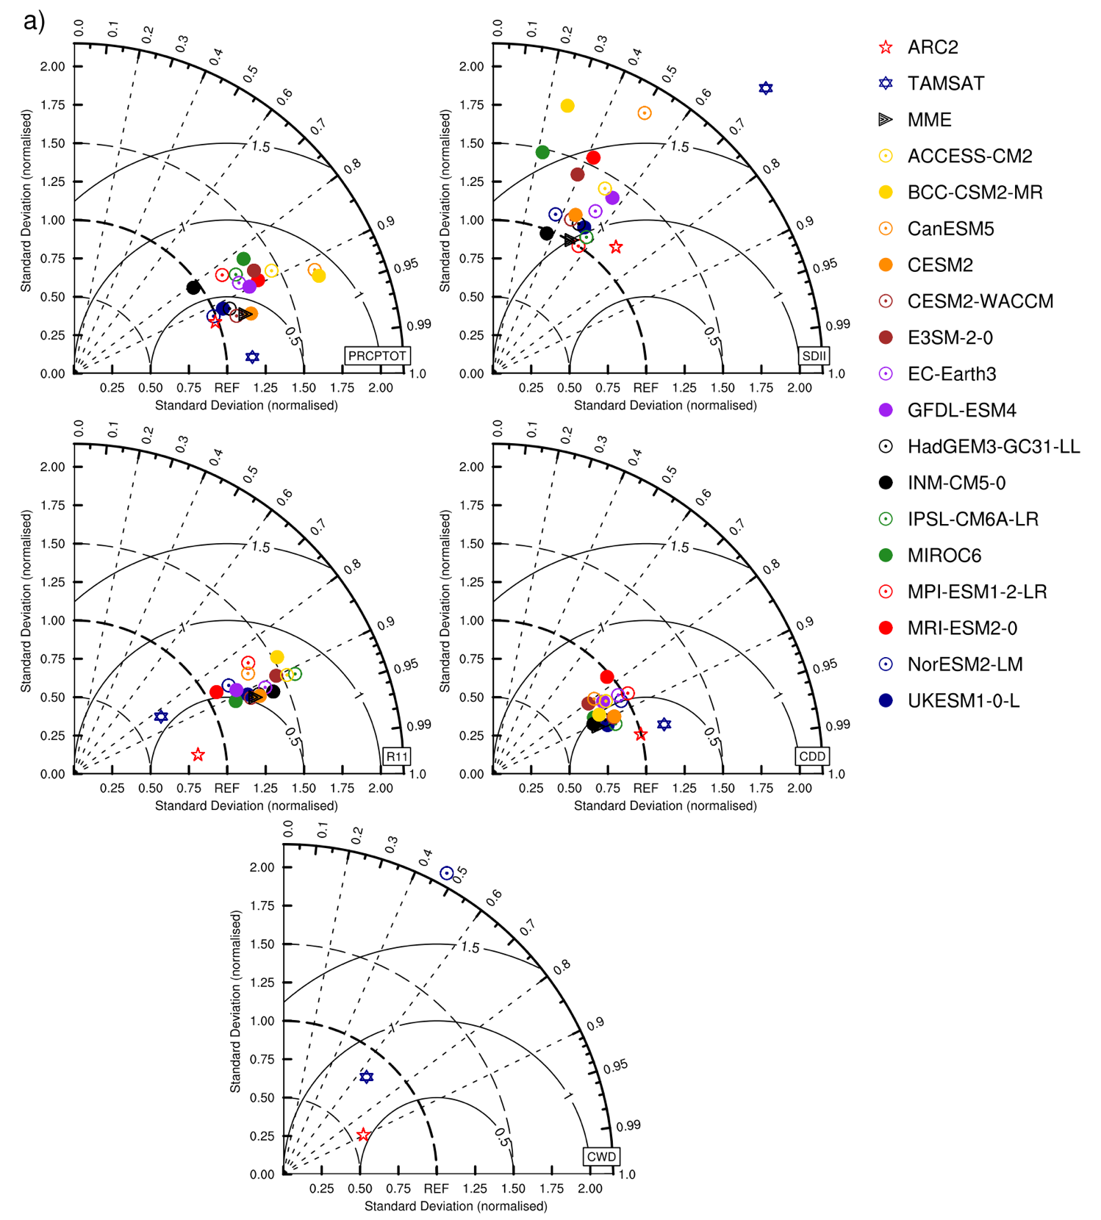
Figure S1: Taylor diagram analysis showing the annual values for a duration and intensity-based indices i.e., total wet-day precipitation amount (PRCPTOT), simple daily intensity index (SDII), wet-day precipitation frequency (RR1), maximum consecutive dry days (CDD) and maximum consecutive wet days (CWD); and b intense precipitation indices i.e., maximum consecutive 5-day precipitation amount (RX5DAY), maximum consecutive 1-day precipitation amount (RX1DAY), 95th percentile of precipitation (R95), total wet-day precipitation amount above the 95th percentile (R95PTOT) and total wet-day precipitation frequency above the 95th percentile (R95P), derived from ARC2, TAMSAT, MME and individual CMIP6 simulation members, averaged over the Central African domain, during the period 1985-2014. CHIRPS has been considered here as reference dataset
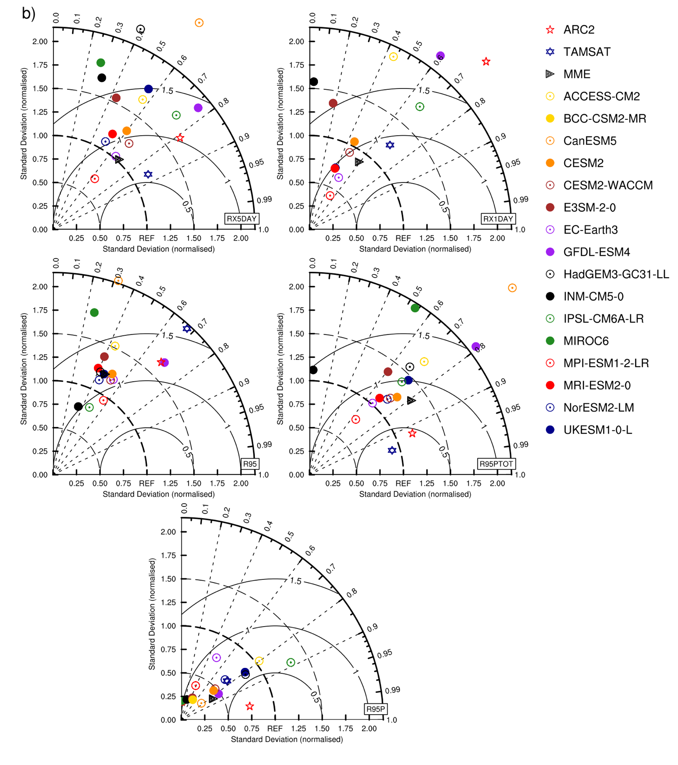
Figure S1: (continued)

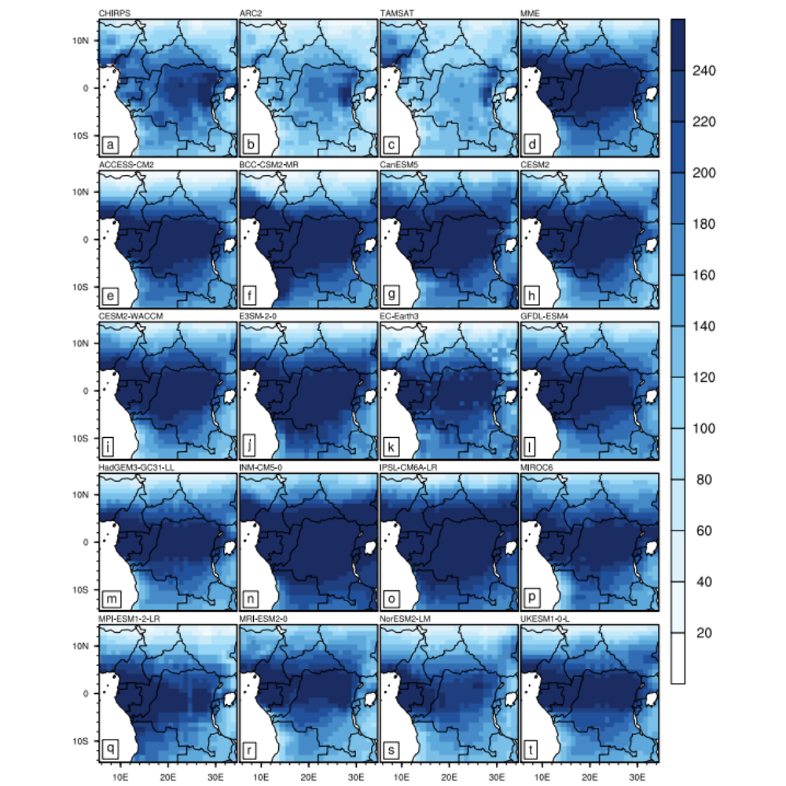
Figure S2: Spatial distribution of the annual wet-day precipitation frequency (RR1; in day), during the period 1985-2014, derived from a CHIRPS, b ARC2, c TAMSAT, d MME and e-t individual CMIP6 simulation members

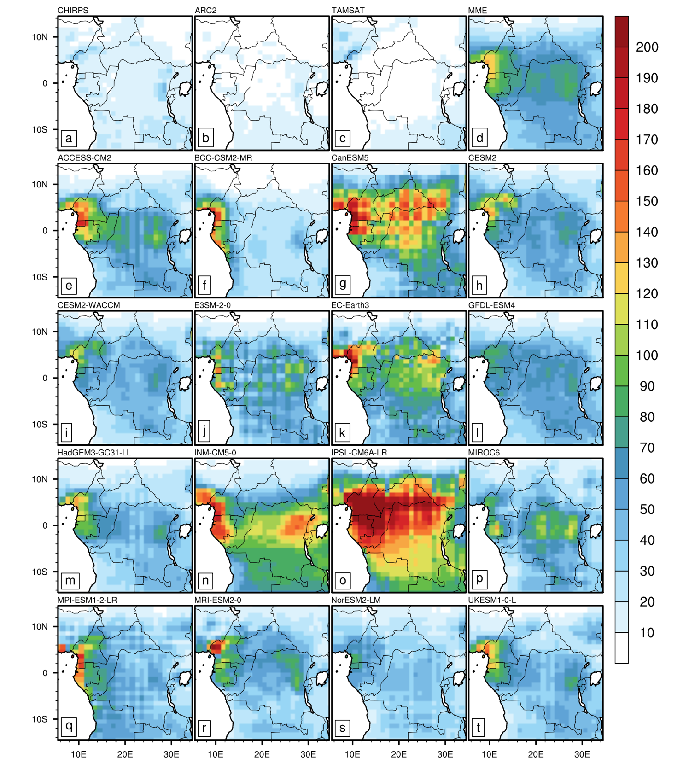
Figure S3: Spatial distribution of the annual maximum consecutive wet days (CWD; in day), during the period 1985-2014, derived from a CHIRPS, b ARC2, c TAMSAT, d MME and e-t individual CMIP6 simulation members

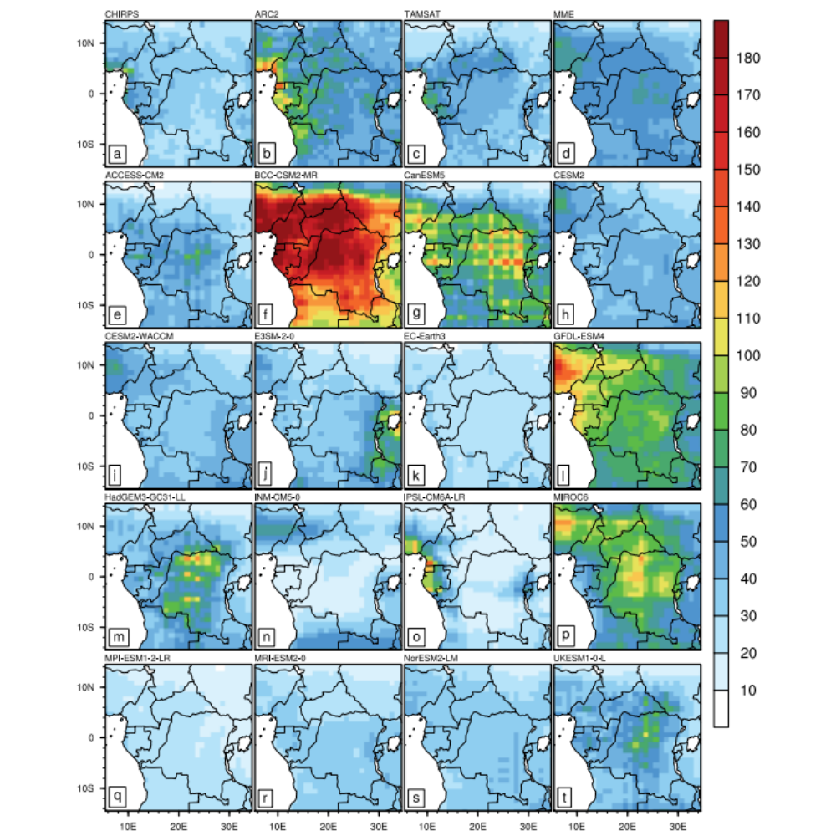
Figure S4: Spatial distribution of the annual maximum consecutive 1-day precipitation amount (RX1DAY; in mm), during the period 1985-2014, derived from a CHIRPS, b ARC2, c TAMSAT, d MME and e-t individual CMIP6 simulation members

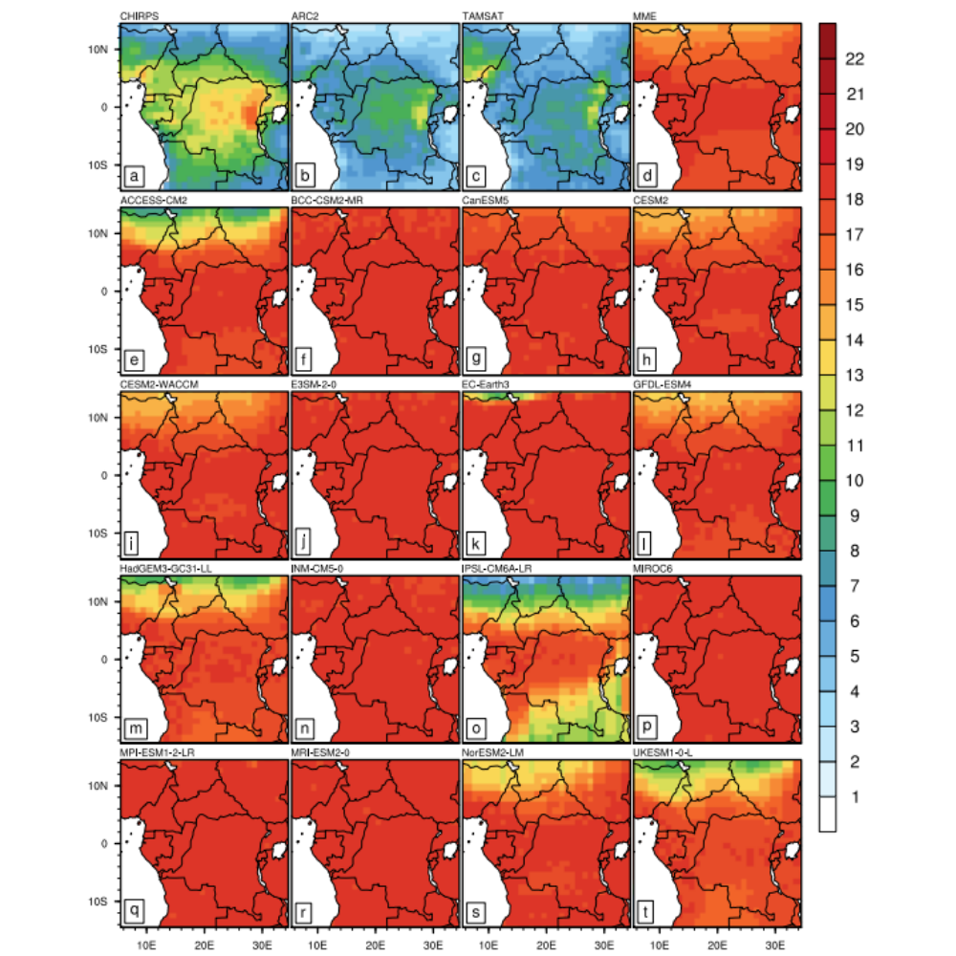
Figure S5: Spatial distribution of the annual total wet-day precipitation frequency above the 95th percentile (R95P; in day), during the period 1985-2014, derived from a CHIRPS, b ARC2, c TAMSAT, d MME and e-t individual CMIP6 simulation members

References
Bi, D., Dix, M., Marsland, S., O’farrell, S., Sullivan, A., Bodman, R., ... & Heerdegen, A. (2020). Configuration and spin-up of ACCESS-CM2, the new generation Australian community climate and earth system simulator coupled model. Journal of Southern Hemisphere Earth Systems Science, 70, 225-251. doi:10.1071/ES19040
Boucher, O., Servonnat, J., Albright, A. L., Aumont, O., Balkanski, Y., Bastrikov, V., ... & Vuichard, N. (2020). Presentation and evaluation of the IPSL‐CM6A‐LR climate model. Journal of Advances in Modeling Earth Systems, 12, e2019MS002010. doi:10.1029/2019MS002010
Danabasoglu, G. (2019a). NCAR CESM2 model output prepared for CMIP6 LUMIP. World Data Center for Climate (WDCC) at DKRZ. https://www.wdc-climate.de/ui/entry?acronym=C6_4625445
Danabasoglu, G. (2019b). IPCC DDC: NCAR CESM2-WACCM model output prepared for CMIP6 CMIP. World Data Center for Climate (WDCC) at DKRZ. https://doi.org/10.26050/WDCC/AR6.C6CMNRCESWA
Döscher, R., Acosta, M., Alessandri, A., Anthoni, P., Arneth, A., Arsouze, T., ... & Zhang, Q. (2021). The EC-earth3 Earth system model for the climate model intercomparison project 6. Geoscientific Model Development Discussions, 2021, 1-90. doi:10.5194/gmd-15-2973-2022
Golaz, J. C., Van Roekel, L. P., Zheng, X., Roberts, A. F., Wolfe, J. D., Lin, W., ... & Bader, D. C. (2022). The DOE E3SM Model Version 2: Overview of the physical model and initial model evaluation. Journal of Advances in Modeling Earth Systems, 14, e2022MS003156. doi:10.1029/2022MS003156
Horowitz, L. W., John, J. G., Blanton, C., McHugh, C., Radhakrishnan, A., Rand, K., ... & Zeng, Y. (2018). NOAA-GFDL GFDL-ESM4 model output prepared for CMIP6 DAMIP hist-aer. World Data Center for Climate (WDCC) at DKRZ. https://www.wdc-climate.de/ui/entry?acronym=C6_4837584
Schupfner, M., Wieners, K. H., Wachsmann, F., Milinski, S., Steger, C., Bittner, M., ... & Roeckner, E. (2021). DKRZ MPI-ESM1. 2-LR model output prepared for CMIP6 ScenarioMIP. https://www.wdc-climate.de/ui/entry?acronym=C6_4076897
Seland, Ø., Bentsen, M., Oliviè, D. J. L., Toniazzo, T., Gjermundsen, A., Graff, L. S., ... & Schulz, M. (2019). NCC NorESM2-LM model output prepared for CMIP6 DAMIP. World Data Center for Climate (WDCC) at DKRZ. https://www.wdc-climate.de/ui/entry?acronym=C6_4653209
Swart, N. C., Cole, J. N., Kharin, V. V., Lazare, M., Scinocca, J. F., Gillett, N. P., ... & Sigmond, M. (2019). CCCma CanESM5 model output prepared for CMIP6 FAFMIP. World Data Center for Climate (WDCC) at DKRZ. https://www.wdc-climate.de/ui/entry?acronym=C6_4136846
Tang, Y., Rumbold, S., Ellis, R., Kelley, D., Mulcahy, J., Sellar, A., ... & Jones, C. (2019). MOHC UKESM1. 0-LL model output prepared for CMIP6 CMIP. World Data Center for Climate (WDCC) at DKRZ. https://www.wdc-climate.de/ui/entry?acronym=C6_4662099

Tatebe, H., Ogura, T., Nitta, T., Komuro, Y., Ogochi, K., Takemura, T., ... & Kimoto, M. (2019). Description and basic evaluation of simulated mean state, internal variability, and climate sensitivity in MIROC6. Geoscientific Model Development, 12, 2727-2765. doi:10.5194/gmd-12-2727-2019
Volodin, E., Mortikov, E., Gritsun, A., Lykossov, V., Galin, V., Diansky, N., ... & Emelina, S. (2019). IPCC DDC: INM INM-CM5-0 model output prepared for CMIP6 ScenarioMIP ssp370. World Data Center for Climate (WDCC) at DKRZ. https://doi.org/10.26050/WDCC/AR6.C6SPINIC0s370
Williams, C., Lunt, D., Singarayer, J., & Guarino, M. V. (2021). CMIP6 PMIP NERC HadGEM3-GC31-LL lig127k. World Data Center for Climate (WDCC) at DKRZ. https://doi.org/10.26050/WDCC/AR6.C6PMNEHGL
Wu, T., Yu, R., Lu, Y., Jie, W., Fang, Y., Zhang, J., ... & Shu, Q. (2020). BCC-CSM2-HR: a high-resolution version of the Beijing Climate Center Climate System Model. Geoscientific Model Development Discussions, 2020, 1-64. doi:10.5194/gmd-14-2977-2021
Yukimoto, S., Koshiro, T., Kawai, H., Oshima, N., Yoshida, K., Urakawa, S., ... & Adachi, Y. (2019). MRI MRI-ESM2. 0 model output prepared for CMIP6 CMIP. World Data Center for Climate (WDCC) at DKRZ. https://www.wdc-climate.de/ui/entry?acronym=C6_5243961

