Phase-separation of Cellulose from Ionic Liquid upon Cooling: Preparation of Microsized Particles

Jingwen Xia, Alistair W. T. King, Ilkka Kilpeläinen*, Vladimir Aseyev*
*Corresponding authors: ilkka.kilpeläinen@helsinki.fi, vladimir.aseyev@helsinki.fi

Department of Chemistry, University of Helsinki, A.I. Virtasen aukio 1, FIN-00560 HY Helsinki, Finland

List of abbreviations
[C₂C₁im][OAc] 1‐ethyl‐3‐methylimidazolium acetate
[P₄₄₄₁][MeOCOO] tributyl(methyl)phosphonium methylcarbonate
[P₄₄₄₁][OAc] tributyl(methyl)phosphonium acetate
[P₄₄₄₄][OAc] tetrabutylphosphonium acetate
AcOH acetic acid
AGU anhydroglucose unit
CI crystallinity index
D bond dipole moment
DLS dynamic light scattering
DMI 1,3-dimethyl-2-imidazolidinone
DMPU 1,3-dimethyl-3,4,5,6-tetrahydro-2(1H)-pyrimidinone
DMSO dimethyl sulfoxide
DSC differential scanning calorimetry
Eq equivalent
EtOH ethanol
GVL γ-valerolactone
IL(s) ionic liquid(s)
IPA isopropyl alcohol
MCC microcrystalline cellulose
MeOH methanol

mmol milimolar

NMR nuclear magnetic resonance
OES organic electrolyte solution
RT room temperature
T_{cp} clouding point temperature
UCST upper-critical solution temperature
WAXS wide angle X-ray scattering

Experimental: Preparation of [P₄₄₄₁][OAc] ionic liquid
Tributyl(methyl)phosphonium acetate ([P₄₄₄₁][OAc]) was synthesized by means of metathesis reaction from tributyl(methyl)phosphonium methylcarbonate ([P₄₄₄₁][MeOCOO], 70 wt.% in methol, Ion-Li-Tec GmbH). 73.10 g (250 mmol, 1 Eq.) of [P₄₄₄₁][MeOCOO] and 14.30 ml (250 mmol, 1 Eq.) of acetic acid (AcOH) were mixed and stirred in 250 ml flask at room temperature overnight. Methanol (MeOH) and CO₂ released from the reaction as byproducts. Next day, MeOH was removed from [P₄₄₄₁][OAc] under reduced pressure at 42 ᵒC and flushed with argon.
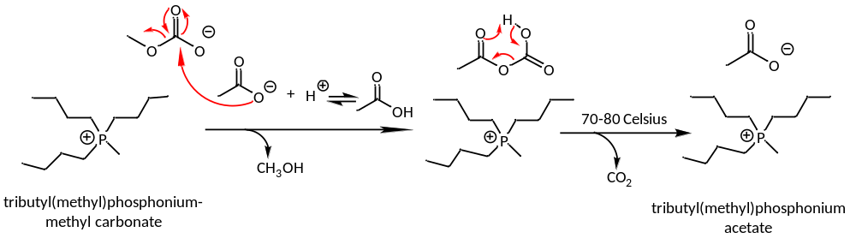
Scheme 1. Synthesis of [P₄₄₄₁][OAc]: Metathesis reaction of [P₄₄₄₁][MeOCOO] with acetic acid.

Regeneration of cellulose particles from [P₄₄₄₁][OAc]:DMSO and [P₄₄₄₁][OAc]:GVL with 70:30 w/w composition.
Solution of MCC in these OESs were prepared using the procedures described in Experimental of the main text and regeneration of cellulose at room temperature in the form of particles was investigated. The typical concentration of the cellulose solutions was 5 wt.%, which was higher than that of [P₄₄₄₄][OAc]:DMSO. It was also possible to obtain the particles from solutions with cellulose concentration below 5 wt.%. However, time required to form visible particles in solutions lower than 3 wt.% was too long; such solutions remained clear at RT for at least 2 weeks until micro-sized particles were formed. Particles formed in these solutions on the earlier stages of the phase separation had size smaller than a wavelength of light and cannot be seen with an optical microscope. Unfortunately, light scattering measurements for the particles detection were not successful: the viscosity of the cellulose solutions was high and intensity fluctuations were strong but slow, which did not allow to reach proper averaging of the LS intensity in time and space. Other ways to visualize the cellulose material after phase separation below 3 wt.% were not fruitful either.

To explain this phenomenon we need to note that the dissolution capacity and therefore thermodynamic quality of the [P₄₄₄₁][OAc] based OESs is better than that of [P₄₄₄₄][OAc]:DMSO with the same composition. Better thermodynamic quality also means the broader range of temperature, where MCC is soluble in [P₄₄₄₁][OAc]:DMSO. One can say that [P₄₄₄₁][OAc]:DMSO at RT is “less poor” solvent for cellulose in comparison to [P₄₄₄₄][OAc]:DMSO with the same concentration and the process of phase separation is slower. Accordingly, increasing the cellulose concentration promotes intermolecular interactions, increases solution viscosity and thus favors regeneration in the form of macroscopic gel, whereas decreasing the cellulose concentration below 3 wt.% improves stability of solutions against phase separation.

Particles regenerated from [P₄₄₄₁][OAc]:DMSO and [P₄₄₄₁][OAc]:GVL have an irregular form, see Figure S1. These solutions are less viscous in comparison to similar solutions in [P₄₄₄₄][OAc]:DMSO. It seems that cellulose chains first aggregate and form spherical particles to minimize their surface area under thermodynamically poor condition. Then they associate together and form secondary structures, heterogeneous gel-like clusters. The mechanism of aggregation in [P₄₄₄₁][OAc]:DMSO and in [P₄₄₄₁][OAc]:GVL seems to be similar. Thus spherical inhomogeneities in the clusters are smaller in [P₄₄₄₁][OAc]:GVL and the clusters are denser than those formed in [P₄₄₄₁][OAc]:DMSO after cooling and equilibrated at RT for 1 week at RT. Further experiments were performed on the particles regeneration from [P₄₄₄₁][OAc]:DMSO, which yields larger particles.

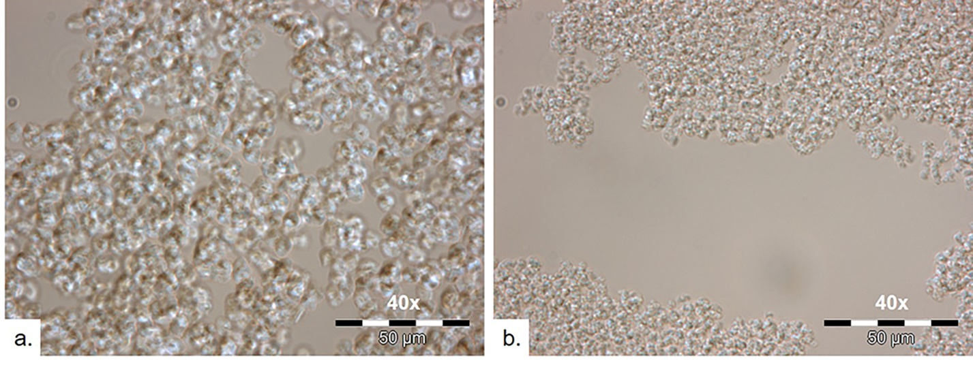
Figure S1. Regenerated cellulose from 5.0 wt.% solution in [P₄₄₄₁][OAc]:DMSO (a) and in [P₄₄₄₁][OAc]:GVL (b) with 70:30 w/w after 1 week equilibration at RT.

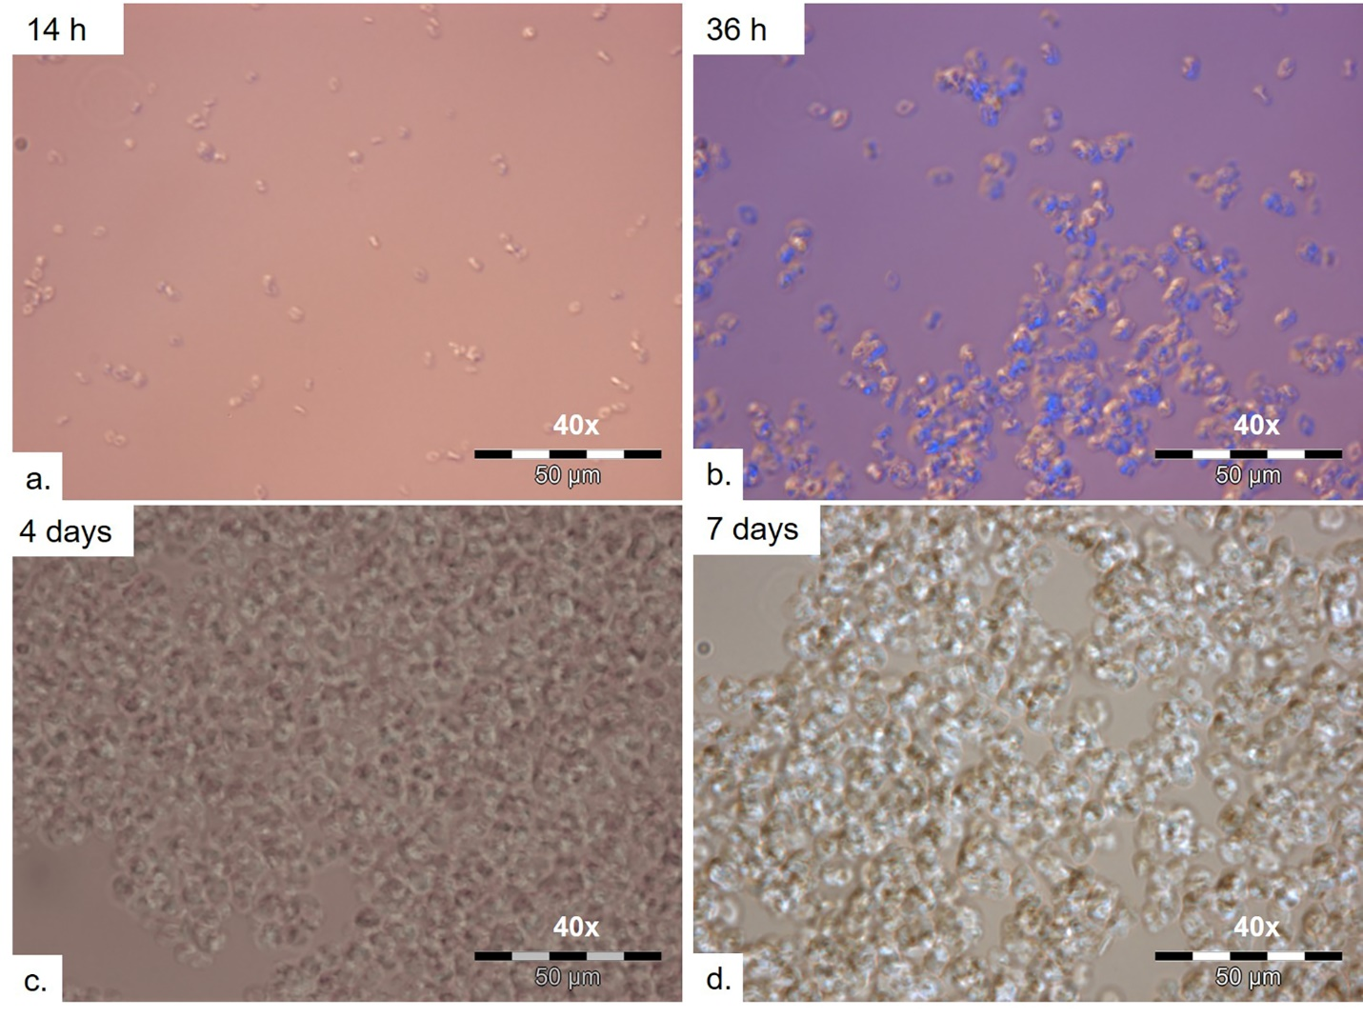
Figure S2. Regeneration of cellulose from 5.0 wt.% solution in [P₄₄₄₁][OAc]:DMSO observed at RT at different times.

Formation of the particles in [P₄₄₄₁][OAc]:DMSO is a time dependent process. Figure S2 shows photos that are taken from the 5.0 wt.% solution at RT at several equilibration times. This way we followed the particles growth inside the vial but not on the slide, took new samples for microscopy from the same vial. Special care was taken to minimize the effect of moisture and air during storage within 7 days. Particles of diameter less than 5 μm can already be observed 14 h after the solution was taken from 120 °C to RT (Figure S2a). The particles gradually grow larger and reach 8 μm after 36 hours of equilibration (Figure S2b). After 4 days, the particles of 10 μm in diameter are formed (Figure S2c). The diversity of the particles becames more narrow with time. Growth of the particles stops after 4 days (Figure S2d). Shape of the particles and the struclure of the clusters formed by the particles also remains the same.

Extraction of dried product
Several solvents were tested for extraction of regenerated cellulose from [P₄₄₄₁][OAc]:DMSO and washing, i.e. ethanol, water, acetone, acetonitrile, formamide, and pyridine. None of them can break the clusters apart and keep the particles separated from each other during and after washing. The particles remain aggregated and even form white fibers when the solvent is added. Pyridine is an exception: large amount of pyridine (5 times compared to the cellulose solution) make cellulose particles swell. Failure of washing the OESs out is another reason why we consider [P₄₄₄₄][OAc]:DMSO as the most promising solvent for our goal, i.e. preparation of individual micro particles of regular shape and size.

Regeneration of cellulose from OES with less appropriate compositions
Results of the successful cellulose regeneration from [P₄₄₄₄][OAc]:DMSO (70:30 w/w) are presented in the main text. Here we present for comparison the results obtained in other solvent compositions but similar experimental conditions.

Regeneration in [P₄₄₄₄][OAc]:DMSO of various solvent compositions was followed by means of optical microscopy (see Figure S3, S4, S5, S6). Experiments confirm that the thermodynamic quality of [P₄₄₄₄][OAc]:DMSO (60:40 w/w) is better than for the other OESs studied, which is in line with its high dissolution capacity. Most of the test were performed on 2.0 wt.% and some on 3.0 wt.%. Material regenerated from of 3.0 wt.% solution is of poor quality: particles are polydisperse, interconnected and their shape cannot be defined, see Figure S3. Decrease in the cellulose concentration down to 2.0 wt.% means less intermolecular interaction on one hand but lower T_{cp} and therefore better solution quality at 20 °C on the other hand. Accordingly, the solution remains clear during 72 h and then forms loose gel, see Figure S4.

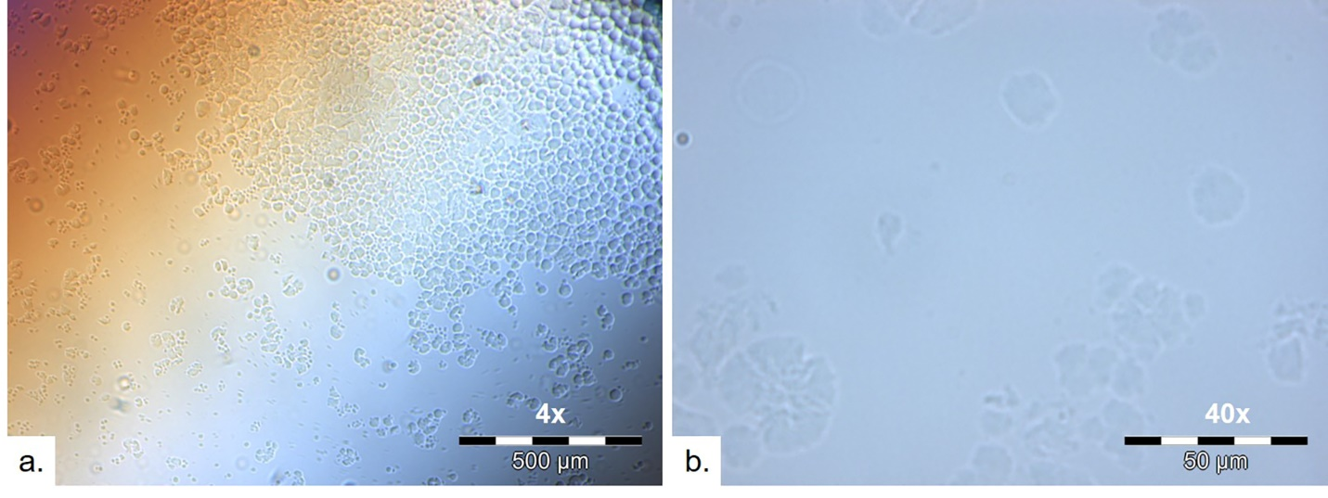
Figure S3. 3.0 wt.% cellulose solution in [P₄₄₄₄][OAc]:DMSO (60:40 w/w). Photos are taken after 18 h of equilibration at 20 °C using 4x (a) and 40x (b) magnifications.

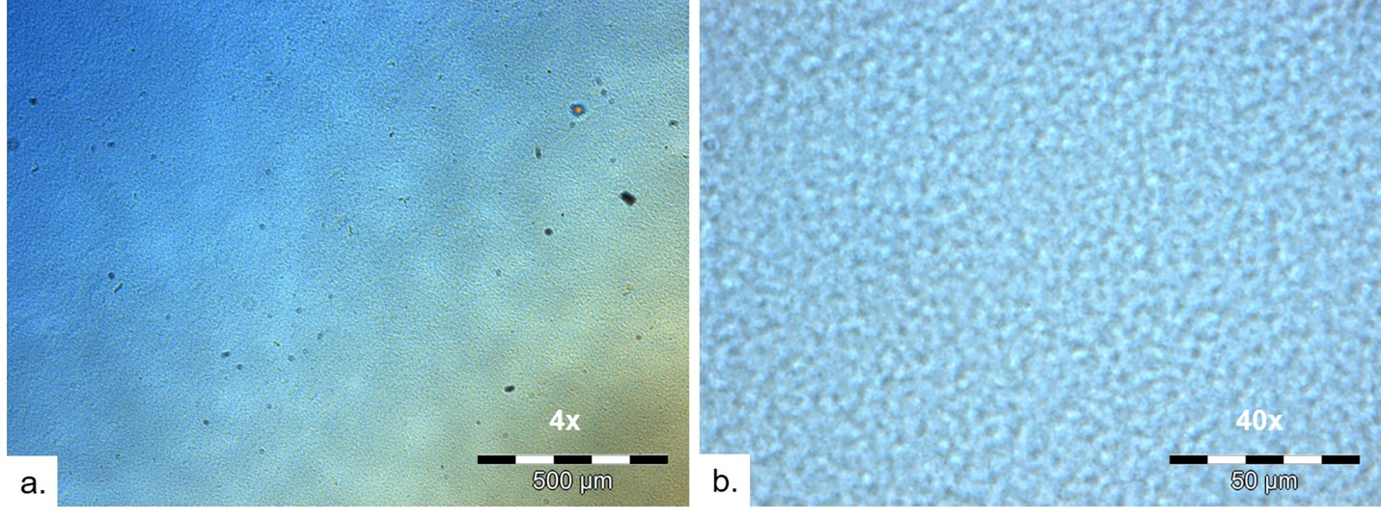
Figure S4. 2 wt.% cellulose solution of [P₄₄₄₄][OAc]:DMSO (60:40 w/w). Photos are taken in 72 h of equilibration at 20 °C using 4x (a) and 40x (b) magnifications.

Increasing the relative content of IL in OES decreases dissolution capacity and increases T_{cp} and therefore solution quality at 20 °C becomes poorer. Formation of the particles is observed in [P₄₄₄₄][OAc]:DMSO (65:35 w/w) with 2.0 wt.% cellulose, see Figure S5. Although the particles have spherical shaple, their internal structure seem to be amorphous, i.e. there are no obvious spherulite effects and no Maltese cross pattern. Interestingly, only the particles obtained from [P₄₄₄₄][OAc]:DMSO (70:30 w/w) have spherulite structure.
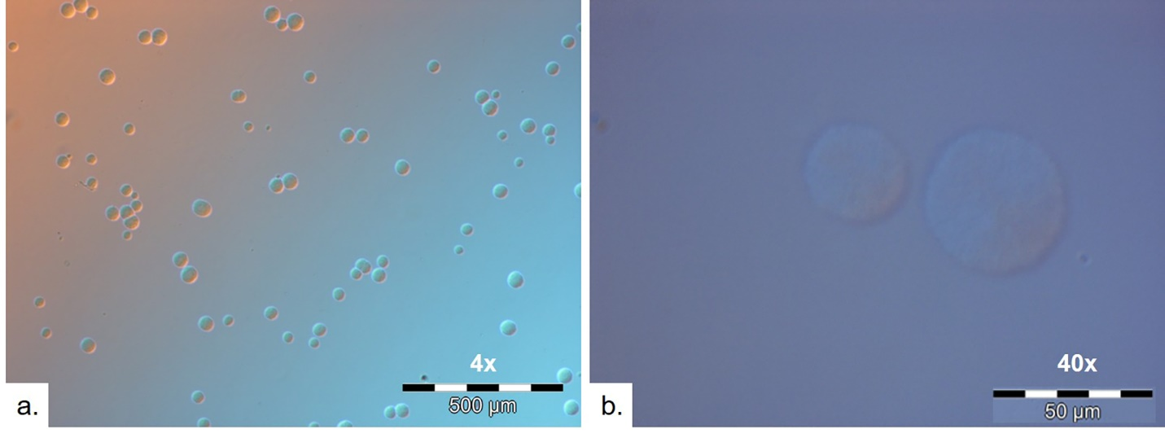
Figure S5. 2.0 wt.% cellulose solution in [P₄₄₄₄][OAc]:DMSO (65:35 w/w). Photos are taken after 18 h of equilibration at 20 °C using 4x (a) and 40x (b) magnifications.

If the IL content in OES is increased further to [P₄₄₄₄][OAc]:DMSO(75:25 w/w), the viscosity of the solution is too high at RT and no particles were observed in 2 wt.% solution, see Figure S6.
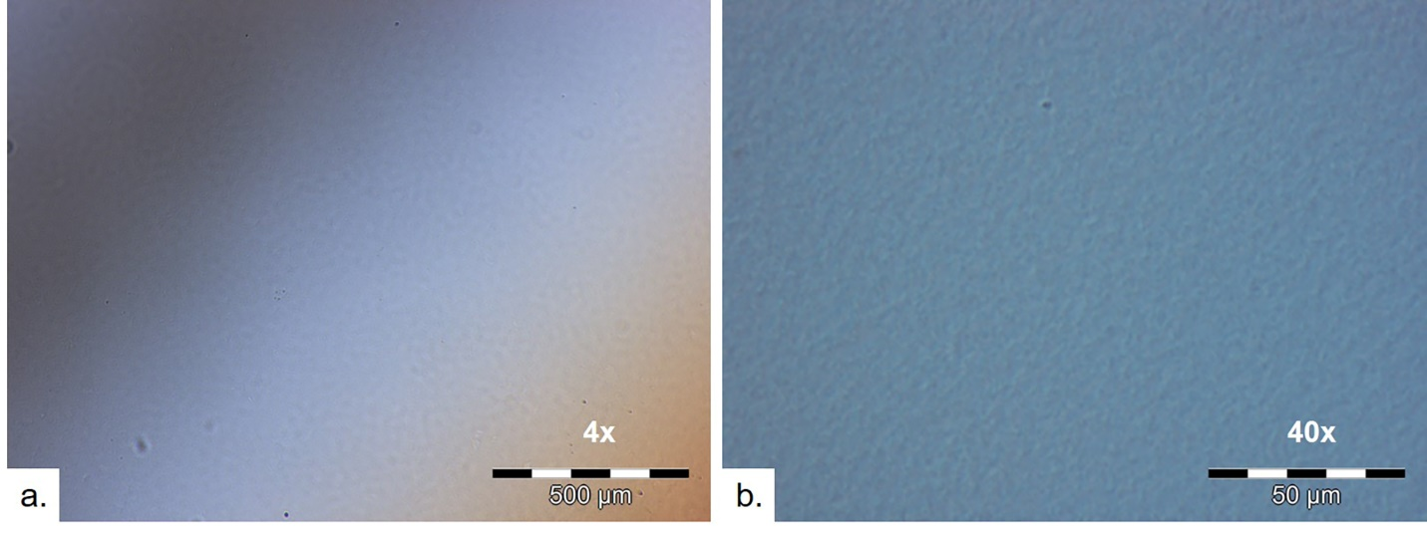

Figure S6. 2.0 wt.% cellulose solution in [P₄₄₄₄][OAc]:DMSO (75:25 w/w). Photos are taken in 18 h of equilibration at 20 °C using 4x (a) and 40x (b) magnifications.

Cellulose solution in [P₄₄₄₄][OAc]:GVL (70:30 w/w) was studied as a reference, see Figure S7. No individual particles were detected under the same experimental condition.

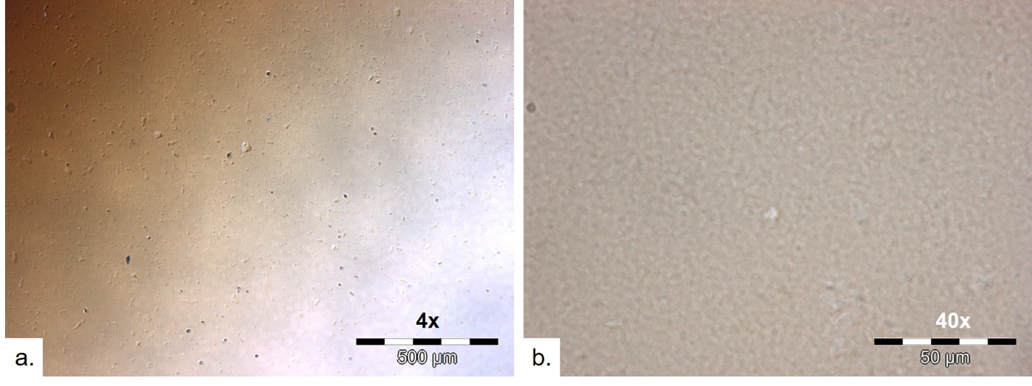
Figure S7. 2.0 wt.% cellulose solution in [P₄₄₄₄][OAc]:GVL (70:30 w/w). Photos are taken in 18 h of equilibration at 20 °C using 4x (a) and 40x (b) magnifications.

Dissolving of cellulose studied by means of differential scanning calorimetry
DSC was used for examining the dissolving process of dry MCC in [P₄₄₄₄][OAc]:DMSO. The MCC concentration was 5 wt.%. High volume pan was used and the weight of sample was 50 mg. Blank experiment was done first for the baseline: [P₄₄₄₄][OAc]:DMSO was heated from 20 °C to 130 °C by heating rate of 20 °C/min, then kept at 130 °C for 5 minutes and cooled down to 20 °C by cooling rate 2 °C/min. The used heating rate is quite fast. Since the heat flow is affected by the heating rate, we are able to observe the heat flow change. As for the slower cooling, we would like to give more time for the cellulose chains to move and aggregate. It took 55 minutes for the solution to cool down to 20 °C and then the second heating and cooling cycle was repeated with the same procedure. The blue curve in Figure S8 represents the first heating cycle and the red curve corresponds to the second heating cycle. A slight endothermic peak between 90 and 120 °C (blue curve) corresponds to the cellulose dissolving in first heating process. Phase separation of cellulose upon cooling is a very slow process and DSC does not give any meaningful data about the phase transition. It is evident that no heat flow change is detected during the second heating (red curve). The difference of the heat flow between the first and the second heating likely indicates the difference in the form of cellulose, i.e. MCC vs. regenerated cellulose.

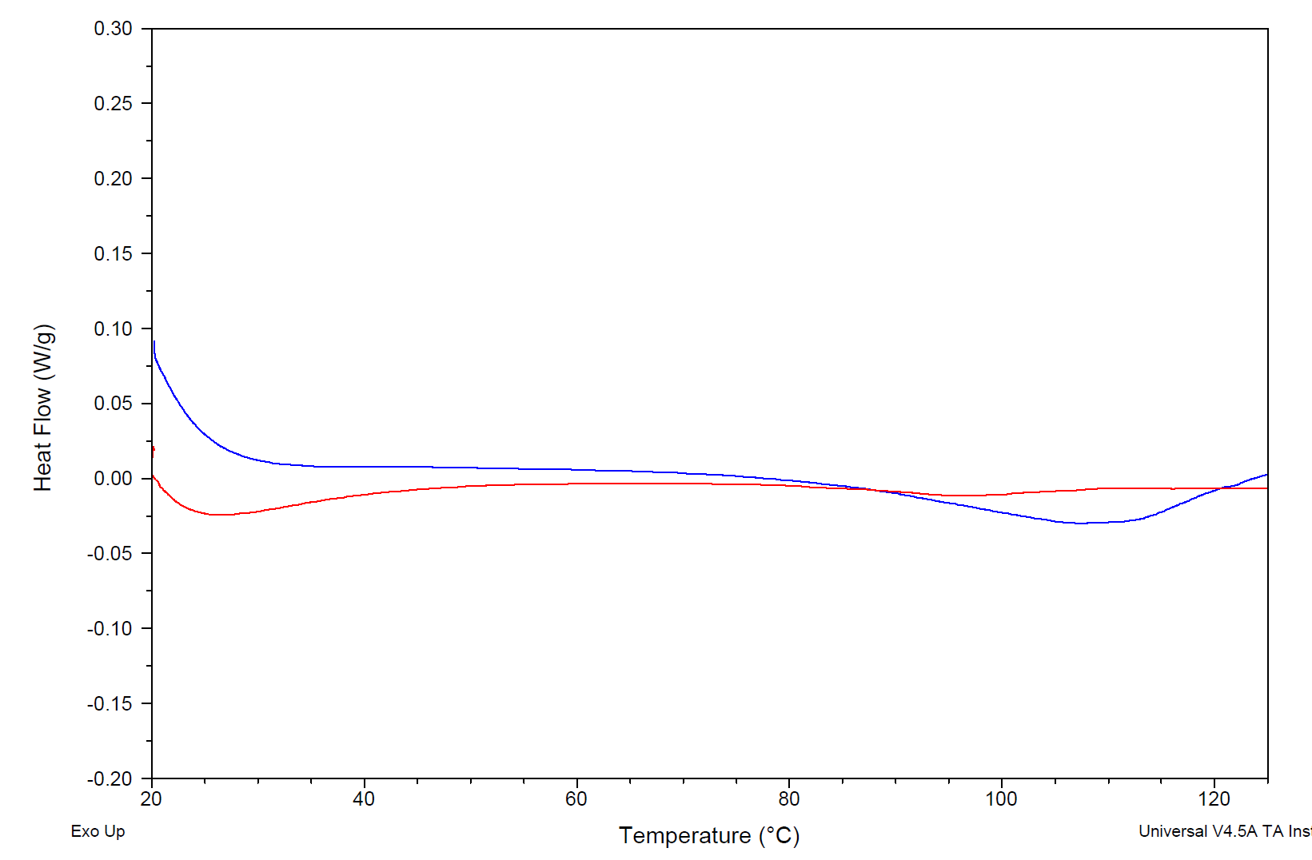
first heating
second heating
Figure S8. DSC thermograms of heating with rate of 20 °C/min of 5.0 wt.% MCC in [P₄₄₄₄][OAc]:DMSO from 20°C to 130 °C with subtracted baseline. Blue curve is the first heating cycle and red curve is the second heating cycle.

Phase separation of cellulose solutions observed by means of light scattering
LS measurements were performed using square quartz cuvettes, the same ones as those used in turbidity studies. Solutions were prepared in [P₄₄₄₄][OAc]:DMSO (70:30 w/w) with concentrations of 1.0 wt.%, 1.5 wt.% and 2.0 wt.%. Dissolution in a 20 ml vial was done in the same way as in other studies. 1.5 ml of freshly made solution were transferred into the quartz cuvette at 120 °C and placed into preheated to 90 °C light scattering device. Intensity of light scattered by solutions upon cooling from 90 °C to 20 °C was recorded with two cooling procedures. Cooling cannot be continuous during the LS experiments. It is done stepwise and the average cooling rate is determined by the number of the measurement points. In the fast cooling procedure, the three measurements were repeated every 5 °C. The sample was equilibrated for 2 min at each temperature step prior to the measurement. As a result, the fast cooling took 3 h. In the fast cooling procedure, the range from 90 to 60 °C was sampled every 5 °C and from 60 to 20 °C every 2 °C. As a result, the slow cooling took over 6 h. In addition, when the cooling stopped at 20 °C, the sample was kept at 20 °C to follow changes during the sample equilibration.

Here are two representative examples. In the first one, the LS intensity gradually increases with the fast cooling, see Figure S9a. The increase is minor because the cellulose in solution has not enough time to respond. The intensity change is mainly due to worsening of the solvent quality rather than intermolecular aggregation. The turning point seems to be about 30 ºC. The slow cooling is demonstrated in Figure S9b. Similar to the fast cooling, the LS intensity gradually increases down to 30 ºC and shoots up when temperature drops below 30 ºC and the aggregation starts. Fluctuations of the intensity below 30 ºC are very strong owing to the high viscosity: chains and particles diffuse slowly and hence intensity is not averaging of in time and space. These random and uncorrelated intensity fluctuations make dynamic light scattering for the particles sizes in OES at RT not possible.

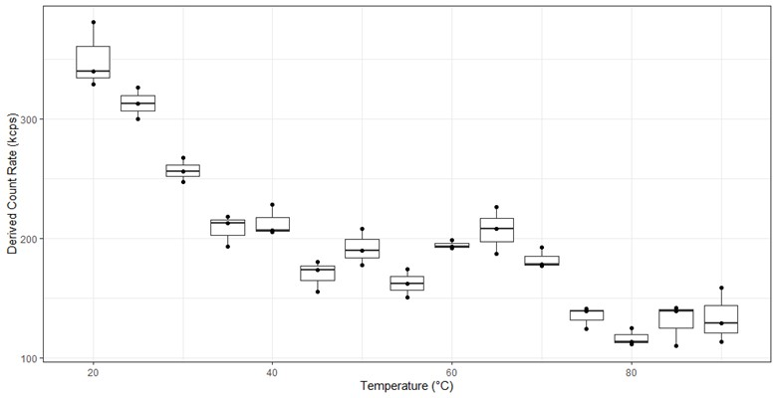
Figure S9a. Intensity of light scattered by a 2.0 wt.% solution in [P₄₄₄₄][OAc]:DMSO (70:30 w/w) upon fast cooling from 90 °C to 20 °C.

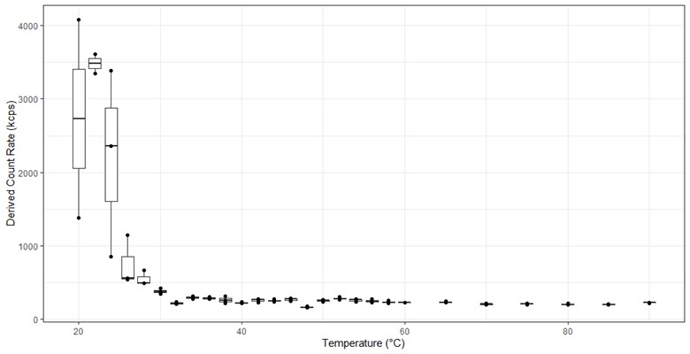
Figure S9b. Intensity of light scattered by a 2.0 wt.% solution in [P₄₄₄₄][OAc]:DMSO (70:30 w/w) upon slow cooling from 90 °C to 20 °C.

The LS intensity suggests that T_{cp} for 2.0 wt.% solution in [P₄₄₄₄][OAc]:DMSO (70:30 w/w) is about 30 ºC. This is the temperature, at which solvent turns poor for cellulose and the intermolecular aggregation starts. The particles are small and not numerous in the beginning of this process. T_{cp} determined with transmittance is 14 ºC and it is an apparent value. It is evident that the LS intensity is more sensitive than transmittance to conformational changes: in the course of continuous cooling, solutions become cloudy when diameter of the particles exceeds a wavelength of light. Our LS studies confirm that regeneration of cellulose from 2.0 wt.% solution indeed takes place below the actual T_{cp}, i.e. under thermodynamically poor condition.

Dynamic light scattering studies on particles dispersed in acetone
Particles regenerated from 2.0 wt.% solution in [P₄₄₄₄][OAc]:DMSO (70:30 w/w) were washed with 10 tinmes volume of acetone as described in the main text. Cloudy dispersions of the particles in the acetone/OES mixtures became clear during 20 min of sonication. The particles cannot be detected with an optical microscope. Therefore, dynamic light scattering was used for detecting these particles in the acetone/OES mixtures after sonication. The cellulose concentration in the acetone/OES mixture used for light scattering studies was about 0.15 wt.%. Dynamic light scattering measurements were performed using a Brookhaven Instruments BI-200SM goniometer, a BI-9000AT digital correlator, and a Coherent Sapphire 488-100 CDRH laser operating at wavelength of 488 nm. The sample was not filtered and the scattering angle was 135°. The measurement cell was thermo-stated at 20 °C. Because of the great excess of acetone in the mixture, we used viscosity and the refractive index of acetone to roughly estimate the mean hydrodynamic diameter of the particles as 150 nm, see Figures S10 and S11. Intensity correlation functions were analyzed using the CONTIN algorithm.

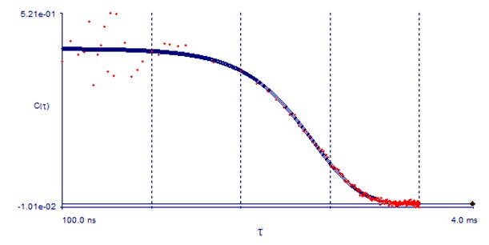
Figure S10. Correlation function of the scattered light intensity obtained for particles dispersed in the acetone/[P₄₄₄₄][OAc]:DMSO mixture after sonication.

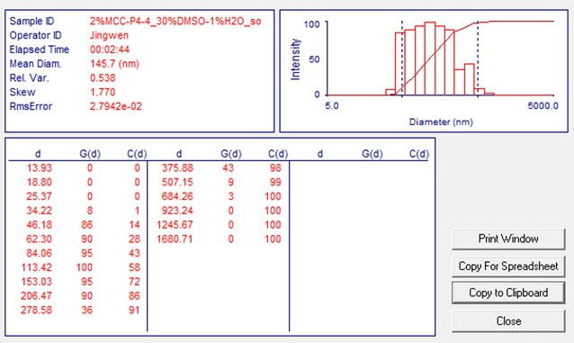
Figure S11. Distribution of the hydrodynamic diameter obtained for the correlation function shown in Figure S10. The mean hydrodynamic diameter of the particles as 145.7 nm.

Examination of the dry product by means of wide angle X-ray scattering (WAXS)
The diffractograms obtained from WAXS were analyzed by Fityk software and the results are shown in Figure S12. The green dotted line is the raw data and the yellow line is the fitting curve after deconvolution. Here we used the function script created by Rico del Cerro, D., et al., (Rico del Cerro et al. 2020). The contributions are as follows: a) background of glass support (magenta line), b) amorphous cellulose contribution (cyan line), c) main crystalline diffraction planes (red lines). The crystallinity index of cellulose was calculated according to Equation 1.

$CI=100\%*({A_{cel-Ⅱ}}/{A_{Tot}})$ Equation 1.
CI---Crystallinity Index
A_{cel-Ⅱ}---Area of curves represent crystalline diffraction planes
A_{Tot}---Area of total curves except background
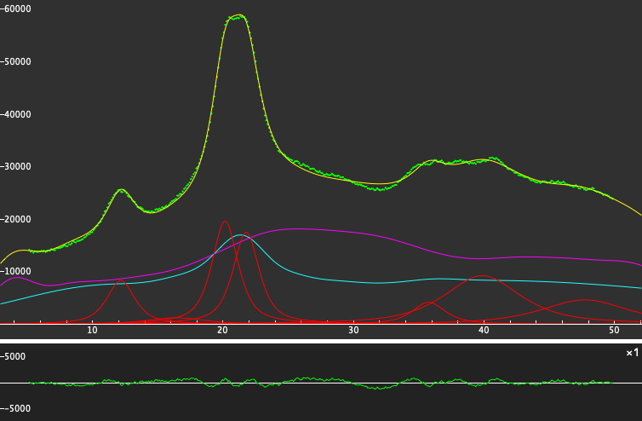
Figure S12. Deconvolution of WAXS diffractograms of the final regenerated products: raw data (green), fitted data (yellow), amorphous cellulose (cyan), background (magenta), main crystalline diffraction planes (red).

Reference

Rico del Cerro DR, Koso TV, Kakko T, King AWT, Kilpeläinen I (2020) Crystallinity reduction and enhancement in the chemical reactivity of cellulose by non-dissolving pre-treatment with tetrabutylphosphonium acetate. Cellulose 27:5545-5562. https://doi.org/10.1007/s10570-020-03044-6

