Supplementary Materials

Computational Mechanisms of Learning and Forgetting Differentiate Affective and Substance Use Disorders

Navid Hakimi¹, Ko-Ping Chou¹, Jennifer Stewart^{1,2}, Martin P. Paulus^{1,2} & Ryan Smith^{1,2}
¹Laureate Institute for Brain Research, Tulsa, OK.
²Oxley College of Health and Natural Sciences, University of Tulsa, Tulsa, OK.

Corresponding author:
Ryan Smith, PhD (rsmith@laureateinstitute.org)
Research Associate Professor
Laureate Institute for Brain Research
6655 S. Yale Ave. Tulsa, Oklahoma, 74136
United States

Supplementary Tables
Table S1. Breakdown of co-morbidities within the affective disorders group.
iADs (n= 242) | MDD | GAD | Social | Panic | PTSD
MDD | 183 | - | - | - | -
GAD | 68 | 71 | - | - | -
Social | 39 | 16 | 43 | - | -
Panic | 42 | 18 | 11 | 45 | -
PTSD | 36 | 9 | 9 | 8 | 37
Note: Participants in this group were required to have a lifetime diagnosis of one or more anxiety/depressive disorder(s). MDD=major depressive disorder, GAD=generalized anxiety disorder, Social=social anxiety disorder, PTSD=post-traumatic stress disorder, Panic=panic disorder. Numbers on the diagonal represent the total count of participants with each specific diagnosis. Numbers below the diagonal show the participants with each comorbid diagnosis.

Table S2. Breakdown of co-morbidities within the substance use disorders group.
 | Alcohol | Cannabis | Stimulant | Opioid | Sedative | Hallucinogen | MDD | GAD | Social | Panic | PTSD
Alcohol | 26 | - | - | - | - | - | - | - | - | - | -
Cannabis | 15 | 38 | - | - | - | - | - | - | - | - | -
Stimulant | 22 | 32 | 58 | - | - | - | - | - | - | - | -
Opioid | 10 | 17 | 21 | 32 | - | - | - | - | - | - | -
Sedative | 10 | 16 | 18 | 16 | 22 | - | - | - | - | - | -
Hallucinogen | 2 | 5 | 4 | 4 | 3 | 5 | - | - | - | - | -
MDD | 13 | 15 | 23 | 15 | 6 | 0 | 95 | - | - | - | -
GAD | 4 | 6 | 7 | 6 | 3 | 0 | 41 | 43 | - | - | -
Social | 5 | 4 | 3 | 4 | 3 | 0 | 19 | 14 | 22 | - | -
Panic | 1 | 3 | 2 | 3 | 0 | 1 | 10 | 6 | 1 | 12 | -
PTSD | 3 | 5 | 7 | 5 | 3 | 2 | 19 | 7 | 3 | 2 | 23
MDD=major depressive disorder, GAD=generalized anxiety disorder, Social=social anxiety disorder, PTSD=post-traumatic stress disorder, Panic=panic disorder. Numbers on the diagonal represent the total count of participants with each specific diagnosis. Numbers below the diagonal show participants with each comorbid diagnosis.

Table S3. Priors on model parameters during fitting.
Variable | Symbol | Bounds | Prior | Prior Variance
Initial Decision Noise | $$β$$ | $$[0,∞)$$ | 0.3 | 0.25
Pessimism | $$ρ_{p}$$ | $$[0,1]$$ | 0.5 | 0.25
Learning Rate (Wins) | $$η_{w}$$ | $$[0,∞)$$ | 0.5 | 0.25
Learning Rate (Losses) | $$η_{l}$$ | $$[0,∞)$$ | 0.5 | 0.25
Forgetting Rate | $$ω$$ | $$[0,1]$$ | 0.25 | 0.25

Table S4. Model-Free Task Performance (Mean (SD)).
Variable | HCs | iADs | iSUDs | Test | $$η^{2}$$ | Post-hoc
Wins | 183.48 (11.95) | 181.54 (11.04) | 179.27 (13.03) | F(2,437)=2.776,  p=0.063 | 0.013 | n.s.
Mean Reaction Time | 0.62 (0.25) | 0.63 (0.31) | 0.57 (0.26) | F(2,437)=1.238,  p=0.291 | 0.006 | n.s.
Win-Stay Proportion | 0.79 (0.17) | 0.82 (0.18) | 0.77 (0.19) | F(2,437)=1.491,  p=0.226 | 0.007 | n.s.
Lose-Shift Proportion | 0.67 (0.2) | 0.66 (0.22) | 0.65 (0.22) | F(2,437)=0.401,  p=0.670 | 0.002 | n.s.
After Potential Outlier Removal (HCs: N=2; iADs: N=12; iSUDs: N=4)
Wins | 183.92(11.59) | 181.85(10.82) | 179.8(12.78) | F(2,419) = 2.495, p = 0.084 | 0.012 | n.s.
Mean Reaction Time | 0.62(0.25) | 0.63(0.31) | 0.57(0.26) | F(2,419) = 1.384, p = 0.252 | 0.007 | n.s.
Win-Stay ratio | 0.79(0.16) | 0.83(0.17) | 0.78(0.18) | F(2,419) = 1.639, p = 0.195 | 0.008 | n.s.
Lose-Shift ratio | 0.67(0.21) | 0.66(0.22) | 0.65(0.23) | F(2,419) = 0.314, p = 0.731 | 0.001 | n.s.

Table S5. Model comparison.
Model | Description | Number of Parameters | Average Action Probability | Model Accuracy | Protected Exceedance Probability
Reinforcement Learning Models
RL1 | 1 LR | 3 | 0.584 | 65.99 | 0
RL2 | 1 LR + Reward Sensitivity | 4 | 0.585 | 66.04 | 0
RL3 | 2 LR | 4 | 0.585 | 66.02 | 0
RL4 | Associability | 4 | 0.577 | 65.69 | 0
RL5 | Associability + Reward Sensitivity | 5 | 0.579 | 65.75 | 0
RL6 | Dynamic Decision Noise | 4 | 0.578 | 65.79 | 0
RL7 | Dynamic Decision + Reward Sensitivity | 5 | 0.583 | 65.93 | 0
Active Inference Models
AI1 | 1 LR | 4 | 0.520 | 61.64 | 0
AI2 | 2 LR | 5 | 0.539 | 63.22 | 0
AI3 | 2 LR + Pessimism Bias | 4 | 0.544 | 62.79 | 0
AI4 | 2 LR + 1 FR + Pessimism Bias | 5 | 0.603 | 67.47 | 0
AI5 | 2 LR + 2 FR + Pessimism Bias | 6 | 0.603 | 67.51 | 0
AI6 | Dynamic forgetting + Pessimism Bias | 5 | 0.602 | 67.38 | 0
AI7 | Dynamic Decision + 1 FR + Pessimism Bias | 5 | 0.602 | 67.43 | 1
AI8 | Dynamic Decision + 2 FR + Pessimism Bias | 6 | 0.601 | 67.42 | 0
Note: LR = Learning Rate, FR = Forgetting Rate.

Table S6 Model parameters estimates for each group (Mean (SD)) after potential outlier removal with iterative grubs (p=0.01)
Variable | HCs  (N=52) | iADs  (N=230) | iSUDs  (N=143) | Test | $$η^{2}$$ | Post-hoc
Decision Noise | 0.38(0.14) | 0.36(0.13) | 0.42(0.14) | F(2,420)=6.409, p=0.002 | 0.03 | iADs – iSUDs, c= -0.050, t=-3.540, p$≤$0.001
Pessimism | 0.57(0.12) | 0.6(0.14) | 0.57(0.14) | F(2,420)=0.455, p=0.635 | 0.002
Learning Rate (Wins) | 0.57(0.25) | 0.58(0.26) | 0.61(0.26) | F(2,420)=0.846, p=0.430 | 0.004
Learning Rate (Losses) | 0.38(0.19) | 0.42(0.26) | 0.35(0.2) | F(2,420)=3.217, p=0.041 | 0.015 | iADs – iSUDs, c= 0.065, t=2.514, p=0.012
Forgetting Rate | 0.29(0.17) | 0.38(0.17) | 0.35(0.14) | F(2,420)=4.159, p=0.016 | 0.019 | HCs – iADs, c= -0.067, t=-2.867, p=0.004  HCs – iSUDs, c= -0.058, t=-2.392, p=0.017

Table S7. Model parameters in individuals with depression with vs. without co-morbid anxiety disorders.
Variable | iDEP+ANX | iDEP | Test | b | $$η^{2}$$
Initial Decision Noise | 0.38(0.16) | 0.37(0.23) | F(1,238)=0.018, p=0.892 | -0.002 [-0.027, 0.024] | 0
Pessimism | 0.59(0.14) | 0.6(0.15) | F(1,238)=0.105, p=0.746 | -0.003 [-0.022, 0.016] | 0
Learning Rate (Wins) | 0.6(0.29) | 0.57(0.25) | F(1,238)=0.923, p=0.338 | -0.019 [-0.057, 0.020] | 0.004
Learning Rate (Losses) | 0.47(0.36) | 0.41(0.3) | F(1,238)=1.633, p=0.202 | -0.031 [-0.078, 0.017] | 0.007
Forgetting Rate | 0.36(0.17) | 0.4(0.17) | F(1,238)=1.043, p=0.308 | 0.011 [-0.010, 0.032] | 0.004
After Potential Outlier Removal (iDEP+ANX: N=9; iDEP: N=3)
Decision Noise | 0.37(0.13) | 0.34(0.12) | F(1,226)=2.154, p=0.144 | -0.013 [-0.031, 0.005] | 0.009
Pessimism | 0.6(0.13) | 0.6(0.15) | F(1,226)=0.130, p=0.719 | -0.003 [-0.022, 0.015] | 0.001
Learning Rate (Wins) | 0.58(0.26) | 0.58(0.26) | F(1,226)=0.139, p=0.710 | -0.007 [-0.043, 0.029] | 0.001
Learning Rate (Losses) | 0.44(0.26) | 0.39(0.27) | F(1,226)=0.866, p=0.353 | -0.018 [-0.055, 0.020] | 0.004
Forgetting Rate | 0.36(0.16) | 0.4(0.17) | F(1,226)=1.800, p=0.181 | 0.014 [-0.007, 0.036] | 0.008
Note: Results are from linear models accounting for effects of age and sex.

Table S8. Model parameters in individuals with substance use disorders with vs. without comorbid affective disorders.
Variable | iSUDs^{AD+} | iSUDs^{AD-} | Test | b | $$η^{2}$$
Initial Decision Noise | 0.47(0.35) | 0.43(0.14) | F(1,130)=0.566, p=0.453 | -0.019 [-0.068, 0.031] | 0.004
Pessimism | 0.54(0.14) | 0.6(0.13) | F(1,130)=5.667, p=0.019 | 0.027 [0.005, 0.050] | 0.042
Learning Rate (Wins) | 0.55(0.24) | 0.67(0.27) | F(1,130)=6.785, p=0.010 | 0.057 [0.014, 0.100] | 0.05
Learning Rate (Losses) | 0.36(0.18) | 0.38(0.31) | F(1,130)=0.154, p=0.696 | 0.008 [-0.034, 0.050] | 0.001
Forgetting Rate | 0.36(0.14) | 0.34(0.14) | F(1,130)=0.508, p=0.477 | -0.009 [-0.033, 0.016] | 0.004
After Potential Outlier Removal (iSUDs^{AD+}: N=3; iSUDs^{AD-}: N=1)
Decision Noise | 0.43(0.14) | 0.41(0.13) | F(1,126)=0.858, p=0.356 | 0.011 [-0.013, 0.035] | 0.007
Pessimism | 0.6(0.13) | 0.55(0.14) | F(1,126)=4.288, p=0.040 | 0.024 [0.001, 0.047] | 0.033
Learning Rate (Wins) | 0.67(0.27) | 0.56(0.25) | F(1,126)=6.031, p=0.015 | 0.054 [0.011, 0.098] | 0.046
Learning Rate (Losses) | 0.35(0.23) | 0.37(0.19) | F(1,126)=0.175, p=0.676 | -0.007 [-0.043, 0.028] | 0.001
Forgetting Rate | 0.34(0.14) | 0.36(0.15) | F(1,126)=0.667, p=0.416 | -0.010 [-0.035, 0.015] | 0.005
Note: Results are from linear models accounting for effects of age and sex.

Table S9. Means and SDs (and group comparisons) for values of within-subject correlations between trial-by-trial reaction times and model confidence metrics.
Variable | HCs | iADs | iSUDs | Test | $$η^{2}$$ | Post-hoc
RT – Belief Update  (within-subject correlations) | 0.15(0.15) | 0.14(0.14) | 0.08(0.13) | F(2,435)=8.654, p<0.001 | 0.038 | HCs – iSUDs, c= 0.073, t=3.232, p=0.001  iADs – iSUDs, c= 0.056, t=3.698, p<0.001
RT – Choice Uncertainty  (within-subject correlations) | 0.39(0.14) | 0.37(0.16) | 0.32(0.14) | F(2,435)=6.218, p=0.002 | 0.028 | HCs – iSUDs, c= 0.075, t=3.129, p=0.002  iADs – iSUDs, c= 0.044, t=2.748, p=0.006
*Age and sex were used as covariates in linear models testing group effects.

Table S10. Correlation between latent factors and computational model parameters.
Variable | HCs | iADs | iSUDs | Test | $$η^{2}$$ | Post-hoc
Negative Affect | -0.3(1.09) | 0.1(0.99) | 0(1.03) | F(2,421)=3.722, p=0.025 | 0.017 | HCs – iADs, c= -0.427, t=-2.724, p=0.007  HCs – iSUDs, c= -0.322, t=-1.969, p=0.050
Interoceptive Awareness | 0.18(1.08) | 0.12(1.01) | 0.12(1.13) | F(2,421)=3.980, p=0.019 | 0.019 | HCs – iADs, c= 0.347, t=2.126, p=0.034  iAD – iSUDs, c= -0.277, t=-2.391, p=0.017
Impulsivity | 0.02(1.02) | 0.13(1.09) | 0.21(1.04) | F(2,421)=4.984, p=0.007 | 0.023 | iAD – iSUDs, c= -0.369, t=-3.156, p=0.002
Early Adversity | 0.05(1.09) | 0.08(1.05) | 0.11(1.06) | F(2,421)=1.116, p=0.329 | 0.005 | n.s.
Working Memory | 0.1(1.17) | 0.01(1.08) | 0.01(1.24) | F(2,421)=0.252, p=0.778 | 0.001 | n.s.
Positive Affect | 0.36(0.97) | 0.12(1.11) | 0.01(1.04) | F(2,421)=4.184, p=0.016 | 0.019 | HCs – iAD, c= 0.476, t=2.880, p=0.004  HCs – iSUD, c= 0.348, t=2.016, p=0.044
Physical Functioning | 0.27(1.08) | 0.07(1.01) | 0.02(1.15) | F(2,421)=2.132, p=0.120 | 0.01 | n.s.
* Age and sex were included as covariates in all models.
Table S11. Correlation between latent factors and computational model parameters.
Variable | Negative Affect | Interoceptive Awareness | Impulsivity | Early Adversity | Working Memory | Positive Affect | Physical Functioning
Initial Decision Noise | F(1,416)=0.464  p=0.496  b=-0.008 [-0.031, 0.015] | F(1,416)=1.283  p=0.258  b=0.012 [-0.009, 0.032] | F(1,416)=3.426  p=0.065  b=0.018 [-0.001, 0.037] | F(1,416)=0.063  p=0.802  b=0.003 [-0.018, 0.023] | F(1,416)=0.536  p=0.464  b=-0.007 [-0.025, 0.011] | F(1,416)=0.043  p=0.835  b=0.002 [-0.018, 0.023] | F(1,416)=0.446  p=0.505  b=-0.007 [-0.029, 0.014]
Pessimism | F(1,416)=0.429  p=0.513  b=0.005 [-0.010, 0.019] | F(1,416)=0.185  p=0.668  b=0.003 [-0.010, 0.016] | F(1,416)=6.219  p=0.013  b=-0.015 [-0.027, -0.003] | F(1,416)=3.961  p=0.047  b=-0.013 [-0.026, -0.000] | F(1,416)=1.534  p=0.216  b=-0.007 [-0.018, 0.004] | F(1,416)=0.011  p=0.917  b=0.001 [-0.012, 0.014] | F(1,416)=0.897  p=0.344  b=-0.006 [-0.020, 0.007]
Learning Rate (Wins) | F(1,416)=1.221  p=0.270  b=0.016 [-0.012, 0.044] | F(1,416)=1.075  p=0.300  b=-0.013 [-0.037, 0.012] | F(1,416)=0.095  p=0.758  b=-0.004 [-0.027, 0.019] | F(1,416)=1.363  p=0.244  b=-0.015 [-0.039, 0.010] | F(1,416)=0.053  p=0.817  b=-0.003 [-0.024, 0.019] | F(1,416)=3.256  p=0.072  b=0.023 [-0.002, 0.048] | F(1,416)=0.096  p=0.757  b=0.004 [-0.022, 0.030]
Learning Rate (Losses) | F(1,416)=0.285  p=0.594  b=-0.009 [-0.043, 0.025] | F(1,416)=0.273  p=0.601  b=0.008 [-0.022, 0.038] | F(1,416)=0.444  p=0.505  b=0.010 [-0.019, 0.038] | F(1,416)=5.819  p=0.016  b=0.037 [0.007, 0.067] | F(1,416)=0.253  p=0.615  b=0.007 [-0.020, 0.033] | F(1,416)=0.026  p=0.873  b=-0.002 [-0.033, 0.028] | F(1,416)=0.021  p=0.884  b=0.002 [-0.029, 0.034]
Forgetting Rate | F(1,416)=0.003  p=0.955  b=-0.000 [-0.017, 0.016] | F(1,416)=3.076  p=0.080  b=-0.013 [-0.028, 0.002] | F(1,416)=0.429  p=0.513  b=0.005 [-0.009, 0.018] | F(1,416)=0.245  p=0.621  b=-0.004 [-0.018, 0.011] | F(1,416)=0.006  p=0.939  b=0.000 [-0.012, 0.013] | F(1,416)=0.028  p=0.868  b=0.001 [-0.014, 0.016] | F(1,416)=0.044  p=0.834  b=0.002 [-0.014, 0.017]
* Age and sex were included as covariates in all models.
** Note that a Bonferroni correction for 35 comparisons entails a corrected p-value threshold of p<.0014.

Supplementary Figures

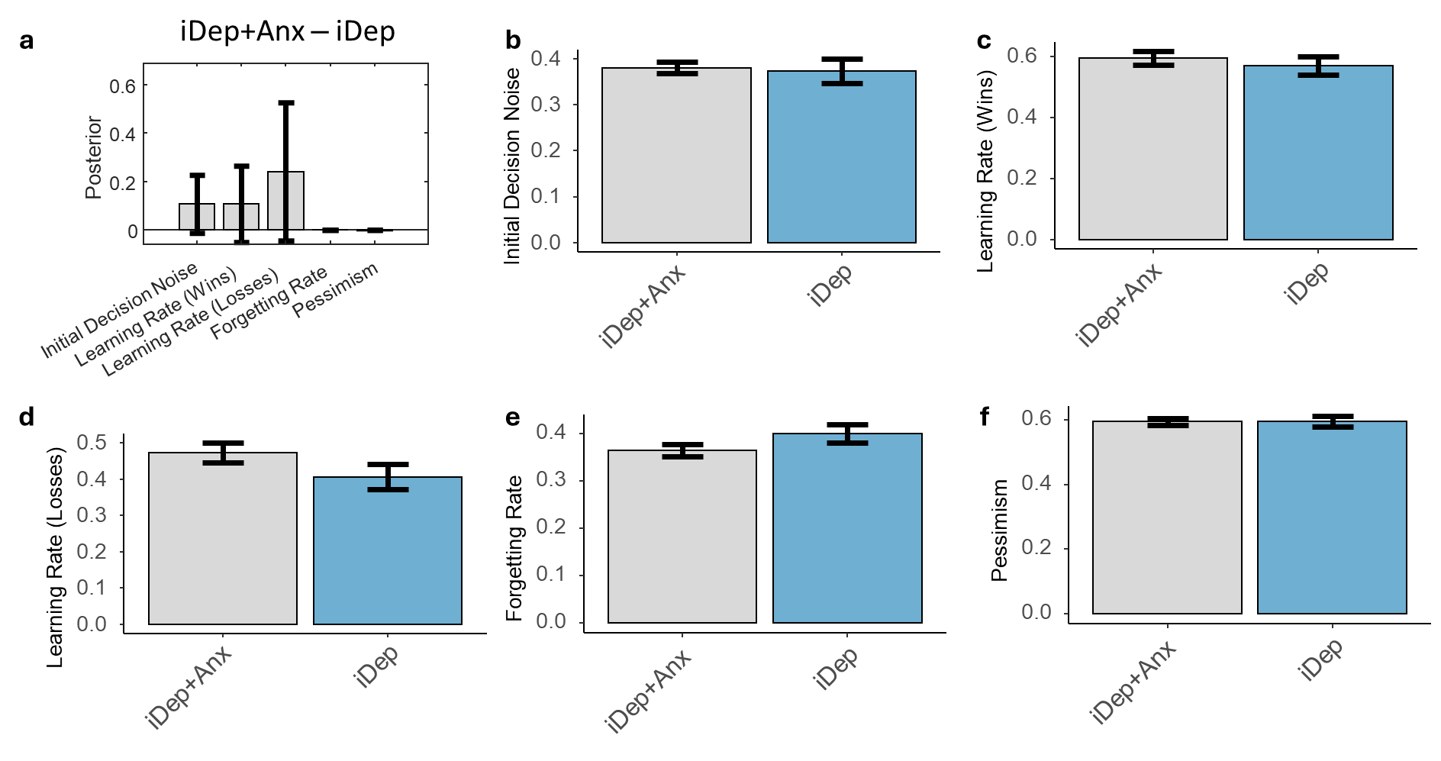
Figure S1. Group differences in model parameters between anxious and non-anxious depression. a) Results from Parametric Empirical Bayes (PEB) analyses showing the posterior means and credible intervals for effects of group (when accounting age and sex). Positive values indicate higher scores in anxious depression. Forgetting and learning rates are displayed in logit space; other parameters are displayed in log space. b-f) Means and standard errors for computational parameters in each group (original units).

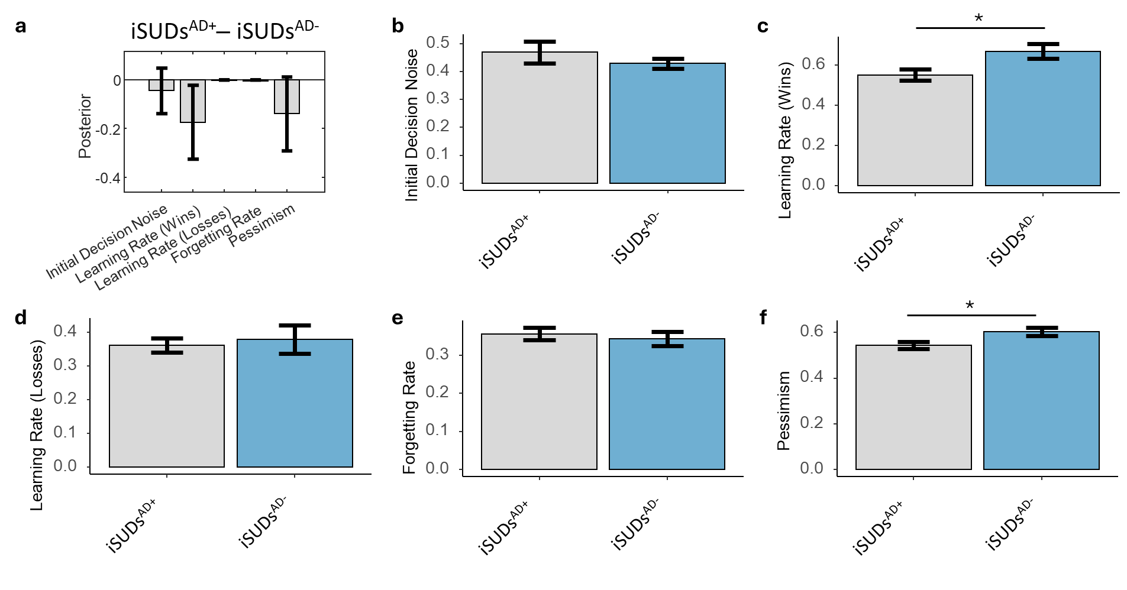
Figure S2. Group differences in model parameters between substance users with vs. without comorbid affective disorders. a) Results from Parametric Empirical Bayes (PEB) analyses showing the posterior means and credible intervals for effects of group (when accounting age and sex). Positive values indicate higher scores in those with comorbid affective disorders. Forgetting and learning rates are displayed in logit space; other parameters are displayed in log space. b-f) Means and standard errors for computational parameters in each group (original units).

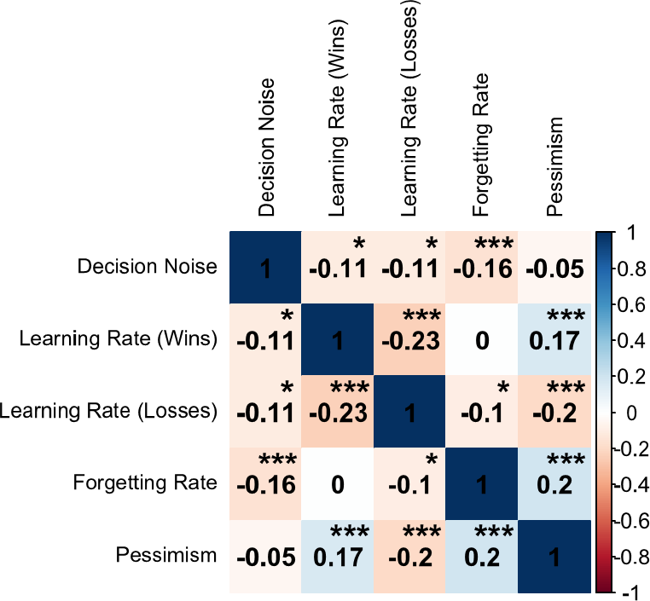
Figure S3. Inter-correlations between model parameters. * p<.05, **p<.01, ***p<.001.

Description of Model Space

Reinforcement Learning Models
Rescorla -Wagner (RW) Model
Standard Rescorla-Wagner models ¹ simulate learning by keeping track of the expected value of each option, and then simulate decision making using a softmax (normalized exponential) function over the expected values ².
$$Q_{1}^{k}=V_{0}$$
$$Q_{t+1}^{k}=Q_{t}^{k}+α∙\left(r_{t}-Q_{t}^{k}\right)$$
Where $Q_{t}^{k}$ is the expected value of option k at time t, $r_{t}∈[0, 1]$ is the reward, and $α$ is the learning rate. An inverse temperature parameter ($β$) controls the shape of the distribution over choices in the softmax function, where lower values lead to less value-sensitive choices.
$$p_{t+1}^{k}= \frac{\exp\left(βQ_{t+1}^{k}\right)}{\sum_{i=1}^{K}{\left(βQ_{t+1}^{i}\right)}}$$
Finally, $V_{0}$ is the expected value of an unseen option, and directly controls exploration ². Higher $V_{0}$ values result in a greater tendency to choose unseen options.
Extended Rescorla-Wagner Models
We also tested various extensions of the RW model, including models with separate learning rates for wins and losses $(α_{win},α_{loss})$, and models allowing for differences in reward sensitivity ($ρ$).
In reward sensitivity models, $ρ>0$ is a subjective weight on observed rewards.
$$Q_{t+1}^{k}=Q_{t}^{k}+α∙\left(ρ∙r_{t}-Q_{t}^{k}\right)$$
Associability Models
Associability models extend the standard RW model by incorporating a dynamic leaning rate mechanism ^{3,4}. Briefly, the learning rate $α$ is modulated by an associability value ($κ$), which is initialized at 1 and then dynamically adjusted based on the absolute value of the prediction error, $\left|r_{t}-Q_{t}^{k}\right|$, on the previous trial.
$$Q_{t+1}^{k}=Q_{t}^{k}+α∙κ_{t}^{k}∙\left(r_{t}-Q_{t}^{k}\right)$$
$$κ_{t+1}^{k}=\left(1-η\right)*κ_{t}^{k}+η\left|r_{t}-Q_{t}^{k}\right|$$
The mixture parameter $η$ (range between 0 and 1) controls how quickly $κ_{t}^{k}$ changes in response to each prediction error. A constraint of ${0.05<κ}_{t}^{k}<1$ was applied to maintain plausible values.
Dynamic Decision Model
Finally, we tested an RW model with an error-dependent mechanism for modulating decision noise (similar to the dynamic decision noise Active Inference model described below). Here, the inverse temperature parameter ($β)$ changes dynamically based on the absolute prediction error, similar to the associability model.
$$κ_{d, t+1}=\left(1-η\right)*κ_{d, t}+η_{d}\left|r_{t}-Q_{t}^{k}\right|$$
$$β_{t+1}=\frac{β}{κ_{d, t+1}}$$
Overall, we tested 7 different possible combinations of the model elements described above (e.g., combinations of reward sensitivity, separated learning rates, dynamic decision noise, etc.; see Table S2). Here we summarize parameters for the RL models:
RL1: $α$ (learning rate), $V_{0}$ (expected value of unseen options), $β$ (inverse temperature)
RL2: $α$, $V_{0}$, $β$, $ρ$ (reward sensitivity)
RL3: $α_{win}$, $α_{loss}$ (learning rate for wins and loss), $V_{0}$, $β$
RL4: $α$, $η$ (associability weight), $V_{0}$, $β$
RL5: $α$, $η$, $V_{0}$, $β$, $ρ$
RL6: $α$, $η_{d}$ (decision noise associability weight), $V_{0}$, $β$
RL7: $α$, $η_{d}$, $V_{0}$, $β$, $ρ$

Active Inference Models
Baseline Active Inference Models
Here we modeled a participant’s data using a partially observable Markov decision process (POMDP) combined with active inference, as has been done previously ^{5,6}. The model has three choice states and two observable outcomes (wins/losses). The matrix $a_{t}$ counts the number of times each outcome has been observed under each state, initialized at values of $a_{0}$. On each trial, added counts are scaled by a learning rate ($η$). Formally, $a_{t}$ is a Dirichlet prior in a Bayesian (Dirichlet-Categorical) learning model. Choice state-dependent reward probabilities ($A_{t}$) are derived by normalizing the columns in $a_{t}$.
$$a_{t=1}= \left[\begin{matrix}a_{0} & a_{0} & a_{0} \\ a_{0} & a_{0} & a_{0}\end{matrix}\right]$$
$$a_{t+1}=a_{t}+η(o_{t}^{reward}⊗s_{t}^{choice})$$
$$A_{t}=norm(a_{t})$$
An outcome value vector ($C$) includes a parameter $c_{r}$ encoding the subjective value of observing a reward.
$$C={\left[\begin{matrix}c_{r} & 0\end{matrix}\right]}^{T}$$
The (inverse) value of an action is encoded by $G_{π}$ (the expected free energy), based on both expected reward and expected information gain about reward probabilities ($Ws_{π,t}$).

$$G_{π}=-[As_{π,t}∙\ln{(σ\left(C\right))]-[As_{π,t}∙Ws_{π,t}]}$$
$$W≔ \frac{1}{2}(a^{⊙\left(-1\right)}-a_{sums}^{⊙\left(-1\right)})$$
where $⊙$ indicates an element-wise operation and $a_{sums}$ is a matrix with the same dimensions as $a$, where each entry in this matrix corresponds to the sum of the column in $a$ to which that entry belongs. This equation creates a bias where a choice state is more likely to be visited if the counts for observations under that state are lower than for other states.
Choice probabilities ($π$) are then found by taking a softmax of $-G_{π}$.
$$π=σ(-{\frac{1}{β}G}_{π})$$
Where $β$ is decision noise (temperature) parameter.

Extended Models
This baseline model can be extended in various ways analogous to the RW model above. This includes separate learning rates for wins and losses ($η_{win}$, $η_{loss}$), and incorporation of dynamic decision noise. Unlike RW models, however, the use of Dirichlet priors in active inference also allows a type of forgetting (and potentially dynamic forgetting) without a clear analogue in reinforcement learning. This forgetting corresponds to scaling down the counts in $a_{t}$ so as to reduce confidence in beliefs about reward probabilities based on previous outcomes. This scaling returns $a_{t}$ closer to its initial prior values and makes new observations more impactful in changing expected reward probabilities (i.e., a recency bias).
$$a_{t}=[(1-ω)⊙{(a}_{t-1}-a_{t=1})+a_{t=1}]+η(o_{t}^{reward}⊗s_{t}^{choice})$$
Here, the prior $a_{t=1}$ is subtracted from the current counts before the new update, $a_{t-1}$, and the result is then scaled by the forgetting rate $ω$ (such that higher values lead to greater downscaling). The downscaled counts are then added back to the prior. The result is then updated based on the new observation, scaled by the learning rate.
Analogous to the initial action values in RW models, where lower values are more pessimistic and deter exploratory behavior, a similar pessimism parameter ($ρ_{p}$) can be incorporated into active inference within the starting expected reward probabilities.
$$a_{t=1}=\left[\begin{matrix}a_{0}(1-ρ_{p}) & a_{0}(1-ρ_{p}) & a_{0}(1-ρ_{p}) \\ a_{0}(ρ_{p}) & a_{0}(ρ_{p}) & a_{0}(ρ_{p})\end{matrix}\right]$$
Here, $ρ_{p}$ takes values between 0 and 1, with higher values indicating greater initial expectations for a loss under each action (scaled by the initialized count value $a_{0}$ = 1). Thus, higher $ρ_{p}$ values will deter exploratory choices directed toward unchosen actions.
Each of these elements can be combined and/or incorporated into models with dynamic decision noise or dynamic forgetting.
Dynamic Decision Noise Model
In this extension, the expected free energy is weighted by a dynamic decision noise parameter $\frac{1}{β_{t}}$ that can change over time ⁷, where higher values lead to noisier choice. After each choice, this parameter is updated based on the discrepancy between the observed free energy ($F_{π}$; encoding how surprising the observation was) and the expected free energy:
$$β_{t=1}=β_{0}$$
$$p\left(choice | γ_{t}\right)=π_{pre}=σ(-\frac{1}{β_{t}}G_{π})$$
$$π_{post}=σ(-\frac{1}{β_{t}}G_{π}-F_{π})$$
$$F_{π}=-\ln{(A^{T}∙o_{t}^{reward})}$$
$$G_{error}=\left(π_{post}-π_{pre}\right)∙G_{π}$$
$$β_{t+1}=β_{t}+G_{error}$$

Here, $G_{error}$ reflects the direction and magnitude of change in belief about what the best action was before vs. after seeing the observation at the end of a trial. Negative values indicate better than expected outcomes (the current action distribution becomes more precise over the chosen action), whereas positive values indicate worse than expected outcomes (the current action distribution becomes less precise and/or now favors a different action). The above equations therefore indicate that more positive values (corresponding to increases in expected free energy) will lead choices on the next trial to become less precise (i.e., more noisy/exploratory).
Dynamic Forgetting Model:
There is also a dynamic forgetting model in active inference ⁸ with some similarity to the associability models in reinforcement learning described above. Here the forgetting rate depends on a “state-action prediction error” (SAPE), where larger SAPEs result in increased forgetting. SAPEs are calculated based on the discrepancy in choice probability vectors between the current and previous timesteps:
$$SAPE_{t}=D_{KL}[p\left(s_{t}^{choice} | a_{t}\right)||p\left(s_{t-1}^{choice} | a_{t-1}\right)]$$
This then controls forgetting as follows:
$$a_{t}=[\frac{1}{decay_{t}}⊙{(a}_{t-1}-a_{t=1})+a_{t=1}]+η(o_{t}^{reward}⊗s_{t}^{choice})$$
$$decay_{t}=1+\frac{decay increment}{1+e^{-SAPE_{t}}}$$
Here, the decay increment was set to 1/3. This model therefore entails that forgetting rate positively scales with the degree to which beliefs change about the best action after a new observation.
Overall, the space of active inference models we tested included 8 combinations of the possible model elements described above (Table S2).
Here we summarize parameters for the AI models:
AI1: $η$ (learning rate), $β$ (decision noise), $cr$ (reward sensitivity), $a_{0}$ (Insensitivity to information)
AI2: $η_{win}$, $η_{loss}$ (separate learning rate for win and loss), $β$, $cr$, $a_{0}$
AI3: $η_{win}$, $η_{loss}$, $β$, $ρ_{p}$ (pessimism bias)
AI4: $η_{win}$, $η_{loss}$, $ω$(forgetting rate), $α$, $ρ_{p}$
AI5: $η_{win}$, $η_{loss}$, $ω_{win}$, $ω_{loss}$ (separate forgetting rates for win and loss), $α$, $ρ_{p}$
AI6: $η_{win}$, $η_{loss}$, $α$, $ρ_{p}$ (pessimism bias), decay
AI7: $η_{win}$, $η_{loss}$, $ω$, $β_{0}$ (initial decision noise), $ρ_{p}$
AI8: $η_{win}$, $η_{loss}$, $ω_{win}$, $ω_{loss}$, $β_{0}$, $ρ_{p}$

The winning model in model comparison (see Table S2) was an active inference model (bolded above) that included dynamic decision noise, two learning rates, one forgetting rate, and pessimism.

Dimensional Measures Included in Factor Analysis

Anxiety Sensitivity Index (ASI) ⁹:
Comprises subscales assessing anxiety sensitivity across cognitive, physical, and social domains. The Cognitive Concerns subscale evaluates fears of mental incapacitation. The Physical Concerns subscale measures worries about bodily symptoms indicating illness. The Social Concerns subscale quantifies anxiety regarding social judgment and embarrassment. Reported Cronbach's α ranges from 0.88 to 0.92 for the full scale ^{10,11}.
Behavioral Activation System (BAS) ¹²:
Addresses motivational aspects tied to goal-oriented behavior. The Drive subscale pertains to persistence in goal pursuit. The Fun-Seeking subscale pertains to the spontaneous search for new rewards. The Reward Responsiveness subscale pertains to positive reactions in response to anticipated or actual rewards. Reported Cronbach's α ranges from 0.70 to 0.87 ¹³⁻¹⁵.
Big Five Inventory (BFI) ¹⁶:
Encompasses five dimensions of personality. Agreeableness involves cooperation and preference for social harmony. Conscientiousness pertains to organization and dependability. Extraversion captures sociability and vitality. Neuroticism relates to emotional instability. Openness reflects an affinity for novel experiences and creativity. Reported Cronbach's α ranges from 0.76 to 0.83 ¹⁷.
Overall Anxiety Severity and Impairment Scale (OASIS) ¹⁸:
Focuses on evaluating the severity and impact of anxiety symptoms. It assesses five domains: frequency of anxiety, severity of anxiety during peak episodes, avoidance behaviors due to anxiety, interference with work/school performance, and interference with social relationships. The OASIS is utilized to provide a comprehensive measure of overall severity and effects on daily functioning. Reported Cronbach's α ranges from 0.80 to 0.88 ¹⁹.

Positive and Negative Affect Schedule - Expanded (PANAS-X) ²⁰:
Assesses a range of emotional experiences across the basic positive and negative affect dimensions. The Positive Affect subscale includes feelings such as joy and excitement, while the Negative Affect subscale covers emotions like sadness and fear. Reported Cronbach's α ranges from 0.87 to 0.92 ^{21,22}.

Patient Health Questionnaire-9 (PHQ-9) ²³:
This scale measures nine specific symptoms of depression, aligning with the diagnostic criteria for major depressive disorder in the DSM-IV. Items address issues like mood, interest in activities, energy levels, sleep patterns, appetite, feelings of self-worth, concentration, psychomotor changes, and suicidal ideation. Reported Cronbach's α ranges from 0.87 to 0.90 ^{24,25}.

Patient-Reported Outcomes Measurement Information System (PROMIS) ²⁶:
The PROMIS scales used here employ item banks that assess physical, mental, and social health domains. These item banks are adaptable, allowing for tailored assessment through computerized adaptive testing (CAT) or short-form questionnaires. In this study, we used scales assessing physical function, anxiety, depression, fatigue, sleep disturbance, and social roles. Reported Cronbach's α ranges from 0.82 to 0.97 ²⁷.

Impulsive Behavior Scale (UPPS-P) ²⁸:
Assesses impulsive personality traits across five distinct dimensions. The UPPS-P model includes Negative Urgency, which measures impulsive behavior in response to negative emotions; Positive Urgency, which assesses impulsivity in reaction to positive emotions; Lack of Premeditation, which evaluates the tendency to act without thinking; Lack of Perseverance, which gauges the ability to remain focused on a task; and Sensation Seeking, which assesses the inclination towards seeking new and thrilling experiences. Reported Cronbach's α ranges from 0.70 to 0.81 ²⁹.

Childhood Trauma Questionnaire (CTQ) ³⁰:
The Childhood Trauma Questionnaire evaluates past emotional, physical, and sexual abuse, and both emotional and physical neglect. Reported Cronbach's α ranges from 0.85 to 0.85 for the scale. ^{31,32}
Toronto Alexithymia Scale (TAS) ³³:
The Toronto Alexithymia Scale (TAS) measures the ability to recognize and articulate emotions. It has three subscales reflecting difficulty identifying feelings, difficulty describing feelings to others, and externally oriented thinking. The TAS-20 has shown good reliability with a Cronbach’s α of 0.87 ³⁴.
Multidimensional Assessment of Interoceptive Awareness (MAIA) ³⁵:
The Multidimensional Assessment of Interoceptive Awareness (MAIA) probes the understanding and regulation of internal bodily sensations. This scale assesses multiple dimensions of interoception, including awareness of subtle bodily signals, the ability to regulate attention to discomfort, and the capacity for understanding relationships between emotions and bodily sensations. Reported Cronbach’s α range from 0.64 to 0.83 ^{35,36}.
Wechsler Adult Intelligence Scale - IV (WAIS-IV): Digit Span ³⁷:
As part of the Wechsler Adult Intelligence Scale - IV (WAIS-IV), the Digit Span battery includes forward and backward digit span tests as well as a number sequencing test. These represent convergent measures of working memory capacity. Reported Cronbach’s α range from 0.78 to 0.89 ³⁸.
Rumination Response Scale (RRS):
The RSS is designed to assess an individual's tendency to ruminate in response to depressed mood or distress. This includes repetitive and passive focus on one's symptoms, their possible causes, and consequences. Reported Cronbach’s α range from 0.90 to 0.92 ³⁹.

References
1 Rescorla, R. A. A theory of Pavlovian conditioning: Variations in the effectiveness of reinforcement and non-reinforcement. Classical conditioning, Current research and theory 2, 64-69 (1972).
2 Sutton, R. S. & Barto, A. G. (MIT press Cambridge, 1998).
3 Li, J., Schiller, D., Schoenbaum, G., Phelps, E. A. & Daw, N. D. Differential roles of human striatum and amygdala in associative learning. Nature neuroscience 14, 1250-1252 (2011).
4 Brown, V. M. et al. Associability-modulated loss learning is increased in posttraumatic stress disorder. Elife 7, e30150 (2018).
5 Smith, R. et al. Imprecise Action Selection in Substance Use Disorder: Evidence for Active Learning Impairments When Solving the Explore-exploit Dilemma. Drug and Alcohol Dependence 215, 108208 (2020).
6 Smith, R., Friston, K. & Whyte, C. A step-by-step tutorial on active inference and its application to empirical data. Journal of Mathematical Psychology, (In Press) (2022).
7 Smith, R. et al. Greater decision uncertainty characterizes a transdiagnostic patient sample during approach-avoidance conflict: a computational modelling approach. Journal of Psychiatry and Neuroscience 46, E74-E87 (2021).
8 Sales, A. C., Friston, K. J., Jones, M. W., Pickering, A. E. & Moran, R. J. Locus Coeruleus tracking of prediction errors optimises cognitive flexibility: An Active Inference model. PLoS computational biology 15, e1006267 (2019).
9 Sandin, B., Chorot, P. & McNally, R. J. Anxiety sensitivity index: normative data and its differentiation from trait anxiety. Behav Res Ther 39, 213-219 (2001). https://doi.org:10.1016/s0005-7967(00)00009-7
10 Kemper, C. J., Lutz, J., Bähr, T., Rüddel, H. & Hock, M. Construct validity of the anxiety sensitivity index–3 in clinical samples. Assessment 19, 89-100 (2012).
11 Altungy Labrador, P. R. et al. Psychometric properties of the Anxiety Sensitivity Index-3 (ASI-3) in Spanish population. (2023).
12 Carver, C. S. & White, T. L. Behavioral inhibition, behavioral activation, and affective responses to impending reward and punishment: the BIS/BAS scales. Journal of personality and social psychology 67, 319 (1994).
13 Xu, M. et al. The Behavioral Inhibition System/Behavioral Activation System Scales: Measurement Invariance Across Gender in Chinese University Students. Frontiers in Psychology 12, 681753 (2021).
14 Firoozjah, M. H., Homayouni, A., Shahrbanian, S., Shahriari, S. & Janinejad, D. Behavioral activation/inhibition systems and lifestyle as predictors of mental disorders in adolescent athletes during Covid19 pandemic. BMC public health 22, 1444 (2022).
15 Lee, S. J., Kim, S. H., Lim, N., Ahn, M. Y. & Chae, H. Study on the difference of BIS/BAS scale between Sasang types. Evidence-Based Complementary and Alternative Medicine 2015 (2015).
16 Costa, P. & McCrae, R. Revised NEO Personality Inventory (NEOPI- R) and NEO Five-Factor Inventory (NEO-FFI) professional manual. (1992).
17 Veloso Gouveia, V. et al. A short version of the big five inventory (BFI-20): evidence on construct validity. (2021).
18 Norman, S. B., Cissell, S. H., Means-Christensen, A. J. & Stein, M. B. Development and validation of an Overall Anxiety Severity And Impairment Scale (OASIS). Depress Anxiety 23, 245-249 (2006). https://doi.org:10.1002/da.20182
19 Sandora, J. et al. The abbreviated overall anxiety severity and impairment scale (Oasis) and the abbreviated overall depression severity and impairment scale (odsis): Psychometric properties and evaluation of the czech versions. International journal of environmental research and public health 18, 10337 (2021).
20 Watson, D., Clark, L. A. & Tellegen, A. Development and validation of brief measures of positive and negative affect: the PANAS scales. J Pers Soc Psychol 54, 1063-1070 (1988). https://doi.org:10.1037//0022-3514.54.6.1063
21 Serafini, K., Malin-Mayor, B., Nich, C., Hunkele, K. & Carroll, K. M. Psychometric properties of the Positive and Negative Affect Schedule (PANAS) in a heterogeneous sample of substance users. The American journal of drug and alcohol abuse 42, 203-212 (2016).
22 David, W. & Clark, L. A. Positive and Negative Affect Schedule--Expanded Version. Journal of Personality and Social Psychology (1994).
23 Kroenke, K., Spitzer, R. L. & Williams, J. B. The PHQ-9: validity of a brief depression severity measure. J Gen Intern Med 16, 606-613 (2001). https://doi.org:10.1046/j.1525-1497.2001.016009606.x
24 Manea, L., Gilbody, S. & McMillan, D. A diagnostic meta-analysis of the Patient Health Questionnaire-9 (PHQ-9) algorithm scoring method as a screen for depression. General hospital psychiatry 37, 67-75 (2015).
25 Shin, C., Ko, Y.-H., An, H., Yoon, H.-K. & Han, C. Normative data and psychometric properties of the Patient Health Questionnaire-9 in a nationally representative Korean population. BMC psychiatry 20, 1-10 (2020).
26 Cella, D. et al. The Patient-Reported Outcomes Measurement Information System (PROMIS) developed and tested its first wave of adult self-reported health outcome item banks: 2005-2008. J Clin Epidemiol 63, 1179-1194 (2010). https://doi.org:10.1016/j.jclinepi.2010.04.011
27 Deyo, R. A. et al. Performance of a patient reported outcomes measurement information system (PROMIS) short form in older adults with chronic musculoskeletal pain. Pain Medicine 17, 314-324 (2016).
28 Whiteside, S., Lynam, D., Miller, J. & Reynolds, S. Validation of the UPPS impulsive behaviour scale: a four-factor model of impulsivity. Eur J Pers 19, 559–574 (2005).
29 Dugré, J. R. et al. The psychometric properties of a short UPPS-P impulsive behavior scale among psychiatric patients evaluated in an emergency setting. Frontiers in Psychiatry 10, 139 (2019).
30 Bernstein, D. P. et al. Development and validation of a brief screening version of the Childhood Trauma Questionnaire. Child Abuse Negl 27, 169-190 (2003). https://doi.org:10.1016/s0145-2134(02)00541-0
31 Kongerslev, M. T. et al. Psychometric validation of the Childhood Trauma Questionnaire-Short Form (CTQ-SF) in a Danish clinical sample. Child abuse & neglect 94, 104026 (2019).
32 Peng, C., Cheng, J., Rong, F., Wang, Y. & Yu, Y. Psychometric properties and normative data of the childhood trauma questionnaire-short form in Chinese adolescents. Frontiers in psychology 14, 1130683 (2023).
33 Bagby, R. M., Parker, J. D. & Taylor, G. J. The twenty-item Toronto Alexithymia Scale--I. Item selection and cross-validation of the factor structure. J Psychosom Res 38, 23-32 (1994). https://doi.org:10.1016/0022-3999(94)90005-1
34 Preece, D., Becerra, R., Robinson, K. & Dandy, J. Assessing alexithymia: Psychometric properties and factorial invariance of the 20-item Toronto Alexithymia Scale in nonclinical and psychiatric samples. Journal of Psychopathology and Behavioral Assessment 40, 276-287 (2018).
35 Mehling, W. E. et al. The Multidimensional Assessment of Interoceptive Awareness (MAIA). PLoS One 7, e48230 (2012). https://doi.org:10.1371/journal.pone.0048230
36 Ferentzi, E. et al. Examining the factor structure and validity of the multidimensional assessment of interoceptive awareness. Journal of Personality Assessment 103, 675-684 (2021).
37 Wechsler, D. Wechsler Adult Intelligence Scale—Fourth Edition (WAIS-IV).[Database Record]. APA PsycTests 10 (2008).
38 Lindau, M., Lundberg, M. & Najström, M. WAIS-IV short form applied to a mixed neurological Swedish clinical sample. Nordic Psychology 74, 114-124 (2022).
39 Liang, L. & Lee, Y.-H. Factor structure of the Ruminative Response Scale and measurement invariance across gender and age among Chinese adolescents. Advances in Applied Sociology 9, 193 (2019).

