Supplementary Matterial

Multidrug-resistant Shigella flexneri outbreak associated with a high-mortality spillover event into nonhuman primates

Shrum Davis et al

Table of Contents

Supplementary Figure 1. Density distribution plot of pairwise SNP comparisons. 2
Supplementary Figure 2. BEAST phylogeny using the alignment against the external reference 3
Supplementary Figure 3. BEAST phylogeny using the alignment against the internal reference 4
Supplementary Figure 4. Tree topology comparisons of BEAST phylogenies. 5
Supplementary Figure 5. Maximum likelihood phylogeny of contexual strains 6
Supplementary Figure 6. Maximum likelihood phylogeny of 28 Nanopore sequenced isolates 7

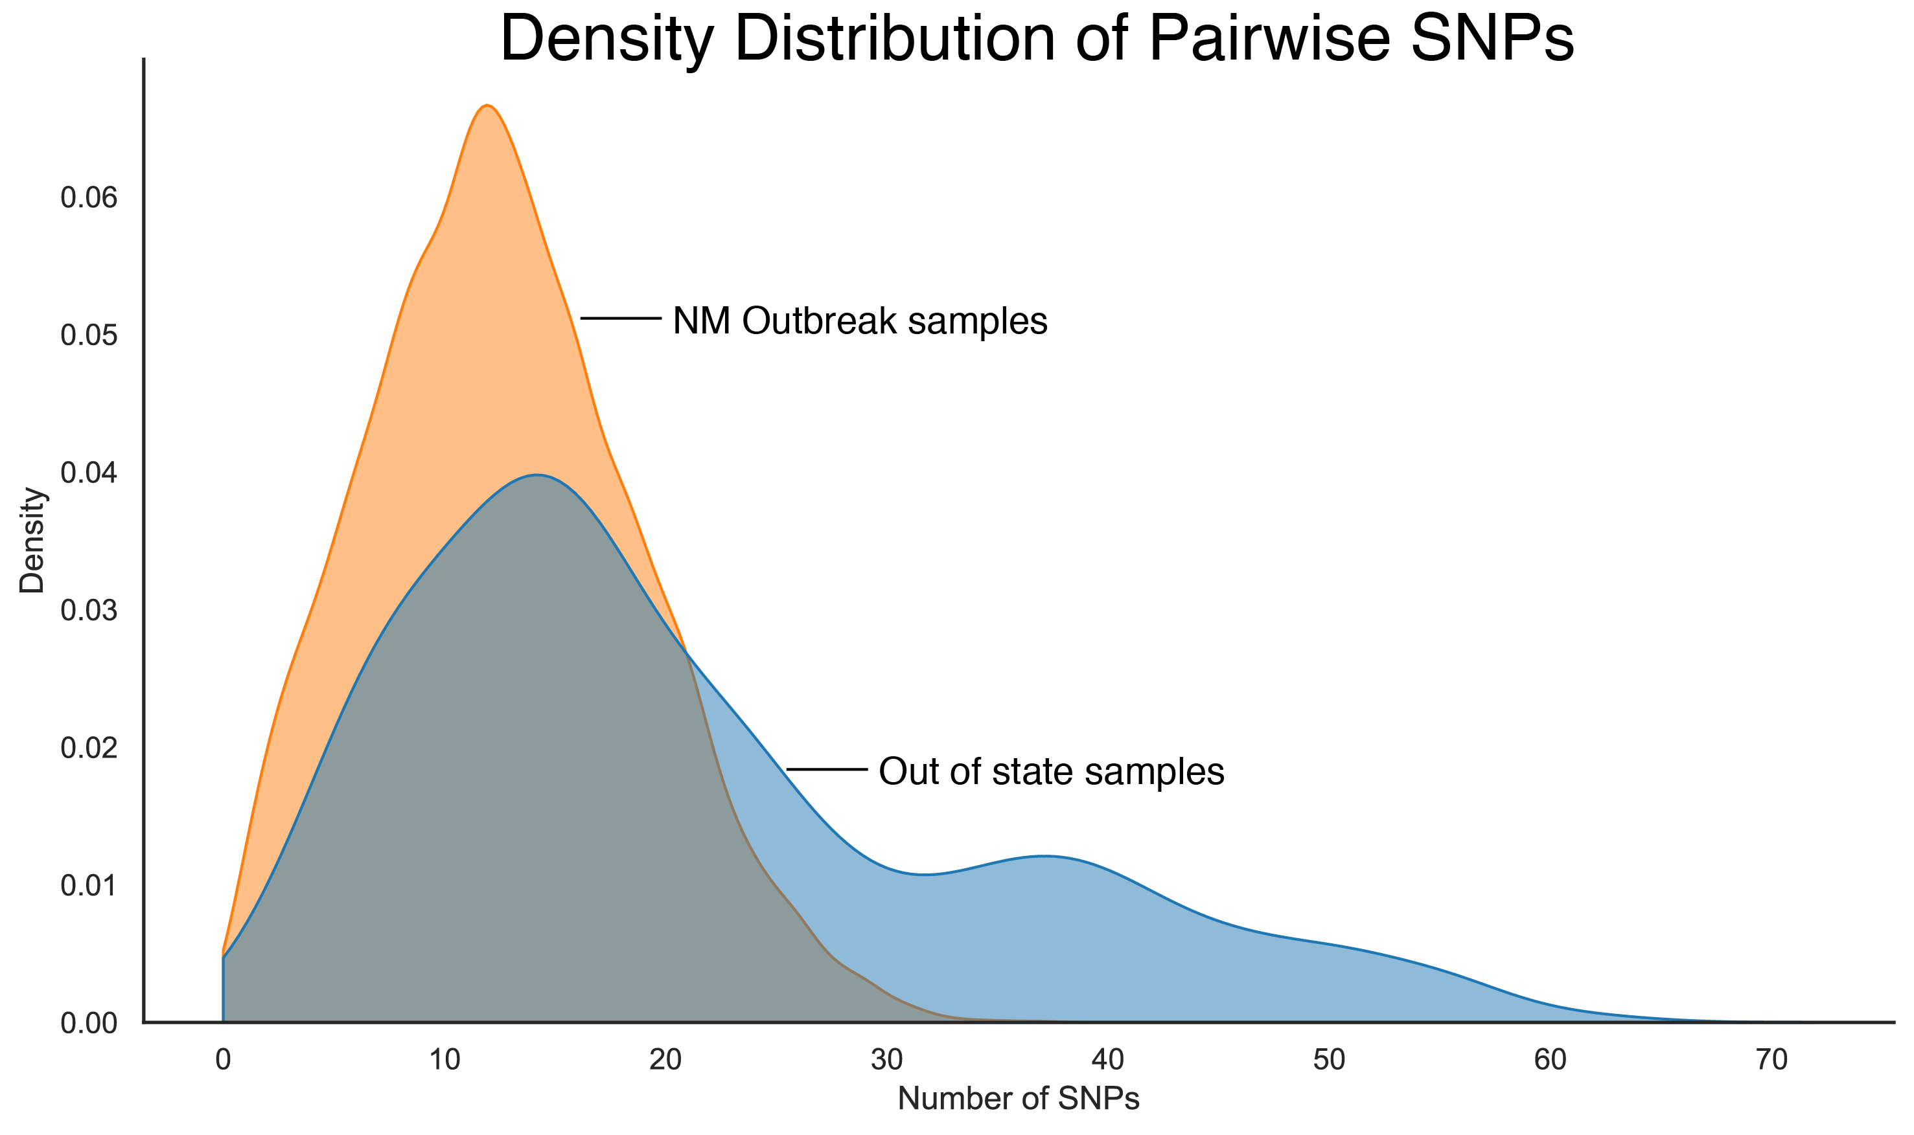

Supplementary Figure 1. Density distribution plot of pairwise SNP comparisons from alignments against the reference genome S. flexneri 2a str. 301. The NM outbreak samples consist only of pairwise comparisons between samples collected in New Mexico.

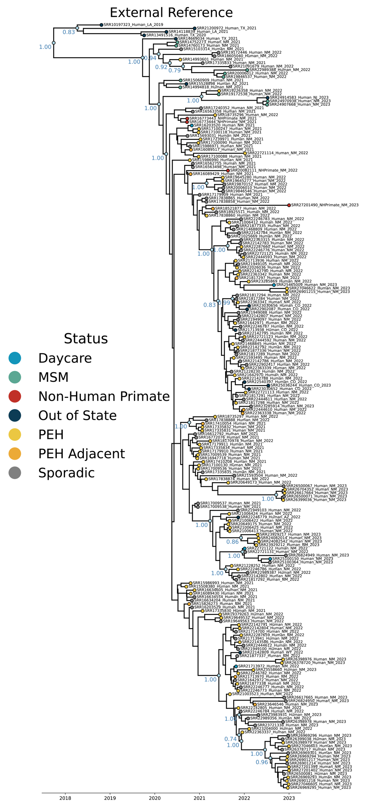
Supplementary Figure 2. BEAST phylogeny using the alignment against the external reference S. flexneri 2a str. 301 under the GTR+GAMMA site heterogeneity model and with a constant molecular clock model. Posterior probability values are shown for nodes with more than 3 descendants with values >0.7.
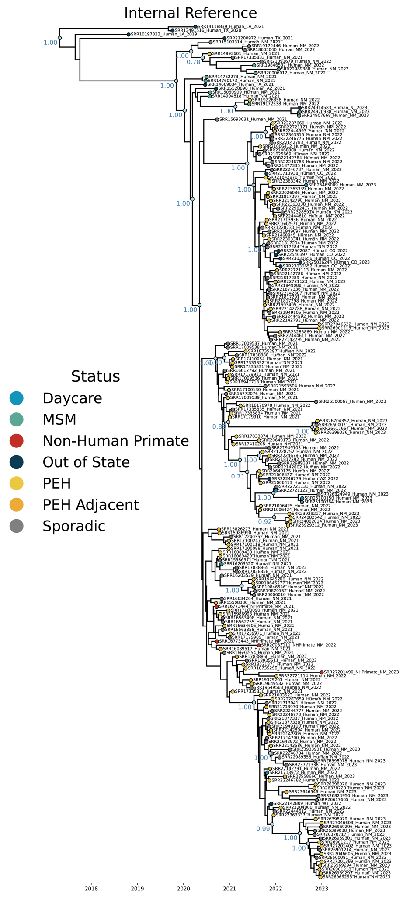
Supplementary Figure 3. BEAST phylogeny using the alignment against the internal reference PNUSAE076676 under the GTR+GAMMA site heterogeneity model and with a constant molecular clock model. Posterior probability values are shown for nodes with more than 3 descendants with values >0.7.

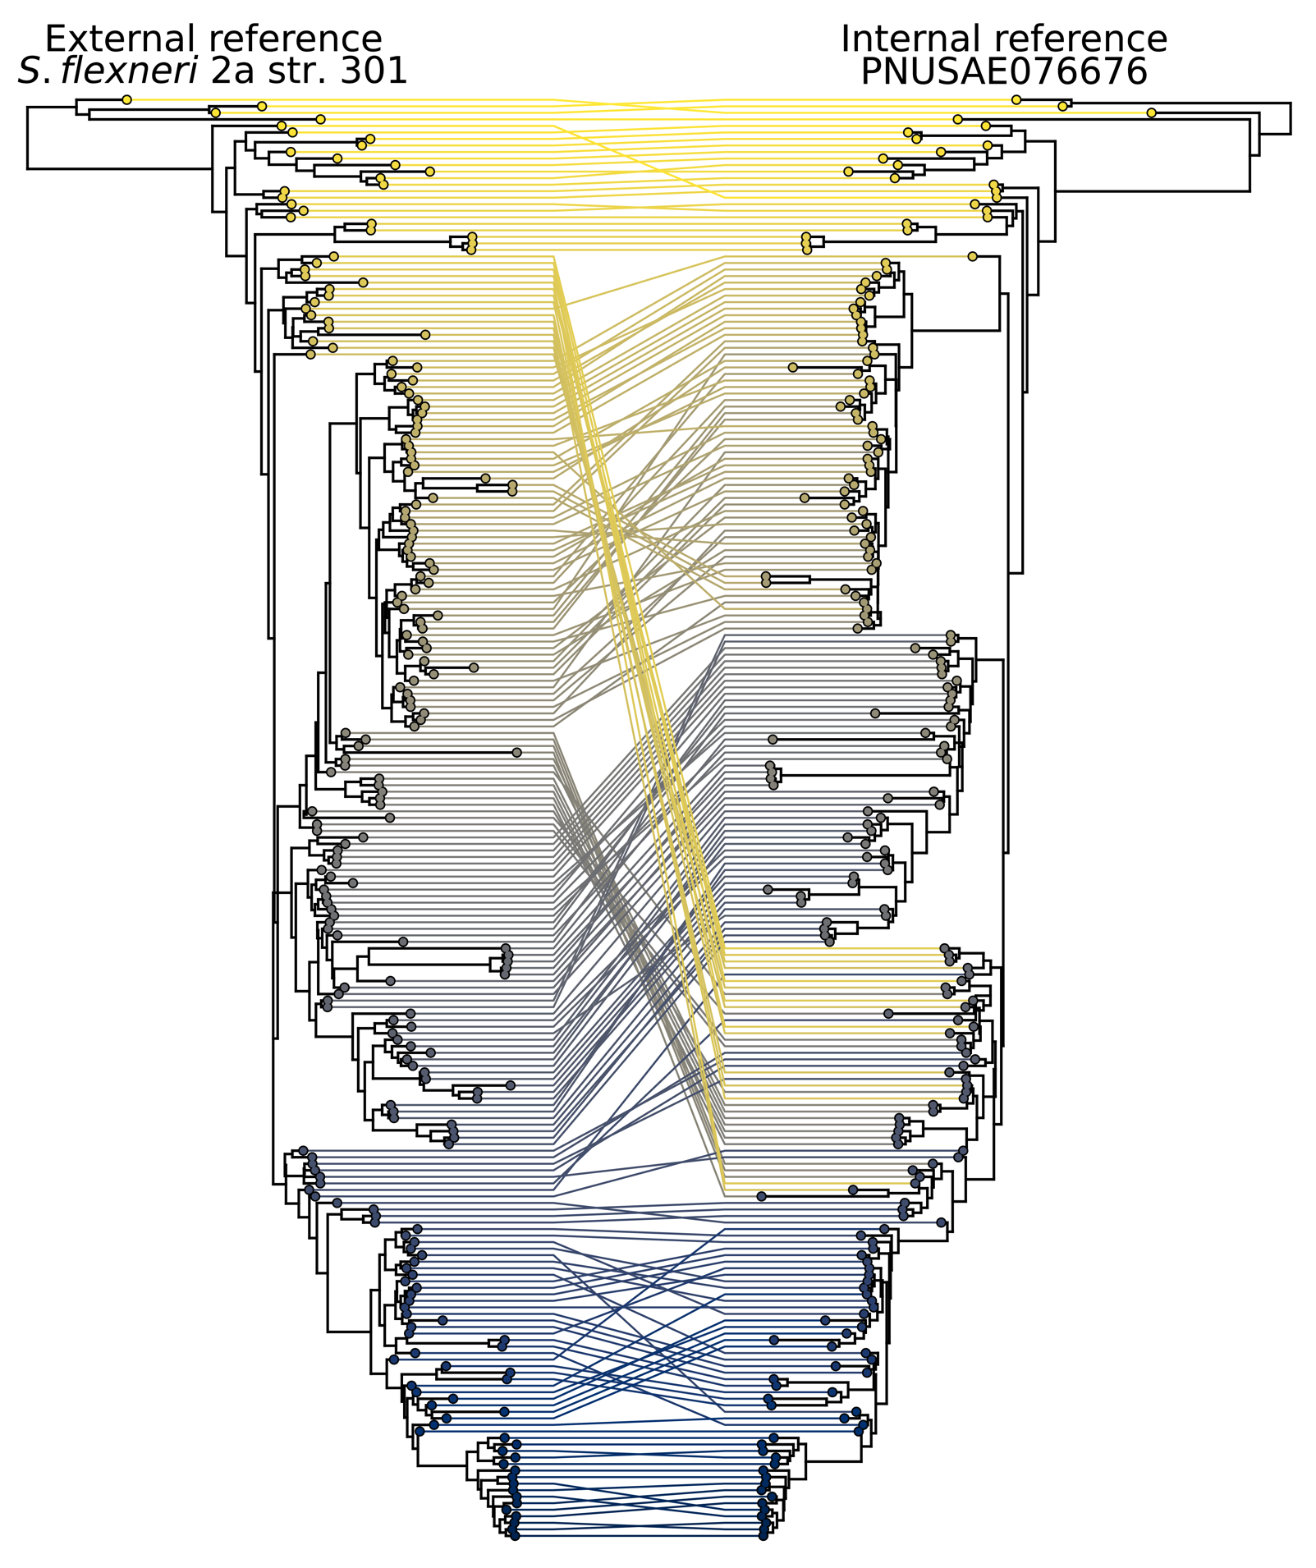

Supplementary Figure 4. Tree topology comparisons of BEAST phylogenies using the external reference Shigella flexneri 2a str. 301 and an internal reference strain PNUSAE076676.

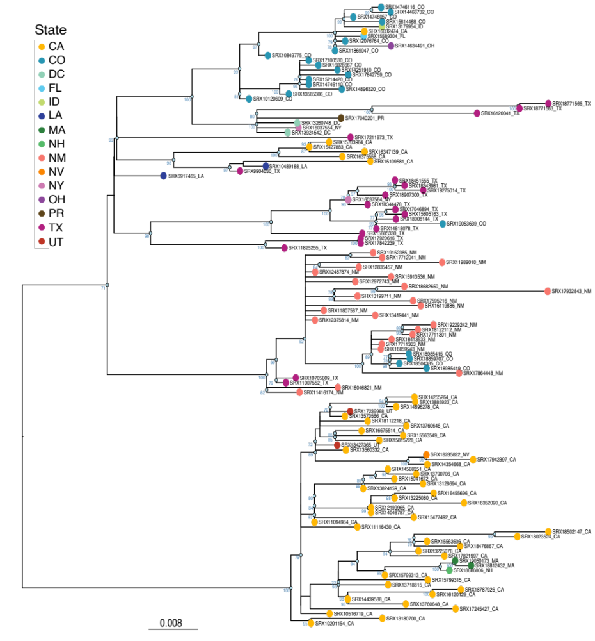
Supplementary Figure 5. Maximum likelihood phylogeny of S. flexneri 2a strains related to the New Mexico outbreak circulating within the U.S. We selected 23 representative sequences from the New Mexico outbreak and placed these in the context of 105 S. flexneri 2a strains that had less than 65 SNPs to the outbreak.

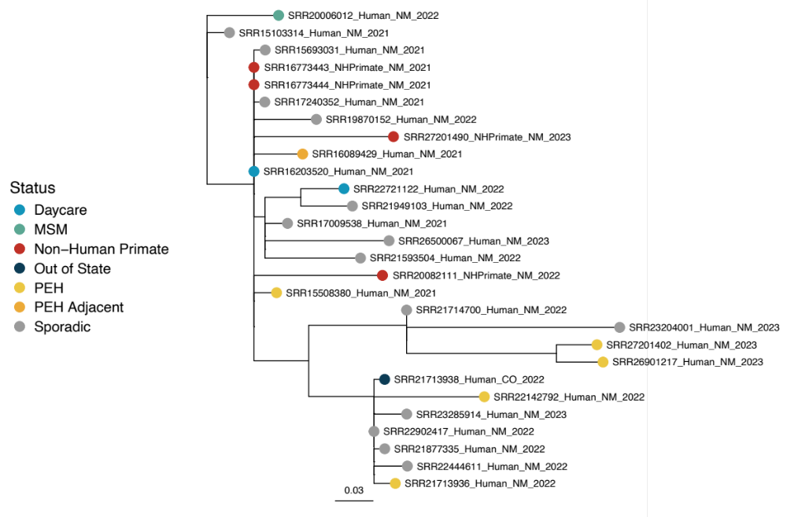
Supplementary Figure 6. Maximum likelihood phylogeny of 28 S. flexneri 2a genomes sequenced via Nanopore and Illumina to create complete genomes. The resulting genomes were compared using a reference-free method using ska2 and the resulting alignment passed to IQ-Tree to generate a maximum likelihood phylogeny under the GTR+GAMMA model.

