Appendices

Table 14. World Health Organization criteria for diagnosing polycythemia vera.
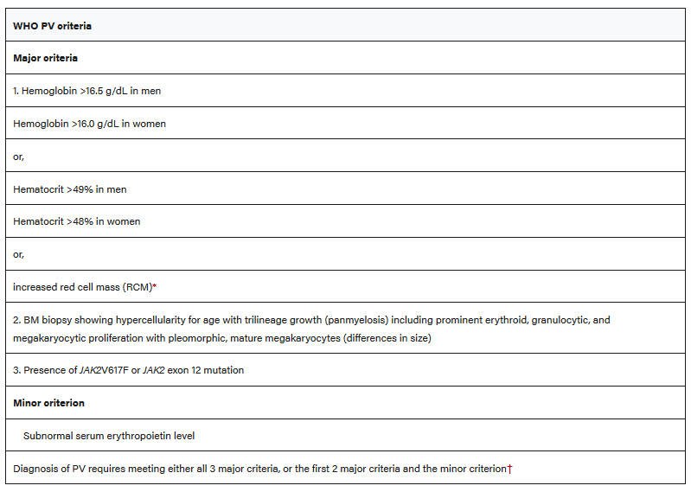
Note. Table adapted from “The 2016 revision to the World Health Organization classification of myeloid neoplasms and acute leukemia,” by Arber et al. Blood, 127(20), 2391–2405. https://doi.org/10.1182/blood-2016-03-643544
*More than 25% above the mean normal predicted value.

