The Anisotropic Self-Assembly Effect of Silica Hairy Nanoparticles:
toward Sustainable Rubber Nanocomposites for Tyre Application
Barbara Di Credico,^{a,}*Laura Tripaldi,^{a,§} Luciano Tadiello,^{b} Lucia Conzatti,^{c} Massimiliano D’Arienzo,ª Luca Giannini,^{b} Silvia Mostoni, ª Andrea Causa,^{b} Paola Stagnaro,^{c} and Roberto Scottiª
ª Dept. of Materials Science, INSTM, University of Milano-Bicocca, Via R. Cozzi, 55, 20125 Milano, Italy. Tel: +39-02-64485189; e-mail: barbara.dicredico@unimib.it
^{b} Pirelli Tyre SpA, Viale Sarca, 222, 20126 Milano, Italy
^{c} Istituto di Scienze e Tecnologie Chimiche (SCITEC) "G. Natta", Consiglio Nazionale delle Ricerche (CNR), Via De Marini 6, 16149 Genova, Italy
§ first author equal contribution
Keywords: silica, hairy nanoparticles, rubber nanocomposites, rolling resistance, green tyre

S1. Synthesis of SiO₂ and SiO₂-APTES
For the synthesis of the SiO₂ core, 62.5 mL of ammonium hydroxide solution (25 wt% in H₂O) and 1250 mL of ethanol were added to a 2000 mL two-necked flask equipped with a reflux condenser. The mixture was stirred at 300 revolutions per minutes (rpm) and heated to 60 °C. A mixture of 31.2 mL of TEOS and 35.0 mL of ethanol was added dropwise in about 50 min. After 20 h, the SiO₂ NPs (labelled SiO₂-ST) were separated by centrifugation, washed with EtOH and redispersed in 125 mL of EtOH. The suspension of SiO₂-ST was then heated at reflux under stirring at 300 rpm with 50 µL of 25 wt% of NH₄OH and 0.799 mL of APTES. After 24 h, the NPs (labelled SiO₂-APTES) were centrifuged and washed with toluene, then redispersed in 120 mL of toluene.
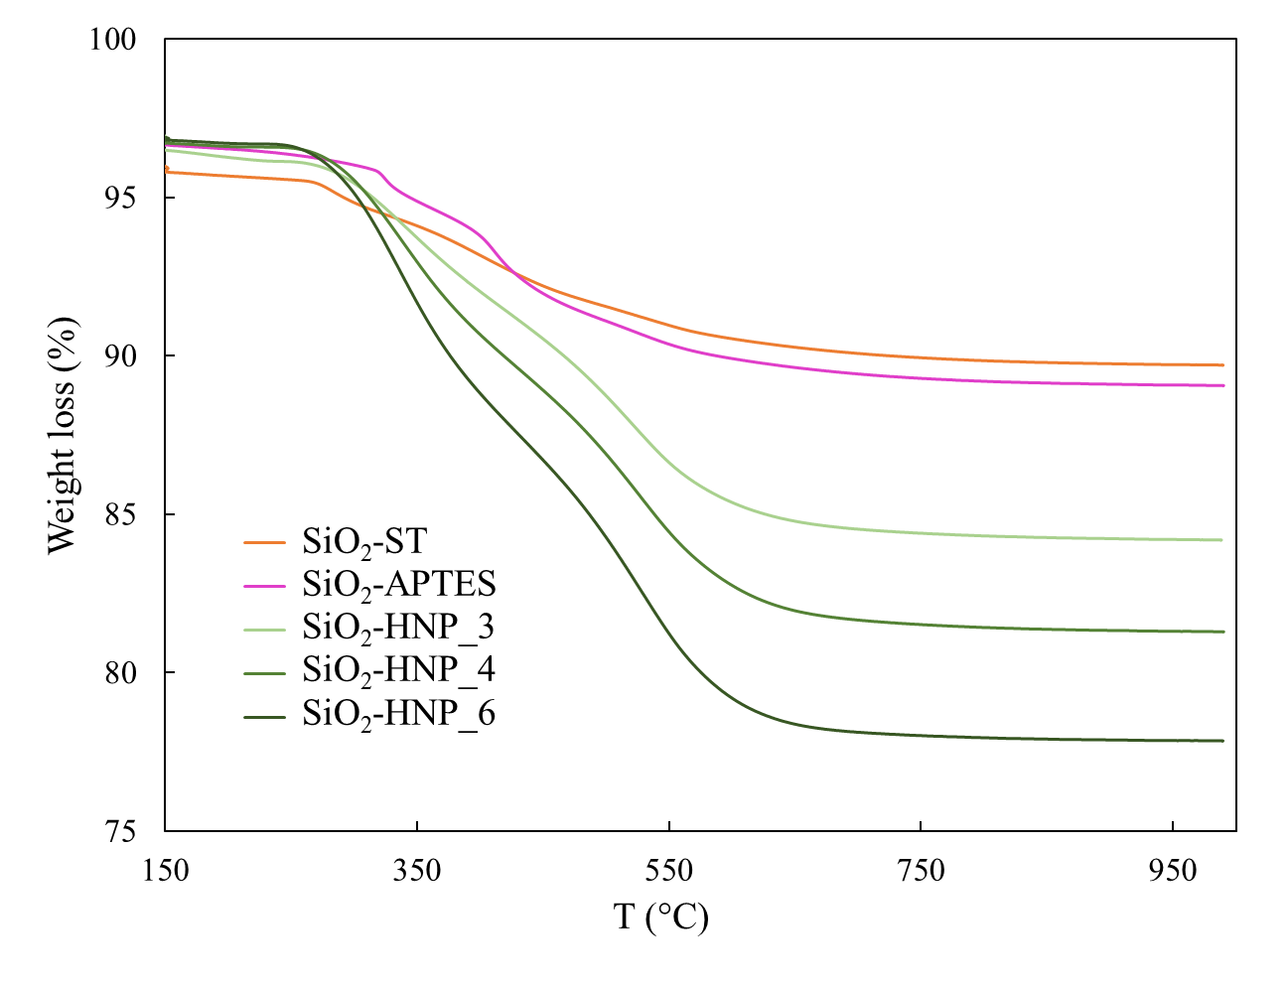

Figure S1. TGA curves of silica fillers showing weight loss between 150 °C and 1000 °C.

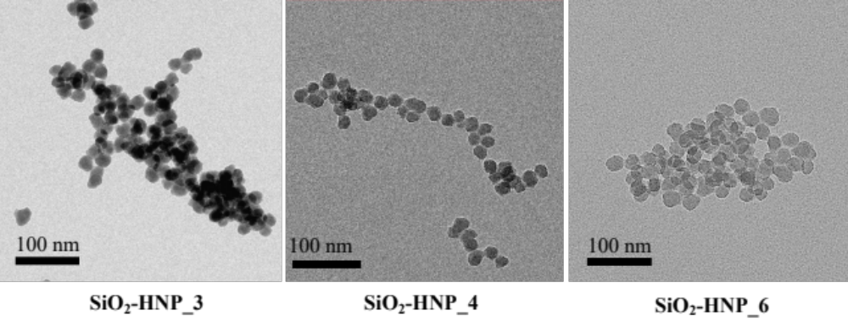
Figure S2. TEM images of SiO₂-HNP_X samples.

Table S1. Vulcanization properties of V-SiO₂-HNP_X/SBR NCs compared with reference materials.

Sample | t_{s2}  (min) | M_{L}  (dNm) | M_{H} (dNm) | ΔM_{H}-M_{L}  (dNm)
SiO₂-ST/SBR | 5 | 2.1 | 9.0 | 6.9
SiO₂-APTES/SBR | 4 | 2.2 | 11.5 | 9.3
SiO₂-HNP_3/SBR | 5 | 2.4 | 10.8 | 8.4
SiO₂-HNP_4/SBR | 5 | 1.8 | 13.6 | 11.8
SiO₂-HNP_6/SBR | 5 | 2.0 | 11.8 | 9.8

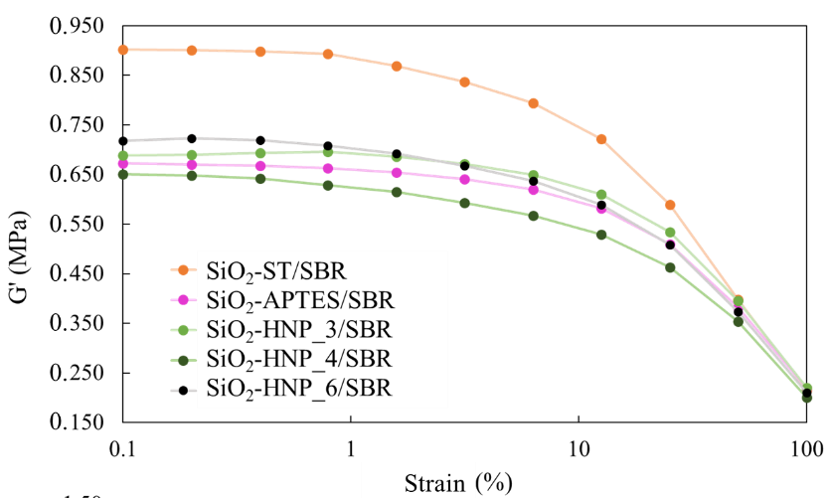
Figure S3. Storage modulus G' vs strain of uncured SiO₂-HNP_X/SBR NCs compared with reference materials.

