Persistent alveolar bronchiolization, interstitial fibrosis and impaired lung function post exercise are features of long-COVID in SARS-CoV-2-Delta variant infected aged hamsters

Laura Heydemann^{1, §}, Małgorzata Ciurkiewicz^{1, §}, Theresa Störk¹, Isabel Zdora¹, Kirsten Hülskötter¹, Katharina Manuela Gregor¹, Lukas Mathias Michaely¹, Wencke Reineking¹, Tom Schreiner¹, Georg Beythien¹, Asisa Volz^{2,4}, Maren von Köckritz-Blickwede^{3,4}, Tamara Tuchel^{2,4}, Christian Meyer zu Natrup^{2,4}, Lisa-Marie Schünemann^{2,4}, Sabrina Clever^{2,4}, Dirk Schaudien⁵, Karl Rohn⁶, Klaus Schughart^{7,8}, Robert Geffers⁹, Yukinari Kato¹⁰, Mika Kaneko¹⁰, Wolfgang Baumgärtner^{1, #} and Federico Armando^{1, 11, #}

¹Department of Pathology, University of Veterinary Medicine, Foundation, Hanover, Germany
²Department of Virology, University of Veterinary Medicine, Foundation, Hanover, Germany
³Department of Biochemistry, University of Veterinary Medicine, Foundation, Hanover, Germany
⁴Research Center for Emerging Infections and Zoonoses (RIZ), University of Veterinary Medicine, Foundation, Hanover, Germany
⁵Fraunhofer Institute for Toxicology and Experimental Medicine (ITEM), Hanover, Germany
⁶Department of Biometry, Epidemiology and Data Management, University of Veterinary Medicine, Foundation, Hanover, Germany
⁷Department of Microbiology, Immunology and Biochemistry, University of Tennessee Health Science Center, Memphis, Tennessee, USA,
⁸Institute of Virology Münster, University of Münster, Münster, Germany
⁹Helmholtz Centre for Infection Research (HZI), Brunswick, Germany
Medicine, Foundation, Hanover, Germany
¹⁰ Department of antibody drug development,Tohoku University, Sendai, Miyagi, Japan
¹¹Pathology unit, Department of Veterinary Science, University of Parma, Parma, Italy

§ These authors contributed equally as co-first authors
# These authors contributed equally as co-last authors

Correspondence and requests for materials should be addressed to Wolfgang Baumgärtner. Wolfgang.baumgärtner@tiho-hannover.de

SUPPLEMENTARY DATA

This file contains:
Supplementary Tables: 3
Supplementary Figures: 6

Supplementary Table 1: Marker gene list of main pulmonary cell populations in the hamster species used in the different investigations

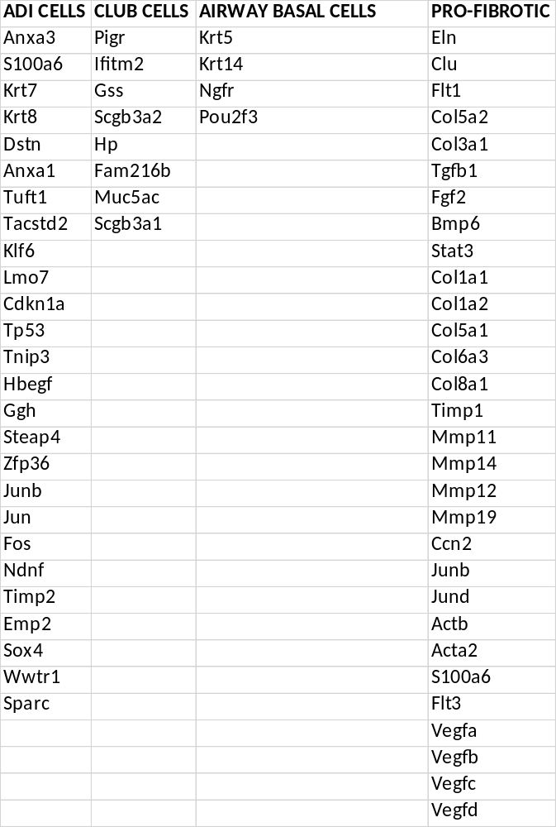
Abbreviations: alveolar differentiation intermediate cells (ADI)

Supplementary Table 2: Description and unit of the parameters chosen for the lung function analysis using whole body plethysmography with a gas analyzer

Parameter | Description | Unit
f | respiratory rate | breaths per minute (BPM)
Penh | enhanced pause, metric for breathing control / airway function;  $$(\frac{PEF}{PIF})*(\frac{Te-Tr}{Tr})$$ | /
PEF | peak expiratory flow of breath | ml/s
PIF | peak inspiratory flow of breath | ml/s
Te | expiratory time | s
Tr | relaxation time (time required to exhale 65 % of breath volume) | s
EF₅₀ | mid-expiratory flow (expiratory flow at 50% exhaled volume) | ml/s
vO₂ | minute volume of O₂ | ml/min
vCO₂ | minute volume of CO₂ | ml/min

References:
Menachery VD, Gralinski LE, Baric RS, Ferris MT. New Metrics for Evaluating Viral Respiratory Pathogenesis. PLoS One. 2015 Jun 26;10 (6):e0131451. doi: 10.1371/journal.pone.0131451. PMID: 26115403; PMCID: PMC4482571.

Supplementary Table 3: Primary antibodies, visualization method, dilution, clonality and host species, secondary antibody as well as positive controls used for immunohistochemical and immunofluorescence investigations.

Primary antibody | Visualization method | Dilution |  | Clonality, host species | Secondary antibody  (1:200) |  | Positive control
Primary antibody | Visualization method | IHC | IF | Clonality, host species | IHC | IF | Positive control
CK8 (Invitrogen PA-29607) | ABC | 1 : 500 |  | polyclonal, rabbit | GAR-b |  | Airways (Hm internal control)
CK8-Alexa Fluor 488 conjugated (abcam, AB192467) | / | / | 1 : 100 | monoclonal, rabbit, clone EP1628Y | / | / | Airways (Hm internal control)
SCGB1A1 (Proteintec, 10490-1-AP) | ABC | 1 : 1600 |  | polyclonal, rabbit | GAR-b |  | Airways (Hm internal control)
SCGB1A1-Alexa Fluor 488-conjugated (Proteintec CL488-10490) | / | / | 1 : 200 | polyclonal, rabbit | / | / | Airways (Hm internal control)
CK14 (invitrogen, PA5-16722) | ABC | 1 : 500 |  | polyclonal, rabbit | GAR-b |  | Airways (Hm internal control)
CK14 (invitrogen, MA5-11599) | / | / | 1 : 250 | monoclonal, mouse, clone LL002 |  | GAM-Cy3 | Airways (Hm internal control)
proSP-C (MEMD Millipore, AB3786) | / | / | 1 : 1000 | polyclonal, rabbit | / | GAR-Cy5 | AT2
Pdpn (kindly provided by Prof. Kato, Tohoku University, Japan) | / | / | 1 : 400 | monoclonal, mouse, 281-mG2a-f | / | GAM-Cy3 | AT1
p53 (NovusBiologicals,  BP53-12) | ABC | 1 : 200 | / | monoclonal, mouse, clone BP53-12 | GAM-b | / | Lymph node (Hm)
Ki-67 (abcam, ab15580-100) | ABC | 1 : 500 | 1 : 1000 | polyclonal, rabbit | GAR-b | GAR-Cy3  GAR-Cy5 | Lymph node (Hm)
p21 (SantaCruz Biotechnology, sc6246) | ABC | 1 : 100 | / | monoclonal, mouse, F-5 | GAM-b | / | Lymph node (Hm)
Δnp63 (Cell Signaling #67825) | ABC | 1 : 1000 | / | monoclonal, rabbit, clone E6Q30 | GAR-b | / | Oral squamous epithelia (Hm)
CD3 (Dako, A0452) | ABC | 1 : 500 | / | polyclonal, rabbit | GAR-b | / | SARS-CoV-2 infected lung, 6dpi (Hm internal control)
pax5 (BioLegend, Cat649702) | ABC | 1 : 500 | / | monoclonal, rat, 1H9 | RaRat-b | / | SARS-CoV-2 infected lung, 6dpi (Hm internal control)
Iba-1 (ThermoFisher, PA5-27436) | ABC | 1 : 1000 | / | polyclonal, rabbit | GAR-b | / | SARS-CoV-2 infected lung, 6dpi (Hm internal control)
MPO (abcam, ab9535) | ABC | 1 : 200 | / | rabbit, polyclonal | GAR-b | / | SARS-CoV-2 infected lung, 6dpi (Hm internal control)
CD204 (Abnova Corporation, MAB1710) | ABC | 1 :500 | / | monoclonal, mouse, clone SRA-E5 | / | / | SARS-CoV-2 infected lung, 6dpi (Hm internal control)
SARS-CoV-2 NP (Sinobiological, 40143-MM05) | EnVision | 1 : 16000 | / | monoclonal, mouse, clone 5 | / | / | SARS-Cov-2 infected lung, 3 dpi (Hm)

Abbreviations: AT1 = alveolar epithelial cell type 1, AT2 = alveolar epithelial cell type 2, -b = biotinylated, CD3 = cluster of differentiation 3, CD204 = cluster of differentiation 204, CK8 = Cytokeratin 8, CK14 = Cytokeratin 14, GAM = goat-anti-mouse, GAR = goat-anti-rabbit, Hm = hamster, Iba -1 = ionized calcium-binding adapter molecule 1, IHC = immunohistochemistry, IF = immunofluorescence, Ki-67 = antigen Kiel 67, MPO = myeloperoxidase, pax5 = paired box protein 5, Pdpn = Podoplanin, p53 = tumor protein 53, RaRat = rabbit-anti-rat, SARS-CoV-2 NP = SARS-CoV-2 nucleocapsid protein, proSP-C = pro-surfactant protein C, SCGB1A1 = secretoglobin 1a1

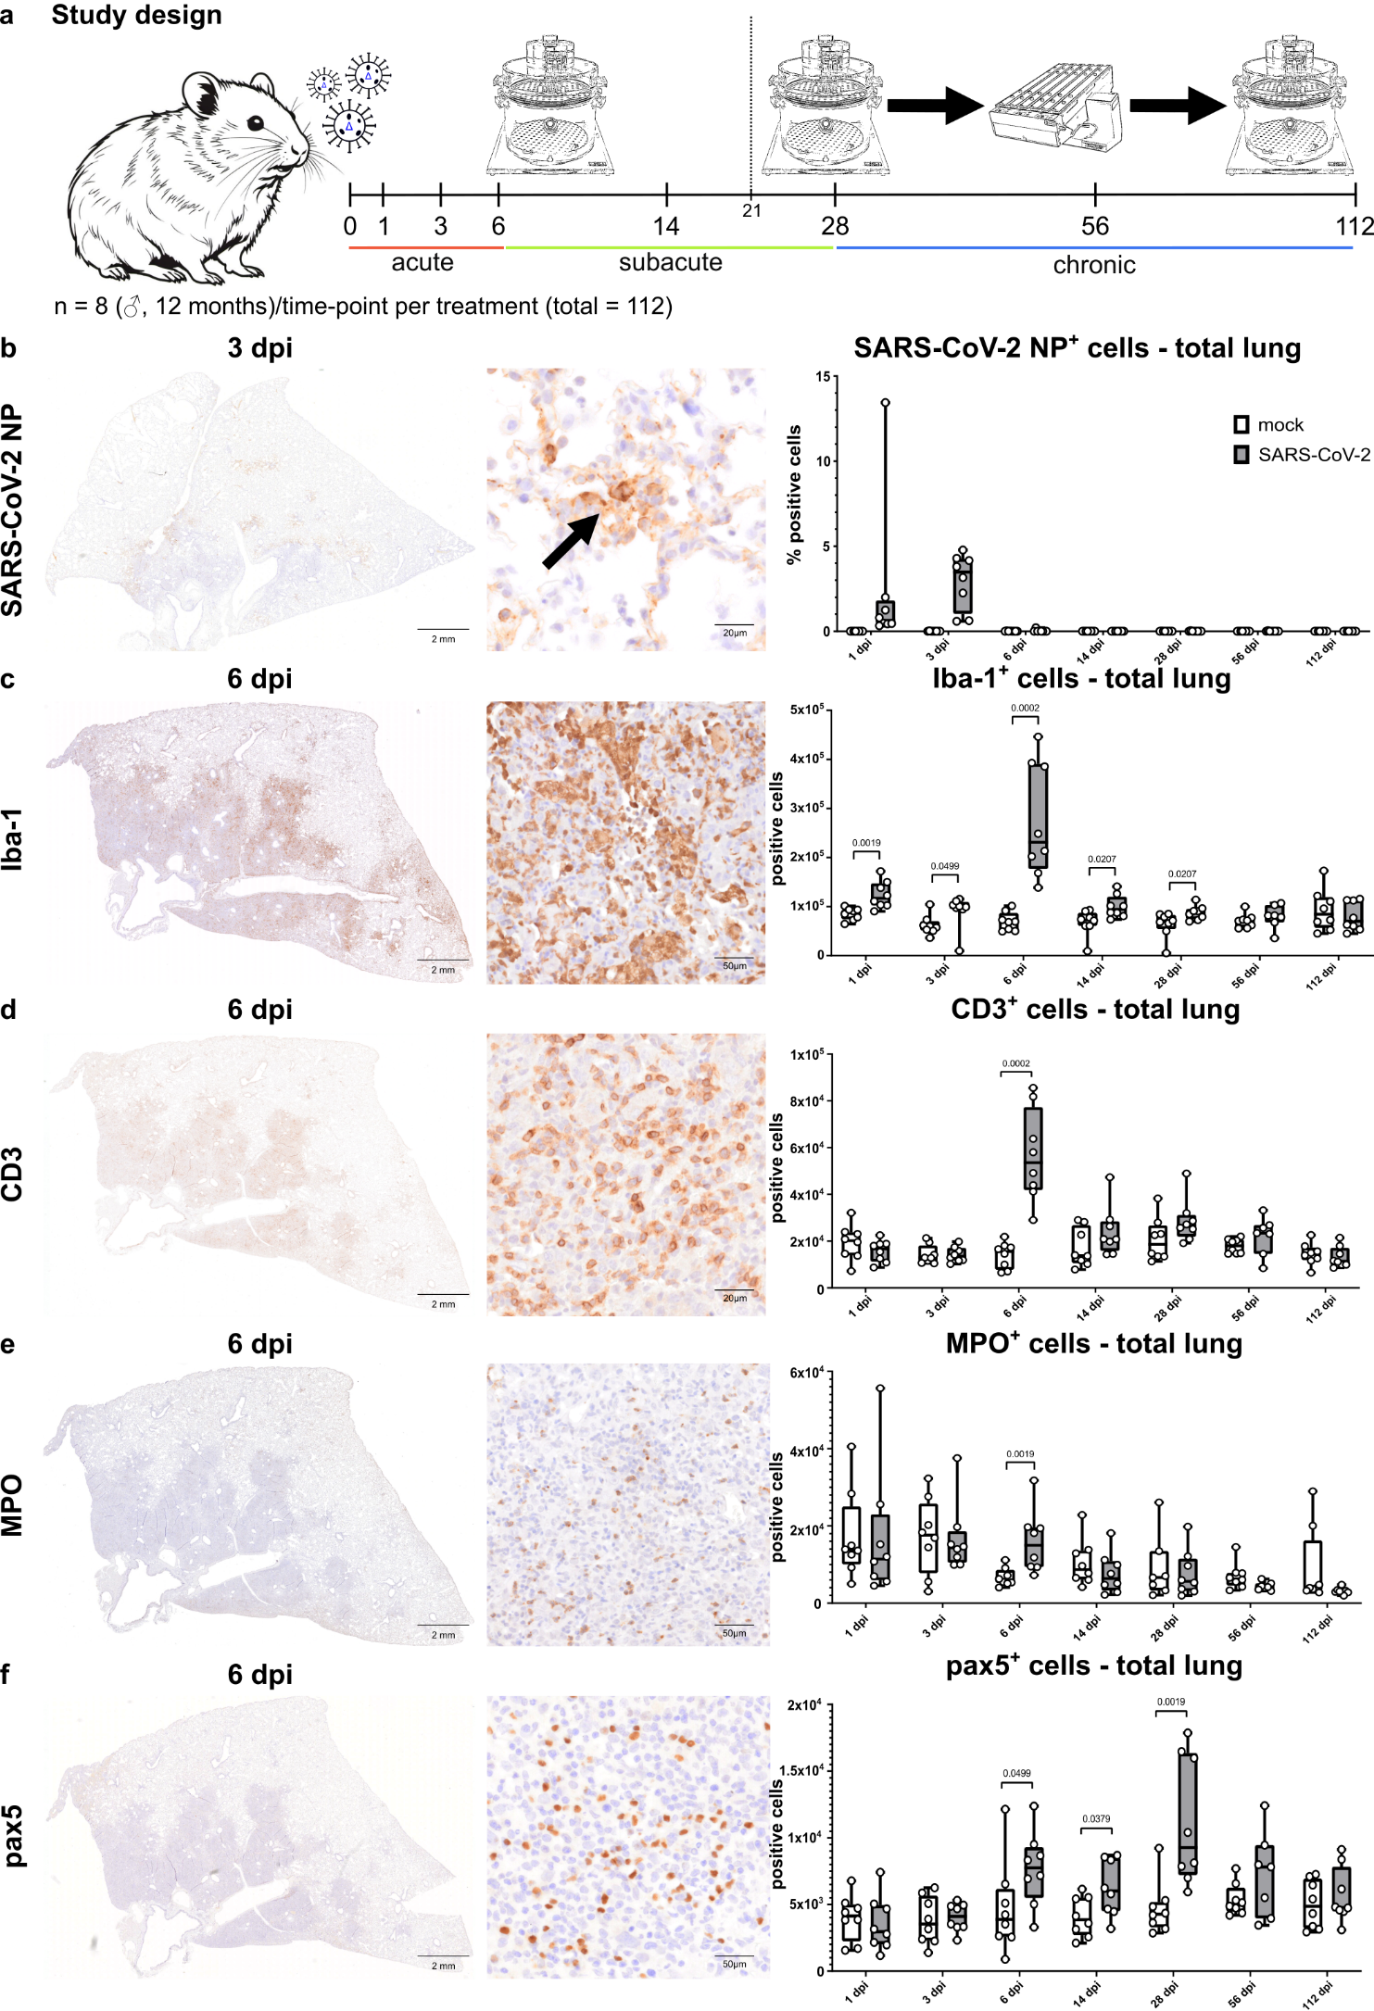

Supplementary figure 1: Experimental design, viral antigen and inflammatory cells in the lung
a Schematic drawing of the experimental design. Male, 1-year old Syrian hamsters were infected with SARS-CoV-2 Delta variant and sacrificed at 1, 3, 6, 14, 28, 56 and 112 dpi. During the experiment, repeated lung function measurements were conducted using a combination of whole-body plethysmography (WBP) with respiratory gas analysis prior and after exercise on a rodent treadmill (when performed). Physical exercise was used to exacerbate possible latent respiratory impairment at the later phase of infection. The study design allowed to distinguish three phases of the disease: acute phase (infection – 6 dpi), sub-acute phase (14 dpi), and chronic phase (28 dpi – 112 dpi). Physical exercise-induced stress was only applied to animals from 21 dpi onwards and was repeated weekly. b-f Immunohistochemistry for SARS-CoV-2 nucleoprotein (NP, a), Iba-1 (macrophages, b), CD3 (T cells, c), myeloperoxidase (MPO, heterophils, e), and Pax5 (B cells, f). For each staining, an overview, a high magnification and the quantification in the whole section of the left lung lobe is shown. Quantitative data is shown as box and whisker plots. The bounds of the box plot indicate the 25th and 75th percentiles, the bar indicates medians, and the whiskers indicate minima and maxima. Dots indicate individual values. Data was tested by two-tailed Mann–Whitney U test. A p value of ≤0.05 was chosen as the cutoff for statistical significance. N = 8 animals/group. Source data is provided as a Source Data file.

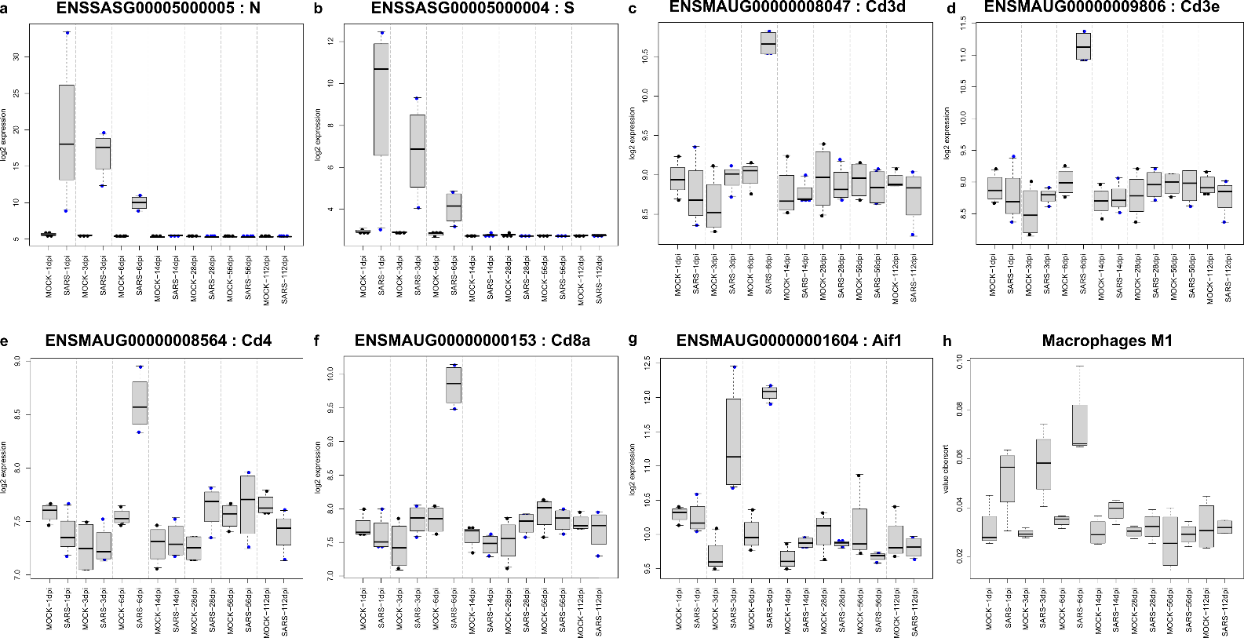

Supplementary figure 2: Beeswarm plots for SARS-CoV-2 genes (a,b), T-cell genes (c-f), and macrophages gene (g). In f there is a cybersortX deconvolution for M1-like macrophage signature genes

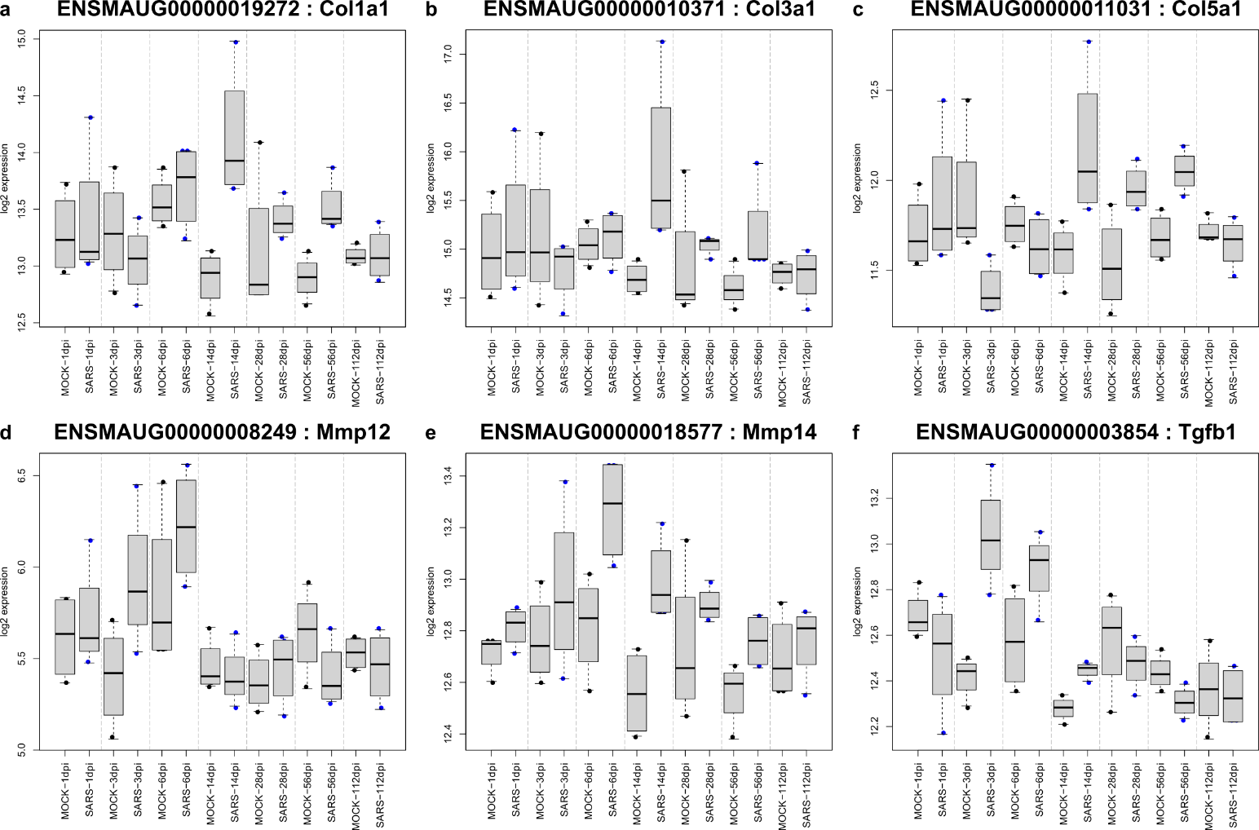

Supplementary figure 3: Beeswarm plots for genes associated with a pro-fibrotic environment in mock- and SARS-CoV-2 infected hamsters at different time-points post infection.

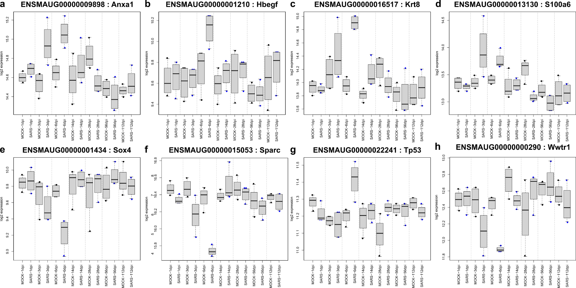

Supplementary figure 4: Beeswarm plots for alveolar differentiation intermediate (ADI) cell genes in mock- and SARS-CoV-2 infected hamsters at different time-points post infection.

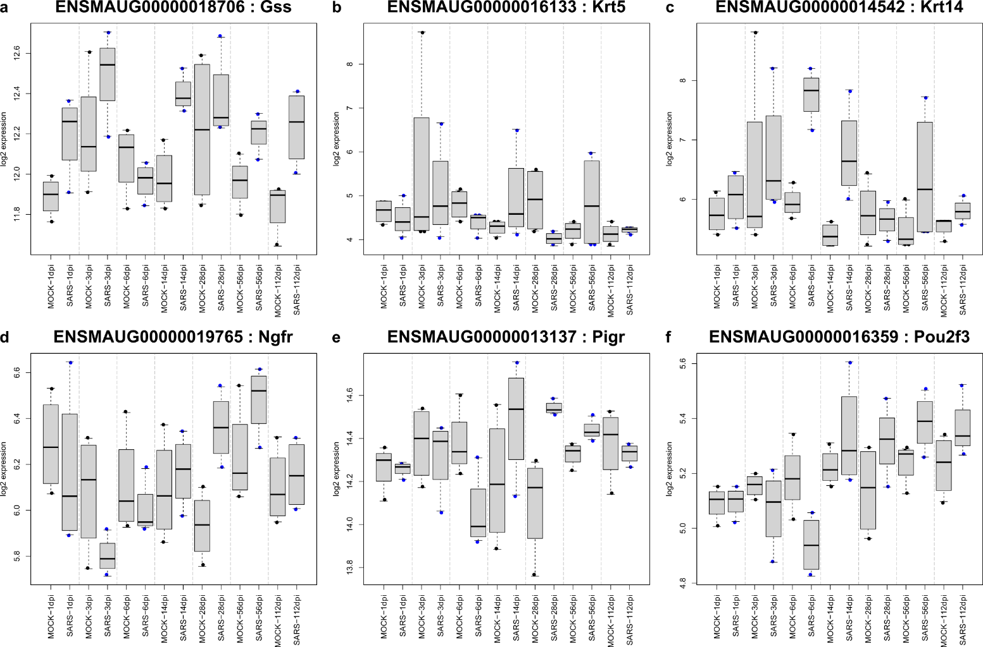

Supplementary figure 4: Beeswarm plots for airway basal cell genes (a-c) and club cell genes (d-f) in mock- and SARS-CoV-2 infected hamsters at different time-points post infection.
.

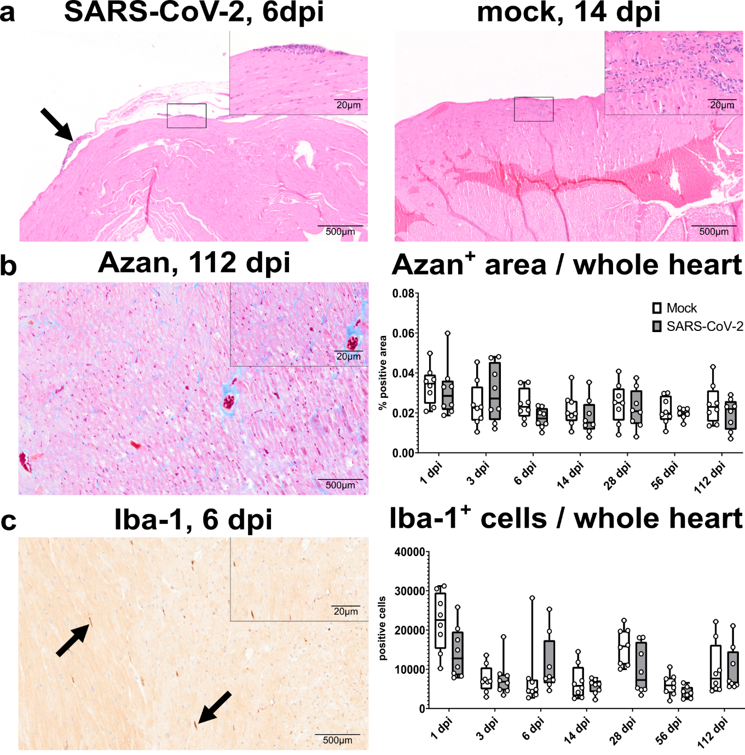

Supplementary figure 6: SARS-CoV-2 infection does not cause marked long term effects in the heart, kidney, liver or spleen of aged hamsters. a-c Lack of SARS-CoV-2 infection-related lesions in the hearts of hamsters. a Mild subepicardial inflammation was detected in SARS-CoV-2 (left panel) and mock (right panel) infected animals. Hematoxylin and eosin (HE) stain. b Left: Mild myocardial fibrosis (blue staining, Azan stain) in a SARS-CoV-2 infected hamster. Right: Quantification of Azan positive area in the hearts of mock and SARS-CoV-2 infected hamsters shows no difference between the groups. c Right: Immunohistochemistry showing small numbers of Iba-1⁺ histiocytic cells (arrows) in the heart of a SARS-CoV-2 infected hamster. Right: Quantification of Iba-1⁺ cells in the hearts of mock and SARS-CoV-2 infected hamsters shows no difference between the groups.

