Dear Editor(s)

The comprehensive search strategies I employed encompassed relevant keywords, medical subject headings (MeSH terms), and major databases to identify all potentially eligible prospective cohort studies and case-control studies examining the association between erectile dysfunction and cardiovascular disease risk.

I rigorously assessed the quality of each included study using the widely accepted Newcastle-Ottawa Scales, with detailed criteria for evaluating the selection, comparability, and outcome/exposure domains. By providing the supplementary information detailing the search strategies used for each database and the quality assessment tools employed,

I aim to promote transparency in the systematic review process and allow for reproducibility of the meta-analysis, enabling others to replicate the search and quality assessment methods.

Supplementary Materials:

1. Search Strategies
1.1. PubMed Search Strategy
1.2. Embase Search Strategy
1.3. Cochrane Library Search Strategy
1.4. Web of Science Search Strategy

2. Quality Assessment Tool
2.1. Newcastle-Ottawa Scale for Cohort Studies
2.2. Newcastle-Ottawa Scale for Case-Control Studies

1. Search Strategies

  - PubMed Search Strategy

("erectile dysfunction"[MeSH Terms] OR "erectile dysfunction"[All Fields] OR "impotence"[All Fields]) AND ("cardiovascular diseases"[MeSH Terms] OR "cardiovascular diseases"[All Fields] OR ("cardiovascular"[All Fields] AND "disease"[All Fields]) OR "cardiovascular disease"[All Fields] OR "coronary artery disease"[MeSH Terms] OR ("coronary"[All Fields] AND "artery"[All Fields] AND "disease"[All Fields]) OR "coronary artery disease"[All Fields] OR "stroke"[MeSH Terms] OR "stroke"[All Fields] OR "cardiovascular mortality"[All Fields] OR "risk factors"[MeSH Terms] OR ("risk"[All Fields] AND "factors"[All Fields]) OR "risk factors"[All Fields] OR "endothelial dysfunction"[MeSH Terms] OR ("endothelial"[All Fields] AND "dysfunction"[All Fields]) OR "endothelial dysfunction"[All Fields]) AND ("prospective studies"[MeSH Terms] OR ("prospective"[All Fields] AND "studies"[All Fields]) OR "prospective studies"[All Fields] OR "cohort studies"[MeSH Terms] OR ("cohort"[All Fields] AND "studies"[All Fields]) OR "cohort studies"[All Fields] OR "case-control studies"[MeSH Terms] OR ("case-control"[All Fields] AND "studies"[All Fields]) OR "case-control studies"[All Fields]) AND ("2009/01/01"[PDAT] : "2023/12/31"[PDAT])

1.2. Embase Search Strategy

('erectile dysfunction'/exp OR 'erectile dysfunction' OR impotence) AND ('cardiovascular disease'/exp OR 'cardiovascular disease' OR 'coronary artery disease'/exp OR 'coronary artery disease' OR stroke/exp OR stroke OR 'cardiovascular mortality' OR 'risk factor'/exp OR 'risk factor' OR 'endothelial dysfunction'/exp OR 'endothelial dysfunction') AND ('prospective study'/exp OR 'prospective study' OR 'cohort analysis'/exp OR 'cohort analysis' OR 'case control study'/exp OR 'case control study') AND [2009-2023]/py

1.3. Cochrane Library Search Strategy
#1 MeSH descriptor: [Erectile Dysfunction] explode all trees
#2 "erectile dysfunction" or impotence
#3 #1 or #2
#4 MeSH descriptor: [Cardiovascular Diseases] explode all trees
#5 "cardiovascular disease" or "coronary artery disease" or stroke or "cardiovascular mortality" or "risk factors" or "endothelial dysfunction"
#6 #4 or #5
#7 #3 and #6
#8 MeSH descriptor: [Prospective Studies] explode all trees
#9 MeSH descriptor: [Cohort Studies] explode all trees
#10 MeSH descriptor: [Case-Control Studies] explode all trees
#11 #8 or #9 or #10
#12 #7 and #11 Publication Year from 2009 to 2023

1.4. Web of Science Search Strategy

TS=("erectile dysfunction" OR impotence) AND TS=("cardiovascular disease*" OR "coronary artery disease" OR stroke OR "cardiovascular mortality" OR "risk factor*" OR "endothelial dysfunction") AND TS=("prospective stud*" OR "cohort stud*" OR "case-control stud*")
Timespan: 2009-2023

2. Quality Assessment Tool

2.1. Newcastle-Ottawa Scale for Cohort Studies
The Newcastle-Ottawa Scale (NOS) for cohort studies consists of three domains: selection, comparability, and outcome. Each domain includes several items, and a study can be awarded a maximum of one star for each item within the selection and outcome domains. A maximum of two stars can be awarded for comparability.

Selection (4 stars)
1) Representativeness of the exposed cohort
a) Truly representative of the average [describe] (1 star)
b) Somewhat representative of the average [describe] in the community (1 star)
c) Selected group of users (e.g., nurses, volunteers)
d) No description of the derivation of the cohort (0 star)

2) Selection of the non-exposed cohort
a) Drawn from the same community as the exposed cohort (1 star)
b) Drawn from a different source
c) No description of the derivation of the non-exposed cohort (0 star)

3) Ascertainment of exposure
a) Secure record (e.g., surgical records) (1 star)
b) Structured interview (1 star)
c) Written self-report
d) No description (0 star)

4) Demonstration that outcome of interest was not present at start of study
a) Yes (1 star)
b) No (0 star)

Comparability (2 stars)
1) Comparability of cohorts on the basis of the design or analysis
a) Study controls for [select most important factor] (1 star)
b) Study controls for any additional factor (1 star)

Outcome (3 stars)

1) Assessment of outcome
a) Independent blind assessment (1 star)
b) Record linkage (1 star)
c) Self-report
d) No description (0 star)

2) Was follow-up long enough for outcomes to occur
a) Yes (1 star)
b) No (0 star)

3) Adequacy of follow-up of cohorts
a) Complete follow-up - all subjects accounted for (1 star)
b) Subjects lost to follow-up unlikely to introduce bias - small number lost (1 star)
c) Follow-up rate < [specify] % and no description of those lost (0 star)
d) No statement (0 star)

2.2. Newcastle-Ottawa Scale for Case-Control Studies

The Newcastle-Ottawa Scale (NOS) for case-control studies consists of three domains: selection, comparability, and exposure. Each domain includes several items, and a study can be awarded a maximum of one star for each item within the selection and exposure domains. A maximum of two stars can be awarded for comparability.

Selection (4 stars)
1) Is the case definition adequate?
a) Yes, with independent validation (1 star)
b) Yes, e.g., record linkage or based on self-reports
c) No description (0 star)
2) Representativeness of the cases
a) Consecutive or obviously representative series of cases (1 star)
b) Potential for selection biases or not stated (0 star)

3) Selection of controls
a) Community controls (1 star)
b) Hospital controls, same community as cases (1 star)
c) No description (0 star)

4) Definition of controls
a) No history of disease (endpoint) (1 star)
b) No description of source (0 star)

Comparability (2 stars)
1) Comparability of cases and controls on the basis of the design or analysis
a) Study controls for [select most important factor] (1 star)
b) Study controls for any additional factor (1 star)

Exposure (3 stars)
1) Ascertainment of exposure
a) Secure record (e.g., surgical records) (1 star)
b) Structured interview where blind to case/control status (1 star)
c) Interview not blinded to case/control status
d) Written self-report or medical record only
e) No description (0 star)

2) Same method of ascertainment for cases and controls
a) Yes (1 star)
b) No (0 star)

3) Non-Response rate
a) Same rate for both groups (1 star)
b) Non-respondents described
c) Rate different and no designation (0 star)

2.3 PRISMA 2020 flow diagram.

Description

The systematic literature search across multiple electronic databases (PubMed, Embase, Cochrane Library, Web of Science)

Initially identified 2,137 potentially relevant records.
After removing duplicates by automation tools, 1,892 records remained for screening.
Through the initial screening of titles and abstracts, 1,712 records were excluded, leaving 180 full-text articles for further assessment.

Upon full-text review, 163 articles were excluded based on the following reasons: 95 did not report relevant outcomes, 32 had insufficient data or inappropriate study design, 18 involved non-eligible populations, and 18 were review articles or conference abstracts.

Ultimately, 17 studies met the inclusion criteria and were included in the qualitative synthesis and meta-analysis. These included 15 prospective cohort studies and 2 case-control studies, involving a total of 236,942 participants.

Records identified from:

Databases (n = 4)
Records identified from:
PubMed (n = 1,012)
Embase (n = 687)
Cochrane Library (n = 215)
Web of Science (n = 223)
Registers (n = 2,137)

Records removed before screening:

Duplicate records removed (n = 245)
Records marked as ineligible by automation tools (n = 0)
Records removed for other reasons (n = 0)
Records screened (n = 1,892)
Records excluded** (n = 1,712)
Reports sought for retrieval (n = 180)
Reports not retrieved (n = 0)
Reports assessed for eligibility (n = 180)
Reports excluded: Irrelevant outcomes (n = 95)
Insufficient data/inappropriate study design (n = 32)
Non-eligible population (n = 18)
Review articles/conference abstracts (n = 18)
Studies included in review (n = 17)
Reports of included studies (n = 17)
Identification of studies via databases and registers

Reasons and corresponding numbers for the excluded reports:

- Irrelevant outcomes (n = 95)
- Insufficient data/inappropriate study design (n = 32)
- Non-eligible population (n = 18)
- Review articles/conference abstracts (n = 18)

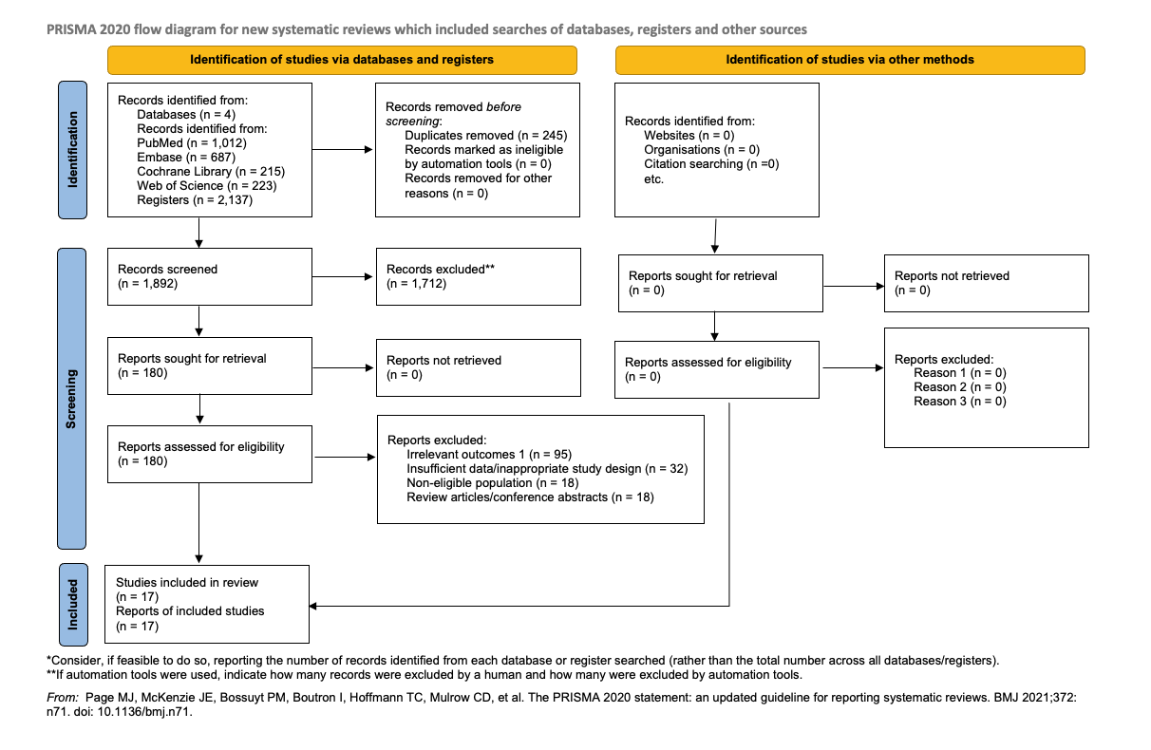

I confirm that this manuscript has not been published previously and is not under consideration for publication elsewhere. As an independent researcher, I have conducted this study independently and have no institutional affiliation to declare.

Thank you for considering my manuscript for publication. I look forward to your feedback and the opportunity to contribute to the scientific community through your esteemed journal.

Sincerely,
Julian Yin Vieira Borges

