Face ethnicity influences which features drive social judgements
Supplementary materials
Expressivity of generative face model. To ensure a high degree of fidelity when generating faces of different ethnicities, we tested the ability of our generative model of the human face (Yu et al., 2012; Zhan et al., 2019) to accurately represent faces which are not in the database (i.e., expressivity) using a cross-validation approach. Generally, at each iteration we rebuilt the generative model using a subset of the total 402 3D faces in the database, for each of 5 levels of coefficient constraints—that is, the range of values each coefficient in the GLM can take (for further details on the generative model building procedure, refer to Yu et al., 2012; Zhan et al., 2019). We then used the resulting version of the generative model to reconstruct each of the corresponding left-out faces. We applied this general procedure using three different cross-validation approaches:
- A k-fold cross-validation approach (k = 10) applied to all faces in the database, to test the overall expressivity of the generative model for faces of all ethnicities.
- A leave-one-out cross-validation approach applied only to Black African faces in the database (n = 8), to test the expressivity of the generative model for Black African faces specifically.
- A one-shot learning cross-validation approach applied only to Black African faces in the database (n = 8), to more conservatively test the expressivity of the generative model for Black African faces specifically.
SM Figure 1 shows the results.
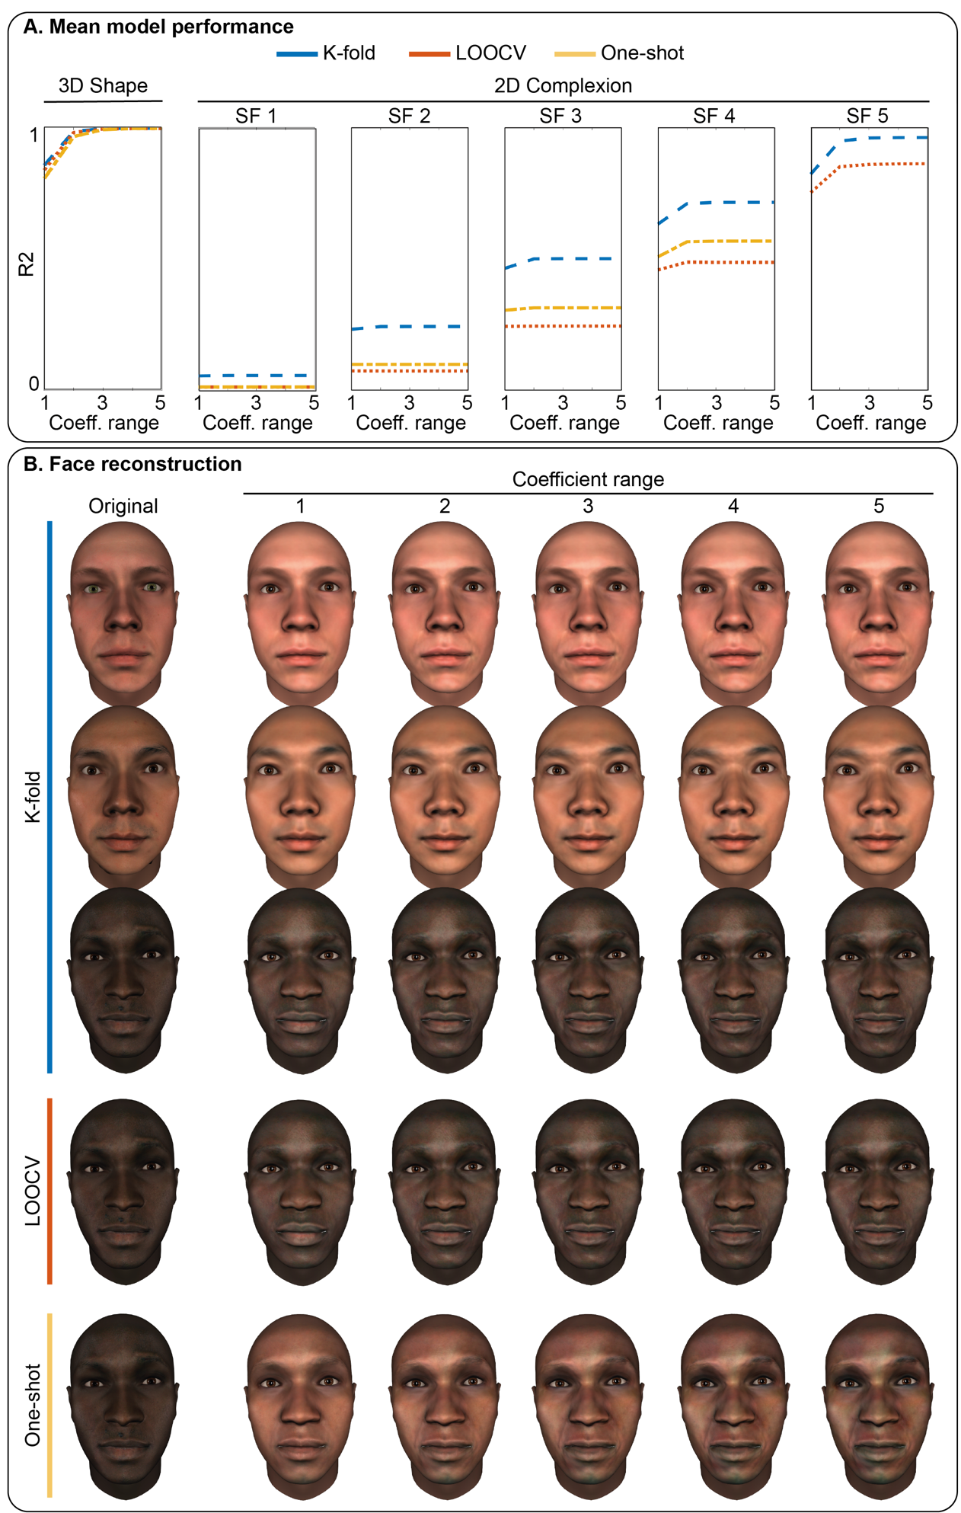
SM Figure 1. Expressivity of the generative model of the human face. A. Mean model performance. For 3D shape and each of the 5 spatial frequency bands for 2D complexion separately, line plots show the model performance (R²) for each of 5 coefficient ranges (x axis), averaged across test faces. Color-coding indicates the cross-validation approach (see legend at the top). B. Face reconstruction. For each cross-validation approach (see labels on left), rows of faces show the original face being tested (left) and its reconstruction (right) for each of the 5 coefficient ranges.

Line plots in SM Figure 1A show the model performance (R²) for each of the 3 cross-validation approaches (see legend at top) across 5 coefficient ranges (x axis), separately for 3D shape and each of 5 spatial frequency bands for 2D complexion. For brevity, results are averaged across test faces. Rows of faces in Figure 5B visualize the reported performance of each cross-validation approach (see labels on left) by showing the reconstruction of randomly selected test faces (left) across the 5 coefficient ranges (right). For 3D shape, the mean model performance was similar across the three cross-validation at each of the 5 coefficient ranges, and indicates a good fit (ranging from 80% to 99%). For 2D complexion, the mean model performance increases across spatial frequency bands in comparable ways across the three cross-validation approaches, which generally indicate an average-to-good fit. Nonetheless, the k-fold approach consistently performs better than both the LOOCV and one-shot approaches. Additionally, the one-shot approach fails to perform above 0 for the broadest spatial frequency band. This is not entirely surprising given that the broadest spatial frequency in the generative model captures overall skin tone; within the one-shot approach, the model is therefore not trained on enough BA exemplars to accurately represent darker skin tones characteristic of these faces. Such reasoning is evident in SM Figure 1B, where the last row of faces (one-shot approach) shows similarly accurate reconstruction of the 3D shape features of the original faces to the LOOCV and k-fold approaches, but much lighter (and thus inaccurate) skin tone.

Model visualization. To visualize the facial features captured by our 3D face models, we compared the significant 3D shape and complexion identity components of each per-observer model to the average face. For clearest comparisons, each model was compared to the ethnically neutral average male or female face. To do this, we first converted the predicted identity component weights for 3D shape and complexion into vertex values in cartesian space and pixel values in L*a*b color space respectively. We then computed the difference between these converted values and those representing the ethnically neutral average face. Specifically, for 3D shape, we subtracted the average face’s cartesian vertex values from those of each predicted face and calculated the cosine of the angle between the model’s difference from the average (i.e., residual) and the vector vertical to the tangent of each vertex of the average face. For complexion, we calculated the difference of the model from the average face for each L*a*b color channel separately.

Female 3D face models. Using the same modelling procedure described in the main text, we identified the specific facial features that drive social trait perception from female faces of different ethnicities. SM Figure 2 shows the results aggregated across individual observers (n = 20 per face ethnicity condition) using the same format as Figure 2.
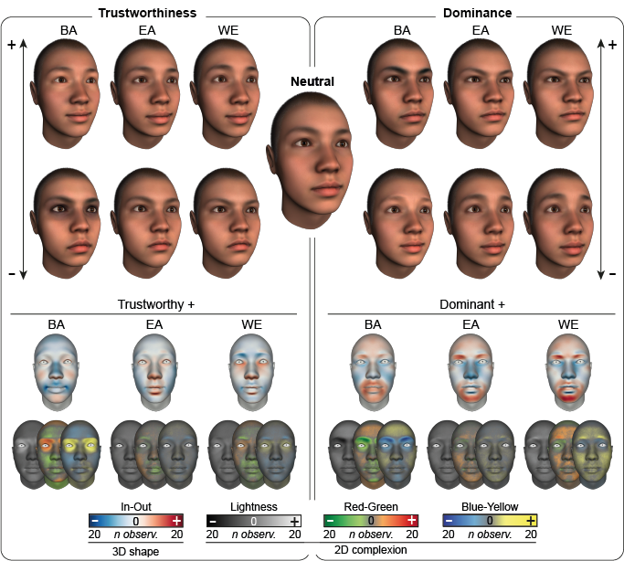

SM Figure 2. Shape and complexion facial features associated with social traits across face ethnicities from female faces. Following the same format as Figure 2, faces at the top show the 3D models of female trustworthy, untrustworthy, dominant, and submissive faces for each face ethnicity— Black African (BA), East Asian (EA) and White European (WE)—displayed on the same ethnically neutral face (see larger face in the center) for comparison. Below, color-coded faces show the results for trustworthy and dominant male faces separately for 3D shape and 2D complexion, with color-coding following the same format as Figure 1. Results are aggregated across participants (n = 20), with all identity components meeting or exceeding population prevalence threshold of n = 4.

Results show that the facial features driving social trait perception from female faces are largely the same as those for male faces. However, the prevalence of the effects is on average slightly weaker (see hue differences between Figure 2 and SM Figure 2).

Female shared vs face ethnicity-specific social trait features. Using Mutual Information as described in the main text, we derived the shared and face ethnicity-specific features observers used to perceive trustworthiness and dominance from female faces. SM Figure 3 shows the results using the same format as Figure 3.
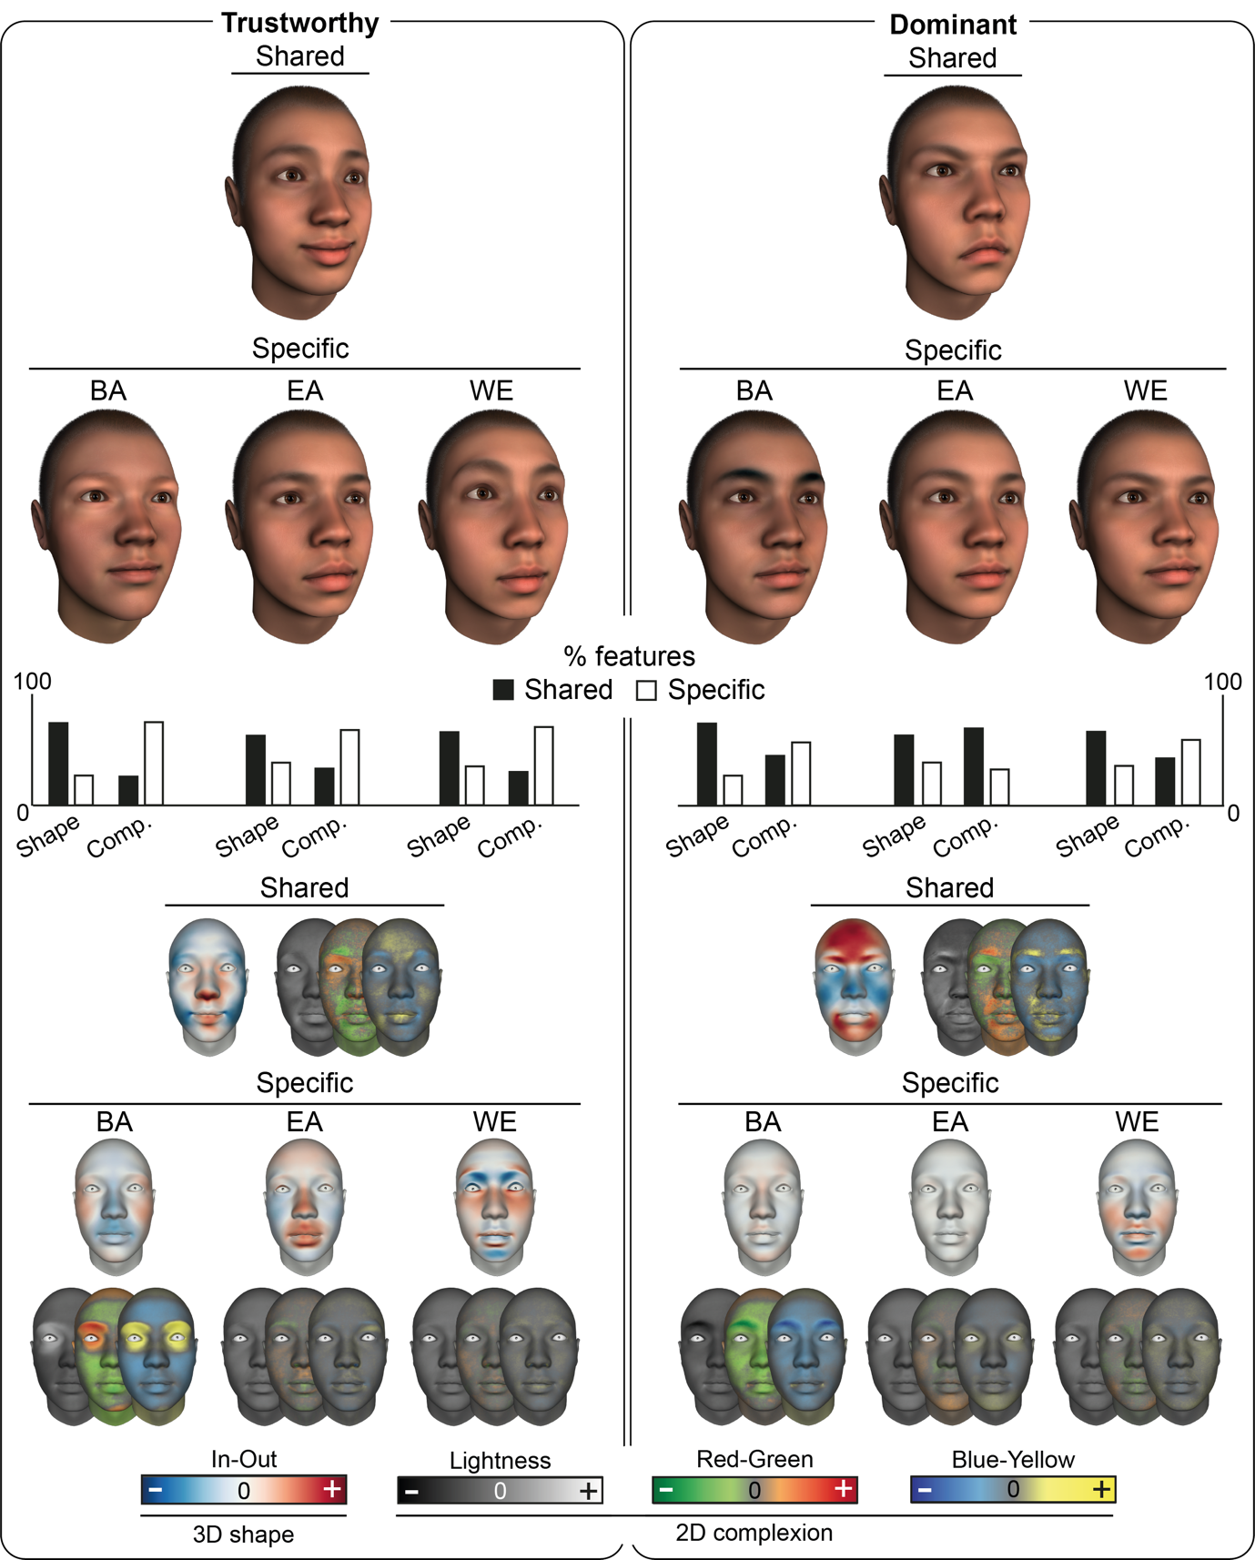
SM Figure 3. Facial features that are shared vs specific to face ethnicity for social trait perception from female faces. Following the same format as Figure 3, faces at the top show the facial features that are shared (top row) vs specific (bottom row) to each face ethnicity (BA—Black African; EA—East Asian; WE—White European), for female trustworthy (left panel) and dominant (right panel) faces. Bar plots below show the proportion of shared (black) vs face ethnicity-specific (white) 3D shape and 2D complexion features for each corresponding face ethnicity. Color-coded faces at the bottom show the results separately for 3D shape and 2D complexion, in the same layout as the faces at the top. Color-coding follows the same format as Figure 1 (see colorbars below), with values normalized per social trait for display purposes.

Results for female faces are generally comparable with, but not identical to, those for male faces. For trustworthiness, both the shared and face-ethnicity specific features are similar to those for male faces, but vary in strength. Specifically, the shared features are stronger (i.e., deviate further from the average) than for male faces, while the face ethnicity-specific features are weaker (i.e., deviate less from the average face) than for male faces. For dominance, the shared features are again similar to those for male faces but stronger (i.e., deviate more from the average), whereas the face ethnicity-specific features are much weaker.

Number of shared vs face ethnicity-specific identity components. SM table 1 reports the total number of shared vs face ethnicity-specific identity components of 3D shape and each of the 5 spatial frequency bands for 2D complexion that we identified using Mutual Information, separately for each social trait and stimulus sex.
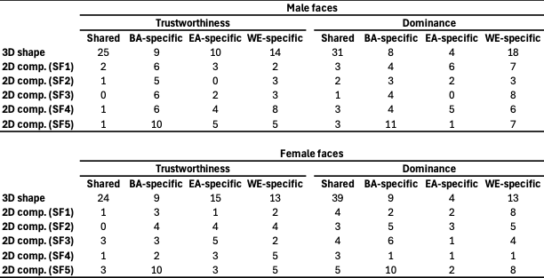
SM Table 1. Number of shared and specific identity components across face ethnicities. For male (top) and female faces (bottom) separately, each table reports the number of identity components that are shared vs face ethnicity-specific for trustworthiness (left) and dominance (right), separately for 3D shape and each of the 5 spatial frequencies for 2D complexion. Note that the number of shared identity components is the same across all three ethnicities.

Ethnic phenotypes in the generative model. To extract the facial features of 3D shape and 2D complexion that represent each ethnic average in our generative model, we first generated an ethnicity- and sex-neutral average face by setting all categorical factors in the generative model of the human face to 0 and adding no identity components. We then generated a sex-neutral average face for each face ethnicity (Black African, East Asian, White European) by setting each corresponding level of the ethnicity categorical factor to 1 in turn and again adding no sex information nor identity components. Finally, we computed the difference between each of these ethnicity-specific average faces and the ethnicity- and sex-neutral average face, separately for 3D shape and 2D complexion. SM Figure 4 shows the results for each ethnicity.
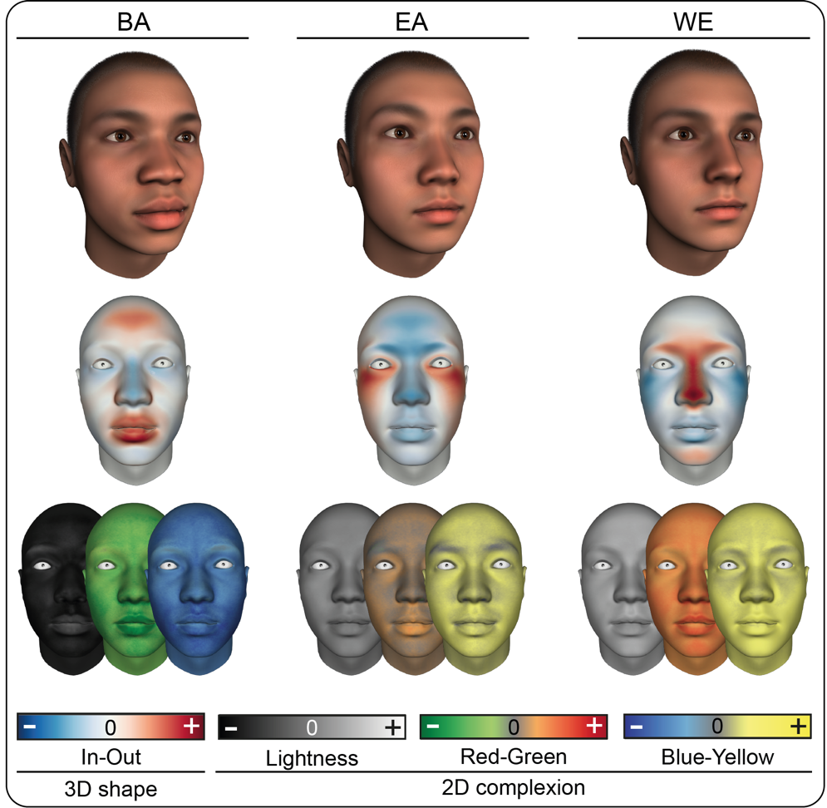
SM Figure 4. Ethnic phenotypic facial features. Faces at the top show the phenotypic facial features of each ethnicity, with shape and complexion combined and displayed on an ethnically and sex-neutral face. Corresponding color-coded faces below show the results separately for 3D shape (top) and 2D complexion (bottom). Color-coding follows the same format as Figure 1 (see colorbars below).

Faces at the tops show the phenotypic facial features of each ethnicity with shape and complexion features combined and displayed on the ethnicity- and sex-neutral face for comparisons. Color-coded faces below show the results separately for 3D shape and 2D complexion, with color-coding following the same format as Figure 1. Black African features comprise a bigger head, flatter nose bridge with a wider nose tip, and fuller lips together with a darker, cooler skin tone than the ethnicity- and sex-neutral average face; East Asian features comprise a smaller head, wider face, higher cheekbones, and a flatter nose and brow ridge together with a warmer skin tone than the ethnicity- and sex-neutral average face; and White European features comprise a narrower face, more prominent brow ridge, higher nose bridge, thinner lips and pointier chin together with a lighter, warmer skin tone than the ethnicity- and sex-neutral average face.

Validating ethnic variance in the facial features that drive social trait judgements from female faces. We used the same approach described in the main text to test whether the face ethnicity-specific features for female faces aligned with key predictions from the literature. SM Figure 5 shows the results using the same format as Figure 4.
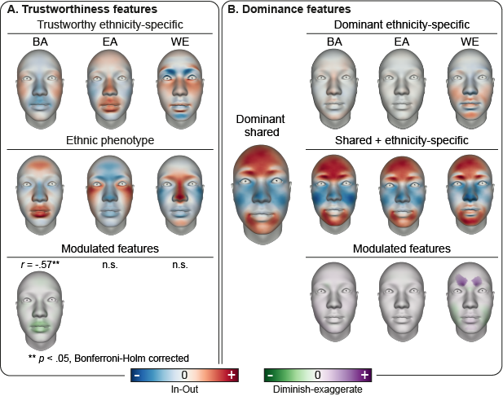
SM Figure 5. Face ethnicity influences which features are diminished or exaggerated for social trait perception from female faces. Following the same format as Figure 4, color-coded faces in A. show the face-ethnicity trustworthy features (top), their corresponding ethnic phenotypes (center), and the specific ethnic phenotypic facial features that are diminished for trustworthiness perception (see colorbar below; Pearson’s r above each face). B. Color-coded faces show the shared (left), face ethnicity-specific (top row), and shared plus face ethnicity-specific dominant features (center row). Green-and-purple color-coded faces below show the shared dominant facial features that are diminished vs exaggerated above-chance by the face-ethnicity specific dominant features, using the same color-coding as A.

SM Figure 5A shows the similarity between the face ethnicity-specific trustworthy features and their corresponding ethnic phenotypes. Results showed that for female faces only Black African-specific trustworthy 3D shape features were correlated with their corresponding ethnic phenotype (r = -.57, p < .001, Bonferroni-Holm corrected, above-chance). Like the male features, this correlation is driven by the size of the mouth, where BA-specific trustworthy features diminish its phenotypically larger size. Notably, the results for East Asian faces showed a similar pattern of effects (r = -.39, p < .001, Bonferroni-Holm corrected) but were not above-chance (r < -.44). Thus, similar to male faces, perceptions of trustworthiness from Black African female faces are driven by features which reduce ethnic phenotypic appearance. However, unlike male faces, this result is not robust for East Asian female faces.
SM Figure 5B shows the results for dominance. Similar to male faces, the WE-specific features exaggerate the shared protrusion of the browbone above-chance, and diminish the width of the jaw above-chance. Neither BA- nor EA-specific features produced any modulating effects. Thus, similar to male faces, perceptions of dominance from female faces rely on a stronger signal when the face is from the same ethnicity. However, unlike male faces, the strength of the signal is not weaker when judging other-ethnicity faces.

Screening questionnaire. Given the known influence of culture on social perception (e.g., De Leersnyder et al., 2011; Jack, 2013; Sutherland et al., 2018), we screened all observers for exposure to non-Western cultures using the following questionnaire. We only recruited observers who answered ‘no’ to all questions or who reported minimal exposure (e.g., having visited a non-Western country for a short period of time and not recently).
- Have you ever lived in a non-Western country (e.g., on a gap year, summer work, due to parental employment)?
- Have you ever visited a non-Western country (e.g., on vacation)?
- Have you ever dated or had a very close friendship with a non-Western person?
- Have you ever been involved with any non-Western culture societies/groups?
*By Western groups/countries, we are referring to Europe (Eastern and Western), USA, Canada, United Kingdom, Australia, and New Zealand.

Cross validation results. SM Figure 6 shows the results of the leave-one-out cross-validation for 3D shape (A) and 2D complexion (B), separately for female (left) and male faces (right). In each subplot, dots represent the prediction accuracy (measured as Spearman’s rho) of each individual observer’s social trait model. Black dots denote that the model’s prediction accuracy is statistically significantly above chance; red dots indicate it is not (see legend in top left subplot).

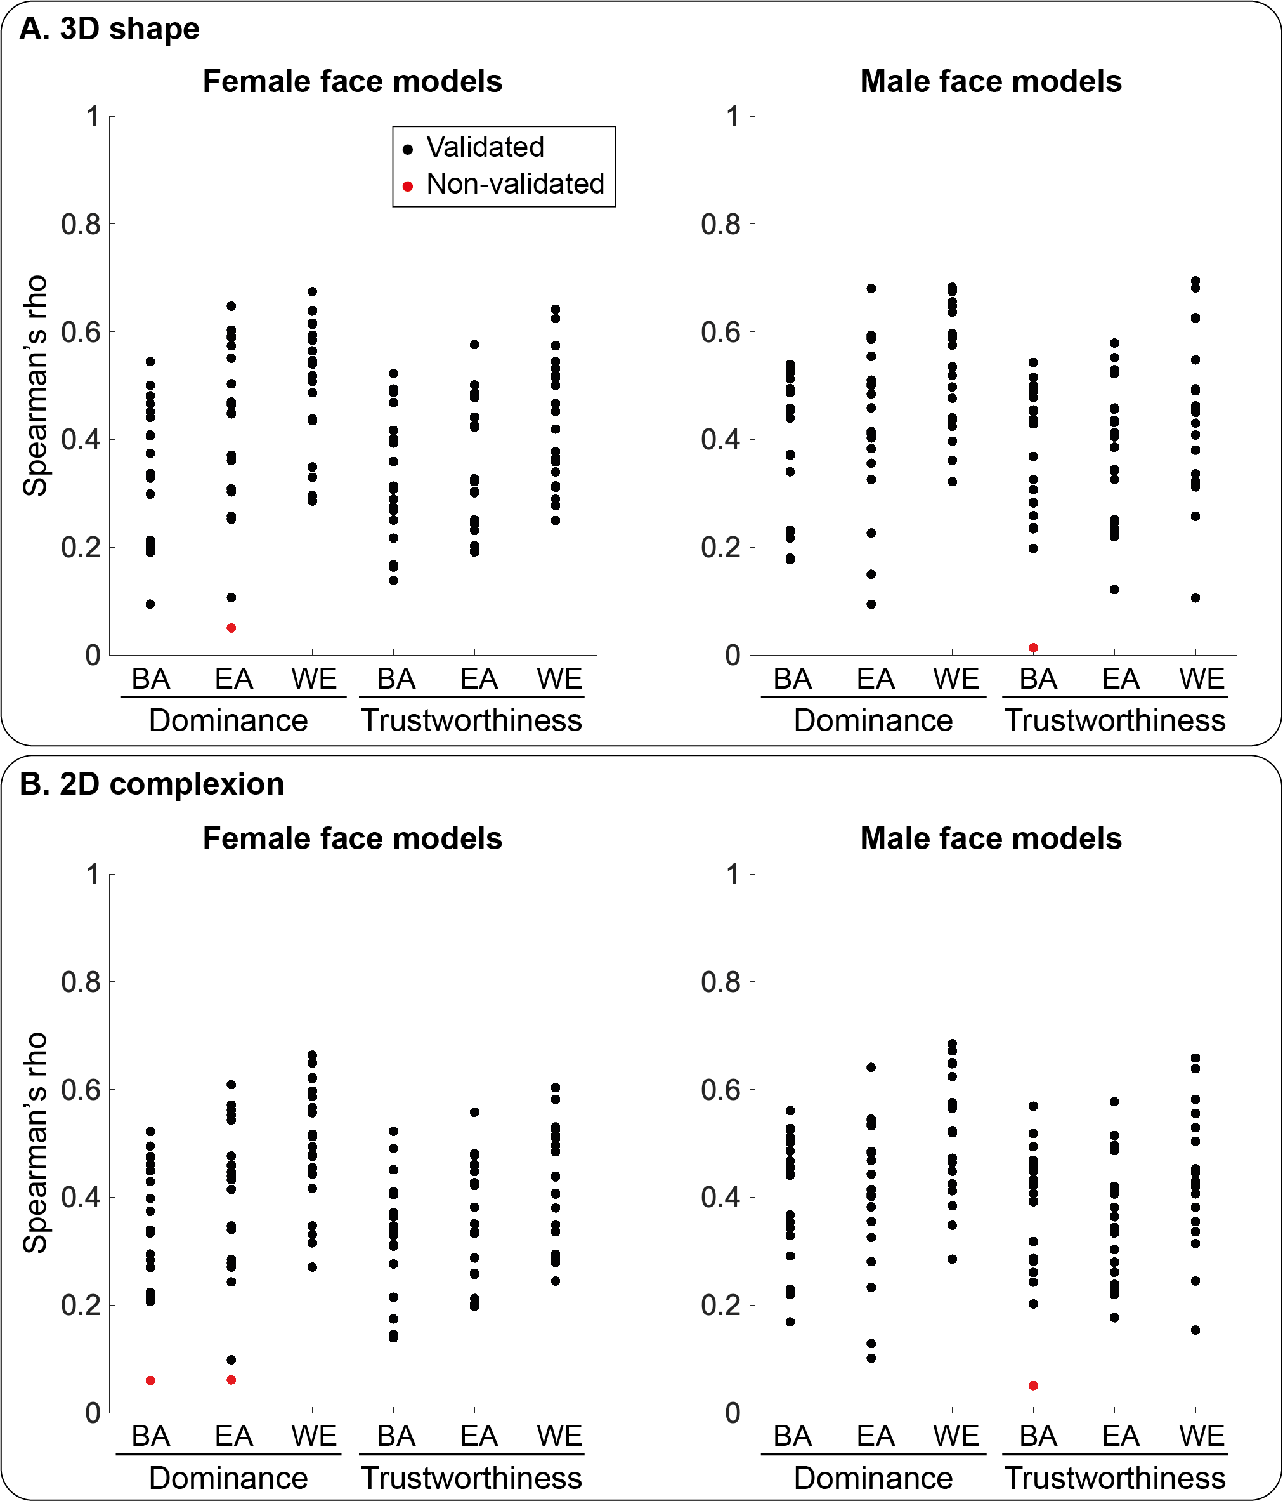
SM Figure 6. Leave-one-out cross-validation results. Each subplot shows the prediction accuracy (measured as Spearman’s rho) of each individual observer’s social trait models based on a leave-one-out cross-validation analysis, separately for 3D shape (A) and 2D complexion (B) and for each stimulus sex. Black denotes that the model’s prediction accuracy is statistically significantly above chance; red indicates it is not (see legend in top left subplot). Most of the 240 face models showed cross-observer validity (238 shape models; 237 complexion models).

De Leersnyder, J., Mesquita, B., & Kim, H. S. (2011). Where do my emotions belong? A study of immigrants' emotional acculturation [Research Support, Non-U.S. Gov't]. Pers Soc Psychol Bull, 37(4), 451-463. https://doi.org/10.1177/0146167211399103
Jack, R. E. (2013). Culture and facial expressions of emotion. Visual Cognition.
Sutherland, C. A., Liu, X., Zhang, L., Chu, Y., Oldmeadow, J. A., & Young, A. W. (2018). Facial first impressions across culture: Data-driven modeling of Chinese and British perceivers’ unconstrained facial impressions. Personality and social psychology bulletin, 44(4), 521-537.
Yu, H., Garrod, O. G. B., & Schyns, P. G. (2012). Perception-driven facial expression synthesis. Computers & Graphics, 36(3), 152-162.
Zhan, J., Garrod, O. G. B., van Rijsbergen, N., & Schyns, P. G. (2019). Modelling face memory reveals task-generalizable representations. Nature Human Behaviour. https://doi.org/10.1038/s41562-019-0625-3

