Supplemental Information
Supplemental Results

 | Supraesophageal
 | Total Proteins | Percent altered
Control | 2771 | 0.0
Pre-Emergent | 2739 | 3.2
Emergent | 2671 | 2.8
1-Day Post | 2639 | 3.7
3-Days Post | 2654 | 3.5
Table S1. Total number of proteins detected in the supraesophageal ganglion, as well as the percentage of proteins altered during parasitism. Pre-emergent caterpillars (caterpillars prior to wasp emergence) were compared to unparasitized caterpillars. Emergent (during wasp emergence), 1-Day Post Emergence and 3-Days Post Emergence caterpillars were compared to pre-emergent caterpillars. Numbers are the average of 3 biological replicates each containing tissues from 10 pooled individuals. The Bold numbers represent the percentage of proteins showing altered abundance that correlate with the change in host behaviour (i.e. are in addition to those changes observed during wasp larval development prior to host behavioural change).

Immune Gene | Immune Protein | Cyto/ECM Gene | Cyto/ECM Protein
attacin-2  Pre, Post | Attacin-2  Pre, Post | actin  Pre | Actin  Pre, Em, Post
gloverin  Pre, Em, Post | Gloverin  Pre, Post | paramyosin  Pre | Paramyosin  Pre, Em, Post
hemolin  Em, Post | Hemolin  Pre, Post | troponin T  Pre | Troponin T  Pre, Em, Post
lysozyme  Em, Post | Lysozyme  Post | troponin I  Pre | Troponin I  Pre, Em, Post
 |  | myosin light chain 1  Pre | Myosin light chain 1  Pre, Em, Post, Post
 |  | filamin-A  Pre | Filamin-A  Pre, Em, Post
 |  | myophilin  Pre | Myophilin-like  Em, Post
 |  | atlastin  Post | Atlastin  Post
 |  | hemicentin-1  Post | Hemicentin-1-like  Pre
 |  | hemicentin-2  Em, Post | Hemicentin-2-like  Em, Post
Table S2. Concordance of Immune and Cytoskeleton (Cyto) or Extracellular matrix (ECM) Genes and Proteins between Pre-Emergent (Pre) Brains and Controls, and between Pre-Emergent Brains and Brains from Caterpillars with Emerging Wasps (Em) or After Wasp Emergence (Post). Genes and proteins that increased from baseline are shown in red, while those that decreased are shown in blue. The timepoints in which the changes were significant are shown below the name, with red demonstrating time points in which the gene or protein was increased compared with baseline, and blue if it was decreased. The EM and Post time points are in bold to highlight changes that occur concomitant with the host’s behavioral change.

 |  |  |  |  |  | Fold Change (log₂)
LOC# |  | Gene |  |  | Pre-Emergence |  | p | Emergent | p | 1-Day Post | p | 3-Days Post | p
LOC115449179 |  | neural/ectodermal development factor IMP-L2 |  |  | 1.29 |  | 0.004 | 2.56 | 0.001 | 2.06 | 0.007 | 2.28 | 0.012
LOC115446816 |  | L-asparaginase 1 |  |  | 1.19 |  | 0.029 | 2.89 | 0.004 | 2.55 | 0.013 | 3.45 | 0.007
LOC115450302 |  | gloverin |  |  | 4.60 |  | 0.000 | 5.31 | 0.000 | 4.04 | 0.006 | 5.35 | 0.002
LOC115444553 |  | myrosinase 1 |  |  | 1.82 |  | 0.006 | 3.29 | 0.000 | 2.03 | 0.015 | 0.03 | 0.158
LOC115450855 |  | calcitonin gene-related peptide type 1 receptor |  |  | 1.45 |  | 0.006 | 1.68 | 0.000 | 1.26 | 0.003 | 0.92 | 0.052
LOC115443503 |  | WAP four-disulfide core domain protein 18-like |  |  | 3.67 |  | 0.002 | 1.47 | 0.029 | 0.12 | 0.082 | 3.19 | 0.003
LOC115449094 |  | peptidoglycan recognition protein |  |  | 1.93 |  | 0.000 | 3.41 | 0.001 | 0.10 | 0.079 | 3.25 | 0.010
LOC115453509 |  | cecropin |  |  | 4.48 |  | 0.001 | 4.01 | 0.001 | 0.09 | 0.024 | 3.87 | 0.008
LOC115454320 |  | cecropin-A-like |  |  | 4.52 |  | 0.000 | 4.16 | 0.003 | 0.06 | 0.070 | 4.39 | 0.010
LOC115449408 |  | putative defense protein Hdd11-like |  |  | 4.57 |  | 0.000 | 2.31 | 0.022 | 0.05 | 0.318 | 6.01 | 0.000
LOC115442912 |  | putative inorganic phosphate cotransporter |  |  | 1.33 |  | 0.053 | 4.41 | 0.000 | 0.11 | 0.057 | 0.02 | 0.420
LOC115449095 |  | peptidoglycan recognition protein |  |  | 4.50 |  | 0.002 | 5.33 | NA | 0.08 | NA | 0.02 | NA
LOC115448547 |  | multidrug resistance protein homolog 49 |  |  | 1.97 |  | 0.000 | -1.13 | 0.011 | -0.29 | 0.128 | -1.22 | 0.034
LOC115446494 |  | tyrosine-protein kinase receptor torso |  |  | 2.72 |  | 0.021 | -3.69 | 0.000 | -5.23 | 0.000 | -0.05 | 0.000
LOC115453942 |  | 3-oxoacyl-[acyl-carrier-protein] reductase FabG |  |  | 5.76 |  | 0.000 | -2.87 | 0.002 | -0.22 | 0.001 | -0.04 | 0.001
LOC115456378 |  | 4-hydroxyphenylpyruvate dioxygenase |  |  | 3.75 |  | 0.012 | -3.99 | 0.001 | -0.17 | 0.011 | -0.03 | 0.150
LOC115445938 |  | 2-oxoisovalerate dehydrogenase subunit alpha, mitochondrial |  |  | 3.98 |  | 0.000 | -4.58 | 0.000 | -4.12 | 0.000 | -0.03 | 0.206
LOC115443889 |  | muscle-specific protein 20 |  |  | 1.35 |  | 0.030 | -2.13 | 0.005 | -0.06 | 0.499 | -0.02 | 0.381
LOC115448453 |  | putative odorant receptor 85e |  |  | 1.08 |  | 0.032 | -1.26 | 0.015 | -0.19 | 0.149 | -0.01 | 0.783
LOC115442124 |  | 60S acidic ribosomal protein P1 |  |  | 1.04 |  | 0.000 | -0.19 | 0.277 | 0.02 | 0.930 | -0.09 | 0.439
LOC115450412 |  | caltractin |  |  | 2.19 |  | 0.003 | -0.29 | 0.071 | -0.88 | 0.051 | -0.06 | 0.008
LOC119191726 |  | 5.8S ribosomal RNA |  |  | 1.39 |  | 0.003 | -0.48 | 0.075 | -0.11 | 0.485 | -0.04 | 0.486
LOC115450859 |  | sodium/potassium/calcium exchanger 4 |  |  | 1.32 |  | 0.042 | -0.95 | 0.038 | -0.67 | 0.061 | -0.04 | 0.218
LOC115441106 |  | UPF0691 protein C9orf116 |  |  | 1.05 |  | 0.009 | -0.15 | 0.434 | -0.15 | 0.393 | -0.03 | 0.667
LOC115448550 |  | NADH dehydrogenase [ubiquinone] 1 beta subcomplex subunit 7-like |  |  | 1.54 |  | 0.041 | -0.31 | 0.072 | -0.20 | 0.092 | -0.03 | 0.382
LOC115446164 |  | plectin |  |  | 1.34 |  | 0.039 | -0.09 | 0.521 | -0.02 | 0.896 | -0.03 | 0.499
LOC115443191 |  | facilitated trehalose transporter Tret1 |  |  | 2.54 |  | 0.037 | -0.13 | 0.118 | -0.02 | 0.823 | -0.03 | 0.214
LOC115440482 |  | protein abrupt |  |  | 1.39 |  | 0.013 | -0.09 | 0.584 | -0.06 | 0.673 | -0.02 | 0.660
LOC115445591 |  | chorion peroxidase |  |  | 2.58 |  | 0.024 | -0.14 | 0.059 | -0.10 | 0.087 | -0.02 | 0.156
LOC115449907 |  | phenoloxidase-activating enzyme |  |  | 1.04 |  | 0.004 | 0.21 | 0.296 | 0.10 | 0.572 | -0.02 | 0.775
LOC115447933 |  | peroxisomal membrane protein 11C |  |  | 4.47 |  | 0.010 | -0.13 | 0.000 | -0.09 | 0.002 | -0.02 | 0.005
LOC115450137 |  | neuroendocrine protein 7B2 |  |  | 1.69 |  | 0.021 | 0.10 | 0.425 | -0.05 | 0.641 | -0.02 | 0.557
LOC115449346 |  | aminoacylase-1 |  |  | 1.47 |  | 0.019 | -0.04 | 0.773 | -0.04 | 0.694 | -0.02 | 0.603
LOC115444662 |  | PR domain zinc finger protein 1 |  |  | 2.39 |  | 0.019 | -0.18 | 0.197 | -0.11 | 0.302 | -0.02 | 0.685
LOC115440656 |  | alkylglycerol monooxygenase-like |  |  | 8.00 |  | 0.002 | -0.09 | 0.000 | -0.06 | 0.008 | -0.02 | 0.001
LOC115446106 |  | growth arrest and DNA damage-inducible protein GADD45 alpha |  |  | 2.80 |  | 0.008 | -0.04 | 0.754 | 0.08 | 0.299 | -0.01 | 0.602
LOC119189995 |  | myosin light chain 1-like |  |  | 2.69 |  | 0.011 | -0.09 | 0.006 | -0.07 | 0.000 | -0.01 | 0.088
LOC115449908 |  | phenoloxidase-activating enzyme |  |  | 1.21 |  | 0.018 | 0.04 | 0.787 | 0.04 | 0.764 | -0.01 | 0.752
LOC115442545 |  | endocuticle structural protein SgAbd-6-like |  |  | 4.06 |  | NA | -0.06 | 0.032 | -0.05 | 0.016 | -0.01 | 0.142
LOC119191901 |  | E3 ubiquitin-protein ligase MYCBP2-like |  |  | 1.71 |  | 0.005 | -0.07 | 0.555 | 0.01 | 0.914 | -0.01 | 0.757
LOC115451649 |  | F-box/LRR-repeat protein 2 |  |  | 1.47 |  | 0.030 | -0.25 | 0.034 | -0.05 | 0.598 | -0.01 | 0.730
LOC115444026 |  | glutamate receptor ionotropic, kainate 3 |  |  | 2.38 |  | 0.015 | -0.12 | 0.060 | -0.09 | 0.073 | -0.01 | 0.683
LOC115453254 |  | filamin-A |  |  | 2.33 |  | 0.011 | -0.13 | 0.012 | -0.03 | 0.598 | -0.01 | 0.667
LOC115447354 |  | leucine-rich repeat-containing protein 49 |  |  | 2.59 |  | 0.010 | -0.01 | 0.934 | -0.10 | 0.037 | -0.01 | 0.776
LOC115440530 |  | titin homolog |  |  | 2.16 |  | 0.025 | -0.15 | 0.043 | -0.06 | 0.313 | -0.01 | 0.826
LOC115444612 |  | titin |  |  | 1.92 |  | 0.025 | -0.08 | 0.191 | 0.03 | 0.678 | -0.01 | 0.801
LOC115441353 |  | spondin-1 |  |  | 3.07 |  | 0.017 | -0.09 | 0.014 | -0.07 | 0.027 | -0.01 | 0.755
LOC115443856 |  | SET domain-containing protein SmydA-8-like |  |  | 2.39 |  | 0.031 | -0.07 | 0.024 | -0.04 | 0.183 | -0.01 | 0.722
LOC115453532 |  | facilitated trehalose transporter Tret1 |  |  | 2.13 |  | 0.051 | -0.14 | 0.001 | -0.11 | 0.001 | 0.00 | 0.834
LOC115445163 |  | gamma-aminobutyric acid receptor subunit delta |  |  | 1.60 |  | 0.048 | -0.17 | 0.034 | -0.13 | 0.033 | 0.00 | 0.889
LOC115448529 |  | flightin |  |  | 3.74 |  | 0.003 | -0.11 | 0.002 | -0.06 | 0.089 | 0.00 | 0.820
LOC115442798 |  | RING finger protein nhl-1 |  |  | 2.43 |  | 0.009 | -0.14 | 0.064 | -0.02 | 0.807 | 0.00 | 0.889
LOC115444972 |  | golgin subfamily A member 4 |  |  | 2.24 |  | 0.014 | -0.10 | 0.064 | -0.02 | 0.807 | 0.00 | 0.864
LOC115447078 |  | lipase 3-like |  |  | 2.61 |  | 0.026 | -0.01 | 0.859 | -0.03 | 0.632 | 0.00 | 0.856
LOC115453561 |  | extensin-2 |  |  | 2.43 |  | 0.018 | -0.14 | 0.021 | -0.06 | 0.273 | 0.00 | 0.896
LOC115447213 |  | endothelin-converting enzyme 2 |  |  | 3.15 |  | 0.041 | -0.06 | 0.013 | -0.04 | 0.081 | 0.00 | 0.810
LOC115444237 |  | protein lethal(2)essential for life |  |  | 3.47 |  | 0.005 | -0.09 | 0.023 | -0.03 | 0.495 | 0.00 | 0.877
LOC115439755 |  | myosin regulatory light chain 2 |  |  | 3.65 |  | 0.002 | -0.10 | 0.001 | -0.06 | 0.102 | 0.00 | 0.878
LOC115443453 |  | troponin C |  |  | 4.39 |  | 0.008 | -0.04 | 0.005 | -0.02 | 0.380 | 0.00 | 0.804
LOC115455845 |  | troponin C |  |  | 4.93 |  | 0.000 | -0.11 | 0.000 | -0.07 | 0.036 | 0.00 | 0.896
LOC119191338 |  | sialin-like |  |  | 2.26 |  | 0.000 | -0.01 | 0.952 | -0.01 | 0.913 | 0.00 | 0.952
LOC115442031 |  | troponin T, skeletal muscle |  |  | 4.49 |  | 0.000 | -0.08 | 0.000 | -0.05 | 0.094 | 0.00 | 0.887
LOC115446228 |  | pollen-specific leucine-rich repeat extensin-like protein 3 |  |  | 2.37 |  | 0.033 | -0.08 | 0.002 | -0.06 | 0.092 | 0.00 | 0.896
LOC115442201 |  | spondin-2 |  |  | 3.61 |  | 0.020 | -0.09 | 0.028 | -0.04 | 0.326 | 0.00 | 0.911
LOC115451171 |  | tropomyosin-1 |  |  | 5.55 |  | 0.000 | -0.07 | 0.001 | -0.04 | 0.165 | 0.00 | 0.899
LOC115446640 |  | troponin I |  |  | 4.94 |  | 0.001 | -0.06 | 0.001 | -0.04 | 0.200 | 0.00 | 0.894
LOC115455744 |  | paramyosin, short form |  |  | 5.28 |  | 0.000 | -0.06 | 0.001 | -0.03 | 0.234 | 0.00 | 0.897
LOC115443891 |  | myophilin |  |  | 4.08 |  | 0.007 | -0.06 | 0.001 | -0.02 | 0.600 | 0.00 | 0.907
LOC115453699 |  | muscle LIM protein 1 |  |  | 4.41 |  | 0.001 | -0.08 | 0.001 | -0.05 | 0.145 | 0.00 | 0.920
LOC115442184 |  | titin |  |  | 2.83 |  | 0.008 | -0.26 | 0.015 | -0.15 | 0.049 | 0.00 | 0.969
LOC115447513 |  | ESX-1 secretion-associated protein EspI |  |  | 1.90 |  | 0.039 | -0.14 | 0.035 | -0.09 | 0.132 | 0.00 | 0.946
LOC115447480 |  | myosin heavy chain, muscle |  |  | 4.83 |  | 0.000 | -0.06 | 0.002 | -0.04 | 0.111 | 0.00 | 0.932
LOC115455100 |  | muscle-specific protein 20 |  |  | 4.60 |  | 0.003 | -0.04 | 0.002 | -0.03 | 0.302 | 0.00 | 0.923
LOC115447103 |  | facilitated trehalose transporter Tret1 |  |  | 2.16 |  | 0.022 | -0.22 | 0.008 | -0.07 | 0.295 | 0.00 | 0.977
LOC115446098 |  | actin, muscle |  |  | 5.24 |  | 0.001 | -0.06 | 0.002 | -0.04 | 0.084 | 0.00 | 0.936
LOC115444681 |  | myosin light chain 1 |  |  | 4.14 |  | 0.003 | -0.07 | 0.001 | -0.04 | 0.247 | 0.00 | 0.950
LOC115444388 |  | SET domain-containing protein SmydA-8 |  |  | 7.09 |  | 0.000 | -0.02 | 0.057 | -0.01 | 0.261 | 0.00 | 0.971
LOC115445553 |  | zinc finger protein 2 homolog |  |  | 2.98 |  | 0.034 | -0.12 | 0.018 | -0.05 | 0.313 | 0.00 | 1.000
LOC115442725 |  | keratin-associated protein 6-2 |  |  | 1.52 |  | 0.045 | -0.06 | 0.513 | 0.00 | 0.962 | 0.00 | 0.993
LOC115449762 |  | tetraspanin-9 |  |  | 1.26 |  | 0.029 | 0.05 | 0.802 | -0.04 | 0.812 | 0.00 | 0.994
LOC115439742 |  | transcription elongation factor SPT4 |  |  | 1.14 |  | 0.008 | -0.12 | 0.456 | -0.04 | 0.763 | 0.00 | 0.992
LOC115454058 |  | zinc finger protein GLIS2 homolog |  |  | 1.71 |  | 0.029 | -0.05 | 0.701 | 0.18 | 0.113 | 0.00 | 0.992
LOC115453593 |  | elongation of very long chain fatty acids protein 7 |  |  | 2.75 |  | 0.005 | -0.03 | 0.766 | -0.01 | 0.894 | 0.00 | 0.983
LOC115447152 |  | myosin-11 |  |  | 1.60 |  | 0.016 | -0.12 | 0.255 | 0.03 | 0.745 | 0.00 | 0.974
LOC115446996 |  | multidrug resistance-associated protein 4 |  |  | 1.28 |  | 0.002 | 0.08 | 0.598 | -0.01 | 0.926 | 0.00 | 0.975
LOC119191637 |  | innexin inx2 |  |  | 3.18 |  | 0.002 | 0.01 | 0.981 | -0.08 | 0.007 | 0.00 | 0.904
LOC115453030 |  | dual specificity protein phosphatase 14 |  |  | 1.09 |  | 0.007 | -0.17 | 0.294 | -0.02 | 0.877 | 0.00 | 0.970
LOC115444873 |  | fibrinogen C domain-containing protein 1 |  |  | 3.76 |  | 0.002 | -0.14 | 0.017 | 0.02 | 0.796 | 0.01 | 0.846
LOC115441705 |  | heterogeneous nuclear ribonucleoprotein A1 |  |  | 1.16 |  | 0.034 | -0.06 | 0.756 | 0.00 | 0.986 | 0.01 | 0.943
LOC115444751 |  | thrombospondin type-1 domain-containing protein 4 |  |  | 1.07 |  | 0.008 | -0.08 | 0.648 | -0.07 | 0.595 | 0.01 | 0.932
LOC115453940 |  | 3-oxoacyl-[acyl-carrier-protein] reductase FabG |  |  | 2.18 |  | 0.013 | -0.04 | 0.688 | -0.03 | 0.710 | 0.01 | 0.873
LOC115447422 |  | MD-2-related lipid-recognition protein |  |  | 1.71 |  | 0.005 | -0.09 | 0.645 | 0.02 | 0.935 | 0.01 | 0.918
LOC115441568 |  | putative ammonium transporter 2 |  |  | 2.00 |  | 0.001 | 0.04 | 0.848 | 0.09 | 0.583 | 0.01 | 0.935
LOC115453668 |  | tubulin beta chain |  |  | 1.79 |  | 0.010 | -0.01 | 0.955 | 0.07 | 0.406 | 0.01 | 0.842
LOC115443974 |  | monocarboxylate transporter 7 |  |  | 2.77 |  | 0.003 | 0.01 | 0.968 | 0.06 | 0.539 | 0.01 | 0.838
LOC115452451 |  | dopamine N-acetyltransferase |  |  | 1.83 |  | 0.014 | -0.23 | 0.098 | -0.05 | 0.671 | 0.01 | 0.842
LOC115452146 |  | ATP-binding cassette sub-family A member 17 |  |  | 1.64 |  | 0.044 | -0.03 | 0.765 | -0.01 | 0.899 | 0.01 | 0.772
LOC115446264 |  | holotricin-3-like |  |  | 4.38 |  | 0.000 | -0.07 | 0.405 | -0.06 | 0.325 | 0.01 | 0.664
LOC115450006 |  | pyrokinin-1 receptor |  |  | 1.09 |  | 0.048 | 0.39 | 0.112 | 0.05 | 0.748 | 0.01 | 0.848
LOC115447302 |  | endochitinase |  |  | 1.08 |  | 0.000 | -0.11 | 0.558 | 0.01 | 0.967 | 0.01 | 0.864
LOC115442692 |  | juvenile hormone epoxide hydrolase |  |  | 2.54 |  | 0.000 | 0.27 | 0.186 | 0.09 | 0.553 | 0.01 | 0.817
LOC115446408 |  | ankyrin-3 |  |  | 2.29 |  | 0.000 | 0.20 | 0.234 | 0.17 | 0.229 | 0.01 | 0.781
LOC115443140 |  | probable chitinase 10 |  |  | 2.42 |  | 0.000 | 0.33 | 0.142 | 1.00 | 0.015 | 0.05 | 0.405
LOC115441359 |  | peptidoglycan recognition protein 3 |  |  | 4.23 |  | 0.000 | 0.08 | 0.043 | 0.00 | 0.935 | 4.30 | 0.016
LOC115449088 |  | peptidoglycan recognition protein 3 |  |  | 2.51 |  | 0.047 | 0.05 | 0.249 | 0.03 | 0.504 | 5.38 | 0.003
LOC115447387 |  | attacin-2 |  |  | 2.68 |  | 0.018 | 0.11 | 0.033 | 0.04 | 0.511 | 3.66 | 0.012
LOC115447396 |  | attacin-E |  |  | 2.05 |  | 0.008 | 0.08 | 0.169 | 0.08 | 0.064 | 4.29 | 0.004
LOC115448941 |  | UDP-glucosyltransferase 2 |  |  | 1.36 |  | 0.008 | 0.12 | 0.072 | 0.09 | 0.092 | 2.67 | 0.038
LOC115445891 |  | DNA topoisomerase 1 |  |  | 2.02 |  | 0.024 | -0.07 | 0.409 | -0.05 | 0.522 | 0.02 | 0.504
LOC115440588 |  | androgen-dependent TFPI-regulating protein |  |  | 1.56 |  | 0.012 | 0.02 | 0.925 | 0.02 | 0.881 | 0.03 | 0.519
LOC115440784 |  | alpha-crystallin B chain |  |  | 1.31 |  | 0.002 | -0.04 | 0.771 | 0.10 | 0.305 | 0.04 | 0.140
LOC115446287 |  | fibrillin-1 |  |  | 1.19 |  | 0.008 | 0.09 | 0.406 | 0.12 | 0.165 | 0.03 | 0.204
LOC115442597 |  | 2-oxoglutarate dehydrogenase, mitochondrial |  |  | 1.24 |  | 0.003 | 0.03 | 0.825 | 0.18 | 0.078 | 0.02 | 0.440
LOC119191609 |  | matrix metalloproteinase-16-like |  |  | 1.43 |  | 0.002 | 0.03 | 0.840 | 0.35 | 0.080 | 0.04 | 0.359
LOC115450325 |  | RNA-binding protein pno1 |  |  | 1.02 |  | 0.000 | 0.46 | 0.036 | 0.56 | 0.021 | 0.11 | 0.324
LOC115450532 |  | Krueppel homolog 1 |  |  | 1.61 |  | 0.004 | 0.56 | 0.047 | 0.59 | 0.044 | 0.45 | 0.135
LOC115450747 |  | pro-resilin |  |  | -1.70 |  | 0.005 | -1.08 | 0.028 | -1.46 | 0.014 | -0.06 | 0.070
LOC115445366 |  | sodium/potassium-transporting ATPase subunit beta-1 |  |  | -1.03 |  | 0.013 | -1.83 | 0.000 | -1.13 | 0.011 | -0.04 | 0.490
LOC115440850 |  | mucin-2 |  |  | -1.85 |  | 0.000 | -1.27 | 0.008 | -0.21 | 0.164 | -0.02 | 0.687
LOC115444843 |  | flocculation protein FLO11 |  |  | -1.10 |  | 0.041 | -1.19 | 0.019 | -0.62 | 0.059 | -0.02 | 0.640
LOC115447346 |  | cartilage oligomeric matrix protein |  |  | -1.12 |  | 0.003 | -0.13 | 0.511 | -0.17 | 0.342 | -0.06 | 0.435
LOC115446005 |  | collagen alpha-1(IV) chain |  |  | -1.21 |  | 0.010 | -0.08 | 0.582 | -0.17 | 0.215 | -0.05 | 0.211
LOC115446006 |  | collagen alpha-1(IV) chain |  |  | -1.20 |  | 0.001 | -0.04 | 0.833 | -0.15 | 0.335 | -0.05 | 0.341
LOC115442236 |  | SPARC |  |  | -1.35 |  | 0.000 | -0.19 | 0.198 | -1.17 | 0.026 | -0.05 | 0.170
LOC115445203 |  | beta-glucuronidase |  |  | -1.21 |  | 0.011 | -0.32 | 0.061 | -1.90 | 0.006 | -0.02 | 0.615
LOC115452830 |  | tubulointerstitial nephritis antigen-like |  |  | -1.13 |  | 0.022 | -0.12 | 0.362 | -0.13 | 0.234 | -0.03 | 0.313
LOC115449761 |  | juvenile hormone esterase |  |  | -1.16 |  | 0.053 | -0.08 | 0.279 | -0.15 | 0.001 | -0.03 | 0.046
LOC115445467 |  | transient receptor potential protein |  |  | -1.51 |  | 0.004 | -0.34 | 0.112 | -0.24 | 0.135 | -0.03 | 0.575
LOC115442277 |  | plasma kallikrein |  |  | -1.07 |  | 0.008 | 0.23 | 0.235 | 0.01 | 0.946 | -0.02 | 0.779
LOC115447951 |  | phospholipase A1 |  |  | -1.53 |  | 0.017 | -0.41 | 0.071 | -0.12 | 0.295 | -0.01 | 0.802
LOC115444660 |  | larval cuticle protein 16/17-like |  |  | -1.81 |  | 0.010 | -0.11 | 0.000 | -0.08 | 0.006 | -0.01 | 0.678
LOC115452076 |  | decaprenyl-diphosphate synthase subunit 2 |  |  | -1.46 |  | 0.003 | -0.11 | 0.527 | -0.01 | 0.949 | -0.01 | 0.922
LOC115444991 |  | myrosinase 1 |  |  | -1.08 |  | 0.041 | 0.00 | 0.995 | 0.12 | 0.256 | 0.04 | 0.232
LOC115445019 |  | dynein heavy chain 6, axonemal |  |  | 0.39 |  | 0.098 | 1.58 | 0.000 | 1.07 | 0.002 | 1.15 | 0.004
LOC115449276 |  | facilitated trehalose transporter Tret1 |  |  | 0.06 |  | 0.489 | 1.38 | 0.012 | 1.53 | 0.011 | 1.16 | 0.080
LOC115453764 |  | trichohyalin |  |  | 1.00 |  | 0.006 | 1.65 | 0.000 | 1.10 | 0.013 | 1.30 | 0.017
LOC115441070 |  | pancreatic lipase-related protein 2 |  |  | 0.05 |  | 0.633 | 2.04 | 0.000 | 2.26 | 0.000 | 1.38 | 0.004
LOC115449989 |  | ETS homologous factor |  |  | 0.38 |  | 0.115 | 1.13 | 0.013 | 1.20 | 0.014 | 1.50 | 0.013
LOC115444177 |  | transient-receptor-potential-like protein |  |  | 0.68 |  | 0.056 | 2.11 | 0.000 | 2.21 | 0.000 | 1.50 | 0.021
LOC115455538 |  | protein henna |  |  | 0.02 |  | 0.623 | 3.26 | 0.000 | 3.27 | 0.000 | 1.51 | 0.054
LOC115455304 |  | armadillo repeat-containing protein 2 |  |  | 0.00 |  | 0.993 | 1.09 | 0.034 | 1.67 | 0.011 | 1.66 | 0.036
LOC115442349 |  | hornerin |  |  | 0.01 |  | 0.952 | 1.62 | 0.012 | 1.49 | 0.023 | 1.83 | 0.033
LOC115449911 |  | phenoloxidase-activating enzyme |  |  | 0.05 |  | 0.542 | 1.77 | 0.011 | 1.74 | 0.016 | 1.97 | 0.031
LOC119188838 |  | apyrase-like |  |  | 0.03 |  | 0.287 | 2.42 | 0.003 | 1.83 | 0.018 | 2.13 | 0.032
LOC115442701 |  | DNA topoisomerase 1 |  |  | 0.00 |  | NA | 1.41 | 0.031 | 1.55 | 0.033 | 2.46 | 0.021
LOC115455811 |  | calmodulin-like protein 6 |  |  | 0.03 |  | 0.242 | 2.33 | 0.000 | 2.30 | 0.000 | 2.56 | 0.000
LOC119193692 |  | acetylcholinesterase-1-like |  |  | 0.03 |  | 0.372 | 2.92 | 0.002 | 2.48 | 0.008 | 2.60 | 0.021
LOC119193691 |  | esterase FE4-like |  |  | 0.05 |  | 0.287 | 3.01 | 0.000 | 3.17 | 0.000 | 2.63 | 0.001
LOC119191110 |  | carboxylesterase 5A-like |  |  | 0.04 |  | 0.441 | 3.11 | 0.003 | 2.54 | 0.013 | 2.77 | 0.029
LOC115446252 |  | esterase FE4 |  |  | 0.07 |  | 0.245 | 3.82 | 0.000 | 3.39 | 0.001 | 2.88 | 0.013
LOC115450343 |  | acetylcholinesterase |  |  | 0.03 |  | 0.456 | 2.73 | 0.012 | 2.71 | 0.017 | 3.28 | 0.026
LOC119190576 |  | insulin-like receptor |  |  | 0.00 |  | 0.982 | 1.15 | 0.012 | 1.05 | 0.024 | 0.01 | 0.893
LOC115446770 |  | facilitated trehalose transporter Tret1 |  |  | 0.04 |  | 0.713 | 2.33 | 0.003 | 3.01 | 0.000 | 0.01 | 0.709
LOC115450414 |  | modular serine protease-like |  |  | -0.03 |  | 0.502 | 2.32 | 0.005 | 2.57 | 0.004 | 0.01 | 0.662
LOC119191009 |  | esterase E4-like |  |  | 0.01 |  | 0.652 | 3.18 | 0.009 | 3.72 | 0.006 | 0.01 | 0.202
LOC115455644 |  | protein I'm not dead yet |  |  | 0.08 |  | 0.497 | 1.66 | 0.001 | 1.88 | 0.001 | 0.02 | 0.733
LOC115451873 |  | transmembrane protease serine 9 |  |  | 0.01 |  | 0.843 | 2.46 | 0.002 | 2.54 | 0.002 | 0.02 | 0.491
LOC115449158 |  | inositol oxygenase |  |  | -0.08 |  | 0.116 | 1.80 | 0.006 | 2.47 | 0.001 | 0.02 | 0.430
LOC115448638 |  | proton-coupled amino acid transporter-like protein pathetic |  |  | 0.02 |  | 0.656 | 3.88 | 0.000 | 2.67 | 0.007 | 0.03 | 0.114
LOC115448307 |  | sorbitol dehydrogenase |  |  | 0.29 |  | 0.144 | 1.21 | 0.008 | 1.15 | 0.014 | 0.03 | 0.506
LOC119188372 |  | proton-coupled amino acid transporter-like protein CG1139 |  |  | 0.03 |  | 0.696 | 1.82 | 0.002 | 3.05 | 0.000 | 0.04 | 0.339
LOC115445694 |  | putative uncharacterized protein DDB_G0282133 |  |  | 0.02 |  | 0.771 | 1.39 | 0.021 | 3.53 | 0.000 | 0.04 | 0.197
LOC115445689 |  | retinol dehydrogenase 13-like |  |  | 0.09 |  | 0.299 | 1.29 | 0.001 | 1.20 | 0.002 | 0.04 | 0.575
LOC115444542 |  | cysteine dioxygenase |  |  | 0.05 |  | 0.449 | 1.56 | 0.003 | 1.96 | 0.001 | 0.04 | 0.336
LOC115449724 |  | phosphatidylinositol 4-kinase beta |  |  | 0.01 |  | 0.972 | 1.03 | 0.011 | 1.40 | 0.002 | 0.04 | 0.406
LOC115445743 |  | 60S ribosomal protein L30 |  |  | 0.00 |  | 0.940 | 1.23 | 0.011 | 1.30 | 0.012 | 0.06 | 0.212
LOC115453832 |  | zinc finger protein ZFMSA12A |  |  | -0.01 |  | 0.854 | 2.94 | 0.000 | 2.29 | 0.001 | 0.07 | 0.043
LOC115449720 |  | AMP deaminase 2 |  |  | -0.03 |  | NA | 2.40 | 0.005 | 3.20 | 0.001 | 0.07 | 0.042
LOC115450761 |  | serine protease snake |  |  | 0.01 |  | 0.922 | 1.14 | 0.007 | 1.01 | 0.019 | 0.07 | 0.163
LOC115445039 |  | proton-coupled amino acid transporter-like protein pathetic |  |  | -0.16 |  | 0.301 | 1.21 | 0.000 | 1.09 | 0.001 | 0.07 | 0.365
LOC115444692 |  | neutral ceramidase |  |  | 0.05 |  | 0.495 | 1.04 | 0.006 | 1.54 | 0.000 | 0.08 | 0.180
LOC115444682 |  | protein lin-28 homolog |  |  | 0.07 |  | 0.486 | 1.62 | 0.000 | 1.10 | 0.003 | 0.10 | 0.186
LOC119193546 |  | phosphatidylinositol 4-kinase beta-like |  |  | 0.00 |  | 0.992 | 1.14 | 0.001 | 1.67 | 0.000 | 0.11 | 0.180
LOC115446424 |  | TBC1 domain family member 1 |  |  | 0.01 |  | 0.940 | 1.01 | 0.000 | 1.07 | 0.000 | 0.12 | 0.238
LOC115451834 |  | pyruvate carboxylase, mitochondrial |  |  | -0.05 |  | 0.641 | 1.10 | 0.000 | 1.15 | 0.000 | 0.38 | 0.140
LOC115449195 |  | ATP-dependent translocase ABCB1 |  |  | 0.03 |  | NA | 1.51 | 0.001 | 1.51 | 0.001 | 0.70 | 0.112
LOC115447264 |  | tyrosine-protein phosphatase corkscrew |  |  | 0.05 |  | 0.603 | 1.10 | 0.000 | 1.10 | 0.001 | 0.86 | 0.017
LOC119191016 |  | esterase E4-like |  |  | 0.80 |  | 0.065 | 1.52 | 0.001 | 1.47 | 0.002 | 0.90 | 0.072
LOC119191016 |  | esterase E4-like (copy) |  |  | 0.80 |  | 0.065 | 1.52 | 0.001 | 1.47 | 0.002 | 0.90 | 0.072
LOC115445609 |  | alanine--glyoxylate aminotransferase 2-like |  |  | 0.01 |  | 0.872 | 1.89 | 0.001 | 2.24 | 0.000 | 0.91 | 0.112
LOC115452581 |  | serine protease snake |  |  | 0.06 |  | 0.520 | 1.39 | 0.000 | 1.37 | 0.000 | 0.92 | 0.001
LOC115446255 |  | glutamyl-tRNA(Gln) amidotransferase subunit B, mitochondrial |  |  | 0.06 |  | 0.564 | 1.60 | 0.000 | 1.65 | 0.000 | 0.93 | 0.034
Trnal-caa_6 |  | tRNA-Leu |  |  | 0.00 |  | NA | 1.53 | 0.039 | 0.01 | 0.869 | -0.01 | 0.494
LOC115453440 |  | cytochrome P450 4d2 |  |  | -0.05 |  | 0.015 | 2.42 | 0.006 | -0.08 | 0.289 | -0.01 | 0.768
LOC115440792 |  | dnaJ protein homolog 1 |  |  | -0.04 |  | NA | 1.23 | 0.006 | -0.10 | 0.480 | -0.01 | 0.907
LOC119188967 |  | neural/ectodermal development factor IMP-L2-like |  |  | 0.02 |  | 0.761 | 1.05 | 0.038 | 0.11 | 0.265 | 0.00 | 0.953
LOC115456174 |  | putative fatty acyl-CoA reductase CG5065 |  |  | 0.02 |  | 0.821 | 1.59 | 0.000 | 0.51 | 0.080 | 0.00 | 0.986
LOC115446368 |  | trypsin |  |  | -0.02 |  | 0.793 | 1.05 | 0.040 | 0.00 | 0.975 | 0.00 | 0.983
LOC115442745 |  | non-classical arabinogalactan protein 31-like |  |  | 0.05 |  | 0.145 | 1.10 | 0.040 | -0.02 | 0.823 | 0.00 | 0.999
LOC115455688 |  | protein adenylyltransferase SelO |  |  | -0.01 |  | NA | 1.98 | 0.007 | 0.06 | 0.472 | 0.00 | 0.984
LOC115448499 |  | arrestin homolog |  |  | 0.01 |  | 0.940 | 1.03 | 0.012 | 0.50 | 0.084 | 0.00 | 0.988
LOC115451537 |  | pancreatic triacylglycerol lipase |  |  | 0.00 |  | NA | 1.52 | 0.036 | 0.01 | 0.857 | 0.00 | 0.892
LOC115449712 |  | zinc finger protein 572 |  |  | 0.03 |  | NA | 1.81 | 0.001 | 0.34 | 0.097 | 0.00 | 0.937
LOC115443979 |  | facilitated trehalose transporter Tret1 |  |  | -0.01 |  | 0.786 | 2.52 | 0.006 | 0.11 | 0.106 | 0.01 | 0.815
LOC115452208 |  | transferrin |  |  | 0.03 |  | 0.562 | 1.19 | 0.019 | 0.13 | 0.262 | 0.01 | 0.896
LOC119190960 |  | esterase E4-like |  |  | 0.01 |  | 0.524 | 2.20 | 0.025 | 0.06 | 0.032 | 0.01 | 0.651
LOC115449596 |  | collagenase |  |  | -0.02 |  | 0.717 | 1.10 | 0.014 | 0.16 | 0.272 | 0.01 | 0.894
LOC115443415 |  | probable G-protein coupled receptor Mth-like 3 |  |  | 0.01 |  | 0.729 | 2.60 | 0.001 | 0.14 | 0.146 | 0.01 | 0.808
LOC115454087 |  | apolipoprotein D |  |  | -0.05 |  | 0.181 | 1.19 | 0.035 | 0.08 | 0.358 | 0.01 | 0.768
LOC119193651 |  | defense protein 3-like |  |  | 0.01 |  | NA | 3.88 | 0.006 | 0.05 | 0.199 | 0.01 | 0.394
LOC115452737 |  | serologically defined colon cancer antigen 8 homolog |  |  | -0.01 |  | 0.901 | 1.16 | 0.013 | 0.70 | 0.059 | 0.01 | 0.808
LOC115443195 |  | CCAAT/enhancer-binding protein |  |  | 0.01 |  | NA | 1.11 | 0.043 | 0.10 | 0.248 | 0.01 | 0.625
LOC119193822 |  | piggyBac transposable element-derived protein 4-like |  |  | 0.04 |  | 0.447 | 1.12 | 0.035 | 0.13 | 0.183 | 0.01 | 0.634
LOC115442164 |  | lipopolysaccharide-induced tumor necrosis factor-alpha factor homolog |  |  | 0.00 |  | NA | 2.87 | 0.014 | -0.02 | 0.627 | 0.02 | 0.198
LOC115447402 |  | esterase FE4 |  |  | 0.03 |  | 0.699 | 1.90 | 0.007 | 0.14 | 0.120 | 0.02 | 0.580
LOC115449956 |  | facilitated trehalose transporter Tret1 |  |  | 0.00 |  | 0.996 | 1.85 | 0.004 | 0.15 | 0.164 | 0.02 | 0.485
LOC115440130 |  | zinc finger protein 675 |  |  | -0.02 |  | 0.712 | 1.21 | 0.032 | 0.17 | 0.123 | 0.03 | 0.423
LOC119192644 |  | serine/threonine-protein kinase BRSK2-like |  |  | -0.01 |  | NA | 1.15 | 0.047 | 0.08 | 0.323 | 0.03 | 0.285
LOC115443684 |  | venom serine carboxypeptidase |  |  | 0.01 |  | 0.943 | 1.59 | 0.018 | 0.98 | 0.050 | 0.03 | 0.202
LOC115441654 |  | proclotting enzyme |  |  | 0.02 |  | 0.572 | 1.74 | 0.009 | 0.19 | 0.081 | 0.03 | 0.271
LOC119190971 |  | nucleolar complex protein 4 homolog |  |  | -0.01 |  | 0.909 | 1.06 | 0.014 | 0.08 | 0.548 | 0.03 | 0.515
LOC115455541 |  | glycine cleavage system H protein-like |  |  | 0.00 |  | 0.986 | 1.37 | 0.007 | 0.99 | 0.033 | 0.03 | 0.421
LOC115440446 |  | juvenile hormone acid O-methyltransferase-like |  |  | 0.01 |  | NA | 2.22 | 0.009 | 0.28 | 0.030 | 0.04 | 0.126
LOC115445764 |  | zinc finger protein MSN2 |  |  | -0.07 |  | 0.262 | 1.16 | 0.000 | 0.56 | 0.046 | 0.04 | 0.602
LOC115440368 |  | pH-sensitive chloride channel 2 |  |  | -0.04 |  | 0.424 | 1.56 | 0.010 | 0.17 | 0.129 | 0.04 | 0.193
LOC115439859 |  | G-protein coupled receptor Mth2 |  |  | 0.01 |  | 0.953 | 1.36 | 0.011 | 0.23 | 0.107 | 0.04 | 0.218
LOC115451428 |  | CD63 antigen |  |  | 0.00 |  | 0.961 | 1.14 | 0.028 | 0.22 | 0.103 | 0.04 | 0.185
LOC115451719 |  | tyrosine-protein phosphatase 10D |  |  | 0.14 |  | 0.335 | 1.13 | 0.013 | 0.66 | 0.067 | 0.05 | 0.297
LOC115442051 |  | leucine-rich repeat-containing protein 70 |  |  | 0.02 |  | 0.757 | 1.47 | 0.008 | 0.27 | 0.086 | 0.05 | 0.185
LOC115450157 |  | cytochrome P450 CYP12A2 |  |  | -0.01 |  | 0.876 | 2.35 | 0.000 | 0.79 | 0.055 | 0.05 | 0.129
LOC115446041 |  | forkhead box protein F2 |  |  | -0.02 |  | NA | 1.26 | 0.028 | 0.27 | 0.079 | 0.05 | 0.142
LOC115449548 |  | tektin-B1-like |  |  | -0.01 |  | 0.790 | 1.25 | 0.018 | 0.39 | 0.073 | 0.06 | 0.125
LOC115446052 |  | alpha-mannosidase 2-like |  |  | -0.01 |  | 0.865 | 1.05 | 0.015 | 0.82 | 0.041 | 0.07 | 0.182
LOC115440639 |  | glucose dehydrogenase [FAD, quinone] |  |  | 0.03 |  | 0.594 | 1.21 | 0.007 | 0.32 | 0.119 | 0.07 | 0.141
LOC115445473 |  | vesicle-associated membrane protein-associated protein B-like |  |  | 0.02 |  | 0.756 | 1.70 | 0.000 | 0.77 | 0.035 | 0.07 | 0.204
LOC115451422 |  | zinc finger protein 395 |  |  | 0.35 |  | 0.053 | 1.27 | 0.002 | 0.96 | 0.017 | 0.08 | 0.158
LOC115443488 |  | cytochrome P450 18a1 |  |  | 0.02 |  | 0.827 | 1.10 | 0.002 | 0.39 | 0.108 | 0.09 | 0.184
LOC115449147 |  | aminopeptidase N |  |  | -0.05 |  | 0.613 | 1.20 | 0.000 | 0.53 | 0.056 | 0.65 | 0.073
LOC115450771 |  | serine protease snake |  |  | 0.03 |  | 0.784 | 1.18 | 0.005 | 0.96 | 0.020 | 0.68 | 0.122
LOC115447847 |  | solute carrier family 22 member 3 |  |  | 0.10 |  | 0.259 | 1.21 | 0.000 | 0.98 | 0.002 | 0.79 | 0.033
LOC119192265 |  | protein FAM135A-like |  |  | -0.04 |  | 0.367 | 1.01 | 0.003 | 0.51 | 0.067 | 0.95 | 0.022
LOC115452515 |  | phenoloxidase-activating enzyme |  |  | 0.07 |  | 0.627 | 1.34 | 0.005 | 0.28 | 0.127 | 0.96 | 0.076
LOC115454511 |  | patched domain-containing protein 3 |  |  | 0.47 |  | 0.090 | 1.76 | 0.000 | 0.76 | 0.031 | 0.97 | 0.037
LOC115447441 |  | enkurin |  |  | -0.02 |  | 0.870 | 1.25 | 0.001 | 0.66 | 0.041 | 0.98 | 0.027
LOC115445527 |  | inter alpha-trypsin inhibitor, heavy chain 4 |  |  | 0.21 |  | 0.197 | 1.60 | 0.000 | 0.51 | 0.080 | 1.07 | 0.037
LOC115452247 |  | neuronal PAS domain-containing protein 4 |  |  | 0.03 |  | 0.436 | 2.08 | 0.000 | 0.17 | 0.188 | 1.15 | 0.076
LOC115450759 |  | serine protease persephone |  |  | -0.03 |  | 0.678 | 1.47 | 0.017 | 0.11 | 0.305 | 1.16 | 0.101
LOC115443900 |  | serine protease 7 |  |  | 0.01 |  | 0.962 | 1.76 | 0.012 | 0.17 | 0.073 | 1.43 | 0.082
LOC115445604 |  | dynein heavy chain 5, axonemal |  |  | -0.01 |  | 0.778 | 1.91 | 0.016 | 0.10 | 0.173 | 1.57 | 0.092
LOC115440787 |  | titin |  |  | 0.02 |  | 0.814 | 1.86 | 0.008 | 0.15 | 0.116 | 1.64 | 0.057
LOC115454286 |  | phenoloxidase-activating enzyme |  |  | 0.07 |  | 0.223 | 3.78 | 0.002 | 0.05 | 0.314 | 1.96 | 0.092
LOC115451617 |  | C-type mannose receptor 2 |  |  | 0.00 |  | 0.979 | 2.43 | 0.006 | 0.13 | 0.049 | 2.33 | 0.033
LOC115447029 |  | multidrug resistance protein homolog 49 |  |  | 0.04 |  | 0.647 | 2.00 | 0.017 | 0.09 | 0.168 | 2.41 | 0.039
LOC115449930 |  | serine protease Hayan-like |  |  | 0.03 |  | 0.751 | 2.13 | 0.001 | 0.77 | 0.056 | 2.43 | 0.001
LOC115450344 |  | esterase E4 |  |  | 0.05 |  | 0.316 | 1.45 | 0.033 | 0.11 | 0.070 | 2.48 | 0.033
LOC115452938 |  | G-protein coupled receptor moody |  |  | -0.01 |  | 0.922 | 4.21 | 0.000 | 0.15 | 0.022 | 2.66 | 0.020
LOC115443044 |  | lysozyme |  |  | 0.09 |  | 0.216 | 3.30 | 0.001 | 0.10 | 0.094 | 2.92 | 0.018
LOC115449303 |  | hemolin |  |  | 0.02 |  | 0.171 | 4.69 | 0.001 | 0.07 | 0.056 | 5.20 | 0.001
LOC115443863 |  | serine protease inhibitor dipetalogastin |  |  | 0.01 |  | NA | 3.16 | 0.013 | 0.06 | 0.067 | 5.21 | 0.003
LOC115443156 |  | serine protease inhibitor |  |  | 0.04 |  | 0.076 | -1.85 | 0.018 | -5.26 | 0.000 | -2.33 | 0.036
LOC115450929 |  | phenoloxidase subunit 2 |  |  | 0.02 |  | 0.720 | -1.78 | 0.000 | -1.48 | 0.002 | -1.17 | 0.026
LOC115441357 |  | pupal cuticle protein |  |  | -0.04 |  | 0.150 | -4.12 | 0.000 | -2.76 | 0.001 | -0.04 | 0.076
LOC115443243 |  | follistatin |  |  | -0.02 |  | 0.808 | -1.46 | 0.015 | -2.35 | 0.001 | -0.01 | 0.690
LOC115441950 |  | juvenile hormone-binding protein |  |  | 0.02 |  | 0.516 | -2.50 | 0.007 | -2.18 | 0.016 | -0.02 | 0.457
LOC115439994 |  | homeobox protein aristaless-like 3 |  |  | -0.03 |  | 0.782 | -2.01 | 0.000 | -2.12 | 0.000 | -0.06 | 0.196
LOC119188795 |  | clavesin-1-like |  |  | 0.03 |  | 0.440 | -1.51 | 0.014 | -2.00 | 0.006 | -0.04 | 0.107
LOC115441341 |  | glucose dehydrogenase [FAD, quinone] |  |  | -0.01 |  | 0.863 | -2.02 | 0.006 | -1.98 | 0.010 | 0.00 | 0.975
LOC115447653 |  | aminoacylase-1 |  |  | -0.02 |  | 0.689 | -1.65 | 0.005 | -1.87 | 0.003 | -0.02 | 0.697
LOC115440230 |  | enhancer of split malpha protein |  |  | -0.05 |  | 0.558 | -1.90 | 0.000 | -1.80 | 0.001 | -0.91 | 0.083
LOC115439868 |  | hemicentin-2 |  |  | -0.14 |  | 0.248 | -1.89 | 0.000 | -1.61 | 0.000 | -0.81 | 0.073
LOC119190759 |  | doublesex- and mab-3-related transcription factor A2-like |  |  | -0.76 |  | 0.057 | -1.57 | 0.005 | -1.55 | 0.008 | -0.03 | 0.411
LOC119191059 |  | barH-like 1 homeobox protein |  |  | -0.02 |  | 0.844 | -1.34 | 0.003 | -1.51 | 0.002 | -0.09 | 0.128
LOC115445605 |  | nuclear receptor subfamily 2 group E member 1 |  |  | -0.19 |  | 0.151 | -1.32 | 0.003 | -1.47 | 0.002 | -0.07 | 0.186
LOC115443492 |  | carbonic anhydrase 7 |  |  | -0.06 |  | 0.255 | -1.75 | 0.001 | -1.46 | 0.007 | -0.04 | 0.328
LOC115446208 |  | pachytene checkpoint protein 2 homolog |  |  | -0.07 |  | 0.272 | -1.55 | 0.011 | -1.45 | 0.021 | -0.01 | 0.720
LOC115446820 |  | insecticyanin-B-like |  |  | -0.46 |  | 0.003 | -1.64 | 0.000 | -1.44 | 0.000 | -0.29 | 0.167
LOC115453274 |  | steroid hormone receptor ERR2 |  |  | -0.02 |  | 0.760 | -1.08 | 0.020 | -1.27 | 0.014 | -0.02 | 0.599
LOC115441530 |  | probable chitinase 10 |  |  | -0.11 |  | 0.261 | -1.02 | 0.016 | -1.27 | 0.008 | -0.04 | 0.342
LOC115451568 |  | DNA replication licensing factor Mcm3 |  |  | -0.22 |  | 0.161 | -1.21 | 0.001 | -1.20 | 0.001 | -0.09 | 0.227
LOC115447379 |  | cyclin-dependent kinases regulatory subunit |  |  | -0.05 |  | 0.600 | -1.11 | 0.005 | -1.17 | 0.005 | -0.07 | 0.227
LOC115443322 |  | protein obstructor-E |  |  | -0.15 |  | 0.113 | -1.19 | 0.022 | -1.16 | 0.030 | -0.02 | 0.560
LOC115441331 |  | pupal cuticle protein |  |  | -0.02 |  | 0.719 | -1.53 | 0.005 | -1.15 | 0.025 | -0.03 | 0.424
LOC115445252 |  | lachesin |  |  | -0.45 |  | 0.042 | -1.08 | 0.001 | -1.15 | 0.001 | -0.43 | 0.137
LOC115448320 |  | RNA-binding protein MEX3B |  |  | -0.17 |  | 0.192 | -1.19 | 0.001 | -1.13 | 0.004 | -0.09 | 0.176
LOC115446603 |  | G1/S-specific cyclin-E |  |  | -0.14 |  | 0.241 | -1.03 | 0.001 | -1.10 | 0.001 | -0.46 | 0.129
LOC115454130 |  | tyrosine-protein kinase-like otk |  |  | -0.15 |  | 0.298 | -1.07 | 0.002 | -1.09 | 0.002 | -0.16 | 0.141
LOC115447362 |  | DNA replication licensing factor MCM4 |  |  | -0.08 |  | 0.506 | -1.12 | 0.000 | -1.00 | 0.001 | -0.42 | 0.129
LOC115440240 |  | histone-lysine N-methyltransferase PRDM16 |  |  | -0.87 |  | 0.011 | -1.21 | 0.003 | -0.98 | 0.015 | -0.02 | 0.775
LOC115452574 |  | DNA polymerase epsilon subunit 3 |  |  | -0.01 |  | 0.960 | -1.25 | 0.000 | -0.94 | 0.007 | -0.09 | 0.201
LOC115441769 |  | cell division cycle protein 20 homolog |  |  | -0.63 |  | 0.024 | -1.13 | 0.002 | -0.90 | 0.013 | -0.06 | 0.339
LOC115447573 |  | trimeric intracellular cation channel type 1B.1 |  |  | 0.07 |  | 0.474 | -1.22 | 0.003 | -0.88 | 0.024 | -0.02 | 0.776
LOC115439936 |  | centromere protein S |  |  | 0.02 |  | 0.873 | -1.26 | 0.001 | -0.83 | 0.020 | -0.08 | 0.248
LOC115446593 |  | ribonucleoside-diphosphate reductase subunit M2 |  |  | -0.04 |  | 0.682 | -1.54 | 0.000 | -0.80 | 0.033 | -0.04 | 0.499
LOC115446407 |  | importin subunit alpha-5 |  |  | -0.10 |  | 0.239 | -1.00 | 0.023 | -0.68 | 0.059 | -0.03 | 0.537
LOC115455127 |  | dolichyl-diphosphooligosaccharide--protein glycosyltransferase subunit 1 |  |  | -0.03 |  | 0.827 | -1.04 | 0.000 | -0.67 | 0.007 | -0.06 | 0.520
LOC115440449 |  | cytochrome c oxidase assembly factor 5 |  |  | 0.04 |  | 0.673 | -1.11 | 0.001 | -0.65 | 0.030 | -0.04 | 0.542
LOC115450110 |  | U1 small nuclear ribonucleoprotein A |  |  | -0.10 |  | 0.382 | -1.03 | 0.000 | -0.64 | 0.015 | -0.08 | 0.372
LOC115446557 |  | follicle-stimulating hormone receptor |  |  | -0.01 |  | 0.933 | -1.32 | 0.011 | -0.63 | 0.064 | -0.02 | 0.600
LOC115454097 |  | cytochrome c oxidase assembly factor 4 homolog, mitochondrial |  |  | 0.05 |  | 0.637 | -1.16 | 0.001 | -0.62 | 0.037 | -0.06 | 0.392
LOC115445917 |  | coiled-coil domain-containing protein 58 |  |  | 0.01 |  | 0.954 | -1.10 | 0.000 | -0.57 | 0.006 | -0.11 | 0.371
LOC115445431 |  | peptidyl-prolyl cis-trans isomerase |  |  | -0.07 |  | 0.608 | -1.04 | 0.000 | -0.48 | 0.030 | -0.11 | 0.338
LOC115447802 |  | NHP2-like protein 1 |  |  | 0.02 |  | 0.881 | -1.10 | 0.000 | -0.43 | 0.057 | -0.41 | 0.122
LOC115440224 |  | U6 snRNA-associated Sm-like protein LSm7 |  |  | -0.01 |  | 0.925 | -1.07 | 0.000 | -0.39 | 0.075 | -0.07 | 0.457
LOC115448339 |  | DDB1- and CUL4-associated factor 10 homolog |  |  | 0.02 |  | 0.837 | -1.46 | 0.006 | -0.37 | 0.077 | -0.04 | 0.272
LOC115443483 |  | transcription factor Sp5 |  |  | -0.05 |  | 0.470 | -1.14 | 0.013 | -0.37 | 0.096 | -0.03 | 0.581
LOC115440997 |  | chitin deacetylase 1 |  |  | -0.10 |  | 0.241 | -1.11 | 0.006 | -0.25 | 0.176 | -0.06 | 0.235
LOC115446957 |  | nidogen |  |  | 0.02 |  | NA | -2.14 | 0.008 | -0.22 | 0.012 | 0.01 | 0.837
LOC119190760 |  | doublesex- and mab-3-related transcription factor A2-like |  |  | -0.09 |  | 0.169 | -2.20 | 0.006 | -0.21 | 0.021 | -0.01 | 0.684
LOC115449330 |  | androgen-induced gene 1 protein |  |  | -0.04 |  | 0.600 | -1.34 | 0.008 | -0.21 | 0.145 | -0.02 | 0.741
LOC115451843 |  | glucose dehydrogenase [FAD, quinone] |  |  | 0.02 |  | 0.560 | -1.27 | 0.029 | -0.21 | 0.057 | -0.03 | 0.229
LOC115441876 |  | cytochrome P450 6k1 |  |  | -0.05 |  | 0.194 | -2.48 | 0.004 | -0.20 | 0.007 | -0.01 | 0.563
LOC115455814 |  | arylphorin subunit alpha |  |  | -0.01 |  | 0.935 | -1.71 | 0.005 | -0.16 | 0.160 | -0.01 | 0.906
LOC115443777 |  | protein rolling stone |  |  | 0.02 |  | 0.731 | -1.29 | 0.027 | -0.15 | 0.118 | -0.01 | 0.831
LOC115446285 |  | proline-rich protein 4 |  |  | 0.03 |  | 0.352 | -2.60 | 0.011 | -0.15 | 0.042 | -0.02 | 0.387
LOC115444211 |  | protein charybde |  |  | -0.50 |  | 0.095 | -1.31 | 0.010 | -0.15 | 0.244 | 0.02 | 0.680
LOC115444619 |  | doublesex- and mab-3-related transcription factor A2 |  |  | -0.99 |  | 0.043 | -1.56 | 0.018 | -0.14 | 0.136 | -0.01 | 0.814
LOC115452193 |  | heterogeneous nuclear ribonucleoprotein L-like |  |  | -0.04 |  | 0.710 | -1.18 | 0.000 | -0.12 | 0.508 | 0.02 | 0.846
LOC115442179 |  | acidic amino acid decarboxylase GADL1 |  |  | 0.05 |  | NA | -1.06 | 0.039 | -0.09 | 0.335 | 0.00 | 0.920
LOC115453569 |  | heat shock protein 68 |  |  | 0.06 |  | 0.404 | -1.36 | 0.007 | -0.08 | 0.510 | 0.02 | 0.738
LOC119191588 |  | zinc finger protein 565-like |  |  | 0.00 |  | 0.956 | -4.49 | 0.000 | -0.05 | 0.519 | 0.00 | 0.946
LOC115446561 |  | complement component 1 Q subcomponent-binding protein, mitochondrial |  |  | -0.05 |  | 0.732 | -1.13 | 0.000 | -0.04 | 0.839 | -0.04 | 0.623
LOC119188528 |  | heat shock protein 83 |  |  | -0.05 |  | 0.631 | -1.08 | 0.000 | -0.02 | 0.937 | 0.05 | 0.647
LOC119191051 |  | probable ribosome production factor 1 |  |  | 0.02 |  | 0.705 | -1.70 | 0.017 | 0.00 | 0.975 | -0.01 | 0.655
LOC119191301 |  | mitochondrial dicarboxylate carrier-like |  |  | -0.02 |  | 0.642 | -1.69 | 0.004 | 0.01 | 0.926 | 0.03 | 0.364
LOC115450699 |  | neuropeptide-like 4 |  |  | -0.01 |  | NA | -1.64 | 0.005 | 0.02 | 0.909 | -0.01 | 0.898
LOC119189569 |  | glutathione S-transferase 1-like |  |  | 0.00 |  | 0.990 | -1.31 | 0.022 | 0.02 | 0.890 | 0.00 | 0.986
LOC119191732 |  | dual specificity mitogen-activated protein kinase kinase 4-like |  |  | -0.01 |  | 0.820 | -1.24 | 0.025 | 0.09 | 0.368 | 0.04 | 0.190
LOC115443858 |  | organic cation transporter protein |  |  | -0.07 |  | 0.551 | 0.11 | 0.564 | 1.31 | 0.000 | -0.04 | 0.619
LOC115448182 |  | proline-rich extensin-like protein EPR1 |  |  | 0.01 |  | 0.962 | 0.00 | 0.986 | 1.32 | 0.009 | -0.02 | 0.745
LOC115448746 |  | acyl-CoA Delta(11) desaturase |  |  | -0.02 |  | 0.846 | 0.02 | 0.916 | 1.18 | 0.017 | -0.01 | 0.899
LOC115442243 |  | scavenger receptor class B member 1 |  |  | -0.01 |  | 0.960 | 0.03 | 0.848 | 1.03 | 0.028 | 0.00 | 0.978
LOC115446072 |  | probable cytochrome P450 301a1, mitochondrial |  |  | 0.02 |  | 0.802 | 0.35 | 0.128 | 1.13 | 0.010 | 0.00 | 0.997
LOC119189016 |  | UDP-glucosyltransferase 2-like |  |  | -0.09 |  | 0.368 | 0.13 | 0.470 | 1.09 | 0.007 | 0.00 | 0.987
LOC115446284 |  | proline-rich protein 4 |  |  | 0.02 |  | NA | 0.08 | 0.248 | 2.90 | 0.010 | 0.00 | 0.914
LOC115441222 |  | vitellogenin |  |  | 0.02 |  | NA | 0.06 | 0.071 | 3.95 | 0.011 | 0.01 | 0.623
LOC115446400 |  | P protein |  |  | -0.04 |  | 0.641 | 0.00 | 0.987 | 2.85 | 0.000 | 0.01 | 0.877
LOC115446382 |  | putative fatty acyl-CoA reductase CG5065 |  |  | -0.01 |  | 0.895 | 0.02 | 0.857 | 1.16 | 0.043 | 0.01 | 0.848
LOC115445629 |  | organic cation transporter protein |  |  | -0.02 |  | 0.872 | 0.11 | 0.470 | 1.29 | 0.013 | 0.01 | 0.883
LOC115453369 |  | cuticle protein 8 |  |  | 0.00 |  | NA | 0.03 | 0.734 | 5.10 | 0.000 | 0.01 | 0.629
LOC115455576 |  | facilitated trehalose transporter Tret1-2 homolog |  |  | 0.02 |  | 0.851 | -0.03 | 0.814 | 2.40 | 0.000 | 0.01 | 0.847
LOC115453335 |  | mucin-5AC-like |  |  | -0.01 |  | NA | 0.07 | 0.268 | 3.70 | 0.006 | 0.01 | 0.554
LOC115450439 |  | esterase E4 |  |  | 0.01 |  | NA | -0.04 | 0.648 | 3.38 | 0.002 | 0.01 | 0.631
LOC115441789 |  | glutathione S-transferase 2-like |  |  | 0.03 |  | 0.479 | -0.02 | 0.849 | 1.86 | 0.027 | 0.01 | 0.670
LOC115441248 |  | zinc finger protein GLI4 |  |  | 0.01 |  | 0.778 | 0.11 | 0.056 | 4.33 | 0.001 | 0.01 | 0.548
LOC115453568 |  | facilitated trehalose transporter Tret1 |  |  | 0.11 |  | 0.461 | 0.07 | 0.736 | 1.01 | 0.007 | 0.01 | 0.877
LOC115444956 |  | phosphatidate phosphatase LPIN3 |  |  | -0.02 |  | 0.932 | 0.21 | 0.208 | 2.00 | 0.001 | 0.01 | 0.808
LOC115452440 |  | antigen LPMC-61-like |  |  | 0.04 |  | 0.157 | 0.07 | 0.439 | 1.85 | 0.030 | 0.01 | 0.548
LOC115441115 |  | probable serine/threonine-protein kinase tsuA |  |  | -0.01 |  | 0.904 | 0.13 | 0.034 | 2.32 | 0.021 | 0.01 | 0.469
LOC115443214 |  | trypsin-7 |  |  | 0.01 |  | 0.895 | 0.57 | 0.052 | 1.06 | 0.004 | 0.01 | 0.851
LOC119193717 |  | trypsin-1-like |  |  | 0.00 |  | NA | 0.06 | 0.157 | 3.82 | 0.009 | 0.02 | 0.071
LOC119188553 |  | general odorant-binding protein 69a-like |  |  | 0.02 |  | 0.642 | 0.01 | 0.921 | 1.43 | 0.039 | 0.02 | 0.505
LOC115441223 |  | trehalase |  |  | -0.16 |  | 0.272 | 0.23 | 0.126 | 1.70 | 0.008 | 0.02 | 0.649
LOC119190751 |  | flexible cuticle protein 12-like |  |  | -0.05 |  | 0.199 | 0.22 | 0.164 | 2.00 | 0.002 | 0.02 | 0.647
LOC119192204 |  | nucleic acid dioxygenase ALKBH1-like |  |  | -0.01 |  | 0.752 | 0.05 | 0.548 | 2.07 | 0.022 | 0.02 | 0.364
LOC115442549 |  | sugar transporter SWEET1 |  |  | 0.05 |  | 0.666 | 0.21 | 0.251 | 1.36 | 0.005 | 0.02 | 0.740
LOC115450888 |  | bumetanide-sensitive sodium-(potassium)-chloride cotransporter |  |  | 0.01 |  | 0.873 | 0.08 | 0.259 | 2.05 | 0.026 | 0.02 | 0.280
LOC115444129 |  | E3 ubiquitin-protein ligase MARCHF1 |  |  | -0.01 |  | NA | 0.11 | 0.220 | 1.88 | 0.034 | 0.02 | 0.414
LOC115449691 |  | U2 spliceosomal RNA |  |  | -0.01 |  | NA | 0.22 | 0.130 | 1.67 | 0.016 | 0.02 | 0.556
LOC115440170 |  | transmembrane protein 135 |  |  | 0.05 |  | 0.623 | 0.85 | 0.038 | 1.15 | 0.020 | 0.02 | 0.683
LOC119188629 |  | bumetanide-sensitive sodium-(potassium)-chloride cotransporter-like |  |  | 0.03 |  | 0.701 | 0.09 | 0.274 | 1.45 | 0.039 | 0.02 | 0.380
LOC115446248 |  | venom carboxylesterase-6 |  |  | 0.01 |  | 0.900 | 0.22 | 0.043 | 1.74 | 0.021 | 0.02 | 0.440
LOC119193484 |  | bumetanide-sensitive sodium-(potassium)-chloride cotransporter-like |  |  | 0.01 |  | 0.789 | 0.11 | 0.136 | 1.89 | 0.029 | 0.02 | 0.218
LOC119189348 |  | probable G-protein coupled receptor Mth-like 3 |  |  | 0.02 |  | 0.779 | 0.87 | 0.047 | 1.76 | 0.011 | 0.02 | 0.519
LOC115444883 |  | hormone receptor 4 |  |  | 0.95 |  | 0.025 | 0.04 | 0.752 | 1.66 | 0.013 | 0.02 | 0.505
LOC115448277 |  | cytochrome B5-like protein |  |  | 0.00 |  | 0.992 | 0.14 | 0.044 | 4.48 | 0.000 | 0.02 | 0.123
LOC115451656 |  | probable serine/threonine-protein kinase roco9 |  |  | 0.00 |  | 0.933 | 0.10 | 0.315 | 1.60 | 0.030 | 0.03 | 0.238
LOC115440234 |  | runt-related transcription factor 3 |  |  | 0.01 |  | 0.952 | 0.10 | 0.244 | 3.17 | 0.002 | 0.03 | 0.120
LOC115446737 |  | microvitellogenin-like |  |  | 0.06 |  | 0.505 | 0.07 | 0.518 | 2.63 | 0.002 | 0.03 | 0.211
LOC115446739 |  | microvitellogenin-like |  |  | -0.01 |  | 0.957 | 0.11 | 0.318 | 2.73 | 0.001 | 0.03 | 0.262
LOC119189923 |  | eukaryotic translation initiation factor 2 subunit 1-like |  |  | -0.01 |  | 0.936 | -0.02 | 0.952 | 1.04 | 0.001 | 0.03 | 0.693
LOC115442999 |  | CCAAT/enhancer-binding protein gamma |  |  | 0.39 |  | 0.033 | 0.07 | 0.653 | 1.57 | 0.008 | 0.03 | 0.371
LOC115448579 |  | 23 kDa integral membrane protein |  |  | 0.00 |  | 0.988 | 0.07 | 0.694 | 1.03 | 0.023 | 0.03 | 0.528
LOC115448600 |  | UNC93-like protein |  |  | 0.06 |  | 0.564 | 0.70 | 0.024 | 1.15 | 0.002 | 0.03 | 0.620
LOC115441798 |  | glutathione S-transferase 2-like |  |  | -0.06 |  | 0.500 | 0.08 | 0.675 | 1.19 | 0.003 | 0.03 | 0.569
LOC115446373 |  | probable multidrug resistance-associated protein lethal(2)03659 |  |  | 0.78 |  | 0.000 | 0.21 | 0.161 | 1.23 | 0.025 | 0.04 | 0.284
LOC115441571 |  | probable nuclear hormone receptor HR3 |  |  | 0.68 |  | 0.057 | 0.64 | 0.031 | 1.01 | 0.004 | 0.04 | 0.555
LOC115446883 |  | nuclear factor NF-kappa-B p100 subunit |  |  | 0.03 |  | 0.856 | 0.96 | 0.044 | 1.13 | 0.039 | 0.04 | 0.137
LOC115450368 |  | probable cytochrome P450 9f2 |  |  | 0.10 |  | 0.163 | 0.00 | 0.982 | 1.73 | 0.011 | 0.04 | 0.137
LOC115452365 |  | leucine-rich repeat-containing protein 74A |  |  | -0.02 |  | 0.738 | 0.22 | 0.149 | 1.49 | 0.014 | 0.04 | 0.211
LOC115443779 |  | insulin receptor |  |  | 0.05 |  | 0.653 | 0.87 | 0.018 | 1.19 | 0.005 | 0.04 | 0.447
LOC115448055 |  | mucin-5AC |  |  | 0.01 |  | 0.955 | 0.66 | 0.059 | 1.19 | 0.011 | 0.05 | 0.307
LOC115448553 |  | peptide transporter family 1 |  |  | 0.33 |  | 0.043 | 0.71 | 0.014 | 1.04 | 0.002 | 0.05 | 0.529
LOC115456281 |  | integrin beta-6 |  |  | 0.12 |  | 0.363 | 0.08 | 0.627 | 1.28 | 0.012 | 0.06 | 0.147
LOC115441914 |  | eukaryotic translation initiation factor 4E-binding protein 2 |  |  | 0.05 |  | 0.656 | 0.51 | 0.063 | 1.19 | 0.001 | 0.06 | 0.381
LOC115451915 |  | protein toll |  |  | 0.04 |  | 0.810 | 0.40 | 0.107 | 1.39 | 0.002 | 0.07 | 0.178
LOC115449659 |  | folylpolyglutamate synthase, mitochondrial |  |  | -0.05 |  | 0.693 | 0.59 | 0.050 | 1.40 | 0.000 | 0.07 | 0.243
LOC115442784 |  | dihydropyrimidine dehydrogenase [NADP(+)] |  |  | 0.00 |  | 0.999 | 0.59 | 0.065 | 1.24 | 0.007 | 0.07 | 0.144
LOC115451742 |  | MAP kinase-interacting serine/threonine-protein kinase 1 |  |  | 0.97 |  | 0.009 | 1.00 | 0.007 | 1.24 | 0.002 | 0.08 | 0.216
LOC115446745 |  | beclin 1-associated autophagy-related key regulator |  |  | 0.19 |  | 0.227 | 0.67 | 0.022 | 1.04 | 0.002 | 0.09 | 0.252
LOC115450901 |  | venom carboxylesterase-6 |  |  | -0.02 |  | 0.846 | 0.83 | 0.012 | 1.55 | 0.000 | 0.12 | 0.141
LOC115439876 |  | ankyrin repeat and zinc finger domain-containing protein 1 |  |  | 0.06 |  | 0.631 | 0.40 | 0.098 | 1.27 | 0.000 | 0.47 | 0.134
LOC115439723 |  | nucleolar GTP-binding protein 1 |  |  | 0.98 |  | 0.014 | 0.79 | 0.002 | 1.18 | 0.000 | 0.55 | 0.065
LOC115453245 |  | probable serine/threonine-protein kinase DDB_G0283337 |  |  | -0.01 |  | 0.958 | 0.83 | 0.023 | 1.01 | 0.014 | 0.59 | 0.128
LOC115444693 |  | neutral ceramidase |  |  | 0.03 |  | 0.698 | 0.76 | 0.014 | 1.57 | 0.000 | 0.65 | 0.078
LOC115440493 |  | chitinase A |  |  | 0.00 |  | 0.986 | 0.35 | 0.131 | 1.53 | 0.000 | 0.97 | 0.014
LOC115453407 |  | P protein |  |  | -0.04 |  | 0.712 | 0.88 | 0.009 | 1.66 | 0.000 | 0.99 | 0.019
LOC115452806 |  | facilitated trehalose transporter Tret1-like |  |  | 0.01 |  | NA | 0.36 | 0.073 | 1.34 | 0.022 | 1.17 | 0.084
LOC115445619 |  | organic cation transporter protein |  |  | -0.08 |  | 0.124 | -0.07 | 0.705 | 1.88 | 0.000 | 1.54 | 0.005
LOC115444780 |  | cytochrome P450 4C1 |  |  | 0.04 |  | 0.465 | 0.05 | 0.583 | 4.68 | 0.000 | 2.63 | 0.033
LOC115449824 |  | apyrase |  |  | 0.00 |  | 0.989 | 0.15 | 0.079 | 1.54 | 0.035 | 3.07 | 0.005
LOC115456434 |  | ras-related and estrogen-regulated growth inhibitor-like protein |  |  | 0.03 |  | 0.708 | -0.39 | 0.114 | -1.07 | 0.011 | -0.93 | 0.056
LOC115440986 |  | probable G-protein coupled receptor Mth-like 3 |  |  | -0.07 |  | 0.454 | -0.57 | 0.049 | -1.21 | 0.001 | -0.92 | 0.032
LOC115439825 |  | E3 ubiquitin-protein ligase RNF25 |  |  | -0.08 |  | 0.539 | -0.42 | 0.070 | -1.07 | 0.000 | -0.63 | 0.041
LOC115442304 |  | facilitated trehalose transporter Tret1 |  |  | -0.05 |  | 0.760 | -0.46 | 0.041 | -1.02 | 0.000 | -0.46 | 0.091
LOC115440346 |  | phosphoglycolate phosphatase 1A, chloroplastic |  |  | -0.03 |  | 0.744 | -0.52 | 0.054 | -1.06 | 0.002 | -0.11 | 0.185
LOC115440552 |  | eukaryotic peptide chain release factor subunit 1 |  |  | 0.02 |  | 0.906 | -0.72 | 0.003 | -1.17 | 0.000 | -0.10 | 0.350
LOC115449711 |  | WW domain-containing oxidoreductase |  |  | -0.01 |  | NA | -0.98 | 0.032 | -1.56 | 0.008 | -0.08 | 0.018
LOC115454384 |  | long-chain fatty acid transport protein 4-like |  |  | -0.02 |  | 0.795 | -0.32 | 0.132 | -1.26 | 0.009 | -0.08 | 0.118
LOC115441482 |  | atlastin |  |  | 0.03 |  | 0.631 | -0.12 | 0.489 | -1.72 | 0.000 | -0.06 | 0.218
LOC115450072 |  | phosphatidylglycerophosphatase and protein-tyrosine phosphatase 1 |  |  | 0.00 |  | NA | -0.85 | 0.030 | -1.20 | 0.010 | -0.06 | 0.195
LOC115443951 |  | achaete-scute complex protein T3 |  |  | -0.07 |  | 0.452 | -0.47 | 0.087 | -1.01 | 0.016 | -0.05 | 0.334
LOC115447940 |  | protein obstructor-E |  |  | -0.08 |  | 0.484 | -0.30 | 0.172 | -1.09 | 0.004 | -0.05 | 0.407
LOC115456237 |  | extracellular serine/threonine protein kinase four-jointed |  |  | -0.06 |  | 0.473 | -0.73 | 0.048 | -1.29 | 0.011 | -0.05 | 0.262
LOC115454035 |  | transcription factor glial cells missing 2 |  |  | -0.61 |  | 0.039 | -0.75 | 0.002 | -1.10 | 0.000 | -0.04 | 0.655
LOC115441425 |  | selenoprotein K |  |  | -0.02 |  | 0.834 | -0.27 | 0.203 | -1.11 | 0.003 | -0.04 | 0.524
LOC115442260 |  | synaptic vesicle glycoprotein 2B |  |  | 0.00 |  | 0.985 | -0.16 | 0.151 | -1.73 | 0.020 | -0.04 | 0.150
LOC119193811 |  | tigger transposable element-derived protein 4-like |  |  | 0.04 |  | 0.407 | -0.16 | 0.193 | -1.50 | 0.025 | -0.04 | 0.207
LOC115447415 |  | UPF0587 protein GA18326 |  |  | -0.03 |  | 0.720 | -0.07 | 0.645 | -1.01 | 0.027 | -0.03 | 0.470
LOC119191429 |  | lipid droplet-regulating VLDL assembly factor AUP1-like |  |  | 0.02 |  | 0.713 | -0.12 | 0.370 | -2.13 | 0.001 | -0.03 | 0.373
LOC115447429 |  | hemicentin-1 |  |  | 0.00 |  | 0.966 | -0.04 | 0.761 | -1.50 | 0.025 | -0.03 | 0.326
LOC115444250 |  | facilitated trehalose transporter Tret1 |  |  | 0.00 |  | 0.964 | -0.08 | 0.614 | -1.19 | 0.018 | -0.03 | 0.605
LOC115447818 |  | bombyxin-related peptide A-like |  |  | -0.07 |  | 0.041 | -0.26 | 0.009 | -3.50 | 0.001 | -0.02 | 0.232
LOC115448090 |  | alpha-tocopherol transfer protein |  |  | 0.00 |  | 0.972 | -0.33 | 0.135 | -1.00 | 0.021 | -0.02 | 0.664
LOC115454597 |  | beta-alanine transporter |  |  | -0.04 |  | 0.586 | 0.07 | 0.627 | -1.03 | 0.034 | -0.02 | 0.637
LOC119190279 |  | collagen alpha-1(IX) chain-like |  |  | -0.01 |  | 0.678 | -0.06 | 0.533 | -8.29 | 0.000 | -0.02 | 0.487
LOC115451051 |  | 3-ketoacyl-CoA thiolase, mitochondrial-like |  |  | -0.03 |  | 0.538 | -0.37 | 0.059 | -2.32 | 0.001 | -0.02 | 0.629
LOC119190757 |  | caldesmon-like |  |  | -0.76 |  | 0.051 | -0.15 | 0.395 | -1.00 | 0.018 | -0.02 | 0.788
LOC119191090 |  | pikachurin-like |  |  | -0.05 |  | 0.662 | -0.09 | 0.588 | -1.11 | 0.010 | -0.02 | 0.817
LOC119188401 |  | MAGUK p55 subfamily member 5-like |  |  | 0.02 |  | 0.732 | 0.02 | 0.928 | -1.34 | 0.005 | -0.01 | 0.810
LOC115456026 |  | protein lethal(2)essential for life |  |  | 0.00 |  | 0.998 | -0.10 | 0.484 | -1.13 | 0.026 | -0.01 | 0.775
LOC115441457 |  | dynein beta chain, ciliary |  |  | -0.02 |  | 0.857 | -0.58 | 0.063 | -1.18 | 0.008 | -0.01 | 0.838
LOC115456168 |  | scavenger receptor class B member 1 |  |  | -0.84 |  | 0.026 | -0.57 | 0.065 | -1.13 | 0.013 | -0.01 | 0.830
LOC115443965 |  | achaete-scute complex protein T3 |  |  | -0.07 |  | 0.241 | -0.29 | 0.071 | -1.28 | 0.031 | -0.01 | 0.779
LOC115450390 |  | cytoplasmic dynein 2 intermediate chain 1 |  |  | 0.06 |  | 0.101 | -0.12 | 0.216 | -3.36 | 0.004 | -0.01 | 0.740
LOC119189628 |  | DAZ-associated protein 2-like |  |  | -0.02 |  | 0.721 | -0.06 | 0.611 | -1.77 | 0.010 | -0.01 | 0.796
LOC115444079 |  | venom allergen 5 |  |  | -0.04 |  | 0.543 | -0.55 | 0.070 | -1.03 | 0.029 | -0.01 | 0.853
LOC115447809 |  | bombyxin-related peptide B-like |  |  | -0.06 |  | 0.213 | -0.12 | 0.275 | -1.41 | 0.028 | -0.01 | 0.800
LOC115451660 |  | ring canal kelch protein |  |  | -0.02 |  | 0.654 | -0.09 | 0.382 | -2.15 | 0.011 | 0.00 | 0.959
LOC115448407 |  | eukaryotic translation initiation factor 2 subunit 1 |  |  | -0.01 |  | 0.930 | -0.05 | 0.655 | -5.98 | 0.000 | 0.00 | 0.985
LOC119189046 |  | 23 kDa integral membrane protein-like |  |  | -0.02 |  | 0.682 | -0.17 | 0.114 | -1.97 | 0.013 | 0.00 | 0.910
LOC115445441 |  | MKI67 FHA domain-interacting nucleolar phosphoprotein |  |  | -0.01 |  | 0.823 | 0.03 | 0.880 | -1.12 | 0.027 | 0.01 | 0.920
LOC115442956 |  | inositol 1,4,5-trisphosphate receptor |  |  | -0.17 |  | 0.059 | 0.07 | 0.595 | -0.03 | 0.828 | -1.69 | 0.008
LOC115443407 |  | C-1-tetrahydrofolate synthase, cytoplasmic |  |  | 0.12 |  | 0.103 | 0.02 | 0.942 | -0.06 | 0.653 | -1.33 | 0.021
LOC115440083 |  | A disintegrin and metalloproteinase with thrombospondin motifs 12 |  |  | 0.03 |  | 0.739 | -0.23 | 0.231 | -0.11 | 0.510 | -1.12 | 0.031
LOC119188432 |  | phospholipid-transporting ATPase ABCA1-like |  |  | -0.03 |  | 0.754 | 0.08 | 0.662 | 0.64 | 0.046 | 1.08 | 0.018
LOC115451282 |  | ninjurin-1 |  |  | 0.03 |  | 0.609 | 0.24 | 0.120 | 0.24 | 0.087 | 1.18 | 0.080
LOC119189364 |  | protein lethal(2)essential for life-like |  |  | 0.02 |  | 0.813 | 0.93 | 0.044 | -0.04 | 0.746 | 1.40 | 0.071
LOC115446074 |  | gastric triacylglycerol lipase |  |  | 0.06 |  | 0.436 | -0.08 | 0.598 | -0.07 | 0.531 | 1.46 | 0.046
LOC115448001 |  | antichymotrypsin-1 |  |  | 0.03 |  | 0.578 | 0.02 | 0.900 | 0.09 | 0.442 | 1.52 | 0.037
LOC115440182 |  | trypsin-4 |  |  | 0.03 |  | NA | 0.30 | 0.126 | 0.81 | 0.054 | 1.58 | 0.018
LOC115453217 |  | CLIP domain-containing serine protease 2 |  |  | 0.04 |  | 0.383 | 0.01 | 0.932 | 0.04 | 0.694 | 1.62 | 0.046
LOC115441517 |  | trehalase |  |  | 0.03 |  | 0.603 | 0.09 | 0.300 | 0.00 | 0.967 | 1.69 | 0.080
LOC115442515 |  | beta-1,3-glucan-binding protein |  |  | 0.00 |  | 0.985 | -0.05 | 0.740 | 0.06 | 0.622 | 1.77 | 0.018
LOC115448681 |  | phospholipase A1 |  |  | 0.03 |  | 0.827 | 0.98 | 0.036 | 0.28 | 0.079 | 1.78 | 0.014
LOC115456189 |  | GATA-binding factor A |  |  | 0.02 |  | 0.691 | -0.10 | 0.352 | 0.00 | 0.973 | 1.91 | 0.043
LOC115450740 |  | neuronal acetylcholine receptor subunit alpha-3 |  |  | 0.06 |  | 0.577 | 0.01 | 0.969 | -0.02 | 0.847 | 1.94 | 0.017
LOC115449369 |  | lysozyme |  |  | -0.01 |  | 0.924 | 0.06 | 0.685 | 0.08 | 0.443 | 2.07 | 0.008
LOC115452206 |  | modular serine protease |  |  | 0.06 |  | 0.367 | 0.08 | 0.404 | 0.02 | 0.840 | 2.17 | 0.031
LOC115451092 |  | cysteine sulfinic acid decarboxylase |  |  | 0.07 |  | 0.184 | 0.13 | 0.049 | 0.06 | 0.356 | 2.68 | 0.037
LOC115445680 |  | zonadhesin |  |  | 0.02 |  | 0.320 | 0.13 | 0.064 | 0.06 | 0.313 | 2.85 | 0.025
LOC115450741 |  | DNA-binding protein D-ETS-6 |  |  | 0.03 |  | 0.088 | 0.05 | 0.465 | 0.02 | 0.741 | 3.01 | 0.031
LOC119190730 |  | very low-density lipoprotein receptor-like |  |  | 0.02 |  | 0.683 | 0.11 | 0.117 | 0.04 | 0.515 | 3.11 | 0.018
LOC115446377 |  | integrin alpha-PS3 |  |  | 0.01 |  | 0.904 | -0.07 | 0.389 | 0.00 | 0.965 | 3.31 | 0.008
LOC115452624 |  | papilin |  |  | -0.02 |  | 0.594 | -0.02 | 0.743 | -0.04 | 0.270 | 3.36 | 0.043
LOC115453334 |  | melanization protease 1 |  |  | 0.00 |  | 1.000 | 0.04 | 0.630 | 0.03 | 0.636 | 3.38 | 0.012
LOC115447870 |  | cytochrome P450 6B1 |  |  | 0.01 |  | 0.667 | -0.06 | 0.246 | -0.02 | 0.684 | 3.60 | 0.029
LOC115453672 |  | bactericidin B-5P-like |  |  | -0.01 |  | 0.932 | 0.08 | 0.330 | 0.01 | 0.946 | 3.68 | 0.002
LOC115454256 |  | phenoloxidase-activating enzyme |  |  | 0.01 |  | 0.766 | 0.11 | 0.037 | 0.08 | 0.081 | 4.29 | 0.003
LOC115448317 |  | neuroendocrine convertase 1 |  |  | 0.03 |  | 0.811 | 0.05 | 0.670 | 0.05 | 0.510 | 4.47 | 0.000
LOC115447179 |  | extensin |  |  | -0.02 |  | 0.359 | -0.03 | 0.633 | 0.00 | 0.951 | 4.50 | 0.007
LOC115447383 |  | defense protein 3 |  |  | 0.01 |  | 0.532 | 0.02 | 0.627 | 0.01 | 0.804 | 4.53 | 0.043
LOC119188533 |  | defense protein 3-like |  |  | 0.01 |  | 0.045 | -0.01 | 0.824 | 0.00 | 0.981 | 4.62 | 0.031
LOC115441347 |  | peptidoglycan-recognition protein LB |  |  | 0.05 |  | 0.175 | 0.06 | 0.240 | 0.06 | 0.177 | 4.91 | 0.003
LOC115441990 |  | cilia- and flagella-associated protein 61 |  |  | 0.04 |  | 0.457 | 0.01 | 0.961 | -0.08 | 0.289 | 5.47 | 0.000
LOC115454699 |  | lebocin-4 |  |  | 0.01 |  | 0.634 | 0.06 | 0.077 | 0.03 | 0.319 | 6.02 | 0.002
LOC115454305 |  | lebocin-3 |  |  | 0.01 |  | 0.455 | 0.06 | 0.114 | 0.03 | 0.493 | 6.35 | 0.001
Table S3. mRNA transcripts identified as having significantly altered abundance during at least one time point during parasitism. Highlighted in red indicates an upregulation at that timepoint, highlighted in blue indicates a downregulation at that timepoint. To be considered significant an FDR adjusted p-value < 0.05 must have been achieved, and a fold change of at least 2. Pre-emergence groups were contrasted with unparasitized caterpillars as a baseline, whereas Emergent, 1-Day Post, and 3-Days Post, were contrasted with the Pre-emergence condition as baseline.

 |  | Fold Change (log₂)
LOC# | Protein | Pre-Emergence | p | Emergence | p | 1-Day Post | p | 3-Days Post | p
LOC115447387 | Attacin-1 | [3/0] | NA | 2.22 | <0.001 | 2.64 | <0.001 | 3.12 | <0.001
LOC115449243 | Unconventional myosin-Va | 2.00 | <0.001 | -1.9 | <0.001 | 3.2 | <0.001 | 2.5 | <0.001
LOC115446640 | Troponin I | 2.46 | <0.001 | [0/3] | NA | 2.69 | <0.001 | 2.04 | <0.001
LOC115451171 | Tropomyosin-1 | 2.85 | <0.001 | -2.88 | <0.001 | 2.22 | <0.001 | 2.02 | <0.001
LOC115455744 | Paramyosin, long form | 3.68 | <0.001 | -3.56 | <0.0001 | 2.65 | <0.001 | 2.04 | <0.001
LOC115456032 | Twitchin | 3.83 | <0.001 | -2.86 | <0.001 | 3.52 | <0.0001 | 1.96 | <0.001
LOC115442031 | Troponin T, skeletal muscle | 4.48 | <0.0001 | -4.94 | <0.0001 | 2.54 | <0.001 | 1.79 | <0.001
LOC115444681 | Myosin light chain 1 | [3/0] | NA | -3.27 | <0.0001 | 2.35 | <0.001 | 1.89 | <0.001
LOC115447545 | Actin, muscle-type A2 | [3/0] | NA | [0/3] | NA | 2.01 | <0.001 | 2.08 | <0.001
LOC115453190 | Four and a half LIM domains protein 2 | 2.06 | <0.001 | -2.26 | <0.001 | 2.67 | <0.001 | 0.37 | 0.01
LOC115442365 | Calcium-transporting ATPase sarcoplasmic/endoplasmic reticulum type | 2.59 | <0.001 | -2.24 | <0.001 | 2.63 | <0.001 | 0.41 | 0.01
LOC115444875 | PDZ and LIM domain protein Zasp | 2.67 | <0.001 | -2.35 | <0.001 | 2.94 | <0.001 | 1.01 | 0.002
LOC115447179 | Extensin | 2.68 | 0.002 | [0/3] | NA | 2.5 | <0.001 | 1.11 | 0.002
LOC115453254 | Filamin-A | [3/0] |  | [0/3] |  | -2.73 | <0.001 | 3.16 | <0.0001
LOC115447513 | LIM domain-binding protein 3 | 2.81 | <0.001 | -2.65 | <0.001 | 2.83 | <0.001 | 0.5 | 0.01
LOC115443889 | Muscle-specific protein 20-like | [3/0] | NA | [0/3] |  | 3.33 | <0.001 | 0.67 | 0.006
LOC115454278 | Chymotrypsin-2-like | 2.24 | <0.001 | -3.7 | <0.0001 | -5.45 | <0.0001 | -3.3 | <0.0001
LOC115448357 | Proclotting enzyme-like | [3/0] | NA | -2.11 | <0.001 | -2.32 | <0.001 | -4.13 | <0.0001
LOC115455028 | Calphotin-like | [3/0] | NA | [0/3] | NA | [0/3] | NA | [0/3] | NA
LOC115454325 | Cuticle protein 21-like | [3/0] | NA | [0/3] | NA | [0/3] | NA | [0/3] | NA
LOC115453369 | Cuticle protein 8-like | [3/0] | NA | [0/3] | NA | [0/3] | NA | [0/3] | NA
LOC115450851 | Glutamate--cysteine ligase regulatory subunit | [3/0] | NA | [0/3] | NA | [0/3] | NA | [0/3] | NA
LOC115455645 | GPI transamidase component PIG-S | [3/0] | NA | [0/3] | NA | [0/3] | NA | [0/3] | NA
LOC115440383 | Putative RNA-binding protein Luc7-like 2 | [3/0] | NA | [0/3] | NA | [0/3] | NA | [0/3] | NA
LOC115440745 | Tyrosine--tRNA ligase, mitochondrial | [3/0] | NA | [0/3] | NA | [0/3] | NA | [0/3] | NA
LOC115442805 | DNA-directed RNA polymerase I subunit RPA1 | [3/0] | NA | [0/3] | NA | [0/3] | NA | 0.18 | 0.03
LOC115452236 | Ribosomal L1 domain-containing protein CG13096 | 2.12 | <0.001 | -1.9 | <0.001 | -1.75 | 0.001 | -1.31 | 0.001
LOC115448529 | Flightin | [3/0] | NA | [0/3] | NA | 0.52 | 0.007 | 0.56 | 0.007
LOC115449101 | Protein rogdi | [3/0] | NA | [0/3] | NA | 0.04 | 0.03 | [0/3] | NA
LOC115453768 | Attacin 2 | 1.54 | <0.001 | -0.36 | 0.013 | 3.29 | <0.001 | 2.38 | <0.001
LOC115442495 | Titin-like | 1.79 | <0.001 | -1.12 | 0.001 | 2.69 | <0.001 | 1.93 | <0.001
LOC115440413 | FK506-binding protein 5 | 1.87 | <0.001 | -0.014 | 0.05 | 3.73 | <0.001 | 2.35 | <0.001
LOC115449303 | Hemolin | 2.15 | <0.001 | -1.5 | 0.001 | 2.47 | <0.001 | 1.95 | <0.001
LOC115450302 | Gloverin | 3.00 | <0.001 | -0.74 | 0.004 | 2.09 | <0.001 | 1.86 | <0.001
LOC115439755 | Myosin regulatory light chain 2 | 4.66 | <0.0001 | [2/3] | NA | 2.02 | <0.001 | 2 | <0.001
LOC115441249 | GABA neurotransmitter transporter | 1.83 | <0.001 | -0.97 | 0.002 | -2.29 | <0.001 | -0.98 | 0.002
LOC115443593 | Larval cuticle protein A2B-like | 5.11 | <0.0001 | -1.02 | 0.002 | [0/3] | NA | [0/3] | NA
LOC115448287 | Probable alpha-aspartyl dipeptidase | [3/0] | NA | 0.07 | 0.04 | [0/3] | NA | [0/3] | NA
LOC115456009 | plasma membrane calcium-transporting ATPase 2 | 1.77 | <0.001 | -0.23 | 0.02 | 0.24 | 0.02 | -0.67 | 0.007
LOC115442692 | Juvenile hormone epoxide hydrolase-like | 2.03 | <0.001 | 0.28 | 0.02 | 0.32 | 0.01 | 0.5 | 0.01
LOC115445701 | 7-methylguanosine phosphate-specific 5-nucleotidase | [3/0] | NA | -0.82 | 0.004 | 0.77 | 0.004 | -0.84 | 0.004
LOC115451364 | TAR DNA-binding protein 43-like | [3/0] | NA | 0.41 | 0.01 | 0.73 | 0.004 | 0.12 | 0.03
LOC115449941 | Egl nine homolog 1 | [3/0] | NA | 0.59 | 0.006 | 0.39 | 0.01 | 0.19 | 0.03
LOC115455791 | Probable very-long-chain enoyl-CoA reductase art-1 | [3/0] | NA | 0.35 | 0.01 | -1.03 | 0.004 | 0.73 | 0.004
LOC115454325 | Probable chitinase 10 | [3/0] | NA | 0.64 | 0.005 | 0.84 | 0.003 | 2.4 | <0.0001
LOC119192340 | Breast carcinoma-amplified sequence 3 homolog | [0/3] | NA | [3/0] | NA | [3/0] | NA | [3/0] | NA
LOC115446324 | G protein-activated inward rectifier potassium Channel 3-like | [0/3] | NA | [3/0] | NA | [3/0] | NA | [3/0] | NA
LOC115444098 | Cleavage and polyadenylation specificity factor 73 | [0/3] | NA | [3/0] | NA | [0/0] | NA | [2/0] | NA
LOC115447424 | Centrosomal protein of 97 kDa | [0/3] | NA | [3/0] | NA | [2/0] | NA | [2/0] | NA
LOC115442180 | Venom protease | [0/3] | NA | [3/0] | NA | [2/0] | NA | [2/0] | NA
LOC115446870 | Pancreatic lipase-related protein 2-like | -4.14 | <0.0001 | [2/3] | NA | 2.39 | <0.001 | 2.58 | <0.001
LOC115440999 | Endoplasmic reticulum-Golgi intermediate Compartment protein 3 | [0/3] | NA | [2/0] | NA | [3/0] | NA | [0/0] | NA
LOC115444961 | Ankyrin repeat domain-containing protein 49 | [0/3] | NA | [2/0] | NA | [3/0] | NA | [2/0] | NA
LOC119193486 | Venom serine carboxypeptidase-like | -2.42 | <0.001 | -1.14 | 0.001 | [0/3] | NA | 0.97 | 0.002
LOC119189271 | arf-GAP with coiled-coil, ANK repeat and PH domain-containing protein 2-like | -3.07 | <0.0001 | [2/3] | NA | [2/3] | NA | [0/3] | NA
LOC115453534 | High mobility group protein D-like | [0/3] | NA | 0.22 | 0.02 | 0.17 | 0.02 | [3/0] | NA
LOC119192142 | Plasminogen activator inhibitor 2, macrophage-like | [0/3] | NA | [2/0] | NA | [0/0] | NA | [3/0] | NA
LOC115449802 | Alpha-tocopherol transfer protein-like | [0/3] | NA | [0/0] | NA | [2/0] | NA | [3/0] | NA
LOC115450990 | Probable proline--tRNA ligase, mitochondrial | -1.84 | <0.001 | 0.36 | 0.013 | 0.36 | 0.013 | 0.08 | 0.03
LOC115448845 | Hemicentin-1-like | [0/3] | NA | -0.37 | 0.01 | -0.03 | 0.04 | 0.19 | 0.02
LOC115444694 | ATPase family protein 2 homolog | [0/3] | NA | [0/0] | NA | [0/0] | NA | [0/0] | NA
LOC115456357 | Immulectin-3 | [0/3] | NA | [0/0] | NA | [0/0] | NA | [0/0] | NA
LOC115445410 | Serpin-13 | [0/3] | NA | [0/0] | NA | [0/0] | NA | [0/0] | NA
LOC115453674 | Immulectin-2 | [0/3] | NA | [1/3] | NA | [0/0] | NA | [0/0] | NA
LOC115451572 | Esterase GA18864 | [0/3] | NA | [2/0] | NA | [0/0] | NA | [0/0] | NA
LOC115442623 | TWiK family of potassium channels protein 7 | [0/3] | NA | [2/0] | NA | [1/3] | NA | [0/0] | NA
LOC115443761 | Alpha/beta hydrolase domain-containing protein 17B hydrolase | [0/3] | NA | [1/0] | NA | [1/0] | NA | [1/0] | NA
LOC115445263 | CBP80/20-dependent translation initiation factor | [0/3] | NA | {2/0] | NA | [0/0] | NA | [2/0] | NA
LOC119189930 | Myophilin-like | [0/0] | NA | [3/0] | NA | [3/0] | NA | [3/0] | NA
LOC115452617 | Teneurin-a | [0/0] | NA | [3/0] | NA | [3/0] | NA | [3/0] | NA
LOC115445843 | NADH dehydrogenase [ubiquinone] 1 alpha subcomplex | 0.08 | 0.05 | 1.85 | <0.001 | 1.97 | <0.001 | 0.65 | 0.006
LOC115451043 | Importin-11 | [0/0] | NA | [3/0] | NA | [3/0] | NA | [2/0] | NA
LOC115449887 | Trypsin, alkaline A-like | [0/2] | NA | [3/0] | NA | [3/0] | NA | [0/0] | NA
LOC115446736 | Microvitellogenin-like | -1.43 | 0.0007 | 1.9 | <0.001 | -2.79 | <0.001 | -0.44 | 0.01
LOC115442893 | Pyruvate dehydrogenase [acetyl-transferring]-phosphatase 1, mitochondrial | -0.33 | 0.01 | 1.82 | <0.001 | 0.12 | 0.02 | 0.44 | 0.01
LOC115449375 | Viral IAP-associated factor homolog | [0/0] | NA | [3/0] | NA | [2/0] | NA | [0/0] | NA
LOC115444414 | WW domain-binding protein 2 | -0.21 | 0.02 | [0/3] | NA | 2.14 | <0.001 | 0.24 | 0.02
LOC115447871 | Serine protease 28 | -0.98 | 0.002 | [0/3] | NA | [0/3] | NA | [0/3] | NA
LOC115451111 | Transforming acidic coiled-coil-containing protein 3 | -0.54 | 0.008 | [0/3] | NA | [0/3] | NA | [0/3] | NA
LOC115450610 | Collagenase-like | -0.45 | 0.01 | [0/3] | NA | [0/3] | NA | [0/3] | NA
LOC115440915 | Jupiter microtubule associated homolog 1-like | -0.08 | 0.04 | [0/3] | NA | [0/3] | NA | [0/3] | NA
LOC115453495 | Guanine nucleotide-binding protein-like 1 | 0.03 | 0.05 | [0/3] | NA | [0/3] | NA | [0/3] | NA
LOC115444714 | STE20-related kinase adapter protein alpha | 0.12 | 0.04 | [0/3] | NA | [0/3] | NA | [0/3] | NA
LOC115447939 | Protein obstructor-E | 0.16 | 0.03 | [0/3] | NA | [0/3] | NA | -2.85 | <0.001
LOC115454499 | Hemicentin-2-like | 0.3 | 0.02 | [0/3] | NA | [0/3] | NA | [0/3] | NA
LOC115451092 | Cysteine sulfinic acid decarboxylase | 0.41 | 0.002 | -3.03 | <0.001 | 2.23 | <0.001 | 2.05 | <0.001
LOC115455814 | Arylphorin subunit alpha | 0.94 | 0.002 | -3.11 | <0.001 | -6.41 | <0.0001 | -2.5 | <0.001
LOC115448651 | Trypsin, alkaline C-like | 1.1 | 0.0015 | -2.9 | <0.001 | -4.32 | <0.001 | -3 | <0.0001
LOC115456132 | Clustered mitochondria Protein homolog | [3/2] | NA | [0/3] | NA | [0/3] | NA | [0/3] | NA
LOC115440430 | Prolyl 4-hydroxylase subunit alpha-2 | 0.5 | 0.01 | [0/3] | NA | [0/3] | NA | [2/3] | NA
LOC115450691 | Cuticle protein 38-like | 0.67 | 0.005 | -3.24 | <0.001 | -2.58 | <0.001 | -1.35 | 0.001
LOC119188443 | Vegetative cell wall protein gp1-like | -1.14 | 0.001 | [0/3] | NA | -0.06 | 0.05 | -0.36 | 0.02
LOC115447196 | Alkaline phosphatase, tissue-nonspecific | -1.05 | 0.001 | [0/3] | NA | [2/3] | NA | [2/3] | NA
LOC115453503 | Larval cuticle protein 16/17-like | -0.79 | 0.003 | -1.83 | <0.001 | -1.41 | 0.002 | 1.24 | 0.001
LOC115456321 | Serine/threonine-protein kinase 26 | -0.34 | 0.015 | [0/3] | NA | -1.19 | 0.003 | 1.42 | 0.0009
LOC119191061 | Xaa-Pro aminopeptidase 3-like | -0.19 | 0.02 | [0/3] | NA | [2/3] | NA | [2/3] | NA
LOC115456175 | Peroxisomal biogenesis factor 19 | 0.003 | 0.05 | [0/3] | NA | 0.09 | 0.03 | -0.24 | 0.03
LOC115453237 | Wiskott-Aldrich syndrome protein family member 3 SCAR | 0.15 | 0.03 | [0/3] | NA | [2/3] | NA | [2/3] | NA
LOC115454934 | Protein yellow | 0.35 | 0.02 | -1.78 | <0.001 | -0.57 | 0.01 | -0.37 | 0.02
LOC115447539 | GATOR complex protein MIOS-B | 0.82 | 0.003 | [0/3] | NA | -0.33 | 0.03 | 0.11 | 0.03
LOC115441282 | Glycogenin-2-like | 0.85 | 0.003 | -1.7 | <0.001 | 0.39 | 0.01 | 0.08 | 0.03
LOC115443136 | Ribosomal protein S6 kinase beta-2 | [3/2] | NA | [0/3] | NA | -0.97 | 0.005 | -0.36 | 0.02
LOC119192345 | Glycerol kinase-like | [3/2] | NA | [0/3] | NA | [2/3] | NA | [2/3] | NA
LOC115451626 | Upstream activation factor subunit spp27 | [3/2] | NA | [0/3] | NA | [2/3] | NA | [2/3] | NA
LOC115448700 | Lysozyme | -1.11 | 0.001 | 0.34 | 0.01 | 2.83 | <0.001 | 1.47 | <0.001
LOC119193853 | Asparagine--tRNA ligase, mitochondrial | [0/2] | NA | [2/0] | NA | [3/0] | NA | [3/0] | NA
LOC115449537 | Nitrilase and fragile histidine triad fusion protein NitFhit | [0/2] | NA | [2/0] | NA | [3/0] | NA | [3/0] | NA
LOC115449632 | Apolipophorins | -0.48 | 0.009 | 0.97 | 0.002 | [3/0] | NA | -0.81 | 0.004
LOC115447236 | Cuticle protein 3-like | 0.48 | 0.01 | -0.36 | 0.01 | 2.12 | <0.001 | 0.01 | 0.04
LOC115447297 | Sarcalumenin | 0.84 | 0.003 | -1.13 | 0.002 | 2.35 | <0.001 | 0.88 | 0.003
LOC115452461 | Alpha-actinin, sarcomeric | 1 | 0.002 | -1.19 | 0.001 | 2.10 | <0.001 | 1.21 | 0.001
LOC115450739 | U4/U6.U5 tri-snRNP-associated protein 1 | [0/0] | NA | [0/0] | NA | [3/0] | NA | [0/0] | NA
LOC115450480 | methanethiol oxidase | [0/0] | NA | [2/3] | NA | [3/0] | NA | [0/0] | NA
LOC115453699 | Muscle LIM protein Mlp84B | [3/2] | NA | [2/3] | NA | 3.01 | <0.001 | 1.17 | 0.002
LOC115446162 | Calcineurin subunit B type 2 | [3/2] | NA | [2/3] | NA | 1.96 | <0.001 | [2/3] | NA
LOC115445134 | Serine/threonine-protein kinase PAK 3 | -0.67 | 0.005 | 0.88 | 0.003 | [0/3] | NA | [0/3] | NA
LOC115448921 | Apolipophorin-III | -0.25 | 0.02 | -0.47 | 0.009 | -1.5 | <0.001 | -1.94 | <0.001
LOC115441485 | Atlastin | 0.008 | 0.05 | 0.411 | 0.01 | -3.06 | <0.001 | -1.53 | <0.001
LOC115445665 | Rap1 GTPase-GDP dissociation stimulator 1-B | 0.31 | 0.02 | -0.37 | 0.01 | [0/3] | NA | [0/3] | NA
LOC115453349 | D-2-hydroxyglutarate dehydrogenase, mitochondrial | 0.38 | 0.015 | 0.4 | 0.01 | [0/3] | NA | [0/3] | NA
LOC115452048 | Ommochrome-binding protein | 0.44 | 0.012 | -1.1 | 0.002 | -2.02 | <0.001 | -2.13 | <0.001
LOC115445307 | Transmembrane protease serine 9-like | 0.58 | 0.008 | -1.23 | 0.001 | -2.50 | <0.001 | -1.86 | <0.001
LOC115443095 | Immunolectin-A precursor | -1.24 | 0.001 | [2/3] | NA | [0/3] | NA | [2/3] | NA
LOC115454100 | Translocon-associated protein subunit delta | -0.22 | 0.02 | -0.44 | 0.01 | -2.55 | <0.001 | -0.35 | 0.02
LOC115443392 | Serine/threonine-protein phosphatase Pgam5, mitochondria | 0.05 | 0.05 | -0.35 | 0.02 | -2.29 | <0.001 | -0.41 | 0.02
LOC115452221 | Transmembrane emp24 domain-containing protein 5 | 0.28 | 0.02 | 0.2 | 0.02 | [0/3] | NA | 0.11 | 0.03
LOC115443168 | Tyrosine decarboxylase | [2/3] | NA | -0.11 | 0.03 | [0/3] | NA | [2/3] | NA
LOC115447882 | BET1 homolog | [3/2] | NA | [2/3] | NA | [0/3] | NA | -0.7 | 0.006
LOC115447999 | Putative deoxyribonuclease TATDN1 | [3/2] | NA | [2/3] | NA | [0/3] | NA | -0.23 | 0.03
LOC115447052 | Structural maintenance of chromosomes protein 1A | [3/2] | NA | [2/3] | NA | -2.53 | <0.001 | 0.21 | 0.02
LOC115452783 | Vacuolar protein sorting-associated protein 8 homolog | [3/2] | NA | -0.5 | 0.008 | [0/3] | NA | [2/3] | NA
LOC115445126 | Probable ubiquitin carboxyl-terminal hydrolase FAF-Y | [3/2] | NA | -0.06 | 0.04 | [0/3] | NA | [2/3] | NA
LOC115441695 | Protein windpipe | [3/2] | NA | 0.89 | 0.002 | [0/3] | NA | [2/3] | NA
LOC115449723 | Dynactin subunit 6 | -0.22 | 0.02 | 0.42 | 0.01 | [0/3] |  | -0.77 | 0.005
LOC119191016 | Esterase E4-like | -0.013 | 0.05 | -0.14 | 0.03 | -0.18 | 0.05 | 1.96 | <0.001
LOC115453218 | CLIP domain-containing serine protease 2-like | 0.029 | 0.05 | 0.05 | 0.05 | 0.23 | 0.02 | 2.21 | <0.001
LOC119192007 | Leukocyte elastase inhibitor-like | [0/0] | NA | [0/0] | NA | [0/0] | NA | [3/0] | NA
LOC115447146 | Conserved oligomeric Golgi complex subunit 7 | [0/0] | NA | [0/0] | NA | [2/0] | NA | [3/0] | NA
LOC115448368 | General odorant-binding protein 83a-like | [0/0] | NA | [0/0] | NA | [2/0] | NA | [3/0] | NA
LOC115453589 | Probable maleylacetoacetate isomerase 2 | [0/2] | NA | [2/0] | NA | [2/0] | NA | [3/0] | NA
LOC115452884 | Cytosolic 10-formyltetrahydrofolate dehydrogenase | -0.32 | 0.02 | 0.4 | 0.01 | 0.04 | NA | -2.16 | <0.001
LOC115441376 | Small G protein signaling modulator 2-like | 0.27 | 0.02 | 0.27 | 0.02 | 0.05 | 0.03 | -2.57 | <0.001
LOC115445275 | Vesicle transport protein SEC20 | 0.78 | 0.004 | -0.62 | 0.006 | [2/3] | NA | [0/3] | NA
LOC115452049 | Exosome complex component RRP4 | 1.26 | 0.001 | 0.32 | 0.02 | -0.36 | 0.03 | -1.80 | <0.001
LOC115449064 | Splicing factor 3B subunit 1 | [3/2] | NA | [2/3] | NA | [2/3] | NA | [0/3] | NA
Table S4. Proteins identified as having significantly altered abundance during at least one time point during parasitism. Highlighted in red indicates an increased abundance at that timepoint, highlighted in blue indicates a reduced abundance at that timepoint. To be considered significant the fold change must have been a minimum of 2 and a p-value of less than 0.001 must have been achieved (false discovery rate correction). Pre-emergence groups were contrasted with unparasitized caterpillars as a baseline, whereas Emergent, 1-Day Post, and 3-Days Post, were contrasted with the Pre-emergence condition as baseline. [#/#] Indicate samples in which a protein was below detection limit in either the experimental group (numerator), or the baseline group (denominator), e.g. 0/3 in the Pre-emergence column means that 0 of the 3 biological replicates from Pre-emergent caterpillars had detectable amounts of a particular protein, but 3/3 of the control samples did.

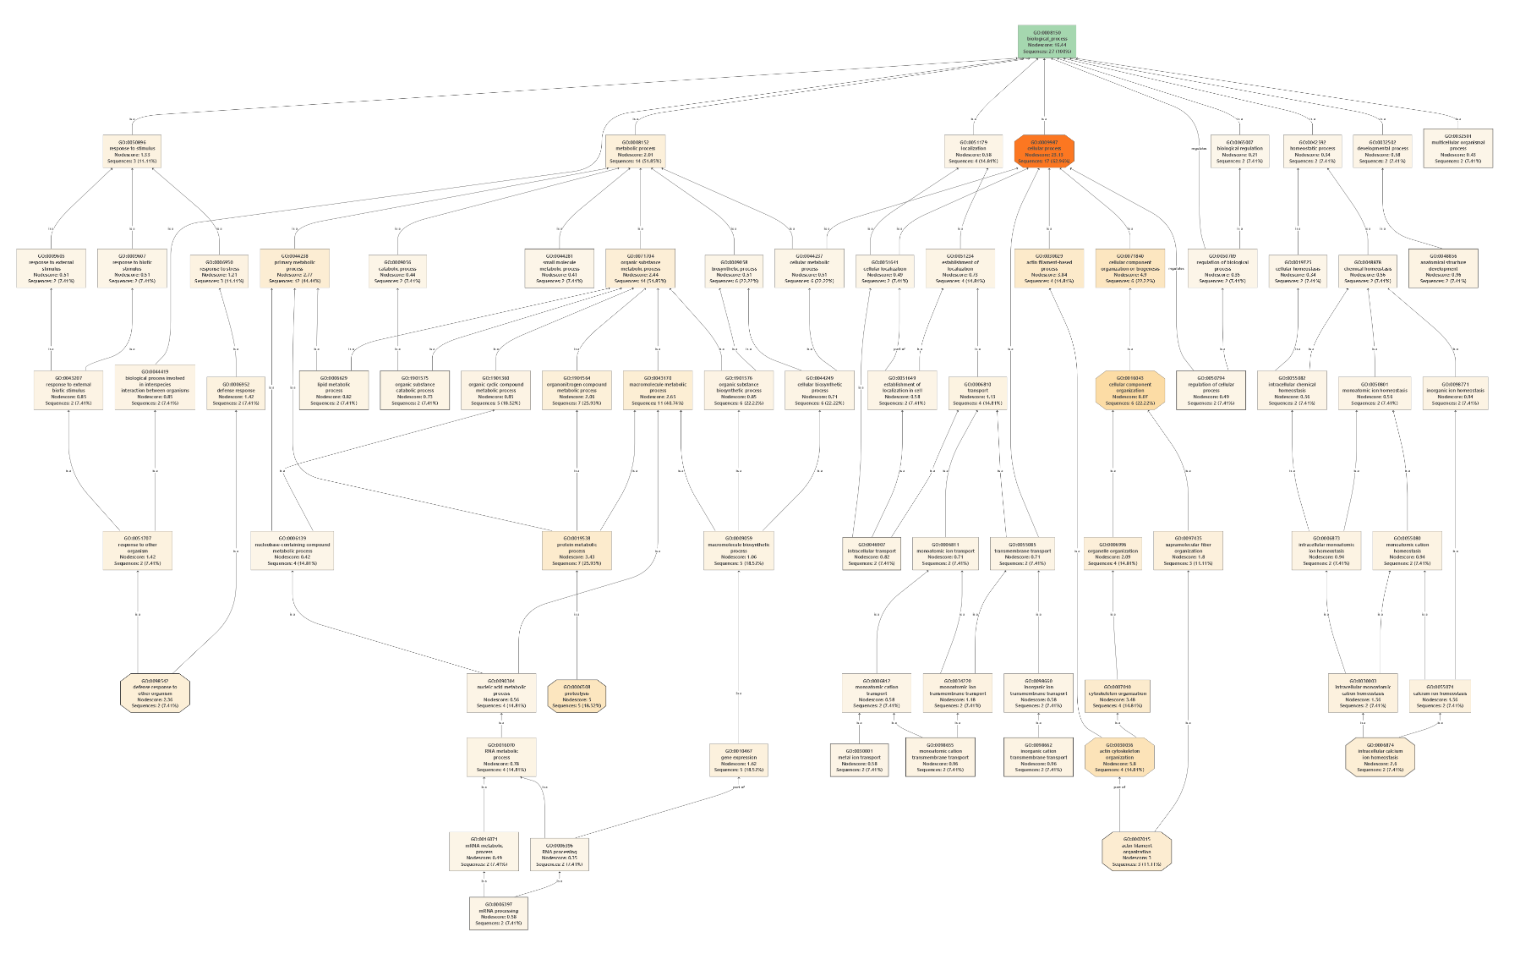
Figure S1. Biological Process GO term tree for proteins that are significantly different between unparasitized and pre-emergence M. sexta caterpillars.

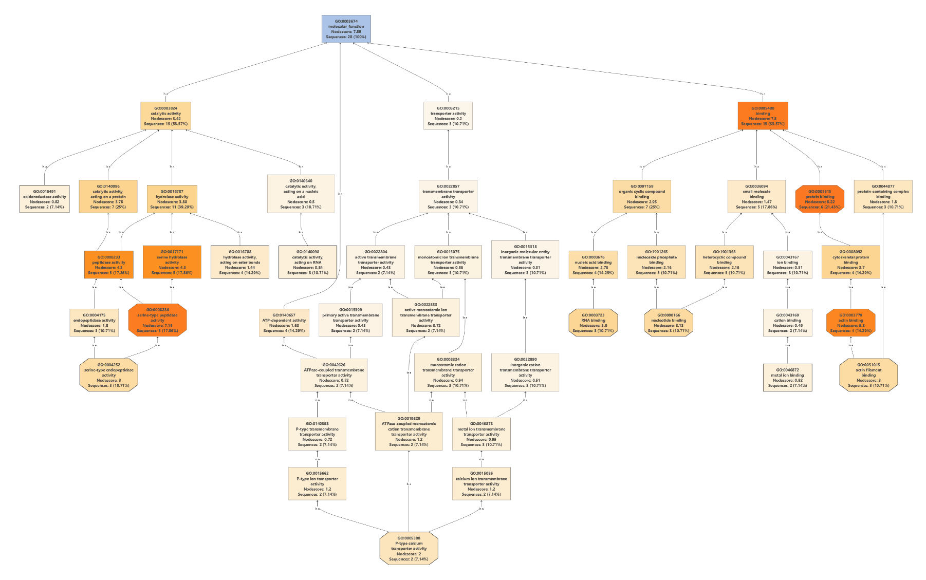
Figure S2. Molecular Function GO term tree for proteins that are significantly different between unparasitized and pre-emergence M. sexta caterpillars.
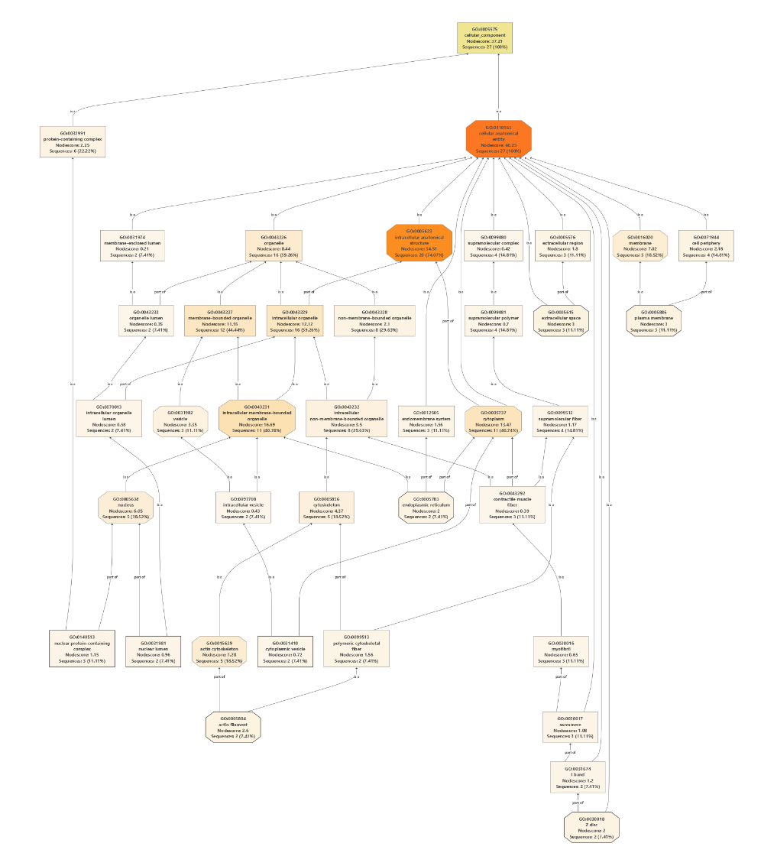
Figure S3. Cellular GO term tree for proteins that are significantly different between unparasitized and pre-emergence M. sexta caterpillars.
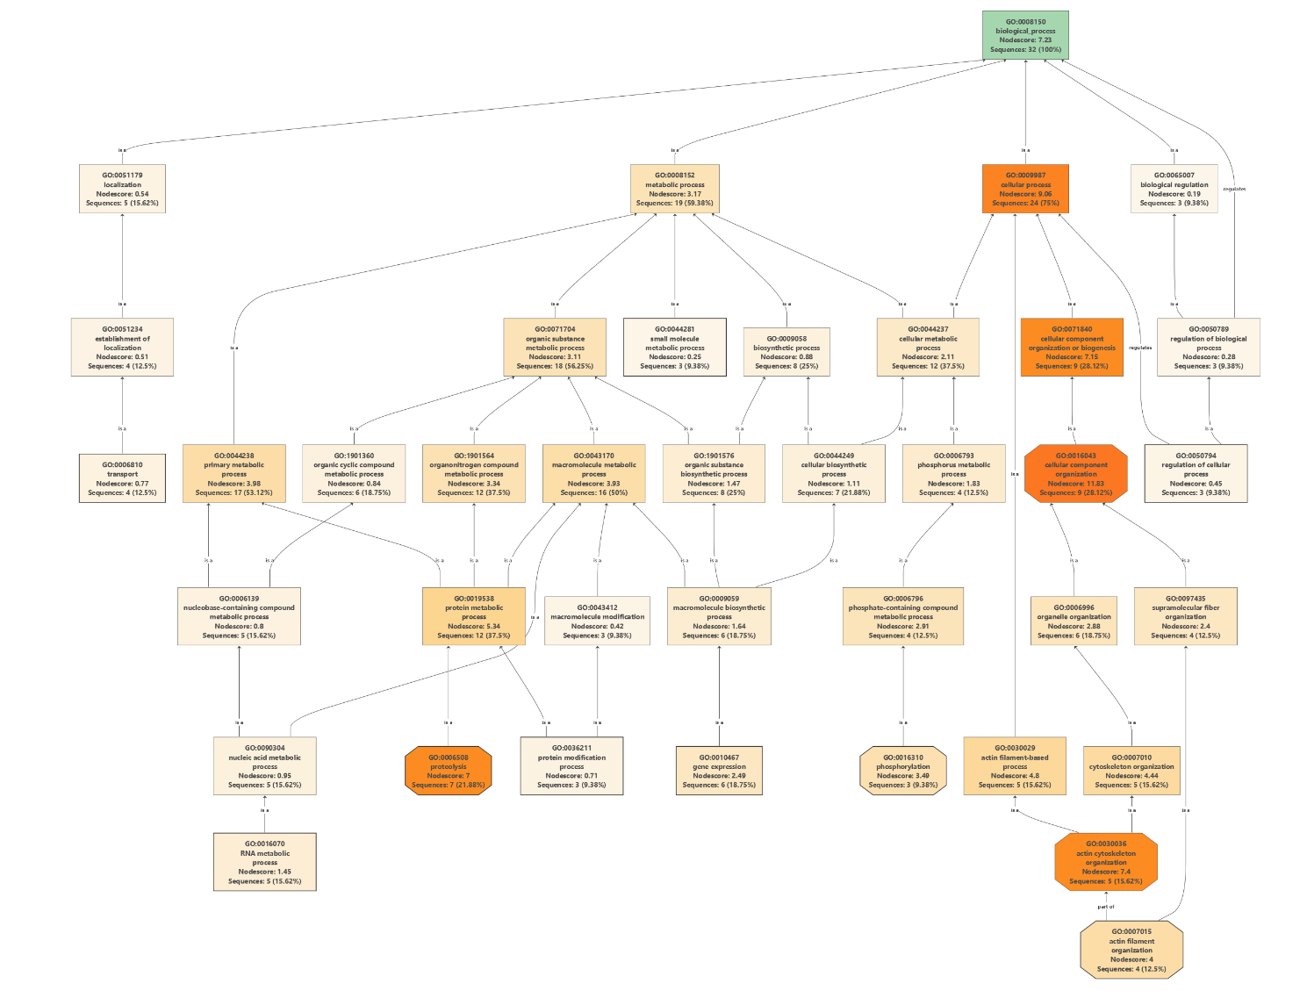

Figure S4. Biological Process GO term tree for proteins that are significantly different between pre-emergence and emergent M. sexta caterpillars.
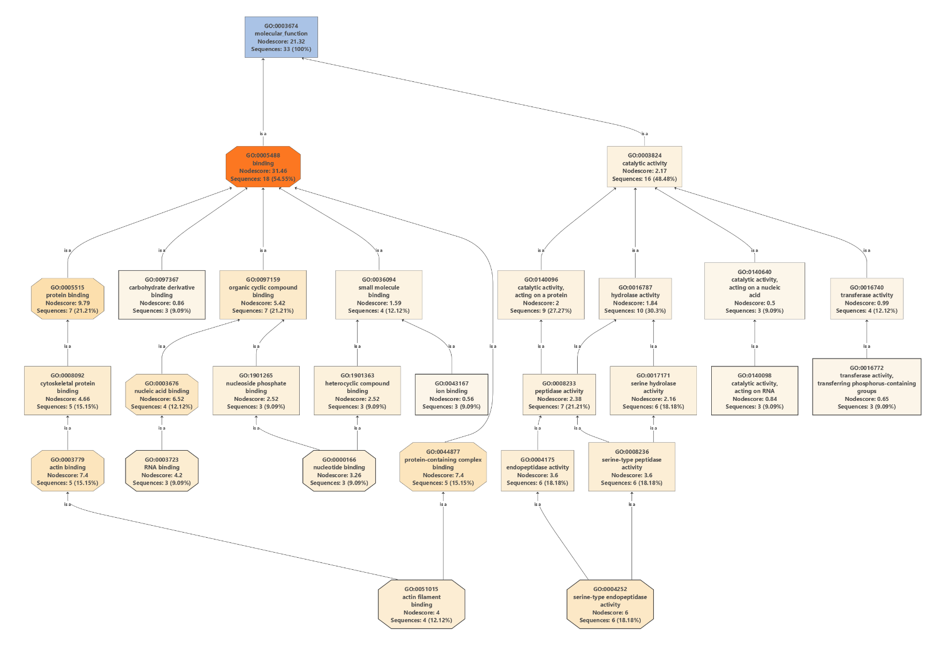
Figure S5. Molecular Function GO term tree for proteins that are significantly different between pre-emergence and emergent M. sexta caterpillars.
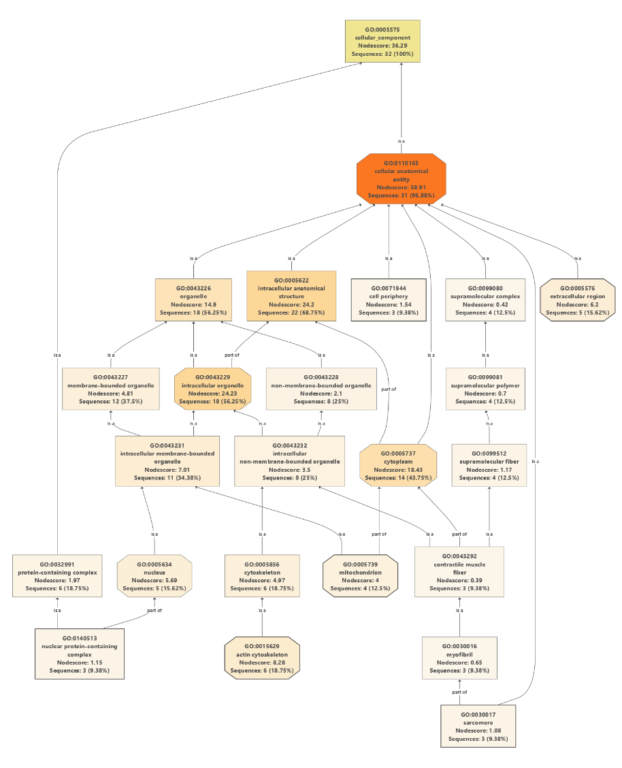
Figure S6. Cellular component GO term tree for proteins that are significantly different between pre-emergence and emergent M. sexta caterpillars.
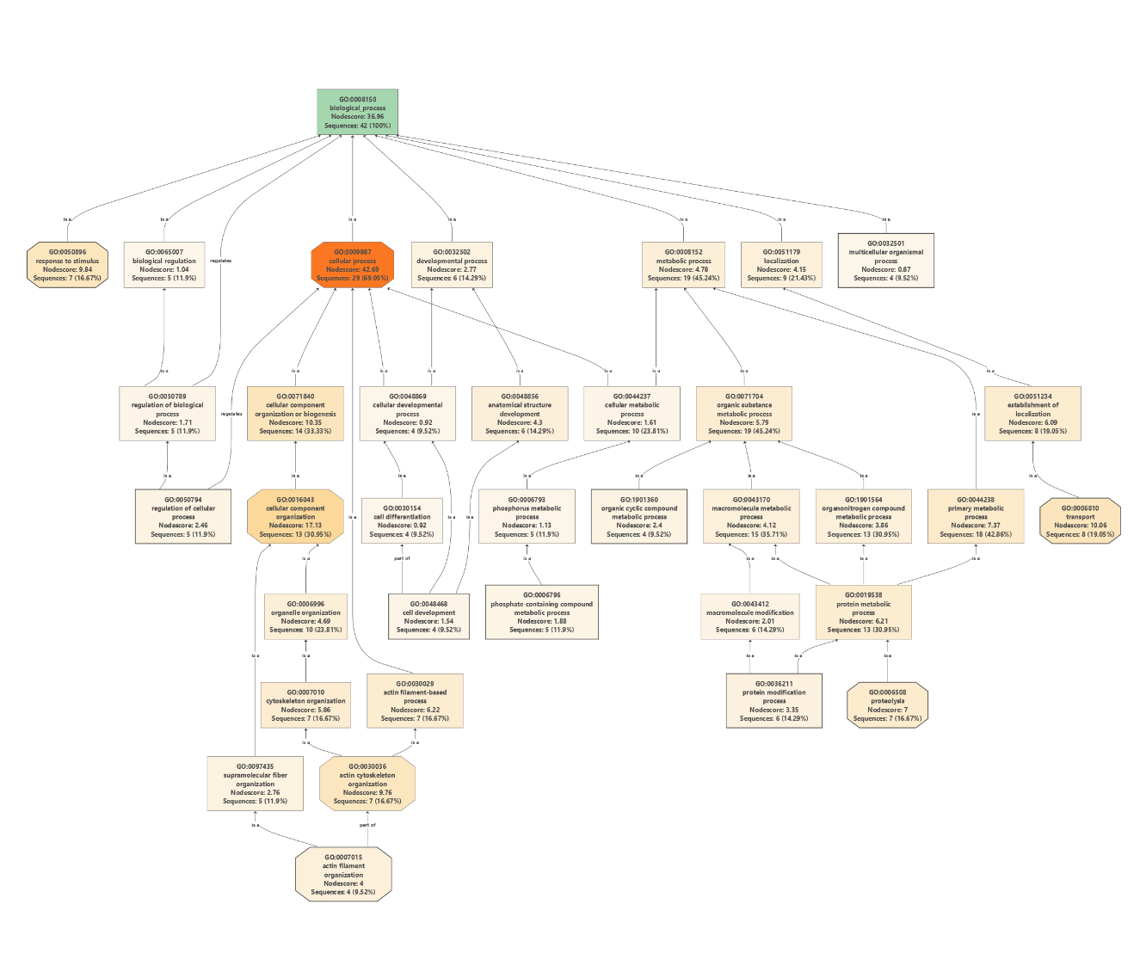
Figure S7. Biological process GO term tree for proteins that are significantly different between pre-emergence and 1-Day Post Emergence M. sexta caterpillars.
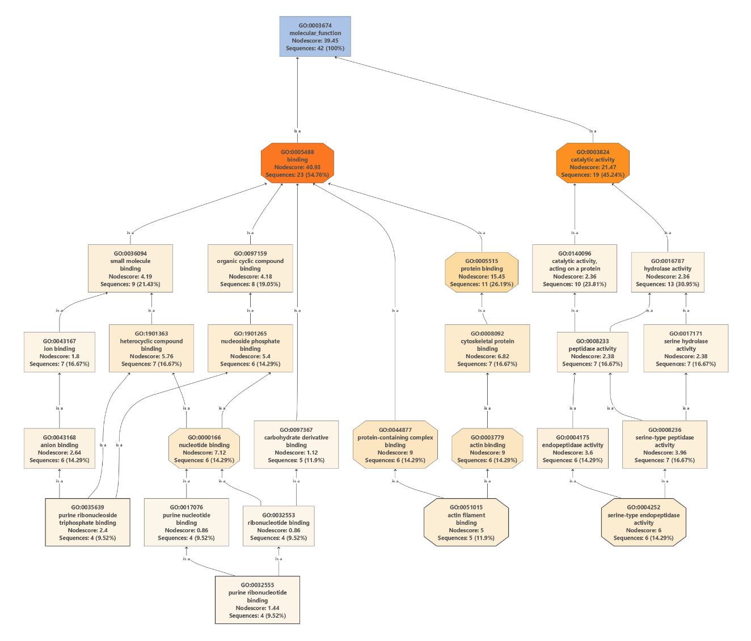
Figure S8. Metabolic function GO term tree for proteins that are significantly different between pre-emergence and 1-Day Post Emergence M. sexta caterpillars.
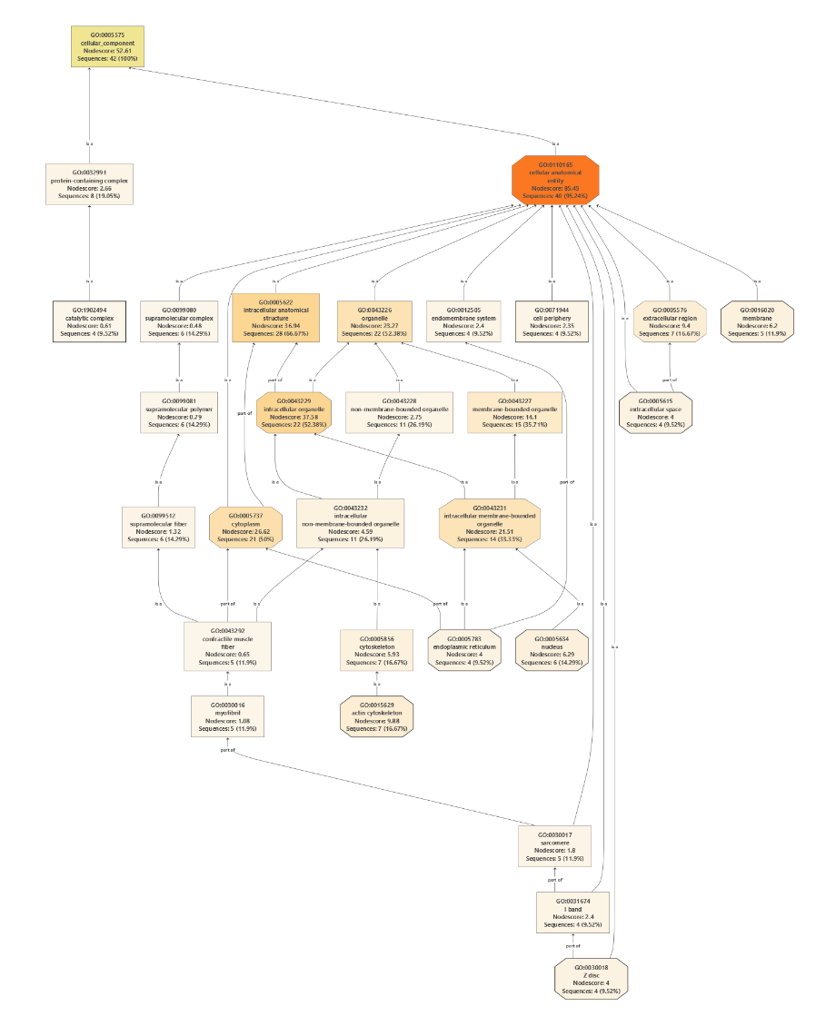
Figure S9. Cellular component GO term tree for proteins that are significantly different between pre-emergence and 1-Day Post Emergence M. sexta caterpillars.
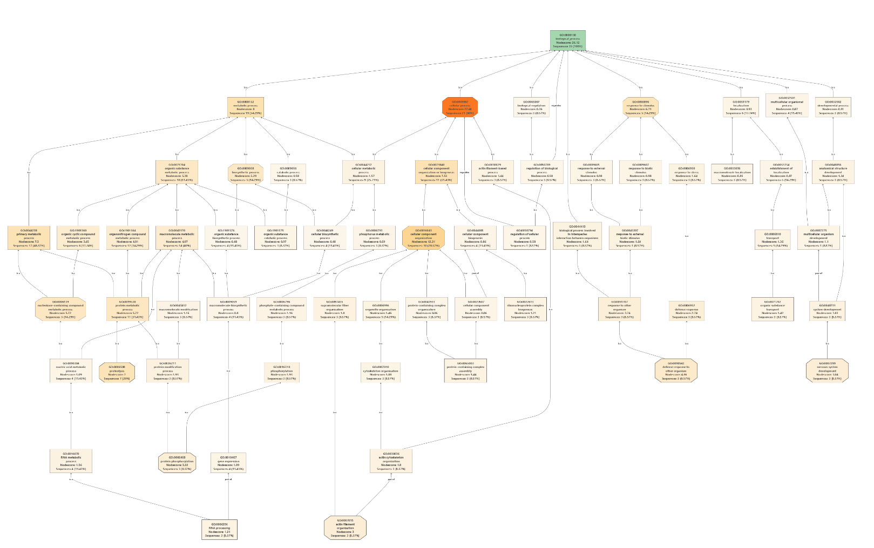
Figure S10. Biological process GO term tree for proteins that are significantly different between pre-emergence and 3-Days Post Emergence M. sexta caterpillars.

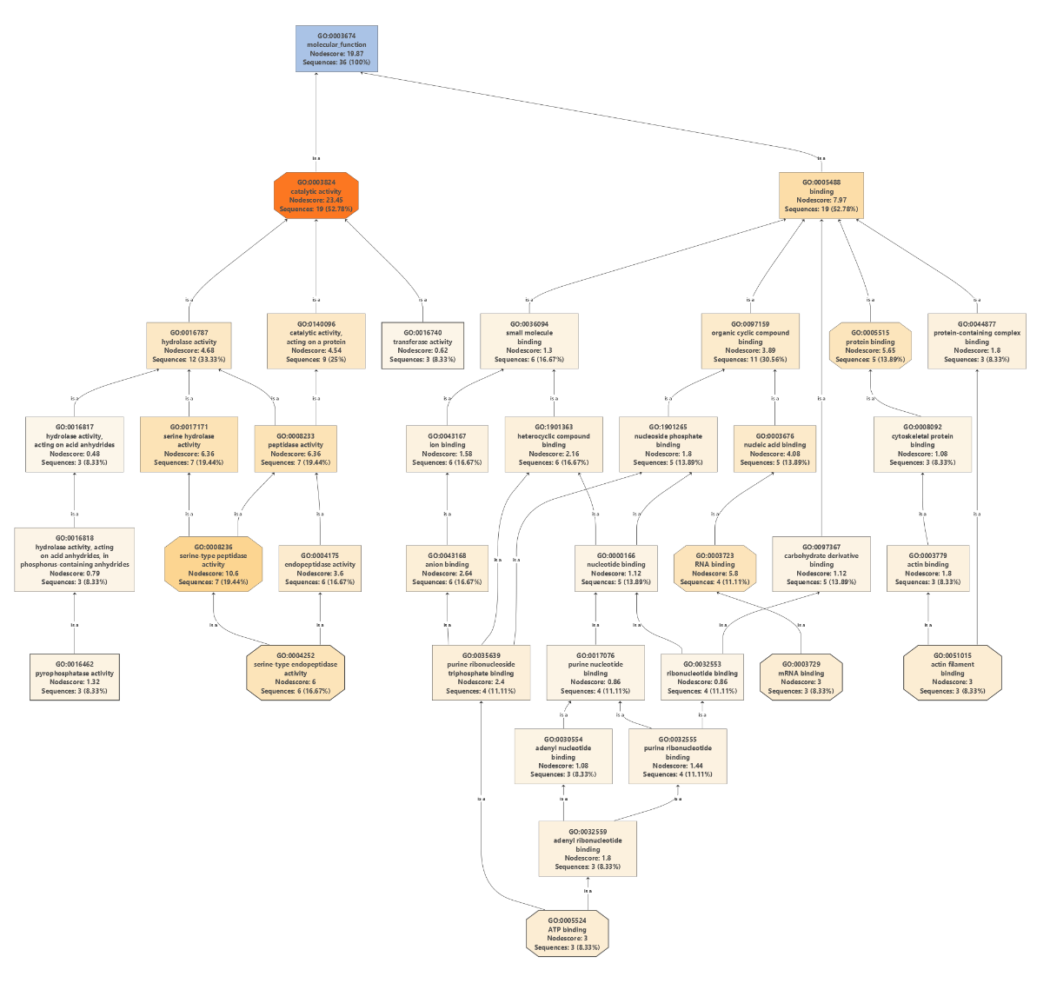
Figure S11. Molecular function GO term tree for proteins that are significantly different between pre-emergence and 3-Days Post Emergence M. sexta caterpillars.

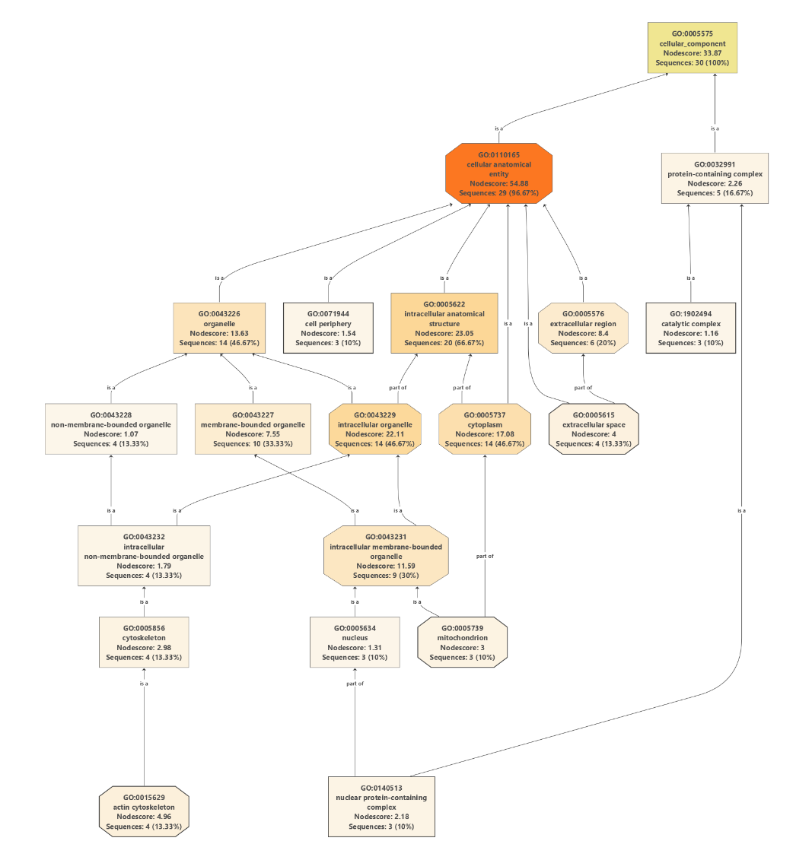
Figure S12. Cellular component GO term tree for proteins that are significantly different between pre-emergence and 3-Days Post Emergence M. sexta caterpillars.
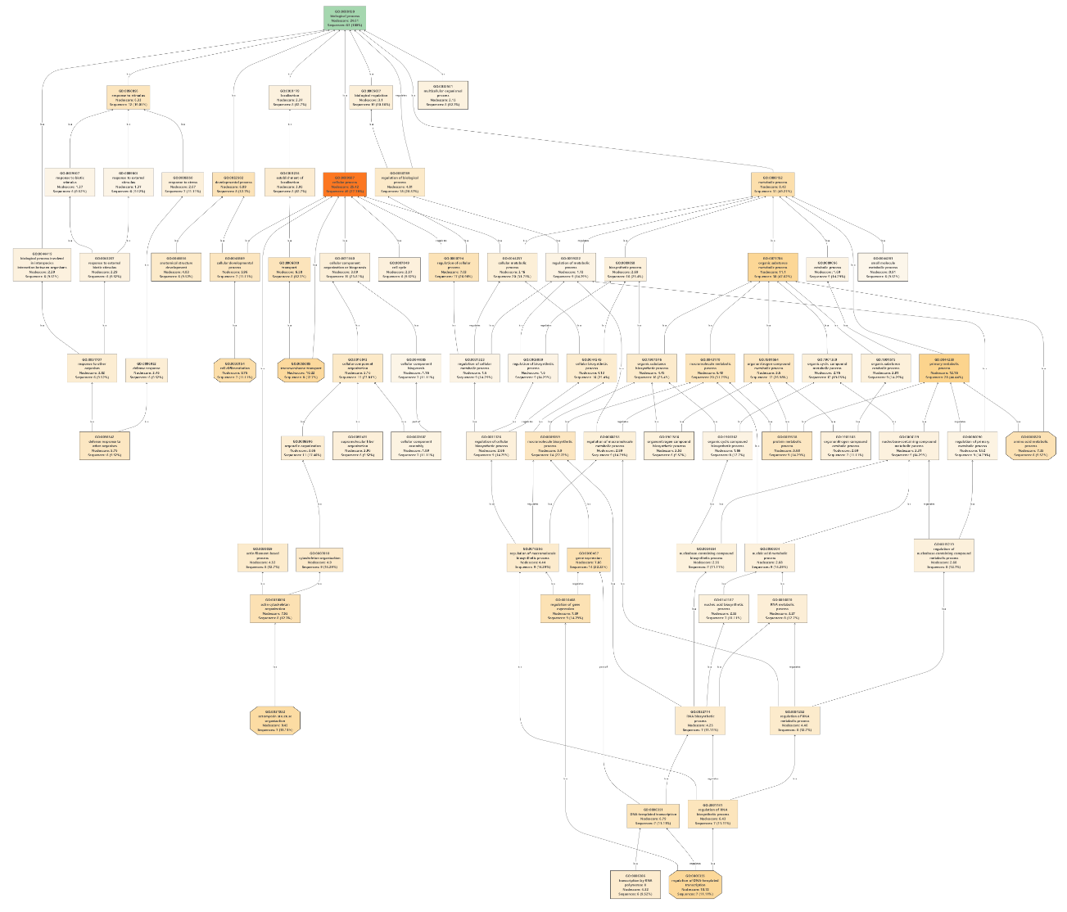
Figure S13. Biological process GO term tree for mRNA transcripts that are differentially expressed unparasitized and pre-emergent M. sexta caterpillars.
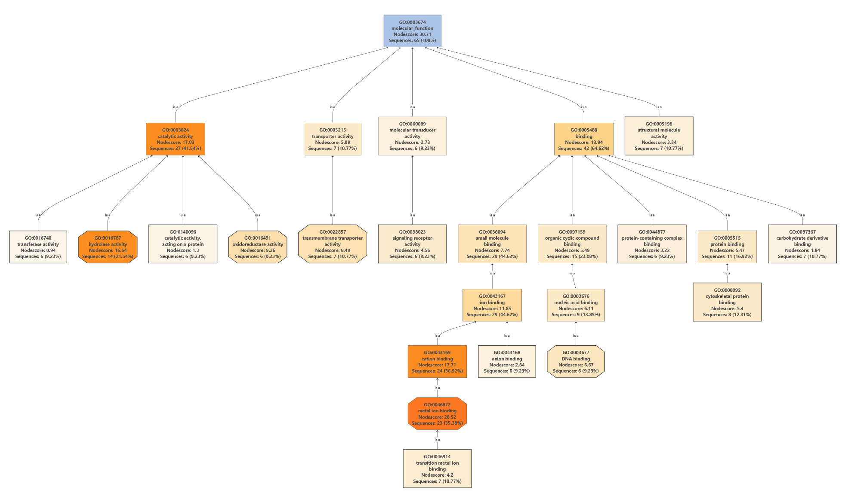
Figure S14. Molecular function GO term tree for mRNA transcripts that are differentially expressed unparasitized and pre-emergent M. sexta caterpillars.

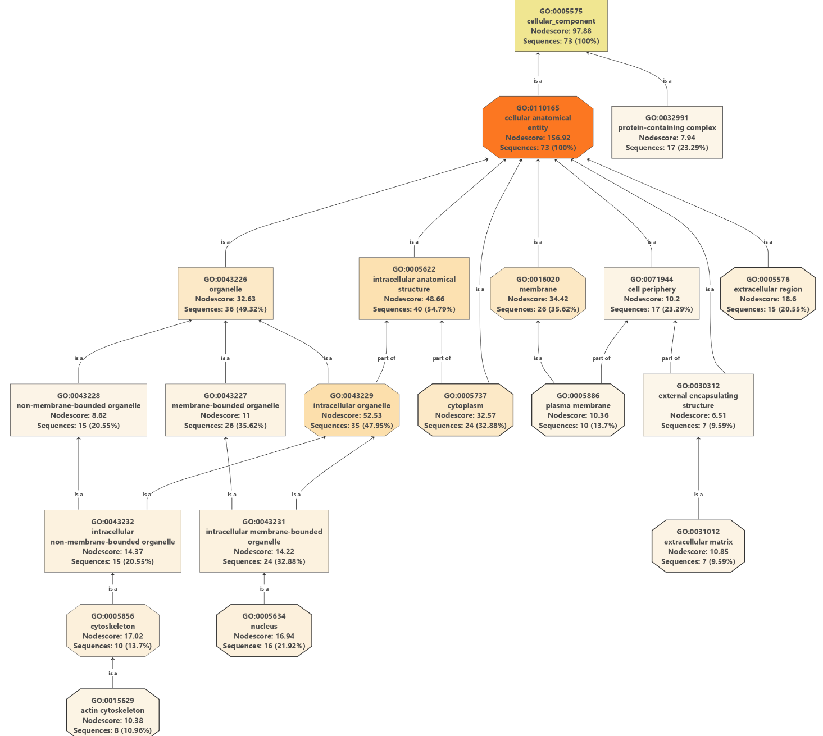
Figure S15. Cellular component GO term tree for mRNA transcripts that are differentially expressed between unparasitized and pre-emergent M. sexta caterpillars.
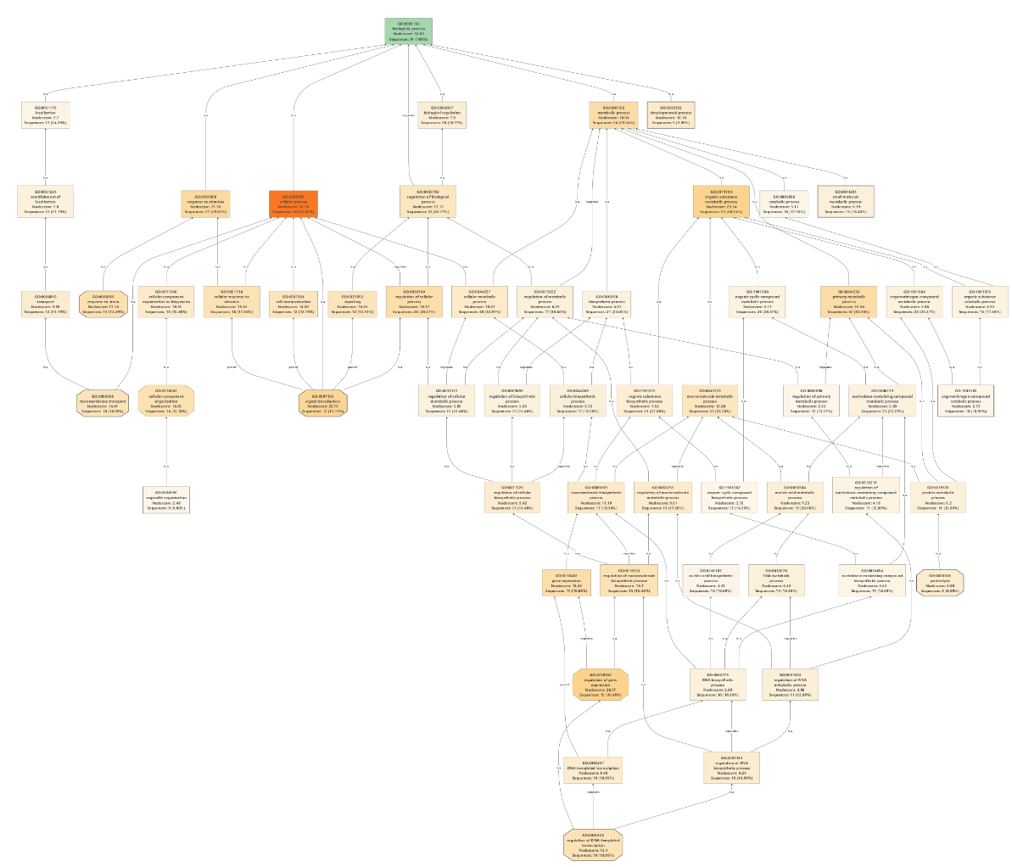
Figure S16. Biological process GO term tree for mRNA transcripts that are differentially expressed between pre-emergent and emergent M. sexta caterpillars.
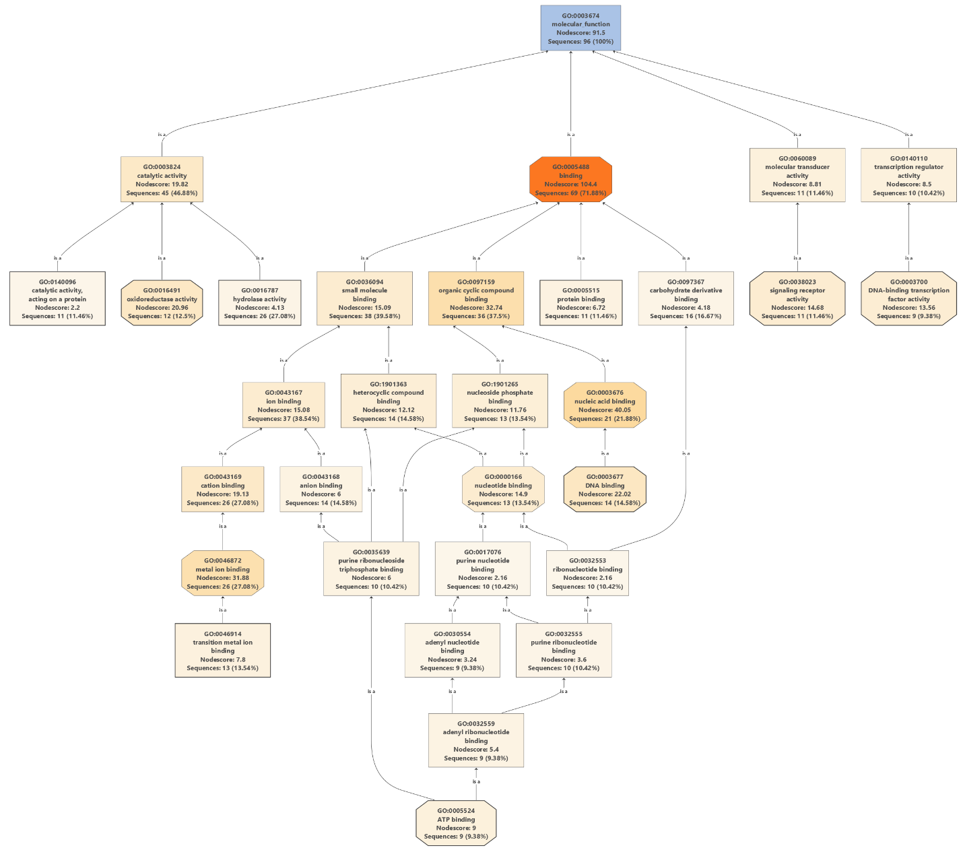
Figure S17. Molecular process GO term tree for mRNA transcripts that are differentially expressed between pre-emergent and emergent M. sexta caterpillars.
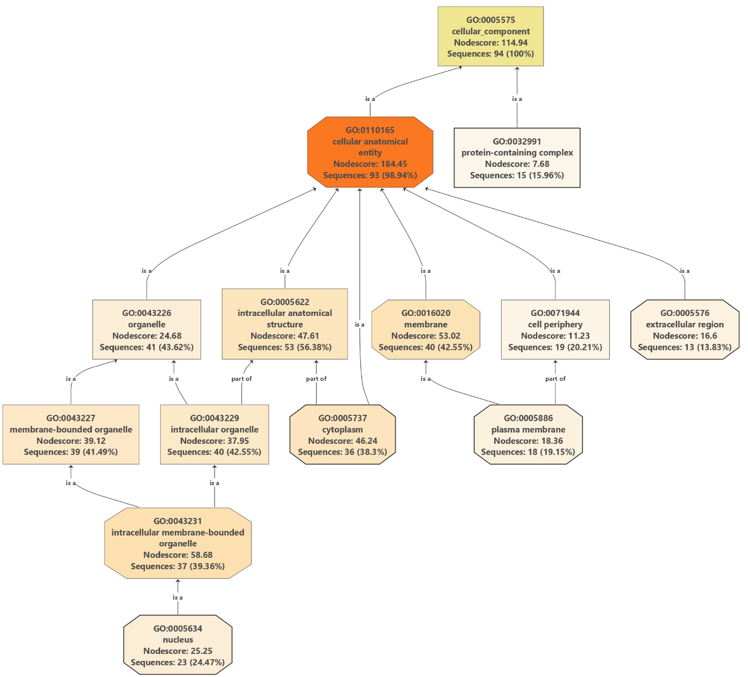
Figure S18. Cellular component GO term tree for mRNA transcripts that are differentially expressed between pre-emergent and emergent M. sexta caterpillars.
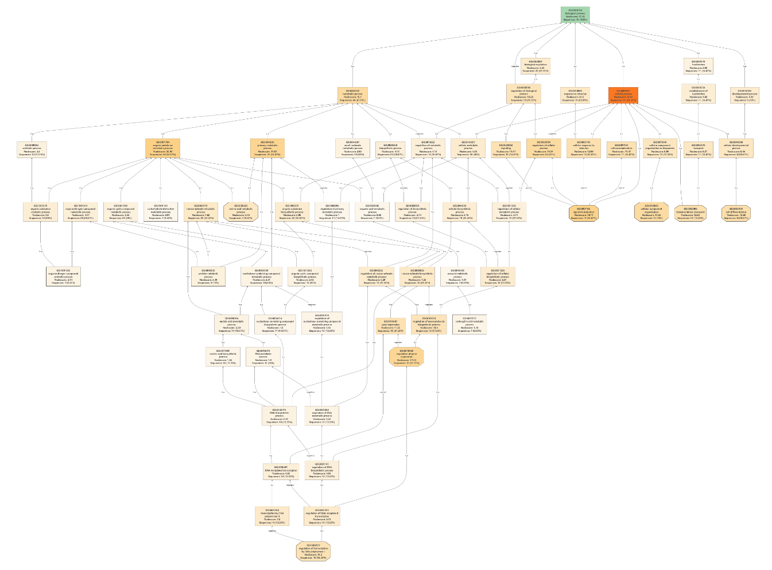
Figure S19. Biological process GO term tree for mRNA transcripts that are differentially expressed between pre-emergent and 1-Day Post M. sexta caterpillars.
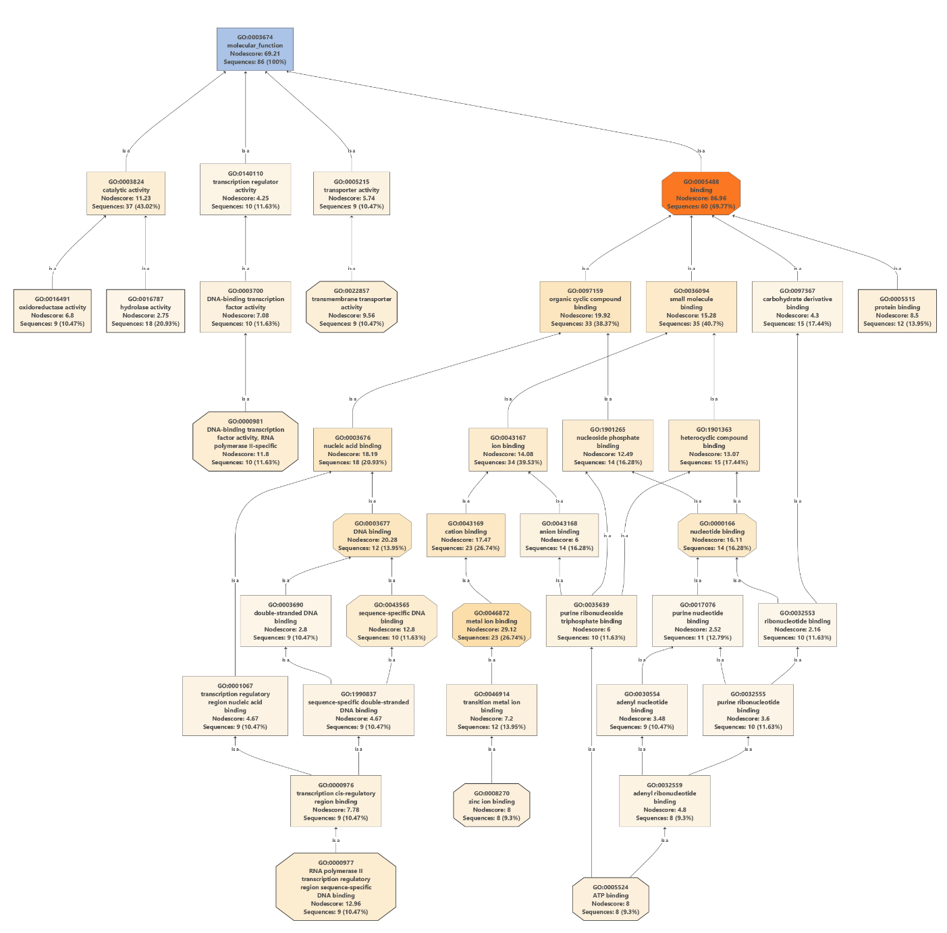
Figure S19. Molecular function GO term tree for mRNA transcripts that are differentially expressed between pre-emergent and 1-Day Post M. sexta caterpillars.
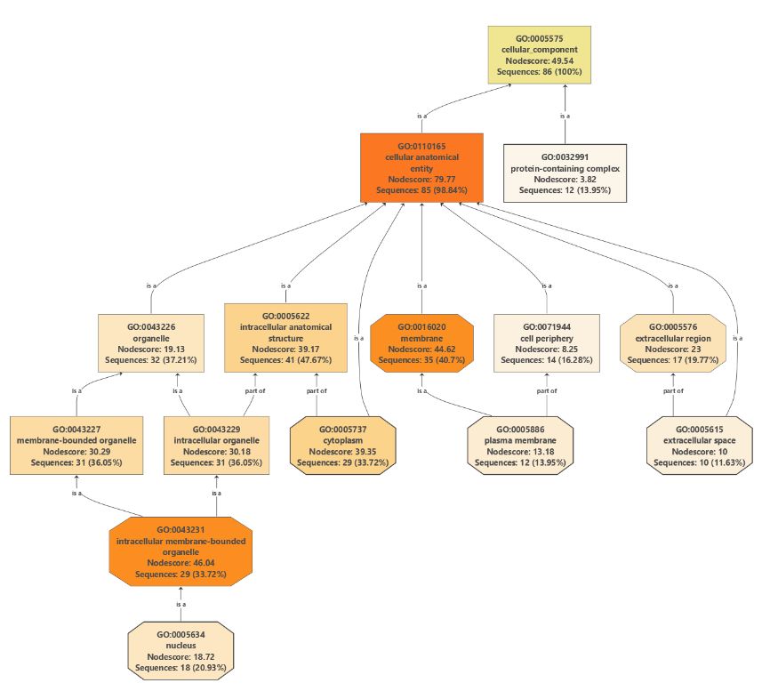
Figure S20. Cellular component GO term tree for mRNA transcripts that are differentially expressed between pre-emergent and 1-Day Post M. sexta caterpillars.
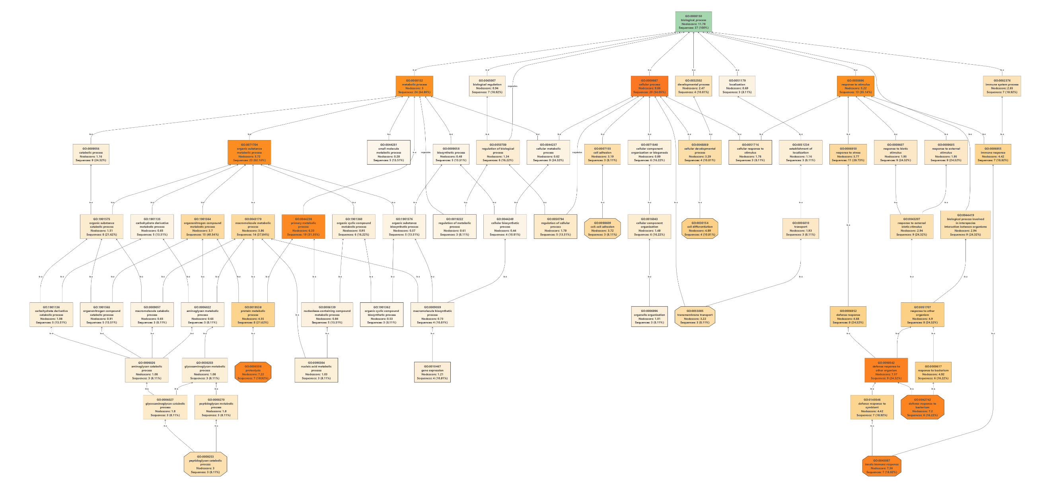
Figure S21. Biological process GO term tree for mRNA transcripts that are differentially expressed between pre-emergent and 3-Days Post M. sexta caterpillars.

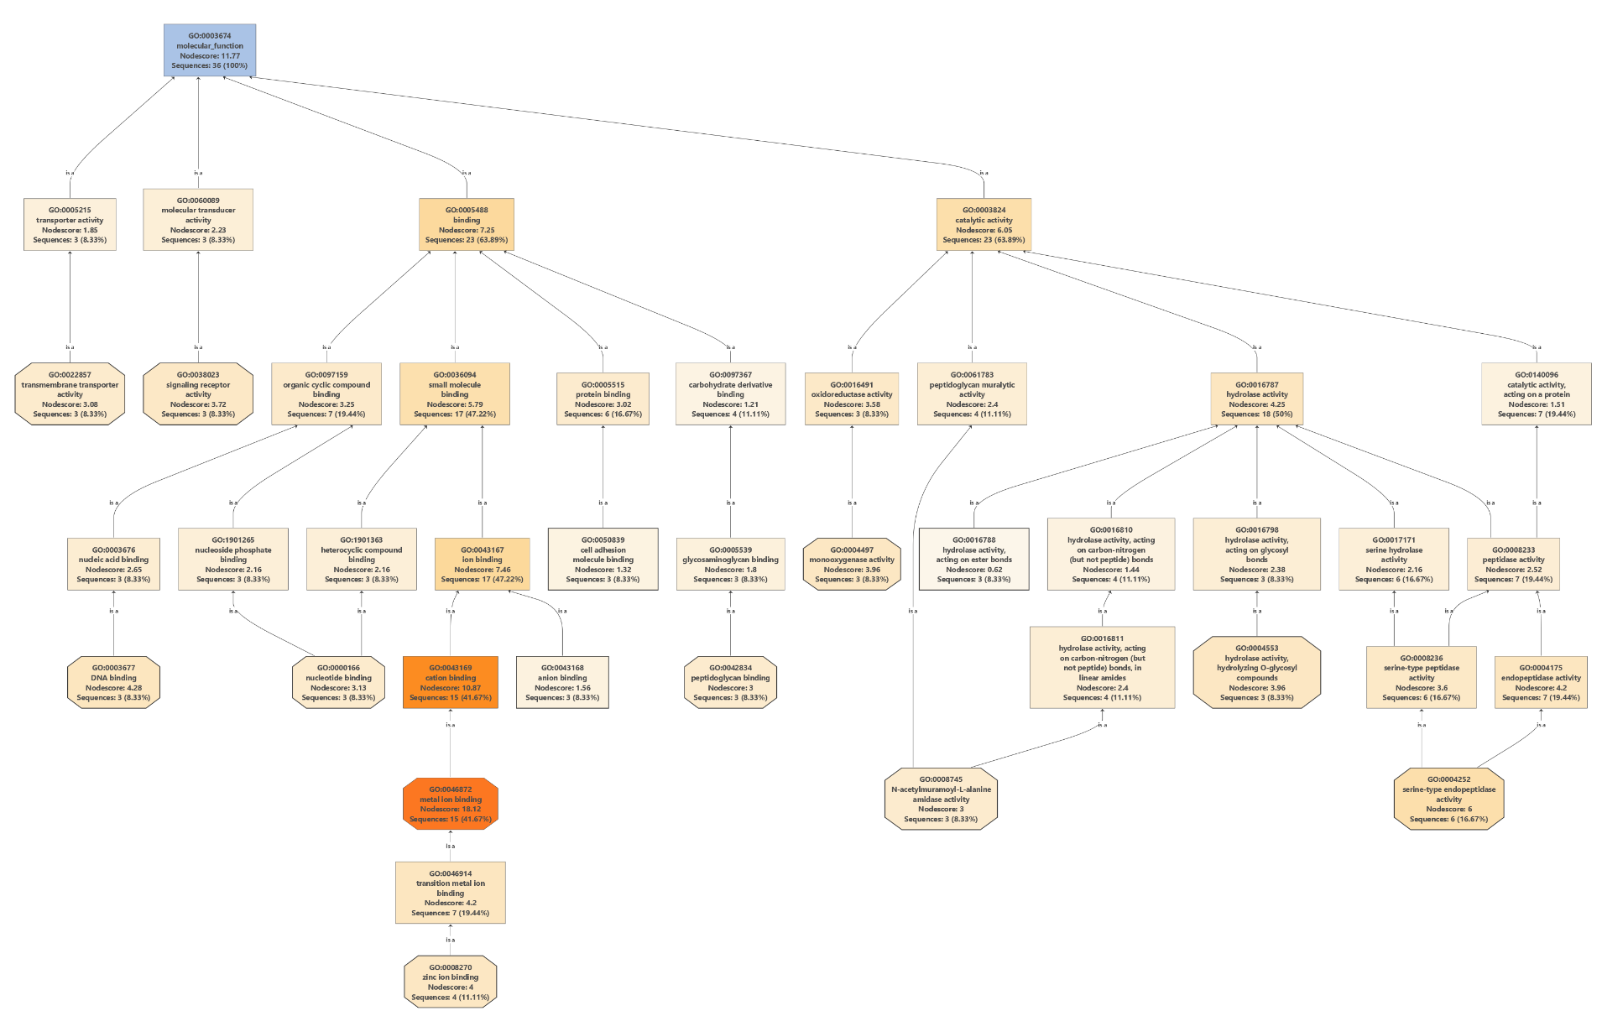
Figure S22. Biological process GO term tree for mRNA transcripts that are differentially expressed between pre-emergent and 3-Days Post M. sexta caterpillars.
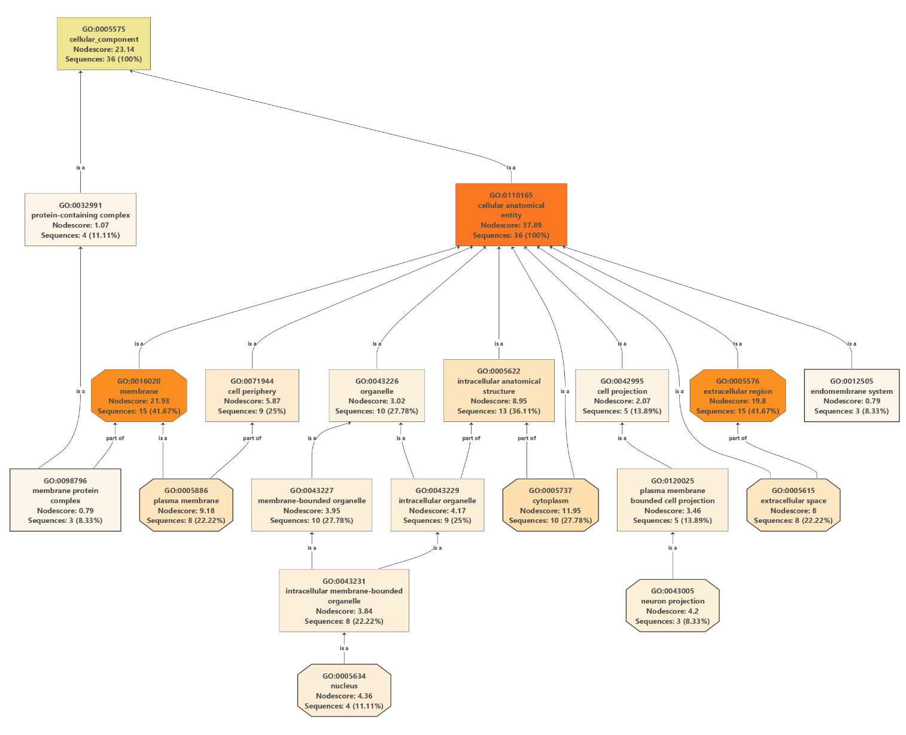
Figure S23. Biological process GO term tree for mRNA transcripts that are differentially expressed between pre-emergent and 3-Days Post M. sexta caterpillars.

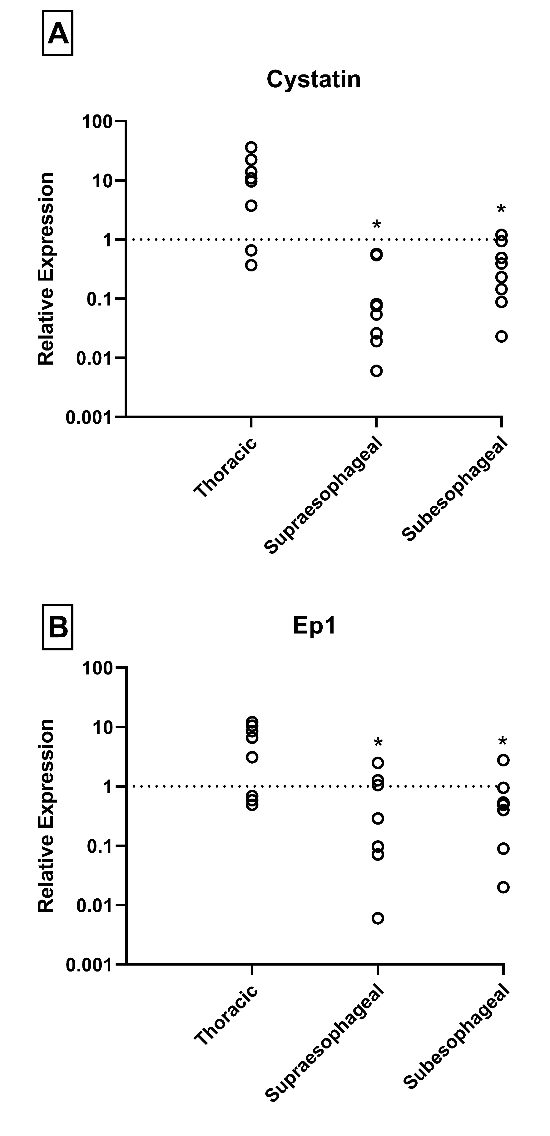
Figure S24. Relative gene expression of two CcBV genes in three neural tissues, the thoracic ganglia, supraesphageal ganglia, and subesophageal ganglia 24 hours post parasitism. The dotted line represents the expression of the genes in the abdominal ganglia which has been normalized to 1. Because control CNS does not contain the polydnavirus, the abdominal ganglia were arbitrarily chosen as the reference point. Asterisks represent tissues in which the gene expression was significantly different compared to abdominal ganglia (p<0.001).
Supplemental Methods
Demonstration that CcBV transcripts exist within the brain of M. sexta
Earlier work showing that CcBV genes were expressed and translated into proteins in the M. sexta brain did not remove the ganglionic sheath (i.e. blood brain barrier) before homogenizing the brain¹. Therefore, it is possible that CcBV RNA was in or on the ganglionic sheath only, and did not enter the brain. Alternatively, dissection activates host hemocytes causing them to adhere to tissue and foreign bodies in M. sexta². It is possible that previous studies were measuring RNA and protein found in adhering hemocytes, instead of the brain itself. To remove this possibility, we excised the supraesophageal ganglion from parasitized caterpillars, washed it well with PBS, made a small incision in the sheath with sterile forceps and collected the brain using a double cannulae system. The outer cannula (24 gauge BD disposable catheter) protected the inner cannula (32 gauge Hamilton syringe) from touching any ganglionic sheath remnants, and the brain was sucked up into the inner cannula. This material was placed in RNALater (Invitrogen) for RNA extraction and qPCR.
Gene Ontology Classification-Proteomics
Using protein amino acid sequences downloaded from NCBI, Omics Box³ was used to assign gene ontology (GO) terms to blasted results (e-value < 1.0E-6, annotation score > 55, and GO weight > 5). Additional GO terms were assigned using EMBL-EBI InterPro search functionality in Blast2GO and merged with the Blast2GO annotations.
Gene Ontology Analysis-Transcriptomics
For functional annotations, translated CDS were blasted with BLASTP from BLAST+ (v2.12) to NCBI’s non-redundant database with an e-value threshold of 1.0E-3 and a maximum of 10 target sequences⁴. Blast2GO⁵ (v6.0.3) was then used to assign gene ontology (GO) terms to blasted results (e-value < 1.0E-6, annotation score > 55, and GO weight > 5). Additional GO terms were assigned using EMBL-EBI InterPro search functionality in Blast2GO and merged with the Blast2GO annotations. GO enrichment analysis of significant DE genes, was assessed with Fisher’s exact test (two tailed FDR < 0.05). We also used the program String (ver 12.0; string-db.org) to help identify gene functions in lepidopterans.

Cotesia congregata genes
The transcriptomics study found evidence for the expression of Cotesia genes that are not found in the CcBV. However, no non-CcBV Cotesia proteins were found in the proteomics results, and the presence of three highly upregulated putative Cotesia congregata genes, Henna, Orkikinin, Synaptogamin could not be verified using qPCR. Determining whether non-CcBV Cotesia genes are expressed in the brain of the host will require further study.

1 Le, N., Asgari, S., Amaya, K., Tan, F. & Beckage, N. E. Persistence and expression of Cotesia congregata polydnavirus in host larvae of the tobacco hornworm, Manduca sexta. Journal of Insect Physiology 49, 533-543 (2003).
2 Miller, J. S. & Stanley, D. W. in Karcher, SJ editör. 21st Workshop/Conference of the Association for Biology Laboratory Education (ABLE). Lincon: University of Nebraska. 135-145 (Citeseer).
3 Conesa, A. et al. Blast2GO: a universal tool for annotation, visualization and analysis in functional genomics research. Bioinformatics 21, 3674-3676 (2005).
4 McCartney, N., Kondakath, G., Tai, A. & Trimmer, B. A. Functional annotation of insecta transcriptomes: A cautionary tale from Lepidoptera. Insect Biochemistry and Molecular Biology 165, 104038 (2024).
5 Love, M. I., Huber, W. & Anders, S. Moderated estimation of fold change and dispersion for RNA-seq data with DESeq2. Genome Biol 15, 550, doi:10.1186/s13059-014-0550-8 (2014).

