Supporting Information

Establishment of Post-Inflammatory Irritable Bowel Syndrome Animal Model Following Acute Colitis Recovery

Eui Sun Jeong¹, Hye-Kyung Jung^{1,}*, Euno Choi², Kyeongeui Yun³, Ayoung Lee⁴ and Yung Sung Kim⁵

¹ Department of Internal Medicine, College of Medicine, Ewha Womans University, Seoul, Korea
² Department of Pathology, College of Medicine, Ewha Womans University, Seoul, Korea
³ HuNBiome Co., Ltd., R&D Center, Seoul, Korea
⁴ Department of Internal Medicine, College of Medicine, Korea University, Ansan, Gyeonggi-do, Korea
⁵ Digestive Disease Research Institute, College of Medicine, Wonkwang University, Iksan, Jeonlabuk-do, Korea

Corresponding author: Hye-Kyung Jung, MD, PhD (E-mail: junghk@ewha.ac.kr)
Supplementary Table S1. Scoring system for the disease activity index¹¹
Score | Weight loss (%) | Stool consistency | Gross blood in stools
0 | ≤ 1 | Normal stool (well-formed pellets) | Normal (no blood in stools)
1 | 1–5 | - | -
2 | 5–10 | Loose stools (pasty and semi-formed stools) | Positive occult blood in stools
3 | 10–20 | - | -
4 | > 20 | Diarrhea (liquid stools that adhere to the anus) | Gross bleeding in stools

Supplementary Table S2. Nucleotide sequences of primers used for real-time polymerase chain reaction in this study.
Primer Name | Forward (5’-3’) | Reverse (5’-3’)
L1b | GAGCCCATCCTCTGTGACTC | TCCATTGAGGTGGAGAGCTT
Il6 | CCGGAGAGGAGACTTCACAG | TCCACGATTTCCCAGAGAAC
Il10 | CAGCCGGGAAGACAATAACT | TCATTTCCGATAAGGCTTGG
Il17 | TCCCTCTGTGATCTGGGAAG | CTCGACCCTGAAAGTGAAGG
Tnfa | ACGGCATGGATCTCAAAGAC | AGATAGCAAATCGGCTGACG
Occludin | AGACTACACGACAGGTGGGG | CTGCAGACCTGCATCAAAAT
ZO-1 | GATCATCCACCCAAAGCAGT | AGAAGGGCTGACGGGTAAAT
Claudin-1 | ACTCCTTGCTGAATCTGAACAGT | GGACACAAAGATTGCGATCCAG
Claudin-4 | ACAGGTCCTGGGAATCTCCT | CACTGCATCTGACCTGTGCT
IL, interleukin; TNF, tumor necrosis factor; ZO, zonular occludens
Supplementary Table S3. Definition of categories and general criteria in histomorphological scores for intestinal inflammation in mice models¹⁵
Category | Criterion | Definition | Score Valueª
I, Inflammatory cell infiltrate | Severity | Leukocyte density of lamina propria area infiltrated in evaluated HPF:  Minimal: <10% | 1
 |  | Mild: 10–25%; scattered neutrophils | 2
 |  | Moderate: 26–50% | 3
 |  | Marked: >51%; dense infiltrate | 4
 | Extent | Expansion of leukocyte infiltration:  Mucosal | 1
 |  | Mucosal and submucosal | 2
 |  | Mucosal, submucosal and transmural | 3
II, Epithelial changes | Hyperplasia | Increase in epithelial cell numbers in longitudinal crypts relative to baseline epithelial cell numbers per crypt, visible as crypt elongation:  Minimal: <25% | 1
 |  | Mild: 25–35% | 2 or 3
 |  | Moderate: 36–50%; mitoses in middle/upper third of crypt epithelium, distant from crypt base | 3 or 4
 |  | Marked: >51%; mitoses in upper third of crypt epithelium, distant from crypt base | 4 or 5
 | Goblet cell loss | Reduction of goblet cell numbers relative to baseline goblet cell numbers per crypt:  Minimal: <20% | 1 or 2
 |  | Mild: 21–35% | 2 or 3
 |  | Moderate: 36–50% | 3 or 4
 |  | Marked: >50% | 4
 | Cryptitis | Neutrophils between crypt epithelial cells | 2 or 3
 | Crypt abscesses | Neutrophils in crypt lumen | 3 to 5
 | Erosion | Loss of surface epithelium | 1 to 4
III, Mucosal architecture^{b} | Ulceration | Epithelial defect reaching beyond muscularis mucosae | 3 to 5
 | Granulation tissue | Connective tissue repair with new capillaries, surrounded by spindle-shaped fibroblasts, myofibroblasts, macrophages, neutrophils and mononuclear cells as well as cell debris; pseudopolyps, villiformous, hypertrophied areas projecting into the lumen | 4 or 5
 | Irregular crypts | Non-parallel crypts, variable crypt diameters, bifurcation and branched crypts | 4 or 5
 | Crypt loss | Mucosa devoid of crypts | 4 or 5
 | Villous blunting | Mild: villous-to-crypt-length ratio of 2:1 to 3:1 | 1 to 3
 |  | Moderate: villous-to-crypt-length ratio of 1:1 to 2:1 | 2 to 4
 |  | Villous atrophy | 3 to 5
HPF, high power field
ª Values given for a single criterion are not additive but represent the final score value that includes all relevant criteria; ^{b} From well-oriented samples/biopsies with longitudinally cut crypts, only include at least five comparable crypts

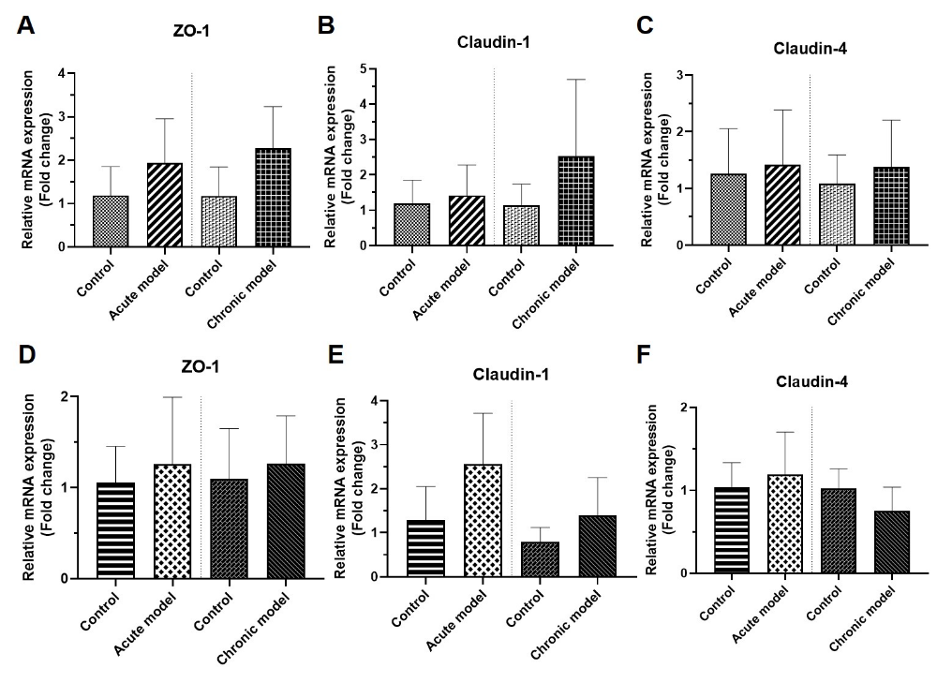
Supplementary Figure S1. The mRNA expression of tight junction proteins in the irritable bowel syndrome models. (A-C) mRNA expression of ZO-1 (A), claudin-1 (B), and claudin-4 (C) in the proximal colon of the acute and chronic models relative to the controls. (D-F) mRNA expression of ZO-1 (D), claudin-1 (E), and claudin-4 (F) in the distal colon of the acute and chronic models compared to that in the controls.
ZO, zonular occludens.

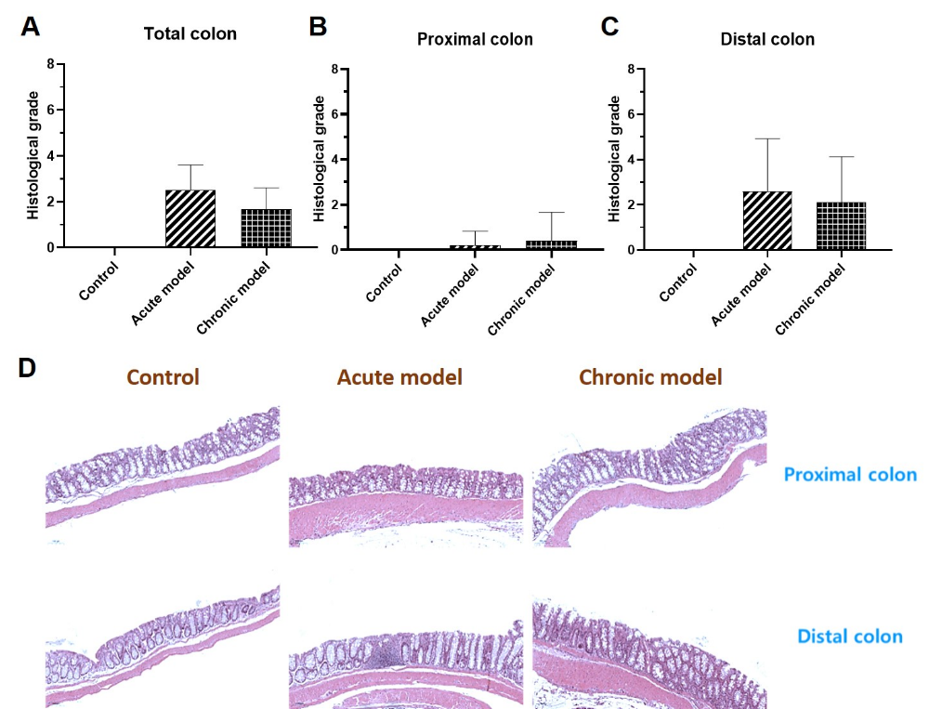
Supplementary Figure S2. Histopathological evaluation in the irritable bowel syndrome models. (A-C) Histologic colitis grading in both the acute and chronic models. (D) Pathologic findings according to the location between each group were obtained by hematoxylin-eosin (H&E) staining (100x).
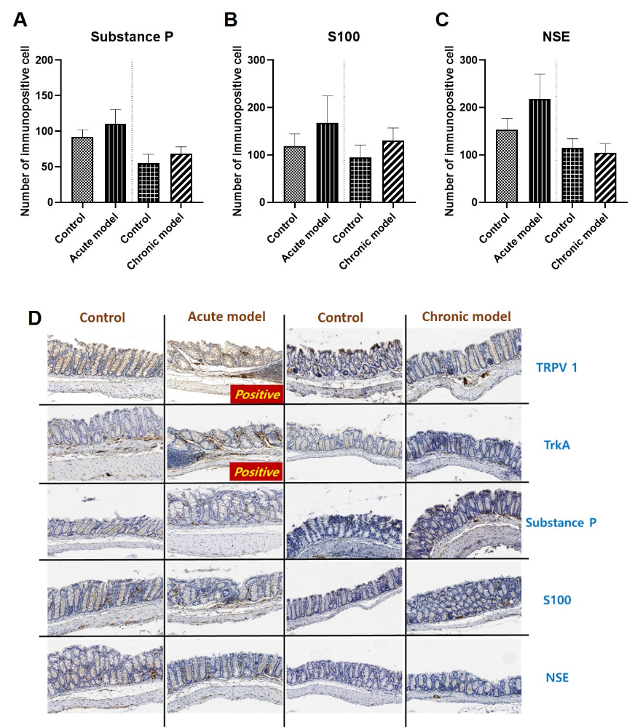Supplementary Figure S3. Immunohistochemistry analysis of neuroinflammatory markers and immunohistochemical staining in the irritable bowel syndrome models. (A-C) Quantitative results of immunopositivity are shown in substance P (A), S100 (B), and NSE (C) in the acute and chronic models. (D) Immunohistochemical staining according to neuroinflammatory markers between each group is expressed TRPV 1, TrkA, substance P, S100, and NSE from top to bottom (200x).
NSE, neuron-specific enolase; TRPV1, transient receptor potential vanilloid 1; TrkA, tropomyosin receptor kinase A.

