Supplementary Materials

Supplement figures
Figure S1: Funnel plot of the trials in White population
Figure S2: Funnel plot of the trials in Asian population
Figure S3: Funnel plot of the trials in Black and other population
Figure S4: Primary outcomes of CVOTs in White patients with type 2 diabetes in placebo-controlled trials
Figure S5: Primary outcomes of CVOTs in Asian patients with type 2 diabetes in placebo-controlled trials
Figure S6: Primary outcomes of CVOTs in black patients with type 2 diabetes in placebo-controlled trials
Figure S7: Primary outcomes of CVOTs in patients with type 2 diabetes from other racial/ethnic groups* in placebo-controlled trials
Figure S8: The risk of MACE of CVOTs in White patients with type 2 diabetes
Figure S9: The risk of MACE of CVOTs in Asian patients with type 2 diabetes
Figure S10: The risk of MACE of CVOTs in black patients with type 2 diabetes
Figure S11: The risk of MACE of CVOTs in patients with type 2 diabetes from other racial/ethnic groups*
*Hispanics, Pacific Islanders, Hawaiian, American Indian, Alaska Native

Supplement tables
Table S1: Chronological List of Cardiovascular Outcome Trials (CVOTs) Included in the Meta-analysis
Table S2: Risk of bias for included studies in this meta-analysis.
Table S3: Primary Outcomes of CVOTs Stratified by Race/Ethnicity
Figure S1: Funnel plot of the trials in White population

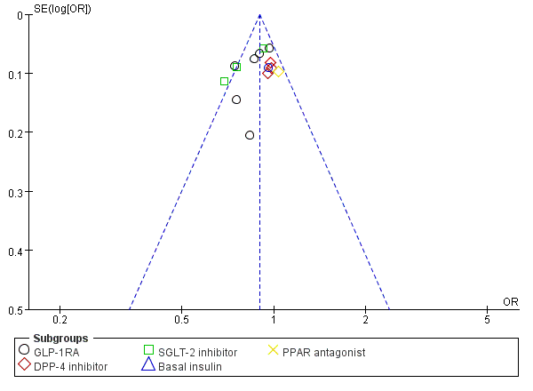

Figure S2: Funnel plot of the trials in Asian population

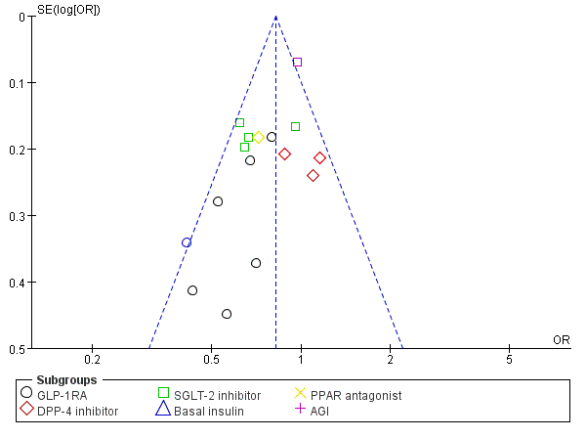

Figure S3: Funnel plot of the trials in Black and other population

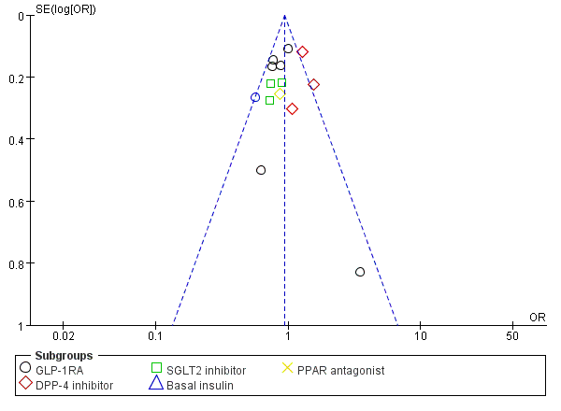

Figure S4: Primary outcomes of CVOTs in White patients with type 2 diabetes in placebo-controlled trials
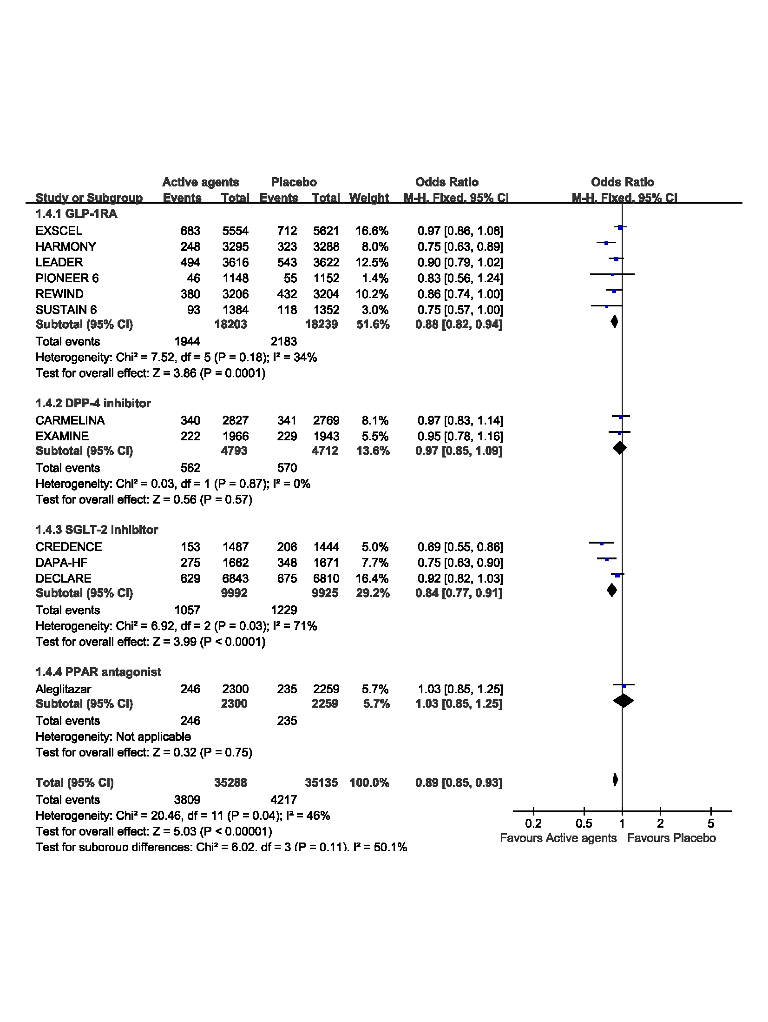

Figure S5: Primary outcomes of CVOTs in Asian patients with type 2 diabetes in placebo-controlled trials
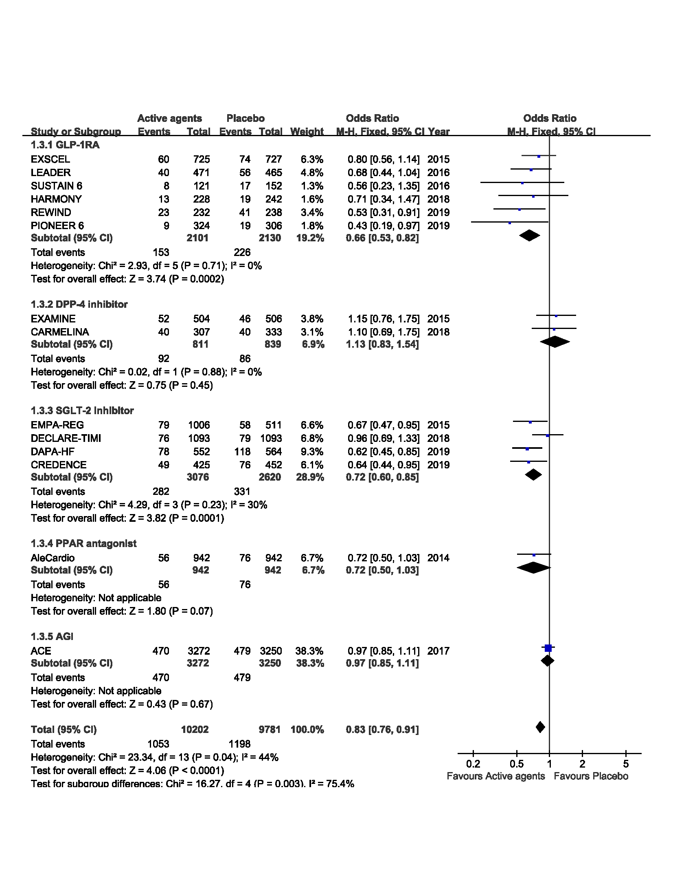

Figure S6: Primary outcomes of CVOTs in black patients with type 2 diabetes in placebo-controlled trials

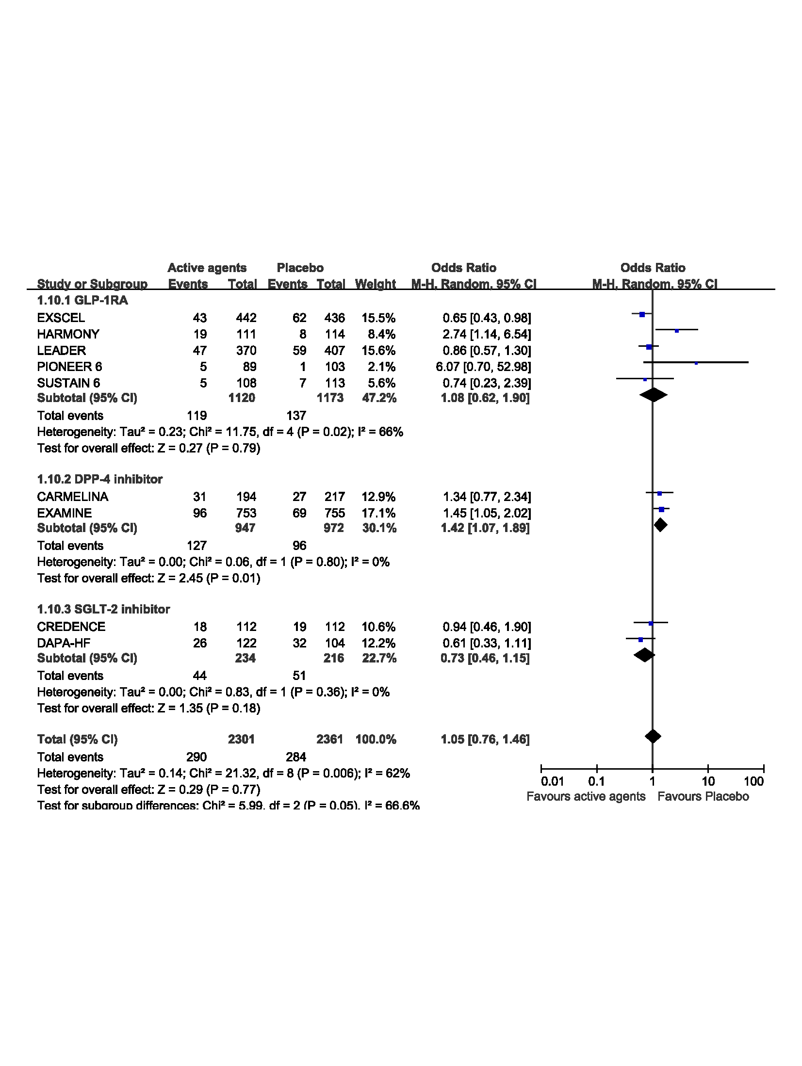

Figure S7: Primary outcomes of CVOTs in patients with type 2 diabetes from other racial/ethnic groups* in placebo-controlled trials
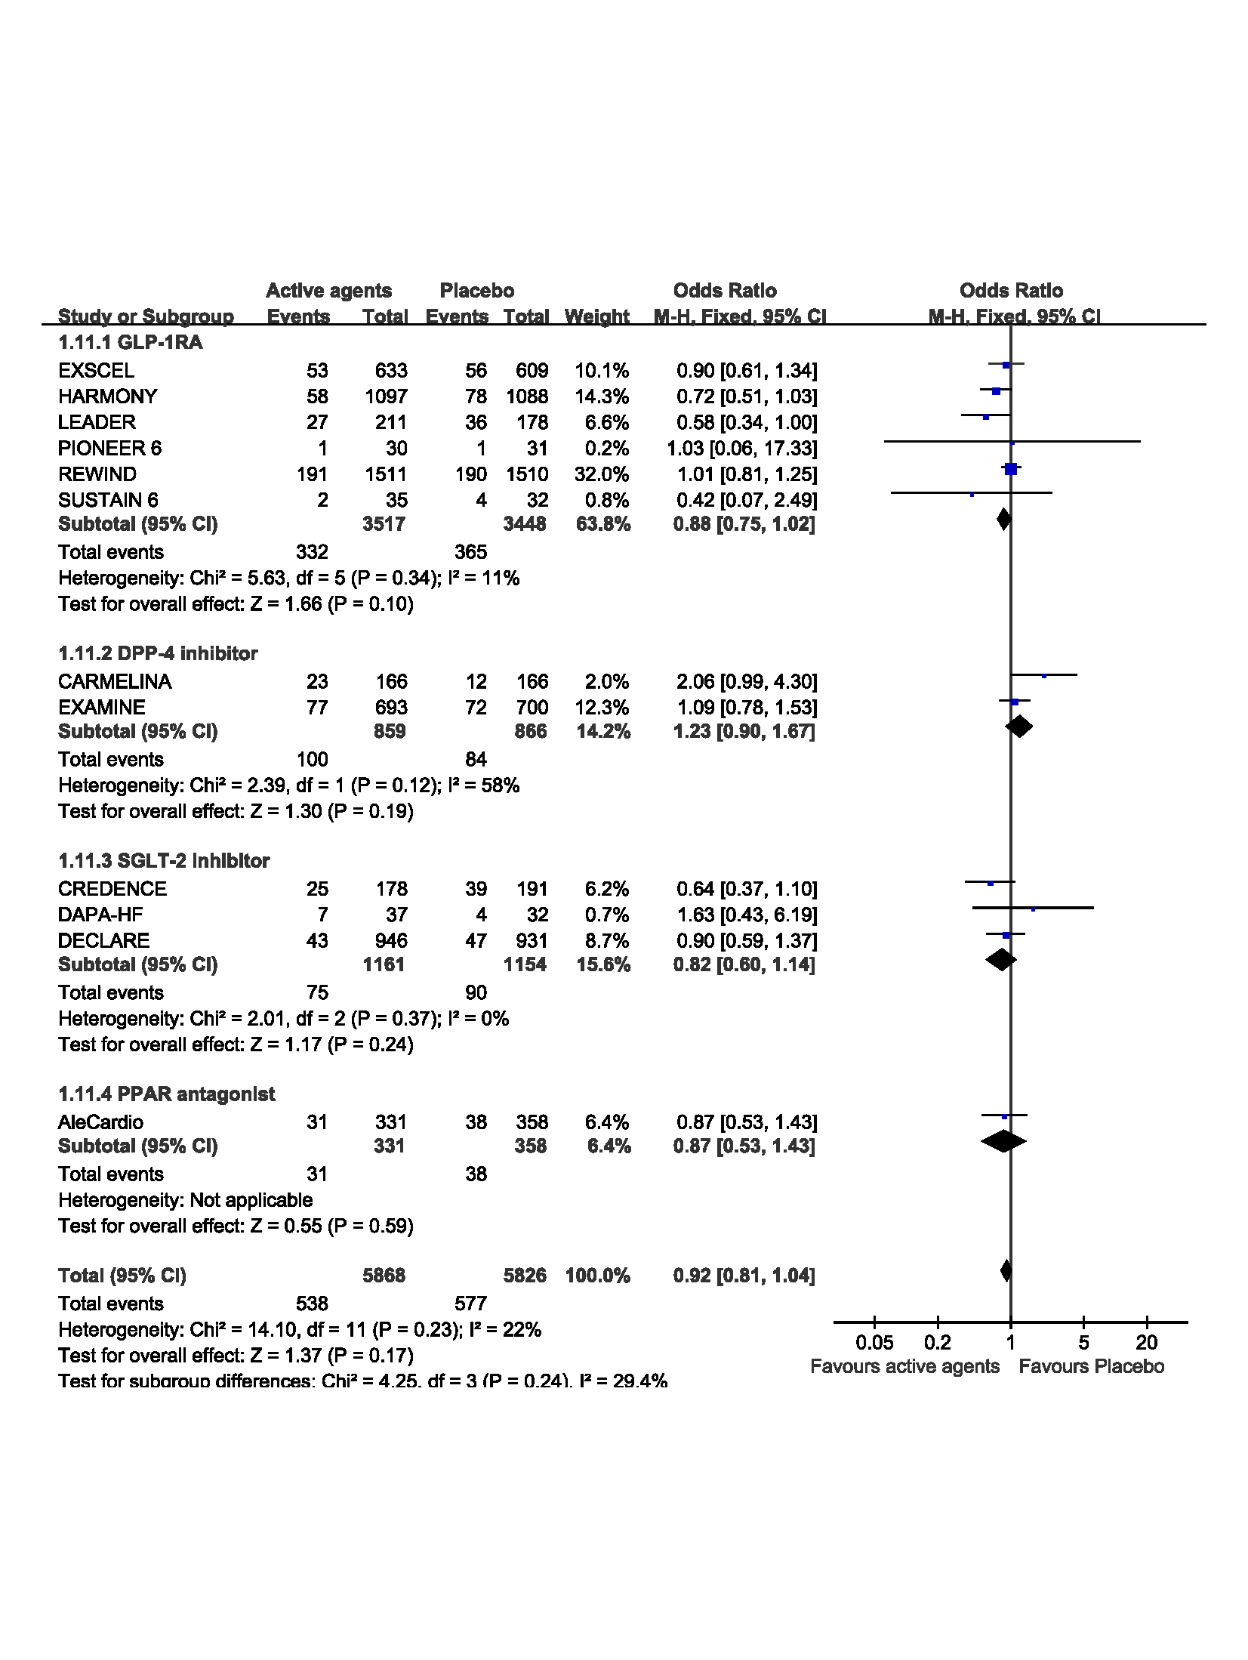
*Hispanics, Pacific Islanders, Hawaiian, American Indian, Alaska Native

Figure S8: The risk of MACE of CVOTs in White patients with type 2 diabetes
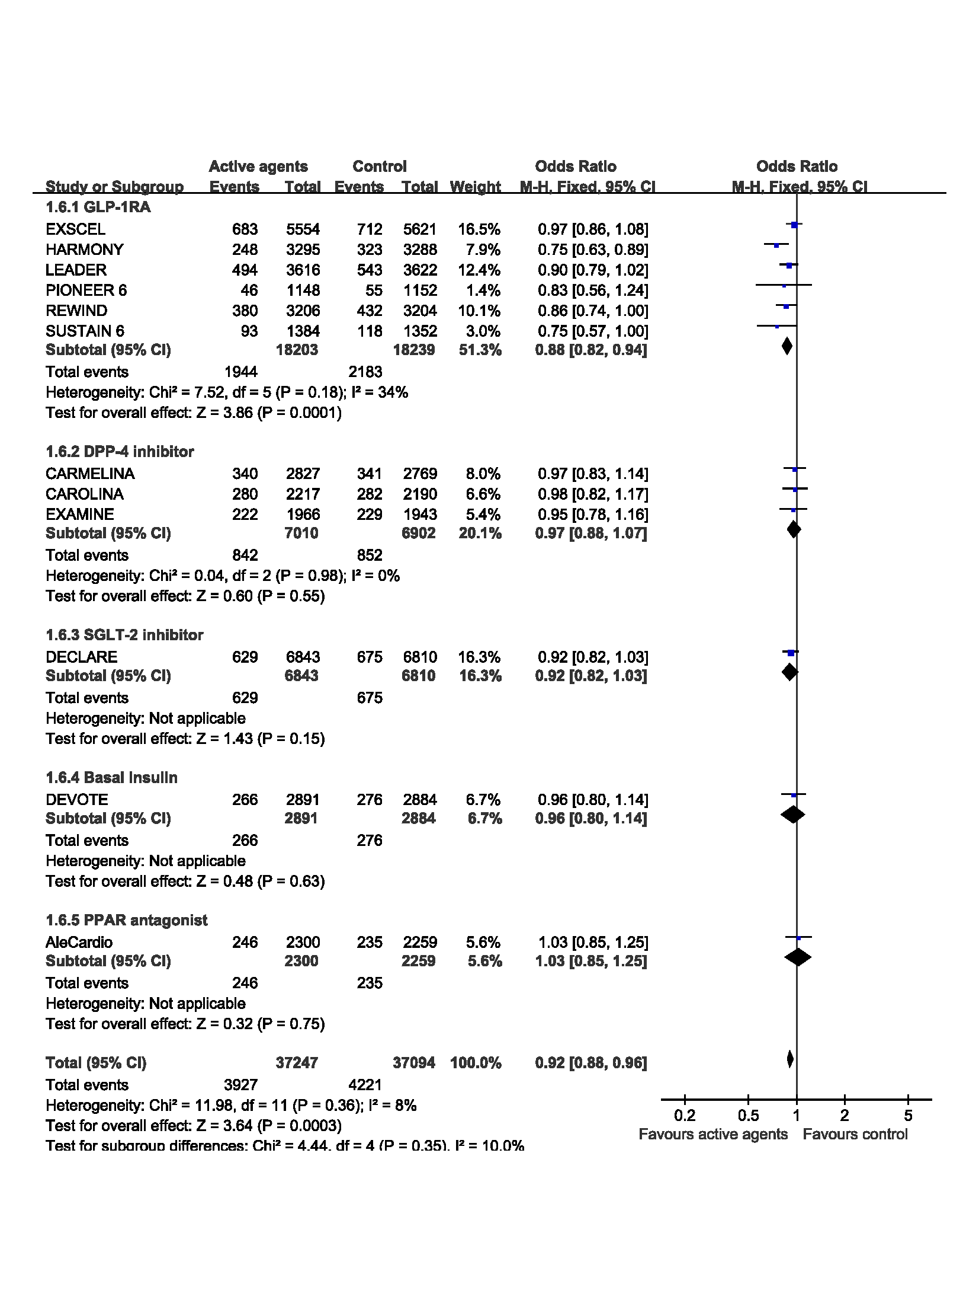

Figure S9: The risk of MACE of CVOTs in Asian patients with type 2 diabetes

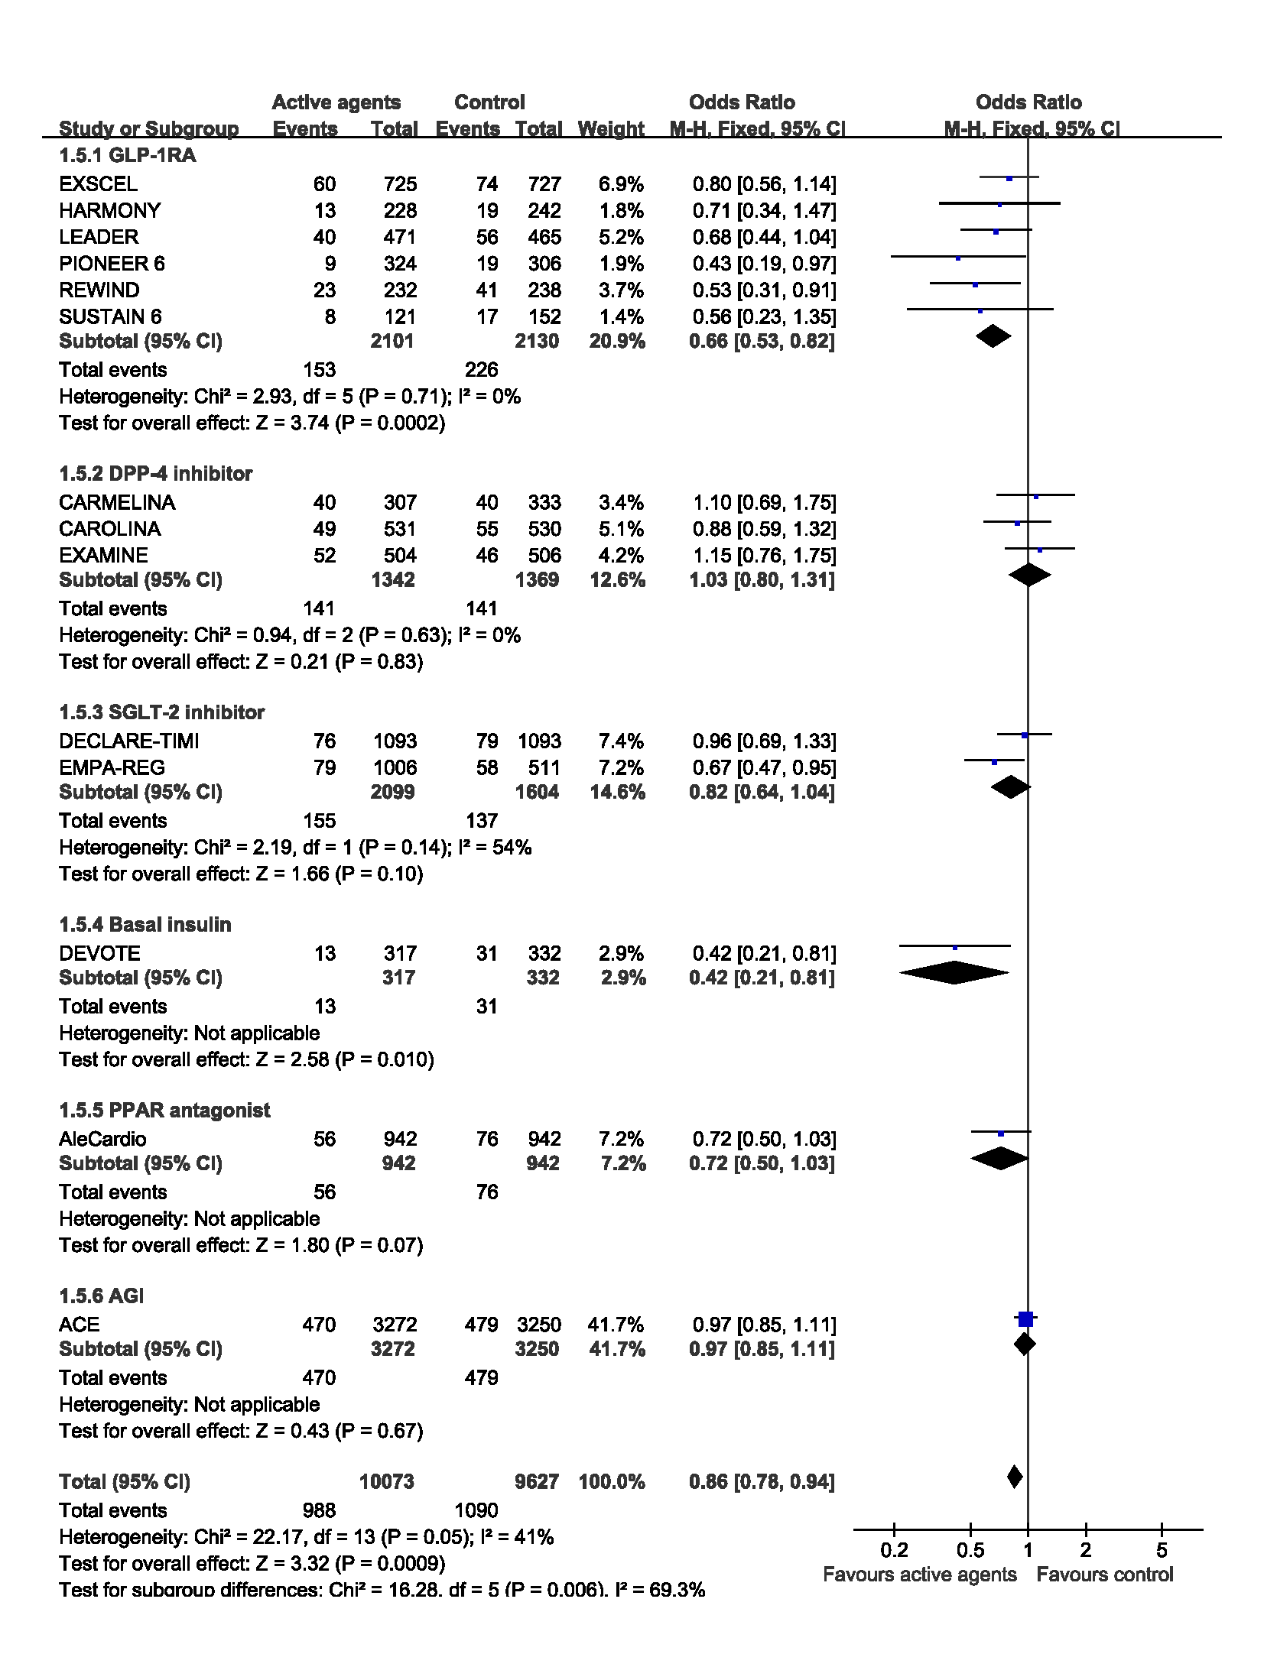

Figure S10: The risk of MACE of CVOTs in black patients with type 2 diabetes

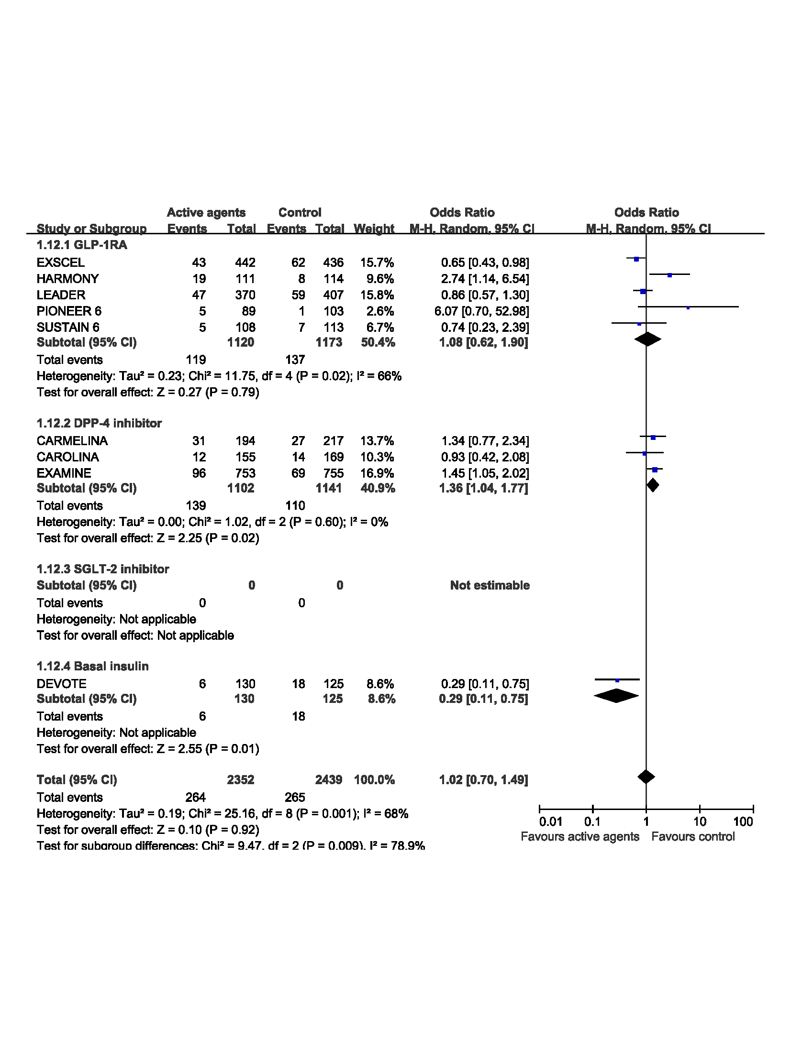

Figure S11: The risk of MACE of CVOTs in patients with type 2 diabetes from other racial/ethnic groups*
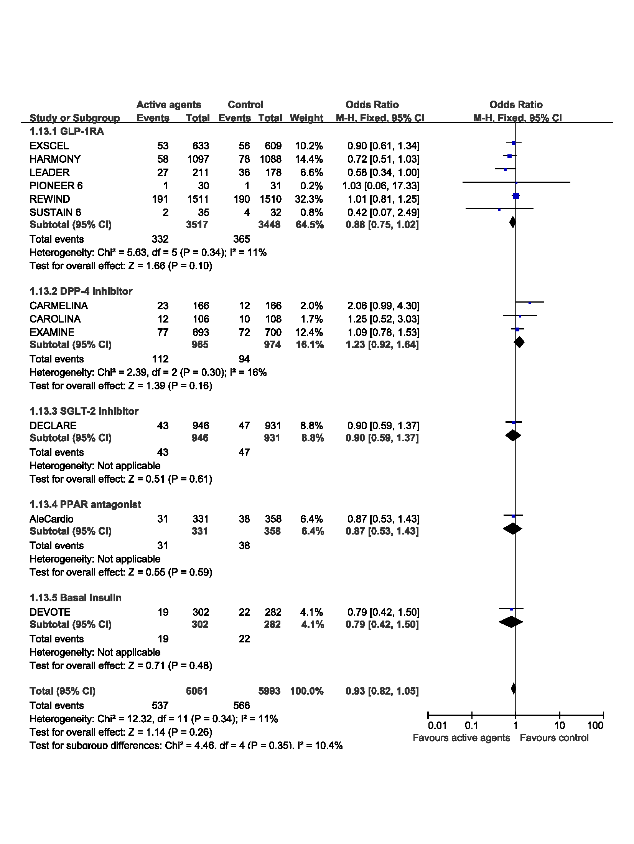
*Hispanics, Pacific Islanders, Hawaiian, American Indian, Alaska Native

Table S1: Chronological List of Cardiovascular Outcome Trials (CVOTs) Included in the Meta-analysis
Author, year | Study duration | Treatment group | No. of patients | Age (years) | Men (%)
White, 2013¹  (EXAMINE) | 18 months | Alogliptin | 2701 | 61 | 67.7
White, 2013¹  (EXAMINE) | 18 months | PBO | 2679 | 61 | 68.0
Lincoff, 2014²  (AleCardio) | 104 weeks | Aleglitazar | 3616 | 61 ± 10 | 73.1%
Lincoff, 2014²  (AleCardio) | 104 weeks | PBO | 3610 | 61 ± 10 | 72.5%
Zinman, 2015³  (EMPA-REG) | 3.1 years | Empagliflozin 10mg | 2345 | 63.0 ± 8.6 | 70.5
Zinman, 2015³  (EMPA-REG) |  | Empagliflozin 25mg | 2342 | 63.2±8.6 | 71.2
Zinman, 2015³  (EMPA-REG) |  | PBO | 2333 | 63.2 ± 8.8 | 72.0
Marso, 2016⁴  (LEADER) | 3.8 years | Liraglutide | 4668 | 64.2 ± 7.2 | 64.5
Marso, 2016⁴  (LEADER) | 3.8 years | PBO | 4672 | 64.2 ± 7.2 | 64.9
Marso, 2016⁵  (SUSTAIN6) | 2.1 years | Semaglutide 0.5 mg | 826 | 64.6 ± 7.3 | 40.1
Marso, 2016⁵  (SUSTAIN6) | 2.1 years | Semaglutide 1.0 mg | 822 | 64.7 ± 7.1 | 37.0
Marso, 2016⁵  (SUSTAIN6) | 2.1 years | PBO 0.5 mg | 824 | 64.8 ± 7.6 | 41.5
Marso, 2016⁵  (SUSTAIN6) | 2.1 years | PBO 10 mg | 825 | 64.4 ± 7.5 | 38.5
Holman,2017⁶  (EXSCEL) | 3.2 years | Exenatide | 7356 | / | 62.0
Holman,2017⁶  (EXSCEL) | 3.2 years | PBO | 7396 | / | 62.0
Holman, 2017⁷  (ACE) | 5.0 years | Acarbose | 3272 | 64.4 ± 8.2 | 73%
Holman, 2017⁷  (ACE) | 5.0 years | PBO | 3250 | 64.3 ± 8.0 | 73%
Marso, 2017⁸  (DEVOTE) | 1.99 years | Degludec | 3818 | 64.9 ± 7.3 | 62.8%
Marso, 2017⁸  (DEVOTE) | 1.99 years | Glargine | 3819 | 65.0 ± 7.5 | 62.4%
Hernandez,2018⁹  (HARMONY) | 28 months | Albiglutide | 4731 | 64.1±8.7 | 70.0
Hernandez,2018⁹  (HARMONY) | 28 months | PBO | 4732 | 64.2±8.7 | 69.0
Rosenstock,2018¹⁰  (CARMELINA) | 180 weeks | Linagliptin | 3494 | 66.1±9.1 | 61.5
Rosenstock,2018¹⁰  (CARMELINA) | 180 weeks | PBO | 3485 | 65.6±9.1 | 64.3
Wiviott,2018¹¹  (DECLARE-TIMI 58) | 206 weeks | Dapagliflozin | 8582 | 63.9±6.8 | 63.1
Wiviott,2018¹¹  (DECLARE-TIMI 58) | 206 weeks | PBO | 8578 | 64.0±6.8 | 62.1
Perkovic, 2019¹²  (CREDENCE) | 2.62 years | Canagliflozin | 2202 | 62.9±9.2 | 65.4
Perkovic, 2019¹²  (CREDENCE) | 2.62 years | PBO | 2199 | 63.2±9.2 | 66.7
Gerstein, 2019¹³  (REWIND) | 5.4 years | Dulaglutide | 4949 | 66.2±6.5 | 53.4
Gerstein, 2019¹³  (REWIND) | 5.4 years | PBO | 4952 | 66.2±6.5 | 53.9
Rosenstock, 2019¹⁴  (CAROLINA) | 6.3 years | Linagliptin | 3023 | 63.9±9.5 | 60.8%
Rosenstock, 2019¹⁴  (CAROLINA) | 6.3 years | PBO | 3010 | 64.2±9.5 | 59.2%
Husain, 2019¹⁵  (PIONEER 6) | 15.9 months | Oral Semaglutide | 1591 | 66±7 | 68.1%
Husain, 2019¹⁵  (PIONEER 6) | 15.9 months | PBO | 1592 | 66±7 | 68.6%
McMurray, 2019¹⁶  (DAPA-HF) | 18.2 months | Dapagliflozin | 2373 | 66.2±11.0 | 76.2%
McMurray, 2019¹⁶  (DAPA-HF) | 18.2 months | PBO | 2371 | 66.5±10.8 | 77.0%
ACE: Effects of acarbose on cardiovascular and diabetes outcomes in patients with coronary heart disease and impaired glucose tolerance
AleCardio: Effect of Aleglitazar on Cardiovascular Outcomes After Acute Coronary Syndrome in Patients With Type 2 Diabetes Mellitus
CANVAS: Canagliflozin and Cardiovascular and Renal Events in Type 2 Diabetes
CARMELINA: The Cardiovascular and Renal Microvascular Outcome Study with Linagliptin
CAROLINA:Effect of Linagliptin vs Glimepiride on Major Adverse Cardiovascular Outcomes in Patients With Type 2 Diabetes
CREDENCE: Canagliflozin and Renal Outcomes in Type 2 Diabetes and Nephropathy
DAPA-HF: Dapagliflozin in Patients with Heart Failure and Reduced Ejection Fraction
DECLARE-TIMI 58: The Dapagliflozin Effect on Cardiovascular Events-Thrombolysis in Myocardial Infarction
DEVOTE: Efficacy and Safety of Degludec versus Glargine in Type 2 Diabetes
EMPA-REG: Empagliflozin, Cardiovascular Outcomes, and Mortality in Type 2 Diabetes
EXAMINE: Alogliptin after Acute Coronary Syndrome in Patients with Type 2 Diabetes
EXSCEL: Exenatide Study of Cardiovascular Event Lowering study
HARMONY: Albiglutide and Cardiovascular Outcomes in Patients with Type 2 Diabetes and Cardiovascular Disease
LEADER: Liraglutide and Cardiovascular Outcomes in Type 2 Diabetes
PIONEER 6: Oral Semaglutide and Cardiovascular Outcomes in Patients with Type 2 Diabetes
REWIND: Dulaglutide and Cardiovascular Outcomes in Type 2 Diabetes
SUSTAIN 6: Semaglutide and Cardiovascular Outcomes in Patients with Type 2 Diabetes

Table S2: Risk of bias for included studies in this meta-analysis.
Author, year | Adequate randomization sequence generation | Adequate  allocation concealment | Blinding  of participants and caregivers | Binding of  outcome assessors  and adjudicators | Free of infrequent  missing outcome data | Free of selective outcome reporting | Free of other bias
White, 2013¹  (EXAMINE) | Probably yes  Randomized,  double-blind | Probably yes  Randomized,  double-blind | Definitely yes  Double-blind  (participant,  investigator) | Definitely yes | Definitely no  There were 22.6% (606/2679) and 21.9% (564/2701) patients in active agent and placebo groups with missing outcome data, respectively; missing outcome data were generally balanced across treatment groups, with similar reasons for missing data | Definitely yes | Probably yes  Generally balanced baseline  characteristics across groups
Lincoff, 2014  (AleCardio)² | Definitely yes  using a permuted block randomizationwithout stratification  through an interactive telephone and web system | Probably yes  Randomized,  double-blind | Definitely yes  Double-blind  (participant,  investigator) | Definitely yes | Definitely yes  There were 6.2% (225/3616) and 6.3% (227/3616) patients in active agent and placebo groups with missing outcome data, respectively; missing outcome data were generally balanced across treatment groups, with similar reasons for missing data | Definitely yes | Probably yes  Generally balanced baseline  characteristics across groups
Zinman, 2015³  (EMPA-REG) | Definitely yes  Using a computer-generated random-sequence and interactive voice-and web-response system | Probably yes  Randomized, double-blind | Definitely yes  Double-blind  (participant,  investigator) | Definitely yes | Definitely yes  There were 3.1% (144/4687) and 2.9% (67/2333) patients in active agent and placebo groups with missing outcome data, respectively; missing outcome data were generally balanced across treatment groups, with similar reasons for missing data across groups | Definitely yes | Probably yes  Generally balanced baseline  characteristics across groups
Marso, 2016⁴  (LEADER) | Definitely yes  Using the interactive voice/web response system | Probably yes  Randomized, double-blind | Probably yes  Double-blind  (details not reported) | Definitely yes | Definitely yes  There were 1.5% (25/1648) and 2.4% (40/1649) patients in active agent and placebo groups with missing outcome data, respectively; missing outcome data were generally balanced across treatment groups, with similar reasons for missing data across groups | Definitely yes | Probably yes  Generally balanced baseline  characteristics across groups
Marso, 2016⁵  (SUSTAIN6) | Probably yes  Randomized,  double-blind | Probably yes  Randomized,  double-blind | Probably yes  Double-blind  (details not reported) | Definitely yes | Definitely yes  There were 3.0% (139/4668) and 3.4% (159/4672) patients in active agent and placebo groups with missing outcome data, respectively; missing outcome data were generally balanced across treatment groups, with similar reasons for missing data across groups | Definitely yes | Probably yes  Generally balanced baseline  characteristics across groups
Holman,2017⁶  (EXSCEL) | Definitely yes  Using an interactive voice-response system | Probably yes  Randomized, double-blind | Definitely yes  Double-blind  (participant,  investigator) | Definitely yes | Definitely yes  There were 3.6% (262/7356) and 4.1% (303/7396) patients in active agent and placebo groups with missing outcome data, respectively; missing outcome data were generally balanced across treatment groups, with similar reasons for missing data across groups | Definitely yes | Probably yes  Generally balanced baseline  characteristics across groups
Holman, 2017⁷  (ACE) | Definitely yes  Using randomization  sequence (coded as A or B) generated by a Diabetes  Trials Unit statistician unconnected to the trial and  uploaded to the electronic Rave Trial Management System | Probably yes  Randomized, double-blind | Definitely yes  Double-blind  (participant,  investigator) | Definitely yes | Definitely yes  There were 5.8% (189/3272) and 6% (195/3250) patients in active agent and placebo groups with missing outcome data, respectively; missing outcome data were generally balanced across treatment groups, with similar reasons for missing data across groups | Definitely yes | Probably yes  Generally balanced baseline  characteristics across groups
Marso, 2017⁸  (DEVOTE) | Probably yes  Randomized | Probably yes  Randomized, double-blind | Probably yes  Double-blind  (details not reported) | Definitely yes | Definitely yes  There were 2.0% (76/3818) and 1.9% (72/3819) patients in detemir and glargine groups with missing outcome data, respectively; missing outcome data were generally balanced across treatment groups, with similar reasons for missing data across groups | Definitely yes | Probably yes  Generally balanced baseline  characteristics across groups
Hernandez,2018⁹  (HARMONY) | Definitely yes  Using a computer-generated randomization code | Probably yes  Randomized, double-blind | Definitely yes  Double-blind  (participant,  investigator) | Definitely yes | Definitely yes  There were 2.5% (111/4371) and 3.3% (154/4732) patients in active agent and placebo groups with missing outcome data, respectively; missing outcome data were generally balanced across treatment groups, with similar reasons for missing data across groups | Definitely yes | Probably yes  Generally balanced baseline  characteristics across groups
Rosenstock,2018¹⁰  (CARMELINA) | Definitely yes  Using a interactive telephone/web–based system | Probably yes  Randomized, double-blind | Definitely yes  Double-blind  (participant,  investigator) | Definitely yes | Definitely no  There were 23.9% (834/3494) and 27.3% (955/3492) patients in active gent and placebo groups with missing outcome data, respectively; missing outcome data were generally balanced across treatment groups, with similar reasons for missing data across groups | Definitely yes | Probably yes  Generally balanced baseline  characteristics across groups
Wiviott,2018¹¹  (DECLARE-TIMI 58) | Definitely yes  Using an interactive-voice/web response system | Probably yes  Randomized, double-blind | Definitely yes  Double-blind  (participant,  investigator) | Definitely yes | Definitely yes  There were 1.3% (109/8582) and 1.7% (145/8578) patients in active agent and placebo groups with missing outcome data, respectively; missing outcome data were generally balanced across treatment groups, with similar reasons for missing data across groups | Definitely yes | Probably yes  Generally balanced baseline  characteristics across groups
Perkovic, 2019¹²  (CREDENCE) | Definitely yes  Using an interactive web response system with a computer-generated randomization schedule | Probably yes  Randomized, double-blind | Definitely yes  Double-blind  (participant,  investigator) | Definitely yes | Definitely yes  There were 0.68% (15/2202) and 1.1% (25/2174) patients in active agent and placebo groups with missing outcome data, respectively; missing outcome data were generally balanced across treatment groups, with similar reasons for missing data across groups | Definitely yes | Probably yes  Generally balanced baseline  characteristics across groups
Gerstein, 2019¹³  (REWIND) | Probably yes  Randomized,  double-blind | Probably yes  Randomized, double-blind | Definitely yes  Double-blind  (participant,  investigator) | Definitely yes | Definitely yes  There were 2.7% (132/4949) and 3.2% (159/4935) patients in active agent and placebo groups with missing outcome data, respectively; missing outcome data were generally balanced across treatment groups, with similar reasons for missing data across groups | Definitely yes | Probably yes  Generally balanced baseline  characteristics across groups
Rosenstock, 2019¹⁴  (CAROLINA) | Definitely yes  Using a computer-generated random sequence and an interactive voice and web response system | Probably yes  Randomized, double-blind | Definitely yes  Double-blind  (participant,  investigator) | Definitely yes | Definitely no  There were 37.3% (1127/3023) and 39.1% (1178/3010) patients in active agent and control groups with missing outcome data, respectively | Definitely yes | Probably yes  Generally balanced baseline  characteristics across groups
Husain, 2019¹⁵  (PIONEER 6) | Definitely yes  Using an interactive-voice/web response system | Probably yes  Randomized, double-blind | Definitely yes  Double-blind  (participant,  investigator) | Definitely yes | Definitely yes  There were 0.3% (5/1591) and 0.4% (6/1592) patients in active agent and placebo groups with missing outcome data, respectively; missing outcome data were generally balanced across treatment groups, with similar reasons for missing data across groups | Definitely yes | Probably yes  Generally balanced baseline  characteristics across groups
McMurray, 2019¹⁶  (DAPA-HF) | Definitely yes  Using a computer-generated randomization code | Probably yes  Randomized, double-blind | Definitely yes  Double-blind  (participant,  investigator) | Definitely yes | Definitely yes  There were 10.5% (249/2373) and 10.9% (258/2371) patients in active agent and placebo groups with missing outcome data, respectively; missing outcome data were generally balanced across treatment groups, with similar reasons for missing data across groups | Definitely yes | Probably yes  Generally balanced baseline  characteristics across groups
ACE: Effects of acarbose on cardiovascular and diabetes outcomes in patients with coronary heart disease and impaired glucose tolerance
AleCardio: Effect of Aleglitazar on Cardiovascular Outcomes After Acute Coronary Syndrome in Patients With Type 2 Diabetes Mellitus
CANVAS: Canagliflozin and Cardiovascular and Renal Events in Type 2 Diabetes
CARMELINA: The Cardiovascular and Renal Microvascular Outcome Study with Linagliptin
CAROLINA:Effect of Linagliptin vs Glimepiride on Major Adverse Cardiovascular Outcomes in Patients With Type 2 Diabetes
CREDENCE: Canagliflozin and Renal Outcomes in Type 2 Diabetes and Nephropathy
DAPA-HF: Dapagliflozin in Patients with Heart Failure and Reduced Ejection Fraction
DECLARE-TIMI 58: The Dapagliflozin Effect on Cardiovascular Events-Thrombolysis in Myocardial Infarction
DEVOTE: Efficacy and Safety of Degludec versus Glargine in Type 2 Diabetes
EMPA-REG: Empagliflozin, Cardiovascular Outcomes, and Mortality in Type 2 Diabetes
EXAMINE: Alogliptin after Acute Coronary Syndrome in Patients with Type 2 Diabetes
EXSCEL: Exenatide Study of Cardiovascular Event Lowering study
HARMONY: Albiglutide and Cardiovascular Outcomes in Patients with Type 2 Diabetes and Cardiovascular Disease
LEADER: Liraglutide and Cardiovascular Outcomes in Type 2 Diabetes
PIONEER 6: Oral Semaglutide and Cardiovascular Outcomes in Patients with Type 2 Diabetes
REWIND: Dulaglutide and Cardiovascular Outcomes in Type 2 Diabetes
SUSTAIN 6: Semaglutide and Cardiovascular Outcomes in Patients with Type 2 Diabetes

Table S3: Primary Outcomes of CVOTs Stratified by Race/Ethnicity
Race/Ethnic groups |  | Number of participants  (Active/Control) | Proportions (%) | Odds ratio | 95%CI | I²
Total
White |  | 40396/40209 | 67.15 | 0.90 | 0.86-0.94 | 41%
Asian |  | 11050/10643 | 18.07 | 0.82 | 0.76-0.90 | 46%
Black |  | 2586/2655 | 4.37 | 0.96 | 0.69-1.32 | 64%
Others |  | 6276/6216 | 10.41 | 0.92 | 0.81-1.04 | 12%
Primary outcomes of CVOTs in placebo-controlled trials
White |  | 35288/35135 | 65.96 | 0.89 | 0.85-0.93 | 46%
Asian |  | 10202/9781 | 18.72 | 0.83 | 0.76-0.91 | 44%
Black |  | 2301/2361 | 4.37 | 1.05 | 0.76-1.46 | 62%
Others |  | 5868/5826 | 10.95 | 0.92 | 0.81-1.04 | 22%
Primary outcome restricted to MACE
White |  | 37247/27094 | 63.77 | 0.92 | 0.88-0.96 | 8%
Asian |  | 10073/9627 | 19.53 | 0.86 | 0.78-0.94 | 41%
Black |  | 2352/2439 | 4.75 | 1.02 | 0.70-1.49 | 68%
Others |  | 6061/5993 | 11.95 | 0.93 | 0.82-1.05 | 11%
Primary outcome in treatment with GLP-1RA
White |  | 18203/18239 | 72.98 | 0.88 | 0.82-0.94 | 34%
Asian |  | 2101/2130 | 8.47 | 0.66 | 0.53-0.82 | 0%
Black |  | 1120/1173 | 4.59 | 1.08 | 0.62-1.90 | 66%
Others |  | 3517/3448 | 13.95 | 0.88 | 0.75-1.02 | 11%
Primary outcome in treatment with DPP4 inhibitor
White |  | 7010/6902 | 66.87 | 0.97 | 0.88-1.07 | 0%
Asian |  | 1342/1369 | 13.03 | 1.03 | 0.80-1.31 | 0%
Black |  | 1102/1141 | 10.78 | 1.36 | 1.04-1.77 | 0%
Others |  | 965/974 | 9.32 | 1.23 | 0.92-1.64 | 16%
Primary outcome in treatment with SGLT2 inhibitor
White |  | 9992/9925 | 70.18 | 0.84 | 0.77-0.91 | 71%
Asian |  | 3076/2620 | 20.07 | 0.72 | 0.60-0.85 | 30%
Black |  | 234/216 | 1.59 | 0.73 | 0.46-1.15 | 0%
Others |  | 1161/1154 | 8.16 | 0.82 | 0.60-1.14 | 0%
Primary outcome in treatment with basal insulin
White |  | 2891/2882 | 79.51 | 0.96 | 0.80-1.14 | /
Asian |  | 317/332 | 8.94 | 0.42 | 0.21-0.81 | /
Black |  | 130/125 | 3.51 | 0.29 | 0.11-0.75 | /
Others |  | 302/282 | 8.04 | 0.79 | 0.42-1.50 | /
Primary outcome in treatment with PPAR antagonist
White |  | 2300/2259 | 63.92 | 1.03 | 0.85-1.25 | /
Asian |  | 942/942 | 26.42 | 0.72 | 0.50-1.03 | /
Black |  | / | 0 | / | / | /
Others |  | 331/358 | 9.66 | 0.87 | 0.53-1.43 | /
Primary outcome in treatment with AGI
White |  | / | 0 | / | / | /
Asian |  | 3272/3250 | 100 | 0.97 | 0.85-1.11 | /
Black |  | / | 0 | / | / | /
Others |  | / | 0 | / | / | /

Reference:
- White WB, Cannon CP, Heller SR, et al. Alogliptin after acute coronary syndrome in patients with type 2 diabetes. N Engl J Med. 2013; 369: 1327-1335.
- Lincoff A M , Tardif J C , Schwartz G G, et al. Effect of Aleglitazar on Cardiovascular Outcomes After Acute Coronary Syndrome in Patients With Type 2 Diabetes Mellitus: The AleCardio Randomized Clinical Trial. JAMA. 2014; 311(15):1515.
- Zinman B, Wanner C, Lachin JM, et al. Empagliflozin, Cardiovascular Outcomes, and Mortality in Type 2 Diabetes. N Engl J Med. 2015; 373: 2117-2128.
- Marso SP, Daniels GH, Brown-Frandsen K, et al. Liraglutide and Cardiovascular Outcomes in Type 2 Diabetes. N Engl J Med. 2016; 375: 311-322.
- Marso SP, Bain SC, Consoli A, et al. Semaglutide and Cardiovascular Outcomes in Patients with Type 2 Diabetes. N Engl J Med. 2016; 375: 1834-1844.
- Holman R R, Bethel M A, Mentz R J , et al. Effect of once-weekly exenatide on cardiovascular outcomes in type 2 diabetes. N Engl J Med. 2017, 377(13):1228.
- Holman RR, Coleman RL, Chan JCN, et al. Effects of acarbose on cardiovascular and diabetes outcomes in patients with coronary heart disease and impaired glucose tolerance (ACE): a randomised, double-blind, placebo-controlled trial. Lancet Diabetes Endocrinol. 2017; 5(11):877-886.
- Marso SP, McGuire DK, Zinman B, et al. Efficacy and Safety of Degludec versus Glargine in Type 2 Diabetes. N Engl J Med. 2017; 377:723-32.
- Hernandez AF, Green JB, Janmohamed S, et al. Albiglutide and cardiovascular outcomes in patients with type 2 diabetes and cardiovascular disease (Harmony Outcomes): a double-blind, randomised placebo-controlled trial. Lancet (London, England). 2018; 392(10157):1519-29.
- Rosenstock J, Perkovic V, Johansen OE, et al. Effect of Linagliptin vs Placebo on Major Cardiovascular Events in Adults with Type 2 Diabetes and High Cardiovascular and Renal Risk: The CARMELINA Randomized Clinical Trial. JAMA. 2019; 321(1):69-79.
- Wiviott SD, Raz I, Bonaca MP, et al. Dapagliflozin and Cardiovascular Outcomes in Type 2 Diabetes. N Engl J Med. 2018;380(4):347-57.
- Perkovic V, Jardine MJ, Neal B, et al. Canagliflozin and Renal Outcomes in Type 2 Diabetes and Nephropathy. N Engl J Med. 2019;380:2295-306.
- Gerstein HC, Colhoun HM, Dagenais GR, et al. Dulaglutide and cardiovascular outcomes in type 2 diabetes (REWIND): a double-blind, randomised placebo-controlled trial.Lancet. 2019;394:121-130.
- Rosenstock J, Kahn SE, Johansen OE, et al. Effect of Linagliptin vs Glimepiride on Major Adverse Cardiovascular Outcomes in Patients With Type 2 Diabetes: The CAROLINA Randomized Clinical Trial. JAMA. 2019;322(12):1155–1166
- Husain M, Birkenfeld AL, Donsmark M, et al. Oral Semaglutide and Cardiovascular Outcomes in Patients with Type 2 Diabetes. N Engl J Med. 2019; 381(9):841-851.
- McMurray JJV, Solomon SD, Inzucchi SE, et al. Dapagliflozin in Patients with Heart Failure and Reduced Ejection Fraction. N Engl J Med. 2019;381(21):1995-2008.

