Microbacterium rhizophilus sp. nov., an indole acetic acid-producing actinobacterium isolated from rhizosphere soil
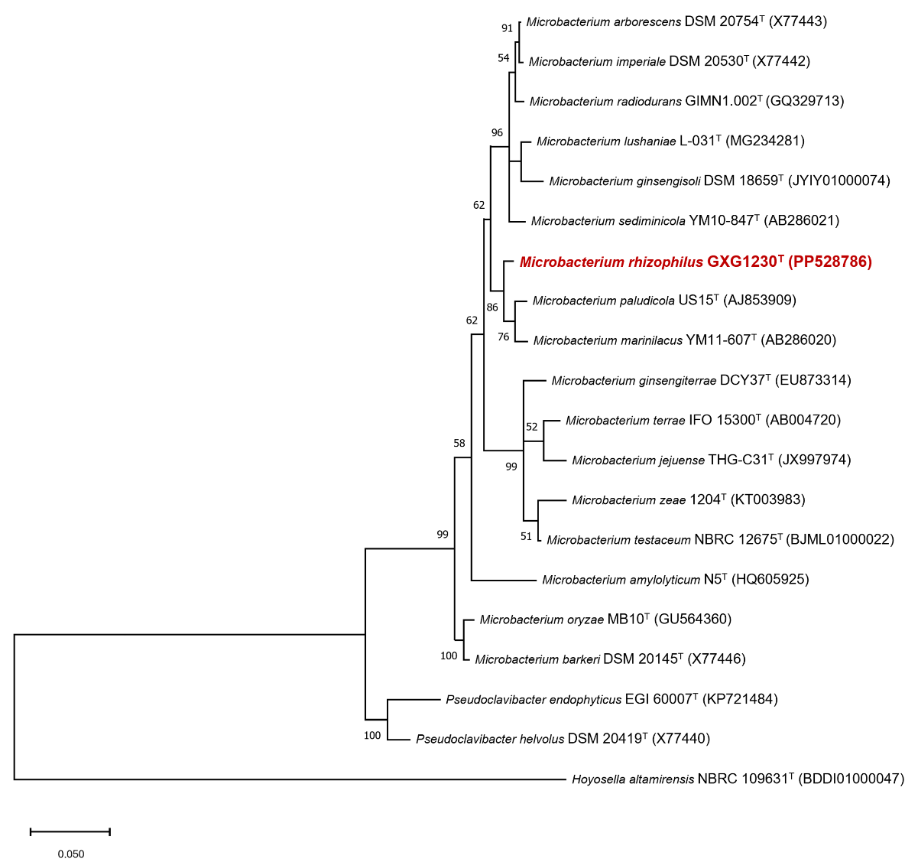
Fig. S1 The Maximum-Likelihood tree based on the 16S rRNA gene sequences showing the phylogenetic relationship of GXG230^{T} with related taxa. The sequence of Pseudoclavibacter endophyticus EGI 60007^{T} (KP721484)、Pseudoclavibacter helvolus DSM 20419^{T} (X77440) and Hoyosella altamirensis NBRC 109631^{T} (BDDI01000047) was used as an outgroup. Bootstrap support values were calculated from 1000 replicates.

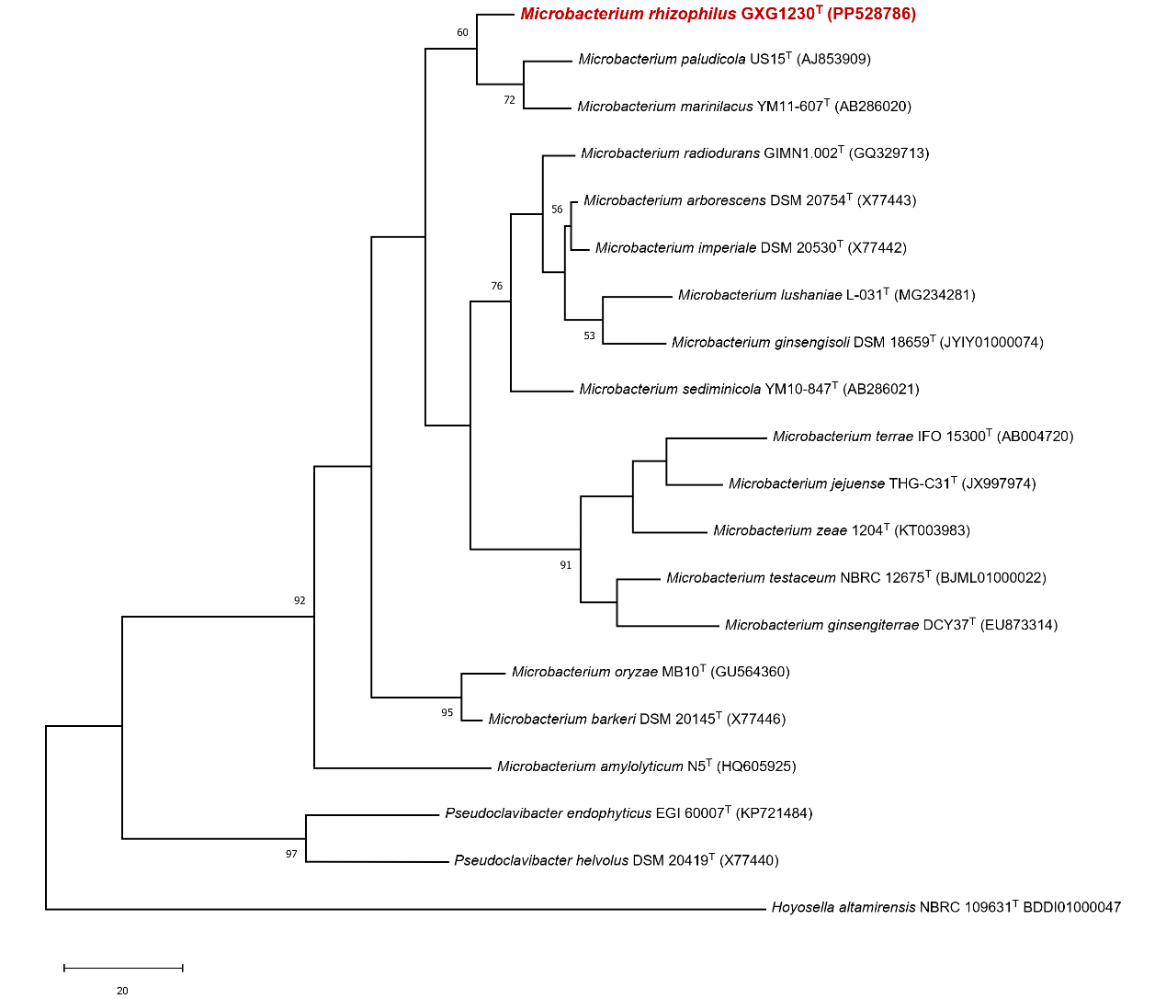
Fig. S2 The Maximum-Parsimony tree based on the 16S rRNA gene sequences showing the phylogenetic relationship of GXG1230T with related taxa. The sequence of Pseudoclavibacter endophyticus EGI 60007T (KP721484)、Pseudoclavibacter helvolus DSM 20419T (X77440) and Hoyosella altamirensis NBRC 109631T (BDDI01000047) was used as an outgroup. Bootstrap support values were calculated from 1000 replicates.

Table S1 Subsystem characterization counts for GXG1230^{T} and related members of the genus Microbacterium.
Subsystem feature counts | GXG1230^{T} | Microbacterium paludicola US15^{T} | Microbacterium marinilacus  YM11-607^{T}
Cofactors, Vitamins, Prosthetic Groups, Pigments | 105 | 110 | 120
Cell Wall and Capsule· | 22 | 26 | 19
Virulence, Disease and Defense | 17 | 26 | 31
Potassium metabolism | 17 | 6 | 5
Photosynthesis | 0 | 0 | 0
Miscellaneous | 19 | 19 | 22
Phages, Prophages, Transposable elements, Plasmids | 2 | 1 | 2
Membrane Transport | 20 | 18 | 21
Iron acquisition and metabolism | 8 | 9 | 15
RNA Metabolism | 26 | 28 | 30
Nucleosides and Nucleotides | 88 | 83 | 83
Protein Metabolism | 126 | 151 | 147
Cell Division and Cell Cycle | 0 | 0 | 0
Motility and Chemotaxis | 0 | 5 | 5
Regulation and Cell signaling | 6 | 6 | 4
Secondary Metabolism | 5 | 4 | 4
DNA Metabolism | 52 | 48 | 60
Fatty Acids, Lipids, and Isoprenoids | 45 | 46 | 65
Nitrogen Metabolism | 6 | 6 | 6
Dormancy and Sporulation | 1 | 1 | 1
Respiration | 33 | 29 | 32
Stress Response | 13 | 13 | 19
Metabolism of Aromatic Compounds | 27 | 11 | 29
Amino Acids and Derivatives | 199 | 213 | 234
Sulfur Metabolism | 3 | 4 | 4
Phosphorus Metabolism | 18 | 20 | 18
Carbohydrates | 155 | 177 | 172

Table S2 antiSMASH of GXG1230^{T} and related members of the genus Microbacterium.
antiSMASH v.7.0.1 | GXG1230^{T} | Microbacterium paludicola  US15^{T} | Microbacterium marinilacus YM11-607^{T}
Terpene | + | + | +
Betalactone | + | + | +
NAPAA* | + | – | +
Lipolanthine | – | + | –
T3PKS* | – | + | +
NAPAA*：Non-alpha poly-amino acids like e-Polylysin. T3PKS: Type III PKS

Table S3 The results of conduct the COG category analysis of coding proteins about GXG1230^{T} and reference strains of the genus Microbacterium.
Functional-Categories | GXG1230^{T} | Microbacterium paludicola  US15^{T} | Microbacterium marinilacus YM11-607^{T}
RNA processing and modification | 0 | 0 | 0
Chromatin structure and dynamics | 0 | 0 | 0
Energy production and conversion | 172 | 141 | 184
Cell cycle control, cell division, chromosome partitioning | 40 | 37 | 37
Amino acid transport and metabolism | 316 | 340 | 410
Nucleotide transport and metabolism | 87 | 79 | 89
Carbohydrate transport and metabolism | 264 | 354 | 292
Coenzyme transport and metabolism | 105 | 106 | 118
Lipid transport and metabolism | 118 | 108 | 142
Translation, ribosomal structure and biogenesis | 152 | 158 | 162
Transcription | 254 | 285 | 374
Replication, recombination and repair | 145 | 139 | 160
Cell wall/membrane/envelope biogenesis | 162 | 145 | 172
Cell motility | 13 | 34 | 29
Posttranslational modification, protein turnover, chaperones | 90 | 77 | 83
Inorganic ion transport and metabolism | 220 | 228 | 336
Secondary metabolites biosynthesis, transport and catabolism | 63 | 55 | 101
General function prediction only | 0 | 0 | 0
Function unknown | 427 | 530 | 599
Signal transduction mechanisms | 101 | 120 | 120
Intracellular trafficking, secretion, and vesicular transport | 50 | 50 | 52
Defense mechanisms | 50 | 64 | 78

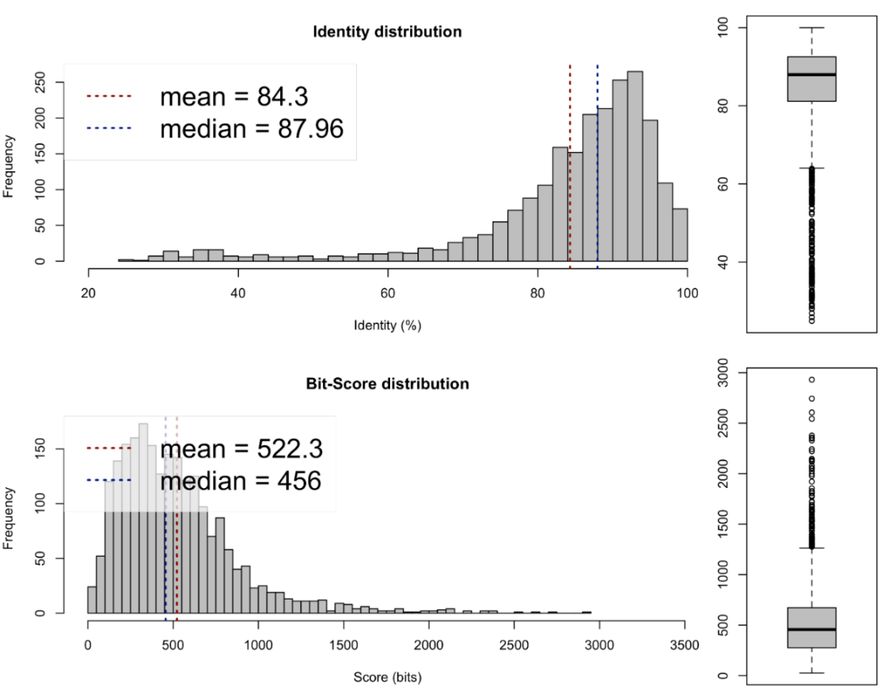
Fig. S3 AAI values between strain GXG1230^{T} and Microbacterium paludicola US15^{T}
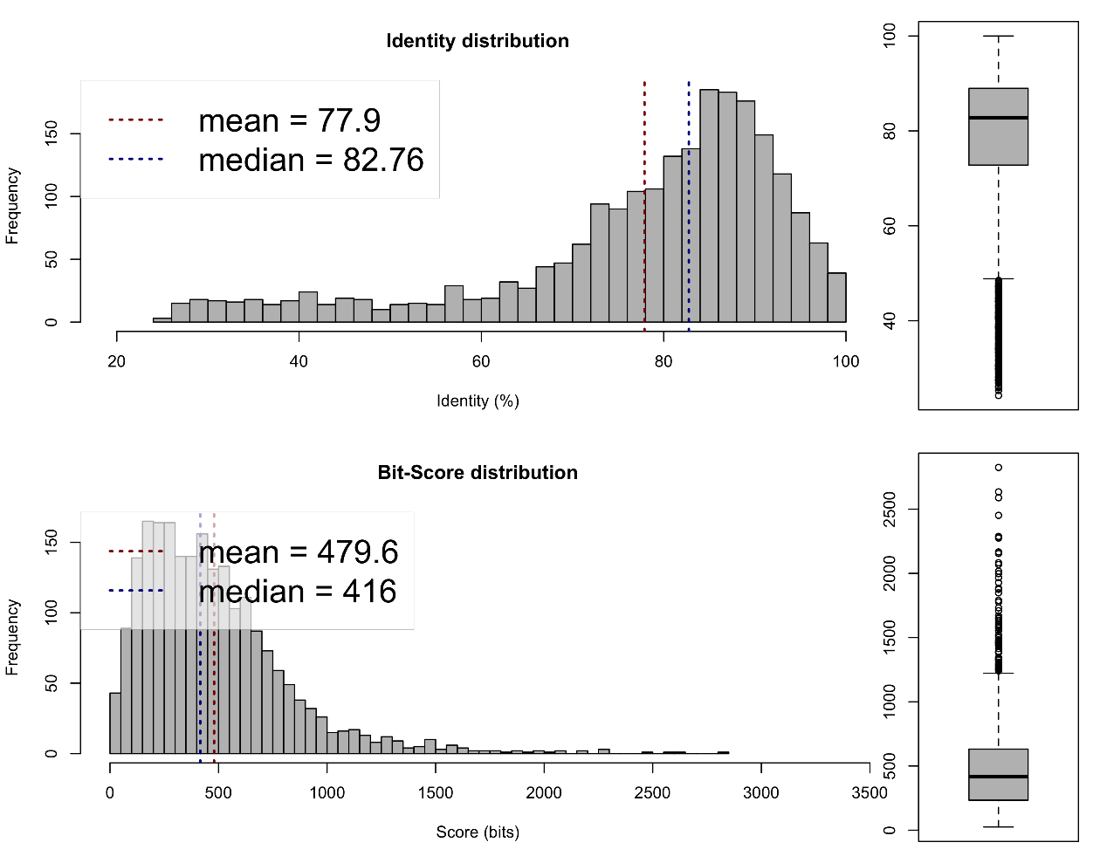
Fig. S4 AAI values between strain GXG1230^{T} and Microbacterium marinilacus YM11-607^{T}

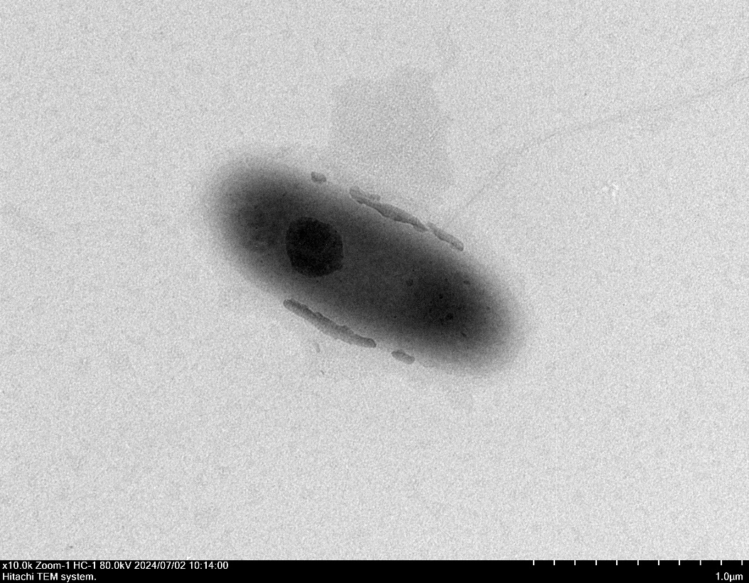

Fig. S5 Transmission electron micrographs of the cells of strain GXG1230^{T} Cells are cultured on LB medium at 30 °C for 24-36 h. Bar, 1μm.
Fig. S6 Polar lipids of GXG1230^{T}. Polar lipids of strain separated by two-dimensional TLC and detected with (A), molybdophosphoric acid reagent; (B), molybdenum blue reagent; (C), 1-naphthol reagent. All data presented are from this study.

Table S4 Cellular fatty acid composition of GXG1230^{T} and related strains. All presented data were obtained in the same laboratory under standardized conditions.
Fatty acids (%) | GXG1230^{T} | Microbacterium paludicola US15^{T} | Microbacterium marinilacus  YM11-607^{T}
iso-C_{14:0} | 5.1 | 3.3 | 2.0
iso-C_{15:0} | 2.0 | 1.3 | 2.1
anteiso-C_{15:0} | 36.9 | 63.9 | 59.1
C_{16:0} | 2.1 | 2.9 | ND
iso-C_{16:0} | 28.9 | 11.7 | 14.4
anteiso-C_{17:0} | 12.1 | 14.4 | 20.9
anteiso-C_{17:1} ꞷ 9c | 4.4 | ND | ND

