Additional file 6 – Results of the longitudinal data analyses using LMM

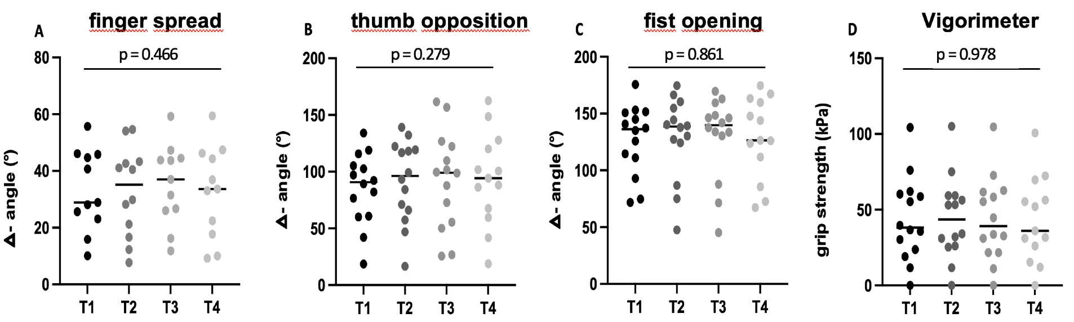

Additional file 6 – Figure 1: Results of repeated measures analyses (Type III ANOVA in R). The graphics (A-D) show the results of the repeated measures ANOVAs which searched for significant differences throughout the whole study course for each movement pattern of the dataglove and for the Vigorimeter as the primary reference tool. Mean (horizontal line) as well as individual values are shown for each time point. P-values are given as the overall result of the ANOVA. Due to missing data of one patient at T₄, the number of patients was reduced by one at this time point for every parameter. Moreover, for the finger spread movement pattern, one patient only contributed to the data at T₂ and T₄ and two further patients did not contribute to any of the time points due to insufficient range of motion.

Additional file 6 - Table 1: p-values of repeated measures ANOVA Type III for the glove movement patterns and the Vigorimeter

Parameter | p-value | F Value | (DFn/DFd)
finger spread | 0.466 | 0.873 | 3 / 30.000
thumb opposition | 0.279 | 1.331 | 3 / 38.033
fist opening  Vigorimeter | 0.861  0.978 | 0.250  0.068 | 3 / 38.008  3 / 38.044
(DFn = degrees of freedom numerator, DFd = degrees of freedom denominator)

Additional file 6 - Table 2: p-values of repeated measures ANOVA Type III for other clinical outcome parameters

Parameter | p-value | F Value | (DFn/DFd)
R-ODS (logits) | 0.957 | 0.1039 | 3 / 37.998
INCAT (arm sub-score) | 0.194 | 1.6522 | 3 / 38.022
MRC (arm sub-score) | 0.335 | 1.168 | 3 / 38.012
(DFn = degrees of freedom numerator, DFd = degrees of freedom denominator, R-ODS = Rasch-built Overall
Disability Scale, INCAT = Inflammatory Neuropathy Cause and Treatment, MRC = Medical Research Council)

Additional file 6 - Table 3: p-values of the LMM - interaction term (time:tool)

Interaction term | p-value
time: finger spread/Vigorimeter | 0.712
time: thumb opposition/Vigorimeter | 0.294
time: fist opening/Vigorimeter | 0.791

The interpretation of the p-values of the LMM-interaction terms had to be done with caution because only little changes occurred for both tools. Moreover, we were only able to demonstrate that there were no significant differences between the trends of the glove movement patterns and the Vigorimeter. Further analyses have to be done, most likely in treatment naive patients, to determine the potential of the data glove to differentiate between clinical stability and relevant changes for confirming the findings of this study.

