Reviewer 1
Authors address pharmacodynamics of 6-nitrodopamine. As a model they used spontaneously beating right rat atria. Positive chrontropy of 6-nitodopamine effects were measured in the presence of propranolol and some nitro-derivatives of propranolol. The pharmacological model is appropriate. My concern relates to interpretation of data. I am afraid that interpretation on conclusions made by the authors are not justified.
Major points
1. The discrepancy between pA2 values of (±)-propranolol and its respective pEC50 indicates that the falls in atrial rate induced by (±)-propranolol should not be attributed to beta-adrenergic antagonism. (l. 49)
Authors describe in Figure 1 negative chronotropy of propranolol. However, the pharmacodynamics are far from clear. At first glance I would expect of cardiac sodium channels by very high concentrations of propranolol? Definitely not by block of β-adrenoceptors since both (-)-propranolol and (+)-propranolol shows the same effect (only the (-)-propranolol behaves as a β-adrenoceptor antagonist. This is not a trivial issue, since the whole argumentation is based in the statement above.

We thank the reviewer for the careful evaluation of our manuscript. As the reviewer pointed out, the statement “The discrepancy between pA2 values of (±)-propranolol and its respective pEC50 indicates that the falls in atrial rate induced by (±)-propranolol should not be attributed to beta-adrenergic antagonism” is one of the main messages of the manuscript. As the reviewer correctly stated, propranolol has local anaesthetic like activity at higher doses than those required to reach maximal beta-blockade, and this activity is not stereoselective (Wang et al., 2010). Indeed, beta-blockers act at the local anaesthetic binding site and block sodium channels with properties similar to those of local anaesthetics (Bankston & Kass, 2010).

Both enantiomers of propranolol block cardiac Na_{v}1.5 channels at equivalent potency (Wang et al., 2010). Thus, one possibility would be that the fall in atrial rate could be due to blockade of this tetrodotoxin-sensitive sodium channel. In the figure presented below (Fig A), please note that pre-incubation of the rat isolated right atrium with tetrodotoxin (TTX; 1 μM) caused a significant fall in atrial rate. However, in TTX-pretreated atria, propranolol (10 μM) provoked a significant fall in atrial rate (Fig. B). Therefore, one can conclude that this fall in atrial rate induced by propranolol (10 μM) is not due to the blockade of cardiac TTX-sensitive Nav channels.

Indeed, propranolol (10 μM) caused a significant fall in atrial rate (Fig. C), and tetrodotoxin (1 μM) can induce fall in atrial rate, even the atrium was pre-incubated with propranolol (Fig. D).

Another piece of evidence that the fall in atrial induced by propranolol (10 mM) is not due to blockade of Nav 1.5 channels is presented by the finding that this sodium channel blocking effect of propranolol is not a class effect of β-blockers, since nadolol and metoprolol did not block Nav 1.5 channels (Wang et al., 2010), and yet, the so called β₁-adrenoceptor antagonists atenolol, metoprolol, and betaxolol, provoked fall in atrial rate in atria pre-treated with tetrodotoxin (Britto-Júnior et al., 2022).

Lidocaine is also a Nav 1.5 channel blocker, it has anti-arrhythmic activity, and is supposed to have at least one locus of action at a site other than the TTX blockade site (Desai et al., 1989). One possibility would be that propranolol would be acting at this other site. This is also unlikely, since as shown below, lidocaine (10 μM) caused a significant fall in atrial rate (Fig. E), and propranolol (10 μM) was able to induce fall in atrial rate in lidocaine-pretreated atria (Fig. F).

Thus, the hypothesis we have proposed is that the fall in atrial rate induced by both propranolol and by 4-nitro-propranolol, is due to blockade of the 6-nitrodopamine receptor. As shown below, propranolol (10 μM) caused significant fall in atrial rate (Fig. G), however, in propranolol-pretreated atria, 4-nitro-propranolol (10 μM) did not alter atrial basal rate (Fig. H).

Similarly, 4-nitro-propranolol (10 μM) caused significant fall in atrial rate (Fig. I), however, in 4-nitro-propranolol-pretreated atria, propranolol (10 μM) did not alter atrial basal rate (Fig. J).

4-nitro-propranol is the first selective antagonist of the 6-ND receptor.
2. Results (l. 248): The increase in atrial rate induced by 6-ND was unaffected by (±)-propranolol at 300 nM (Fig. 4A), but fully inhibited at a higher concentration (1 µM; Fig. 4B). It seems very unlikely that increasing concentration of an antagonist by a factor of only 3 would change response from zero to 100 %. Schild plots as given for NA und Adr would be necessary to give a meaningful insights.
A careful reanalysis of the concentration-response curves for the agonists in the absence and presence of increasing concentrations of propranolol and its nitrosylated analogues revealed that the slopes of the regression lines in the Schild plots were invariably lower than the theoretical unity predicted for simple competitive antagonism. Since the slopes of the regression lines in the Schild plots differed significantly from 1.0, we chose to estimate the potencies of propranolol and its nitrosylated analogues in antagonizing the positive chronotropism produced by the agonists through its pA2 values calculated by the Gaddum equation (pA2 = -log [B] + log (CR-1)) using as –log [B] the lowest effective concentration of the antagonists. The Methods section has been rewritten accordingly (page 8, lines 176-180) and the estimated potencies for the antagonists are shown in Tables 2 and 3.
The positive chronotropic effect produced by 6-nitrodopamine 10pM is difficult to wash away (Britto-Júnior et al., 2022; Britto-Júnior et al., 2023), that is, chronotropism remains increased even after extensive exchanges of Krebs solution in the muscle chamber; Such an apparently "irreversible" effect unfortunately prevents complete concentration-response curves for 6-nitrodopamine from being constructed in the absence and presence of antagonists. Due to this methodological limitation, the effects of antagonists on only a single concentration of 6-nitrodopamine are shown in Figure 4.

3. What is new?
Authors cite “Zatz R., De Nucci G., 2024. Endothelium-derived dopamine and 6-nitrodopamine in the cardiovascular system. Physiology. 1;39(1):44-59. doi: 10.1152/physiol.00020.2023“ where one can many of the statements made in this paper.
Please comment.
The reviewer is correct that the concept that falls in atrial rate induced by selective β₁-adrenoceptor antagonists are not due to their actions on the β₁-adrenoceptors has been discussed in the review mentioned above. Here we have reinforced this concept with the non-selective β₁β₂-adrenoceptor antagonist propranolol and with the identification of a selective 6-ND receptor antagonist 4-nitro-propranolol.
4. Title
The title should represent the main message and should attract the attention of potential readers.
Following the reviewer’s comment, the title of the revised version changed to:

The negative chronotropic effects of (±)-4-NO₂-propranolol and (±)-propranolol on the rat isolated right atrium are due blockade of 6-nitrodopamine receptor
Minor points
1. In the isolated atria, the stimulation of beta1-adrenoceptors is associated with increases in atrial rate (Brodde, 1991). l. 69
Please provide an appropriate reference.
The reference Brodde, 1991 was replaced by Lands et al., 1967.
2. Methods
Have the authors used any intervention to wash out endogenous noradrenalin?
In the revised version, it was introduced some experiments where the atria were pre-treated with noradrenaline.
3. Results (l. 192): Compared with (±)-propranolol and (R)-(+)-propranolol the concentration-response curve to (R)-(+)-propranolol was displaced to the right with a significant reduction in pEC50.
Unclear sentence. Please check and correct.
The sentence was corrected in the revised version. It reads as follows:
Compared with (±)-propranolol, both (S)-(+)-propranolol and (R)-(+)-propranolol concentration-response curves were displaced to the right with a significant reduction in pEC₅₀ (Table 1).

4. Results (l. 195): Similar results were compared with (±)-propranolol and (S)-(-)-propranolol.
Unclear sentence. Please check and correct.
The sentence was corrected, as displaced above.
5. Results (Figure 2)
What is the reason for unexpected low potency of NA on beating rate. Other papers give –LogEC50 values around 7.5 or so. Please comment.
Well, it may depend on the age of the rats. In Table 2 (illustrated below) published in Oliveira et al., 2015 (European Journal of Pharmacology 764 (2015) 385–394), the results obtained with right atria isolated from adult rats (our case), the value reported (6.692) is very close to ours (6.47).

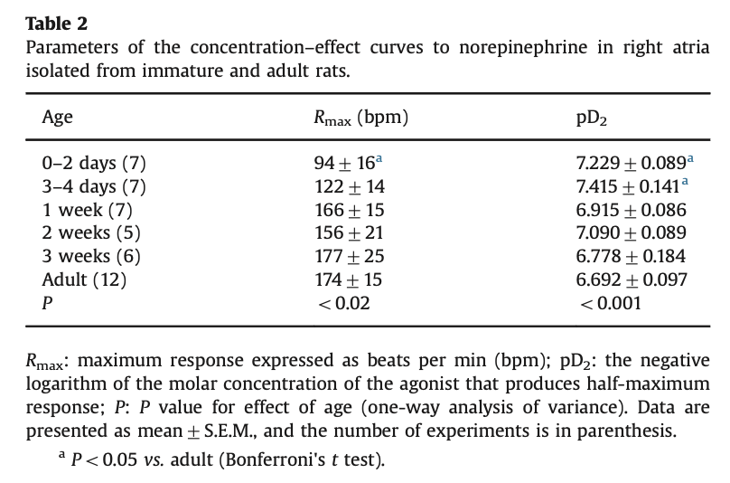

6. Results (Figure 4)
There must be something wrong. C and F just copied. Please check.
The reviewer is correct. In the revised version, Panel C now illustrates the lack of effect of (±)-4-NO₂-propranolol (10 nM) on the positive chronotropic effect induced by 6-ND (10 pM).

