[Supplementary Materials]

Superconductivity in bcc-selenium under megabar pressure
Zhongyan Wu¹, Timofey Fedotenko², Nico Giordano², Jaeyong Kim¹
¹Department of Physics, Institute for High Pressure, Hanyang University, Seoul 04763, Korea
²Deutsches Elektronen-Synchrotron DESY, Notkestr. 85, Hamburg 22607, Germany

Table S1. Lattice parameters at different pressures. The atomic volume of each phase decreases monotonically with pressure (negative linear compressibility).
P  (GPa) | a  (Å) | b  (Å) | c  (Å) | α  (°) | β  (°) | γ  (°) | V  (Å³) | q | V/atom  (Å³)
Se(I), trigonal, P3₁21
5.4 | 3.91553 |  | 5.06546 |  |  |  | 67.256 |  | 22.41867
7.4 | 3.8663 |  | 5.0333 |  |  |  | 65.159 |  | 21.71967
10.9 | 3.74659 |  | 5.01689 |  |  |  | 60.987 |  | 20.329
Se (II), triclinic, P-1
10.9 | 2.79533 | 3.70778 | 6.29443 | 102.558 | 92.705 | 112.169 | 58.364 |  | 19.45467
(H₂Se)₂H₂, tetragonal, I4/mcm
10.9 | 6.868 |  | 5.801 |  |  |  | 273.643 |  | 34.20537
19.4 | 6.666 |  | 5.70234 |  |  |  | 253.387 |  | 31.67338
Se (III), triclinic, P-1
19.4 | 2.68027 | 3.58732 | 6.23503 | 103.981 | 89.556 | 112.909 | 53.335 |  | 17.77833
21.4 | 2.67216 | 3.5062 | 6.24964 | 102.379 | 93.706 | 111.97 | 52.357 |  | 17.45233
25.9 | 2.62348 | 3.42615 | 6.27639 | 102.258 | 93.741 | 111.996 | 50.459 |  | 16.81967
Se (IV), body-centered modulated monoclinic, I'2/m(0q0)s0
30.4 | 3.3675 | 4.01664 | 2.60019 |  | 112.597 |  | 32.47 | 0.3062 | 16.235
35.4 | 3.30912 | 4.01401 | 2.59121 |  | 112.778 |  | 31.734 | 0.306 | 15.867
40.9 | 3.24871 | 4.0134 | 2.56893 |  | 112.851 |  | 30.866 | 0.3075 | 15.433
45.4 | 3.20822 | 3.9949 | 2.55242 |  | 113.041 |  | 30.104 | 0.308 | 15.052
50.6 | 3.16453 | 3.99519 | 2.52996 |  | 113.125 |  | 29.338 | 0.3078 | 14.669
53.9 | 3.14491 | 3.99004 | 2.52984 |  | 113.576 |  | 29.095 | 0.3131 | 14.5475
57.9 | 3.12804 | 3.97168 | 2.53407 |  | 114.209 |  | 28.714 | 0.2969 | 14.357
63.4 | 3.10793 | 3.98139 | 2.50832 |  | 113.741 |  | 28.411 | 0.2969 | 14.2055
67.9 | 3.09446 | 3.95003 | 2.49776 |  | 113.298 |  | 28.041 | 0.2941 | 14.0205
71.9 | 3.08576 | 3.94048 | 2.48895 |  | 113.507 |  | 27.752 | 0.2927 | 13.876
Se (V), primitive rhombohedral, R-3m
67.9 | 3.96012 |  | 3.06799 |  |  |  | 41.668 |  | 13.88933
71.9 | 3.95053 |  | 3.04518 |  |  |  | 41.158 |  | 13.71933
77.4 | 3.93682 |  | 3.02237 |  |  |  | 40.567 |  | 13.52233
79.4 | 3.9275 |  | 3.0092 |  |  |  | 40.199 |  | 13.39967
80.4 | 3.92308 |  | 3.00226 |  |  |  | 40.016 |  | 13.33867
83.4 | 3.91407 |  | 2.98783 |  |  |  | 39.641 |  | 13.21367
85.4 | 3.90589 |  | 2.97555 |  |  |  | 39.313 |  | 13.10433
87.9 | 3.89578 |  | 2.96147 |  |  |  | 38.925 |  | 12.975
91.9 | 3.89068 |  | 2.95231 |  |  |  | 38.703 |  | 12.901
96.4 | 3.88124 |  | 2.9384 |  |  |  | 38.334 |  | 12.778
97.9 | 3.87623 |  | 2.93033 |  |  |  | 38.13 |  | 12.71
100.4 | 3.87042 |  | 2.92091 |  |  |  | 37.894 |  | 12.63133
101.9 | 3.86478 |  | 2.91191 |  |  |  | 37.667 |  | 12.55567
104.4 | 3.85879 |  | 2.90312 |  |  |  | 37.437 |  | 12.479
107.4 | 3.85113 |  | 2.89004 |  |  |  | 37.12 |  | 12.37333
110.4 | 3.83971 |  | 2.87136 |  |  |  | 36.662 |  | 12.22067
114.4 | 3.83451 |  | 2.86036 |  |  |  | 36.423 |  | 12.141
117.4 | 3.82808 |  | 2.85128 |  |  |  | 36.185 |  | 12.06167
120.9 | 3.82343 |  | 2.84145 |  |  |  | 35.973 |  | 11.991
124.9 | 3.82015 |  | 2.83158 |  |  |  | 35.786 |  | 11.92867
126.8 | 3.81474 |  | 2.82427 |  |  |  | 35.593 |  | 11.86433
128.9 | 3.81442 |  | 2.81019 |  |  |  | 35.41 |  | 11.80333
131.4 | 3.81886 |  | 2.78767 |  |  |  | 35.147 |  | 11.71567
133.9 | 3.82291 |  | 2.76581 |  |  |  | 35.006 |  | 11.66867
137.4 | 3.82679 |  | 2.73563 |  |  |  | 34.694 |  | 11.56467
137.9 | 3.83529 |  | 2.72047 |  |  |  | 34.655 |  | 11.55167
139.4 | 3.83815 |  | 2.70263 |  |  |  | 34.48 |  | 11.49333
140.9 | 3.84284 |  | 2.6863 |  |  |  | 34.355 |  | 11.45167
145.4 | 3.84527 |  | 2.66945 |  |  |  | 34.183 |  | 11.39433
146.4 | 3.84747 |  | 2.65822 |  |  |  | 34.078 |  | 11.35933
148.4 | 3.84808 |  | 2.64699 |  |  |  | 33.945 |  | 11.315
150.4 | 3.85224 |  | 2.64001 |  |  |  | 33.928 |  | 11.30933
154.9 | 3.85026 |  | 2.63165 |  |  |  | 33.786 |  | 11.262
155.4 | 3.84833 |  | 2.62546 |  |  |  | 33.673 |  | 11.22433
156.9 | 3.84812 |  | 2.61879 |  |  |  | 33.584 |  | 11.19467
157.9 | 3.84822 |  | 2.61366 |  |  |  | 33.52 |  | 11.17333
Se (VI), body-centered cubic, Im-3m
133.9 | 2.83953 |  |  |  |  |  | 22.895 |  | 11.4475
137.4 | 2.83492 |  |  |  |  |  | 22.784 |  | 11.392
137.9 | 2.83481 |  |  |  |  |  | 22.781 |  | 11.3905
139.4 | 2.83378 |  |  |  |  |  | 22.756 |  | 11.378
140.9 | 2.82848 |  |  |  |  |  | 22.629 |  | 11.3145
145.4 | 2.82502 |  |  |  |  |  | 22.546 |  | 11.273
146.4 | 2.82357 |  |  |  |  |  | 22.511 |  | 11.2555
148.4 | 2.82042 |  |  |  |  |  | 22.436 |  | 11.218
150.4 | 2.81784 |  |  |  |  |  | 22.374 |  | 11.187
154.9 | 2.81526 |  |  |  |  |  | 22.313 |  | 11.1565
155.4 | 2.81386 |  |  |  |  |  | 22.28 |  | 11.14
156.9 | 2.8119 |  |  |  |  |  | 22.233 |  | 11.1165
157.9 | 2.80904 |  |  |  |  |  | 22.165 |  | 11.0825
159.4 | 2.80665 |  |  |  |  |  | 22.109 |  | 11.0545
161.4 | 2.80357 |  |  |  |  |  | 22.036 |  | 11.018
163.9 | 2.8001 |  |  |  |  |  | 21.954 |  | 10.977
165.4 | 2.79667 |  |  |  |  |  | 21.874 |  | 10.937
168.4 | 2.7938 |  |  |  |  |  | 21.806 |  | 10.903
170.4 | 2.7908 |  |  |  |  |  | 21.736 |  | 10.868
173.4 | 2.78645 |  |  |  |  |  | 21.635 |  | 10.8175
175.9 | 2.78252 |  |  |  |  |  | 21.543 |  | 10.7715
178.9 | 2.78046 |  |  |  |  |  | 21.496 |  | 10.748
182.4 | 2.77329 |  |  |  |  |  | 21.33 |  | 10.665

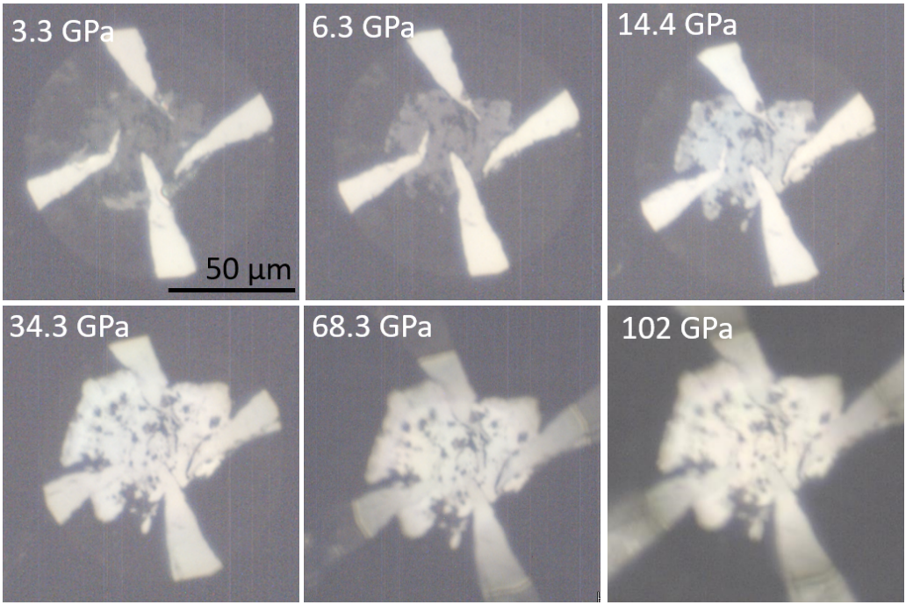
FIG. S1(a). Sample images as upon compression at low pressure before measurement.

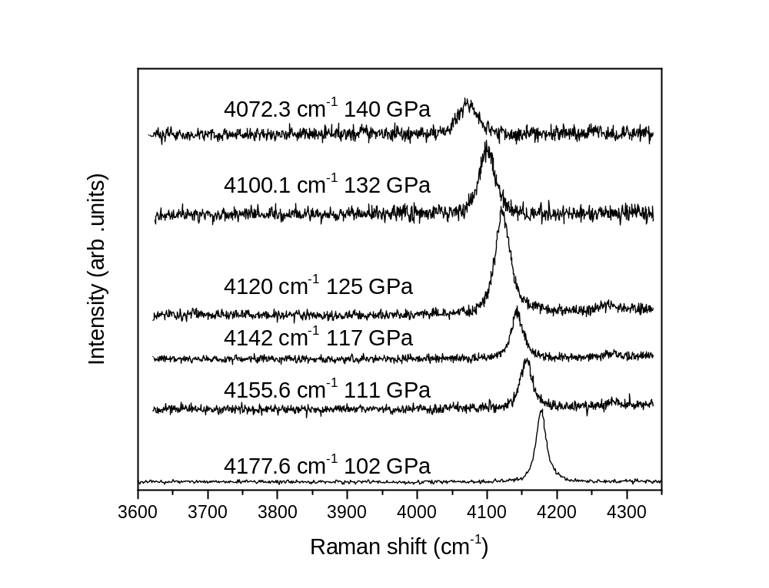
FIG. S1(b). Pressure calibration through the Raman shift of H2 vibron.

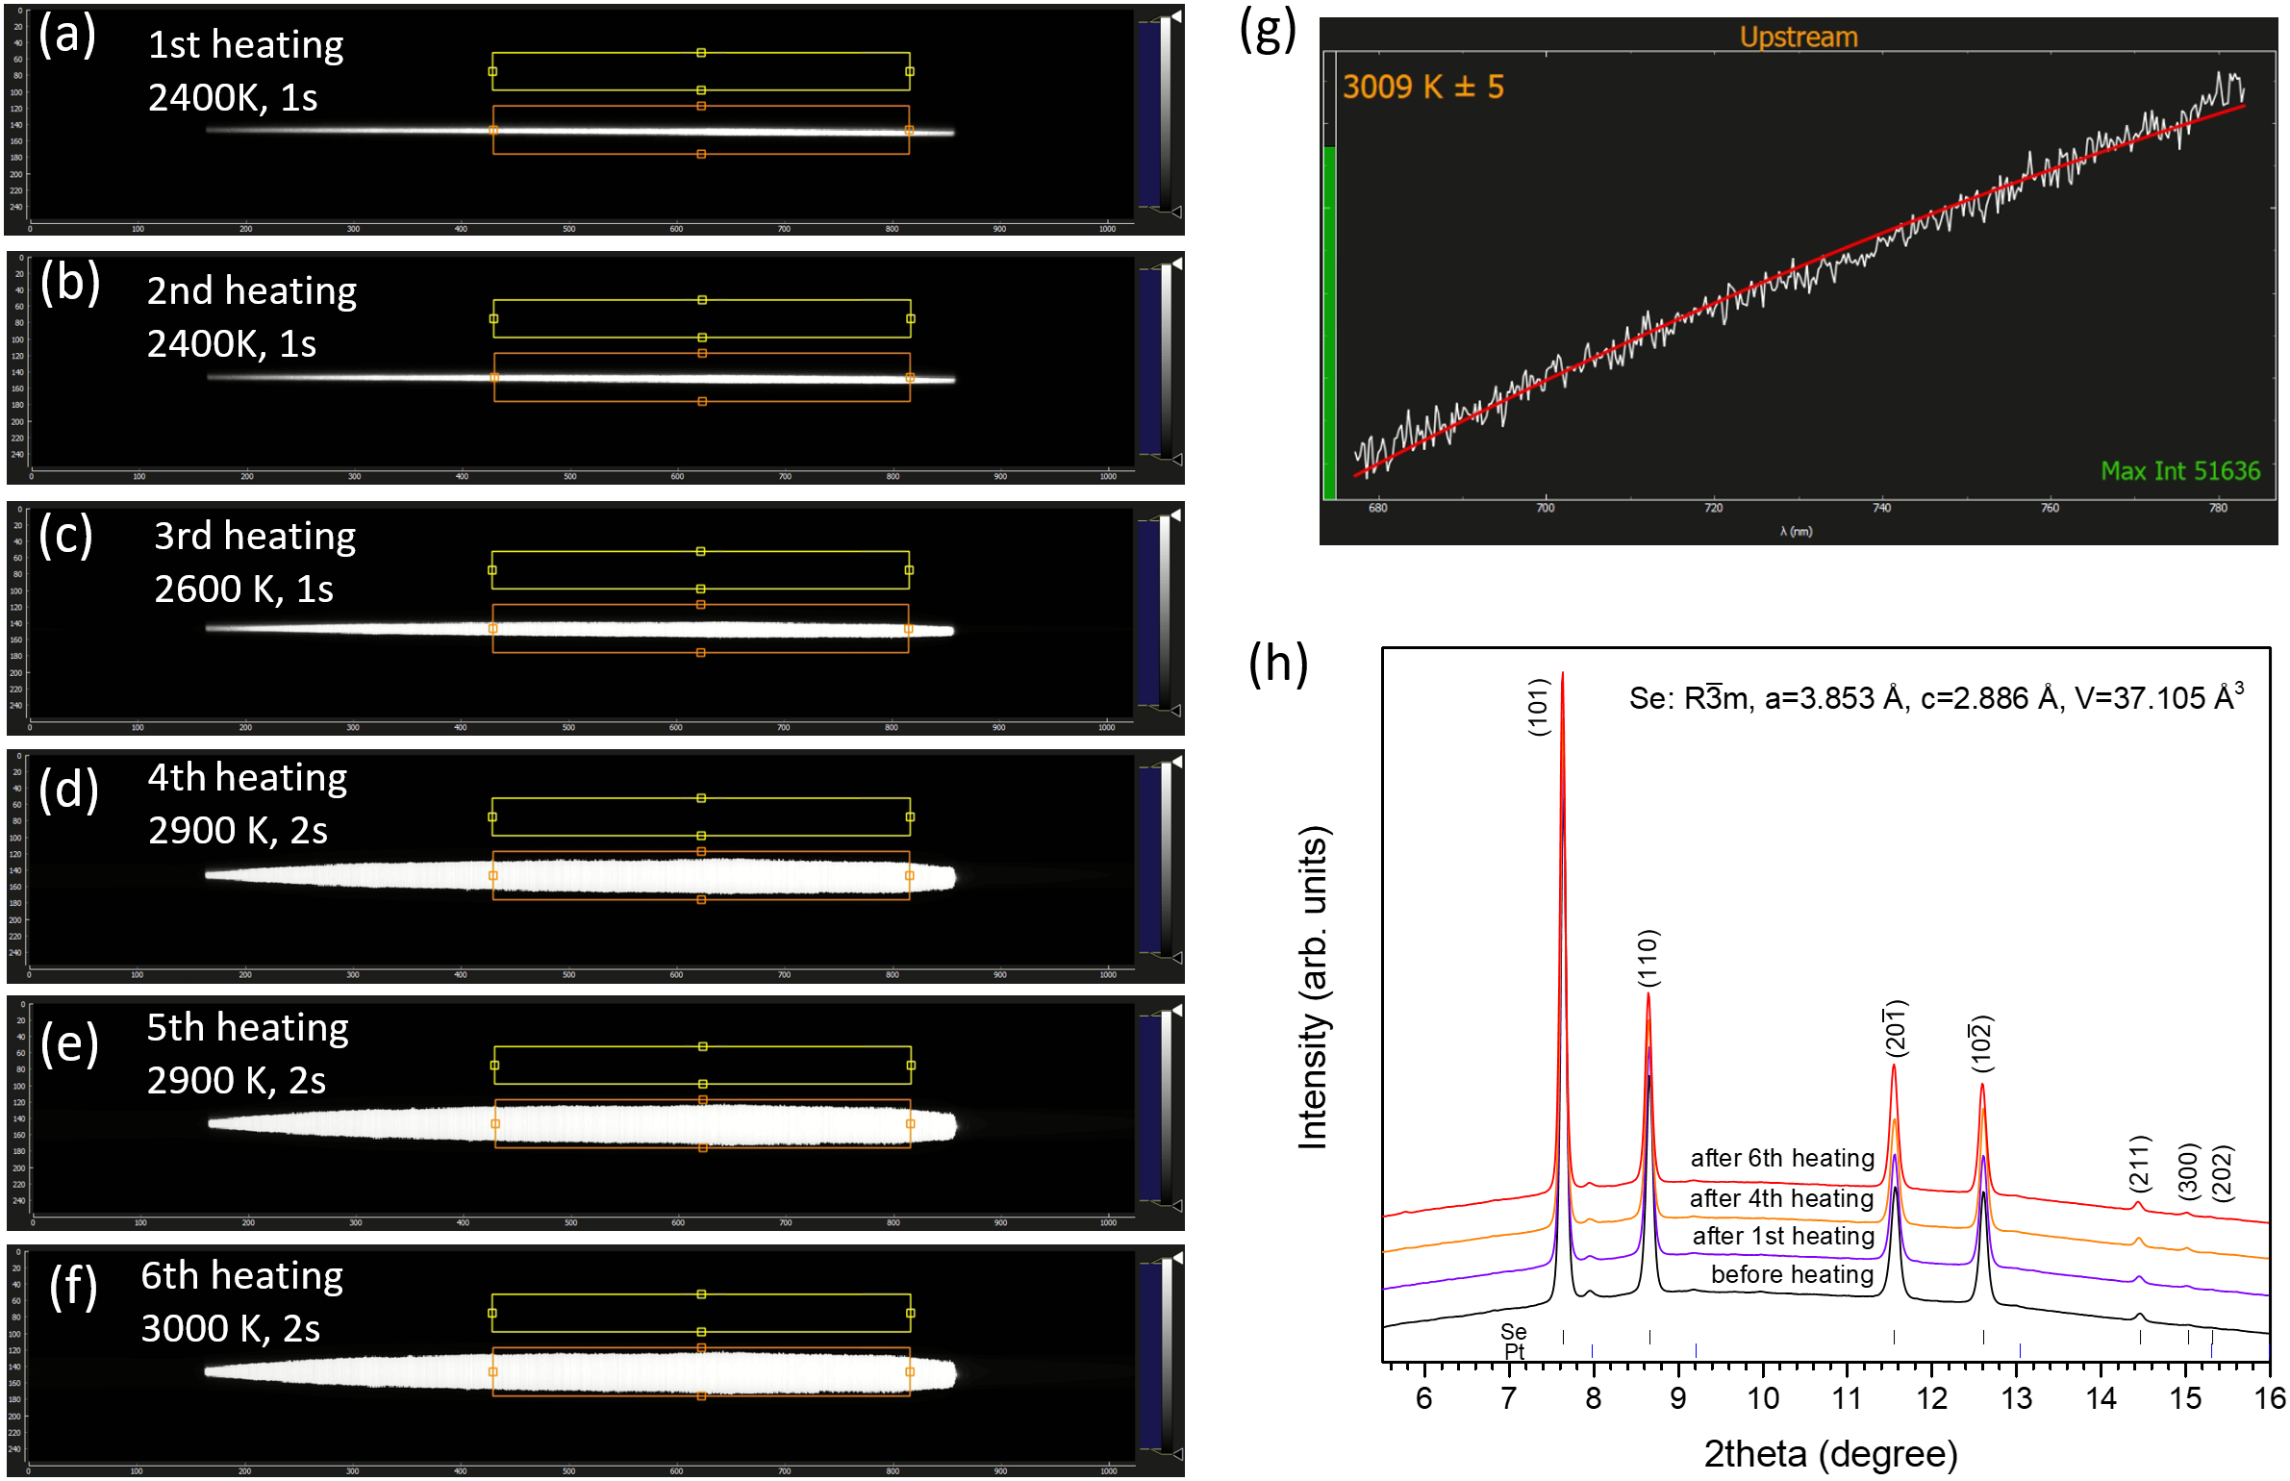
FIG. S2. (a)-(f) Pyrometry spectra measured during laser heating, the yellow and orange boxes are ROI for temperature measurement. Only the upstream side was successfully heated from the observation of a single bright stripe. (g) Representative plank fit for temperature estimation (sixth heating, ~3000 K) using T-Rax program. (h) Comparison of XRD patterns before and after laser heating.
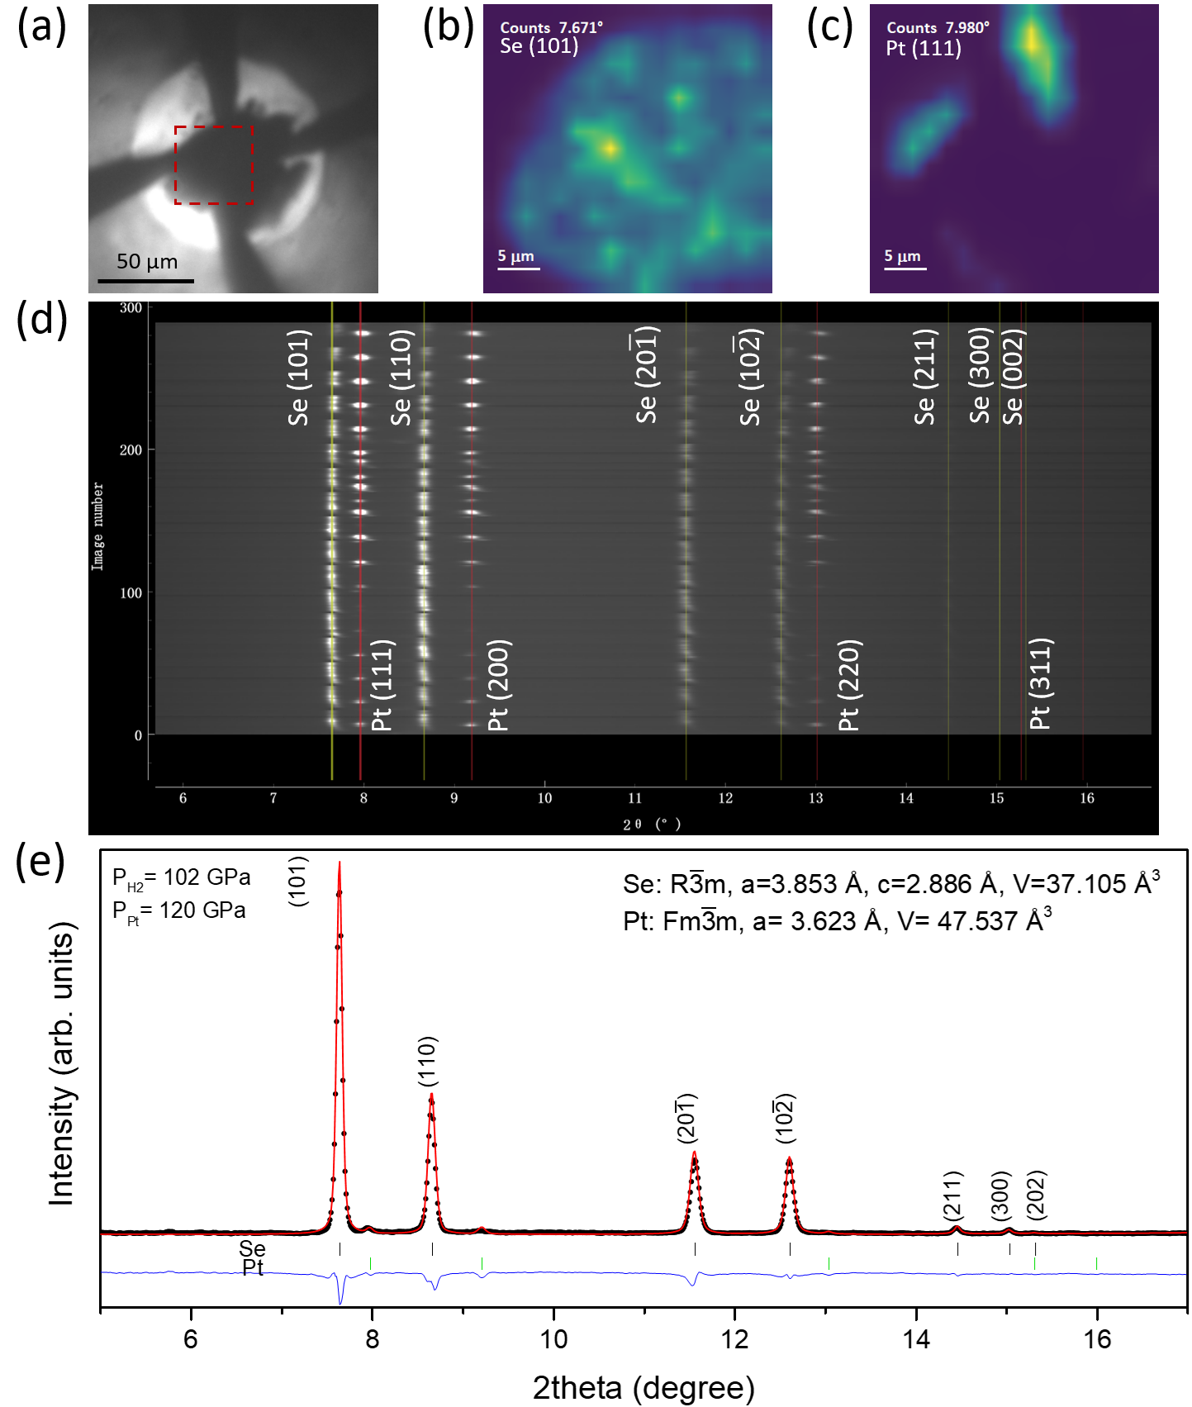 FIG. S3. XRD mapping after laser heating at 102 GPa with grid size of 34 × 34 μm (17 × 17, 2 μm step, 2 μm beam size). (a) Microscope photo taken at the beamline; the red dash square indicates the mapping region. (b)-(c) Scanning X-ray diffraction images counting on the main peak of Se (101) and Pt (111), respectively. The peak intensity is indicated by bright (strong) and dark (weak) color. (d) Batch view of total 289 XRD data, the yellow and red lines mark the peaks of β-Po Se and Pt, respectively. The peak shift is due to the pressure gradient across the diamond culet. The pressure difference of sample at different positions is within ~7 GPa according to the equation of states of Pt. (e) Le Bail Refinement at the center position.
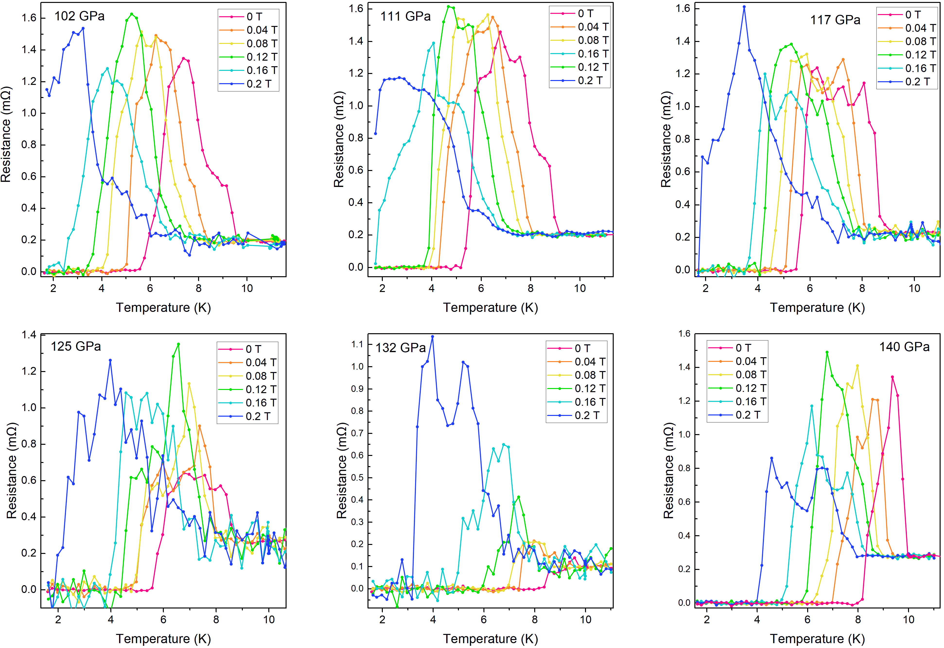
FIG. S4(a). Superconductivity under external magnetic field at different pressures. As increasing magnetic field at 132 GPa, the temperature difference of the overlapped T_{p} and T_{c} (transition width) increases, thus the bump turns into giant peak again.
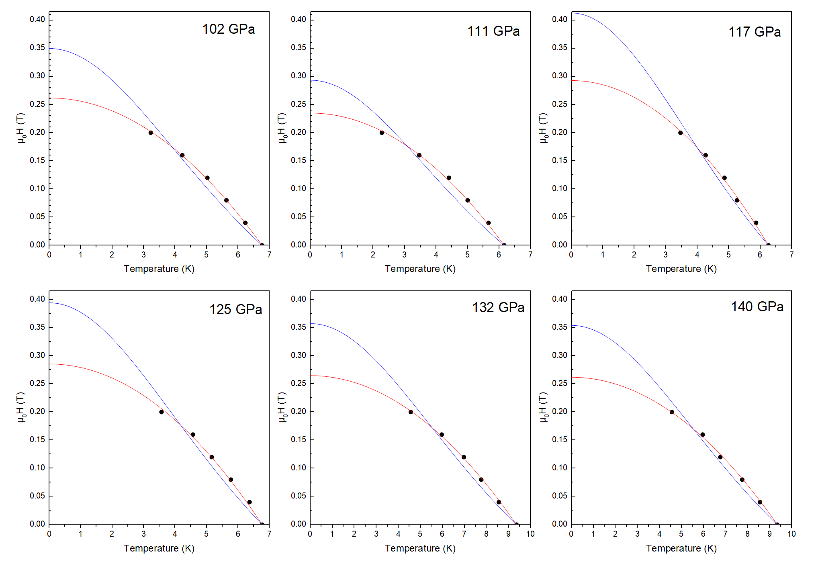
FIG. S4(b). Critical magnetic field fitted by parabolic (red curve) $μ_{0}H_{c}\left(T\right)=μ_{0}H_{c}\left(0\right)(1-{(T/{T_{C}})}^{2})$ and Ginzburg-Landau formula (blue) $μ_{0}H_{c}\left(T\right)=μ_{0}H_{c}\left(0\right)\left({(1-{(T/{T_{C}})}^{2})}/{(1+{(T/{T_{C}})}^{2})}\right)$, respectively.
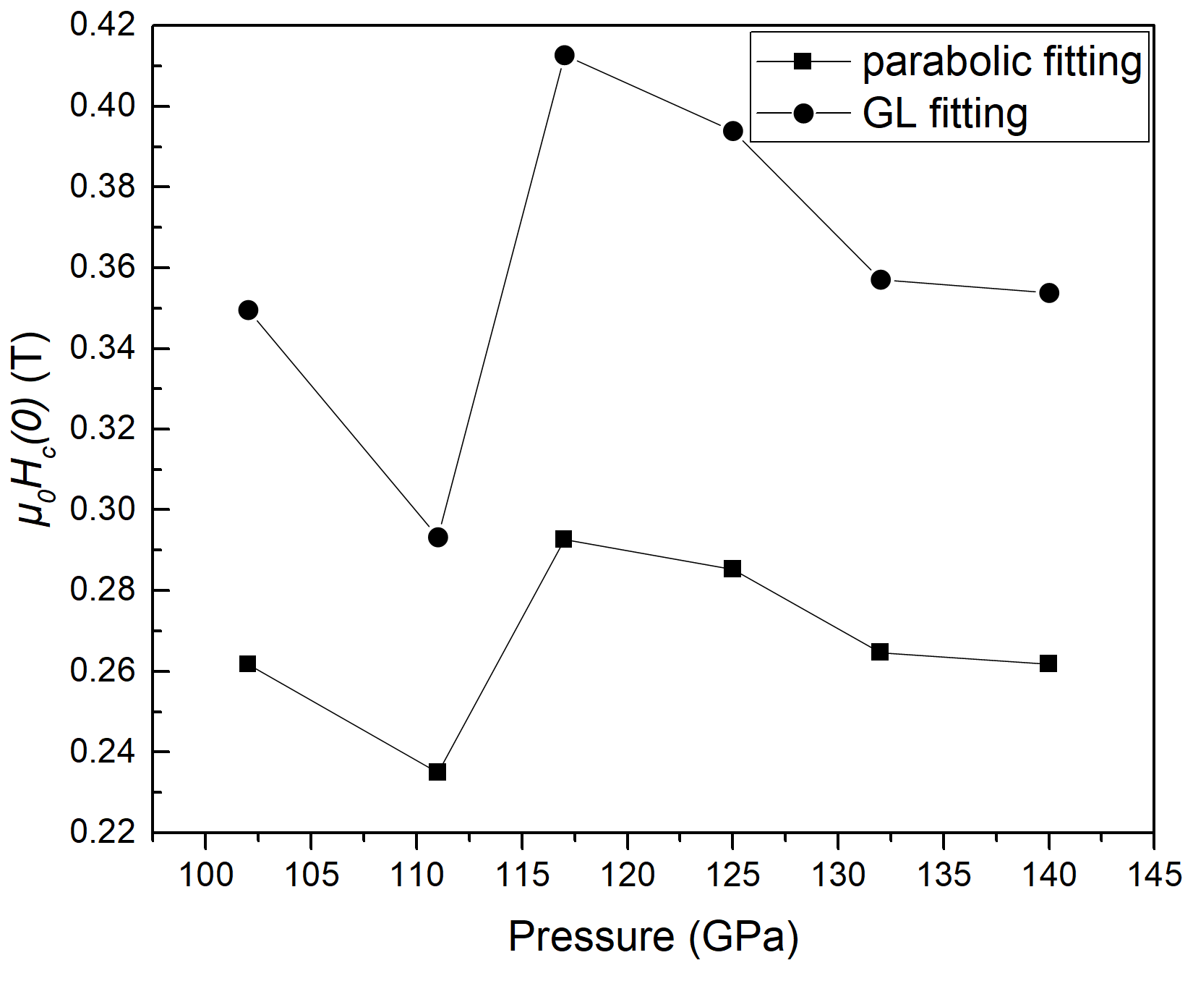
FIG. S4(c). Estimation of ${μ_{0}H}_{c}\left(0\right)$ by parabolic (square) and Ginzburg-Landau (circle) fitting over the studied pressure range.

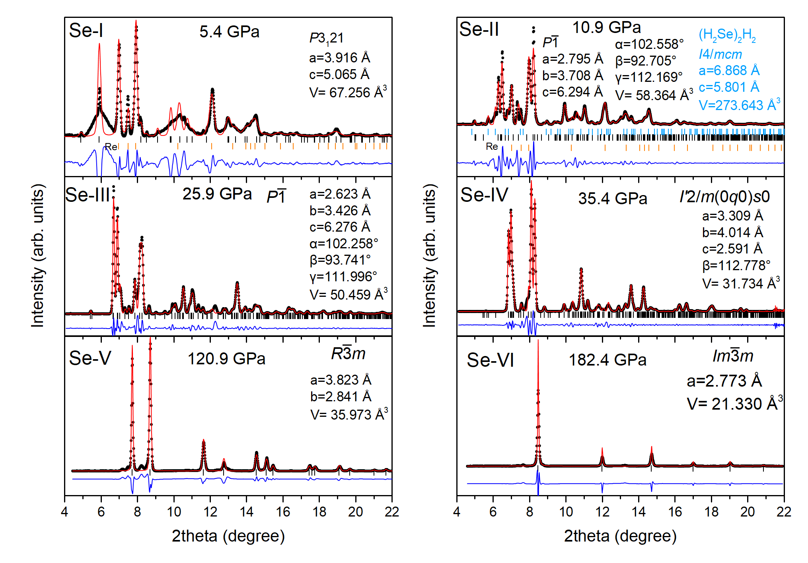
FIG. S5. Representative Le Bail refinement for different phases of Se. The black dots, red lines, and blue lines are experimental data, Le Bail refinement, and residues, respectively.

