Supplementary figures
Supplementary Figure S1
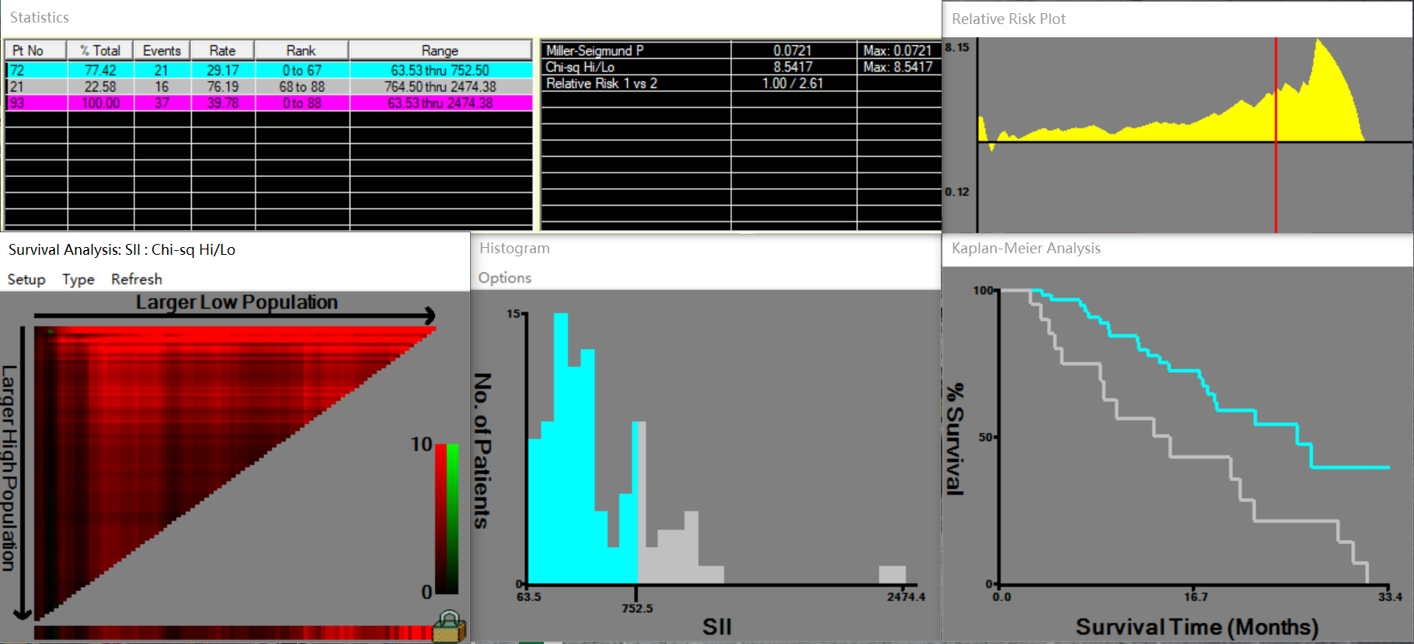
Supplementary Figure S1. The optimal cutoff value for the SII was selected by X-tile 3.6.1 software (Yale University, New Haven, CT, USA).

Supplementary Figure S2
a

b c
d e
Supplementary Figure S2. The ORR in training and validation cohort (A). The Kaplan–Meier analysis of PFS and OS in the training and validation cohorts (B - E).

Supplementary Figure S3
a b
c d
e f

Supplementary Figure S3. The Kaplan–Meier analysis of PFS (A) and OS (B) for the PLR in the training cohort. The Kaplan–Meier analysis of PFS (C) and OS (D) for the NLR in the training cohort. Comparison of ORR for the NLR and PLR in the training cohort (E - F).

Supplementary Figure S4
a b
c d
e f
Supplementary Figure S4. Comparison of ORR for the NLR and PLR in the validation cohort (A-B). The Kaplan–Meier analysis of PFS and OS for the PLR and NLR in the validation cohort (C - F).

Supplementary table S1. Univariate logistic regression analyses of prognostic factors for response probability in the training and validation cohort
Variable | Category | Univariate analysis |  |  |  | Multivariate analysis
 |  | OR (95% CI) | P-value |  |  | OR (95% CI) | P-value
Training cohort
Age(y) | >50 vs. ≤50 | 1.156 (0.451 - 2.966) |  | 0.763
Sex | Male vs. Female | 2.000 (0.494 - 8.089) |  | 0.331
Child-Pugh | B vs. A | 1.322 (0.250 - 6.991) |  | 0.743
HBsAg | Positive vs. Negative | 1.639 (0.424 - 6.330) |  | 0.474
ALT(U/L) | >50 vs. ≤50 | 1.380 (0.448 - 4.256) |  | 0.575
AFP (ng/mL) | >20 vs. ≤20 | 1.182 (0.474 - 2.944) |  | 0.720
Macrovascular tumor thrombus | Yes vs. No | 1.193 (0.452 - 3.150) |  | 0.721
Extrahepatic metastasis | Yes vs. No | 1.432 (0.526 - 3.896) |  | 0.482
BCLC | B+C vs. A | 1.590 (0.251 - 10.079) |  | 0.623
NLR | >3 vs. ≤3 | 2.353 (0.787 - 7.036) |  | 0.126
PLR | >150 vs. ≤150 | 2.864 (0.881 - 9.312) |  | 0.080 |  | 1.580 (0.418 - 5.973) | 0.500
SII | >752 vs. ≤752 | 5.370 (1.158 - 24.901) |  | 0.032 |  | 4.185 (0.778 - 22.515) | 0.095
Validation cohort
Age(y) | >50 vs. ≤50 | 1.667 (0.790 - 3.515) |  | 0.180
Sex | Male vs. Female | 1.174 (0.461 - 2.990) |  | 0.736
Child-Pugh | B vs. A | 1.439 (0.532 - 3.890) |  | 0.473
HBsAg | Positive vs. Negative | 1.508 (0.731 - 3.111) |  | 0.266
ALT(U/L) | >50 vs. ≤50 | 0.806 (0.385 - 1.685) |  | 0.566
AFP (ng/mL) | >20 vs. ≤20 | 1.705 (0.858 - 3.386) |  | 0.128
Macrovascular tumor thrombus | Yes vs. No | 1.089 (0.567 - 2.090) |  | 0.798
Extrahepatic metastasis | Yes vs. No | 1.292 (0.675 - 2.474) |  | 0.439
BCLC | B+C vs. A | 1.418 (0.440 - 4.573) |  | 0.559
NLR | >3 vs. ≤3 | 1.251 (0.636 - 2.458) |  | 0.516
PLR | >150 vs. ≤150 | 1.859 (0.913 - 3.784) |  | 0.087 |  | 1.336 (0.599 - 2.978) | 0.479
SII | >752 vs. ≤752 | 2.660 (1.097 - 6.452) |  | 0.030 |  | 2.265 (0.842 - 6.094) | 0.106

Abbreviation: ALT, albumin; AFP, alpha‐fetoprotein; BCLC, Barcelona Clinic Liver Cancer; NLR, neutrophil-to-lymphocyte ratio; PLR, platelet-to-lymphocyte ratio; SII, systemic immune-inflammation index

Supplementary table S2. Univariate and Multivariate Cox regression analyses of the SII with clinicopathologic characteristics for PFS [training cohort (n=93) and validation cohort (n = 175)]

Variable | Category | Univariate analysis |  |  | Multivariate analysis
 |  | HR (95% CI) | P-value |  | HR (95% CI) | P-value
Training cohort
Age(y) | >50 vs. ≤50 | 1.524 (0.829 - 2.803) | 0.175
Sex | Male vs. Female | 1.402 (0.433 - 4.543) | 0.573
Child-Pugh | B vs. A | 1.155 (0.406 - 3.281) | 0.787
HBsAg | Positive vs. Negative | 1.440 (0.444 - 4.671) | 0.544
ALT(U/L) | >50 vs. ≤50 | 1.626 (0.796 - 3.320) | 0.182
AFP (ng/mL) | >20 vs. ≤20 | 1.657 (0.878 - 3.129) | 0.119
Macrovascular tumor thrombus | Yes vs. No | 1.604 (0.810 - 3.175) | 0.175
Extrahepatic metastasis | Yes vs. No | 1.093 (0.584 - 2.045) | 0.782
BCLC | B+C vs. A | 1.071 (0.205 - 5.605) | 0.935
NLR | >3 vs. ≤3 | 1.248 (0.665 - 2.345) | 0.490
PLR | >150 vs. ≤150 | 1.780 (0.951 - 3.334) | 0.072 |  | 1.252 (0.611 - 2.563) | 0.539
SII | >752 vs. ≤752 | 2.296 (1.264 - 4.170) | 0.006 |  | 2.084 (1.059 - 4.100) | 0.033
Validation cohort
Age(y) | >50 vs. ≤50 | 1.229 (0.779 - 1.938) | 0.376
Sex | Male vs. Female | 0.906 (0.479 - 1.715) | 0.763
Child-Pugh | B vs. A | 1.050 (0.506 - 2.180) | 0.896
HBsAg | Positive vs. Negative | 1.124 (0.672 - 1.879) | 0.657
ALT(U/L) | >50 vs. ≤50 | 1.594 (1.003 - 2.536) | 0.049 |  | 1.672 (1.047 - 2.670) | 0.031
AFP (ng/mL) | >20 vs. ≤20 | 1.125 (0.695 - 1.819) | 0.632
Macrovascular tumor thrombus | Yes vs. No | 1.286 (0.825 - 2.005) | 0.267
Extrahepatic metastasis | Yes vs. No | 1.379 (0.898 - 2.119) | 0.142
BCLC | B+C vs. A | 1.512 (0.558 - 4.103) | 0.416
NLR | >3 vs. ≤3 | 1.338 (0.870 – 2.059) | 0.185
PLR | >150 vs. ≤150 | 1.466 (0.949 - 2.264) | 0.085 |  | 0.804 (0.455 - 1.421) | 0.454
SII | >752 vs. ≤752 | 2.546 (1.614 - 4.015) | < 0.001 |  | 2.602 (1.485 - 4.561) | < 0.001

Abbreviation: albumin; AFP, alpha‐fetoprotein; BCLC, Barcelona Clinic Liver Cancer; NLR, neutrophil-to-lymphocyte ratio; PLR, platelet-to-lymphocyte ratio; SII, systemic immune-inflammation index
Supplementary table S3. Univariate and Multivariate Cox regression analyses of the SII with clinicopathologic characteristics for OS [training cohort (n=93) and validation cohort (n = 175)]

Variable | Category | Univariate analysis |  |  | Multivariate analysis
 |  | HR (95% CI) | P-value |  | HR (95% CI) | P-value
Training cohort
Age(y) | >50 vs. ≤50 | 1.214 (0.626 - 2.353) | 0.566
Sex | Male vs. Female | 1.445 (0.499 - 4.184) | 0.497
Child-Pugh | B vs. A | 1.226 (0.374 - 4.022) | 0.737
HBsAg | Positive vs. Negative | 1.256 (0.383 - 4.124) | 0.706
ALT(U/L) | >50 vs. ≤50 | 1.224 (0.533 - 2.810) | 0.633
AFP (ng/mL) | >20 vs. ≤20 | 1.256 (0.383 - 4.124) | 0.882
Macrovascular tumor thrombus | Yes vs. No | 0.978 (0.492 - 1.948) | 0.951
Extrahepatic metastasis | Yes vs. No | 0.978 (0.492 - 1.948) | 0.059 |  | 1.210 (0.556 - 2.633) | 0.630
BCLC | B+C vs. A | 1.412 (0.245 - 8.126) | 0.699
NLR | >3 vs. ≤3 | 2.126 (1.120 - 4.038) | 0.021 |  | 1.171 (0.440 - 3.120) | 0.752
PLR | >150 vs. ≤150 | 2.098 (1.081 - 4.072) | 0.029 |  | 2.098 (1.081 - 4.072) | 0.669
SII | >752 vs. ≤752 | 2.692 (1.395 - 5.196) | 0.003 |  | 2.330 (1.094 - 4.962) | 0.028
Validation cohort
Age(y) | >50 vs. ≤50 | 0.909 (0.617 - 1.338) | 0.628
Sex | Male vs. Female | 1.164 (0.675 - 2.005) | 0.585
Child-Pugh | B vs. A | 1.405 (0.712 - 2.769) | 0.327
HBsAg | Positive vs. Negative | 1.339 (0.883 - 2.031) | 0.170
ALT(U/L) | >50 vs. ≤50 | 1.423 (0.970 - 2.088) | 0.071 |  | 1.421 (0.963 - 2.098) | 0.077
AFP (ng/mL) | >20 vs. ≤20 | 1.033 (0.701 - 1.523) | 0.869
Macrovascular tumor thrombus | Yes vs. No | 1.343 (0.940 - 1.919) | 0.106
Extrahepatic metastasis | Yes vs. No | 0.972 (0.683 - 1.383) | 0.875
BCLC | B+C vs. A | 1.284 (0.454 - 3.633) | 0.637
NLR | >3 vs. ≤3 | 1.682 (1.175 - 2.407) | 0.004 |  | 1.396 (0.943 - 2.066) | 0.096
PLR | >150 vs. ≤150 | 1.733 (1.212 - 2.477) | 0.003 |  | 1.249 (0.821 - 1.899) | 0.298
SII | >752 vs. ≤752 | 2.148 (1.456 - 3.168) | < 0.001 |  | 1.664 (1.051 - 2.634) | 0.030

Abbreviation: ALT, albumin; AFP, alpha‐fetoprotein; BCLC, Barcelona Clinic Liver Cancer; NLR, neutrophil-to-lymphocyte ratio; PLR, platelet-to-lymphocyte ratio; SII, systemic immune-inflammation index

