Table S1. Physical and chemical characteristics of the initial soil used in pot experiment.
Characteristics | Unit | Soil
pH | - | 5.99
Organic Matter | g/kg | 14.23
Cation Exchange Capacit | cmol/kg | 26.82
Pb | mg/kg | 72.98
Total Nitrogen | g/kg | 1.52
Total Phosphorus | g/kg | 0.66
Total Potassium | g/kg | 7.32

Table S2. Gene primers used in qRT-PCR.
Gene | Forward Primer (5’-3’) | Reverse Primer (5’-3’)
reference gene | TTAATGTGCCTGCCATGTATGT | GACCACTTGCATAAAGGGAGA
VIPP1 | CATCGCAAAAGCGGTTGGAA | TTGTGCCAGGTCGTCATCAA
FLS2 | ATTACGGTCAACCCTGCTCG | AGAGTGCAGGCTTTTCTGGT
LHCA1 | ATGCTTGCTGTTCCAGGGAT | GGTTGCCTAGGTAGGTTGCT
HCF | GAGCCATGGTGGTTAGTCCC | CGTTGCAATTCTGCCAGAGG
CCS | AGCAAGGAATGCCGTCAGAA | CAGCCAAGCAATGTGTGCAT
STI1 | TGAATCCCAGCGATGGTACG | GCTCTCGGGGTCAAGCATTA
THF | GCCGTGGTGGAGGTTACTAC | CGGCTTCCAATTCCGAGTCT
PCS | TGCAAGTCCTGTAGTGGCTG | GTAGATGATCCCCGTGCCAG
rbcS | ACCTCCATCACAAGCAACGG | CCTGGTGACTTGTTGTGCTC
SOD2 | ACCACCCACTACCCCATGTA | AACCCAGCCAGAACCAAACA

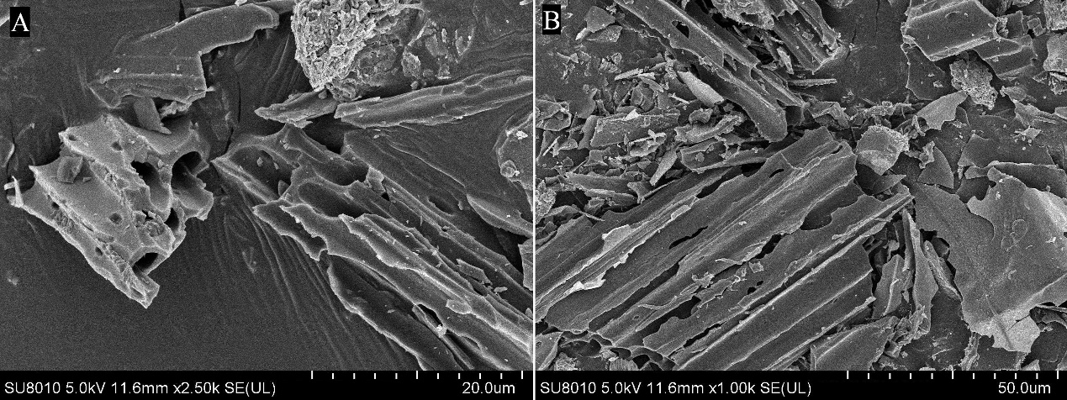
Figure S1. The SEM images of biochar under 20 μm (A) and 50 μm (B).

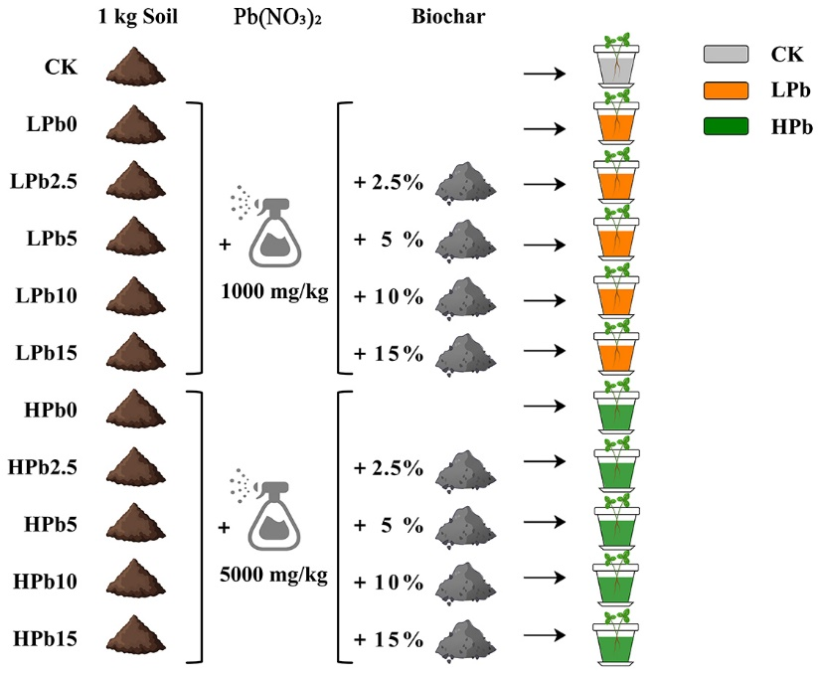
Figure S2. Pot experiment design. There are a total of 11 treatments, as follows: a control where plants were grown without Pb and biochar (CK), a 1000 mg/kg of Pb (LPb0), a 1000 mg/kg of Pb + 2.5% of biochar (LPb2.5), a 1000 mg/kg of Pb + 5% of biochar (LPb5), a 1000 mg/kg of Pb + 10% of biochar (LPb10), a 1000 mg/kg of Pb + 15% of biochar (LPb15), a 5000 mg/kg of Pb (HPb0), a 5000 mg/kg of Pb + 2.5% of biochar (HPb2.5), a 5000 mg/kg of Pb + 5% of biochar (HPb5), a 5000 mg/kg of Pb + 10% of biochar (HPb10) and a 5000 mg/kg of Pb + 15% of biochar (HPb15) treatment.

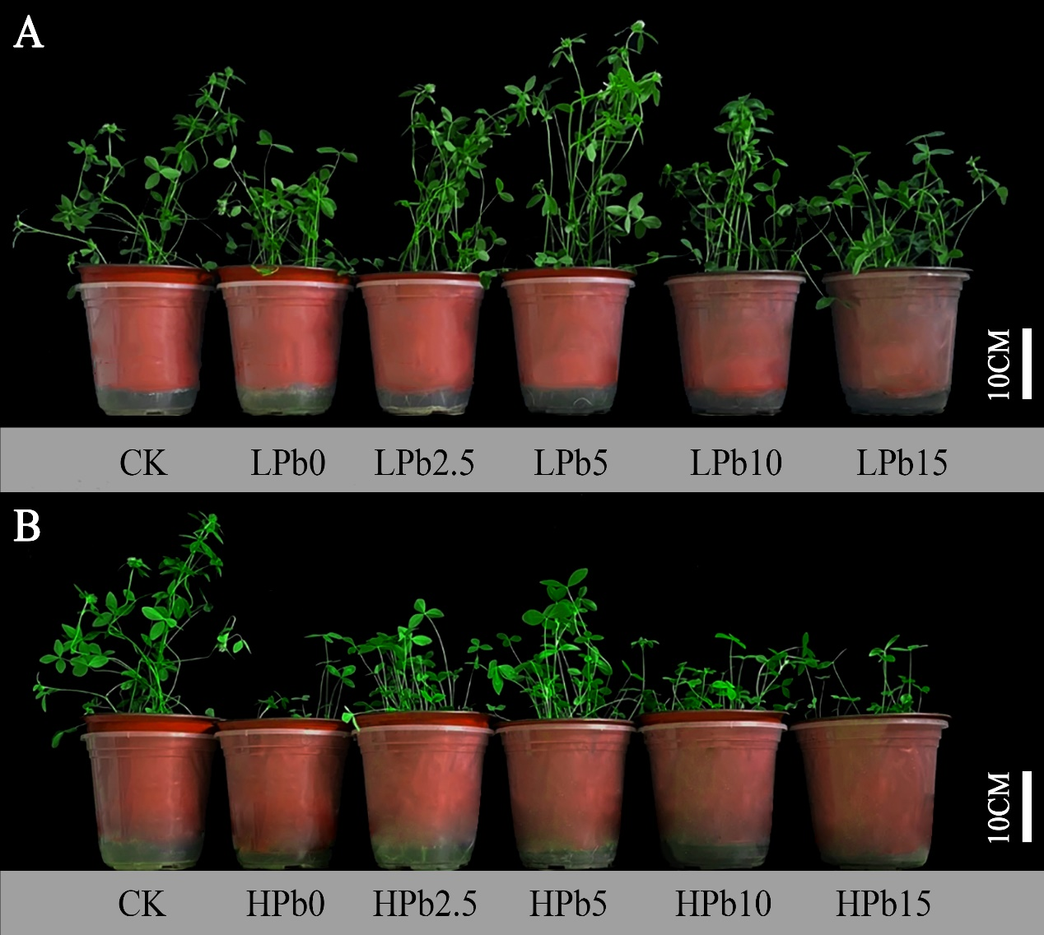
Figure S3. Effects of different concentrations of biochar on growth of red clover under 1000 mg/kg (A) and 5000 mg/kg (B) Pb stress.
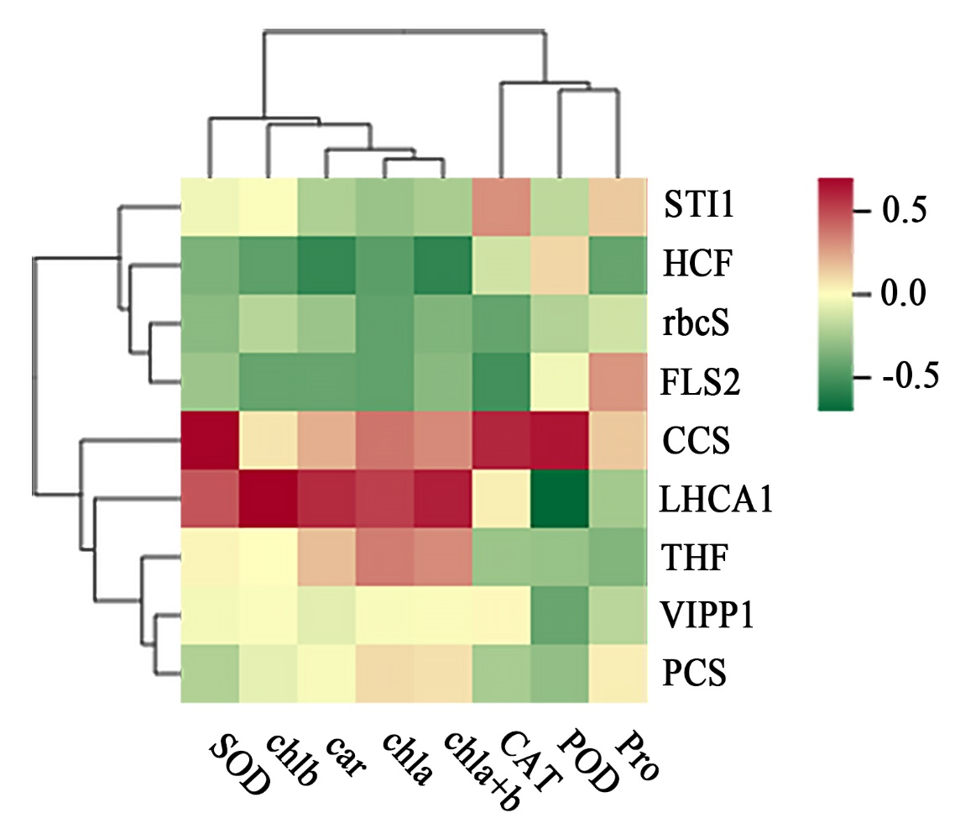
Figure S4. The correlation between chloroplast development and antioxidant related genes and plant physiological indices.

