Supplementary

Materials and Methods
Cell culture and OGD (oxygen-glucose deprivation) treatment
SH-SY5Y cells were purchased from American Type Culture and cultured in DMEM/1640 medium (Gibco, USA) supplemented with 10% FBS and 1% Penicillin/ Streptomycin at 37◦C normal cell incubator. OGD experiment was applied to mimic cerebral I/R injury in vitro. In details, after growing to 80%-90%, the SH-SY5Y cells seeded in 6-well plates were cultured with glucose-free DMEM medium and incubated in a hypoxic chamber (MIC-101, Billups-Rothberg Inc., Del Mar, CA, USA) containing the gas mixture of 5% CO₂ and 95% N₂ at 37◦C for 4 h followed and then be replaced with DMEM/1640 medium in normal incubator for another 24 h for reoxygenation.
MTT assay
3-(4, 5)-dimethylthiahiazo (-z-y1)-3,5- diphenytetrazoliumromide (MTT) kit (Sigma, M5655, USA) was used to detect cell viability with or without OGD exposure. Briefly, SH-SY5Y cells were plated in 96-well plate and incubated with MTT solution (final concentration: 0.5 mg/ ml) at 37 °C in darkness for 4 h. After removing the supernatant, the precipitated formazan crystals were solubilized in dimethyl sulfoxide (DMSO, 200 μl/ well). The optical density was examined by a microplate fluorescence reader (Infinite M200 Pro; TECAN, Grodig, Austria) at a wavelength of 570 nm.
Results
Melatonin treatment inhibited I/R-induced decrease of α7nAChR expression
α7nAChR is involved in OGD-induced HMGB1 release in primary cultured neurons (Wang et al. 2012), and expression of α7nAChR was significantly decreased after reperfusion(Wang et al. 2012). Here, our results showed that I/R significantly decreased the expression of α7nAChR and melatonin treatment could inhibit such effect, indicating that melatonin alleviates ischemia/reperfusion-induced BBB damage through upregulation of α7nAChR (Fig. S1).
HMGB1 was secreted from nucleus and cytoplasm after 4 h OGD and 24 h reoxygenation.
SH-SY5Y cell line was used to confirm the HMGB1 expression in neuron after OGD in vitro. As shown in Supplementary Fig. 1, OGD/R induced SH-SY5Y cell injury which was demonstrated by lower cell viability when compared with Saline group. The level of total HMGB1 in SH-SY5Y cells was significantly decreased after OGD treatment, as well as the downregulated level of HMGB1 both in the cytoplasm and nuclear. This is consistent with our immunofluorescence results (Figure 3), indicating that I/R injury could promote HMGB1 nucleocytoplasmic translocation and release from neuron to aggravate inflammation-induced brain injury after ischemia/reperfusion (Fig.S2).
Figure Legend
Fig.S1. Melatonin treatment inhibited I/R-induced decrease of α7nAChR. (A) Representative immunoblot showed the bands of α7nAChR (upper panel). The band intensity of α7nAChR was quantitated (lower panel). I/R induced a significant reduction in the expression of α7nAChR (*P<0.05 or vs. non-ischemic hemisphere in the same group). Treatment with melatonin prevented the decrease of α7nAChR protein (#P<0.05 vs. the saline group in ischemic hemisphere) after I/R. N=4 for each group. Data were expressed as mean±SEM.
Fig.S2 OGD/R treatment decreased HMGB1 expression in SH-SY5Y cells in vitro. SH-SY5Y was induced by 4 h OGD, and 24 h reoxygenation. (A) Cell viability of SH-SY5Y under normal or OGD condition. Data were expressed as mean±SEM. (B) Representative immunoblot showed the bands of HMGB1 expression in whole cell, cytoplasm or nuclear. (C) The band intensity of HMGB1. OGD treatment significantly reduce the levels of HMGB1 in SH-SY5Y cells (***P<0.001 vs. ctrl group). N=3 for each group. (***P<0.0001 vs. ctrl group). 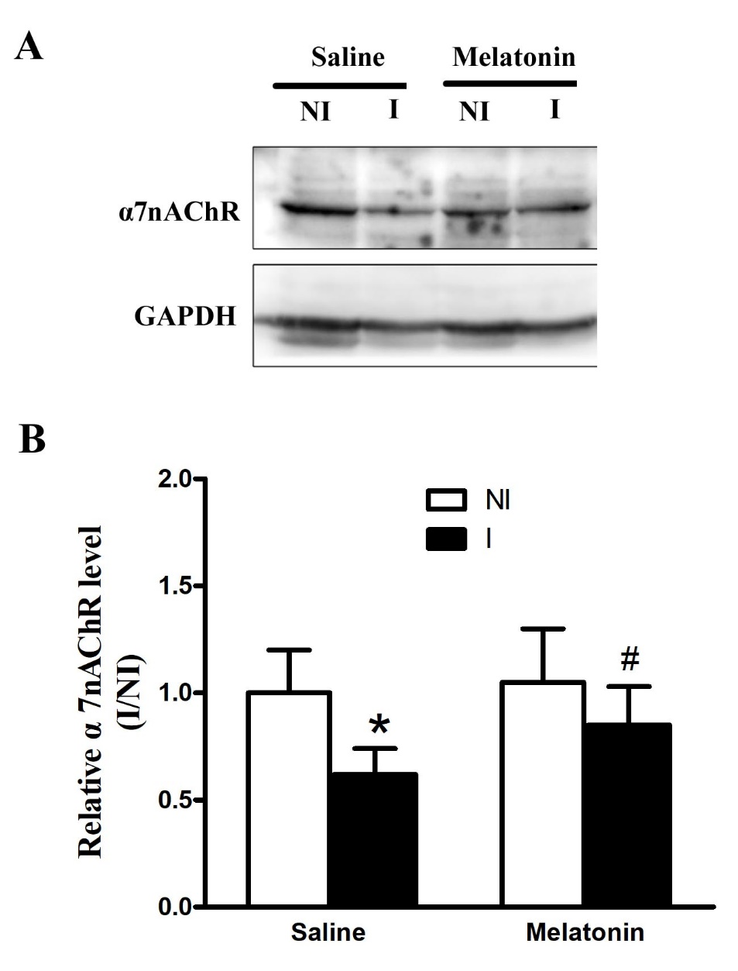
Fig. S1
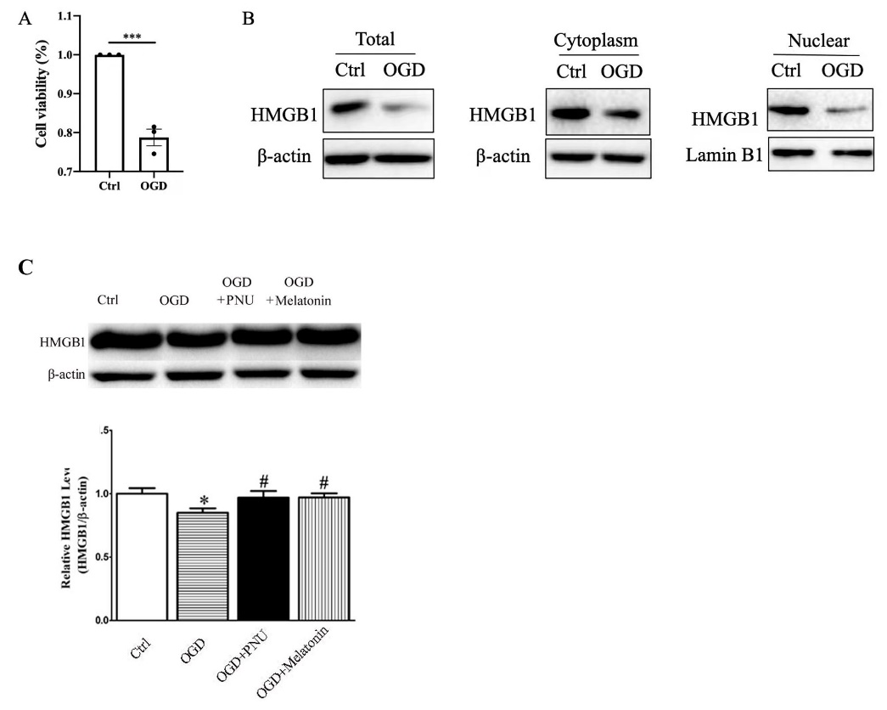
Fig. S2

