Supplementary information for ‘CARAT: an innovative tool for quantifying carbon sequestration in agroforestry systems’
Table S1. Species-specific parameter values (α, β and γ) for the leaf fall distribution model of Ferrari and Sugita (1996). For each of the nineteen different tree species in the CARAT tool, the leaf size and shape was compared to the tree species from temperate deciduous forests in Japan included in a study by Ishihare and Hiura (2011). Based on this comparison with the Japanese tree species, the parameter values of the typical agroforestry tree species in CARAT were completed.
Tree species in CARAT | Matching tree species in Ishihara and Hiura (2011) | α | β | γ
Acer pseudoplatanus | Acer mono | 41.4 | 1.5 | 0.21
Alnus glutinosa | Sorbus alnifolia | 0.9 | 3 | 0.16
Aesculus hippocastanum | Magnolia obvata | 28.1 | 1.5 | 0.3
Corylus avellana | Ostrya japonica | 77.9 | 1.5 | 0.17
Fraxinus excelsior | Fraxinus lanuginosa | 14.2 | 2.03 | 0.16
Juglans regia | Fraxinus lanuginosa | 14.2 | 2.03 | 0.16
Malus domestica | Carpinus cordata | 36.8 | 1.5 | 0.3
Populus × canadensis | Tilia maximowicziana | 18.8 | 1.5 | 0.3
Prunus avium | Prunus ssiori | 19.8 | 1.5 | 0.3
Pyrus communis | Carpinus cordata | 36.8 | 1.5 | 0.3
Quercus petraea | Quercus robur* | 0.55 | 2.1 | 0.13
Quercus robur | Quercus robur* | 0.55 | 2.1 | 0.13
Robinia pseudoacacia | Fraxinus lanuginosa | 14.2 | 2.03 | 0.16
Salix sp. | Carpinus cordata | 36.8 | 1.5 | 0.3
Sorbus aucuparia | Fraxinus lanuginosa | 14.2 | 2.03 | 0.16
Sorbus torminalis | Morus australis | 11.9 | 1.5 | 0.3
Tilia cordata | Tilia janopica | 0.9 | 2.44 | 0.19
Tilia platyphyllos | Tilia americana | 3.2 | 2.35 | 0.21
Ulmus sp. | Ulmus davidiana | 0.3 | 2.87 | 0.3
* For Q. robur, we found more accurate parameter values for forest trees in Belgium in Jonard et al. (2006).
Table S2. Calculation of the DPM:RPM ratios of the tree species included in de Schrijver et al. (2012) based on the Van Soest fractions [soluble ($SOL$), cellulose ($CEL$) and lignin ($LIC$); expressed in %]. The approach of Peltre et al. (2012) was used to determine the fractions of labile ($f_{DPM}$) and recalcitrant ($f_{RPM}$) organic matter in the leaf material of the different species.
Species | $$SOL$$ | $$CEL$$ | $$LIC$$ | $$C_{3d}$$ | $$I_{ROC}$$ | $$f_{DPM}$$ | $$f_{RPM}$$ | DPM:RMP | Slow vs. fast
Alnus glutinosa | 44.33 | 15.37 | 21.23 | 5.00 | 66.95 | 31.97 | 56.61 | 0.57 | Slow  DPM:RPM = 0.62
Fagus sylvatica | 43.46 | 20.60 | 20.94 | 5.08 | 65.08 | 34.31 | 54.79 | 0.63 | Slow  DPM:RPM = 0.62
Tilia cordata | 43.58 | 21.09 | 20.53 | 5.19 | 64.50 | 35.04 | 54.22 | 0.65 | Slow  DPM:RPM = 0.62
Quercus rubra | 41.83 | 17.17 | 20.40 | 5.23 | 64.24 | 35.37 | 53.96 | 0.66 | Slow  DPM:RPM = 0.62
Prunus avium | 51.34 | 14.60 | 13.73 | 7.04 | 60.67 | 39.84 | 50.47 | 0.79 | Fast  DPM:RPM = 0.8
Populus x euramericana | 48.70 | 17.23 | 15.04 | 6.68 | 60.55 | 39.99 | 50.35 | 0.79 | Fast  DPM:RPM = 0.8
Fraxinus americana | 51.88 | 17.20 | 13.62 | 7.07 | 60.27 | 40.34 | 50.08 | 0.81 | Fast  DPM:RPM = 0.8

Table S3. DPM:RPM ratios for the nineteen different tree species included in CARAT. Following de Schrijver et al. (2012), a distinction was made between trees with slow (DPM:RPM = 0.62) and fast decomposing leaf material (DPM:RPM = 0.80). The tree species in CARAT were then assigned to one of these two categories based on the decomposition rate of their leaf material (from literature and expert knowledge).
Species | DPM:RPM ratio
Acer pseudoplatanus | 0.8
Alnus glutinosa | 0.62
Aesculus hippocastanum | 0.62
Corylus avellana | 0.8
Fraxinus excelsior | 0.8
Juglans regia | 0.62
Malus domestica | 0.8
Populus × canadensis | 0.8
Prunus avium | 0.8
Pyrus communis | 0.8
Quercus petraea | 0.62
Quercus robur | 0.62
Robinia pseudoacacia | 0.8
Salix sp. | 0.8
Sorbus aucuparia | 0.8
Sorbus torminalis | 0.8
Tilia cordata | 0.8
Tilia platyphyllos | 0.8
Ulmus sp. | 0.8

Table S4. Pre-defined land use scenarios in CARAT. DPM/RPM-ratios are indicated between brackets for both the crop residues and the manure.
Scenario | Land use | Manure type and dose
1 | Rotation: potato (DPM:RPM 1.52) - winter wheat (DPM:RPM 1.35) - sugar beet (DPM:RPM 1.54) – cob maize (DPM:RPM 1.35) | Pig slurry, 25 ton ha⁻¹ year⁻¹ (DPM:RPM 1.15)
2 | Monoculture silage maize (DPM:RPM 1.27) w/ cover crop grass (1 cutting, DPM:RPM 1.27) | Cattle slurry, 25 ton ha⁻¹ year⁻¹ (DPM:RPM 1.15)
3 | Perennial grassland (DPM:RPM 1.37) | Cattle slurry, 25 ton ha⁻¹ year⁻¹ (DPM:RPM 1.15)

Table S5. Relative distribution of SOC in the active C pools of RothC before and after a warming-up simulation of 100 years, for three soil types and two crop rotations.
 |  | Potato – sugar beet – winter wheat |  |  |  | Silage maize
Soil type | Timestep | DPM | RPM | HUM | BIO | DPM | RPM | HUM | BIO
Sand | Initial | 0.010 | 0.120 | 0.855 | 0.015 | 0.010 | 0.200 | 0.775 | 0.015
 | 100 years | 0.017 | 0.113 | 0.849 | 0.020 | 0.011 | 0.153 | 0.818 | 0.018
Sandy loam | Initial | 0.010 | 0.120 | 0.855 | 0.015 | 0.010 | 0.200 | 0.775 | 0.015
 | 100 years | 0.018 | 0.116 | 0.843 | 0.023 | 0.012 | 0.160 | 0.809 | 0.020
Silt | Initial | 0.010 | 0.120 | 0.855 | 0.015 | 0.010 | 0.200 | 0.775 | 0.015
 | 100 years | 0.017 | 0.108 | 0.853 | 0.023 | 0.011 | 0.148 | 0.821 | 0.021

Table S6. Crop rotation and timing (x) of soil sampling on the field in Lochristi.
Year | Crop | SOC
2012 | Silage maize | x
2013 | Silage maize
2014 | Winter wheat
2015 | Silage maize | x
2016 | Winter wheat
2017 | Silage maize
2018 | Silage maize
2019 | Winter wheat
2020 | potato | x
2021 | Silage maize
2022 | Silage maize
2023 | Potato
2024 | Silage maize | x

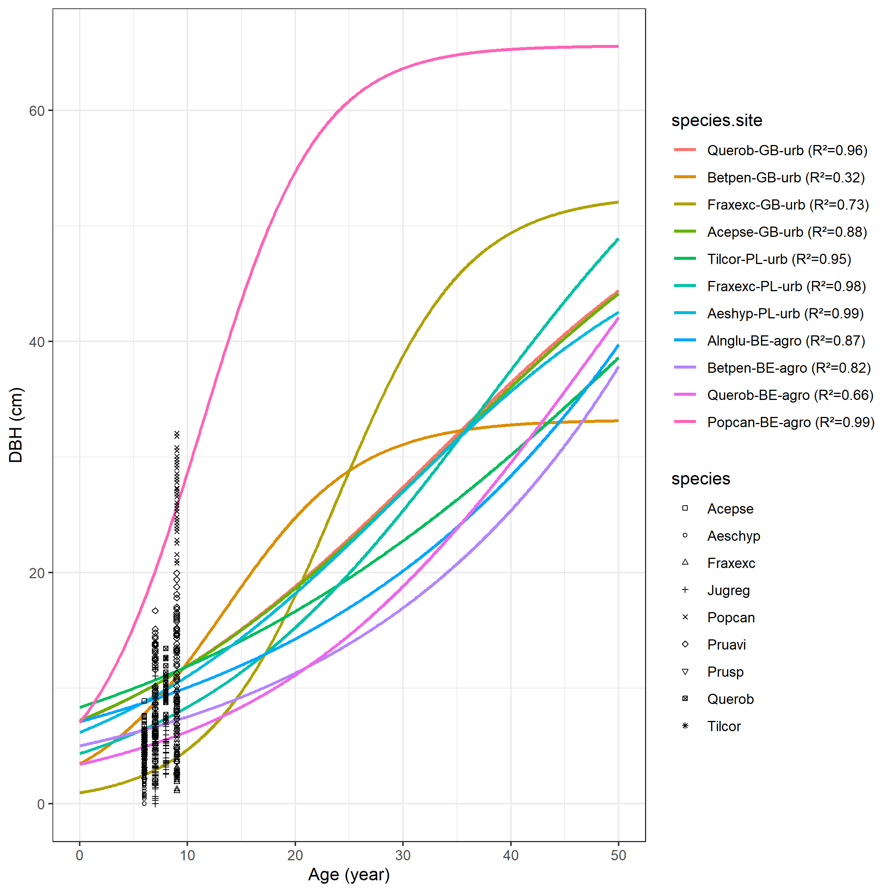
Literature data
Actual agroforestry field
Figure S1. Relationships between diameter at breast height (DBH; cm) and age (years) for the different tree species incorporated in CARAT. All relationships were modelled using literature data from open-grown trees in urban context or trees growing in hedgerows or treelines within rural areas [Monteiro et al. (2017) – GB-urb, Lukaszkiewicz & Kosmala (2008) – PL-urb, Van den berge et al. (2021) – BE-agro en Pardon (2018) – BE-agro]. Logistic curves were fit to these data and the goodness of fit (R²) is reported. Dots represent measurements from an actual agroforestry field in Flanders, Belgium.
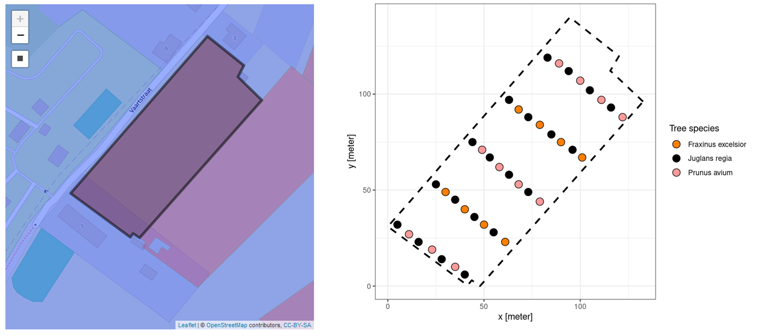
Figure S2. Selection of a random field in Flanders, Belgium using the user interface of CARAT (left) and creation of a fictitious agroforestry system with tree different tree species arranged in a customized configuration on the field (right).
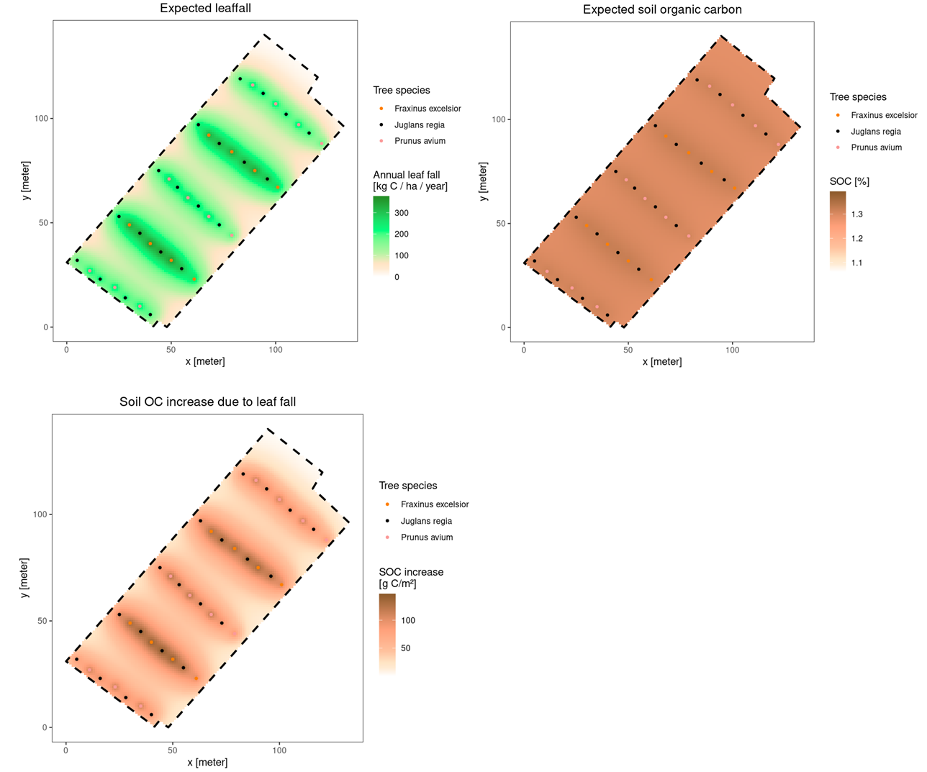
Figure S3. Raster output displayed in the user interface of the CARAT tool for a fictitious agroforestry field showing the spatial distribution of leaf fall (kg C ha⁻¹ year⁻¹), total soil organic carbon (SOC; %) and SOC increase due to leaf fall (g C m⁻²) after 30 years.
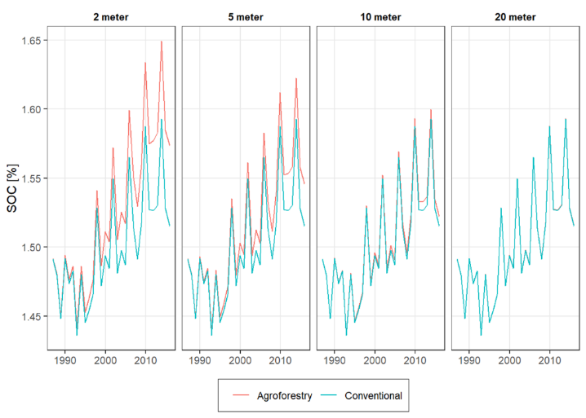
Figure S4. Yearly evolution in SOC% as modelled by CARAT for the agroforestry field and a conventional field at varying distances to the closest tree.

