Supplementary Information
Etch characteristics of maskless Oxide/Nitride/Oxide/Nitride (ONON) stacked structure using C₄H₂F₆ -based gas

Nam Il Cho¹⁼, Jong Woo Hong ²⁼, Hee Jin Yoo³, Hyeong Joon Eoh⁴, Chan Ho Kim⁴, Jun Won Jeong⁵, Kyung Lim Kim¹, Jung Hun Kwak⁶, Yong Jun Cho⁶, Dong Woo Kim^{2*}, Geun Young Yeom^{2,4*}

1 Department of Semiconductor Display Engineering, Sungkyunkwan University, Suwon, Gyeonggi-do 16419, Republic of Korea
2 School of Advanced Materials Science and Engineering, Sungkyunkwan University (SKKU), Suwon, Gyeonggi-do 16419, Republic of Korea
3 School of Chemical Engineering, Sungkyunkwan University (SKKU), Suwon, Gyeonggi-do 16419, Republic of Korea
4 SKKU Advanced Institute of Nanotechnology (SAINT), Sungkyunkwan University (SKKU), Suwon, Gyeonggi-do 16419, Republic of Korea
5 Department of Semiconductor Convergence Engineering, Sungkyunkwan University (SKKU), Suwon, Gyeonggi-do 16419, Republic of Korea
6 Research & Development Department Team, SK Specialty, 130, Myeonghaksandan-ro, Yeongdong-myeon, Sejong-Si 30068, Republic of Korea

=These authors contributed equally.

*E-mail: dwkim111@gmail.com, gyyeom@skku.edu
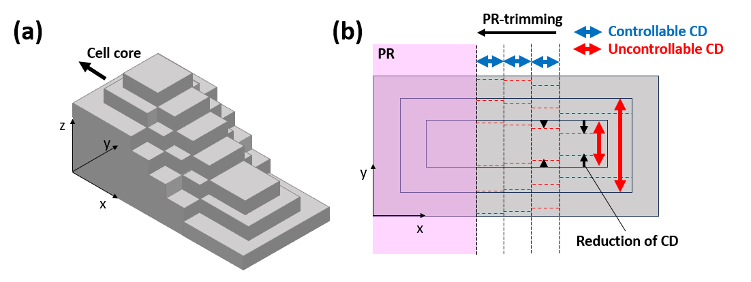
Figure S1. Schematic drawing of a simple staircase structure in 3D vertical NAND memory device. (a) Slanted view and (a) top view.

Fig S1 (a) and (b) show simple schematic drawings of the staircase etching structure for understanding the problem related to the CD reduction during the maskless ONON stack feature etching of 3D NAND device. To reduce the number of ON staircase layer-by-layer etching steps, maskless ONON stack feature etching (rectangular shaped features in (b)) is performed and the etching of one ON layer-by-one ON layer is followed with PR trimming to x-direction. The CD reduction and slanting of the etched feature during the maskless ONON stack feature etching will significantly reduce the contact area in y-direction for each ON device during the following etching of one ON layer-by-layer while PR trimming.

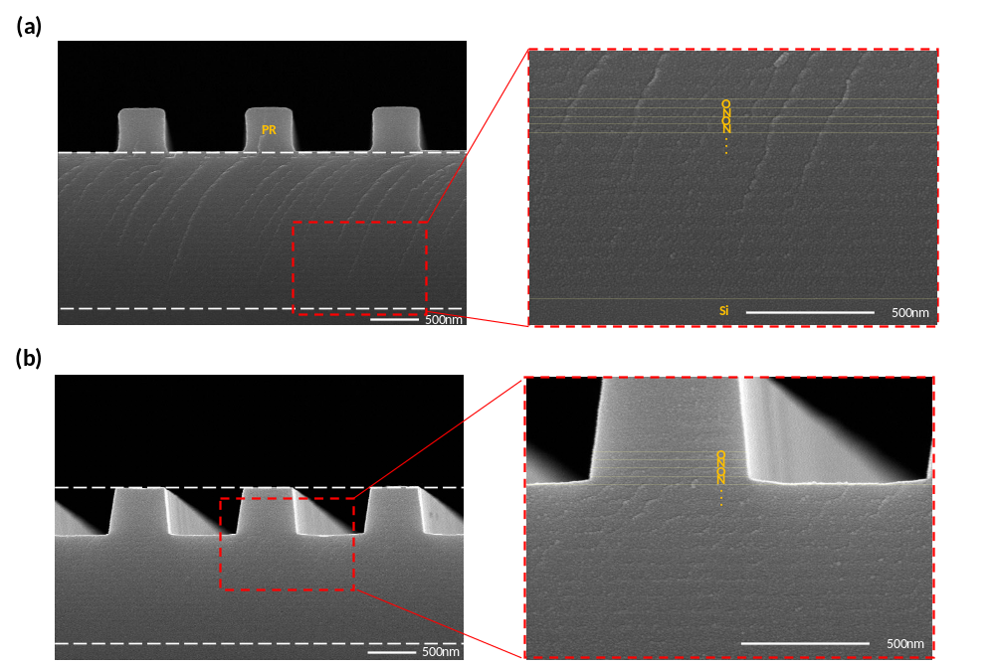
Figure S2. Magnified SEM images: (a) from Fig. 1 (a) and (b) from Fig. 1 (b).

For clear confirmation of the SiO₂ and SiN_{x} layers in the maskless ONON stacked feature, SEM images were magnified from 30K to 100K scales. This allowed us to confirm the positions and boundary layers of the ~510 nm thick maskless ONON stack feature.

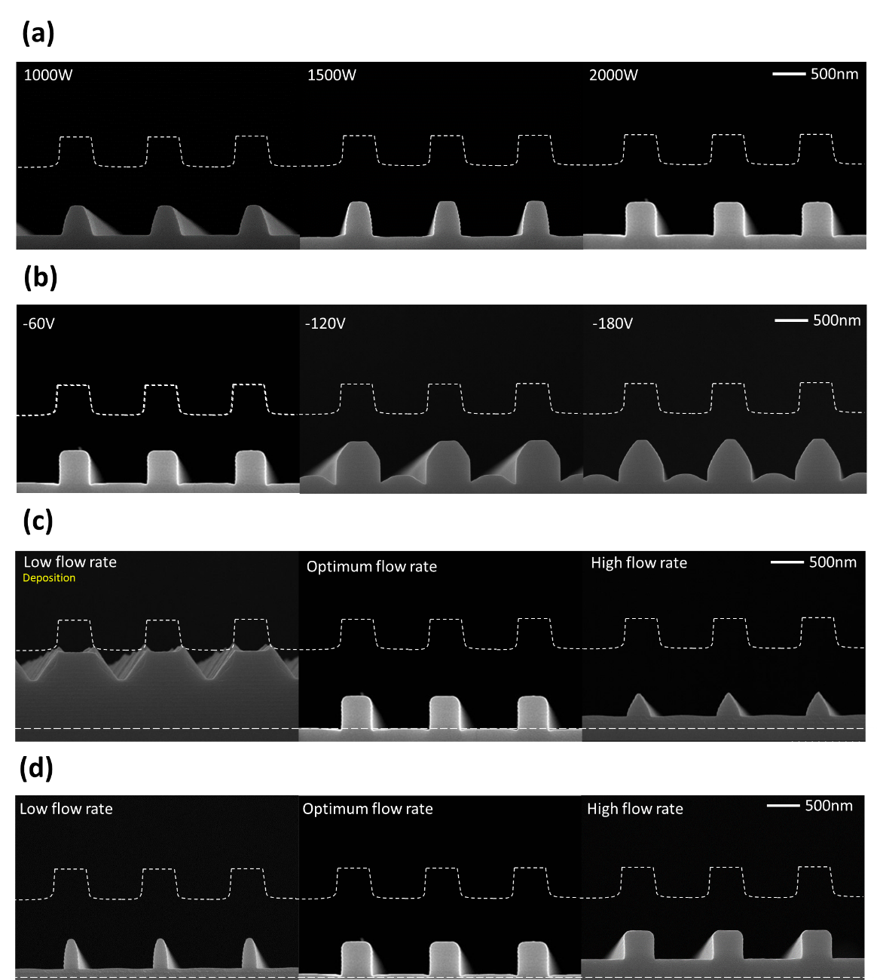

Figure S3. SEM images of maskless ONON stack feature etched with C₄H₂F₆/CF₄/O₂/Ar gas mixture as functions of (a) source power, (b) DC bias voltage, (c) O₂ gas flow rate, and (d) CF₄ flow rate.

Optimal conditions for the maskless ONON stack feature etching using C₄H₂F₆-based gas were investigated by varying RF power, DC bias voltage, and the flow rates of O₂ and CF₄ gases, respectively, and, 2000 W of source power and -60 V of DC bias voltage were selected with the additive gases of CF₄/O₂/Ar.
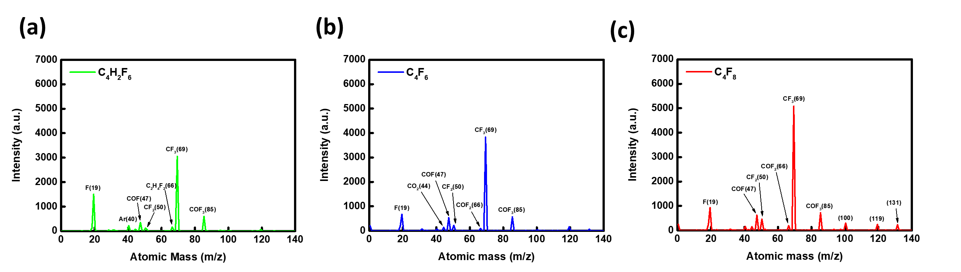
Figure S4. Radical intensities measured by QMS for (a) C₄H₂F₆, (b) C₄F₆, and (c) C₄F₈-based gases mixed with CF₄/Ar/O₂. The process conditions were the same as those in Figure 2.

Figure S4 shows the radical intensities measured by QMS for (a) C₄H₂F₆, (b) C₄F₆, and (c) C₄F₈-based gases mixed with CF₄/Ar/O₂ and, as shown, radicals related to the passivation such as CF₂, C₂H₂F₂, etc. and radicals related to etching such as CF₃, F, etc. could be observed.

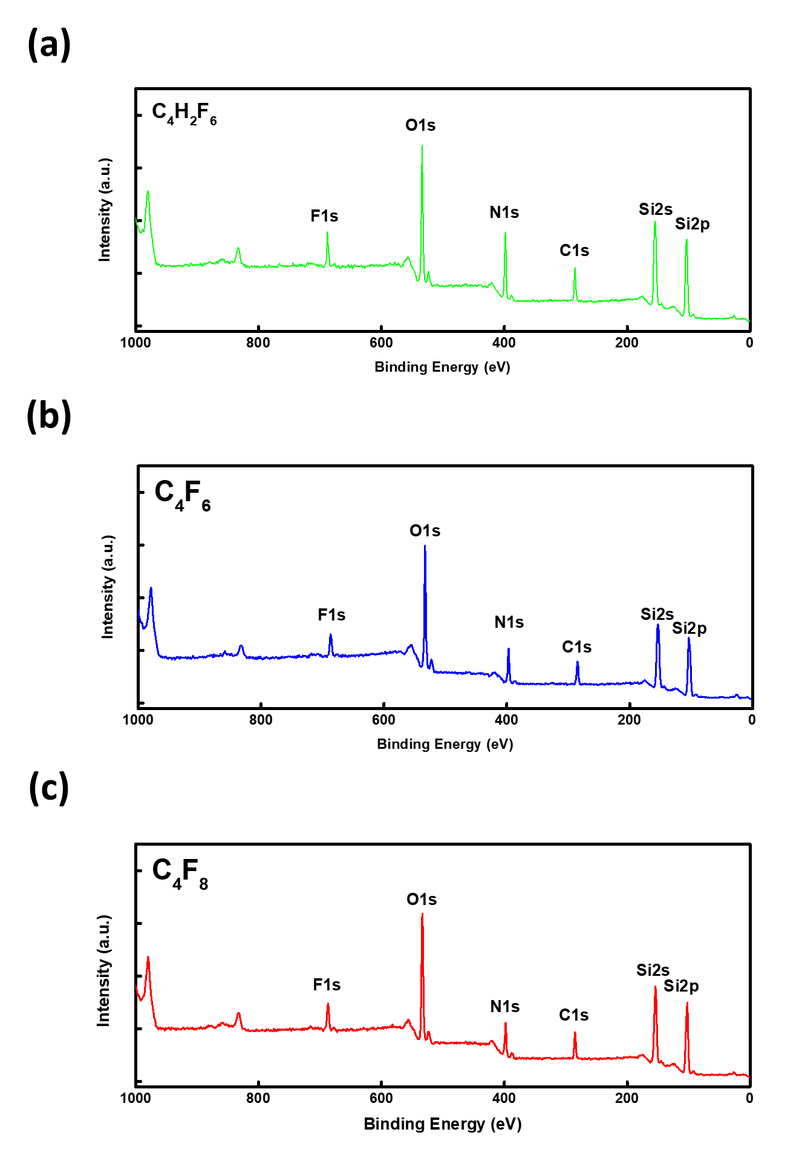
Figure S5. XPS widescan data measured at 50° tilting of samples for the study of sidewall residues remaining on the maskless ONON stack features etched with (a) C₄H₂F₆, (b) C₄F₆, and (c) C₄F₈-based gases. The process conditions were the same as those in Fig. 2.

Figure S5 shows XPS widescan data for observation of the components on the sidewall surfaces of the maskless ONON stack features etched with C₄H₂F₆, C₄F₆, and C₄F₈-based gases. As shown in Fig. S4, Si, C, O, F, and N were observed as the major components for all cases. Among these, Si, O, and N were from the ONON substrate, therefore, C and F were the major residue components observed by XPS.

